

CSE 6334 Software Requirements Engineering

Project Part 1: Elicitation Execution

Group :7

|  |  |
| --- | --- |
| Name | Student ID |
| Akid Syazwan bin Nor Azman Shah | 1211111238 |
| Teng Chay Xuan | 1231300802 |
| Kishen Kumar A/L Kumaran | 1211111528 |
| Shannon Fernandez | 1211106748 |

The result of requirement from all same with task 3 potential + update event report for club committee

1. Elicitation Execution

In this section we will outline the execution of the elicitation process, including the method used to identify the requirement, stakeholder involve, and the key outcomes. It highlights the gathered requirement and insight that will guide the system design and development.

* 1. Interview

As part of the requirements elicitation process for the Student Club Management System (SCMS), we conducted interviews with key stakeholders, primarily club committee members.

The primary purpose of these interviews was to:

* Identify existing pain points in managing club activities, event proposals, budget submissions, and venue bookings.
* Understand user expectations and operational workflows that need to be supported by the system.
* Validate assumptions about required integrations with university systems (e.g., finance, venue reservation, authentication).
* Capture specific needs for role-based access, approval hierarchies, and reporting functionalities.

This qualitative method allowed us to gain first-hand insights into the real-world challenges and user behaviours that are difficult to capture through documentation alone. The results were used to shape user stories, system features, and interface designs that are both relevant and usable.

1.1.1 Interview Execution: Interview 1 with Club Committee from The Board Game Club

Date of Session: 22 May 2025

Platform: Microsoft Teams

Recording Link: <https://youtu.be/R5zW947_m4k>

1.1.1.1. Current Process

The club currently manages its activities using a **Discord server** where all members are present. The built-in Discord event system is used to schedule events, share general information (e.g., activity type, games to be played), and allow members to RSVP by clicking "Interested."

#### 1.1.1.2 Challenges Identified

* Limited Event Functionality
* Poor Member Management
* Lack of Automation and Flexibility

1.1.1.3 Desired Improvements / Feature Requests

* Event Editing with Notifications
* Member Management Module
* General Automation

#### 1.1.1.4. Overall Summary

The interviewee described the current system as **“bare bones”** and **makeshift**, acknowledging that while Discord is accessible, it lacks the depth and flexibility required for effective club management. The club is eager to adopt a solution that offers **better structure, automation, and control** over both events and membership data.

1.1.2 Interview Execution: Interview 2 with Club Committee from the MMU eSports Club

Date of Session: 24 May 2025

Platform: Microsoft Teams

Recording Link: <https://youtu.be/R5zW947_m4k>

1.1.2.1. Current Process

The current MMU eSports manages its activities using a **Discord server**. Google Forms are created to manage signups, promotions are handled via group chats and emails, and spreadsheets are used to track attendance and participation. This results in a multi-tool process where each aspect of event and activity management is handled separately.

#### 1.1.2.2 Challenges Identified

* Fragmented Tools
  + Multiple platforms (Google Forms, Discord, emails, spreadsheets) lead to scattered information and poor coordination.
* Lack of Real-Time Updates
  + Difficulty in managing changes and keeping everyone updated promptly.
* No Integration with University Systems
  + The current system doesn’t connect with university platforms. Forms must be submitted physically or via email.

1.1.2.3 Desired Improvements / Feature Requests

* **Centralized Platform**
  + A unified system that brings together event registration, communication, attendance tracking, and budgeting.
* **Attendance and Participation Tracking Automation**
  + Automatically log attendance and generate insights or reports.
* **Event Registration and Reminder Automation**
  + Ability to register for events and receive automated reminders.
* **Integration with University Systems**
  + Auto-link with university financial and venue booking systems for smoother administration.

#### 1.1.2.4. Overall Summary

The interviewee described the current system as **“bare bones”** and **makeshift**, acknowledging that while Discord is accessible, it lacks the depth and flexibility required for effective club management. The club is eager to adopt a solution that offers **better structure, automation, and control** over both events and membership data.

* 1. Questionnaire  
       
     **Questionnaire (Google Form)**  
       
     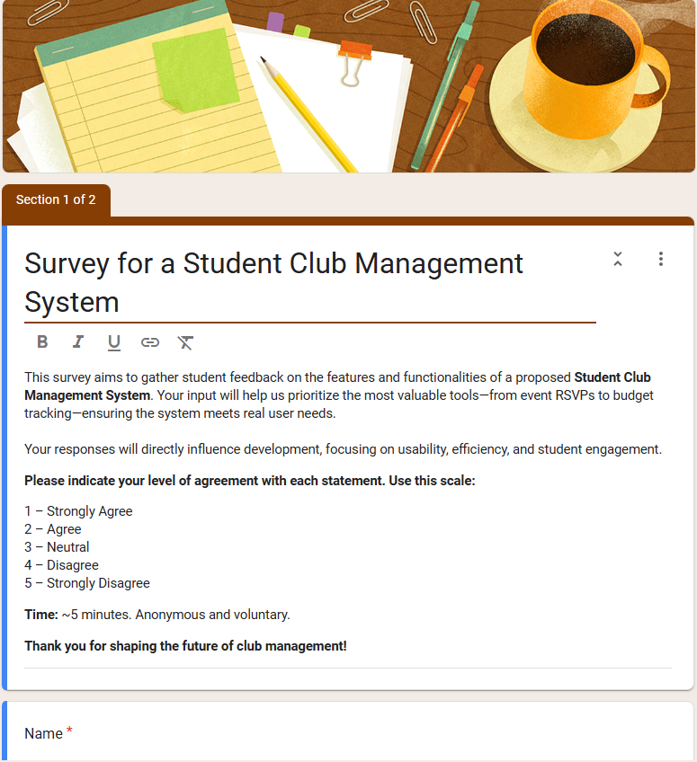

**Inquiry of Responder**  
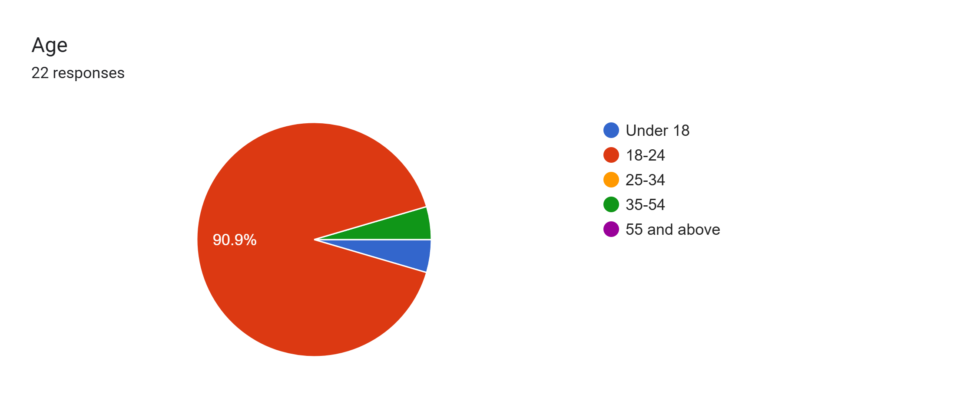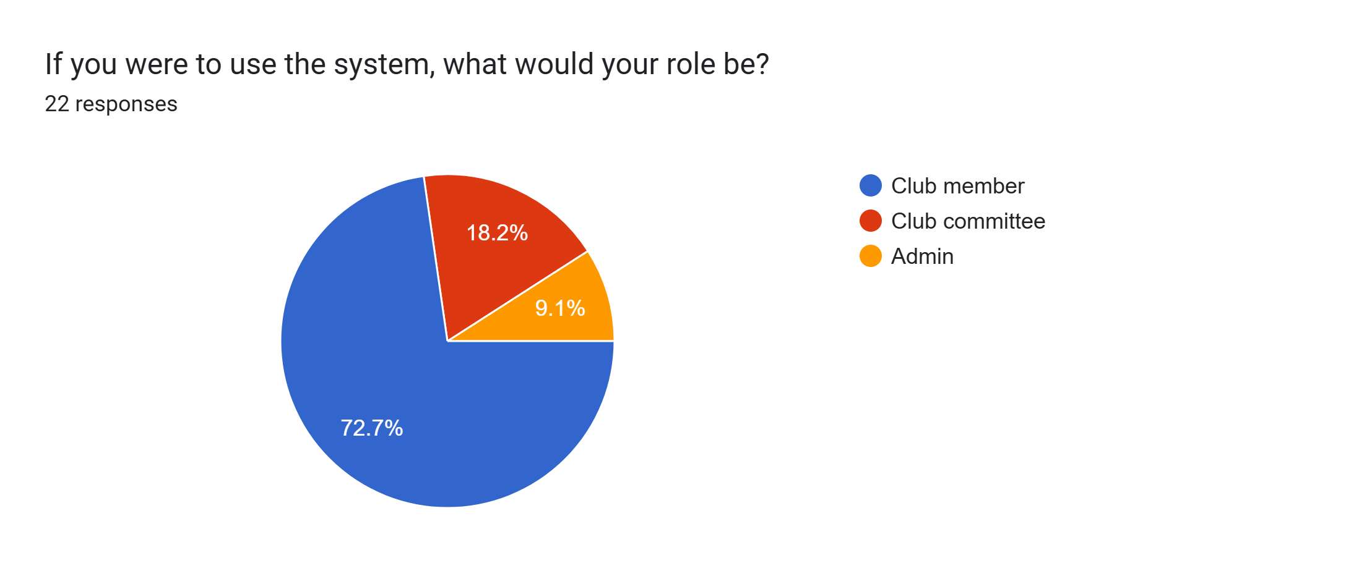  
  
**Questions from the Survey**  
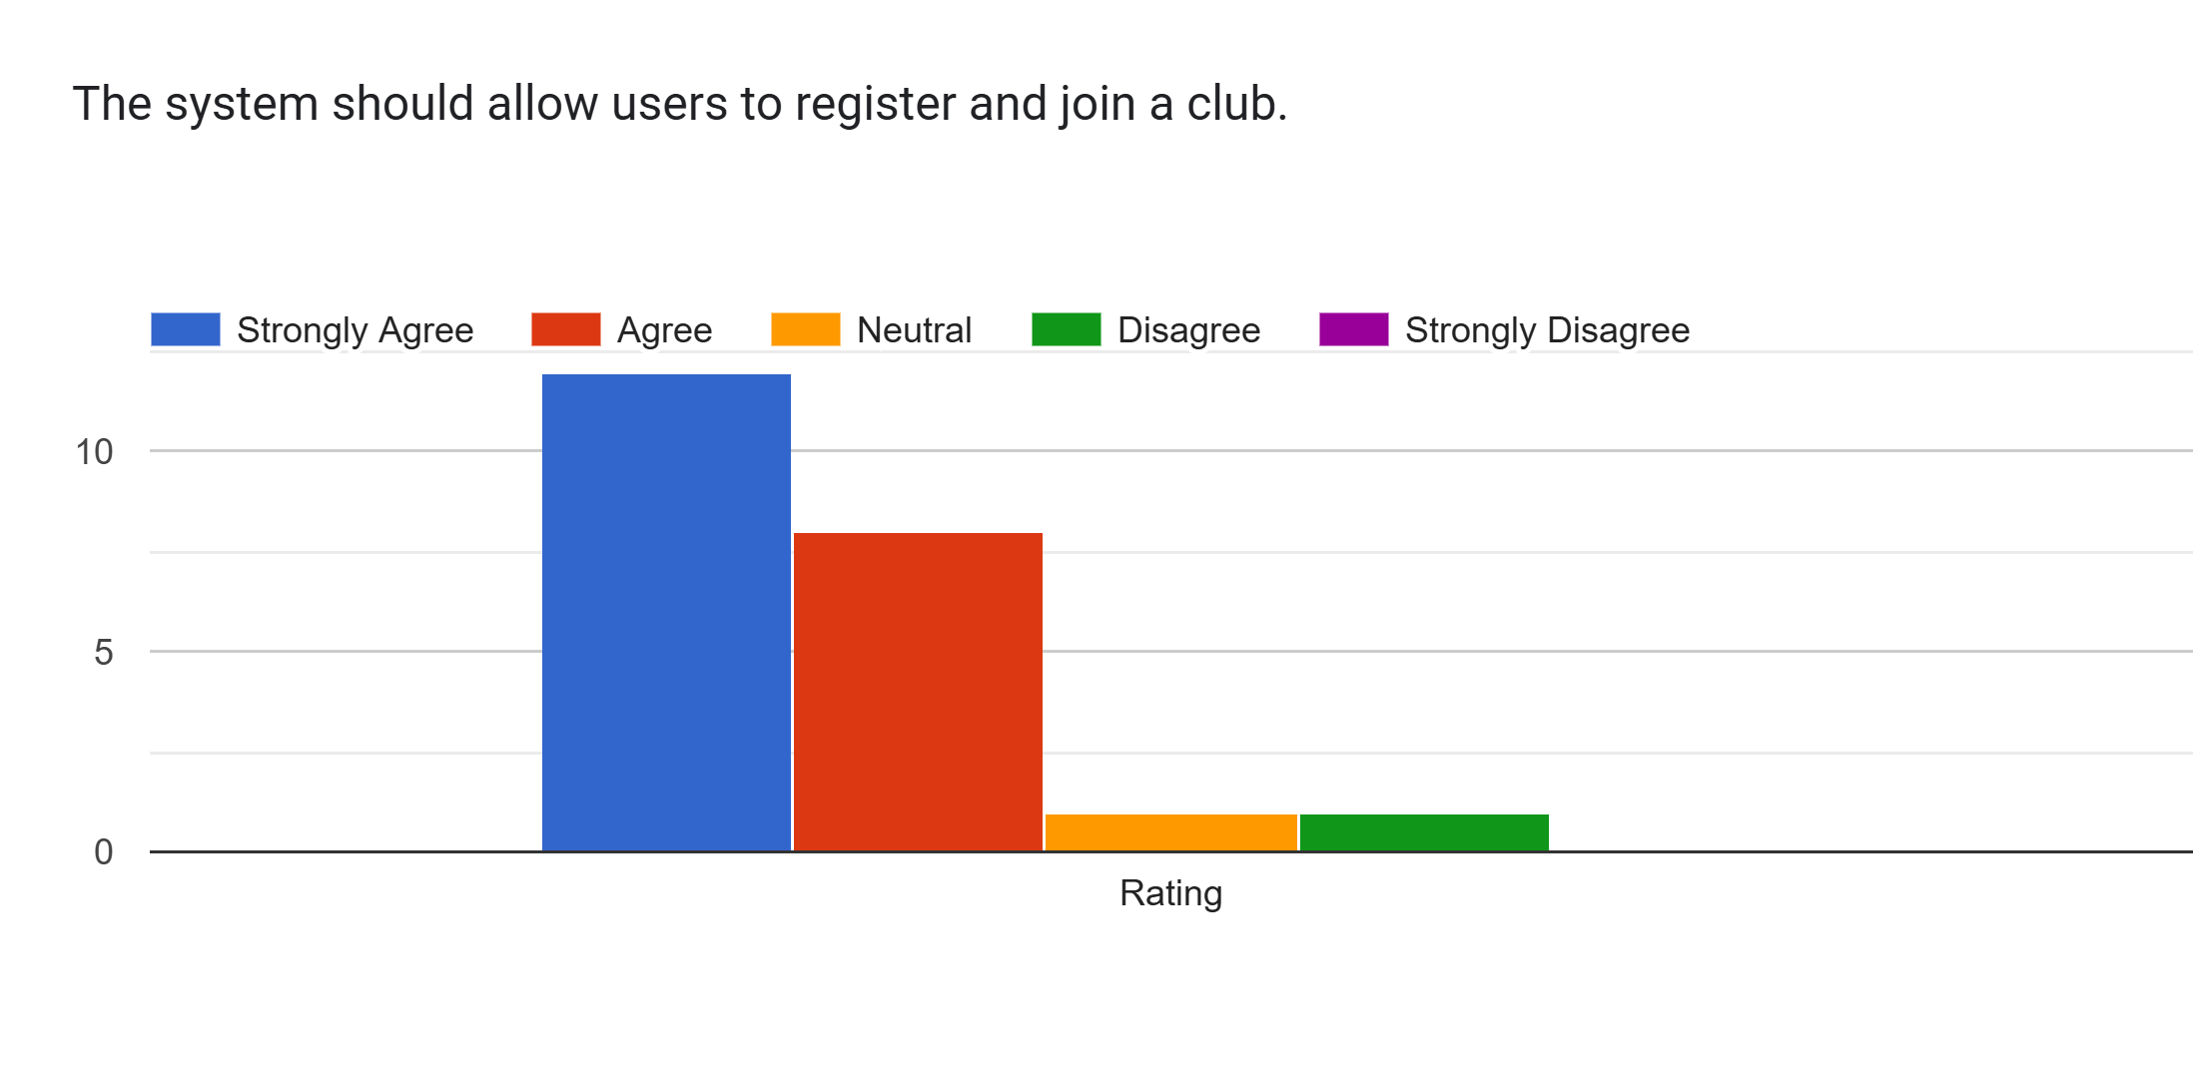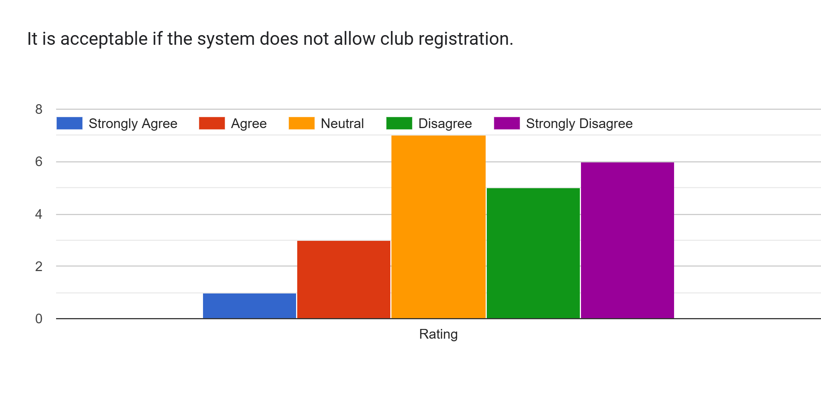  
Forms response chart. Question title: The system should allow members to RSVP for events.
. Number of responses: .  
Forms response chart. Question title: It is acceptable if RSVP for events is not provided.
. Number of responses: .  
Forms response chart. Question title: The system should allow committee members to manage club member information.
. Number of responses: .  
  
Forms response chart. Question title: It is acceptable if club members cannot be managed through the system.
. Number of responses: .Forms response chart. Question title: The system should allow submission of event proposals for approval.
. Number of responses: .  
Forms response chart. Question title: It is acceptable if event proposal submission is not included.
. Number of responses: .Forms response chart. Question title: The system should support budget proposal submission and approval.
. Number of responses: .  
Forms response chart. Question title: It is acceptable if budget approval features are not available.
. Number of responses: .Forms response chart. Question title: The system should allow venue booking and approval.
. Number of responses: .Forms response chart. Question title: It is acceptable if venue booking is handled outside the system.
. Number of responses: .Forms response chart. Question title: The system should let authorized users update or submit event reports.
. Number of responses: .Forms response chart. Question title: It is acceptable if event reports cannot be updated through the system.
. Number of responses: .Forms response chart. Question title: The system should allow administrators to monitor club and event activities.
. Number of responses: .

**Results of the Questionnaire**  
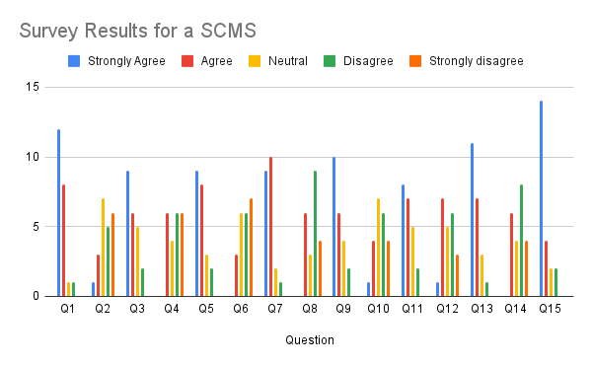

Conclusion/Summary  
  
Most people strongly agreed with the idea that the system should include core features like user registration, event RSVP, and the ability to submit budget or event proposals. These features had the highest number of "Strongly Agree" responses, which shows that respondents see them as essential. It makes sense—these are basic tools that make it easier for members and committee leaders to participate and manage club activities.  
On the other hand, when asked if it would be acceptable to leave out those same features, the most common answers were "Disagree" or "Strongly Disagree." That tells us people don’t just want these features—they expect them. They’re not comfortable with the idea of a system that skips important functions, even if they’re not always used.  
  
A few questions, especially those about features like budget approvals or committee management, got more mixed results. Some people were neutral, which might mean they don’t see those as personally relevant, or they’re unsure how important they are. Still, the overall message is pretty clear: the system should support active involvement from both regular members and committee members, and people want it to be capable—not minimal.  
  
  
  
  
*Table Requirement list for questionnaire*

|  |  |  |  |
| --- | --- | --- | --- |
| **Stakeholder** | **Requirement** | **Kano Category** | **Justification** |
| Club Member | Register to system | Dissatisfier | Fundamental functionality needed for any user to access the system. |
| Club Member | RSVP for events | Satisfier | Enables members to easily express interest and participate in events. |
| Club Committee | Create event proposal | Satisfier | Core functionality for planning and initiating club activities. |
| Club Committee | Submit budget proposal | Satisfier | Supports financial planning and approval workflow for club activities. |

* 1. Brainstorming

The brainstorming session key objective was to encourage an open, collaborative discussion among the key stakeholders to generate a creative idea, uncover hidden requirement and validate initial assumption gathered from the questionnaire and interview. The goal of brainstorming was to promote cross-role communication and uncover insightful information that might not be revealed using the other elicitation techniques.

1.3.1 Brainstorming Execution

Date of session: 22 May 2025

Platform: Microsoft Teams

Participants:

- 1 Club member

- 1 Club Committee

- 1 System Administrator

Recording Link: https://youtu.be/ecFU02LAhuw

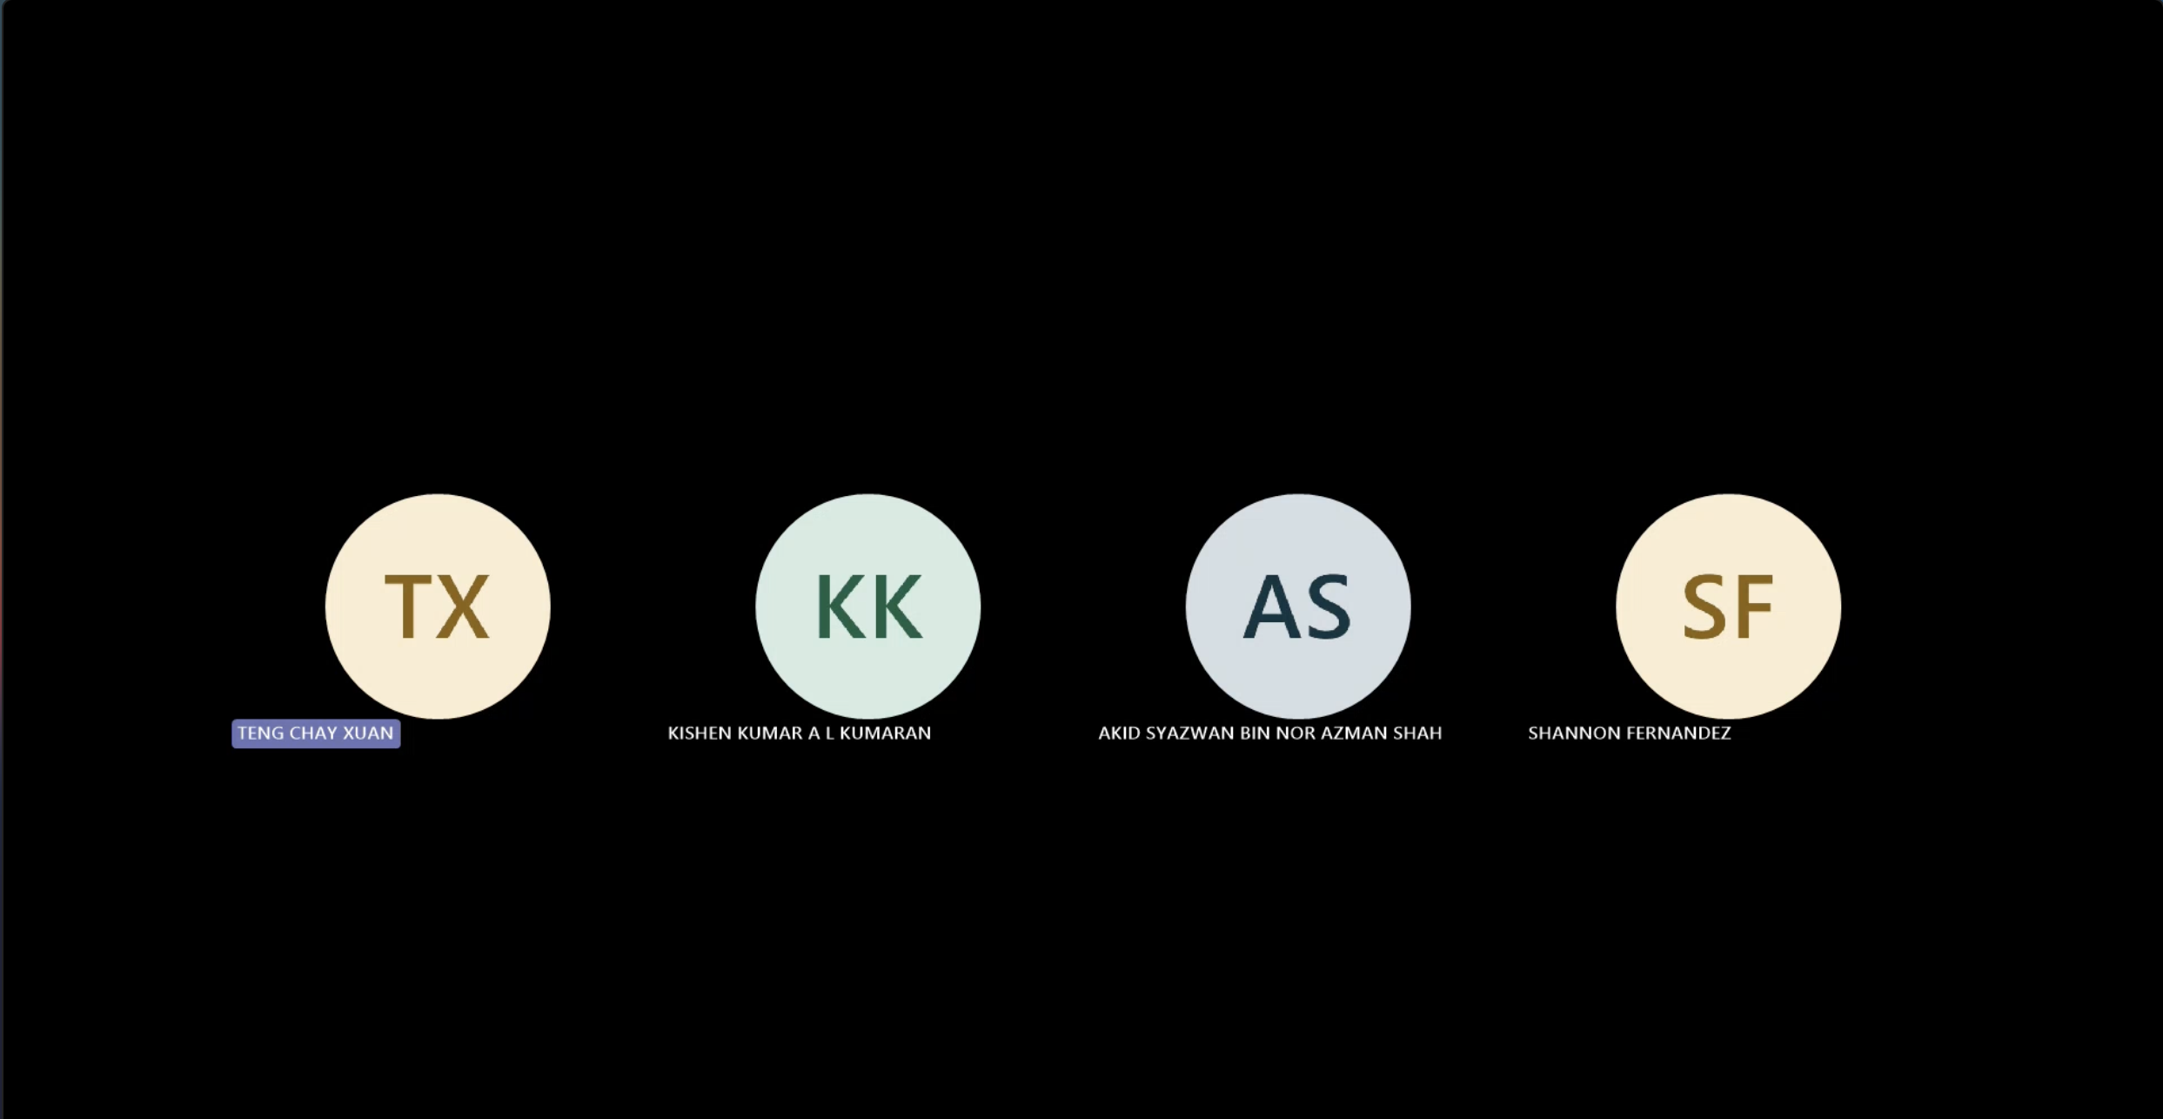

*Figure 1.3.1 Brainstorming session*

1.3.2 Brainstorming Session Summary

The brainstorming session successfully expanded the pool of potential requirement by incorporating diverse perspective. One new requirement – event report updating by club committee – did not previously capture in the questionnaire and interview phases. This suggestion will be included in the requirement prioritisation and feasibility analysis phase. Table 1.3.2 below show the list of requirement outcome get from the brainstorming session with their Kano specification.

*Table 2.3.2 Requirement list for brainstorming*

|  |  |  |  |
| --- | --- | --- | --- |
| **Stakeholder** | **Requirement** | **Kano Category** | **Justification** |
| **Club Member** | Login to system | Dissatisfier | Basic access control |
| Register to system | Dissatisfier | Fundamental user function |
| Join club | Dissatisfier | Members join the club available |
| View upcoming events | Dissatisfier | Users expect to be informed of upcoming activities |
| RSVP for events | Satisfier | Helps users engage in club activities |
| **Club Committee** | Login to system | Dissatisfier | Expected for secure access |
| Manage club members | Satisfier | Directly impacts club operations and user experience |
| Create event proposal | Satisfier | Essential for organizing club events |
| Submit budget proposal | Satisfier | Key to planning |
| Submit venue booking proposal | Satisfier | Necessary for holding physical events |
| Cancel event | Satisfier | Important for managing unforeseen changes |
| Update and submit event report | Satisfier | Finalize post-event details for reference |
| **Admin** | Login to system | Dissatisfier | Required for administrative access |
| Monitor club and event activity | Satisfier | Helps in overseeing operations efficiently |
| Generate advanced reports | Delighter | Provides added value for details report beyond basic report |

1. Summary

To ensure the system meets the need and expectation of all the stakeholders, three elicitation technique were executed which is questionnaire, interview and brainstorming. These methods were specifically selected to collect both general and detailed information from all the stakeholders such as club member, club committee, and system admin. Table 2.1 below show the listing for all the requirements caught from all the elicitation techniques with their Kano category.

Table 2.1 Requirement outcome from all technique

|  |  |  |  |  |
| --- | --- | --- | --- | --- |
| **Stakeholder** | **Requirement** | **Kano Category** | **Justification** | **Technique(s)** |
| **Club Member** | Login to system | Dissatisfier | Basic access control | Brainstorming |
| Register to system | Dissatisfier | Fundamental user function | Brainstorming Questionnaire |
| Join the club | Dissatisfier | Fundamental user function | Brainstorming |
| View upcoming events | Dissatisfier | Users expect to be informed of upcoming activities | Brainstorming |
| RSVP for events | Satisfier | Helps users engage in club activities | Brainstorming  Interview Questionnaire |
| **Club Committee** | Login to system | Dissatisfier | Expected for secure access | Brainstorming |
| Manage club members | Satisfier | Directly impacts club operations and user experience | Brainstorming  Interview |
| Create event proposal | Satisfier | Essential for organizing club events | Brainstorming Questionnaire |
| Submit budget proposal | Satisfier | Key to planning | Brainstorming  Interview Questionnaire |
| Submit venue booking proposal | Satisfier | Necessary for holding physical events | Brainstorming  Interview |
| Cancel event | Satisfier | Important for managing unforeseen changes | Brainstorming  Interview |
| **Update and submit event report** | Satisfier | Allows committee to edit and finalize post-event details | **Brainstorming** |
| **Admin** | Login to system | Dissatisfier | Required for administrative access | Brainstorming |
| Monitor club and event activity | Satisfier | Helps in overseeing operations efficiently | Brainstorming |
| Generate advanced reports | Delighter | Provides added value for detailed reporting beyond basic features | Brainstorming |