

CSE 6334 Software Requirements Engineering

Project Part 1: Project Preliminary

Group :7

|  |  |
| --- | --- |
| Name | Student ID |
| Akid Syazwan bin Nor Azman Shah | 1211111238 |
| Teng Chay Xuan | 1231300802 |
| Kishen Kumar A/L Kumaran | 1211111528 |
| Shannon Fernandez | 1211106748 |

### **Vision**

The vision of the Student Club Management System is to digitally transform and centralize the operations of student clubs by providing an integrated platform that simplifies the management of memberships, events, finances, and venue bookings. The system aims to reduce administrative burden, improve communication and transparency, and empower club committees and members to participate more actively in campus life.

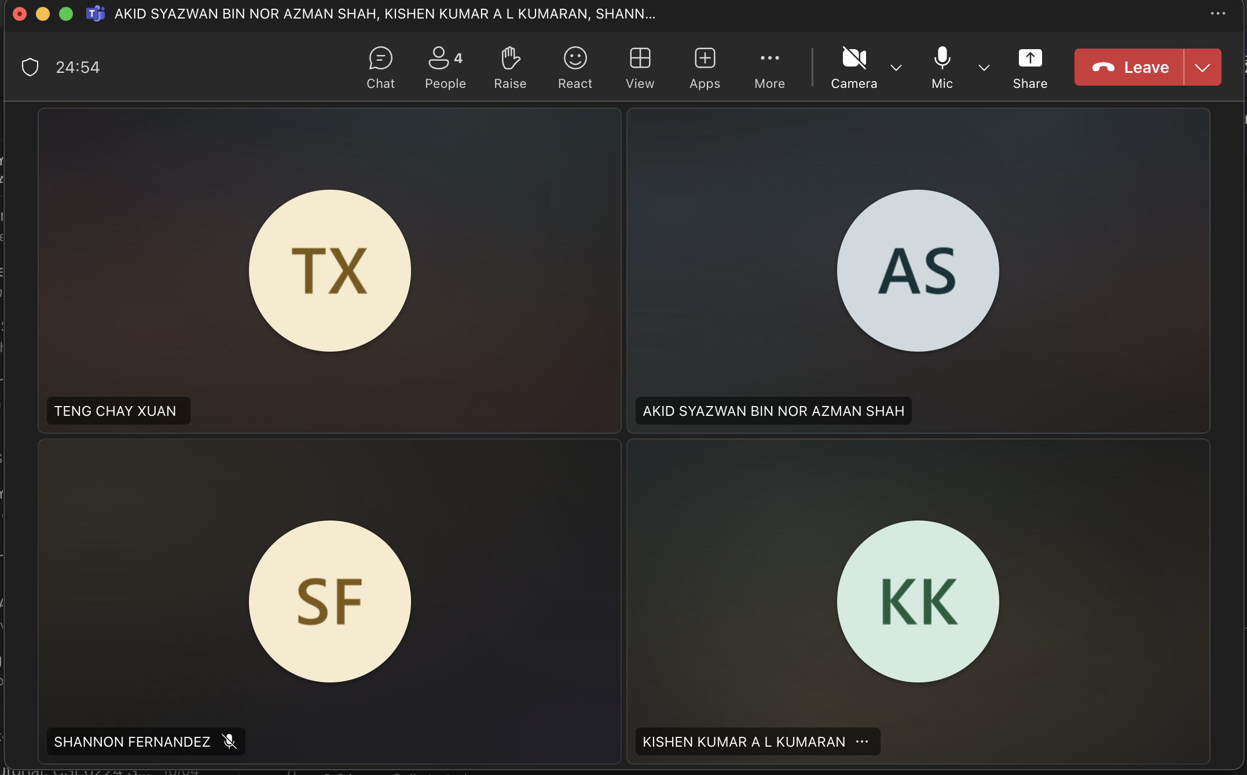

1. **Goals**

In software systems, goals define what the system is intended to achieve, guiding its development, design, and functionality. They help ensure that all components work together toward meeting user needs and business requirements. Clear goals also support better planning, testing, and evaluation, making the software more efficient, reliable, and aligned with its intended purpose.

A discussion has been carried out on the goals of the system between the members of the group in a Microsoft Teams chat room, one of the defined system goals are club management which is to streamline the administration of student clubs by managing memberships, roles, events, and communications in a centralized system. Other than that, finance integration, enable accurate tracking and management of club budgets, funding requests, and expenditure approvals with real-time financial reporting. Lastly, venue booking, to simplify the process of reserving campus facilities by providing an integrated platform for checking availability, submitting requests, and receiving booking confirmations. With these goals, we can define the high-level modules.

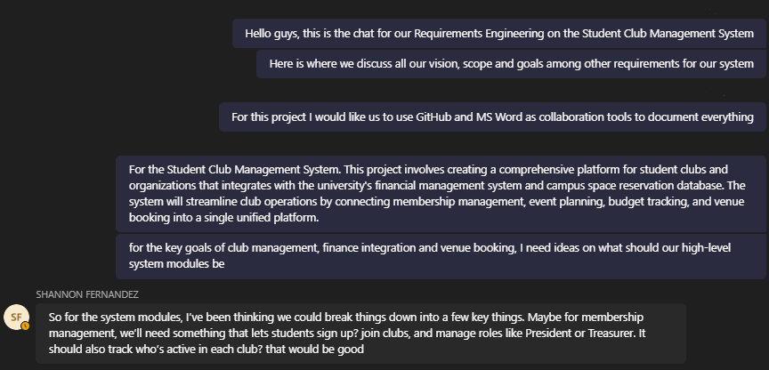

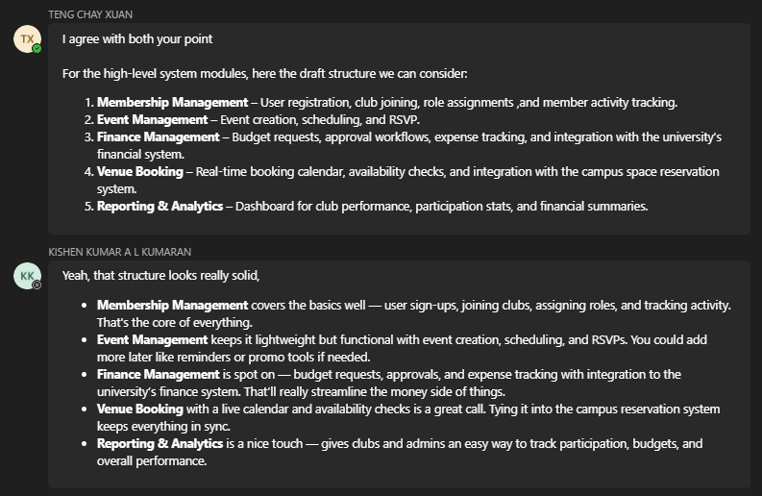

### **Scope**

The Student Club Management System is a web-based platform designed to serve three main user groups: club committees, regular club members, and university administration.

The system will provide the following core functionalities:

* **Club Management**
* Registration and renewal of club memberships
* Role assignment and user access control
* Member directory and activity tracking

* **Event Management**
* Event planning and scheduling
* RSVP and attendance tracking
* Event announcements and calendar integration
* **Financial Integration**
* Budget planning and approval workflows
* Expense tracking and funding request submissions
* Financial reporting and audit logs

* **Venue Booking**
* Browsing venue availability
* Submitting booking requests
* Booking status tracking and notifications

* **Administration & Reporting**
* Access for university staff to review budgets and event requests
* Automated generation of reports (e.g., club activity summaries, financial usage)