

CSE 6334 Software Requirements Engineering

Project Part 1: Requirements Elicitation Plan Using Kano Model

Group :7

|  |  |
| --- | --- |
| Name | Student ID |
| Akid Syazwan bin Nor Azman Shah | 1211111238 |
| Teng Chay Xuan | 1231300802 |
| Kishen Kumar A/L Kumaran | 1211111528 |
| Shannon Fernandez | 1211106748 |

1. **Introduction**

The Student Club Management System with Budget and Venue integration is designed to serve as a centralized platform for managing the various activities of student club within the university. The aim of this system is to make necessary task like club membership registration, event planning, budget submission and approval and venue booking more efficient. The platform will also integrate with the university space reservation and finance management system to facilitate easier departmental cooperation. To ensure the system aligns with the actual need of stakeholders, a structured requirement elicitation plan is required. This can be achieved by identifying and ranking characteristics according to their influence on user satisfaction using the Kano Model. This plan describes the use of Kano Model to guide the elicitation and classification of system requirement from diverse stakeholders.

The Kano Model is a technique used in requirement engineering to classify product or system feature into three main categories which is dissatisfiers, satisfiers, and delighters. Dissatisfiers also known as the must have features or the function that users expect to have in the system. The next one is the satisfiers or also known as the performance attributes are the features that directly influence the user satisfaction. The last one is the delighter or also known as the excitement attribute, these are the unexpected features that user may not ask for but are pleased to find in the system. By applying the Kano Model, the development team can effectively prioritize the implementation of the core or the categorized as dissatisfier function or feature based on their impact on user experience and can deeper insight into the user expectation and strategically plan which feature to implement first.

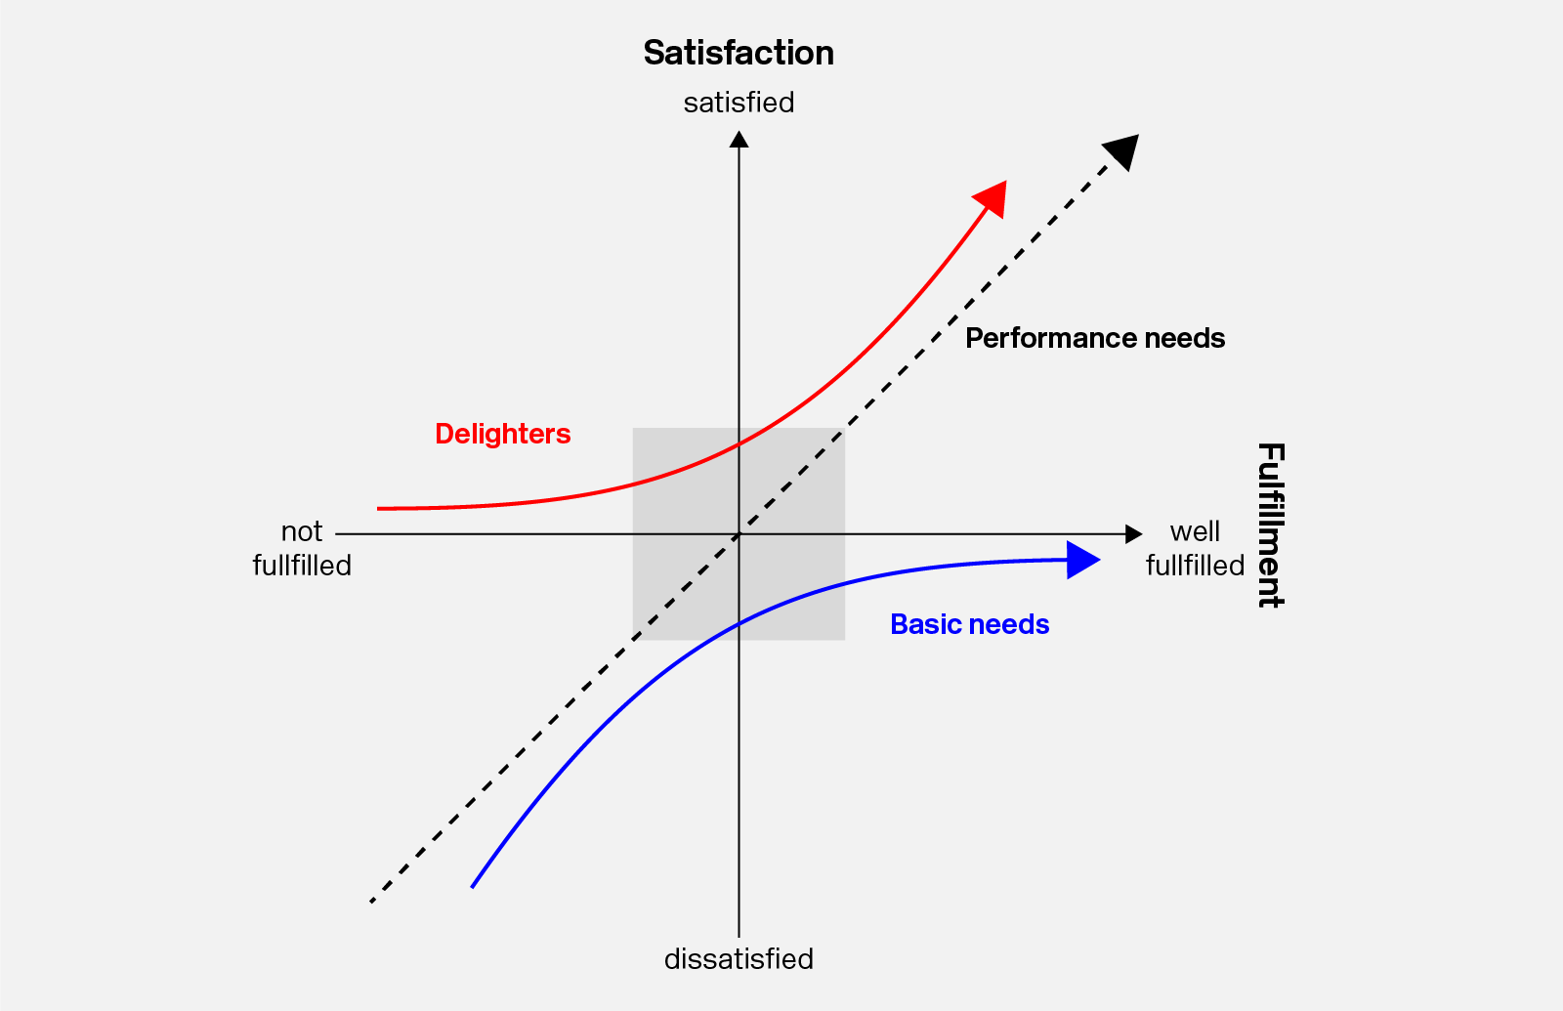

Figure 1.1 Kano Model diagram

1. **Stakeholder identification**

Stakeholders are the one who will fully involve or partially involve in the development process of the system. There were several stakeholders have been identified in this system as the table 2.1 below.

*Table 2.1 Stakeholder list*

|  |  |
| --- | --- |
| Stakeholder | Role |
| Club Member | Register and join the club, login to system, view upcoming event, RSVP for event. |
| Club Commitee | Register and login to system, manage club member, create event proposal, submit budget proposal for approval, submit book venue for approval, cancel event, update event report |
| Admin | Login to system, monitor club and event, generate event report |
| Financial Department Staff | View, approve or decline budget proposal |
| Venue Booking Staff | View, approve or decline venue booking proposal |

1. **Elicitation techniques**

To ensure the system meets the need and expectations of all the stakeholders, three primary elicitations will be employed which include surveys, interviews and focus group discussion. These methods are used to collect thorough requirement from various stakeholders' group such as members of club, club committee and administrative personnel.

The first technique is questionnaire, which we will distribute it to club member, who are the student of the university. Google forms will be used to administer the survey, enabling the widespread participation and effective data gathering and scaling using the strongly agree to strongly disagree. The objective of this survey is to ascertain user's general requirement and expectation about the suggested system. The development teams can find common trends and requirement that should be included in the system by collecting both quantitative and qualitative data. This method helps lay the groundwork for user-driven requirement, which is particularly helpful in the early phases of the project. Table 3.2 shows the question will be ask in the questionnaire thru the Google Form platform to gather the information. Each response will be recorded and used for the elicitation.

The second method is conducting unstructured interview with specific stakeholders, such as committee of club, venue and finance staff and administrative. These interviews will take place online in one-on-outilising ultilising Microsoft Teams for one time interview only. Though these interview, the administrative process, particularly functional requirement will be better understood from the viewpoint of individual who oversee club operations. The Kano Model which divides requirement into three categories which is dissatisfier, satisfiers and delighter will be used to record and analyse responses during the session. This will help development team which they can prioritise the critical user need first. Table 3.3 below will list the question that will be ask in the interview. Each answer will be recorded and analysis to use it as the possible requirement or features in the system.

The final technique is the brainstorming, which will function as a cooperative brainstorming session with participant from any stakeholders. Depending on the availability of participants, the session will be conducted online using Microsoft Teams. Facilitating candid dialogue and innovative suggestion on possible feature and general functionality is the major objective of this technique. Idea generated during this session will be documented and evaluated for violability. This approach promotes stakeholder participation and consensus-building, which eventually result in a more user centred solution.

*Table 3.1 Elicitation technique list*

|  |  |  |
| --- | --- | --- |
| Technique | Stakeholder group | Purpose |
| Questionnaire | Club member | Gather general expectation and the need |
| Interviews | Club committee | Understand administrative workflow |
| Brainstorming | All available stakeholders | Brainstorm feature idea and prioritize based on Kano Model |

*Table 3.2 Questionnaire question list*

|  |  |
| --- | --- |
| No. | Question |
| 1 | The system should allow users to register and join a club. |
| 2 | It is acceptable if the system does not allow club registration. |
| 3 | The system should allow members to RSVP for events. |
| 4 | It is acceptable if RSVP for events is not provided. |
| 5 | The system should allow committee members to manage club member information. |
| 6 | It is acceptable if club members cannot be managed through the system. |
| 7 | The system should allow submission of event proposals for approval. |
| 8 | It is acceptable if event proposal submission is not included. |
| 9 | The system should support budget proposal submission and approval. |
| 10 | It is acceptable if budget approval features are not available. |
| 11 | The system should allow venue booking and approval. |
| 12 | It is acceptable if venue booking is handled outside the system. |
| 13 | The system should let authorized users update or submit event reports. |
| 14 | It is acceptable if event reports cannot be updated through the system. |
| 15 | The system should allow administrators to monitor club and event activities. |

*Table 3.3 Interview question list*

|  |  |  |
| --- | --- | --- |
| No. | Question | Type |
| 1 | Can you describe your current process for managing club activities and events? | Open-ended |
| 2 | What are the current challenges you face while managing the club? | Open-ended |
| 3 | Are there any improvement or possible feature that can be automated from the current system? | Open-ended |
| 4 | What are your overall thoughts on the system? | Open-ended |
| 5 | Does current system integrate with the university financial and club system? | Closed-ended |

1. **Classification of potential requirement using Kano Model**

Before conducting the elicitation, we use the Kano Model to identify the potential requirement based on their impact on user satisfaction. These models ensure and help to identify which is a require, expected and have potential to delight users. Table 4.1 below show the potential requirement along with their Kano classification.

*Table 4.1 list of potential requirements*

|  |  |  |  |  |
| --- | --- | --- | --- | --- |
| **Stakeholder** | **Requirement** | **Kano Category** | **Justification** | **Technique** |
| **Club Member** | Login to system | Dissatisfier | Basic access control | Questionnaire |
| Register and join the club | Dissatisfier | Fundamental user function | Questionnaire |
| View upcoming events | Dissatisfier | Users expect to be informed of upcoming activities | Questionnaire |
| RSVP for events | Satisfier | Helps users engage in club activities | Questionnaire |
| **Club Committee** | Login to system | Dissatisfier | Expected for secure access | Questionnaire |
| Manage club members | Satisfier | Directly impacts club operations and user experience | Questionnaire, Interview, Brainstorming |
| Create event proposal | Satisfier | Essential for organizing club events | Questionnaire, Brainstorming |
| Submit budget proposal | Satisfier | Key to planning | Questionnaire, Interview, Brainstorming |
| Submit venue booking proposal | Satisfier | Necessary for holding physical events | Questionnaire, Interview, Brainstorming |
| Cancel event | Satisfier | Important for managing unforeseen changes | Questionnaire, Brainstorming |
| **Admin** | Login to system | Dissatisfier | Required for administrative access | Questionnaire, Brainstorming |
| Monitor club and event activity | Satisfier | Helps in overseeing operations efficiently | Questionnaire,  Brainstorming |
| Generate advanced reports | Delighter | Provides added value for details report beyond basic report | Interview, Brainstorming |

1. **Conclusion**

The various needs of stakeholders for the Student Club Management system have been categorised and prioritised with the use of the Kano Model for requirement elicitation. This method ensure that the performance related features are optimised, value adding innovation are identified for the future development and basic system demands are handheld first by classifying features into dissatisfiers, satisfiers and delighters. Planning improvements ensure that the development effort are in line with the user expectation and the result is a system that is both useful and meet all requirements by the stakeholders.