Copying Wide Tables From SPSS to MS Word.

One of the tables that is produced when using SPSS to conduct an independent sample *t* test is so wide that it will not fit on a standard portrait page in Word. One easy way to resolve this problem is to change the document properties when exporting the output to Word.

After obtaining the output in SPSS, click File, Export. In the Export Output window, select “All visible” and “Word Document (*.docx).

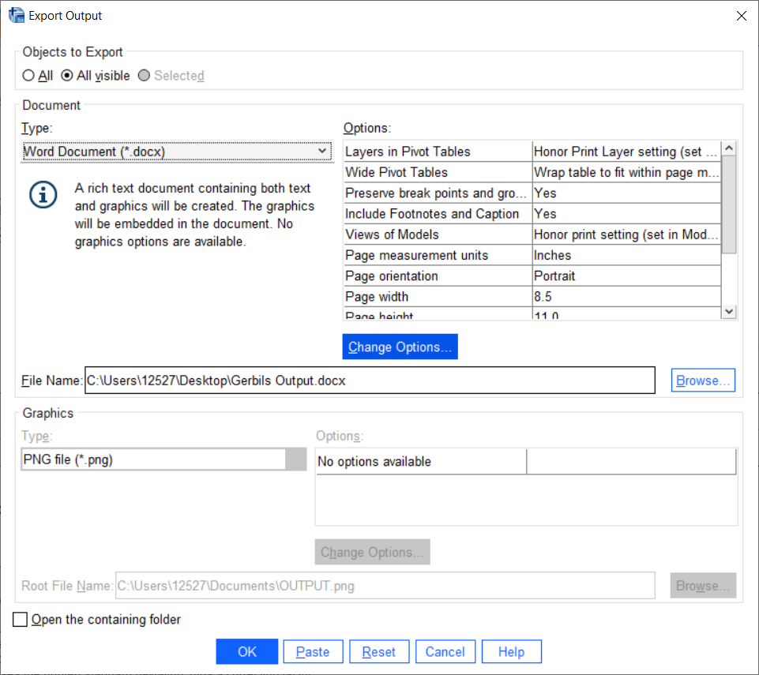

Then click the “Change Options” button. In the resulting window, Click “Page Setup for Export.”

|  |  |
| --- | --- |
|  |  |

Click OK, Continue, OK.

If necessary, you could also narrow the page margins.

The wide table in the Word document is going to look like this:

| **Independent Samples Test** | | | | | | | | | | |
| --- | --- | --- | --- | --- | --- | --- | --- | --- | --- | --- |
|  |  | Levene's Test for Equality of Variances | | t-test for Equality of Means | | | | | | |
|  |  | F | Sig. | t | df | Sig. (2-tailed) | Mean Difference | Std. Error Difference | 95% Confidence Interval of the Difference | |
|  |  | Lower | Upper |
| addsc | Equal variances assumed | .856 | .357 | 1.663 | 86 | .100 | 4.503 | 2.708 | -.880 | 9.886 |
| Equal variances not assumed |  |  | 1.723 | 75.029 | .089 | 4.503 | 2.614 | -.704 | 9.710 |

[Return to Wuensch’s SPSS Lessons Page](http://core.ecu.edu/psyc/wuenschk/SPSS/SPSS-Lessons.htm).