**User Manual for “MS2Purifier_model_generation.r”**

(Version 1.0, Dec 14, 2020)

Shipei Xing, Tao Huan*

Department of Chemistry, Faculty of Science, University of British Columbia, Vancouver Campus, 2036 Main Mall, Vancouver, V6T 1Z1, BC, Canada

* Author to whom correspondence should be addressed:

Dr. Tao Huan

Tel: (+1)-604-822-4891

E-mail: thuan@chem.ubc.ca

Internet: <https://huan.chem.ubc.ca/>

* This R script allows users to generate their own random forest models that can be embedded in MS2Purifier.
* The program is written in R and is now publicly available on GitHub (https://github.com/HuanLab/MS2Purifier).
* Please see below for the code instructions.

1. Install the R language, Rstudio and following packages: xcms, randomForest.
2. Download and open the R script “MS2Purifier_model_generation.r” in Rstudio.
3. Change the file directory and model directory in the R script. The file directory should contain mzXML files collected in DDA and DIA (AIF) mode. Use “/” instead of “\” in the directory.

Note that the mzXML files of the same sample in the file directory should be named as “XXX_DDA.mzXML” and “XXX_AIF.mzXML”.



1. Set the parameters in the following table. Set the “step” as 1.

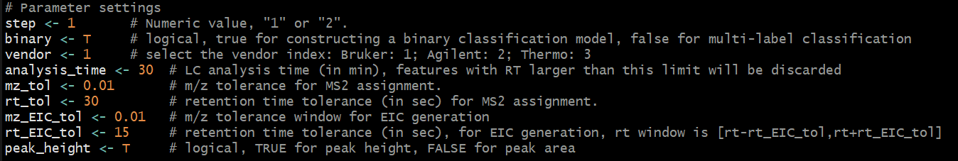

**Table.** Parameter settings.

|  |  |
| --- | --- |
| **Parameter name** | **Function** |
| step | Numeric value: 1 or 2. |
| binary | Logical, true for constructing a binary classification model, false for multi-label classification. |
| vendor | MS vendor index. Bruker: 1; Agilent: 2; Thermo: 3. |
| analysis_time | LC analysis time (in min), features with RT larger than this limit will be discarded. |
| mz_tol | The *m/z* tolerance for MS2 assignment. |
| rt_tol | The retention time tolerance (in sec) for MS2 assignment. |
| mz_EIC_tol | The *m/z* tolerance window for EIC generation in AIF data. |
| rt_EIC_tol | The retention time tolerance (in sec) for EIC generation in AIF data. RT window is [rt - rt_EIC_tol, rt + rt_EIC_tol]. |
| peak_height | Logical, TRUE for peak height, FALSE for peak area. |

1. Run the R script by clicking “Source” on the top right of the Rstudio panel.
2. A new csv file “Fragment_for_manual_check.csv” and a subfolder “EIC_plots” containing the EIC plots of precursor-fragment pairs will be created. Manual inspections will then be needed to fill in the column of “manual_check” in the csv file.

Note: For binary classification, please use “T” for true fragments, “F” for contamination ions and “NA” for unchecked fragments. For multi-label classification, use “NA” for unchecked fragments.

1. After manual checking, save the edited csv file and change the “step” into 2 in the R script.



1. Click “Source”, and a new random forest model “RF_new_binary_model.rds” or “RF_new_multi_model.rds” will be generated in the file directory.