**User Manual for “MS2Purifier.r”**

(Version 1.0, Feb 17, 2021)

Shipei Xing, Tao Huan*

Department of Chemistry, Faculty of Science, University of British Columbia, Vancouver Campus, 2036 Main Mall, Vancouver, V6T 1Z1, BC, Canada

* Author to whom correspondence should be addressed:

Dr. Tao Huan

Tel: (+1)-604-822-4891

E-mail: thuan@chem.ubc.ca

Internet: <https://huan.chem.ubc.ca/>

* This R script performs MS2 spectra purification collected in data-dependent acquisition (DDA) mode with help of all-ion fragmentation (AIF) data in data-independent acquisition (DIA) mode.
* The program is written in R and is now publicly available on GitHub (https://github.com/HuanLab/MS2Purifier).
* Please see below for the code instructions.

1. Install the R language, Rstudio and following packages: xcms, randomForest.
2. Download and open the R script “MS2Purifier.r” in Rstudio.
3. Change the file directory and model directory in the R script. The file directory should contain mzXML files collected in DDA and DIA (AIF) mode. The model directory should contain the random forest models “RF_model_binary.rds” and “RF_model_multi.rds”. Use “/” instead of “\” in the directory.

Note that the mzXML files of the same sample in the file directory should be named as “XXX_DDA.mzXML” and “XXX_AIF.mzXML”.



1. Set the parameters in the following table.

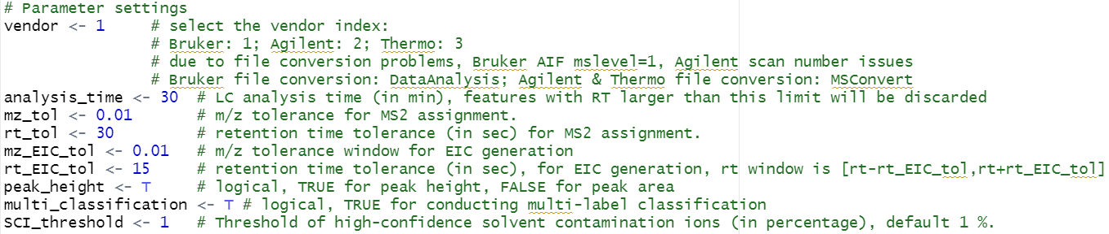

**Table.** Parameter settings.

|  |  |
| --- | --- |
| **Parameter name** | **Function** |
| vendor | MS vendor index. Bruker: 1; Agilent: 2; Thermo: 3. |
| analysis_time | LC analysis time (in min), features with RT larger than this limit will be discarded. |
| mz_tol | The *m/z* tolerance for MS2 assignment. |
| rt_tol | The retention time tolerance (in sec) for MS2 assignment. |
| mz_EIC_tol | The *m/z* tolerance window for EIC generation in AIF data. |
| rt_EIC_tol | The retention time tolerance (in sec) for EIC generation in AIF data. RT window is [rt - rt_EIC_tol, rt + rt_EIC_tol]. |
| peak_height | Logical, TRUE for peak height, FALSE for peak area. |
| multi_classification | Logical, TRUE for performing the multi-label classification. |
| SCI_threshold | Threshold of high-confidence solvent contamination ions (in percentage), default 1%. |

1. Run the R script by clicking “Source” on the top right of the Rstudio panel.
2. Three csv files will be output with the names of “Feature_table_DDA_MS2assigned.csv”, “Fragment_prediction_result.csv” and “Feature_table_DDA_MS2purified.csv”. They refer to the DDA feature table with MS2 spectra assigned, the binary classification prediction result of each fragment ion and the feature table with purified MS2 spectra. If multi-label classification is enabled, another csv file named “Fragment_prediction_multi_result.csv” will be output. See below for detailed information on these output files.
3. For the feature table output, the column of “ms2_file” refers to the file name where the MS2 spectra are extracted; columns of “ms2mz” and “ms2int” store the original MS2 information; columns of “purified_ms2mz” and “purified_ms2int” store the purified MS2 spectra.

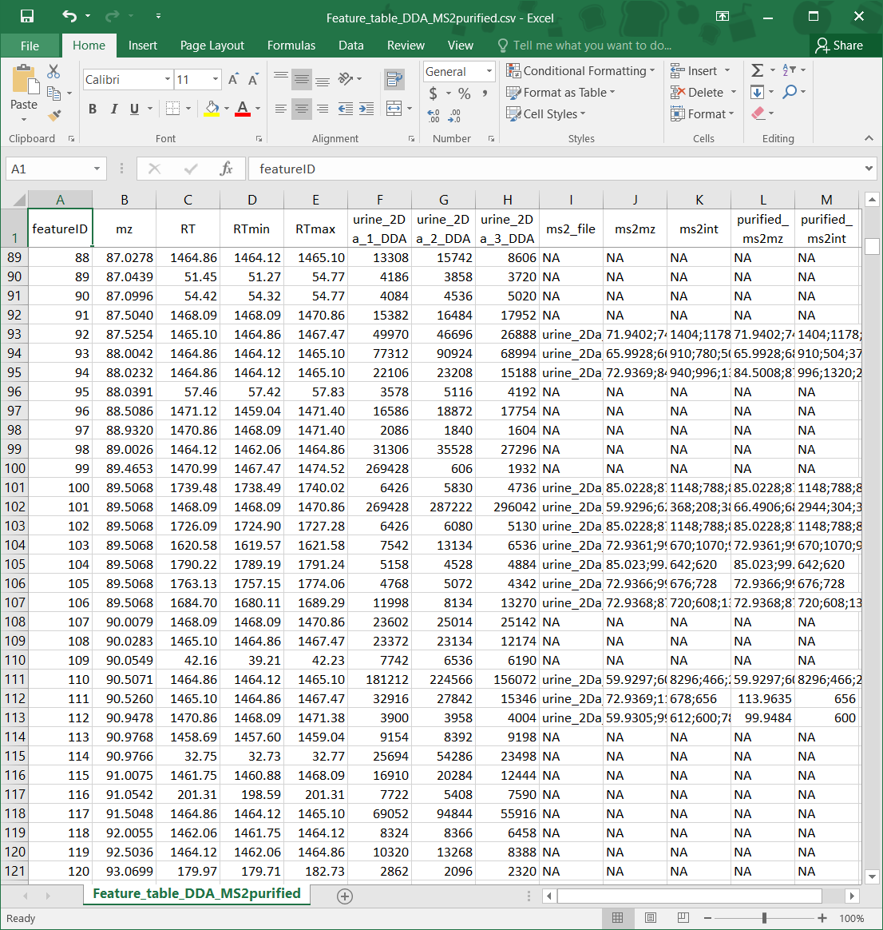

1. For fragment prediction results, factors calculated for machine learning process and the prediction result of each fragment is shown. In binary classification result, the predictions are noted as “T” for TFIs and “F” for CFIs; in multi-label classification result, the predictions are noted as “True_fragment”, “Solvent_contaminant_high_confidence”, “Solvent_contaminant_low_confidence”, “Adjacent_contaminant” and “Undetermined”.

