*COVID-19 Update January 12, 2021*

As of **January 11, 2021, at 8:30 PM**, the total of laboratory-confirmed and probable COVID-19 cases reported among Connecticut residents is **213358**, including **201124** laboratory-confirmed and **12234** probable cases. **One thousand one hundred forty-two** patients are currently hospitalized with laboratory-confirmed COVID-19. There have been **6418** COVID-19-associated deaths.

In Connecticut during the early months of this pandemic, it became increasingly clear that it would be necessary to track probable COVID-19 cases and deaths, in addition to laboratory-confirmed (RT-PCR) cases and deaths. This was needed to better measure the burden and impact of this disease in our communities and is now part of the [national surveillance case definition for COVID-19](https://www.cdc.gov/coronavirus/2019-ncov/covid-data/faq-surveillance.html). Prior to June 1, probable and confirmed cases were reported together.

| Overall Summary | Total** | Change Since Yesterday |
| --- | --- | --- |
| COVID-19 Cases (confirmed and probable) | 213358 | +0 |
| COVID-19 Tests Reported (molecular and antigen) | 4724211 | +0 |
| Daily Test Positivity* |  | NaN% |
| Patients Currently Hospitalized with COVID-19 | 1142 | +0 |
| COVID-19-Associated Deaths | 6418 | +0 |

**Includes confirmed plus probable cases

**COVID-19 Cases and Associated Deaths by County of Residence**  
*As of 01/11/21 8:30pm.*

| County | COVID-19 Cases | | COVID-19-Associated Deaths | |
| --- | --- | --- | --- | --- |
| Confirmed | Probable | Confirmed | Probable |
| Fairfield County | 58,633 | 4,440 | 1,416 | 382 |
| Hartford County | 51,627 | 2,265 | 1,579 | 379 |
| Litchfield County | 7,881 | 615 | 208 | 31 |
| Middlesex County | 7,322 | 435 | 216 | 65 |
| New Haven County | 50,354 | 3,570 | 1,408 | 241 |
| New London County | 12,850 | 310 | 211 | 71 |
| Tolland County | 5,335 | 354 | 94 | 24 |
| Windham County | 6,423 | 165 | 78 | 14 |
| Pending address validation | 699 | 80 | 1 | 0 |
| **Total** | **201124** | **12234** | **5211** | **1207** |

[National COVID-19 statistics](https://www.cdc.gov/coronavirus/2019-ncov/cases-updates/cases-in-us.html) and information about [preventing spread of COVID-19](https://www.cdc.gov/coronavirus/2019-ncov/prevent-getting-sick/prevention.html) are available from the Centers for Disease Control and Prevention.

**Day-to-day changes reflect newly reported cases, deaths, and tests that occurred over the last several days to week.** All data in this report are preliminary; data for previous dates will be updated as new reports are received and data errors are corrected. Hospitalization data were collected by the Connecticut Hospital Association. Deaths reported to either OCME or DPH are included in the daily COVID-19 update.

### Hospitalization Surveillance

The map below shows the number of patients currently hospitalized with laboratory-confirmed COVID-19 by county based on data collected by the Connecticut Hospital Association. The distribution is by location of hospital, not patient residence. The labels indicate the number of patients currently hospitalized with the change since yesterday in parentheses.

**Patients Currently Hospitalized by Connecticut County**

*Distribution by location of hospital not patient residence. Data from the Connecticut Hospital Association.*

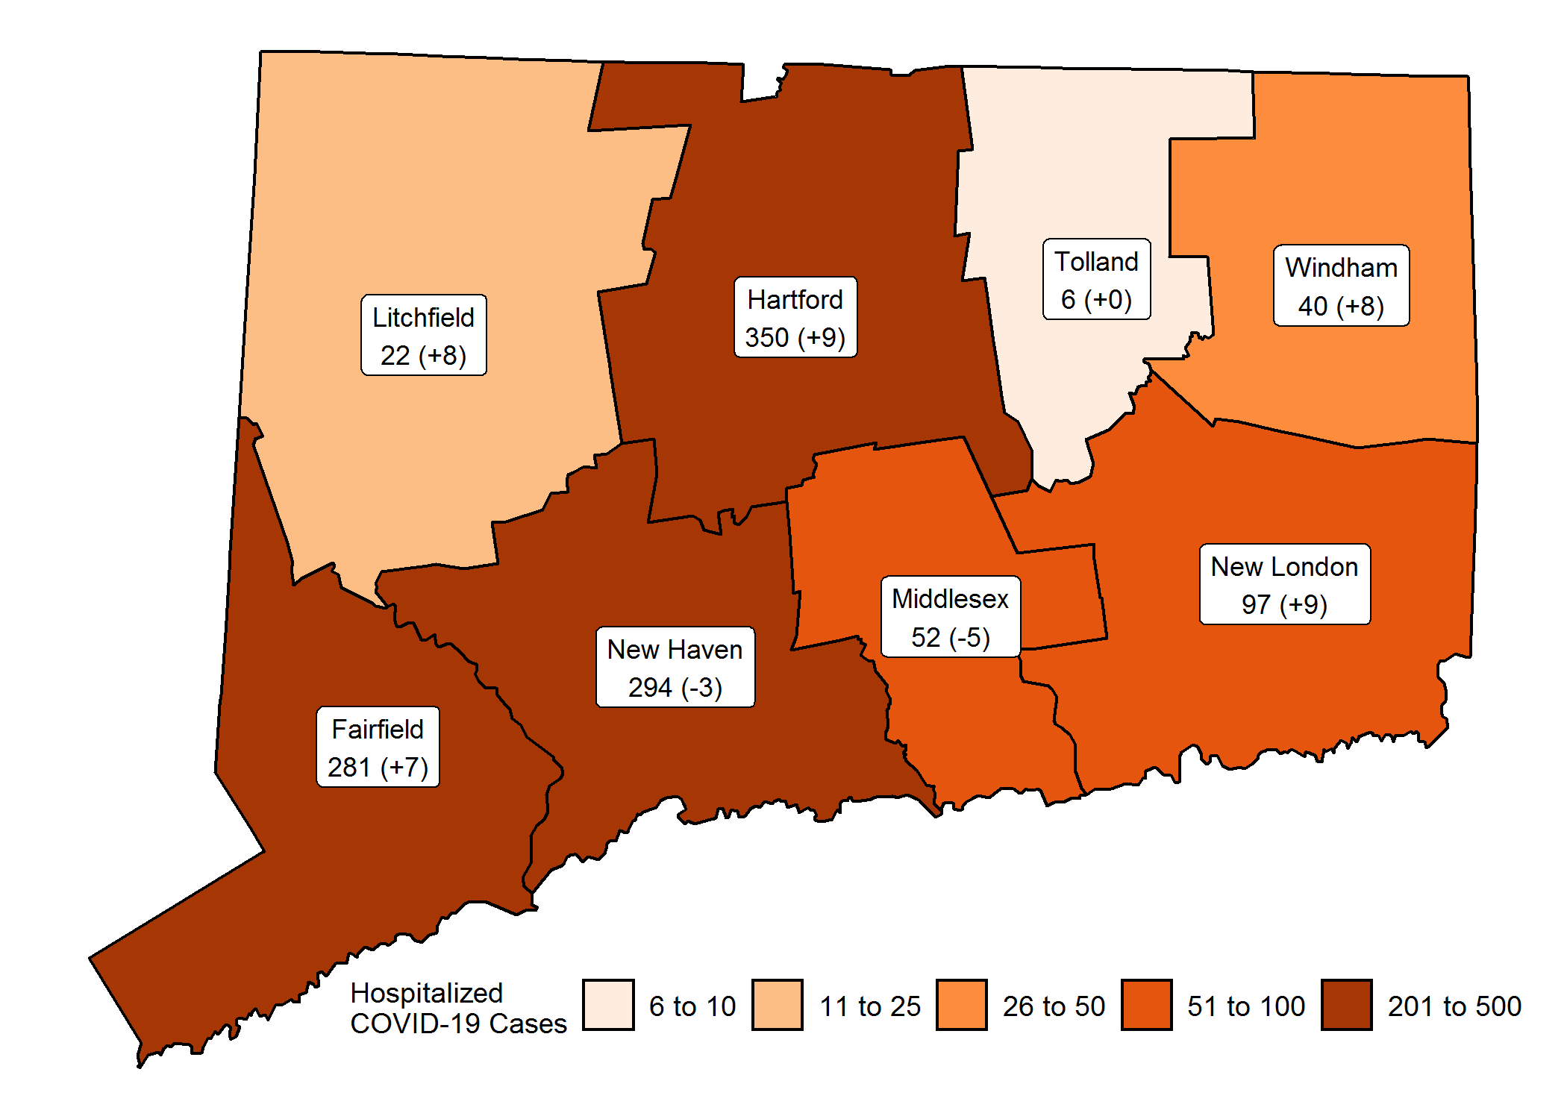 More information about hospitalized cases of COVID-19 in New Haven and Middlesex Counties is available from [COVID-NET.](https://gis.cdc.gov/grasp/COVIDNet/COVID19_3.html)

### Characteristics of COVID-19 Cases and Associated Deaths

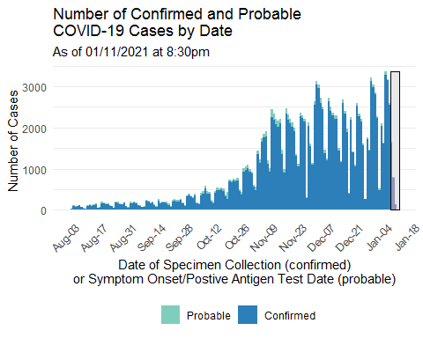

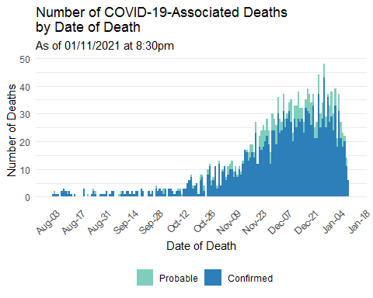

### Cumulative Number of COVID-19 Cases by Town

*Map does not include 779 cases pending address validation*

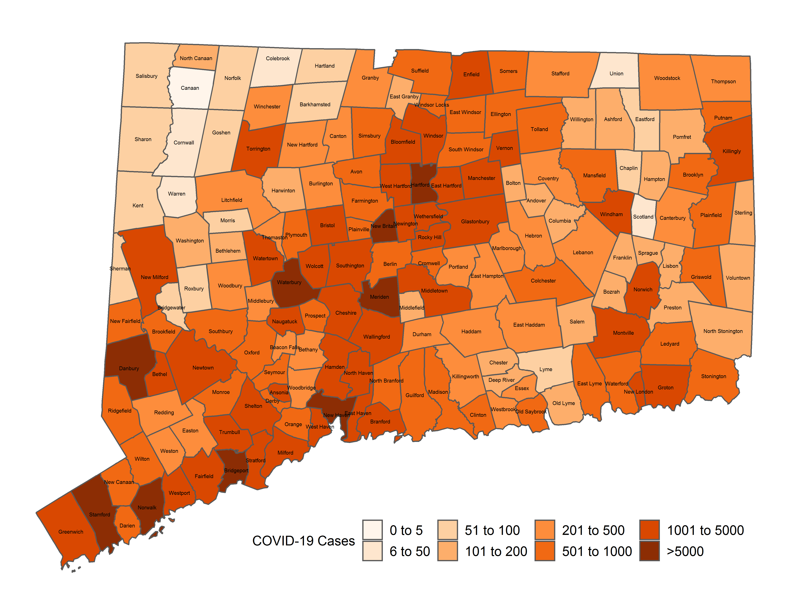

**APPENDIX A. Cumulative Number of COVID-19 Cases by Town**  
*Table does not include 779 cases pending address validation*

| Town | Confirmed Cases | Probable Cases | Town | Confirmed Cases | Probable Cases | Town | Confirmed Cases | Probable Cases |
| --- | --- | --- | --- | --- | --- | --- | --- | --- |
| Andover | 100 | 8 | Griswold | 551 | 5 | Prospect | 508 | 32 |
| Ansonia | 1,051 | 84 | Groton | 1,549 | 82 | Putnam | 468 | 34 |
| Ashford | 133 | 3 | Guilford | 703 | 43 | Redding | 287 | 27 |
| Avon | 554 | 27 | Haddam | 289 | 19 | Ridgefield | 753 | 91 |
| Barkhamsted | 95 | 3 | Hamden | 3,254 | 253 | Rocky Hill | 1102 | 55 |
| Beacon Falls | 317 | 17 | Hampton | 103 | 0 | Roxbury | 51 | 8 |
| Berlin | 936 | 46 | Hartford | 11,021 | 312 | Salem | 121 | 0 |
| Bethany | 232 | 16 | Hartland | 52 | 1 | Salisbury | 80 | 2 |
| Bethel | 1,110 | 148 | Harwinton | 172 | 10 | Scotland | 35 | 0 |
| Bethlehem | 120 | 7 | Hebron | 290 | 16 | Seymour | 913 | 63 |
| Bloomfield | 1,325 | 54 | Kent | 73 | 16 | Sharon | 56 | 1 |
| Bolton | 136 | 9 | Killingly | 971 | 38 | Shelton | 2147 | 176 |
| Bozrah | 127 | 0 | Killingworth | 188 | 13 | Sherman | 74 | 26 |
| Branford | 1,243 | 129 | Lebanon | 263 | 5 | Simsbury | 618 | 34 |
| Bridgeport | 11,942 | 621 | Ledyard | 565 | 3 | Somers | 607 | 46 |
| Bridgewater | 43 | 10 | Lisbon | 163 | 2 | South Windsor | 954 | 42 |
| Bristol | 3,410 | 155 | Litchfield | 230 | 14 | Southbury | 801 | 56 |
| Brookfield | 798 | 157 | Lyme | 57 | 5 | Southington | 2010 | 189 |
| Brooklyn | 508 | 9 | Madison | 631 | 42 | Sprague | 144 | 2 |
| Burlington | 287 | 9 | Manchester | 2,977 | 151 | Stafford | 345 | 14 |
| Canaan | 5 | 0 | Mansfield | 774 | 92 | Stamford | 9973 | 420 |
| Canterbury | 230 | 3 | Marlborough | 261 | 16 | Sterling | 156 | 2 |
| Canton | 280 | 17 | Meriden | 4,826 | 239 | Stonington | 553 | 18 |
| Chaplin | 64 | 3 | Middlebury | 434 | 35 | Stratford | 2871 | 236 |
| Cheshire | 1,232 | 65 | Middlefield | 151 | 10 | Suffield | 772 | 39 |
| Chester | 146 | 6 | Middletown | 2,623 | 155 | Thomaston | 403 | 28 |
| Clinton | 529 | 26 | Milford | 2,563 | 259 | Thompson | 378 | 14 |
| Colchester | 692 | 37 | Monroe | 758 | 57 | Tolland | 557 | 38 |
| Colebrook | 29 | 2 | Montville | 1,062 | 19 | Torrington | 2115 | 63 |
| Columbia | 186 | 5 | Morris | 82 | 3 | Trumbull | 1833 | 141 |
| Cornwall | 36 | 0 | Naugatuck | 2,017 | 134 | Union | 20 | 1 |
| Coventry | 387 | 20 | New Britain | 6,209 | 264 | Vernon | 1222 | 71 |
| Cromwell | 773 | 48 | New Canaan | 845 | 51 | Voluntown | 102 | 1 |
| Danbury | 8,290 | 884 | New Fairfield | 545 | 71 | Wallingford | 2618 | 128 |
| Darien | 794 | 88 | New Hartford | 205 | 7 | Warren | 12 | 3 |
| Deep River | 186 | 13 | New Haven | 7,775 | 431 | Washington | 103 | 9 |
| Derby | 707 | 45 | New London | 2,024 | 30 | Waterbury | 9536 | 605 |
| Durham | 352 | 27 | New Milford | 1,047 | 246 | Waterford | 962 | 34 |
| East Granby | 153 | 5 | Newington | 1,717 | 86 | Watertown | 1361 | 111 |
| East Haddam | 224 | 13 | Newtown | 944 | 115 | West Hartford | 2700 | 189 |
| East Hampton | 448 | 25 | Norfolk | 52 | 1 | West Haven | 3134 | 267 |
| East Hartford | 4,100 | 131 | North Branford | 582 | 70 | Westbrook | 242 | 15 |
| East Haven | 1,590 | 220 | North Canaan | 138 | 6 | Weston | 312 | 34 |
| East Lyme | 729 | 36 | North Haven | 1,196 | 138 | Westport | 967 | 80 |
| East Windsor | 623 | 25 | North Stonington | 148 | 3 | Wethersfield | 1636 | 70 |
| Eastford | 56 | 1 | Norwalk | 6,915 | 388 | Willington | 138 | 8 |
| Easton | 222 | 13 | Norwich | 2,528 | 23 | Wilton | 605 | 68 |
| Ellington | 573 | 26 | Old Lyme | 181 | 3 | Winchester | 383 | 5 |
| Enfield | 2,181 | 57 | Old Saybrook | 525 | 28 | Windham | 2049 | 42 |
| Essex | 253 | 17 | Orange | 572 | 61 | Windsor | 1794 | 71 |
| Fairfield | 2,976 | 353 | Oxford | 500 | 27 | Windsor Locks | 658 | 17 |
| Farmington | 880 | 55 | Plainfield | 833 | 12 | Wolcott | 1089 | 80 |
| Franklin | 134 | 0 | Plainville | 893 | 64 | Woodbridge | 330 | 31 |
| Glastonbury | 1,218 | 71 | Plymouth | 525 | 32 | Woodbury | 376 | 24 |
| Goshen | 89 | 4 | Pomfret | 150 | 0 | Woodstock | 289 | 4 |
| Granby | 306 | 13 | Portland | 393 | 20 |  |  |  |
| Greenwich | 2,672 | 195 | Preston | 195 | 2 |  |  |  |

**APPENDIX B.** The following graphs show the number of cases per 100,000 Connecticut residents statewide and by county, age group, and gender. Population estimate from: [DPH Population Statistics](https://portal.ct.gov/DPH/Health-Information-Systems--Reporting/Population/Population-Statistics)

Time hack 2021-01-12 11:20:12

**APPENDIX C.** The following graphs show the number of cases and deaths by race and ethnicity. *Categories are mutually exclusive. The category “multiracial” includes people who answered ‘yes’ to more than one race category. NH=Non-Hispanic*

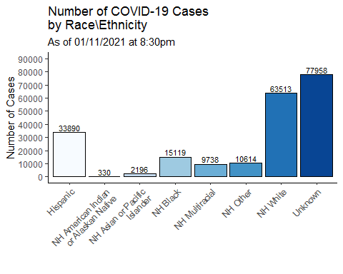

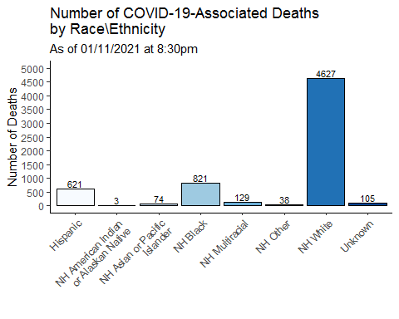

The following graphs show the number of COVID-19 cases and COVID-19-associated deaths per 100,000 population by race and ethnicity. Crude rates represent the total cases or deaths per 100,000 people. Age-adjusted rates consider the age of the person at diagnosis or death when estimating the rate and use a standardized population to provide a fair comparison between population groups with different age distributions. Age-adjustment is important in Connecticut as the median age of among the non-Hispanic white population is 47 years, whereas it is 34 years among non-Hispanic blacks, and 29 years among Hispanics. Because most non-Hispanic white residents who died were over 75 years of age, the age-adjusted rates are lower than the unadjusted rates. In contrast, Hispanic residents who died tend to be younger than 75 years of age which results in higher age-adjusted rates.

The 2018 Connecticut and 2000 US Standard Million populations were used for age adjustment; population estimates from: [DPH Population Statistics.](https://portal.ct.gov/DPH/Health-Information-Systems--Reporting/Population/Population-Statistics) *Categories are mutually exclusive. Cases missing data on race/ethnicity are excluded from calculation of rates. NH=Non-Hispanic*

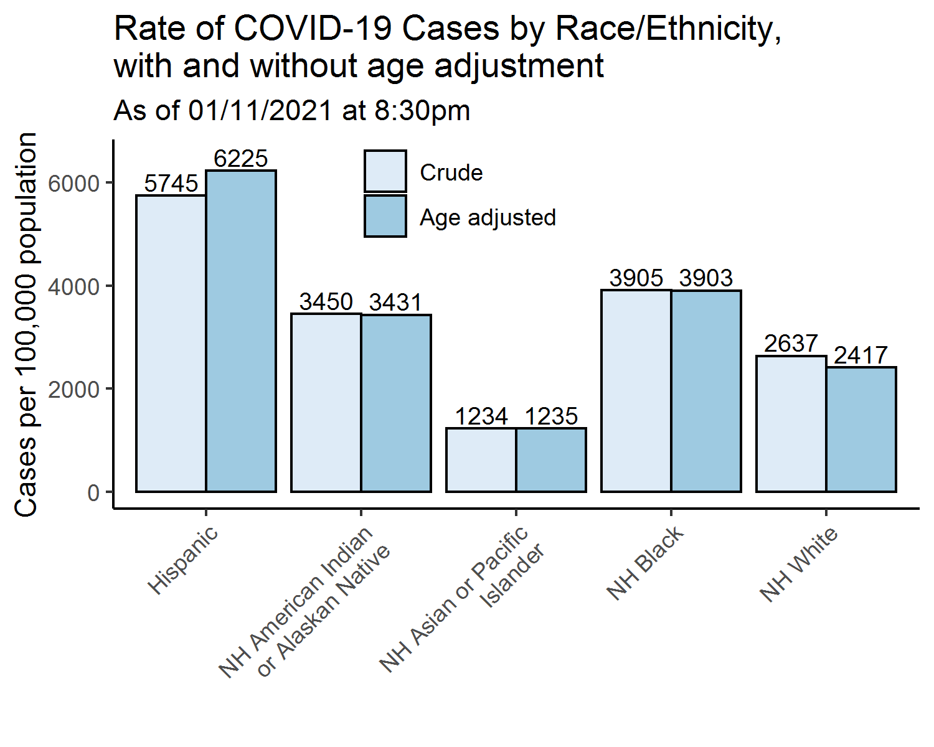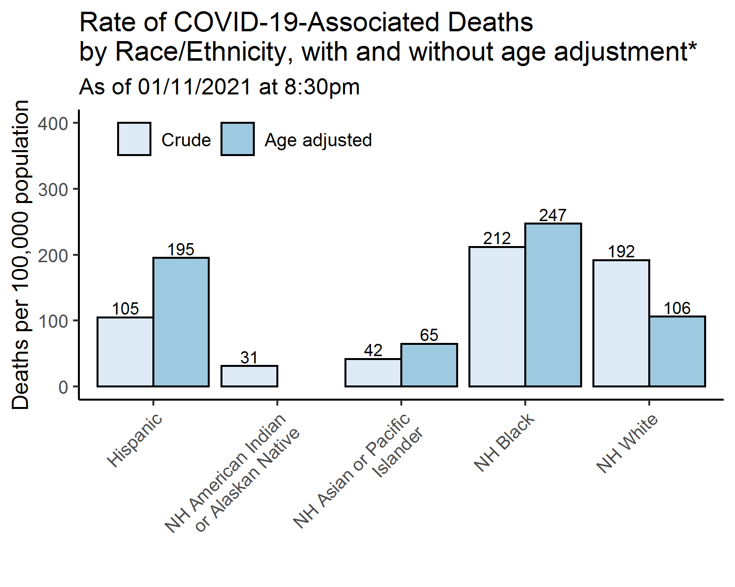

*\*Age adjusted rates only calculated for groups with at least 30 deaths*

Time hack 2021-01-12 11:23:03