COVID-19 Update April 04, 2020

As of April 04, 2020, a total of **5059** laboratory-confirmed cases of COVID-19 have been reported among Connecticut residents (Figure 1). Nine hundred nine patients are currently hospitalized. One hundred forty-six residents have died. The increase in cases reported today is related to catch up of data entry and implementation of a new method for reporting cases to the Department of Public Health. This increase does not reflect a change in the trajectory of the outbreak.

All data in this report are preliminary; data for previous dates will be updated as new reports are received and data errors are corrected. Hospitalization data were collected by the Connecticut Hospital Association. Deaths* reported to either the OCME or DPH are included in the daily COVID-19 update.

*For public health surveillance, laboratory-confirmed COVID-19-associated deaths are defined as patients who tested positive for COVID-19 around the time of death; this is not a determination of the cause of death.

## Overall Summary

| **myRegion** | **Current_Perc_1** | **Current_Perc_2** | **curr_change_1_to_2** |
| --- | --- | --- | --- |
| a | 85.9 | 88.0 | 2.1 |
| b | 90.8 | 91.0 | 0.2 |
| c | 89.7 | 89.0 | -0.7 |
| **BRITISH COLUMBIA** | **88.4** | **89.3** | **0.9** |

**Laboratory-Confirmed COVID-19 Cases and Associated Deaths by County of Residence**

*As of 04/04/20 12:30pm. Includes patients tested at the State Public Health Laboratory, hospital, and commercial laboratories.*

| **myRegion** | **Current_Perc_1** | **Current_Perc_2** | **curr_change_1_to_2** |
| --- | --- | --- | --- |
| a | 85.9 | 88.0 | 2.1 |
| b | 90.8 | 91.0 | 0.2 |
| c | 89.7 | 89.0 | -0.7 |
| **BRITISH COLUMBIA** | **88.4** | **89.3** | **0.9** |

[National COVID-19 statistics](https://www.cdc.gov/coronavirus/2019-ncov/cases-updates/cases-in-us.html) and information about [preventing spread of COVID-19](https://www.cdc.gov/coronavirus/2019-ncov/prevent-getting-sick/prevention.html) are availiable from the Centers for Disease Control and Prevention.

A weekly report on season influenza activity can be found on [DPH website](https://portal.ct.gov/DPH/Epidemiology-and-Emerging-Infections/Influenza-Surveillance-and-Statistics).

### Syndromic Surveillance

The Department of Public Health EpiCenter hospital emergency department (ED) syndromic surveillance system receives near real-time information from all 38 licensed, hospital EDs in Connecticut. The percentage of individuals seeking care for “unexplained fever/flu” syndrome ED visits is monitored to identify individuals that may have symptoms consistent with COVID-19; this differs from the “fever/flu” syndrome in the weekly influenza report since patients with a known diagnosis (e.g., influenza, strep throat) are not included. **The syndromic surveillance systems suggest that many more people are seeking care for respiratory illnesses, including COVID-19, than usual at this time.**

## [1] "INSERT SYS PLOT HERE"

### Hospitalization Surveillance

The map below shows the number of patients currently hospitalized with laboratory-confirmed COVID-19 by county based on data collected by the Connecticut Hospital Association. The distribution is by location of hospital, not patient residence. The labels indicate the number of patients currently hospitalized with the change since yesterday in parentheses.

**Patients Currently Hospitalized by Connecticut County**  
*Distribution by location of hospital not patient residence. Data from the Connecticut Hospital Association.*

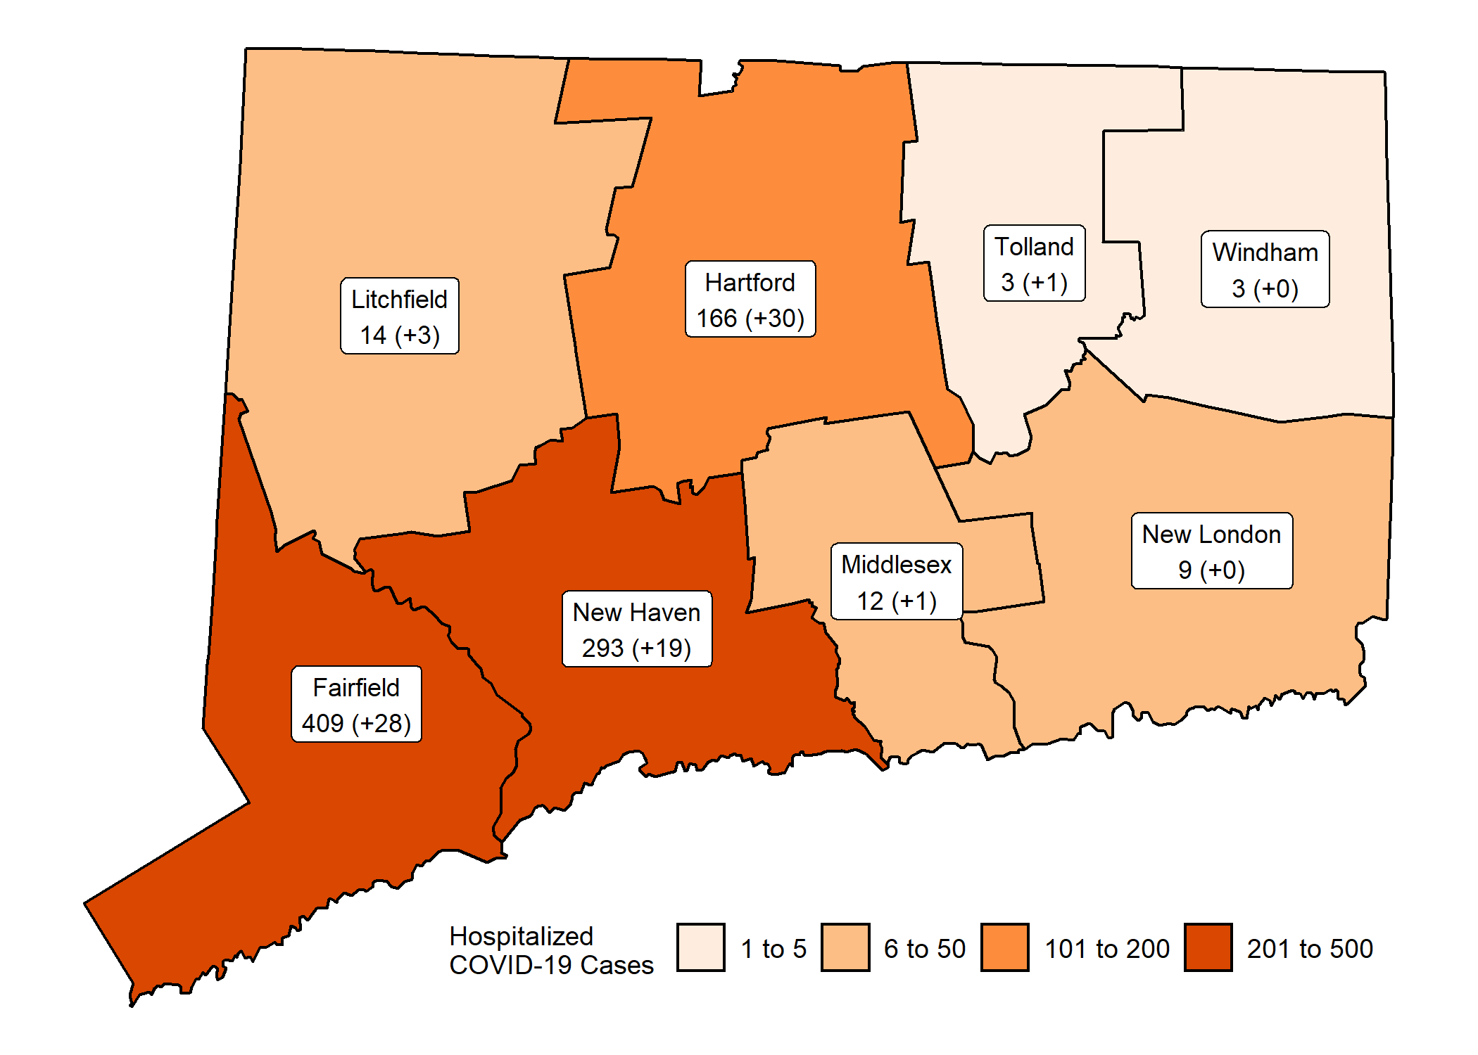 More information about hospitalized cases of COVID-19 in New Haven and Middlesex Counties is available from [COVID-NET.](https://gis.cdc.gov/grasp/COVIDNet/COVID19_3.html)

### Nursing Home Surveillance

Among 215 nursing homes in CT, 48 (22%) have had at least one confirmed case of COVID-19. A total of **221** nursing home residents with laboratory-confirmed COVID-19 have been identified of whom 80 (36%) were hospitalized and 23 (10%) have died. The graph below shows the number of nursing homes with laboratory confirmed COVID-19 cases by the first date a positive specimen was collected.

## [1] "INSERT NURSING HOME PLOT HERE"

*\*Test results may be reported several days after the result. Data from previous dats are routinely updated.*

### Laboratory Surveillance

The Dr. Katherine A. Kelley State Public Health Laboratory has tested a total of 2403 patients for COVID19; 491 (20%) patients tested positive. The graph below shows the number of patients tested by date specimens were received. Hospital and commercial laboratories also are offering testing for COVID-19 in Connecticut; in total, more than 20015 tests have been reported to date.

## [1] "INSERT LAB PLOT HERE"

*Testing of specimens recieved since March 28 is on going and does not reflect a decrease in testing.*

### Characteristics of Laboratory-Confirmed COVID-19 Cases and Associated Deaths

*Test results amy be reported several days after the result. Data are incomplete for most recent dates shaded in grey. Data from previous dats are routinely updated.* 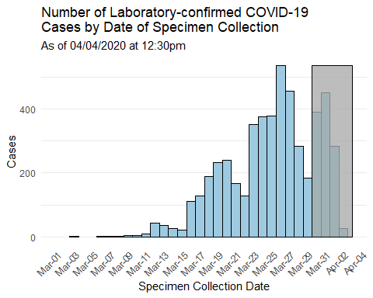 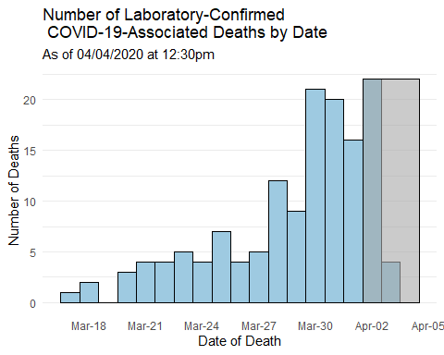

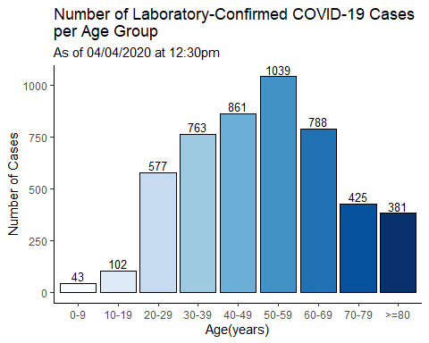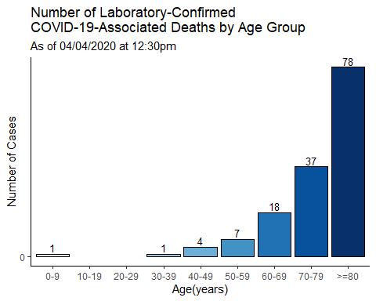

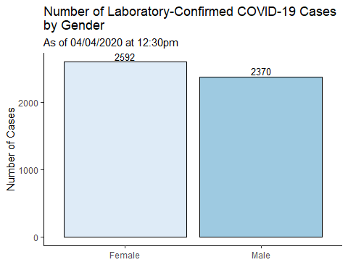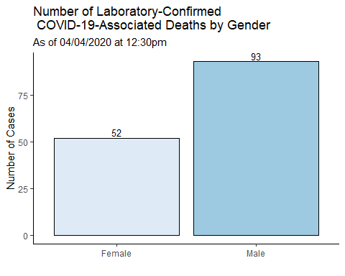

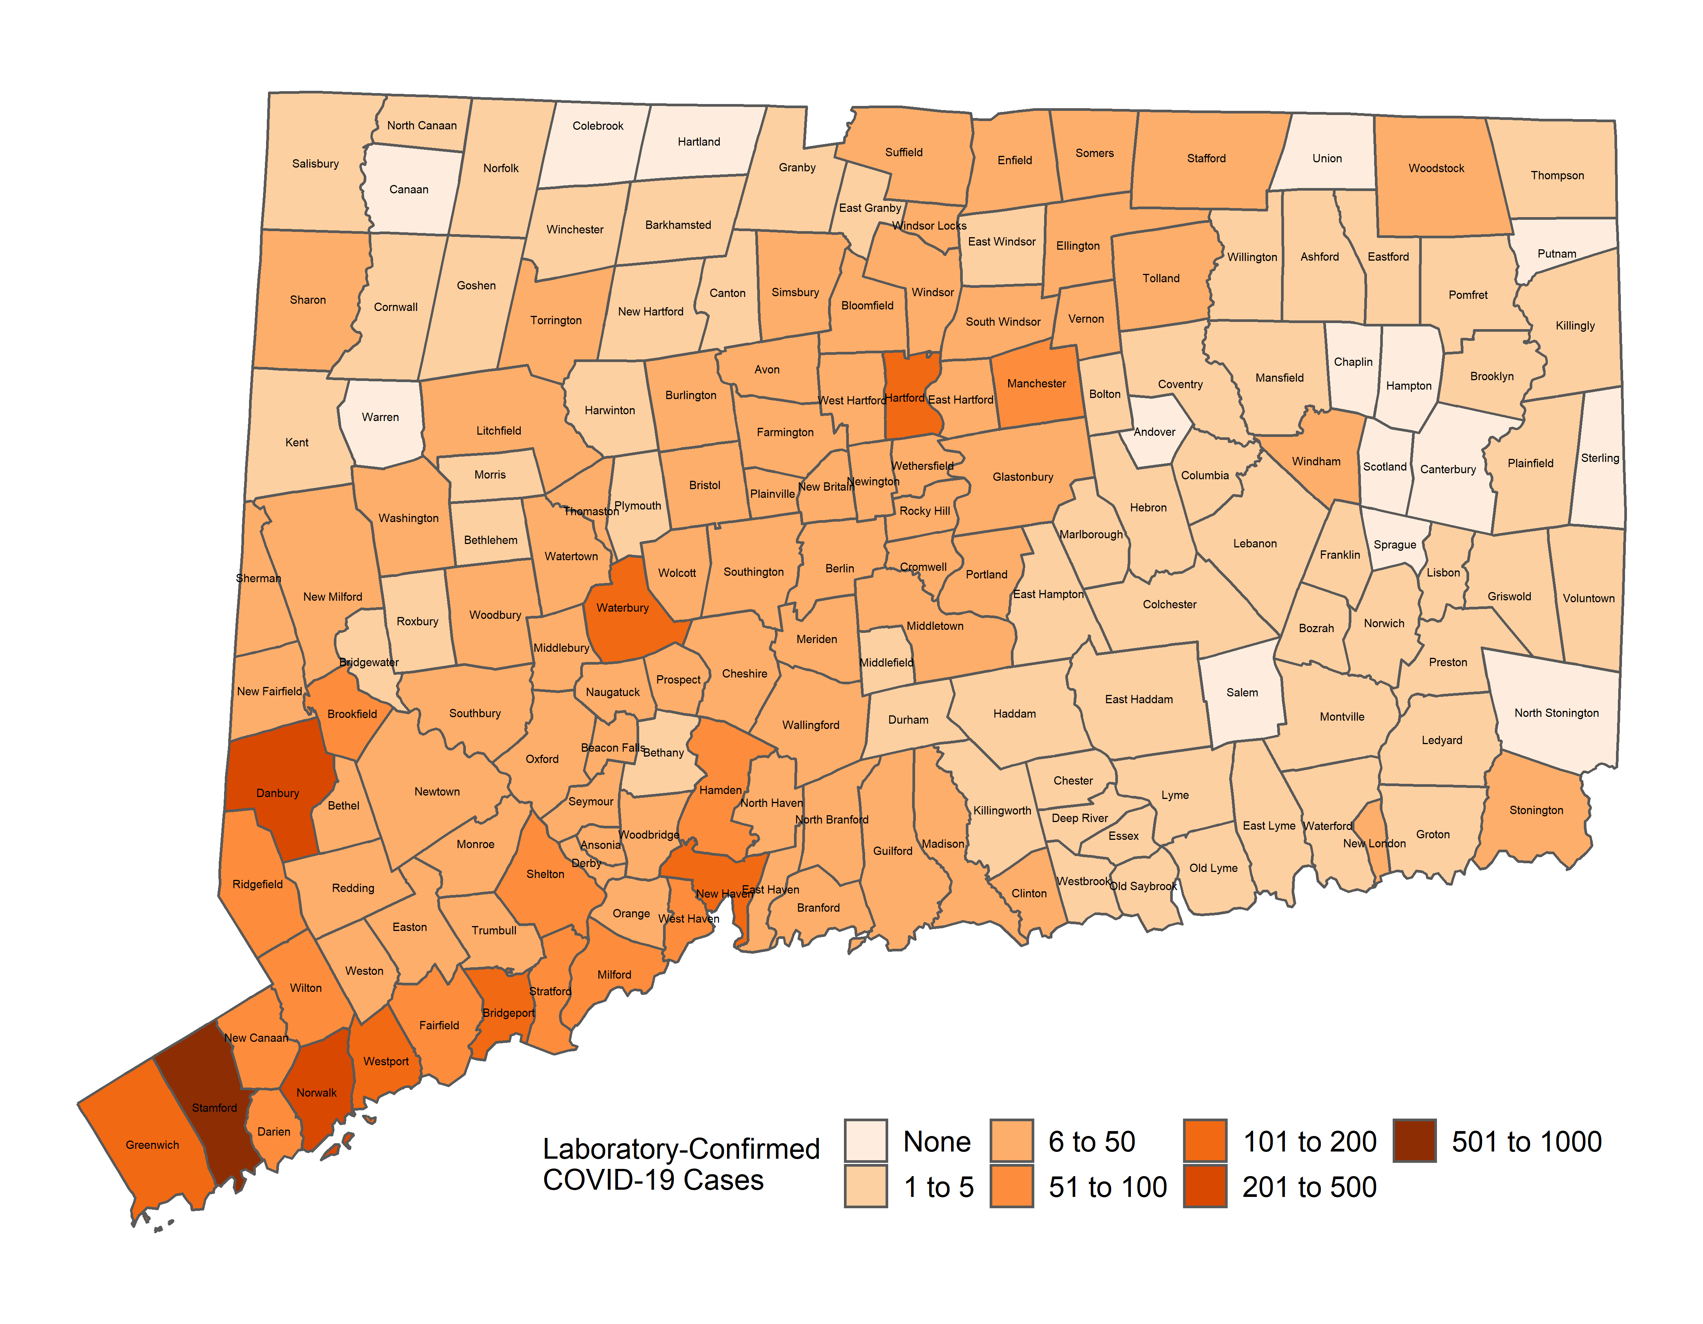

**APPENDIX A. Towns with Confirmed Cases of COVIDS-19**  
*Table does not include 999 cases pending address validation*

## [1] "FIGURE OUT AWFUL TABLE"

**APPENDIX B.** The following graphs show the rate of cases per 100,000 Connecticut residents in each age group and by gender. Population estimate from: [https://portal.ct.gov/DPH/Health-Information-Systems–Reporting/Population/Population-Statistics](https://portal.ct.gov/DPH/Health-Information-Systems--Reporting/Population/Population-Statistics) 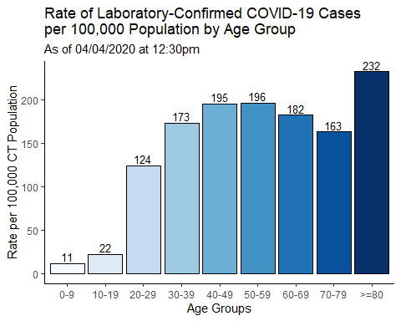 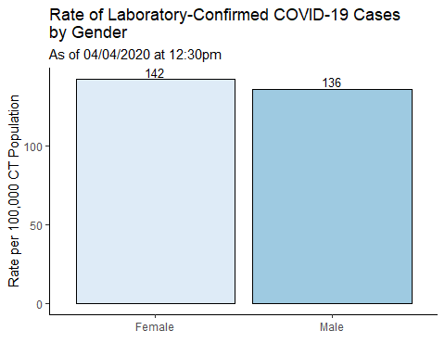

**APPENDIX C.** The following graphs show the number of cases and deaths by race and ethnicity. *Categories are mutually exclusive. Cases answering ‘yes’ to more than one race category are counted as ‘other’. Counts may not add up to total case counts as ddata on race and ethnicity may be missing.* *NH=Non-Hispanic*

