Shiny App Instruction and Findings

In this app, (<https://huandongchang.shinyapps.io/WomenHapiness>) the user can choose the predictor, color-by variable, chart type, facet variable, and the filter type. Here are a few examples:

To create the graphic used in our report select the following:

* Predictor: “With Husband”,
* Color by: “Happiness during activities”,
* Chart Type: “Percent”.
* Filter survey type: all survey types are selected
* Show all happiness levels: Not checked so that only Fairly Happy and Very Happy are displayed.

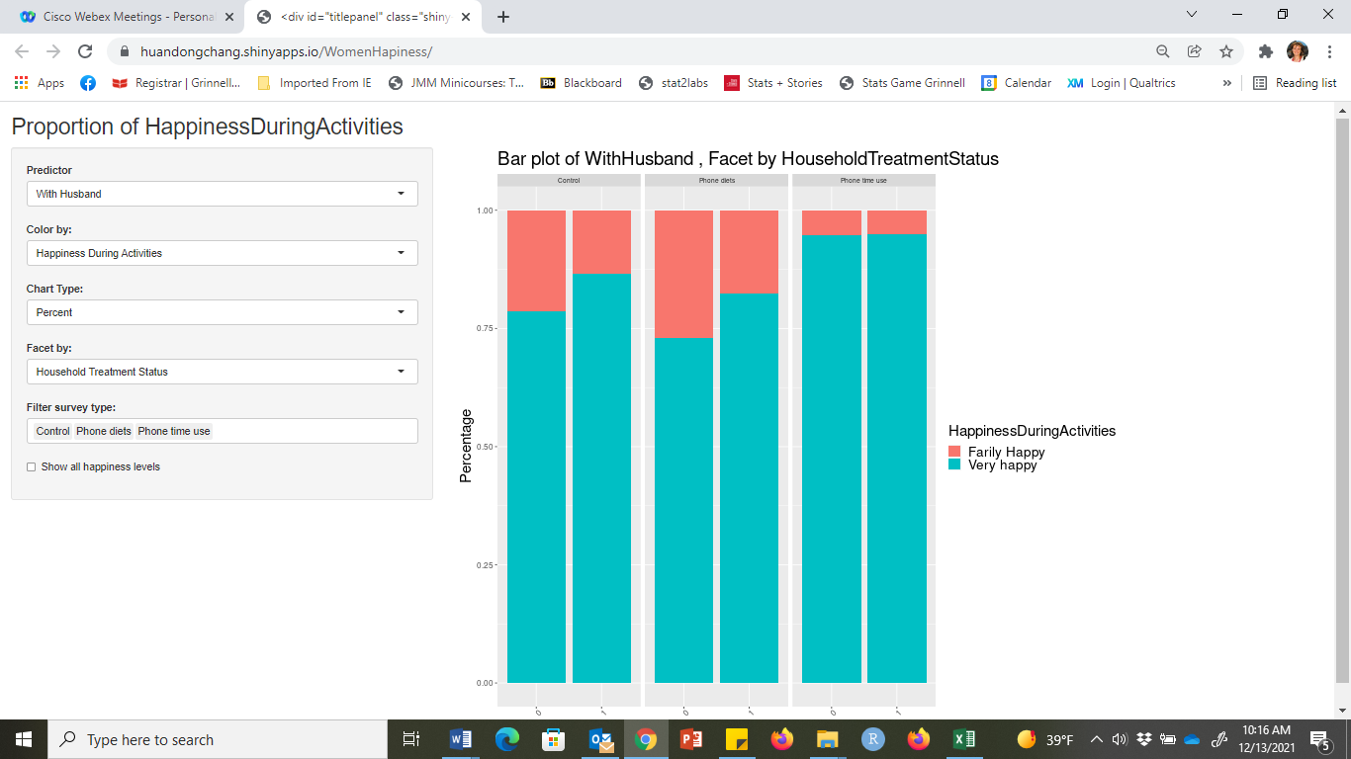

To look at all happiness levels we can check “Show all happiness levels”

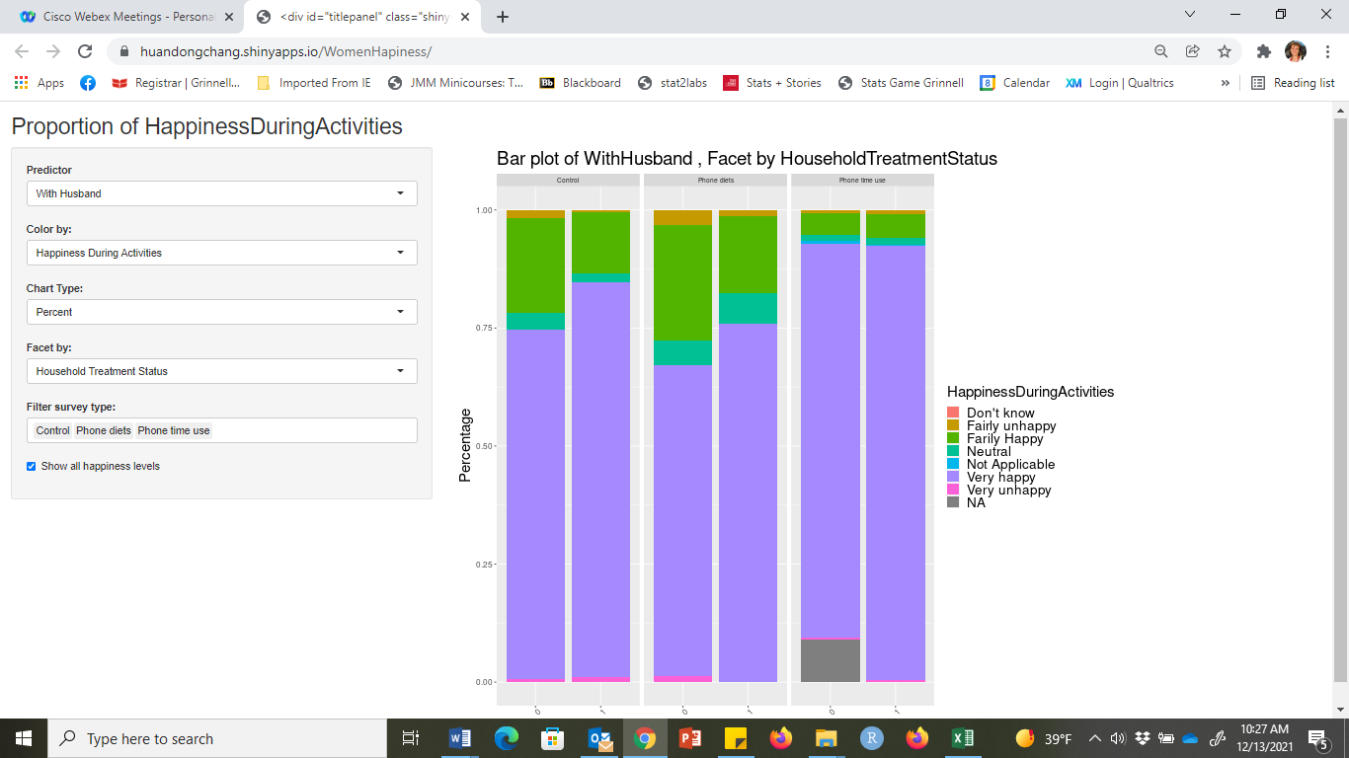

Below are additional graphs that we found interesting:

1. From the bar chart below, we can see that a lot of time is spent on “Household/Domestic work” and “Family/Social/Community activities”. Though the default setting only includes responses of “Fairly Happy” and “Very Happy”, the user can change this to show all levels of happiness by checking the checkbox “Show all happiness levels”.

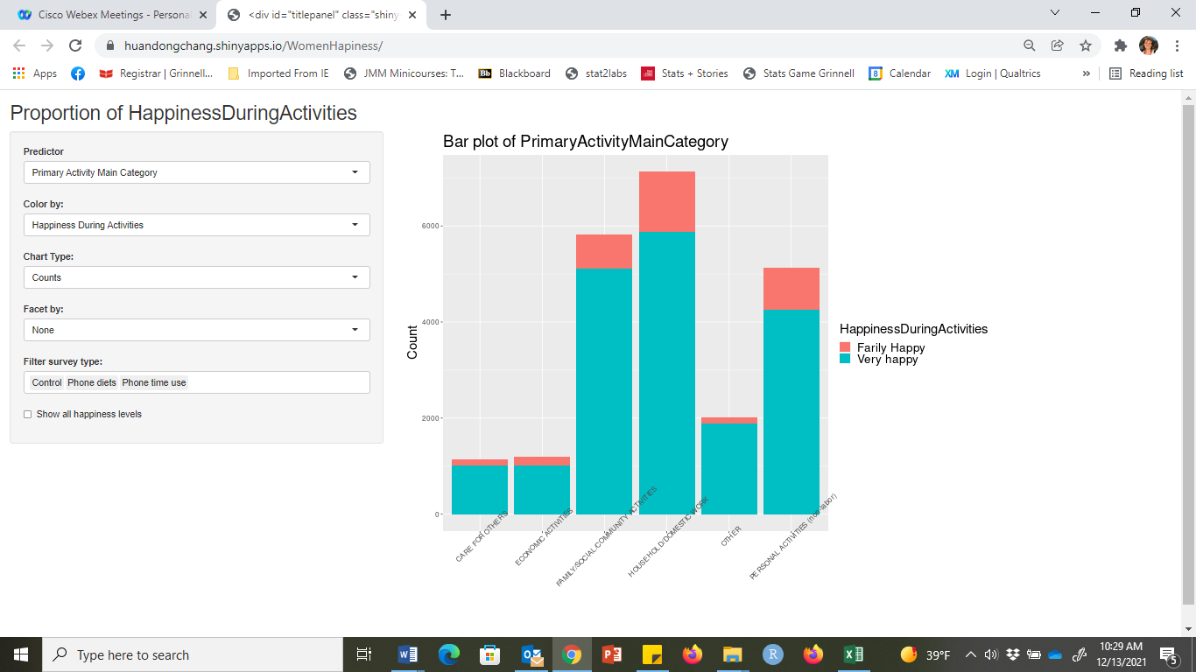

1. This bar chart is faceted by the survey type(Household Treatment Status). We can see that there are more household/domestic work reports in the PT method than the other two which are in person interviews.

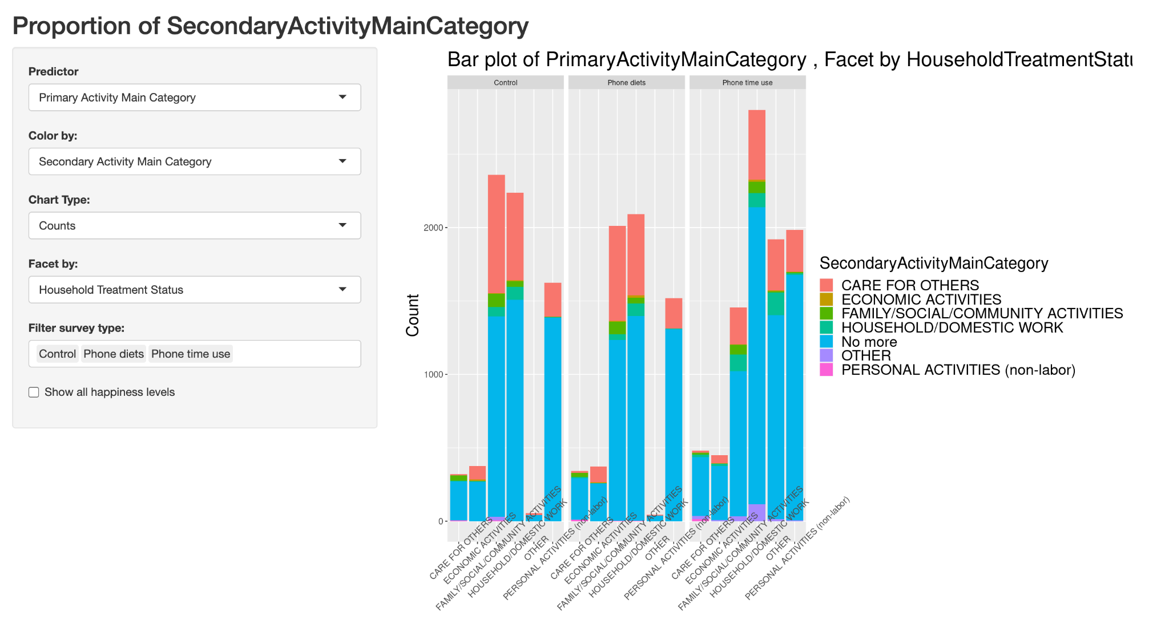

1. We can also see from this percentage bar chart that the proportion of “Very Happy” is higher for the PT group than the other two.

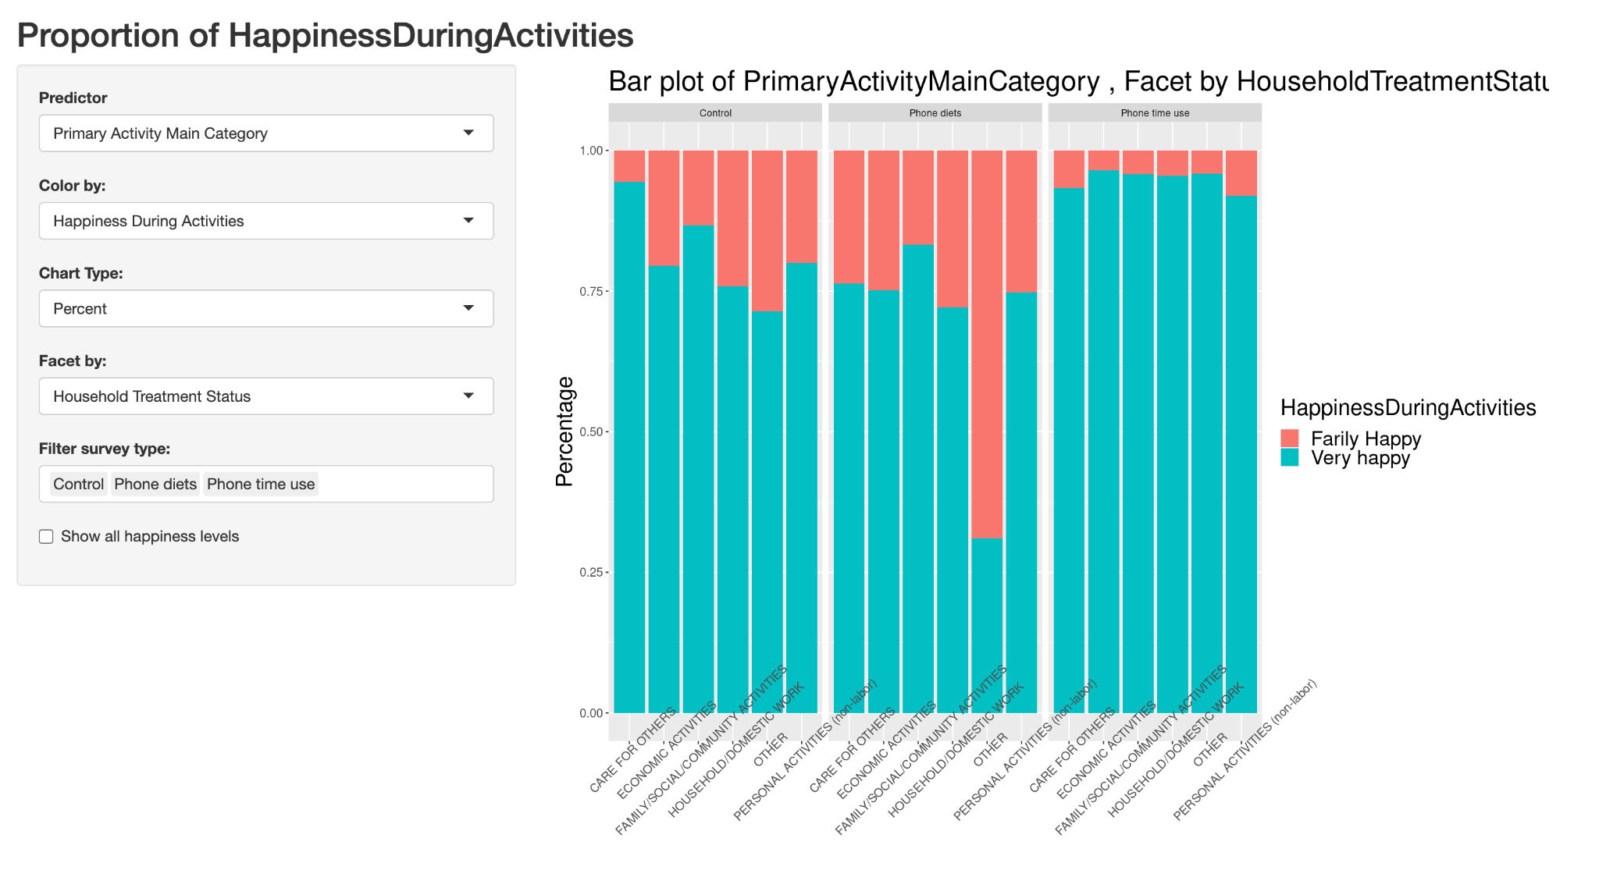

1. By faceting by Period, we can see what kind of activities were done in a specific time range. For example, personal activities are mainly done between 5 to 9 am, with less proportion of secondary activity, which is “Care for Others”.

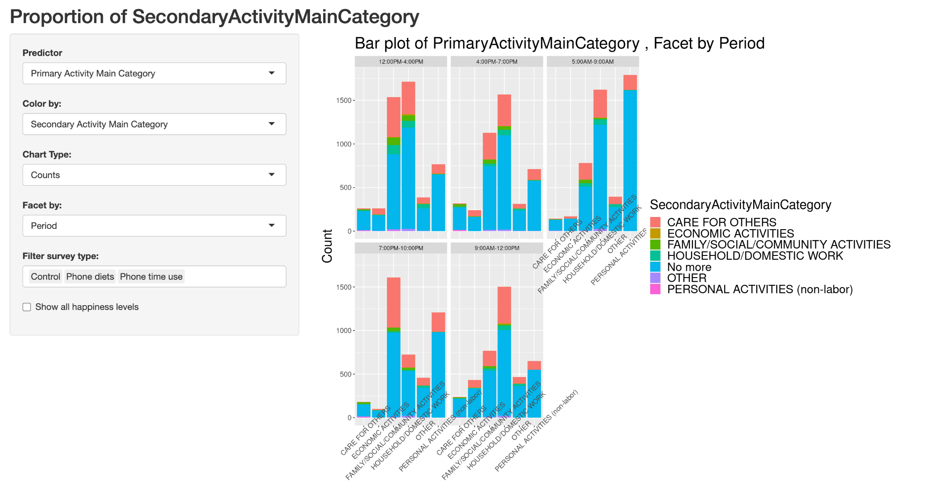

1. These two have the same variable settings, but the chart type is different. The predictor is “With Husband” which is 1 if the woman is with her husband and 0 if not. There are significantly less “with husband” in the PT group than the rest. Furthermore, the proportion of “Very happy” is slightly larger in the PT group.

