Bubble Compliance in a Syringe Hydraulic Transmission
Static Stiffness, Dynamic Response, and Variable Stiffness
An experimental study with 1, 2, and 5 mL air volumes

Technical Report
Zihao Huang
October 2026
All data are measured; no simulated data are used.

Abstract
This report studies how a trapped air bubble changes the static stiffness, dynamic response, and variable-stiffness capability of a small syringe hydraulic transmission. The circuit uses a 10 mL input syringe, a 20 mL output syringe, a silicone tube, and an output extension spring. Known air volumes of 1, 2, and 5 mL are injected to set the effective compliance. Static tests apply known water weights (0.3, 0.55, and 0.85 kg); dynamic tests use a fast input step and 240 fps video. All results are calculated from measured CSV data with 2-4 repeats per condition.
The static stiffness K_{air} decreases from 6.82±1.60 to 3.41±0.13 and 1.38±0.02 N/mm for 1, 2, and 5 mL. The 1/K_{air}-V relation is linear, giving C = 6.95 N·mm/mL, a baseline air volume V₀ = 0.03 mL, and a polytropic index n = 1.00, consistent with an isothermal static process. The time constant τ increases linearly with air volume: 0.113±0.001, 0.181±0.013, and 0.409±0.029 s, with τ = 0.035 + 0.074V (three-point fit, R² = 0.9995). The soft-joint stiffness K_{eff} is 7.44±0.25, 4.57±0.09, and 2.40±0.05 N/mm, a 3.1× tuning range over 1-5 mL, and agrees with K_{eff} = k_{s} + K_{air} within 5%. The results show that a trapped bubble can act as a passive, valve-free variable-stiffness element, and that the response time can be used as a bubble index. The main limitations are the resolution at 1 mL, the ramp input, a single output area, and the absence of pressure and temperature sensors.
Keywords: hydraulic transmission; bubble compliance; air spring; variable stiffness; time constant; soft robotics

1 Introduction

1.1 Background
Hydraulic transmission converts force and displacement through a confined fluid and offers high power density, flexible routing, and direct linear actuation [4]. In small syringe-based systems, the fluid volume is small, the tubing is narrow, and the number of seals is large, so air is easily trapped as bubbles in the syringe or tube.
Bubbles are usually undesirable: they reduce the effective stiffness, delay the output, and cause pressure fluctuations, noise, and energy loss [4]. From another perspective, a trapped bubble is a compressible air spring whose compliance is proportional to its volume [4]. If the bubble volume is controlled, the bubble can be turned from a defect into a passive, valve-free compliance element.

1.2 Soft robotics and variable stiffness
Soft robots are built from elastomers, fibre-reinforced layers, or flexible chambers and offer high compliance and safe human interaction [1,2,5]. Their low stiffness, however, limits load capacity and positioning accuracy. Variable-stiffness actuators switch between soft and stiff states in the same device, so that the robot can be compliant during contact and stiff when a load must be carried [1,2,5].
Existing variable-stiffness approaches include granular jamming, layer jamming, low-melting-point materials, antagonistic actuation, and additional springs [3,6]. These approaches often require extra structures, valves, or energy input. A syringe hydraulic circuit with a controlled bubble offers a simpler route: the air volume is a passive, valve-free, and repeatable stiffness knob.

1.3 Bubble detection
Bubbles are also a target for fluid-line health monitoring [4]. A bubble slows the response and degrades displacement transfer. If the bubble volume can be inferred from the output response, incipient air ingestion or leakage can be detected without a dedicated bubble sensor. The time constant is a candidate bubble index because it grows with the trapped air volume.

1.4 Scope and questions
This work does not use a load cell; it uses known water weights, an output spring, and displacement measurement. The study addresses four questions:
- How does the bubble volume V change the static equivalent stiffness K_{air}?
- How does V change the step-response time constant τ, and is τ proportional to V?
- Can the output spring and the bubble be combined into a usable variable-stiffness joint, and how large is the stiffness range?
- Are the static stiffness, dynamic response, and spring additivity self-consistent, and can the result be used for bubble detection?

1.5 Main results
Three experiments were performed. The static stiffness K_{air} falls from 6.82 to 1.38 N/mm as V increases from 1 to 5 mL, and 1/K_{air} is linear in V. The time constant τ rises from 0.113 to 0.409 s and is linear in V (three-point fit, R² = 0.9995). The soft-joint stiffness K_{eff} falls from 7.44 to 2.40 N/mm, a 3.1× range, and agrees with k_{s} + K_{air} within 5%. The three data sets are mutually consistent.

1.6 Structure
Section 2 presents the air-spring, static, dynamic, and volume-balance models. Section 3 describes the setup, calibration, bubble injection, and the three experiments. Section 4 reports the measured results and the cross-checks. Section 5 discusses the engineering implications, bubble detection, and limitations. Section 6 concludes.

2 Theory

2.1 Bubble as an air spring
Let p₀ and V be the initial absolute pressure and volume of the trapped air. The compression follows the polytropic relation pVⁿ = constant [4], where n is the polytropic index: n is about 1 for a slow, isothermal process and about 1.4 for a fast, adiabatic process. Linearising about the equilibrium gives
dp = - n p₀ dV / V
For an output piston of area A_{out} and a small displacement x, the air volume changes by dV = -A_{out} x. The pressure change therefore produces an equivalent stiffness
K_{air} = n p₀ A_{out}² / V
Equation (2) shows that K_{air} is inversely proportional to V: more air makes the system softer. For 5 mL, A_{out} = 262 mm², and n = 1, K_{air} is about 1.4 N/mm, the same order as the output spring (about 1 N/mm); the bubble is therefore the main compliance source.

2.2 Static stiffness and 1/K linearity
With the output spring removed, the output is loaded only by the water weight and the air pressure. Let V₀ be the residual air volume and V the injected volume. The total air volume is V₀ + V, and
1 / K_{air} = (V₀ + V) / C, C = n p₀ A_{out}²
Thus 1/K_{air} is linear in V, with slope 1/C and intercept V₀/C. When a spring of stiffness k_{s} is installed in parallel with the bubble, the static equivalent stiffness is
K_{eff} = k_{s} + K_{air}
Equation (4) is the criterion for the soft-joint experiment: the measured K_{eff} minus K_{air} should equal the calibrated spring stiffness.

2.3 Dynamic response and time constant
The hydraulic circuit is treated as a first-order system: the bubble provides the hydraulic capacitance C_{h}, and the tubing and syringes provide the hydraulic resistance R_{h}. For a small disturbance, the output displacement follows
x(t) = x_{f} [1 - exp(-t / τ)], τ = R_{h} C_{h}
where x_{f} is the final displacement. The hydraulic capacitance of the bubble is
C_{h} = V / (n p₀)
and therefore
τ = R_{h} V / (n p₀) = (R_{h} / (n p₀)) (V₀ + V)
Equation (7) predicts that τ is linear in V with slope R_{h}/(n p₀). A measured linear τ-V relation therefore supports the assumptions that bubble compliance dominates and that the hydraulic resistance is approximately constant.

2.4 Volume balance and final displacement
Let A_{in} and x_{in} be the input area and displacement, and A_{out} and x_{f} the output area and final displacement. The input volume pushes the output and compresses the air:
A_{in} x_{in} = A_{out} x_{f} + V dp / p₀
The output spring force balances the pressure, dp = k_{s} x_{f} / A_{out}. Substitution gives
x_{f} = A_{in} x_{in} / [A_{out} + V k_{s} / (p₀ A_{out})]
The term V k_{s}/(p₀ A_{out}) in the denominator acts as an equivalent bubble volume: part of the input liquid is used to compress the air, so the effective volume that drives the output piston is reduced and x_{f} decreases as V increases. This explains why the 5 mL case has a smaller output displacement than the 2 mL case.

2.5 Link between static and dynamic behaviour
The static stiffness K_{air} = n p₀ A_{out}²/V and the dynamic time constant τ = R_{h} V/(n p₀) both follow from the same hydraulic capacitance C_{h} = V/(n p₀). The static 1/K slope gives C and V₀; the dynamic τ slope gives R_{h}/(n p₀). The two data sets can therefore be used to check each other and to estimate the order of magnitude of R_{h}.

2.6 Main parameters
Table 1. Main parameters and units.
Parameter | Symbol | Value | Unit / note
Input syringe area | A_{in} | 160 | mm², nominal for 10 mL
Output syringe area | A_{out} | 262 | mm², from scale spacing and air-spring fit
Area ratio | A_{out}/A_{in} | 1.64 | -
Atmospheric pressure | p₀ | 0.1013 | N/mm² (101.3 kPa)
Polytropic index | n | 1.00 | isothermal static fit
Output spring stiffness | k_{s} | 1.02 | N/mm, water calibration (3 repeats)
Static compliance parameter | C | 6.95 | N·mm/mL
Baseline air volume | V₀ | 0.03 | mL
Dynamic slope | m | 0.074 | s/mL

3 Experimental setup and methods

3.1 Setup
The setup consists of mechanical, hydraulic, drive, and measurement parts. The mechanical part includes a stepper motor, a lead-screw linear stage, an input-syringe holder, an output-syringe holder, an output extension spring, and a fixed end. The hydraulic part is a 10 mL input syringe, a 20 mL output syringe, and a silicone tube. The drive part is an Arduino Mega2560, a TB6600 driver, and a 12 V supply. The measurement part is a set of known water weights (0.3, 0.55, and 0.85 kg), a caliper, a 0.2 mm printed scale, and a 240 fps phone camera. No load cell is used; the force is set by the known water weight and the calibrated spring.
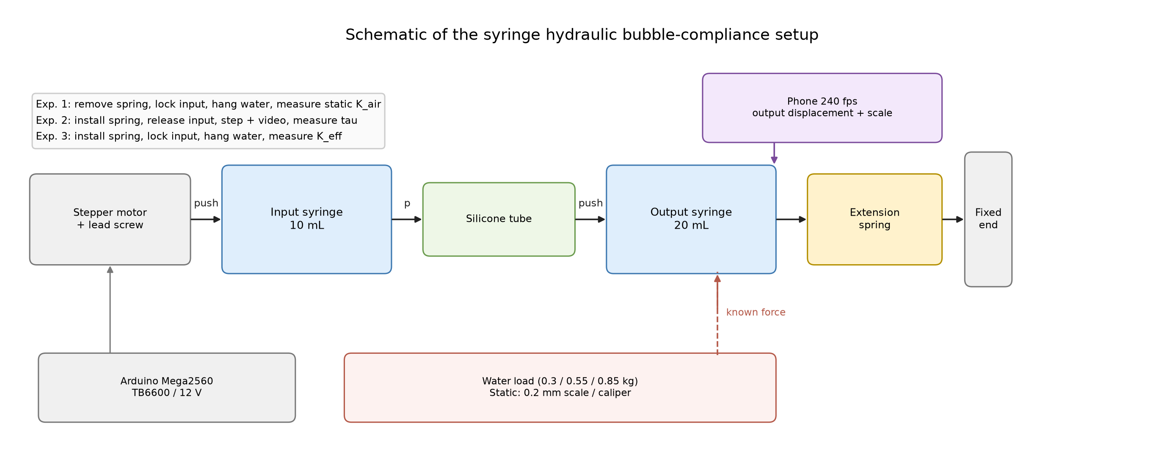
Figure 1. Schematic of the syringe hydraulic bubble-compliance setup.
Figure 2 shows the hydraulic circuit and displacement measurement. The output syringe and extension spring are on the left, the input syringe and lead screw are on the right, and the phone on its stand records the output at 240 fps. The water load and the pulley are shown schematically in Figure 1.
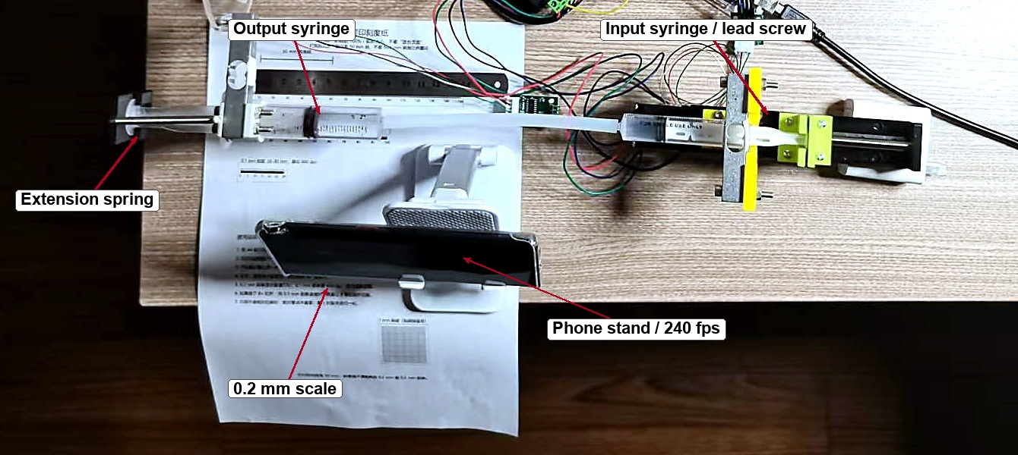
Figure 2. Hydraulic circuit and displacement measurement (output syringe and extension spring, input syringe and lead screw, 0.2 mm scale, phone stand and 240 fps phone).
Table 2. Main hardware.
Component | Specification | Role
Input syringe | 10 mL, A_{in} = 160 mm² | hydraulic input
Output syringe | 20 mL, A_{out} = 262 mm² | hydraulic output
Silicone tube | 4 mm inner diameter | connects the syringes
Output spring | k_{s} = 1.02 N/mm | load, return, soft joint
Water weights | 0.3, 0.55, 0.85 kg | known static force 2.94/5.39/8.34 N
Linear stage | 2 mm lead, 3200 steps/rev | input displacement
Driver | TB6600, 0.5 A, 1/16 microstep | stepper drive
Controller | Arduino Mega2560 | pulses and serial
Camera | 240 fps phone + 0.2 mm scale | dynamic displacement
Caliper | 0.02 mm resolution | static displacement
Printed parts | syringe clamps, rod clamp, brackets | fixture and force transfer

3.2 Area and calibration
The output area is not taken from the nominal 20 mL value of 287 mm². The 20 mL syringe has 0.5 mL per small division and a measured spacing of about 1.9 mm, giving A_{out} = 500/1.9 = 263 mm². The static 1/K fit gives C = 6.95 N·mm/mL and, with n = 1, A_{out} = 262 mm². The two estimates agree. The input area is the nominal 10 mL value, A_{in} = 160 mm²; the area ratio is 1.64.
The output spring was calibrated independently by hanging known water weights. Three repeat F-Δx slopes were 1.018, 1.013, and 1.038 N/mm; the pooled fit gives k_{s} = 1.02 N/mm, b = -0.24 N, and R² = 0.999 (Figure 3). The bottle and string weight affect only the intercept, not the slope.
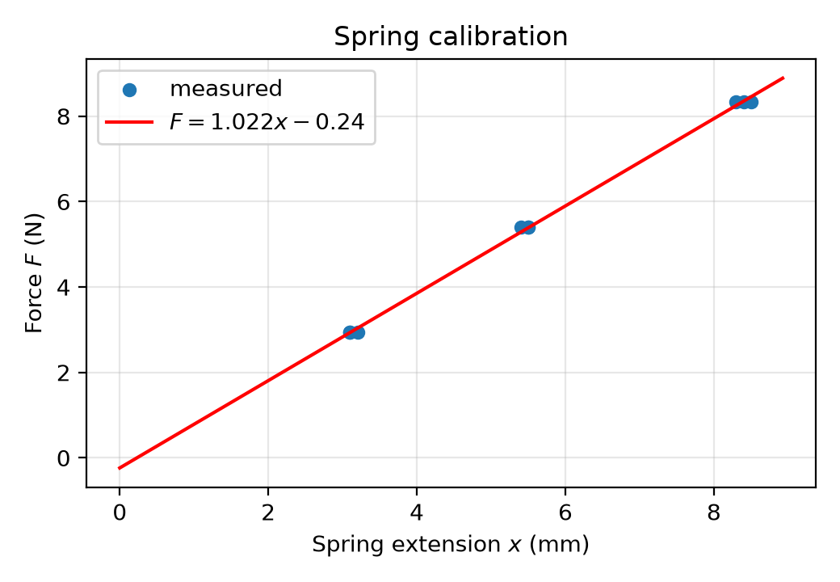
Figure 3. Output-spring calibration: force versus extension for three repeats.

3.3 Bubble injection and baseline
Before each test, the syringes were repeatedly pushed, tapped, and tilted to remove visible bubbles; this is the 0 mL baseline. A three-way valve and a 1 mL syringe were used to inject 1, 2, or 5 mL of air; when a three-way valve was not available, the output tube was removed, the output rod was pulled to draw in the set volume, and the tube was reconnected. The injected volume was read from the syringe scale with an uncertainty of about ±0.05 mL. The residual volume V₀ was not measured directly; it was obtained from the intercept of the 1/K-V fit (V₀ = 0.03 mL). The 0 mL and 0.2 mL cases were too stiff for the available displacement resolution and were not used in the quantitative fit.

3.4 Static stiffness experiment
The output spring was removed. A clamp locked the input rod so that the input did not move and the total air volume stayed constant. The output rod was connected by a thin string over a smooth bar to a water bottle, converting the vertical weight into a horizontal force along the output axis. The 0.3, 0.55, and 0.85 kg weights were applied in turn; after 5-10 s the output displacement x_{out} was measured with the caliper. Each bubble volume was tested three times.

3.5 Step-response experiment
The output spring was reinstalled and the input lock was released. The stepper drove the input from the same starting point in each run. After 1-2 s of baseline, a fast step was commanded and the output rod and scale were filmed from above at 240 fps until the output had been flat for at least 2 s. The video time was computed as t = frame/240 s; the slow-motion time shown by the player was not used.
For 2 and 5 mL, the input step was 2 mm at 10 mm/s (0.2 s ramp). For 1 mL, whose time constant is smaller, the step was 0.5 mm at 16 mm/s (0.031 s ramp) and the output was about 0.27 mm, read with the 0.2 mm scale. The time constant was defined at 63.2% of the total change. To reduce the effect of the input ramp, the script used the 10% and 63% crossings: τ = (t₆₃ - t₁₀)/0.8946.
Three early 5 mL runs were excluded: 0.109 and 0.205 s, where the output reached its final value too early and the bubble position or input state was abnormal, and 0.425 s, which used a different 4 mm/8 mm/s protocol. One early 1 mL run (0.118 s) was excluded because the rising part was sampled too sparsely; after additional sampling, 0.113 and 0.112 s were used. All exclusions are documented.

3.6 Soft-joint experiment
The output spring was installed and the input was locked, so the total air volume was fixed. The output spring acted as the elastic element of a soft joint. For each bubble volume, the 0.3, 0.55, and 0.85 kg weights were applied and the output displacement was measured; K_{eff} was obtained from the F-x slope. Each bubble volume was tested three times. K_{eff} was compared with k_{s} + K_{air}, and the stiffness range over 1-5 mL was calculated.

3.7 Data processing
The raw data are CSV files. For the static tests the columns are air volume, load, displacement, and repeat; for the dynamic tests they are time and output displacement. Python scripts group the data by bubble volume and repeat, fit each three-point set to obtain K, compute the mean, standard deviation, and R², extract τ at 63.2%, and fit 1/K-V and τ-V. All figures and tables in this report are generated from the same measured CSV files; no simulated data are used.

3.8 Uncertainty
The main uncertainty sources are the water mass (about ±1%; the bottle and string weight are treated as an intercept), the bubble volume (±0.05 mL), the static displacement (caliper ±0.02 mm; for 1 mL the 0.3 kg displacement is only 0.4-0.5 mm, so the relative error can reach 10-20%), the dynamic displacement (video ±0.05-0.1 mm; the 1 mL output is only 0.27 mm), the output area (±3%), the spring stiffness (calibrated, ±1%), and temperature and bubble position (not actively controlled). The standard deviation of the repeats is used as the main error estimate, and the raw points are retained in the figures.

4 Results

4.1 Static bubble stiffness
Table 3 summarises the static stiffness. K_{air} is 6.82±1.60 N/mm at 1 mL (relative error about 23%), 3.41±0.13 N/mm at 2 mL (3.9%), and 1.38±0.02 N/mm at 5 mL (1.1%). K_{air} decreases with increasing bubble volume, following the 1/V law.
Table 3. Static bubble stiffness.
V (mL) | K_{air} (N/mm) | SD (N/mm) | Relative error | n
1 | 6.82 | 1.60 | 23.4% | 3
2 | 3.41 | 0.13 | 3.9% | 3
5 | 1.38 | 0.02 | 1.1% | 3

Figure 4 shows K_{air} and 1/K_{air} against V. Grey circles are individual repeat fits, blue squares are means ± SD, and the red line is the model C/(V₀ + V). The 1 mL points scatter more, but the 2 and 5 mL points are stable; the linear 1/K-V fit gives R² = 1.0000.
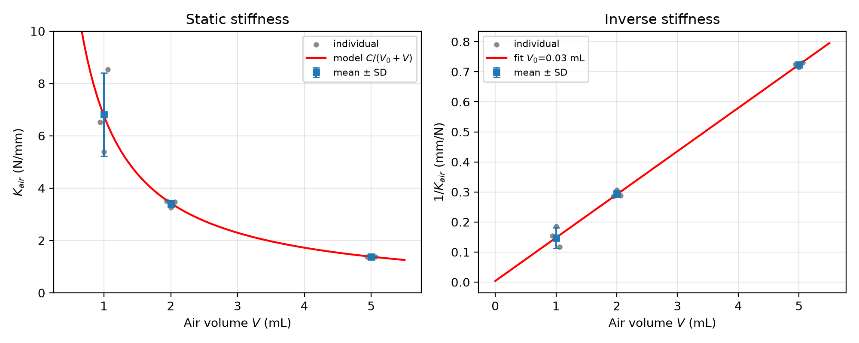
Figure 4. Static stiffness and inverse stiffness versus air volume (individual points, mean ± SD, and model).
The linear fit is
1/K_{air} = 0.0038 + 0.1439 V (R² = 1.0000)
giving C = 6.95 N·mm/mL and V₀ = 0.03 mL. Using A_{out} = 262 mm²,
n = C x 1000 / (p₀ A_{out}²) = 1.00
which is consistent with an isothermal static process; the theoretical C = n p₀ A_{out}²/1000 = 6.95 N·mm/mL differs from the measured value by less than 1%. The output area, the bubble volume, and the air-spring model are therefore mutually consistent.
The 1 mL scatter needs a separate comment. Its 0.3 kg displacement is only 0.4-0.5 mm; the caliper resolution and the initial-position error are of order 0.1 mm, which can produce a slope error of 10-20%. The three individual K values are 6.51, 5.39, and 8.54 N/mm. The 1/K fit is therefore anchored mainly by the 2 and 5 mL data.
The 1/K-V fit uses only the three mean points at 1, 2, and 5 mL. A three-point fit has only one degree of freedom, so R² is easily close to 1; it shows that the three points are nearly collinear but is not a test of statistical significance. The reliability of the model comes from the repeatability of the measurements and from the independent static, dynamic, and soft-joint checks.

4.2 Step response and time constant
Table 4 summarises the step response. τ is 0.113±0.001 s at 1 mL (n = 2), 0.181±0.013 s at 2 mL (n = 4), and 0.409±0.029 s at 5 mL (n = 4). τ increases with bubble volume, as expected from C_{h} proportional to V.
Table 4. Step-response time constant.
V (mL) | τ (s) | SD (s) | Relative error | n
1 | 0.113 | 0.001 | 0.7% | 2
2 | 0.181 | 0.013 | 7.1% | 4
5 | 0.409 | 0.029 | 7.0% | 4

Figure 5 shows τ against V. The three points are approximately collinear, and the ratio τ(5 mL)/τ(2 mL) = 2.26 is close to the volume ratio 2.5.
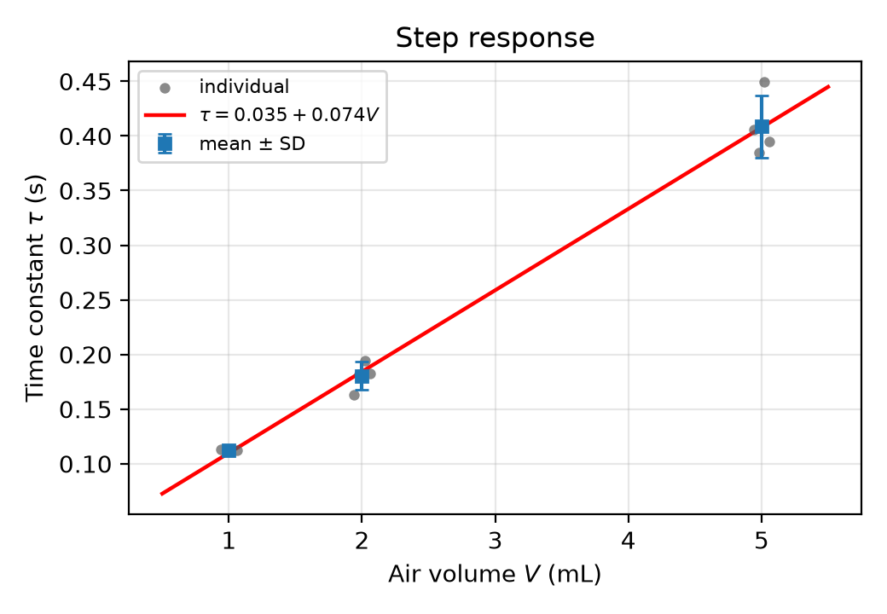
Figure 5. Time constant versus air volume (individual points, mean ± SD, and linear fit).
The linear fit is
τ = 0.035 + 0.074 V (R² = 0.9995)
The predicted values are 0.109, 0.183, and 0.405 s for 1, 2, and 5 mL; the measured values are 0.113, 0.181, and 0.409 s, within about 3%. The intercept of 0.035 s corresponds to residual bubble and line compliance. The R² of this three-point fit is also only a measure of collinearity, not a significance test.
Figure 6 shows the normalized step responses, one representative curve per bubble volume, aligned at the 10% rise time t₁₀. The 1 mL response is the fastest and the 5 mL response the slowest; all curves reach 1, indicating no significant leakage or lost steps. The inset zooms the first 0.4 s of the 1 mL response.
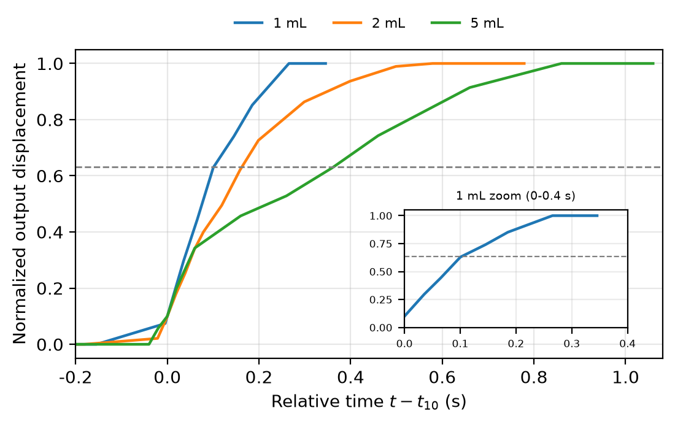
Figure 6. Normalized step responses for 1, 2, and 5 mL (representative curve per volume; time is relative to t₁₀; inset: 1 mL zoom).

4.3 Soft-joint variable stiffness
Table 5 gives the soft-joint stiffness. K_{eff} is 7.44±0.25 N/mm at 1 mL, 4.57±0.09 N/mm at 2 mL, and 2.40±0.05 N/mm at 5 mL; the stiffness range over 1-5 mL is 7.44/2.40 = 3.1×.
Table 5. Soft-joint equivalent stiffness.
V (mL) | K_{eff} (N/mm) | SD (N/mm) | Relative error | n
1 | 7.44 | 0.25 | 3.3% | 3
2 | 4.57 | 0.09 | 1.9% | 3
5 | 2.40 | 0.05 | 2.1% | 3

Figure 7 shows K_{eff} against V. Grey circles are individual repeats, blue squares are means ± SD, and the red line is the model k_{s} + C/(V₀ + V) with k_{s} = 1.02 N/mm.
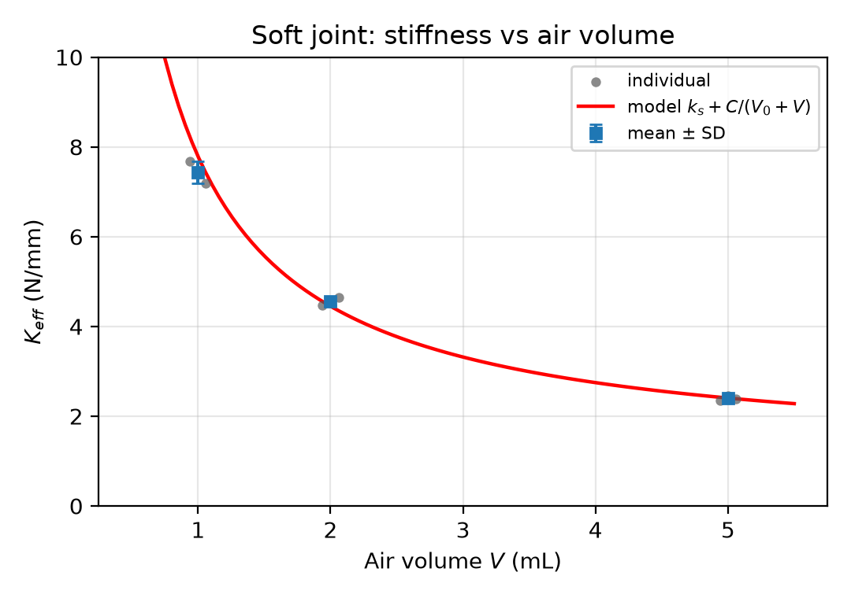
Figure 7. Soft-joint stiffness versus air volume (individual points, mean ± SD, and model).
Table 6 compares K_{eff} with the prediction k_{s} + K_{air}. The deviations are -5.1%, +3.0%, and -0.3%, all within about 5%. The measured spring stiffness is k_{s} = 1.02±0.01 N/mm; the values back-calculated from K_{eff} - K_{air} are 0.62, 1.16, and 1.01 N/mm (mean about 0.93 N/mm), close to the calibrated value. The -5.1% deviation at 1 mL comes mainly from the scatter of the 1 mL static K_{air}; the +3.0% at 2 mL may come from a slight underestimate of the static K_{air}. Considering the 1 mL reading error, the spring additivity holds.
Table 6. Spring additivity (k_{s} = 1.02 N/mm). k_{s} is the output-spring stiffness and K_{air} is the bubble stiffness.
V (mL) | K_{air} | k_{s} + K_{air} | K_{eff} measured | Deviation
1 | 6.82 | 7.84 | 7.44 | -5.1%
2 | 3.41 | 4.43 | 4.57 | +3.0%
5 | 1.38 | 2.40 | 2.40 | -0.3%

4.4 Cross-validation
Four independent checks are used:
- Static theory: the measured C is 6.95 N·mm/mL, the theoretical value is 6.95 N·mm/mL, and n = 1.00.
- Spring additivity: K_{eff} agrees with k_{s} + K_{air} within about 5% (k_{s} = 1.02 N/mm, water calibration).
- Static-dynamic consistency: the static data give C_{h} proportional to V, and the dynamic data give τ proportional to V; the two slopes are of the same order.
- Volume balance: the final displacements for 5 mL/2 mm, 2 mL/2 mm, and 1 mL/0.5 mm are 0.70, 0.95, and 0.27 mm, consistent with Eq. (9).
Table 7. Cross-validation summary.
Check | Expected | Measured | Conclusion
Static C | n p₀ A_{out}²/1000 = 6.95 | 6.95 | difference <1%
K_{eff} additivity | k_{s} + K_{air} | 7.44/4.57/2.40 | within about 5%
τ-V linearity | τ proportional to V | R² = 0.9995 | three points collinear (R² for reference)
Final displacement | Eq. (9) | 0.70/0.95/0.27 mm | consistent

The validation uses analytical models and independent experiments, not simulated data. All numbers in this report come from measured CSV files.

5 Discussion

5.1 Bubble as an air spring
The static data give a clean 1/K_{air}-V line, and C differs from the theoretical value by less than 1%, with n = 1.00 [4]. Under slow, well-exchanged conditions, the trapped air therefore behaves as an isothermal air spring, and the bubble volume is the main compliance source. The compliance of the tubing and syringes appears only in the small V₀ of 0.03 mL. This provides a quantitative basis for using the bubble as an adjustable spring: changing the injected volume sets the stiffness according to 1/V.
The 1 mL scatter is a reminder that the air-spring model is limited by the gauge and by static friction at very small volume and displacement. The 0.3 kg displacement at 1 mL is only 0.4-0.5 mm; the 0.02 mm caliper resolution and a 0.05 mm initial-position error are enough to cause more than 10% slope error. For high-stiffness applications, a finer displacement sensor or a longer loading stroke should be used instead of a 0.5 mm scale.

5.2 Static-dynamic consistency
Static and dynamic data point to the same C_{h} = V/(n p₀). The static 1/K slope gives C = 6.95 N·mm/mL; the dynamic τ slope gives 0.074 s/mL. The two cannot be equated directly because the units differ, but they can be used to check each other: from τ = R_{h} C_{h}, the τ-V slope should be proportional to R_{h}/(n p₀); from the static data, C = n p₀ A_{out}². Combining the two gives the order of magnitude of R_{h} and shows that it is approximately independent of the bubble volume. The 1 mL τ is slightly higher, probably because of the input ramp or the bubble position.
The dynamic τ was measured with 2 mm at 10 mm/s (0.2 s ramp) or 0.5 mm at 16 mm/s (0.031 s ramp), so it is an effective time constant that includes the input shape. The 2 mL τ of 0.181 s is close to the 0.2 s ramp, so the absolute τ may be slightly overestimated. The 2 and 5 mL data use the same protocol, so their ratio of 2.26 can still be attributed to the air volume. The 1 mL run uses a faster ramp, and its τ of 0.113 s differs by only 3% from the 0.109 s extrapolated from the 2/5 mL line, so the protocol difference does not break the trend.

5.3 Variable stiffness for soft robotics
The soft-joint experiment shows that the output spring and the bubble in parallel reduce K_{eff} from 7.44 to 2.40 N/mm, a range of about 3.1× over 1-5 mL. Extrapolating to 0.5 mL gives K_{eff} of about 14 N/mm and a range of about 6× (not measured). This range is relevant to small soft joints, grippers, and wearable devices [1,2]: with one hydraulic source, the same actuator can switch between compliant contact and load-bearing positioning by changing the air volume.
The cost is a slower response: as K_{eff} falls from 7.44 to 2.40 N/mm, τ rises from 0.113 to 0.409 s. For fast tasks, the air volume should be small; for compliant, impact-tolerant tasks, it can be larger. This soft-slow trade-off is inherent to bubble compliance and must be considered in design. Compared with granular jamming and low-melting-point materials [3,6], the bubble approach is structurally simple, valve-free, and requires no extra energy input; its limitations are the stiffness range set by the bubble volume, the slower response, and long-term leakage and bubble coalescence.

5.4 Bubble detection
The linear τ-V relation provides a basis for bubble detection [4]. Under a fixed input protocol, a single step response gives τ and hence the air volume from τ = 0.035 + 0.074V. Using the standard deviation of the repeats (3 sigma), the resolution is about 0.5 mL near 2 mL and about 1.2 mL near 5 mL; the 1 mL displacement is too small and the number of repeats too low to set a detection threshold. The method is therefore suitable for detecting obvious air ingestion or leakage, not very small bubbles. In practice, the bubble position (syringe versus tube) changes the dynamic response, temperature affects p₀ and n, and the input ramp mixes into τ; the τ-V curve should therefore be calibrated in situ with the same fixture and protocol.

5.5 Limitations
- The 1 mL static displacement is only 0.4-0.5 mm and K_{air} has a 23% relative error; the 1 mL step response has only two repeats.
- The dynamic input is a 0.2 s or 0.031 s ramp, not an ideal step; the 2 mL τ may be overestimated by the input shape.
- Bubble position, coalescence, and leakage were not tightly controlled; three early 5 mL runs were excluded for this reason.
- Only 1, 2, and 5 mL were measured; 0.5 mL and below are extrapolated.
- Only one output area (A_{out} = 262 mm²) was used; the A_{out}² scaling is supported indirectly by the scale spacing and n = 1, but has not been independently tested with 5 and 10 mL output syringes.
- No pressure or temperature sensor was used; n = 1 is a static inference and the dynamic n may differ.
- The spring stiffness was calibrated by the water method, but the calibration pose may differ from the installed pose; the k_{s} uncertainty enters K_{eff}.
- The video spatial resolution is about 0.05-0.1 mm, which is marginal for the 0.27 mm 1 mL output.

5.6 Future work
Future work includes adding 0.5 and 0.2 mL measurements, adding a low-cost pressure sensor to measure the p-V curve directly, using a velocity step instead of a position ramp, automating the video tracking, building a tunable-volume bubble chamber for closed-loop stiffness control, and studying temperature, bubble position, and long-term leakage.

6 Conclusion
This report studied, with real measurements, how a trapped air bubble affects the static stiffness, dynamic response, and variable-stiffness capability of a syringe hydraulic transmission.
- K_{air} falls as 1/V: 6.82±1.60, 3.41±0.13, and 1.38±0.02 N/mm at 1, 2, and 5 mL. The 1/K_{air}-V relation is linear (three-point fit, R² = 1.0000), with C = 6.95 N·mm/mL, V₀ = 0.03 mL, and n = 1.00.
- τ rises linearly with V: 0.113±0.001, 0.181±0.013, and 0.409±0.029 s; τ = 0.035 + 0.074V (three-point fit, R² = 0.9995).
- The output spring and bubble in parallel give K_{eff} = 7.44±0.25, 4.57±0.09, and 2.40±0.05 N/mm, a 3.1× range over 1-5 mL, agreeing with K_{eff} = k_{s} + K_{air} within 5%.
- The static, dynamic, and soft-joint results are mutually consistent; more bubble means a softer and slower system. The effect can be used for variable-stiffness soft joints and for τ-based bubble detection.
- The main limitations are the 1 mL resolution, the input ramp, the bubble position, and the absence of pressure and temperature measurements; 0.5 mL and below are extrapolated.
Overall, a trapped bubble in a small hydraulic system is both a passive defect and a quantifiable compliance element. With controlled bubble volume and a fixed measurement protocol, the bubble becomes a simple, low-cost, valve-free variable-stiffness knob.

References
[1] Rus D, Tolley M T. Design, fabrication and control of soft robots. Nature, 2015, 521(7553): 467-475.
[2] Polygerinos P, Correll N, Morin S A, et al. Soft robotics: Review of fluid-driven intrinsically soft devices; manufacturing, sensing, control, and applications in human-robot interaction. Advanced Engineering Materials, 2017, 19(12): 1700016.
[3] Van Ham R, Sugar T G, Vanderborght B, et al. Compliant actuator designs. IEEE Robotics & Automation Magazine, 2009, 16(3): 81-94.
[4] Manring N D, Fales R C. Hydraulic Control Systems. 2nd ed. Hoboken: Wiley, 2019.
[5] Wehner M, Truby R L, Fitzgerald D J, et al. An integrated design and fabrication strategy for entirely soft, autonomous robots. Nature, 2016, 536(7617): 451-455.
[6] Manti M, Cacucciolo V, Cianchetti M. Stiffening in soft robotics: A review of the state of the art. IEEE Robotics & Automation Magazine, 2016, 23(3): 93-106.

Data and code availability
The measured CSV files, analysis scripts, and figure-generation scripts are available in the accompanying GitHub repository. The repository contains the raw step-response files, the static and soft-joint data, and the scripts used to generate every figure and table in this report. A DOI will be assigned through Zenodo when the repository is released.
The author declares no conflict of interest. No human or animal subjects were involved.

