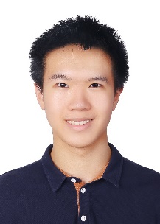
Tianyang Huang
Ph.D. student in ECE, University of Wisconsin-Madison

Phone number (1) 6084213867
e-mail thuang272@wisc.edu
personal website

Education
2025-present Ph.D. Engineering in Electric and Computer Engineering,
Kats Research group, University of Wisconsin-Madison
Focus Optics
2021-2025 B.S. AMEP, University of Wisconsin-Madison
Triple-Major AMEP (Applied Mathematics, Engineering, and Physics)
Physics
Mathematics
GPA 3.772
Major GPA Math: 3.952 AMEP: 3.758 Physics: 3.710
2014-2021 Shanghai Foreign language School (China)

Research interest
Optic measurement, ellipsometry, and AI

Research projects
2024/02 – Present Kats Research Group, Machine Learning for ellipsometry
Advisor:
Mikhail Kats,
Jack St. Clair Kilby Professor and Antoine-Bascom Professor,
Department of Engineering: Electrical and Computer Engineering
Project description:
Developed an AI tools that can do automatic refractive index fit from ellipsometry data, which used to be hours of days of work manually by human experts

Honor
Undergraduate
ECE Undergraduate Research Symposium 2nd place reward.
Dean list
College of Letters & Science Scholarships for First-Year Students
High School
AMC 12: top 1% , USAMO qualifier
Canada Open Mathematics Challenge (COMC): International Champions 4th place
Australia Science Olympiads-Physics (ASOP): 14th place, “High Distinction”
PUPC2020: Honorable Mention

