1 Understanding Vector Machines
Support vector machines deal with data classification problems, the purpose is to learn a two-class function model, which belongs to the method of supervised learning and is widely used in statistical classification and regression analysis. The sample data is classified by establishing a hyperplane. The hyperplane involves the application of convex optimization and kernel function, and how to find the optimal hyperplane is the content of this part.

2 Linear classification
It is assumed that the data sample set is linearly separable, that is, there is a hyperplane that divides it into two categories. The following derivation process is based on linear separability, nonlinear classification is to add a relaxation factor to the linear classification, and the derivation of the linear classification starts below.

2.1 Labels for Linear Classification
In the previous Logistic regression algorithm, we divided the data into 0 and 1, but here we use -1 and 1 for the generality of the derivation in the future. The classification function is f (x) = ωTx + b , where ω = (ω1 , ω2 , ... , ωn) and x = (x1, x2 , ... ,xn). In layman's terms, the problem solved by the support vector machine is to find the best classification hyperplane. For example, in a two-dimensional plane, its hyperplane is a straight line. As shown in the figure below, find the best classification in the straight line that can separate the two categories. the straight line. The best criterion for judging a straight line is: in the case of classification, the farther the distance between the sample point and the straight line, the better the straight line. This leads to the evaluation of the function interval and the geometric interval for the selected line.
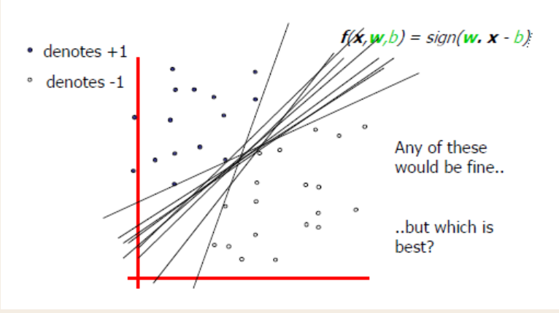
2.2 Functional and geometrical intervals
In general, the distance of a point from the hyperplane can be expressed as the confidence or accuracy of the classification prediction. When the hyperplane wTx+b=0 is determined, |wTx+b| can relatively represent the distance from the point x to the hyperplane, and whether the sign of wTx+b is consistent with the sign of the class label y indicates whether the classification is correct, Therefore, the positive and negative of the quantity y(wTx+b) can be used to judge or express the correctness and certainty of the classification. That is, the classification is correct when y(wTx+b) > 0; the classification is wrong when y(wTx+b) < 0.

2.2.1 Function interval
The functional interval of the hyperplane f ( x ) with respect to the sample points (x (i) , y (i)): 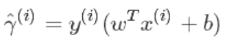
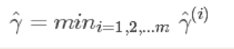
The definition of 1 is to maximize the interval, 1 represents the minimum value of the function interval between the hyperplane and the samples in the training set, as long as 1 is maximized below. Note that the function interval does not actually represent the distance from the point to the hyperplane, because when the hyperplane (ω,b) parameter is expanded by the same multiple, such as (2ω,2b), the position of the hyperplane does not change, but the function interval Also becomes larger by the same multiple of 2γ^(i).
2.3 Maximizing the interval
Now go a step further, from the original to find a hyperplane to the present to find the maximum interval of the hyperplane. Through the definition of function interval and geometric interval, it is appropriate to use geometric interval to measure the best standard, because geometric interval is a distance in the true sense, just like we find the distance from a point to a plane:
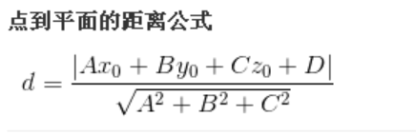
Next, we will introduce another concept: support vectors. As shown in the figure below, assuming that the red line in the middle is the hyperplane, then the sample points on the dotted line are the support vectors.
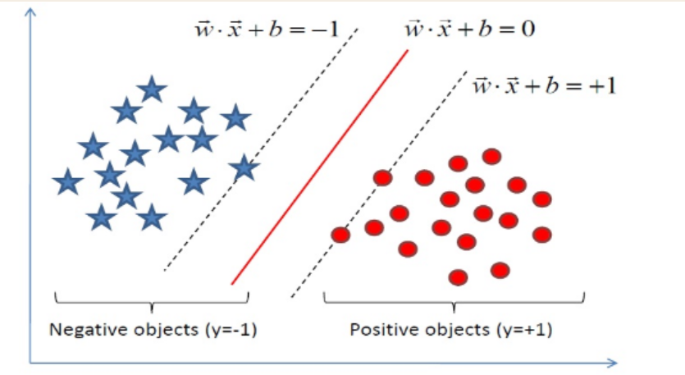
With this, we can define interval maximization:
max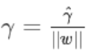
The conditions that need to be met are:
Valid sample points for the interval are the points of the support vector, i.e. the points that conform to the function interval equal to 1. Then the maximization of the interval can be:
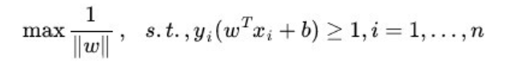
2.4 Transformation to dual problem
The convex optimization problem is obtained by changing the above formula, that is to convert max 1/ || ω || into min 1/2 || ω || 2 , the two are equivalent
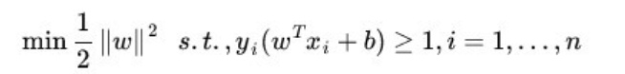
Converted to this form, our problem becomes a convex optimization problem, or more specifically, a convex quadratic programming problem because the objective function is now quadratic and the constraints are linear. This problem can be solved with any ready-made QP optimization package, which boils down to one sentence: under certain constraints, the goal is optimal and the loss is minimal.

In addition to the conventional method of solving the QP problem, the optimal solution can also be obtained by solving the dual problem, which is the dual algorithm of the support vector machine under the linearly separable condition. The advantage of this is that the dual problem is often easier to solve. ; the two can naturally introduce the kernel function, and then generalize to the nonlinear classification problem.

Now to solve the convex optimization, the empirical solution given now is to obtain the optimal solution by solving the dual problem. What is the dual problem? This leads to Lagrangian functions, incorporating constraints into the objective function by adding a Lagrangian multiplier α to each constraint.
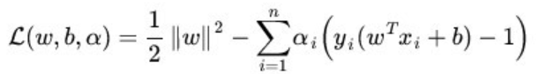
Then make:
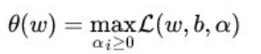
Now our objective function becomes:
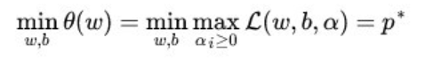
Understanding of this formula: Under the condition that the constraints are satisfied (that is, the sample points are support vectors), the smallest value in the largest geometric interval is taken. max L(w,b,a) is the sample points to get the support vector, and then find the minimum value (maximum interval) of min 1/2 || w ||2 among these sample points.

Note that the dual problem comes out (p* is the original problem, d* is the dual problem), exchange the minimum and maximum positions, and get the following formula:
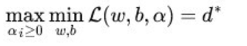
The problem after the exchange is not equivalent, there is the following relationship: d* <= p* . But under certain conditions (KKT conditions), the two are equal.
2.5 Solving the Dual Problem
It can be seen from the above that the equivalent condition of the original problem and the dual problem is that certain conditions are satisfied, and the condition is KKT. It doesn't matter if you don't know the KKT condition, now you just need to understand that the original problem is to satisfy the KKT condition, and the KKT condition is explained in the kernel function. Solving this dual learning problem is divided into three steps: 1. Minimize L(ω, b, α) with respect to ω and b; 2. Find the maximum of α; 3. Use the SMO algorithm to solve the dual factor (α ). I mainly talk about 1 and 2 here, and step 3 is covered in the second part.

Step 1: Fix α, then L(ω, b, α) finds the partial derivative with respect to ω and b, and its partial derivative is equal to zero.
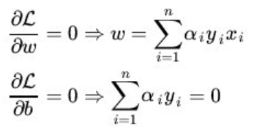
Put the result into L:
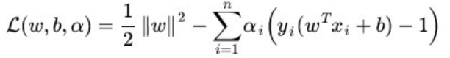
We can get:
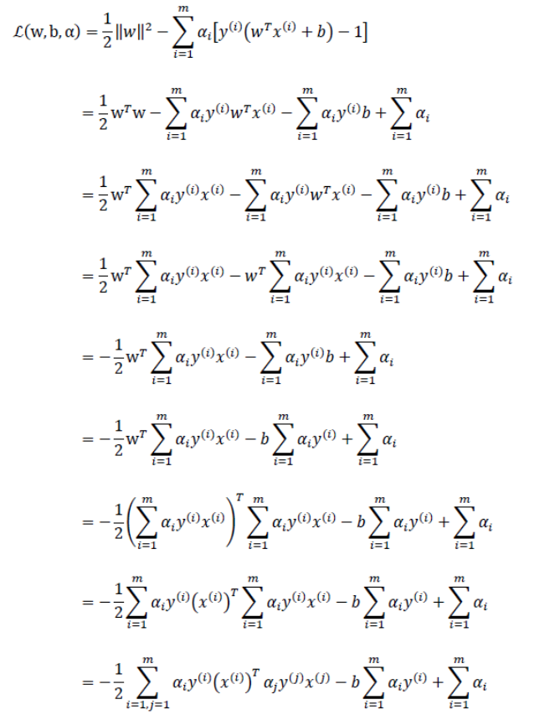
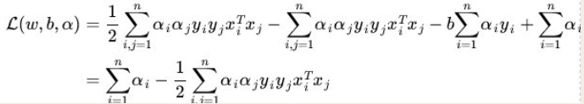
Step 2: Maximize α. Through step 1, the variables ω and b have been eliminated, and the function is only α
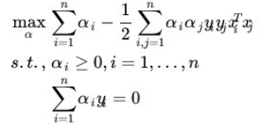
If we find the duality factor, then we can get the optimal hyperplane f (x) = ωT x + b ;
b According to the KKT condition, αi [ y(i)(ωTx(i) + b ) -1] =0, i =1, 2 ,..., m , there must be a αj not equal to 0, y(j) (ωTx(j) + b )=1 , multiply both sides by y(j) to get:

b = y(j) - Σi=1mαi y(i) x(i)x(j) , or a weighted average of all b satisfying the condition.

