CoupledMD: molecular dynamics trajectories of active GPCR–G-protein complexes
Jianxiang Huang^{1,2,3}, Xin Qiao³, Shaoyong Lu^{1,2,3,*}

¹Artificial Intelligence Clinical Research Center for Drug Discovery, Shanghai Key Laboratory of Flexible Medical Robotics, Institute of Medical Robotics, Tongren Hospital, Shanghai Jiao Tong University School of Medicine, Shanghai 200336, China
²Key Laboratory of Protection, Development and Utilization of Medicinal Resources in Liupanshan Area, Ministry of Education, Peptide & Protein Drug Research Center, School of Pharmacy, Ningxia Medical University, Yinchuan 750004, China

*To whom correspondence should be addressed
Dr. Shaoyong Lu; E-mail: lushaoyong@sjtu.edu.cn

Abstract
Molecular dynamics (MD) trajectories of G protein-coupled receptor (GPCR)–G-protein complexes are among the most expensive and least reusable data in structural pharmacology, because simulation protocols, molecular representations and annotations differ between studies and are rarely shared in interoperable form. Here we present CoupledMD, a curated cohort of 207 active-state GPCR–G-protein complexes spanning 174 receptors, two GPCR classes (A and B) and all four major G-protein families (Gi/o, Gs, Gq/11 and G12/13). Every complex was simulated in a POPC membrane under a CHARMM36-family force field as three validated 500-ns replicas, yielding 621 production trajectories and 310.5 µs of aggregate sampling—one of the largest uniformly prepared trajectory collections of the receptor–transducer assemblies that dominate the drug-target landscape. CoupledMD adds system metadata, GPCRdb-mapped pocket annotations, transmembrane-gateway records, reduced visualization trajectories and a versioned REST API; a complete DOI-linked archive of primary trajectories, topologies and inputs is in preparation. We built CoupledMD as a shared, extensible foundation the GPCR community can inherit for trajectory-method benchmarking, receptor-aware comparative analysis and reuse of structurally derived annotations.

Background & Summary
G protein-coupled receptors (GPCRs) transduce extracellular signals across the plasma membrane by coupling to heterotrimeric G proteins, and they constitute the largest family of validated drug targets, accounting for roughly one-third of marketed small-molecule and biologic therapeutics^{1,2}. Signal transduction begins when an agonist stabilizes an active receptor conformation that engages a specific Gα subunit, catalyzing nucleotide exchange and downstream effector activation. Which G-protein family a receptor recruits, and how ligand chemistry biases that recruitment, are encoded in the dynamics of the receptor–G-protein interface rather than in any single static structure². Over the past decade, cryo-electron microscopy and X-ray crystallography have resolved hundreds of active-state GPCR–G-protein complexes and transformed the structural picture of coupling. These structures are static endpoints, however; the conformational ensembles, interface fluctuations and membrane-mediated effects that govern coupling emerge only from molecular simulation.
Molecular dynamics (MD) is the established route to these ensembles, yet the resulting trajectories are costly to generate and are rarely shared in a form that supports reuse. Meaningful cross-receptor and cross-family comparison requires simulations prepared under a common protocol, embedded in a defined membrane, annotated with a transferable residue-numbering scheme and distributed in interoperable formats with verifiable provenance. Published GPCR simulations instead differ in force field, membrane composition, trajectory length, atom selection, file format and identifier conventions, so assembling a comparable multi-receptor collection from the literature is prohibitively laborious. As a result, the data that most directly report on coupling dynamics remain among the least reusable in structural pharmacology.
Several community resources address parts of this problem. GPCRdb provides receptor classification, curated structures, sequence alignments and the generic residue-numbering scheme that enables positional comparison across the superfamily^{3,4}, and GproteinDb extends this framework to G proteins and their couplings⁹. GPCRmd pioneered community-accessible GPCR trajectory sharing and demonstrated its value for dynamics-aware receptor analysis⁵. At the whole-proteome scale, mdCATH assembled all-atom simulations of 5,398 protein domains with an explicit cohort definition, hierarchical data schema, file-level provenance, technical validation and executable access examples, establishing a template for the reusable MD Data Descriptor⁶. None of these resources, however, offers a standardized, membrane-embedded collection of GPCR–G-protein complexes with matched topologies, derived interface annotations and programmatic access. CoupledMD fills this gap. Relative to single-receptor MD studies and to soluble-domain collections such as mdCATH, its distinguishing feature is that every system is a multi-chain, membrane-embedded receptor–transducer assembly—a class that demands careful treatment of membrane construction, chain-role assignment, multi-component topology and G-protein annotation.
CoupledMD comprises 207 active-state systems selected from a 222-record working inventory. The cohort spans 174 distinct receptor names (173 mapped UniProt accessions) across Class A (181 systems) and Class B (26 systems) GPCRs and all four major G-protein families (95 Gi/o, 65 Gs, 41 Gq/11 and 6 G12/13). Each system contributes three validated 500-ns production replicas simulated under a CHARMM36-family force field in a POPC bilayer, yielding 621 trajectories and 310.5 µs of aggregate sampling. A further thirteen records remain unresolved—owing to periodic-boundary or trajectory-continuity issues, component discontinuity or incomplete-trajectory evidence—and two records (Gq_7E9W and Gq_7DWC) are excluded: Gq_7E9W is a non-GPCR duplicate of Gq_8E9W, and Gq_7DWC is a duplicate source identity of Gq_8DWC (both MRGPRX1, Q96LB2); we document these explicitly, and none contributes to the release counts, derived records or API responses. To our knowledge, this is one of the largest uniformly prepared trajectory collections of the receptor–transducer assemblies that dominate the drug-target landscape, and we built it to be inherited and extended by the broader GPCR community.

CoupledMD supports four modes of reuse: (i) selection of systems by receptor, GPCR class, G-protein family, ligand context, construct provenance or simulation protocol; (ii) benchmarking of trajectory-analysis, pocket-detection and structural-comparison methods against a defined cohort; (iii) cross-receptor positional joins using PDB, UniProt, GPCRdb and CGN identifiers; and (iv) rapid visual inspection through reduced representative trajectories, which are not substitutes for quantitative production data. An interactive web portal (https://www.coupledmd.cn) and a versioned REST API provide the current access layer, and a complete DOI-linked archive will become the immutable version of record upon deposition. Throughout, the derived pocket, gateway and G-protein records are computational annotations and are not evidence of coupling selectivity, biased signalling or druggability.

Methods
Source structures and eligibility criteria
Active-state GPCR–G-protein complex structures were collected from the Protein Data Bank (PDB)7 by restricting to entries containing both a seven-transmembrane receptor and a heterotrimeric or engineered G-protein assembly in an active or active-like conformation. Receptor chains were cross-referenced to UniProt8, GPCRdb3 and GproteinDb9; G-protein chains were assigned to one of four families (Gi/o, Gs, Gq/11 or G12/13) from the Gα-subtype annotation. Structural provenance was recorded separately from receptor activation state: of the 207 included systems, 197 derive from experimental coordinates and 10 carry an engineered or uncertain provenance flag, so that users may apply stricter inclusion criteria if required.
Each system is identified as <family>_<PDBID> (for example, Gi_7F1Q). Inclusion in the release required a GPCR–G-protein assembly assignable to one of the four families, processing through the CHARMM36-family workflow, and readiness evidence selecting three validated 500-ns replicas. Thirteen unresolved systems are documented rather than silently discarded; Gq_7E9W is excluded as a non-GPCR duplicate/mislabel. The release uses the readiness-selected replicas for Gq_8J9N rather than stale six-replica metadata, and repaired final metadata for Gi_7E32 and Gi_8HK2.
System construction and membrane embedding
Complexes were embedded in a homogeneous POPC lipid bilayer using CHARMM-GUI Membrane Builder10,11. Missing residues and side chains in the receptor and G protein were modeled during preparation; protonation states were assigned at pH 7.4. Systems were solvated with TIP3P water leaving at least 15 Å of padding between the protein and the periodic box edge, and neutralized with Na⁺/Cl⁻ ions to an ionic strength of 0.15 M. Ligands retained from the source structure were parameterized with the CHARMM General Force Field (CGenFF)12 where applicable. All 207 systems are annotated as POPC membrane-embedded.
Simulation protocols
Three protocol groups are represented in the release, all built on the CHARMM36m force field¹⁵:
Protocol | Systems | Engine | Thermostat | Barostat
P1 | 180 | AMBER pmemd.cuda | Langevin (γ = 1 ps⁻¹) | Monte Carlo, semi-isotropic
P2 | 26 | AMBER (CHARMM-GUI inputs) | Langevin (γ = 1 ps⁻¹) | Monte Carlo, semi-isotropic
P3 | 2 | GROMACS | Nosé–Hoover¹³ | Parrinello–Rahman, semi-isotropic¹⁴
All protocols used NPT conditions at 310 K and 1 bar, a 2-fs integration step, particle-mesh Ewald electrostatics16 and constraints on bonds to hydrogen (SHAKE for AMBER17; LINCS for GROMACS18). Nonbonded interactions used a 12-Å cutoff with force-switching from 10 Å (AMBER) or a 1.2-nm cutoff with switching from 1.0 nm (GROMACS). Coordinates were written every 50 ps. Each system underwent energy minimization followed by multi-stage equilibration with protein and lipid restraints progressively released before production. Each of the three production replicas ran for 500 ns from independently assigned initial velocities, giving 1.5 µs per system and 310.5 µs across the cohort. The three workflow groups share a force-field family and membrane composition but differ in engine, thermostat and barostat implementation; workflow group should therefore be treated as a potential batch variable. Production replicas are computational repeats rather than biological replicates.
Trajectory processing and reduced visualization records
Full production trajectories, with their matched engine-compatible topology and the input files needed to interpret atom order and simulation conditions, are the primary data records. AMBER systems use NetCDF trajectories with PRMTOP/PARM7 topologies; GROMACS systems use TRR trajectories with TPR and topology files. A separate reduced tier was generated for browser-based inspection: solvent, POPC and ions were removed, protein coordinates were aligned to a Cα reference, and frames were strided to 2,500 frames spanning 500 ns, written as matched PDB/XTC pairs. Reduced records support visual screening and system selection but must not be used for solvent-, lipid- or ion-dependent measurements, or for kinetics faster than their sampling interval.
Pocket detection and orthosteric-site annotation
Pocket-analysis records were generated for all 207 systems using fpocket19. Persistent pockets were detected in 206 systems; Gi_7YK6 and Gi_8YIC produced valid zero-pocket records rather than missing analyses. For each system, approximately 200 frames per replica (600 frames across three replicas) were sampled at a stride of 50 stored production frames. Protein coordinates in each frame were aligned to the reference structure by Cα atoms, and fpocket was executed independently per frame. Alpha-sphere occupancy was accumulated on a 1.5-Å Cartesian grid, and grid points occupied in at least 85% of analyzed frames were retained. Retained points were clustered by DBSCAN (ε = 2.85 Å, min_samples = 3), and protein heavy atoms within 4.0 Å of a persistent cluster were assigned as pocket-lining residues. For peptide-ligand systems, a cluster was labelled orthosteric when any retained grid point lay within 5.0 Å of a ligand heavy atom; best_ortho_freq is the maximum mean grid-point frequency among orthosteric clusters.
GPCRdb mapping and anatomical pocket classification
Pocket-lining residues were mapped to GPCRdb generic positions using PDB-specific structural records and sequence alignment to the GPCRdb reference^{3,4,20}, enabling positional comparison across receptors that do not share residue numbering. Each pocket was also assigned to an anatomical class: orthosteric, extracellular vestibule, TM-core allosteric, intracellular allosteric, coupling interface, other or receptor-unresolved. The GPCR-centered reuse atlas uses the first four classes and retains the original per-system pocket identifiers so that every plotted record can be joined back to its source system.
Transmembrane-gateway annotations
Gateway records quantify lipid access between seven adjacent TM helix pairs (TM1-TM2 through TM7-TM1), with TM boundaries taken from GPCRdb helix assignments (Supplementary Figure S2). For each sampled frame, the trajectory was centered on the receptor and wrapped by residue; lipid heavy atoms within 5.0 Å of both helices and within the central TM z-band (25th-75th percentile of TM Cα z-coordinates) were classified as wedged. Penetration was the maximum inward radial displacement of a wedged atom relative to the nearest helix-pair Cα wall, and a frame was classified as open when penetration was at least 0.5 Å. Per-system values are means across three replica summaries, with 95% intervals from 1,000 bootstrap resamples under a fixed seed. occupancy is the mean number of wedged lipid heavy atoms per frame and is a dimensionless count, not a distance.
Harmonized receptor-core and coupling-interface validation
Trajectories were read with MDAnalysis²⁵. Each selected replica was sampled at 1,001 evenly spaced frames and superposed on a sequence-verified receptor TM1-TM7 Cα core. Three framewise quantities were calculated: TM-core Cα RMSD; Gα interface-region Cα RMSD after the same receptor-core fit; and retention of receptor-Gα Cα contacts present within 8 Å in the initial frame, scored as retained within 12 Å. Replica summaries report distribution quantiles. Figure 5 uses the 95th-percentile TM-core and Gα-interface RMSDs and the 5th-percentile contact retention, emphasizing unfavorable excursions and lower-tail interface preservation.
Archive, web portal and REST API
The CoupledMD product is organized in three tiers. The planned DOI-linked archive will contain production trajectories, matched topologies and inputs, reduced visualization records, derived annotations, metadata tables, per-replica QC reports, a file-level SHA-256 manifest, code snapshots and licence documentation. The web portal at https://www.coupledmd.cn provides interactive browsing, filtering and per-system visualization with NGL21. The REST API, versioned under /api/v1/, exposes final-cohort system metadata, pocket records, gateway records and visualization assets. It filters system IDs against the 207-system final cohort; unresolved IDs and Gq_7E9W and Gq_7DWC have no release record.

Data Records
Dataset scope and composition
The CoupledMD release comprises 207 GPCR–G-protein systems, 174 distinct receptor names, 173 mapped UniProt accessions and 310.5 µs of aggregate production sampling across 621 trajectories (Table 1; Fig. 1A). By GPCR class it contains 181 Class A and 26 Class B systems; by transducer it contains 95 Gi/o, 65 Gs, 41 Gq/11 and 6 G12/13 systems. Coverage is deliberately broad rather than uniform: it mirrors the composition of the experimental structural record, in which Gi/o- and Gs-coupled complexes are abundant and G12/13 complexes remain rare. Gs_8HTI is a consensus OR52c model without a canonical UniProt mapping and is retained with an explicit null accession. Gq_7E9W and Gq_7DWC are excluded, not flagged as cohort systems.

Table 1. Composition of the CoupledMD release by GPCR class and G-protein family.
GPCR class | G-protein family | Systems | Distinct receptors | Sampling (µs)
Class A | Gi/o | 92 | — | 138.0
Class A | Gs | 46 | — | 69.0
Class A | Gq/11 | 39 | — | 60.0
Class A | G12/13 | 4 | — | 6.0
Class B | Gi/o | 3 | — | 4.5
Class B | Gs | 19 | — | 28.5
Class B | Gq/11 | 2 | — | 3.0
Class B | G12/13 | 2 | — | 3.0
Total | All | 207 | 174 names / 173 mapped accessions | 310.5
Receptors represented with more than one transducer family enable within-receptor, across-family comparison (Fig. 1B; Supplementary Figure S1), and ligand context is resolved by G-protein family (Fig. 1C). Receptor coverage is reported both as 174 distinct receptor names and as 173 mapped UniProt accessions (Fig. 1D); the two totals differ because Gs_8HTI, a consensus OR52c model, lacks a canonical accession. Per-cell receptor counts in Table 1 are not additive, because a receptor may occur with more than one G-protein family. The planned archival hierarchy and current access-layer organization are described in Table 2 and Figure 2.

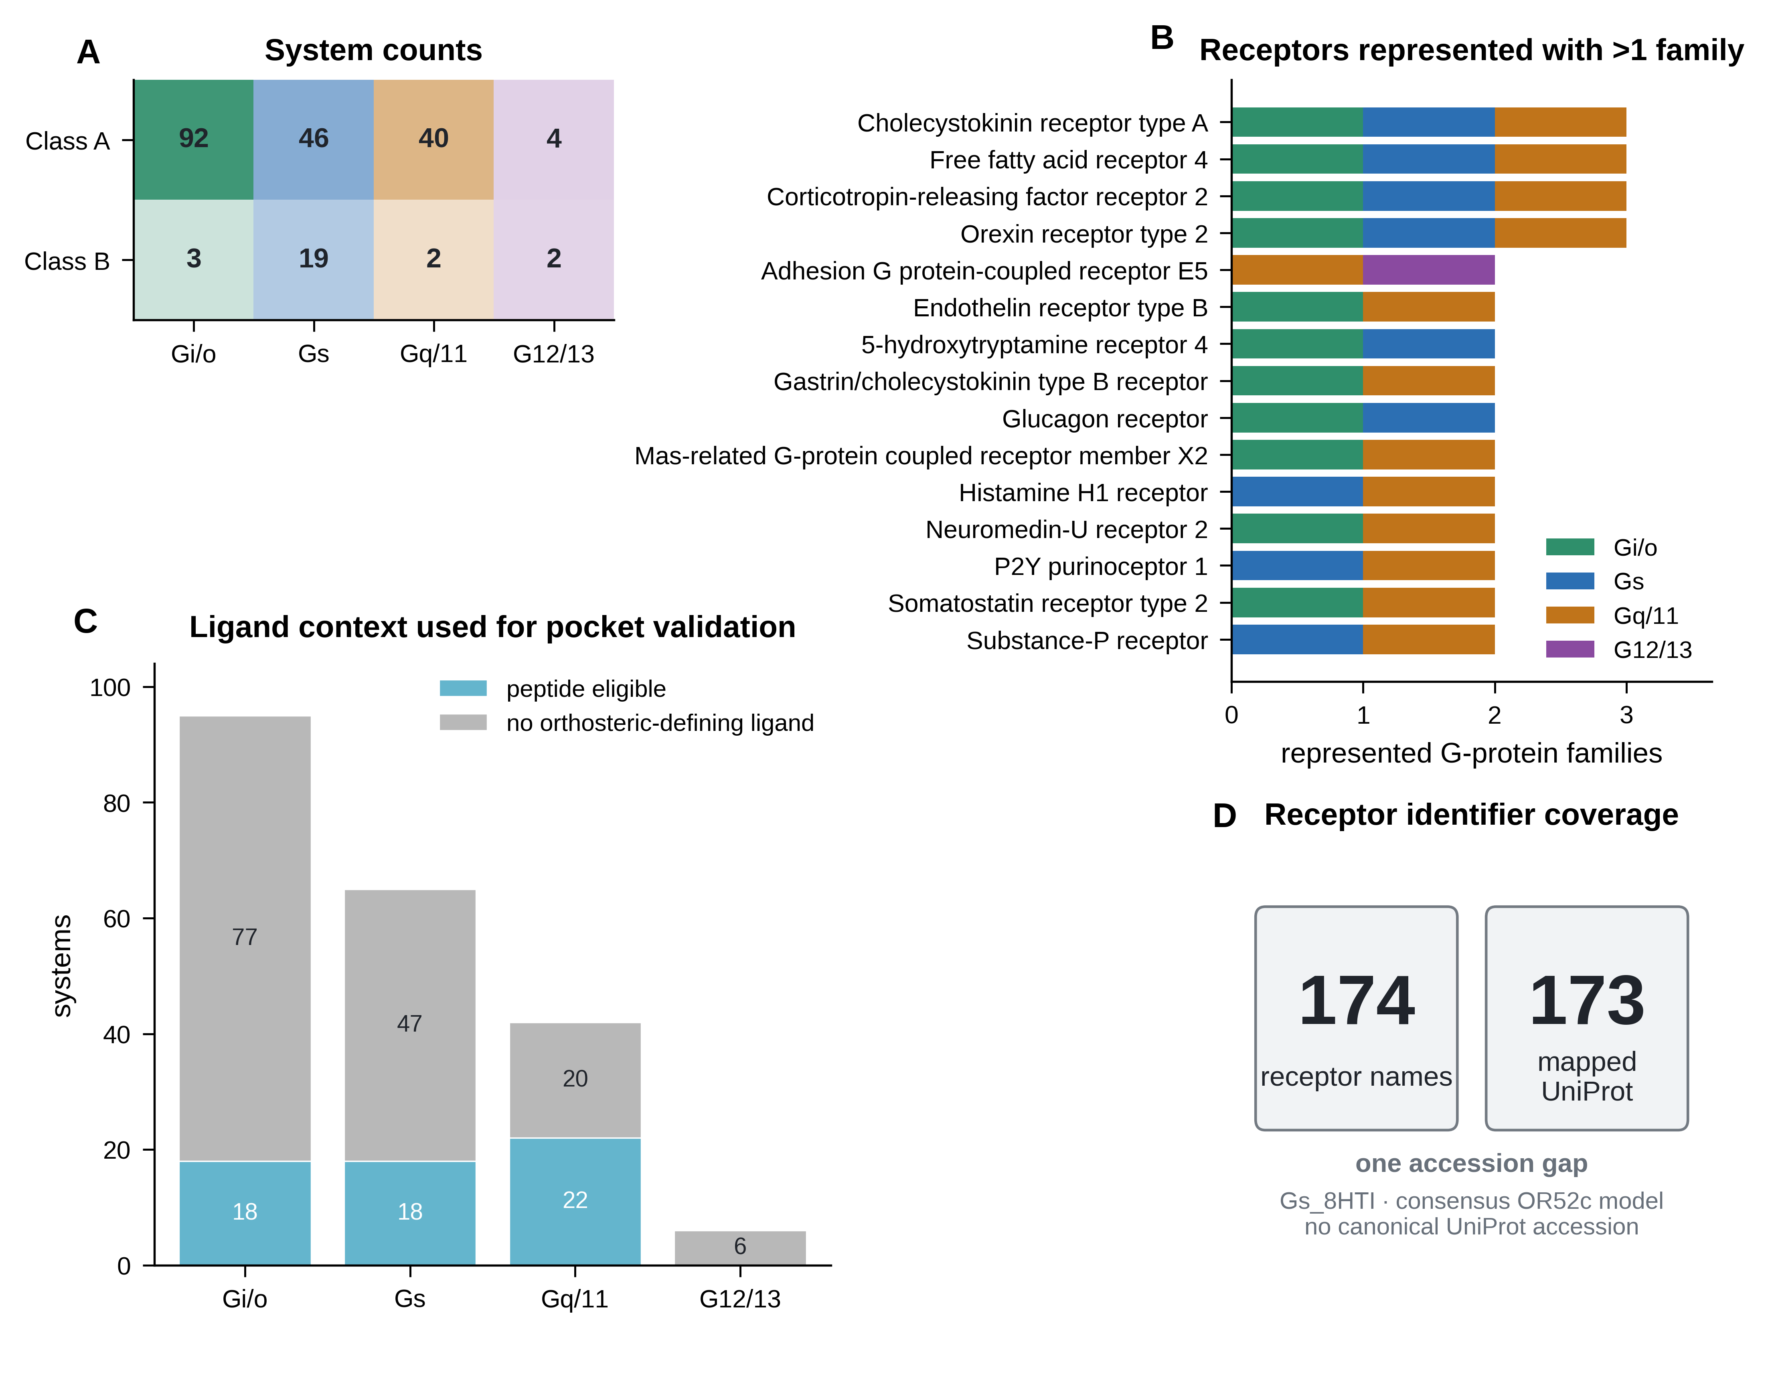
Figure 1 | Composition of the 207-system CoupledMD dataset. (A) System counts by GPCR class and G-protein family. (B) Receptors represented with more than one G-protein family. (C) Family-resolved numbers of peptide-eligible systems and systems lacking an orthosteric-defining ligand. (D) Coverage of receptor identifiers: 174 receptor names and 173 mapped UniProt accessions; Gs_8HTI is the single unmapped consensus receptor model. Family colors are Gi/o, green; Gs, blue; Gq/11, orange; and G12/13, purple.

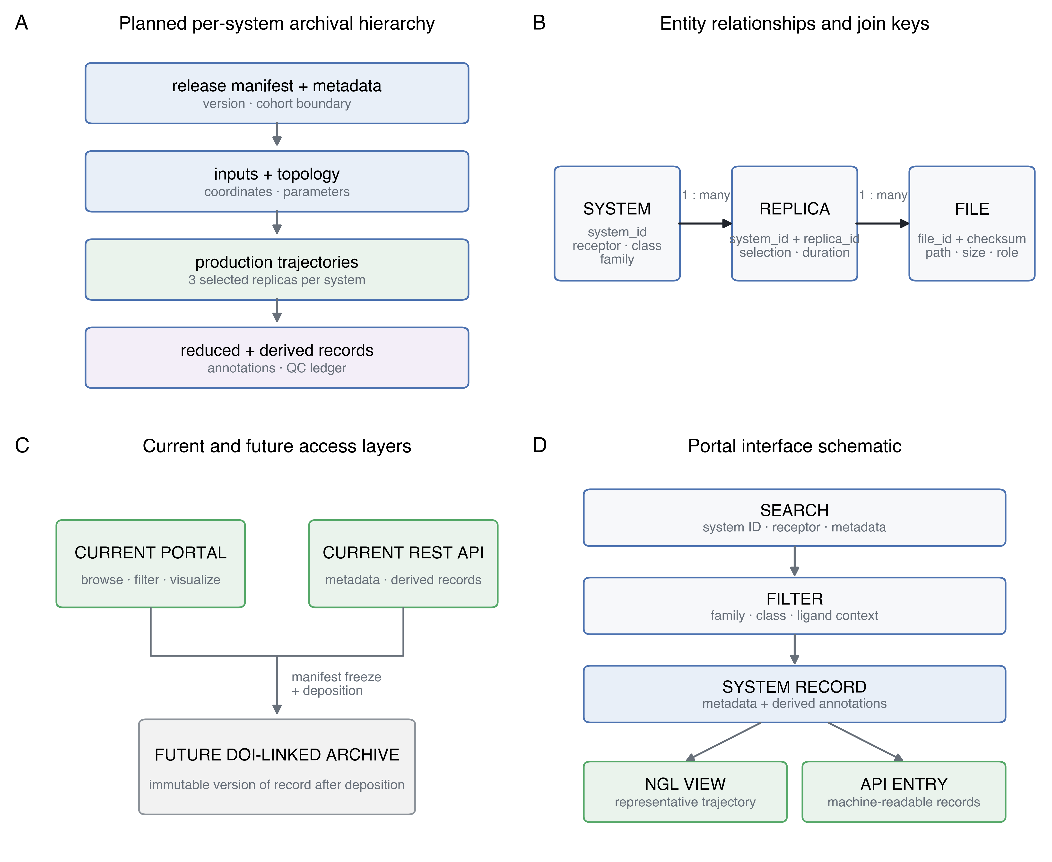
Figure 2 | Data organization and access architecture. (A) Planned hierarchy from the release manifest and input files to production trajectories and derived records. (B) System, replica and file entities linked by stable identifiers. (C) Current portal and REST API access layers and the planned DOI-linked archive following manifest freeze and deposition. (D) Portal workflow from search and filtering to system records, NGL visualization and API access.

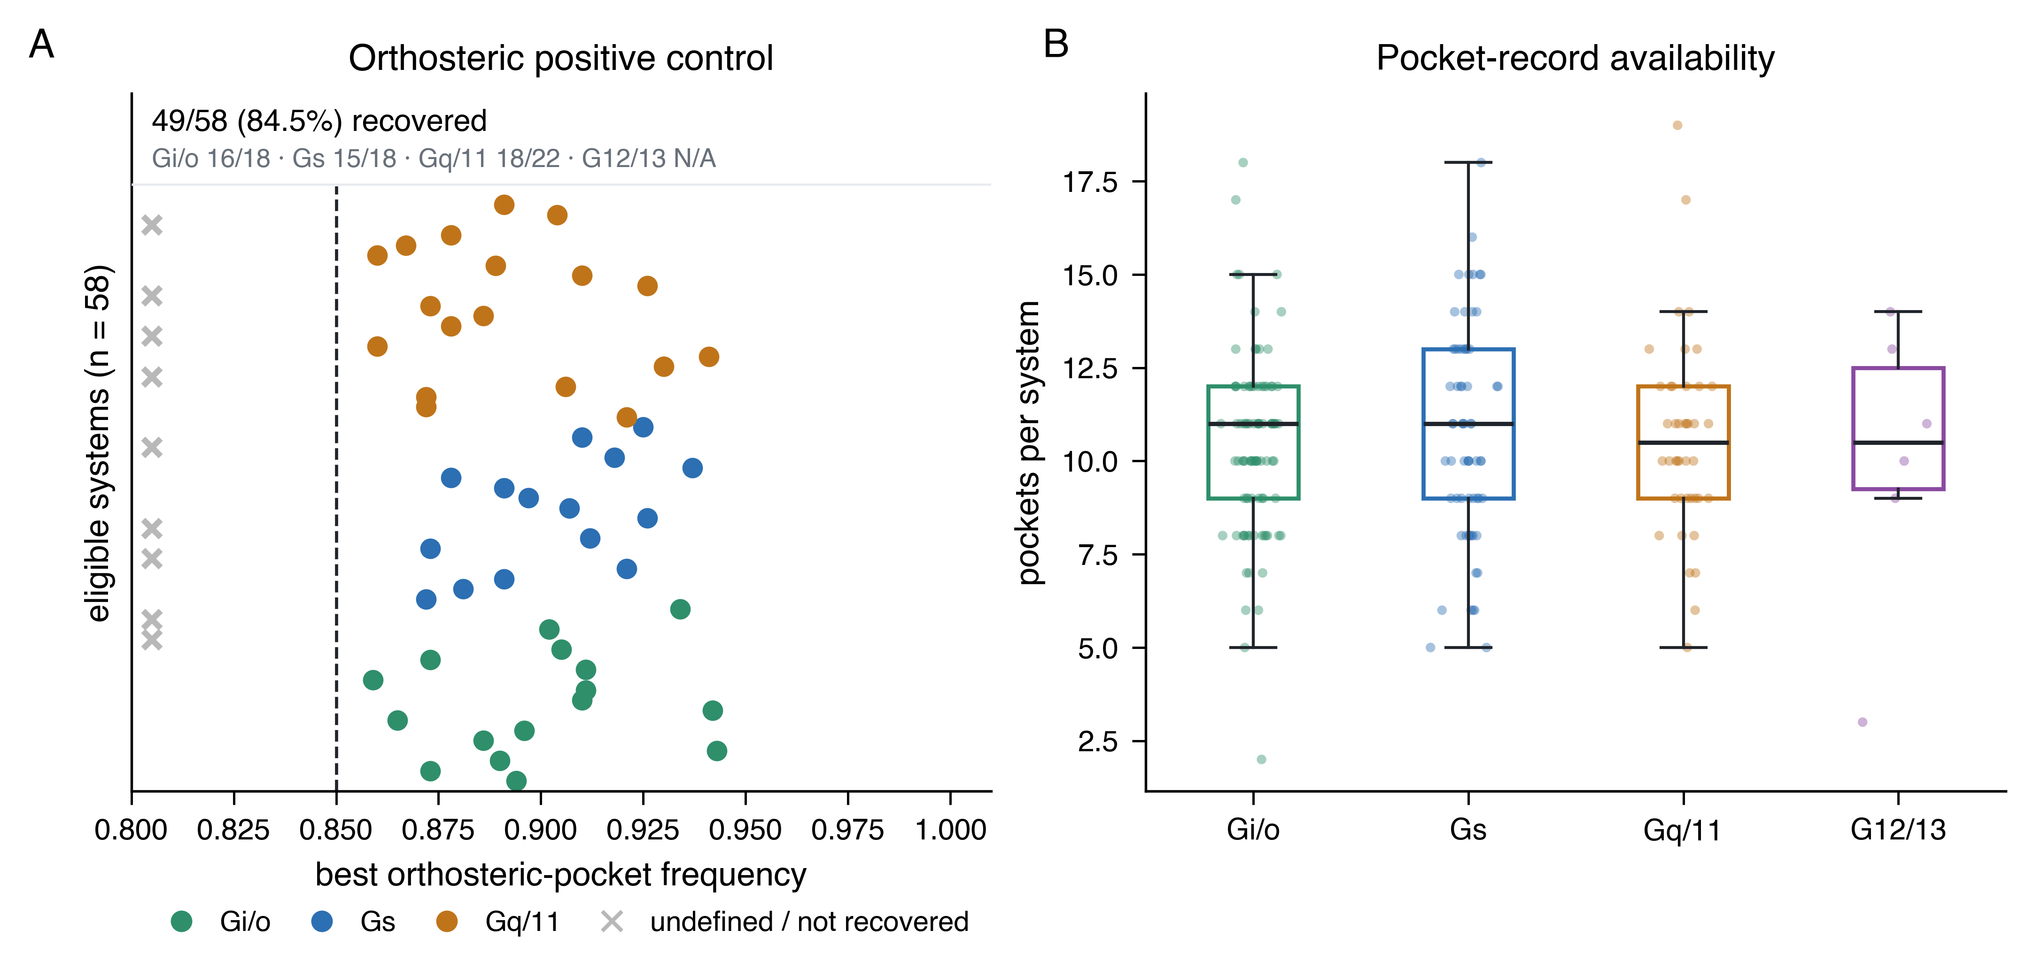
Figure 3 | Validation and availability of pocket records. (A) Best orthosteric-pocket frequency for 58 peptide-eligible systems. The dashed line marks the 0.85 recovery threshold; 49 systems (84.5%) were recovered, while crosses denote undefined or unrecovered records. (B) Detected-pocket counts for the 206 systems containing at least one persistent pocket, resolved by G-protein family; points represent systems and box plots summarize medians and interquartile ranges. Gi_7YK6 and Gi_8YIC are retained in the data as valid zero-pocket records and are not included in the box plots.

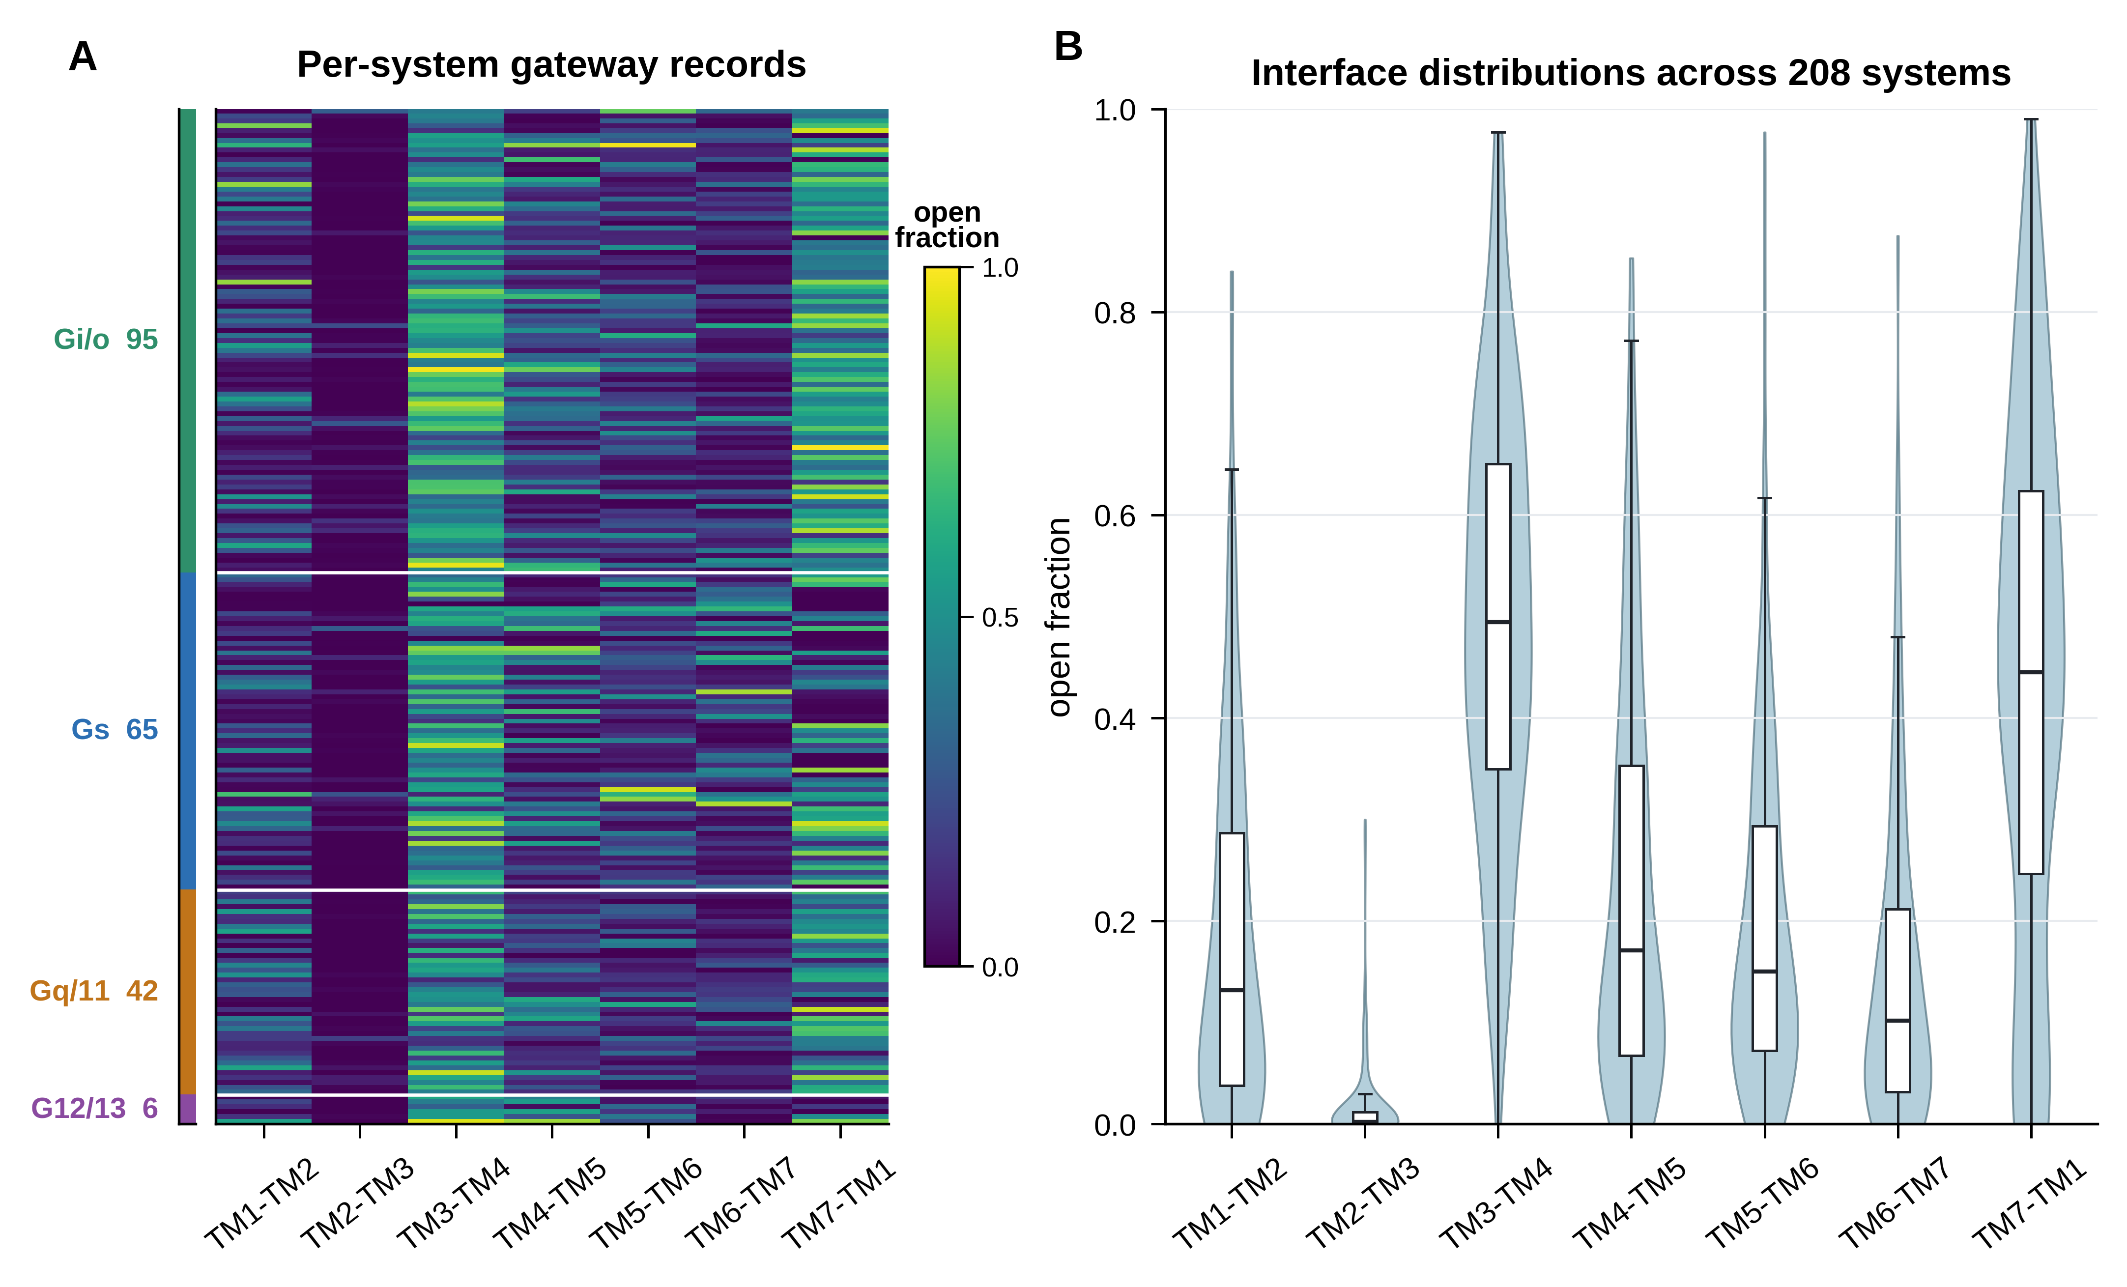
Figure 4 | Transmembrane-gateway opening across the dataset. (A) Open fractions for seven adjacent TM-helix interfaces in 207 systems, ordered by G-protein family. (B) Violin and box-plot summaries of the corresponding interface-specific open-fraction distributions. All 207 systems contain numerical records for all seven interfaces.

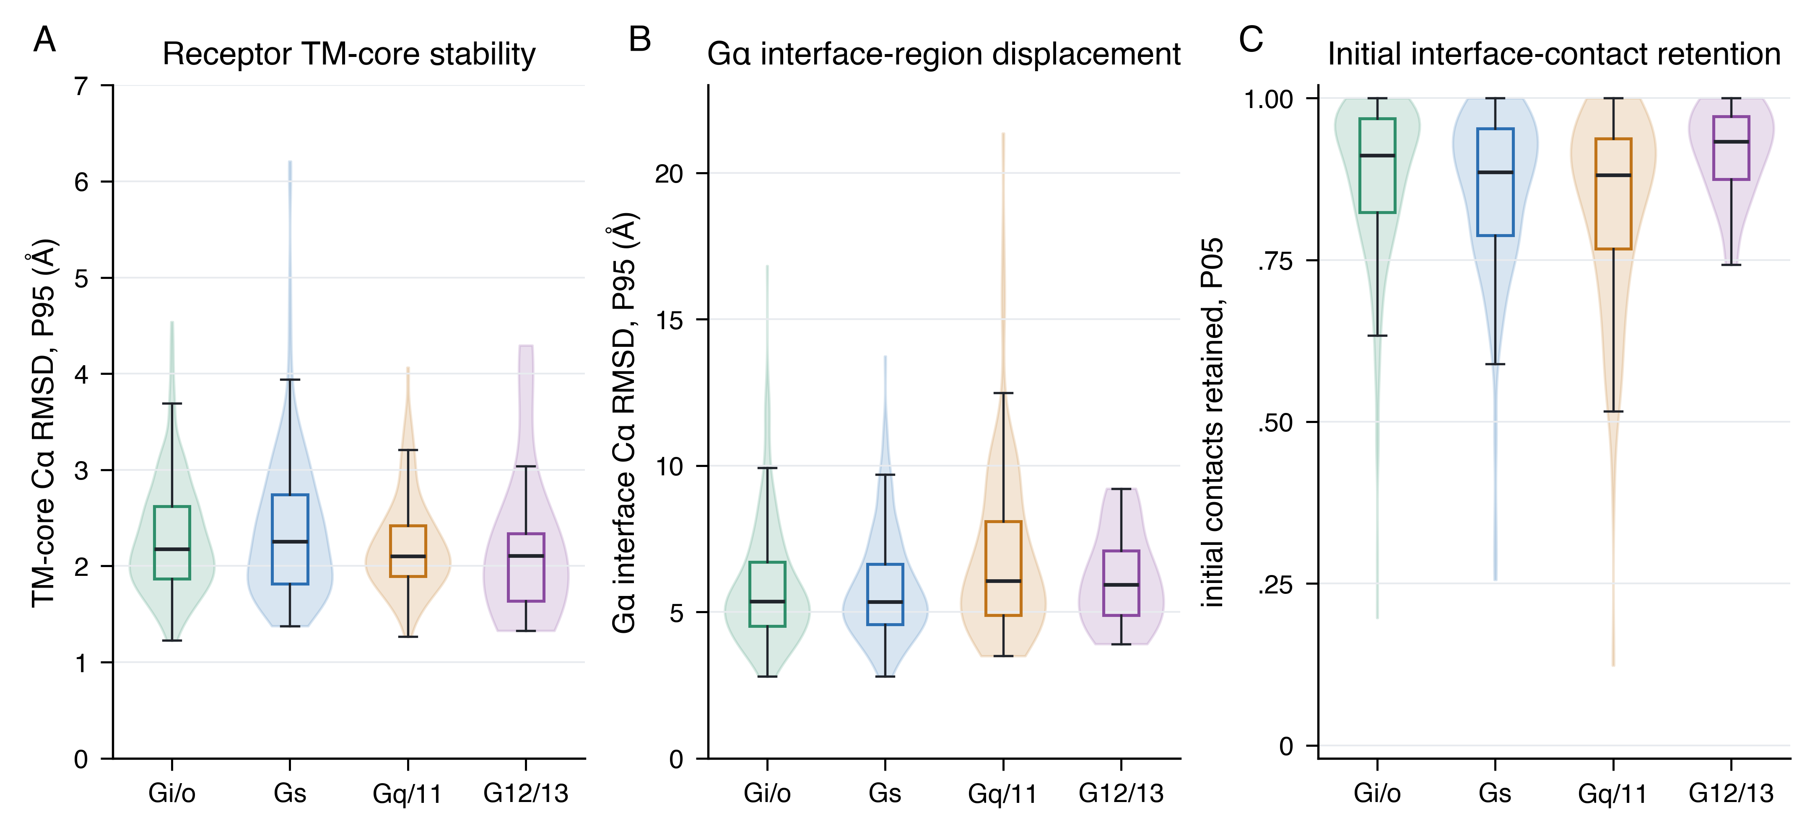
Figure 5 | Structural stability and interface-retention validation. Family-resolved distributions of (A) the 95th-percentile receptor TM-core Cα RMSD, (B) the 95th-percentile Gα interface-region Cα RMSD and (C) the 5th-percentile fraction of initial interface contacts retained. Distributions comprise 618 distinct, available replicas from 206 systems; violins show distributions and box plots show medians and interquartile ranges.

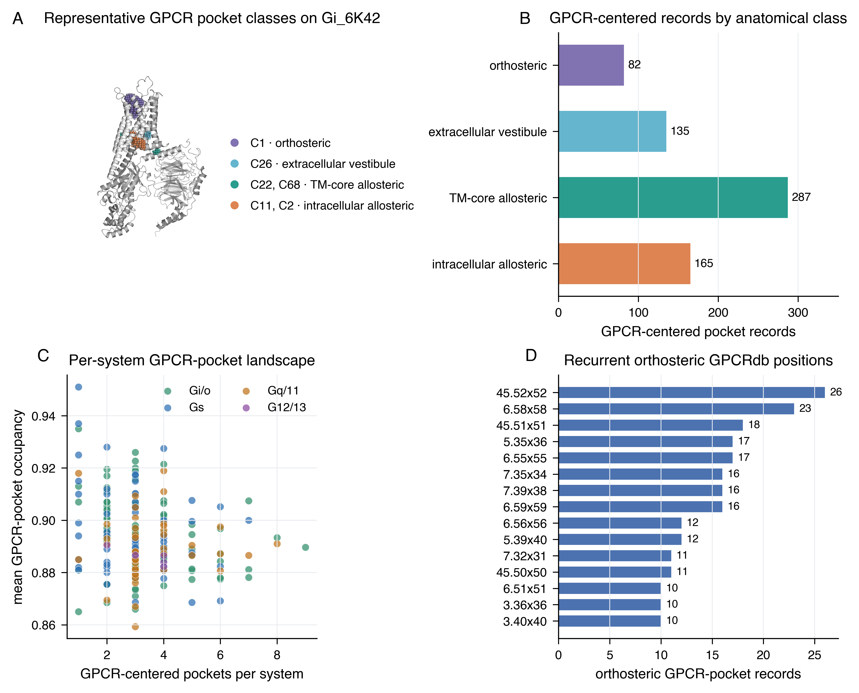
Figure 6 | GPCR-centered pocket reuse atlas. (A) Representative pockets on Gi_6K42, including C1 orthosteric, C26 extracellular-vestibule, C22/C68 TM-core-allosteric and C11/C2 intracellular-allosteric pockets. (B) Numbers of GPCR-centered pocket records in the four anatomical classes. (C) Number and mean occupancy of GPCR-centered pockets across the 201 systems containing such records. (D) Fifteen most recurrent GPCRdb generic positions among orthosteric pocket records.

Derived annotation and validation records
The current API contains a schema-valid pocket record for every included system: 206 records contain at least one persistent pocket and two explicitly report zero detected pockets. Figure 3 validates the pocket layer against the peptide-defined orthosteric positive control and summarizes detected-pocket counts without treating ligand-free or zero-pocket systems as technical failures.
Gateway records are complete for all 207 systems and contain four metrics for each of seven adjacent helix pairs: penetration, penetration_p90, open_fraction and occupancy, with replica values and confidence intervals. Figure 4 displays open_fraction, whereas Supplementary Figure S2 defines the complete record and its aggregation.
The harmonized receptor-core/interface audit contains 621 replica rows. Figure 5 uses 618 distinct, quantitatively available replicas from 206 systems; the three Gs_8HTI replicas lack the canonical receptor mapping required for this calculation.
Figure 6 summarizes 669 GPCR-centered pocket records from 201 systems. Panels B-D focus on orthosteric, extracellular-vestibule, TM-core-allosteric and intracellular-allosteric pockets; coupling-interface, other and receptor-unresolved records are excluded from those panels to avoid conflating GPCR-centered reuse with noisier G-protein-surface annotations.
Repository organization and molecular formats
The planned archive follows a predictable per-system hierarchy (Table 2; Fig. 2A). Every molecular trajectory will have exactly one declared matching topology, and every file will be resolved through the frozen manifest rather than a live filesystem path. Current API and server-record coverage is reported in Supplementary Data S9; Supplementary Figure S2 instead defines how transmembrane-gateway records are constructed and aggregated.
Table 2. Planned archive hierarchy and current coupledMD access-layer status.
Path | Contents | Principal format
manifest/ | Release metadata, one-row-per-file SHA-256 manifest, version record | TSV, JSON
metadata/systems.csv | System-level metadata for the 207 included systems | CSV
metadata/unresolved_systems.csv | 13 unresolved systems with current evidence | CSV (planned archive)
systems/<id>/inputs/ | Starting coordinates, topology, parameter and engine input files | PDB, PRMTOP/PARM7, TPR, MDIN, MDP
systems/<id>/replicas/rep{1,2,3}/ | Production trajectories and per-replica QC | NetCDF or TRR; JSON/TSV
systems/<id>/reduced/ | Reduced reference and visualization trajectory | PDB, XTC
systems/<id>/annotations/ | Pocket, gateway, GPCRdb-mapping and chain-role records | JSON, NPZ, CSV
systems/<id>/qc/ | Per-system QC summaries | JSON, TSV
code/ | Processing, validation and figure scripts with environment files | Python, YAML
web_api_snapshot/ | OpenAPI schema and final-cohort response fixtures | JSON, YAML

Metadata schema
System-, replica- and file-level metadata are separated conceptually and joined by stable identifiers (Fig. 2B). The current system inventory records release identifiers, receptor and transducer classification, ligand context where available, replica design, force-field/workflow labels, membrane composition, structural provenance and source-file availability. Replica ledgers use system_id plus replica_id; the frozen archive manifest will add one row per physical file with repository-relative paths, byte counts and SHA-256 checksums. Null values are empty strings in CSV and null in JSON; numerical zero is never used as a missing-value surrogate. Supplementary Data S3 defines the fields actually distributed in the supplementary tables, including entity level, type, unit, requiredness, nullability, vocabulary, provenance authority and schema version.
FAIR implementation
CoupledMD implements FAIR principles²² in stages (Fig. 2C,D). Findable: stable PDB, UniProt, GPCRdb and release identifiers support discovery through the current portal and API; a persistent DOI will be assigned on deposition. Accessible: metadata, derived records and reduced visualization assets are currently exposed by open web routes, while the primary trajectory archive remains pending. Interoperable: molecular files use standard formats and the API follows OpenAPI 3.0 with controlled vocabularies. Reusable: explicit cohort boundaries, workflow provenance, machine-readable annotations and versioned code support current reuse; file-level checksums and frozen per-replica archival QC will accompany the DOI-linked release.

Technical Validation
Validation proceeds from the release boundary inward: cohort and identifier integrity, pocket positive-control recovery, gateway-record completeness, harmonized receptor-core and Gα-interface metrics, source-trajectory readiness evidence, and reduced-visualization audit. Current machine-readable CoupledMD tables are versioned to the final cohort; the archival manifest/QC package remains pending its freeze and deposition.
Cohort integrity and identifier verification
The CoupledMD boundary was enforced against the 222-record working inventory. All 207 included systems have three selected 500-ns replicas and final-cohort membership (Fig. 1A,D). Thirteen systems remain unresolved: eight have PBC/trajectory-continuity evidence, four component-continuity evidence and one incomplete-trajectory evidence. Gq_7E9W and Gq_7DWC are separately excluded: Gq_7E9W as a non-GPCR duplicate/mislabel and Gq_7DWC as a duplicate source identity of Gq_8DWC. A programmatic audit confirms 207 unique release IDs, 621 selected replicas, 310,500 ns aggregate sampling and no unresolved or excluded identifier in the final API cohort; record-level evidence is provided in Supplementary Data S2.
Identifier verification confirmed that each included PDB code resolves to the intended GPCR–G-protein complex and that chain-role assignments are consistent with GPCRdb structural records. Gs_8HTI is a consensus OR52c model without a canonical UniProt accession and is retained with an explicit null mapping. Gq_7E9W is not retained: it is documented as a non-GPCR duplicate/mislabel of Gq_8E9W. This transparent treatment avoids silently dropping unmapped systems while preventing an invalid identifier from entering the release.
Pocket-annotation validation
The pocket layer was validated using orthosteric-site recovery as a positive control. All 207 systems have a pocket-analysis record; 205 contain at least one detected pocket and Gi_7YK6 and Gi_8YIC are explicit zero-pocket results. The positive-control denominator is the 58 peptide-ligand systems: 49/58 (84.5%) recover an orthosteric cluster at the 0.85 grid-frequency threshold (Fig. 3A). Family-resolved recovery is 16/18 Gi/o, 15/18 Gs and 18/22 Gq/11; G12/13 has no eligible peptide-defined system and is not applicable. The remaining 150 systems lack the defining positive-control ligand and are not counted as failures. These results validate a derived structural annotation, not druggability or binding mechanism.

Gateway-record completeness
For every final system, the seven expected adjacent TM interfaces are present with one numerical value for each of four metrics, three contributing replica summaries and bounded confidence intervals. The open_fraction values lie between 0 and 1 and are complete across the 207 × 7 system-interface matrix shown in Figure 4. Identity keys are fixed by helix pair; missing records, if introduced in a future version, must be encoded as null with a reason rather than as zero.
Harmonized structural and interface validation
The structural-validation audit contains one row for each of 621 selected replicas and uses exactly 1,001 evenly spaced observations for every quantitative record. After excluding the three explicit Gs_8HTI nulls, all 618 plotted records contain finite TM-core RMSD, Gα-interface RMSD and contact-retention summaries (Fig. 5). The distributions therefore report validation coverage and variability without silently converting unavailable or duplicate records into numerical observations.
The selected source trajectories were additionally assessed through a seven-tier readiness framework. The current release tables provide selection status and evidence pointers; the frozen archive will add the corresponding per-file checksums and detailed per-replica archival QC records:
1. Source-file presence, non-zero size and readability; SHA-256 agreement will be evaluated against the frozen archive manifest at deposition;
2. Exact expected duration (500 ns), correct frame count and monotonic timestamps;
3. Finite coordinates throughout and valid periodic unit-cell vectors on every frame;
4. Atom-count and atom-order agreement between each trajectory and its declared topology;
5. Periodic-boundary continuity, with detection of catastrophic chain or complex separation;
6. Structural-integrity review of receptor TM-core displacement, Gα-interface displacement and initial-contact retention, summarized in Figure 5;
7. Thermodynamic-control indicators (temperature and box-volume stability) where these quantities are stored.
Reduced-trajectory audit
The reduced visualization tier was audited independently because it is a lossy derivative intended only for inspection. For all 207 systems, 40 sampled frames per record were checked for topology-trajectory atom-count agreement, blank PDB element fields, box consistency, intra-chain backbone breaks, inter-chain splitting and coordinate scatter. The audit returned 205 systems classified PBC OK and three WARN for minor coordinate scatter only, with seven scatter frames in total and no atom-count, blank-element, box-mismatch or chain-break failures. Frame counts are 2,500 for 205 systems, 2,501 for two systems and 200 for Gs_3SN6. This audit validates sampled reduced frames only and does not validate unsampled reduced frames or replace production-trajectory QC.

Usage Notes
Access tiers
CoupledMD supports three access levels. The current portal and API provide metadata, derived pocket and gateway records, and reduced trajectories for discovery, method prototyping and visual inspection. Reduced trajectories must not be used for quantitative solvent, lipid, ion or fast-kinetics analyses. Quantitative production-trajectory reuse requires the matched topology, the primary trajectory and checksum verification from the DOI-linked archive once deposition is complete.
Example workflows
System selection and download:
# List Gi/o-coupled Class A systems
curl https://www.coupledmd.cn/api/v1/systems?family=Gi&class=A&limit=20
# Retrieve metadata and pocket annotations for a specific system
curl https://www.coupledmd.cn/api/v1/systems/Gi_7F1Q
curl https://www.coupledmd.cn/api/v1/systems/Gi_7F1Q/pockets

Post-deposition production-trajectory pattern:
import MDAnalysis as mda
import hashlib
# Verify the file against its manifest checksum before use
with open("Gi_7F1Q_rep1.nc", "rb") as fh:
assert hashlib.sha256(fh.read()).hexdigest() == expected_sha256
u = mda.Universe("Gi_7F1Q.prmtop", "Gi_7F1Q_rep1.nc")
receptor = u.select_atoms("protein and segid PROA")
The production-trajectory and checksum example is a post-deposition workflow. The current portal and API support the preceding metadata and annotation queries; executable download examples will be released with the frozen archive manifest.
Figure 6 illustrates reuse of the GPCR-centered pocket layer. The representative Gi_6K42 structure links original pocket codes to four anatomical classes, while the cohort panels summarize class counts, per-system pocket number and occupancy, and recurrent orthosteric GPCRdb positions. Coupling-interface, other and receptor-unresolved records are retained in the underlying data but excluded from the main atlas panels so that GPCR-centered comparisons are not dominated by noisier G-protein-surface annotations.

Reuse guidance
Split machine-learning datasets by receptor accession or higher-level receptor grouping, never by replica, to prevent leakage between correlated trajectories.
Treat workflow/protocol group, GPCR class, ligand context, construct type and source PDB as potential batch variables when comparing across G-protein families.
The six G12/13 systems do not support precise family-wide statistical inference and should be used qualitatively.
Pocket and gateway records are derived computational annotations that require task-specific validation before biological interpretation; occupancy is a lipid-atom count, not a distance.
Cite both the Scientific Data article and the exact dataset DOI and version used.

Limitations
CoupledMD is restricted to active-state GPCR–G-protein complexes present in the structural record and is therefore not representative of physiological coupling frequencies; inactive receptors, arrestin complexes and nucleotide-free states are out of scope. Starting structures include engineered constructs, and related receptors or structures are not statistically independent. The uniform POPC membrane does not reproduce native lipid diversity, and a 500-ns trajectory may not sample transitions on microsecond or longer timescales. The three protocol groups share a force-field family and membrane composition but differ in thermostat and barostat algorithms and should be treated as batch variables. MD trajectories and derived annotations are computational model outputs, not experimental observations.

Data Availability
The CoupledMD web portal is available at https://www.coupledmd.cn and API documentation at https://www.coupledmd.cn/api/docs. The current public access layer exposes the final 207-system metadata and derived records, including one reduced representative PDB/XTC visualization pair per included system. Complete primary trajectories, matched topologies, inputs, checksums and the frozen file manifest are being prepared for DOI-linked archival deposition. Until that deposition, this manuscript makes no claim of archive completeness, DOI availability, direct raw-trajectory download or public release of all 621 primary trajectories.

Code Availability
Processing, validation and figure-generation code will be released at [CODE REPOSITORY URL] under the MIT licence (release tag: [TAG]; commit: [HASH]). The versioned release will include the scripts used to build the final cohort tables, pocket and gateway annotations, harmonized structural validation, figures and Supplementary Data package, together with the recorded build environment. No code DOI or immutable commit is claimed until those placeholders are replaced.

Author Contributions
J.H. and S.L. conceived the dataset. J.H. curated the system inventory, performed the molecular dynamics simulations, developed the processing and annotation workflows, implemented the web portal and REST API, performed the technical validation, and generated the figures and tables. X.Q. contributed to data curation and validation. J.H. and S.L. wrote the manuscript. All authors reviewed and approved the final version.

Competing Interests
The authors declare no competing interests.

Acknowledgements
The authors acknowledge computational resources provided by Shanghai Jiao Tong University.

Funding
This work was supported by the Noncommunicable Chronic Diseases–National Science and Technology Major Project (2024ZD0531200) and the Innovative Research Team of High-Level Local Universities in Shanghai.

References
1. Hauser, A. S. et al. Pharmacogenomics of GPCR drug targets. Cell 172, 41–54.e19 (2018). https://doi.org/10.1016/j.cell.2017.11.033
2. Weis, W. I. & Kobilka, B. K. The molecular basis of G protein-coupled receptor activation. Annu. Rev. Biochem. 87, 897–919 (2018). https://doi.org/10.1146/annurev-biochem-060614-033910
3. Kooistra, A. J. et al. GPCRdb in 2021: integrating GPCR sequence, structure and function. Nucleic Acids Res. 49, D335–D343 (2021). https://doi.org/10.1093/nar/gkaa1080
4. Isberg, V. et al. Generic GPCR residue numbers—aligning topology maps while minding the gaps. Trends Pharmacol. Sci. 36, 22–31 (2015). https://doi.org/10.1016/j.tips.2014.11.001
5. Rodríguez-Espigares, I. et al. GPCRmd uncovers the dynamics of the 3D-GPCRome. Nat. Methods 17, 777–787 (2020). https://doi.org/10.1038/s41592-020-0884-y
6. Mirarchi, A., Giorgino, T. & De Fabritiis, G. mdCATH: a large-scale MD dataset for data-driven computational biophysics. Sci. Data 11, 1299 (2024). https://doi.org/10.1038/s41597-024-04140-z
7. Berman, H. M. et al. The Protein Data Bank. Nucleic Acids Res. 28, 235–242 (2000). https://doi.org/10.1093/nar/28.1.235
8. UniProt Consortium. UniProt: the Universal Protein Knowledgebase in 2025. Nucleic Acids Res. 53, D609–D617 (2025). https://doi.org/10.1093/nar/gkae1010
9. Pándy-Szekeres, G. et al. GproteinDb in 2024: new G protein–GPCR couplings, AlphaFold2-multimer models and interface interactions. Nucleic Acids Res. 52, D466–D475 (2024). https://doi.org/10.1093/nar/gkad1089
10. Jo, S., Kim, T., Iyer, V. G. & Im, W. CHARMM-GUI: a web-based graphical user interface for CHARMM. J. Comput. Chem. 29, 1859–1865 (2008). https://doi.org/10.1002/jcc.20945
11. Lee, J. et al. CHARMM-GUI Membrane Builder for complex biological membrane simulations with glycolipids and lipoglycans. J. Chem. Theory Comput. 15, 775–786 (2019). https://doi.org/10.1021/acs.jctc.8b01066
12. Vanommeslaeghe, K. et al. CHARMM General Force Field: a force field for drug-like molecules compatible with the CHARMM all-atom additive biological force fields. J. Comput. Chem. 31, 671–690 (2010). https://doi.org/10.1002/jcc.21367
13. Nosé, S. A unified formulation of the constant temperature molecular dynamics methods. J. Chem. Phys. 81, 511–519 (1984). https://doi.org/10.1063/1.447334
14. Parrinello, M. & Rahman, A. Polymorphic transitions in single crystals: a new molecular dynamics method. J. Appl. Phys. 52, 7182–7190 (1981). https://doi.org/10.1063/1.328693
15. Huang, J. et al. CHARMM36m: an improved force field for folded and intrinsically disordered proteins. Nat. Methods 14, 71–73 (2017). https://doi.org/10.1038/nmeth.4067
16. Darden, T., York, D. & Pedersen, L. Particle mesh Ewald: an N·log(N) method for Ewald sums in large systems. J. Chem. Phys. 98, 10089–10092 (1993). https://doi.org/10.1063/1.464397
17. Ryckaert, J.-P., Ciccotti, G. & Berendsen, H. J. C. Numerical integration of the Cartesian equations of motion of a system with constraints: molecular dynamics of n-alkanes. J. Comput. Phys. 23, 327–341 (1977). https://doi.org/10.1016/0021-9991(77)90098-5
18. Hess, B. et al. LINCS: a linear constraint solver for molecular simulations. J. Comput. Chem. 18, 1463–1472 (1997). https://doi.org/10.1002/(SICI)1096-987X(199709)18:12%3C1463::AID-JCC4%3E3.0.CO;2-H
19. Le Guilloux, V., Schmidtke, P. & Tuffery, P. Fpocket: an open source platform for ligand pocket detection. BMC Bioinformatics 10, 168 (2009). https://doi.org/10.1186/1471-2105-10-168
20. Pándy-Szekeres, G. et al. GPCRdb in 2024: integrating GPCR sequence, structure and function. Nucleic Acids Res. 52, D148–D157 (2024). https://doi.org/10.1093/nar/gkad1011
21. Rose, A. S. et al. NGL viewer: web-based molecular graphics for large complexes. Bioinformatics 34, 3755–3758 (2018). https://doi.org/10.1093/bioinformatics/bty419
22. Wilkinson, M. D. et al. The FAIR Guiding Principles for scientific data management and stewardship. Sci. Data 3, 160018 (2016). https://doi.org/10.1038/sdata.2016.18
23. Salomon-Ferrer, R. et al. Routine microsecond molecular dynamics simulations with AMBER on GPUs. 2. Explicit solvent particle mesh Ewald. J. Chem. Theory Comput. 9, 3878–3888 (2013). https://doi.org/10.1021/ct400314y
24. Abraham, M. J. et al. GROMACS: high performance molecular simulations through multi-level parallelism from laptops to supercomputers. SoftwareX 1–2, 19–25 (2015). https://doi.org/10.1016/j.softx.2015.06.001
25. Michaud-Agrawal, N. et al. MDAnalysis: a toolkit for the analysis of molecular dynamics simulations. J. Comput. Chem. 32, 2319–2327 (2011). https://doi.org/10.1002/jcc.21787
26. Flock, T. et al. Selectivity determinants of GPCR–G-protein binding. Nature 545, 317–322 (2017). https://doi.org/10.1038/nature22070
27. McGibbon, R. T. et al. MDTraj: a modern open library for the analysis of molecular dynamics trajectories. Biophys. J. 109, 1528–1532 (2015). https://doi.org/10.1016/j.bpj.2015.08.015

