Supplementary Information

Reduced molecular dynamics trajectories of 207 active GPCR–G-protein complexes
Jianxiang Huang^{1,2,3}, Xin Qiao³, Shaoyong Lu^{1,2,3,*}
¹ Artificial Intelligence Clinical Research Center for Drug Discovery, Shanghai Key Laboratory of Flexible Medical Robotics, Institute of Medical Robotics, Tongren Hospital, Shanghai Jiao Tong University School of Medicine, Shanghai 200336, China
² Key Laboratory of Protection, Development and Utilization of Medicinal Resources in Liupanshan Area, Ministry of Education; Peptide & Protein Drug Research Center, School of Pharmacy, Ningxia Medical University, Yinchuan 750004, China
³ Department of Pharmacology, School of Medicine, Shanghai Jiao Tong University, Shanghai 200025, China
*Correspondence: Shaoyong Lu (lushaoyong@sjtu.edu.cn)

Supplementary Note 1. Frozen cohort and the 208-to-207 transition
The authoritative cohort is data/release_cohort_v9_final207.csv. It contains 207 unique system_id values and is used as an allow-list for all v12 tables, figures and API consistency checks. The class counts are 181 Class A and 26 Class B. The family counts are 95 Gi/o, 65 Gs, 41 Gq/11 and 6 G12/13. The cross-tabulation is:
GPCR class | Gi/o | Gs | Gq/11 | G12/13 | Total
Class A | 92 | 46 | 39 | 4 | 181
Class B | 3 | 19 | 2 | 2 | 26
Total | 95 | 65 | 41 | 6 | 207

The 222-record working inventory is partitioned into 207 included, 13 unresolved and two excluded records. The two exclusions are:
- Gq_7E9W: non-GPCR duplicate or mislabel of Gq_8E9W.
- Gq_7DWC: duplicate source identity of Gq_8DWC; both source records were assigned to MRGPRX1 (Q96LB2).
Earlier 208-system files included Gq_7DWC. Its exclusion changes 208 systems to 207, Class A from 182 to 181, Gq/11 from 42 to 41, production repeats from 624 to 621 and nominal sampling from 312.0 to 310.5 µs. Historical files containing final208 or final624 in their names are source-provenance inputs only. Their contents are filtered against the final-207 allow-list, and no active v12 submission artifact uses those labels.
Gs_8HTI is retained as a valid system but has no canonical receptor UniProt accession. It is serialized with an explicit null value, not a fabricated accession.

Supplementary Note 2. Source-protocol evidence
The protocol assignment is regenerated by joining the final cohort to parallel_codex/provenance_direct/protocol_system_evidence.csv. The counts are P1 179, P2 26 and P3 2. There are 205 AMBER-family systems and two GROMACS systems. Source records include production output paths, hashes where available, recovered version strings, output interval, random-seed evidence and a structured settings record.
Evidence is classified as verified for 202 systems and partial for five systems:
System | Protocol | Evidence status | Interpretation
Gi_8EFO | P1 | partial | one or more requested provenance fields were not recovered
Gi_8HK2 | P1 | partial | one or more requested provenance fields were not recovered
Gq_7RAN | P1 | partial | one or more requested provenance fields were not recovered
Gq_7XWO | P1 | partial | one or more requested provenance fields were not recovered
Gq_7XXH | P1 | partial | one or more requested provenance fields were not recovered

The v12 text therefore does not assign one global engine version to the collection. Recovered version strings and their evidence scope are retained per system in Supplementary Data S7. Protocol group, construct provenance and source PDB should be treated as potential batch variables.
The three production replicas are computational repeats. They do not represent biological specimens, independent receptor constructs or independent experimental structures.

Supplementary Note 3. Sampling definitions and Gq_8ZPT replica 2
Three sampling quantities must remain distinct:
- Nominal protocol sampling: 207 × 3 × 500 ns = 310.5 µs.
- Original file-observed coordinate sampling: 310.4168 µs.
- Reduced-release coordinate coverage: the represented time between the first and last of 2,500 frames is 499.8 ns per released record.
The 83.2-ns difference between the first two quantities arises from the original Gq_8ZPT replica 2 coordinate record, which contains 416.8 ns rather than 500 ns. A continuation-derived coordinate source used for reduced-release repair was independently checked over 10,000 frames. It has monotonic timestamps, no non-finite frame, no invalid box frame and a represented span of 499.95 ns. The audit verdict is GOOD.
The repaired source is sufficient for deterministic production of the reduced PDB/XTC record. It is not evidence that a repaired full-system trajectory, topology and preparation input set are deposited. The v12 manuscript reports nominal and original file-observed campaign totals separately.
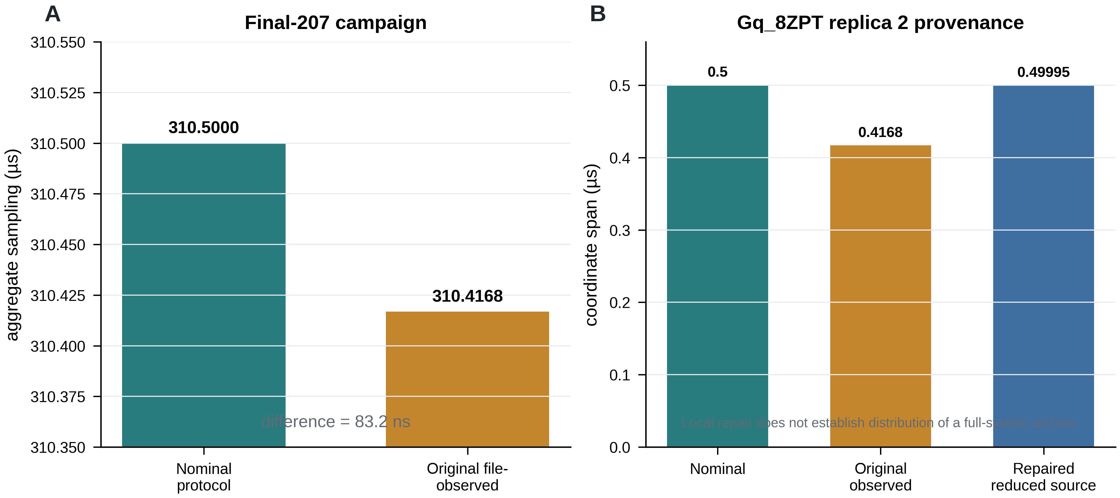
Supplementary Figure S2 | Nominal, original file-observed and repaired reduced-source sampling. (A) The final-207 nominal protocol design is 310.5 µs; original coordinate files contain 310.4168 µs. (B) Gq_8ZPT replica 2 accounts for the difference. The continuation-derived reduced source spans 499.95 ns. This local repair does not establish public distribution of a repaired full-system archive.

Supplementary Note 4. Reduced-record construction
The replica-specific release builder receives a replica number and the frozen 207-system table. Each target system directory contains a copied canonical structure.pdb and a generated traj.xtc. The PDB defines the retained atoms and ordering.
For a source trajectory already matching the PDB, coordinates are written directly. When a full-system or differently ordered source contains additional atoms, target atoms are mapped by (resname, resid, atom name) against a matching source topology. This selection is checked to contain exactly the PDB atom count. The reduction does not infer a ligand-selection rule; users must inspect the released PDB to determine which non-protein components, if any, were retained.
The output schedule is:
Source form | Selection | Output
10,000 or 10,001 frames at ~50 ps | every fourth frame, first 10,000-frame span | 2,500 frames
2,501 frames at ~200 ps | first 2,500 frames | 2,500 frames
canonical 2,500-frame reduced source | preserve | 2,500 frames

All released trajectories use an approximately 200-ps interval and represent 499.8 ns between first and last frame. The reduction excludes membrane lipids, solvent and mobile ions. The underlying full-system trajectories are not included in the reduced release.

Supplementary Note 5. Full-frame reduced-release QC
The JSON audit for each release replica contains one system_qc record per system and an aggregate status. Every frame of each locally complete release is tested for finite coordinates, monotonic finite time and a valid unit cell. The PDB/XTC atom count must match. Reference backbone geometry is used to detect atom-order errors while documented starting-coordinate gaps are excluded from false-positive bond checks. Component geometry is screened for catastrophic chain breaks, coordinate scatter and receptor–G-protein separation.
The release-level assertions are:
Assertion | Required result
Cohort directories | exactly 207
Unresolved or excluded directories | 0
PDB files | 207
XTC files | 207
Frames per XTC | 2,500
Source replica values | one declared replica
Manifest absolute paths | 0
PDB/XTC atom-count mismatches | 0
Non-finite coordinate frames | 0
Non-monotonic time records | 0
Invalid periodic boxes | 0
Catastrophic chain-break systems | 0
Coordinate-scatter systems | 0
Complex-separation systems | 0

At the v12 build time, replicas 1 and 3 satisfy the local manifest and full-frame-QC requirements. Replica 2 remains under parallel generation and is represented as pending, not as a failed or zero-sized record. The three remote records remain private drafts. The v12 release gate must be rerun after replica 2 completes.

Supplementary Note 6. Independent portal-oriented reduced-record audit
The portal-oriented reduced records predate the uniform replica-specific release builder and have a nonuniform frame-count distribution. The exact final-207 audit samples 40 frames per system and checks:
- PDB/XTC atom-count agreement;
- PDB element-field completeness;
- presence and consistency of unit-cell dimensions;
- intra-chain backbone breaks;
- coordinate scatter; and
- inter-chain splitting.
All 207 systems are classified OK. The frame-count distribution is 203 × 2,500, 2 × 2,501, 1 × 681 (Gq_7RAN) and 1 × 200 (Gs_3SN6). These counts describe the older portal-oriented records. They do not describe the three replica-specific reduced releases, for which the target is uniformly 2,500 frames.

Supplementary Note 7. Pocket and gateway records

Pocket records
Supplementary Data S5 has 2,149 detected-pocket rows from 205 systems. Two additional rows explicitly record valid completed analyses with no persistent pocket: Gi_7YK6 and Gi_8YIC. The system denominator is therefore:
205 systems with detected pockets
+ 2 systems with valid zero-pocket results
= 207 system records
The 58-system orthosteric positive-control denominator is defined by the presence of a peptide-based reference and an evaluable pocket analysis. Forty-nine systems recover an orthosteric cluster at the specified 0.85 frequency threshold. Ligand-free systems are not counted as failures. The analysis is a technical check on annotation recovery; pocket recurrence, ranking, biological interpretation and druggability are outside the database paper.

Gateway records and reproducibility boundary
Supplementary Data S6 contains 5,796 rows:
207 systems × 7 adjacent TM interfaces × 4 metrics
The values were calculated from full-system trajectories containing membrane lipids. The reduced release contains no membrane lipids. S6 therefore serves as the processed intermediate needed to reproduce database-paper summaries, but the molecular calculation cannot be rerun from the reduced XTC files. The active API consensus cache has been regenerated from the final-207 intermediate:
Group | n_systems
ALL | 207
Class A | 181
Class B | 26
Gi/o | 95
Gs | 65
Gq/11 | 41
G12/13 | 6

The v12 main figures do not display the family-organized gateway distribution.
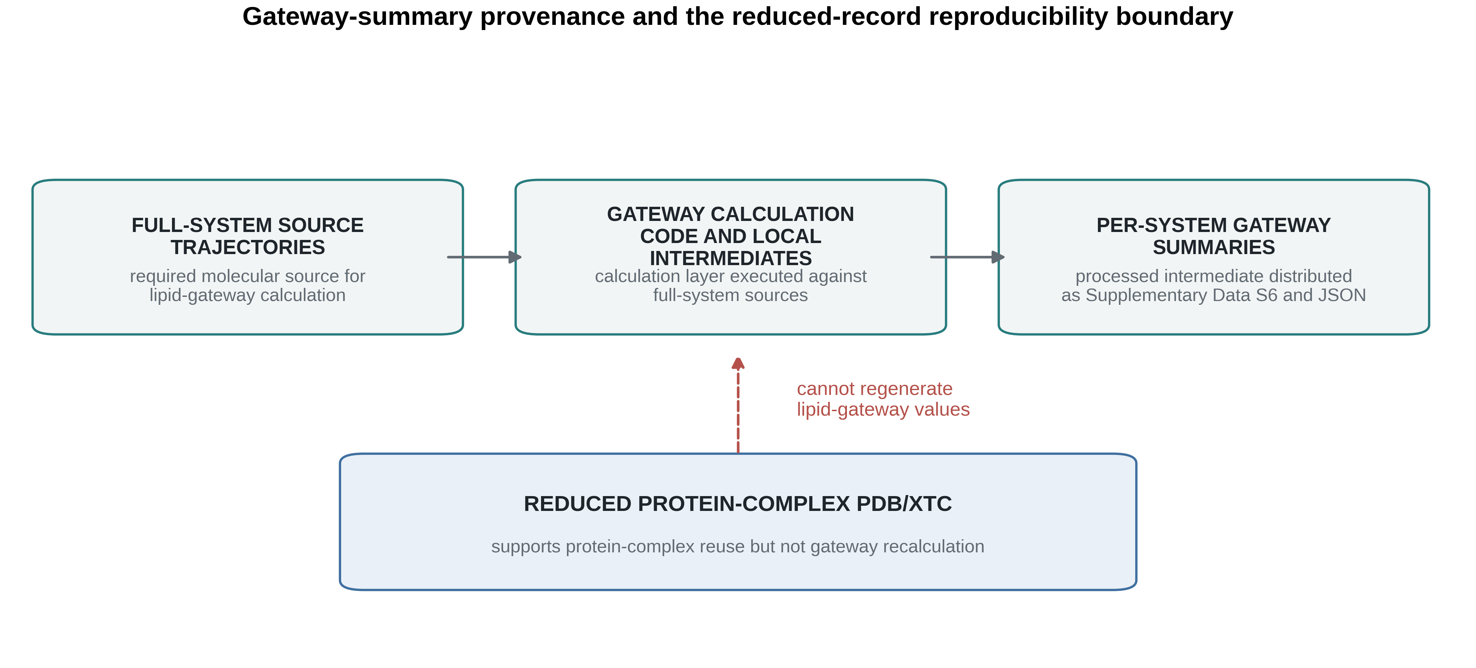
Supplementary Figure S1 | Gateway-summary provenance and reduced-record boundary. Full-system trajectories are required to calculate lipid-gateway records. The calculation code produces per-system processed summaries distributed in Supplementary Data S6 and the API. Reduced PDB/XTC records support protein-complex reuse but cannot regenerate lipid-gateway measurements.

Supplementary Note 8. Worked checksum and loading example
The following complete example reads the replica-1 manifest, locates G12_7SF7, verifies both SHA-256 digests and loads the PDB/XTC pair. The user must first extract the relevant family archive without changing member names.
from pathlib import Path
import hashlib
import pandas as pd
import MDAnalysis as mda
release = Path(".")
manifest = pd.read_csv(
release / "CoupledMD_reduced_trajectory_manifest.csv"
)
row = manifest.loc[
manifest["system_id"].eq("G12_7SF7")
& manifest["source_replica"].eq(1)
].iloc[0]
pdb_path = release / row["pdb_relative_path"]
xtc_path = release / row["xtc_relative_path"]
def sha256(path):
digest = hashlib.sha256()
with path.open("rb") as handle:
for block in iter(lambda: handle.read(8 * 1024 * 1024), b""):
digest.update(block)
return digest.hexdigest()
assert pdb_path.is_file()
assert xtc_path.is_file()
assert sha256(pdb_path) == row["pdb_sha256"]
assert sha256(xtc_path) == row["xtc_sha256"]
universe = mda.Universe(pdb_path, xtc_path)
assert universe.atoms.n_atoms == int(row["n_atoms"])
assert len(universe.trajectory) == int(row["n_frames"]) == 2500
assert float(row["frame_interval_ps"]) == 200.0
assert float(row["represented_span_ns"]) == 499.8
print(
row["system_id"],
universe.atoms.n_atoms,
len(universe.trajectory),
)
The same verification can be performed without Python:
sha256sum path/from/manifest/structure.pdb
sha256sum path/from/manifest/traj.xtc
Both output strings must match the manifest exactly before analysis.

Supplementary Note 9. Reproducible v12 commands
The v12 build is regenerated from the manuscript workspace with:
python audit_v12_release_status.py
python update_v12_gateway_consensus.py
python run_final207_viz_audit.py
python build_v12_data.py
MPLCONFIGDIR=/tmp/mpl-v12 python plot_v12_figures.py
python build_v12_documents.py
python validate_v12_submission.py
run_final207_viz_audit.py is the active wrapper around a historical implementation that predates the 207-system freeze. Its output is final207_reduced_visualization_audit_40frames.csv. The historical implementation filename is not distributed as an active v12 artifact. All generated source-data tables and reports use v12 or final-207 naming.
The frozen environment and file hashes are in Supplementary Data S10 and reports/v12_environment_freeze.json. The build must be rerun after any release-status change because remote-state fields, release manifests, QC tables, Figure 5 and Data Availability are coupled.

Supplementary Table S1. Molecular record specification
Record | Format | Pairing | Molecular scope | Supported use | Explicit limitation
Reduced structure | PDB | reduced XTC | atoms defined by PDB | topology and atom-order reference | not a full-system topology
Reduced trajectory | XTC | reduced PDB | selected protein-complex representation | protein-complex structural reuse | no membrane, solvent, mobile ions or fast kinetics
System metadata | CSV/JSON | system_id | 207 systems | discovery and joins | no coordinates
Replica provenance | CSV | system_id, replica_id | 621 expected repeats | protocol and sampling audit | source molecular files not included
Pocket summary | CSV/JSON | system_id | 207 completed system records | technical annotation reuse | no experimental druggability claim
Gateway summary | CSV/JSON | system_id, interface, metric | processed full-system result | reproduction of reported summaries | cannot be recalculated from reduced XTC
Release QC | CSV/JSON | system and release replica | reduced files | integrity screening | does not validate unavailable full-system files

Supplementary Table S2. Database-versus-resource claim and data overlap
Topic or artifact | Database Data Descriptor | Resource-atlas manuscript | Permitted overlap and disclosure
207-system cohort and 222-record boundary | owns definition, exclusions and identifiers | may cite as analysis cohort | exact metadata may be reused with citation
Simulation construction and protocols | owns provenance and limitations | may summarize only as input provenance | methods overlap must be disclosed
Three computational repeats | owns record definition, sampling truth and QC | may use as analysis inputs | must not call biological replicates
Reduced PDB/XTC release | owns archive, checksums and reuse | may link to data | no full-system claim
Pocket calculation method | owns limited method and positive control | may reuse method | shared processed inputs disclosed
2,149 pockets; 205 detected + 2 zero | owns completeness accounting | may use as atlas input | database paper does not rank or interpret
Orthosteric recovery 49/58 | owns technical positive control | may cite validation | no druggability conclusion
Recurrent pocket clusters and rankings | excluded | owns | no main-text or figure overlap
Sixty-five pocket clusters | excluded | owns | absent from database figures and headlines
C7–Gq enrichment | excluded | owns | absent
Partner-associated pocket changes | excluded | owns | absent
Gateway biological distributions | method/intermediate only; no main figure | owns biological comparison | S6 shared as disclosed input
Gateway biological interpretation | excluded | owns | absent
α5 or family-selectivity analyses | excluded | owns | absent
Mechanistic or druggability conclusions | excluded | owns | absent
Learned models, predictions and BRET | excluded | excluded from resource paper if reserved for AI study | no overlap in this descriptor

Supplementary Table S3. Current release and submission gate
Requirement | Current v12 state | Status
Final cohort is exactly 207 systems | machine verified | PASS
Three expected repeats per system | 621-row design ledger | PASS
Exact final-207 portal-reduced audit | 207/207 OK | PASS
Replica 1 local manifest and full-frame QC | 207/207, passed | PASS
Replica 2 local manifest and full-frame QC | processing in parallel | HOLD
Replica 3 local manifest and full-frame QC | 207/207, passed | PASS
Three authenticated remote records | private, restricted, unsubmitted drafts | HOLD
Three unauthenticated DOI resolutions | not publicly resolvable at audit time | HOLD
Anonymous reviewer access | not machine verified | HOLD
Reduced-release component scope | explicitly documented | PASS
Stable full-system molecular access | absent | BLOCKED for full-system-only claims
Figure source data | generated for all panels | PASS
Gateway processed intermediates | S6 generated | PASS
Gateway recalculation from reduced XTC | impossible by design | BLOCKED if claimed
Paper repository v12 commit/tag | not yet pushed | HOLD

Supplementary Data files
File | Rows expected at v12 build | Description
Supplementary_Data_S1_included_system_inventory.csv | 207 | Frozen included cohort
Supplementary_Data_S2_release_boundary_exceptions.csv | 15 | Thirteen unresolved and two excluded records
Supplementary_Data_S3_metadata_dictionary.csv | variable | Field-level schema
Supplementary_Data_S4_reduced_release_manifest.csv | 1,242 | 207 × 3 × two molecular file roles; pending entries retained
Supplementary_Data_S5_pocket_summaries_gpcrdb.csv | 2,151 | Detected and explicit zero-pocket records
Supplementary_Data_S6_gateway_per_system.csv | 5,796 | Processed gateway intermediates
Supplementary_Data_S7_source_simulation_replica_provenance.csv | 621 | Nominal, observed and repair provenance
Supplementary_Data_S8_reduced_release_qc.csv | 621 | Expected release QC grid
Supplementary_Data_S9_api_access_audit.csv | variable | API coverage and consensus-cache audit
Supplementary_Data_S10_code_environment_inventory.csv | variable | Build files and software versions

Supplementary Data Availability
The three Zenodo identifiers are reserved for replica-specific reduced releases:
- Replica 1: 10.5281/zenodo.21395292
- Replica 2: 10.5281/zenodo.21447748
- Replica 3: 10.5281/zenodo.21448037
At the v12 audit time, all are restricted, unsubmitted private drafts and none resolves publicly without authentication. Replica 2 remains under processing. No DOI, public-release or archive-completeness claim should be copied from this supplement until the remote audit is rerun and all records pass.
The code/web repository is https://github.com/HuangJianxiang-SJTU/coupledmd. The paper and source-data repository is https://github.com/HuangJianxiang-SJTU/coupledmd_database. A v12 commit and release tag remain to be created. The underlying full-system trajectories are not included in the reduced Zenodo records.

