Exercise 1: Linear Algebra

(a) A is not symmetric positive definite, but B is.

(b) maximum: u = 3

(d) Yes

Exercise 2: 2D Transformations as Affine Matrices

(a) denote T1 as 0T1. The required result is as fellowing:

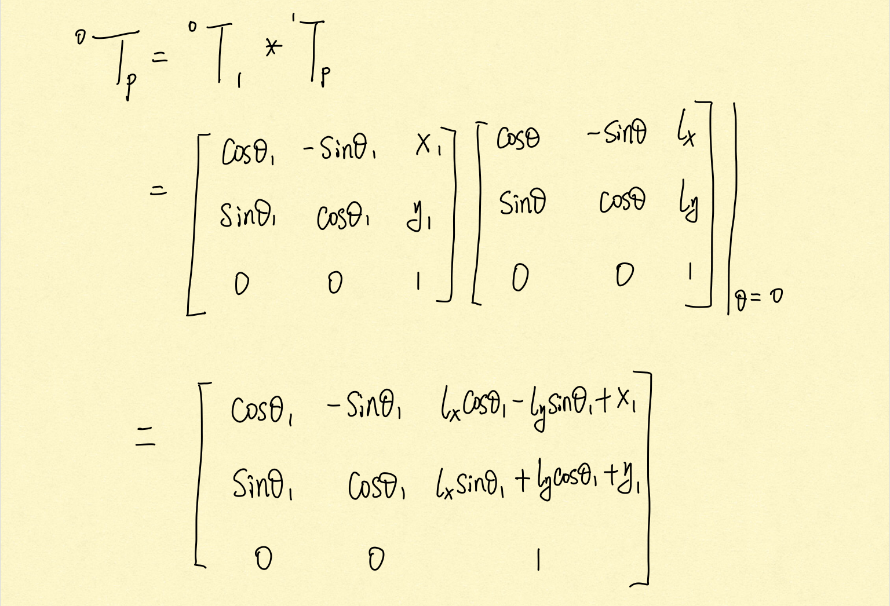(b) 1Tp = (1T0)-1 \* 0TP

(c) T12 = (0T1)-1 \* 0T2

(d) 2TP = (0T2)-1 \* 0TP