作业1【占总成绩的10分】

设子串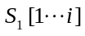和子串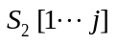之间的加权编辑距离（weighted edit distance）为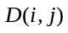，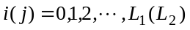。对双序列的全局比对问题，的递推关系为：
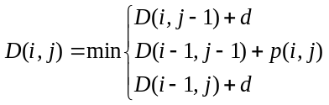
其中，若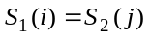（精确匹配），则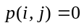；若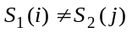（失配），则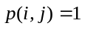；空位罚分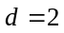；且边界条件定义为: 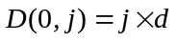，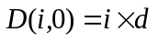。
对附件给出的新冠病毒（SARS-CoV-2）Wuhan-Hu-1.fasta和MD-MDH-0232.fasta，试利用Python或MATLAB对上述全局比对算法进行编程，并相应完成：
- 以文件形式给出具有最短加权编辑距离的最优全局比对结果；
最优全局比对结果: match.out
- 以文件形式给出相应的最优编辑转文（edit transcript）；
最优编辑转文(IDRM): transcript.out
- 试计算加权编辑距离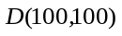、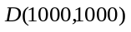和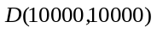，并给出总的最短编辑距离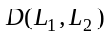。
D(100,100)=16
D(1000,1000)=17
D(10000,10000)=19
总的最短编辑距离=99

Definition 1 (edit transcript): Let I denote the insert operation, D denote the delete operation, R the substitute (or replace) operation, and M the nonoperation of ‘match’. A string over the alphabet {I, D, R, M} that describes a transformation of one string to another is called an edit transcript, or transcript for short, of the two strings. For example, the optimal edit transcript is in format of MIMDRRDDIIM….

Definition 2 (edit distance): The edit distance between two strings is defined as the minimum number of edit operations, i.e., insertions, deletions, and substitutions, that are needed to transform the first string into the second. For emphasis, note that matches are not counted.

Definition 3 (operation-weight edit distance problem): With arbitrary operation weights, the operation-weight edit distance problem is to find an edit transcript that transform string 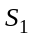 into 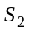with the minimum total operation weight.

