Introduction
This project implements a multifunctional Command-Line Engineering Toolkit designed for students studying Electronic and Electrical Engineering. The application provides a set of essential analysis and calculation tools commonly used in laboratory sessions, coursework exercises, and early-stage circuit design.
The system integrates the following modules:
- Resistor Colour Code Decoder
- RC Circuit Simulator
- Basic Circuit Analyser
- Signal Generator
- Chat Interface with DeepSeek (AI Assistant)
All functions are accessed through an intuitive menu-driven command-line interface, allowing users to perform calculations, explore electrical principles, and generate waveform data quickly and effectively.

Rationale for the Application Design
The features in this toolkit were selected based on the common difficulties and practical needs faced by engineering students:

1. Resistor Colour Code Decoder
Resistor colour coding is one of the first concepts introduced in electronics courses. Students often find it difficult to memorise the mapping between colours, numerical values, multipliers, and tolerances. Providing an automated decoder reduces mistakes and speeds up practical lab work.

2. RC Circuit Simulator
RC circuits are fundamental in filters, transient analysis, timing circuits, and control systems. Simulating capacitor charging and discharging helps students visualise the effect of the time constant ( \tau = RC ) and better understand exponential behaviour in dynamic circuits.

3. Basic Circuit Analyser
Manually calculating total resistance, voltage division, or current sharing becomes time-consuming when multiple components are involved. This module automates series and parallel circuit analysis, enabling students to verify homework or compare theoretical and experimental results.

4. Signal Generator
Understanding waveforms is critical in analogue electronics. The software can generate and display sinusoidal, square, triangle, and sawtooth waveforms, allowing students to study signal behaviour without requiring dedicated laboratory equipment such as function generators or oscilloscopes.

5. AI Chat Interface
The DeepSeek chat module enables users to ask theory-related questions or seek assistance directly within the application. This supports independent study and encourages deeper exploration of electrical engineering concepts.

Technical Background and Underlying Theory

1. Resistor Colour Coding Theory
Resistor bands encode numerical values, multipliers, and tolerance according to a standardised colour scheme: 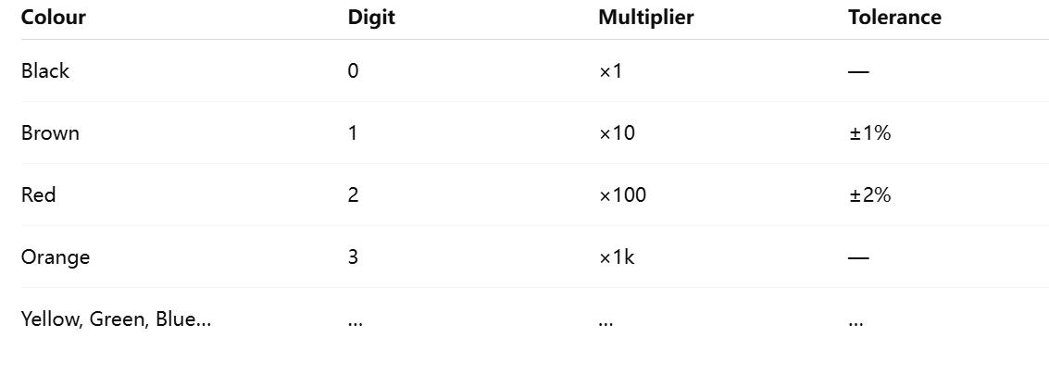

Four-band structure
| Digit 1 | Digit 2 | Multiplier | Tolerance |

Five-band structure
| Digit 1 | Digit 2 | Digit 3 | Multiplier | Tolerance |
Automatic unit conversion (Ω, kΩ, MΩ) is also included in the software.

2. RC Circuit Theory
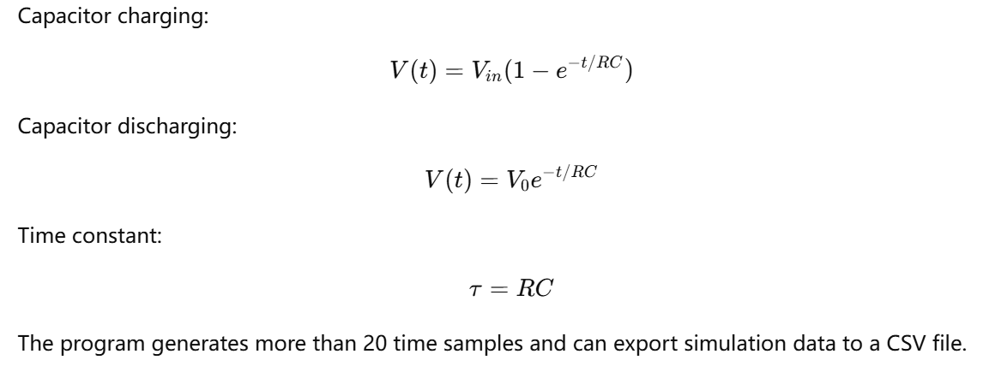

3. Basic Circuit Analysis
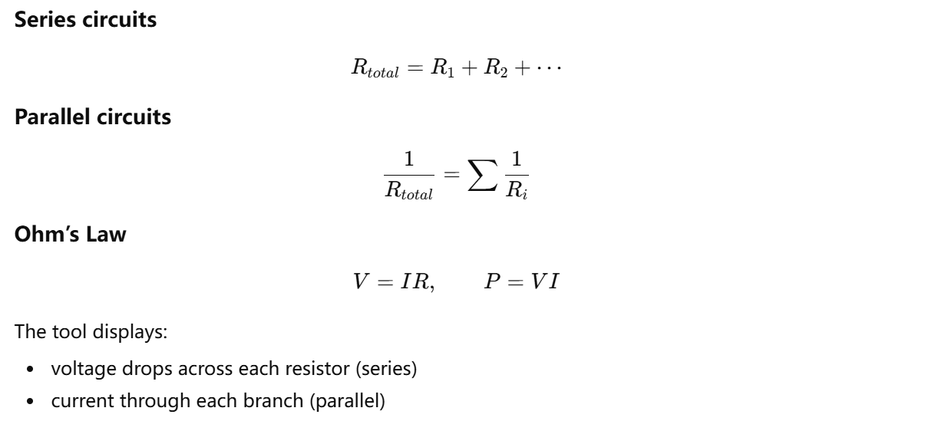

4. Signal Generator Theory
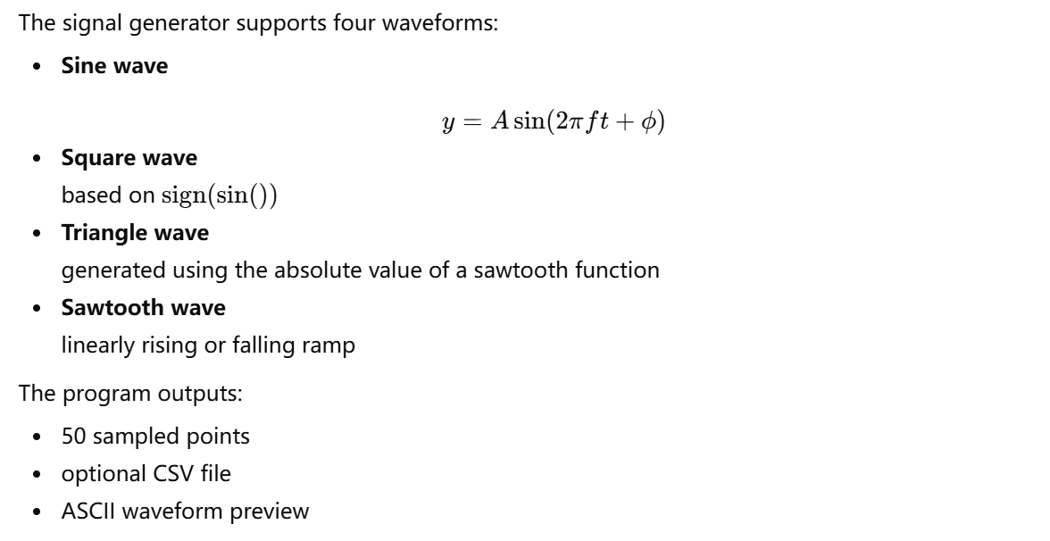

5. System Structure and Menu Handling
The CLI uses an infinite loop controlled by a menu-selection process:
┌───────────────────┐
│ main() │
└─────────┬─────────┘
↓
┌───────────────────┐
│ main_menu() │
└─────────┬─────────┘
↓
┌───────────────────┐
│ get_user_input() │
└─────────┬─────────┘
↓
┌───────────────────┐
│ select_menu_item() │
└─────────┬─────────┘
↓
Run selected module

Block Diagram of the System
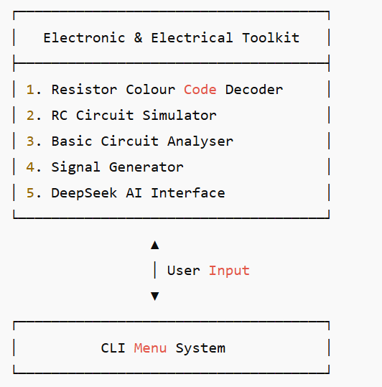

1. High-Level Architecture
Application Type: single-process, console-driven, menu loop.
Primary Files:
- main.c: menu printing, user input validation, dispatch, return control.
- funcs.h: declarations of feature entry points.
- funcs.c: implementations of five menu items + static helper functions.
- (Optional future) tests.c, rc.c, waveform.c for separation of pure logic.
Runtime Flow (text diagram):
User → main.c (loop) → select_menu_item(choice) → menu_item_X() → output (console / optional CSV) → wait 'b' (go_back_to_main) → main loop.
Data Flow:
- All user inputs collected interactively via scanf into local variables.
- No global mutable state shared between modules.
- Output either printed to stdout or written to CSV (RC and waveform).
Extensibility: add new feature = implement menu_item_N + expose in funcs.h + case in select_menu_item + line in print_main_menu.
2. Functional Decomposition
Menu Features:
- menu_item_1: Resistor Colour Code Decoder
  - Inputs: number of bands (4 or 5), band1..band4 (current implementation treats 3rd as multiplier, 4th as tolerance; 5th ignored for extra digit).
  - Helpers: get_color_value, get_tolerance, format_resistance.
  - Outputs: formatted resistance with tolerance and numeric value.
- menu_item_2: RC Circuit Simulator
  - Inputs: R (Ω), C (F), V (V), mode (charging/discharging).
  - Computation: τ = R*C; simulate 0→5τ (≈99% transition) with 21 points.
  - Formulas: Charging Vc = V(1 − e^(−t/τ)), I = (V/R)e^(−t/τ); Discharging Vc = V e^(−t/τ), I = −(V/R)e^(−t/τ).
  - Output: table + optional rc_simulation.csv (Time, Voltage, Current mA).
- menu_item_3: Basic Circuit Analyzer
  - Inputs: circuit type (series / parallel), number of resistors (2–10), resistor values, supply voltage.
  - Computation:
    - Series: R_total = ΣRi
    - Parallel: R_total = 1 / Σ(1/Ri)
    - I_total = V / R_total, P_total = V * I_total.
    - Series extra: voltage drops Vi = I_total * Ri.
    - Parallel extra: branch currents Ii = V / Ri.
  - Output: summary block with totals and per-branch metrics.
- menu_item_4: Signal Generator
  - Inputs: waveform type (sine/square/triangle/sawtooth), frequency, amplitude, phase (deg).
  - Derived: period = 1/f, samples per period = 50, sample_rate = f * samples, phase radians = phase_deg * π/180.
  - Per sample: t = i * period / samples; θ = 2π f t + phase_radians.
  - Waveforms:
    - sine: A sin(θ)
    - square: (sin(θ) ≥ 0) ? A : -A
    - triangle: piecewise using fmod(θ,2π) linear ramps
    - sawtooth: linear ramp normalized to [-A, A]
  - ASCII plot: map value in [-A, A] to index [0..40], zero axis at 20 ('|'), point at index '*'.
  - Optional file: waveform_data.csv (Time, Amplitude).
- menu_item_5: Chat placeholder
  - Currently: prints stub message.
  - Future: integrate external API / local inference module.
Static Helper Functions (funcs.c):
- get_color_value(color): maps color string → digit 0–9 or -1 if invalid (case-insensitive, supports synonyms violet/purple, grey/gray).
- get_tolerance(color): returns tolerance percentage (brown=1%, red=2%, gold=5%, silver=10%, default 20%).
- format_resistance(resistance, out): chooses prefix (Ohm / kOhm / MOhm) based on magnitude.
Design Rationale:
- Single responsibility per menu_item function (each wraps entire interaction cycle).
- Static helpers conceal internal mapping details (namespace hygiene).
- No dynamic memory needed (arrays of fixed size).
- Simplicity prioritized for teaching context; easy for extension and testing extraction later.
3. Algorithms (Detailed Pseudocode)
Resistor decoder (4-band path):
- prompt num_bands
- if num_bands not in {4,5} -> error return
- read band1, band2, band3, band4
- val1 = get_color_value(band1)
- val2 = get_color_value(band2)
- mult = get_color_value(band3)
- if any invalid -> error return
- R = (val1*10 + val2) * 10^mult
- tol = get_tolerance(band4)
- format_resistance(R, formatted)
- print formatted +/- tol
RC simulation:
- read resistance R (>0), capacitance C (>0), voltage V (>0)
- read mode (1 charge, 2 discharge)
- tau = R * C
- max_time = 5 * tau
- num_points = 20
- for i = 0..num_points:
- t = i * max_time / num_points
- if mode == charge:
- Vc = V * (1 - exp(-t/tau))
- I = (V/R) * exp(-t/tau) // A
- else:
- Vc = V * exp(-t/tau)
- I = -(V/R) * exp(-t/tau)
- print t, Vc, I*1000 (mA)
- if saving: write CSV row
Circuit analyzer:
- read circuit_type (1=series,2=parallel)
- read num_resistors (2..10)
- for each i: read Ri (>0)
- read V (>0)
- if series:
- R_total = sum(Ri)
- else:
- reciprocal_sum = sum(1/Ri)
- R_total = 1/reciprocal_sum
- I_total = V / R_total
- P_total = V * I_total
- print summary
- if series:
- for each Ri: Vi = I_total * Ri
- else:
- for each Ri: Ii = V / Ri
- print per-branch

Waveform generator:
- read type, frequency f (>0), amplitude A (>0), phase_deg
- phase_rad = phase_deg * PI / 180
- period = 1 / f
- samples = 50
- for i=0..samples-1:
- t = i * period / samples
- theta = 2*PI * f * t + phase_rad
- switch type:
- sine: value = A * sin(theta)
- square: value = (sin(theta) >= 0) ? A : -A
- triangle:
- phase_norm = fmod(theta, 2*PI)
- if phase_norm < PI:
- value = A * (2*phase_norm/PI - 1)
- else:
- value = A * (3 - 2*phase_norm/PI)
- sawtooth:
- phase_norm = fmod(theta, 2*PI)
- value = A * (2 * phase_norm / (2*PI) - 1) // linear in [-A,A]
- bar_index = (value/A + 1) * 20 // map [-A,A] → [0,40]
- build ASCII line with zero axis '|'
- print t, value, ASCII
- if saving: write CSV row
ASCII plotting:

- initialize char plot[42] with spaces
- plot[20] = '|'
- if 0 <= bar_index <= 40:
- plot[bar_index] = '*'
- terminate string
Tolerance mapping:
- switch(lowercase_color):
- brown -> 1.0
- red -> 2.0
- gold -> 5.0
- silver->10.0
- default -> 20.0
4. Testing Strategy
Current State:
- No automated unit tests included.
- Manual inspection via running each menu path.
Recommended Layers:
- Build Verification
  - Compile with:
gcc -std=c99 -Wall -Wextra -Wshadow -Wconversion -pedantic main.c funcs.c -o main.out -lm
  - Ensure zero warnings for code quality baseline.
- Unit Tests (after extracting pure functions)
  - get_color_value: test all valid colors and invalid string.
  - get_tolerance: brown/red/gold/silver + unknown (expect 20%).
  - RC formulas:
    - t=0 charge: Vc≈0, discharge: Vc≈V.
    - t=5τ charge: Vc>0.99V; discharge: Vc<V*0.01.
  - Waveform values at canonical angles:
    - θ=0: sine=0, square=+A, triangle=-A (start ramp), sawtooth≈-A.
    - θ=π: sine=0, square=-A, triangle=+A, sawtooth≈0.
  - Parallel extreme mixture: {1Ω, 1MΩ} to ensure numeric stability.
- Integration Tests
  - Scripted stdin: feed sequence to traverse all menu items, redirect output to file, grep for key markers.
  - Confirm rc_simulation.csv and waveform_data.csv generated when saving.
- Property Tests
  - RC charging voltage monotonically increases; discharging decreases.
  - For waveform_data.csv, max amplitude ≈ +A, min ≈ -A.
  - Square wave count of +A vs -A roughly balanced.
- Edge & Negative Tests
  - Invalid menu choice loops back gracefully.
  - Non-numeric in numeric input triggers error + return.
  - Very large multiplier (white=9) still formats properly.
  - Very small capacitance (e.g. 1e-9) still computes tau.
- Static Analysis
  - cppcheck --enable=all .
  - clang-tidy for early return consistency, unchecked return values.
- Suggested Automation
  - Add tests.c with asserts for pure functions.
  - GitHub Actions workflow: build → run test harness → artifact CSV verification.
Example proposed pure test (after refactor):

- // Example skeleton
- double rc_voltage(double t, double V, double tau, int charging) {
- return charging ? V * (1.0 - exp(-t/tau)) : V * exp(-t/tau);
- }
5. Dependencies
Headers Used:
- stdio.h: printf, scanf, FILE operations.
- string.h: strcmp.
- math.h: pow, exp, sin, fmod.
- ctype.h: tolower.
- funcs.h: internal declarations.
Link:
- -lm (required for math functions).
Potential Additions:
- stdlib.h for future use (strtol, exit).
- time.h if timing benchmarks or random waveform types added.
6. Best Practices Applied
- No global mutable state; local scope variables only.
- Fixed-size buffers with width specifiers (e.g. %19s) to avoid overflow.
- Input validation checks return values of scanf.
- Separation of helper logic into static functions (encapsulation).
- Use of consistent numeric formatting (%.2f / %.4f).
- Simple ASCII visualization for portability (no external graphics).
7. Improvement & Refactoring Suggestions
Refactor Targets:
- Extract computation-only routines:
  - decode_resistor_4(val1,val2,mult), apply_tolerance(nominal,tol).
  - rc_voltage(t,V,tau,charging), rc_current(t,V,R,tau,charging).
  - series_total(array,n), parallel_total(array,n).
  - waveform_value(type, theta, A).
- Convert repeated input buffer clearing into clear_input_line().
- Replace sprintf with snprintf for safety.
- 8. Risks and Mitigations
Risk | Description | Mitigation
Input mishandling | Wrong formats cause early returns | Add retry loops
Floating precision | Parallel extremes produce rounding errors | Use double (already), optional Kahan summation
Code growth | All logic inside funcs.c leads to clutter | Split into domain files
Limited testing | No automated regression yet | Introduce test harness + CI
Hard-coded samples | Waveform sample count fixed at 50 | Add user-set or config parameter
Unused 5th band | Provided by user but not processed | Implement 5-band path or clarify usage

9. Summary
The current design is clear, modular at the feature level, readable for educational purposes, and easily extensible. Immediate value comes from making pure computation functions testable and enhancing error handling. Longer-term improvements include structural refactoring, automated CI, expanded waveform types, and integrating the placeholder AI chat. The architecture fulfills its teaching support role while leaving a straightforward path for professional-grade enhancements.

