**作业1**

姓名：黄亮铭 学号：2022155028

The process of studying computer science at shenzhen University can be divided into three parts. The first part is learning basics knowledge in order to learn more about computer science.In this part, you can take math courses like advanced math and linear algebra and you can also take basic computen science courses such as fundamentals of programming.The second part is learning computer science expertise.You can take courses such as operating systems and computer networks, which are essential and professional knowledge for computer science.The last part is the internship, which is ameng aiming at find a good job aften graduation.In this part, you can familiarize yourself with the me work in advance and nnderstand the difference between study and work.

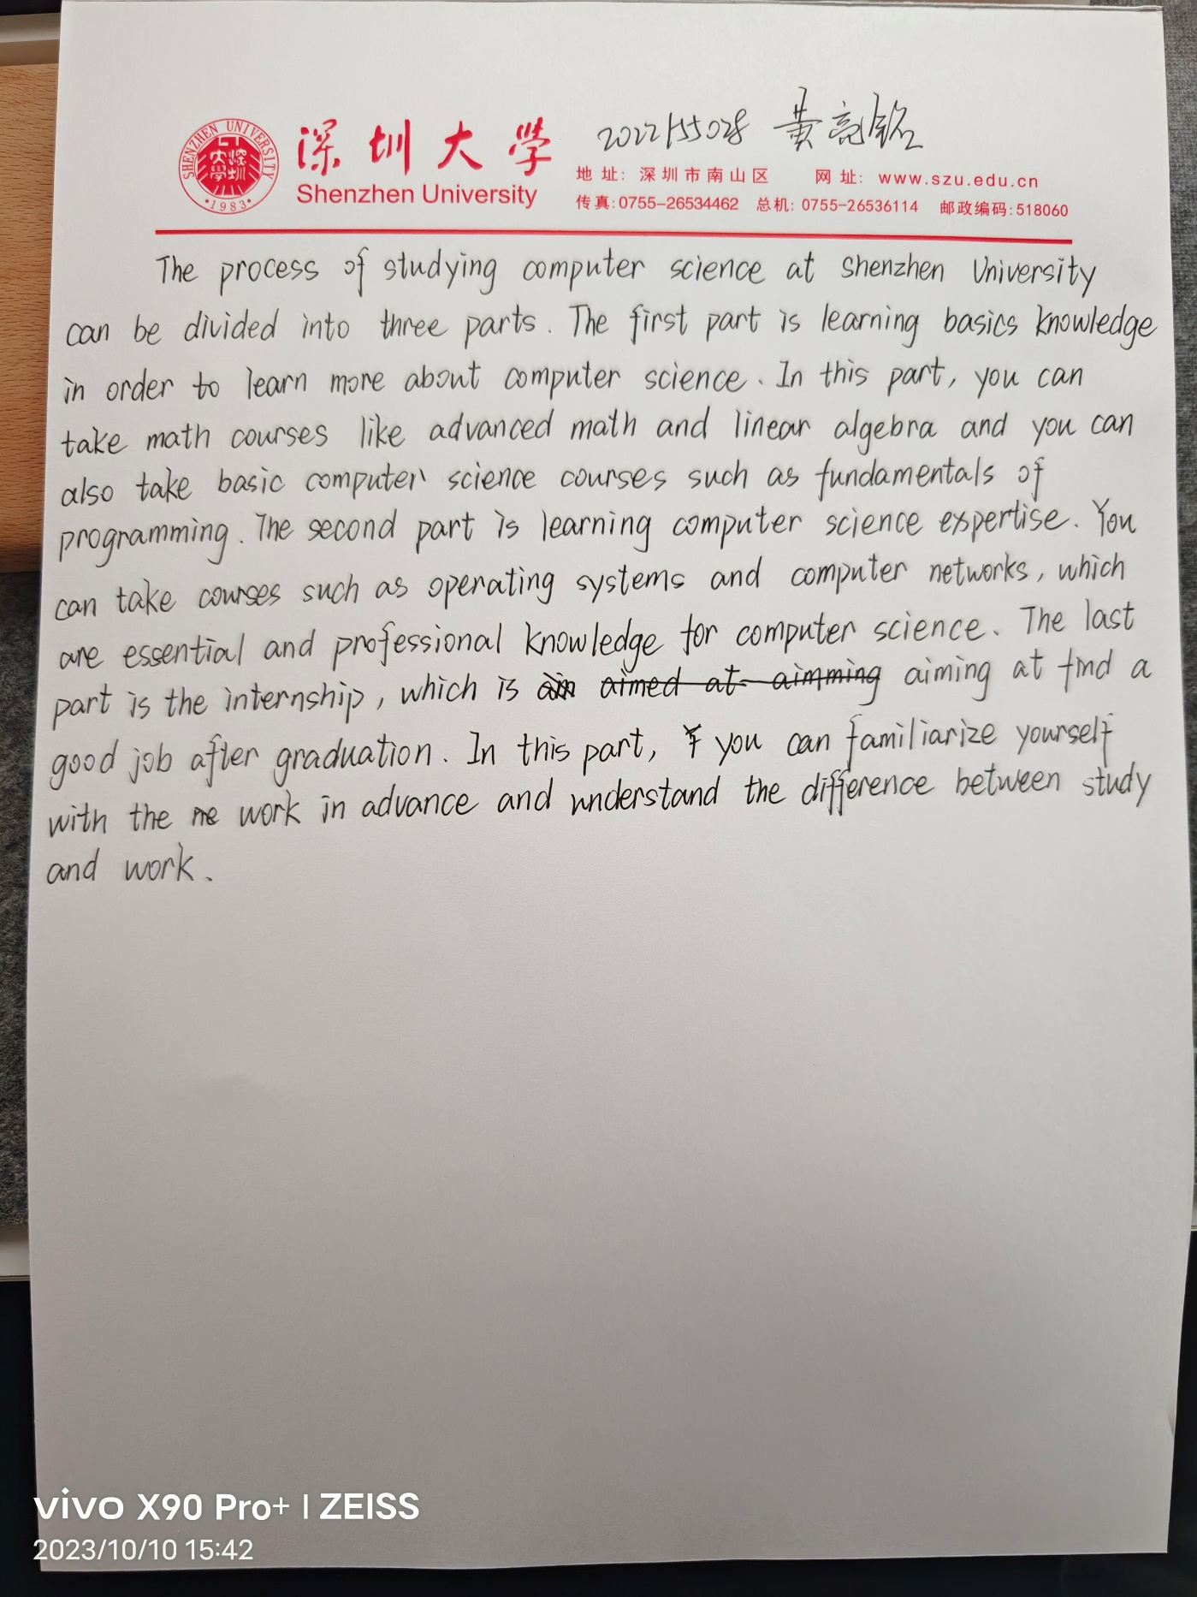作业原图