Caution in interpreting data

1. **The table below shows the percentage of Welsh speakers in Wales over a 60-year period.**

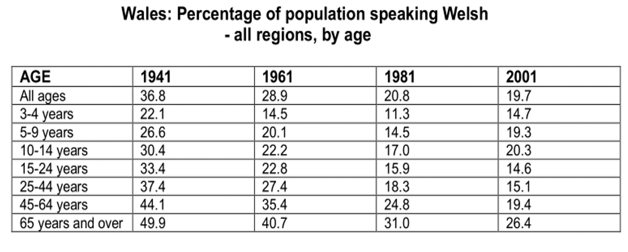

1. **Northedge’s guidelines**

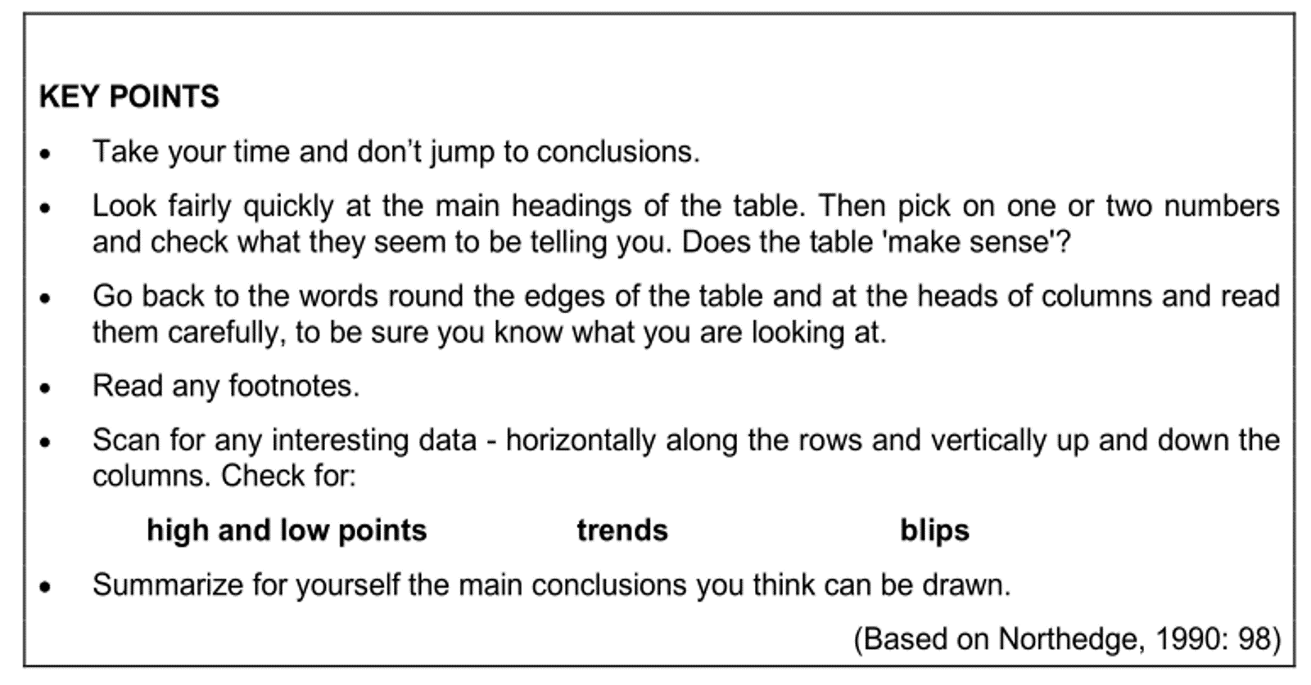

1. **Language Boxes**

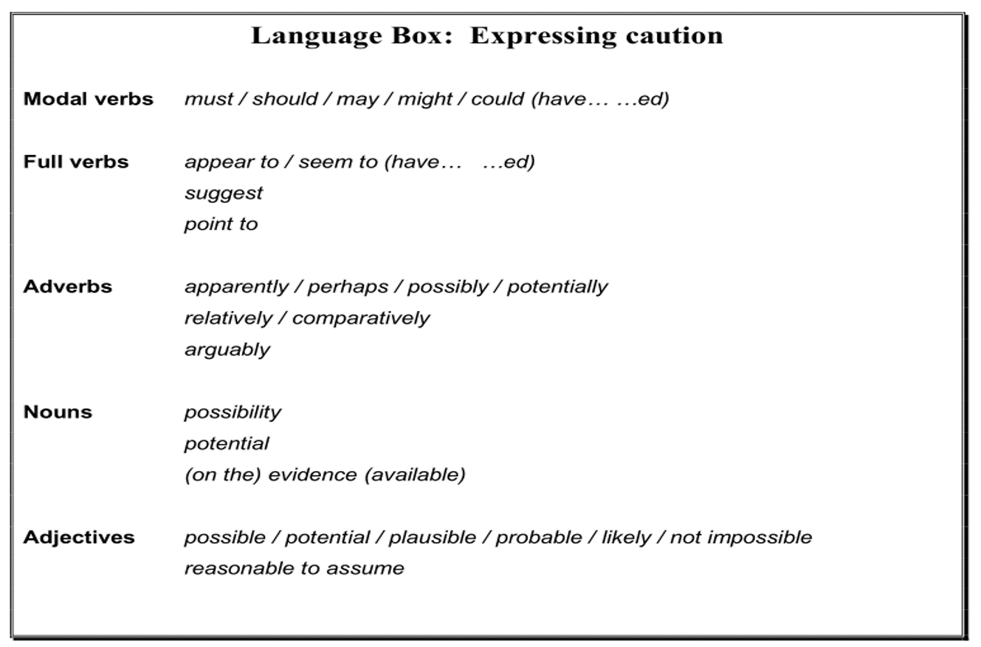

**Writing task**

* The previous table shows the percentage of Welsh speakers in Wales over a 60-year period.
* Decide what conclusions you can draw about life and education in Wales, on the basis of this evidence.
* Use Northedge’s guidelines and the Language Boxes to help you express the right level of caution.
* **Write your interpretations in a paragraph with full sentences.**