**网络答题成绩：**

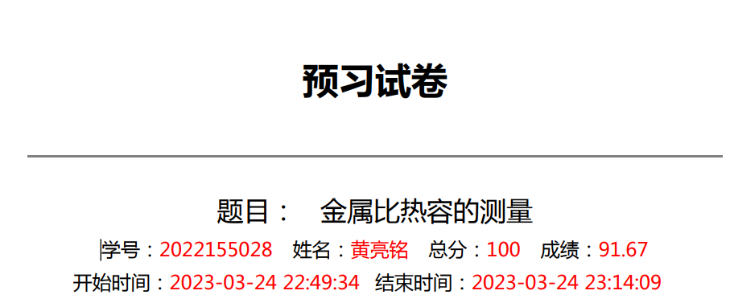

|  |
| --- |
| **实验目的：** |
| **实验仪器：** |
| **实验原理：** |
| **实验内容：** |

**原始数据记录表：**

组号 姓名

|  |  |  |  |  |  |  |
| --- | --- | --- | --- | --- | --- | --- |
| 次数  样品 | 1 | 2 | 3 | 4 | 5 | 平均值 |
| Fe |  |  |  |  |  |  |
| Cu |  |  |  |  |  |  |
| A1 |  |  |  |  |  |  |

|  |  |  |  |  |  |  |  |  |
| --- | --- | --- | --- | --- | --- | --- | --- | --- |
| 时 间  （s） |  |  |  |  |  |  |  |  |
| 电 压  （mV） |  |  |  |  |  |  |  |  |
| 时 间  （s） |  |  |  |  |  |  |  |  |
| 电 压  （mV |  |  |  |  |  |  |  |  |