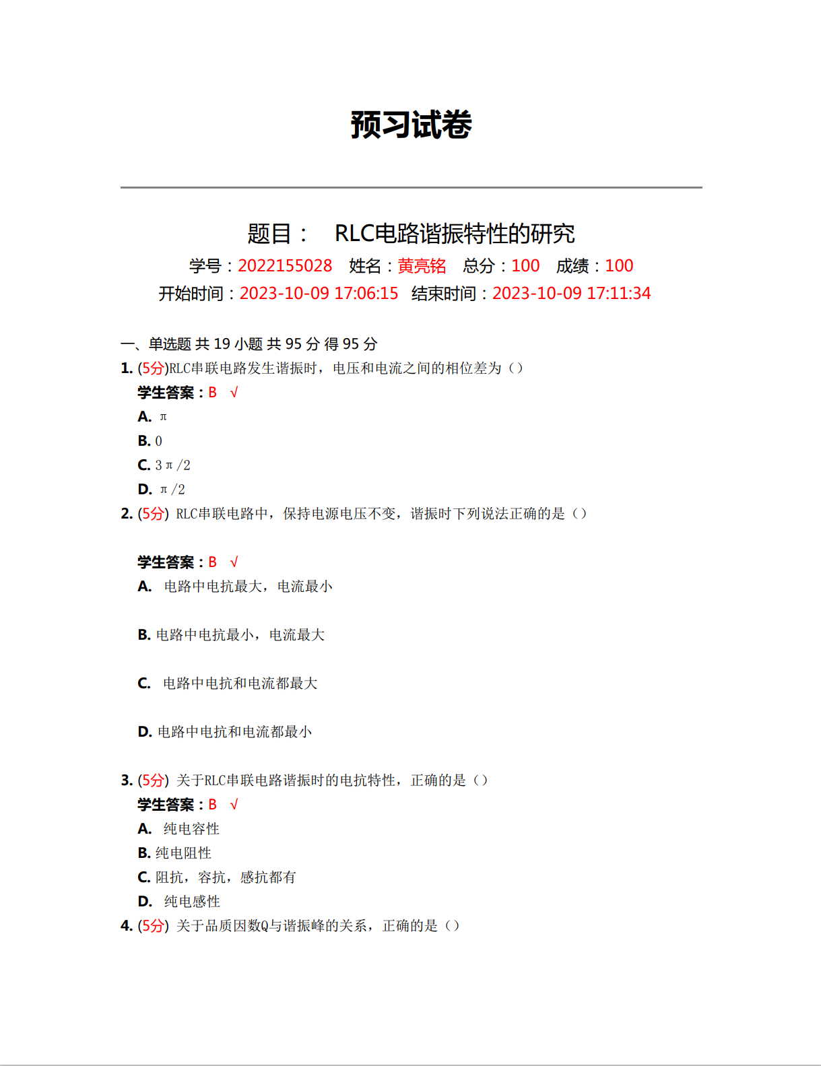

原始数据记录表

组号： 19 ；姓名 黄亮铭

|  |  |  |  |  |  |  |  |  |  |
| --- | --- | --- | --- | --- | --- | --- | --- | --- | --- |
| f / Hz | $$R_{1}=100Ω$$ | | $$R_{2}=200Ω$$ | | f / Hz | $$R_{1}=100Ω$$ | | $$R_{2}=200Ω$$ | |
| $$U/mV$$ | $$I/mA$$ | $$U/mV$$ | $$I/mA$$ | $$U/mV$$ | $$I/mA$$ | $$U/mV$$ | $$I/mA$$ |
| 1600 |  |  |  |  | 2400 |  |  |  |  |
| 1700 |  |  |  |  | 2450 |  |  |  |  |
| 1800 |  |  |  |  | 2500 |  |  |  |  |
| 1900 |  |  |  |  | 2550 |  |  |  |  |
| 2000 |  |  |  |  | 2600 |  |  |  |  |
| 2100 |  |  |  |  | 2700 |  |  |  |  |
| 2150 |  |  |  |  | 2800 |  |  |  |  |
| 2200 |  |  |  |  | 2900 |  |  |  |  |
| 2250 |  |  |  |  | 3000 |  |  |  |  |
| 2300 |  |  |  |  | 3100 |  |  |  |  |
| 2350 |  |  |  |  | 3200 |  |  |  |  |

$$C= L=$$

串联电路的谐振曲线