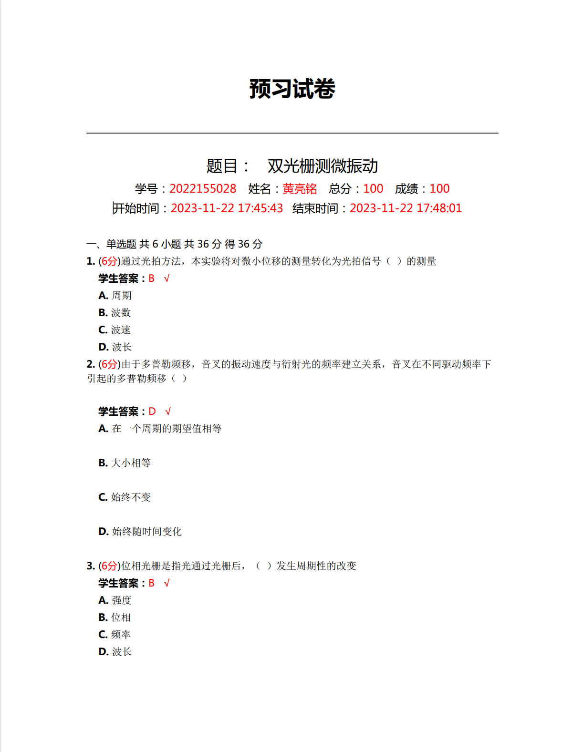

原始数据记录：

组号： 19 ；姓名 黄亮铭

光栅常数：

音叉谐振频率：

|  |  |  |
| --- | --- | --- |
| 组数 | 频率 | 波数 |
| 1 |  |  |
| 2 |  |  |
| 3 |  |  |
| 4 |  |  |
| 5 |  |  |
| 6 |  |  |
| 7 |  |  |
| 8 |  |  |
| 9 |  |  |
| 10 |  |  |
| 11 |  |  |
| 12 |  |  |
| 13 |  |  |
| 14 |  |  |
| 15 |  |  |
| 16 |  |  |
| 17 |  |  |
| 18 |  |  |
| 19 |  |  |
| 20 |  |  |
|  |  |  |
|  |  |  |