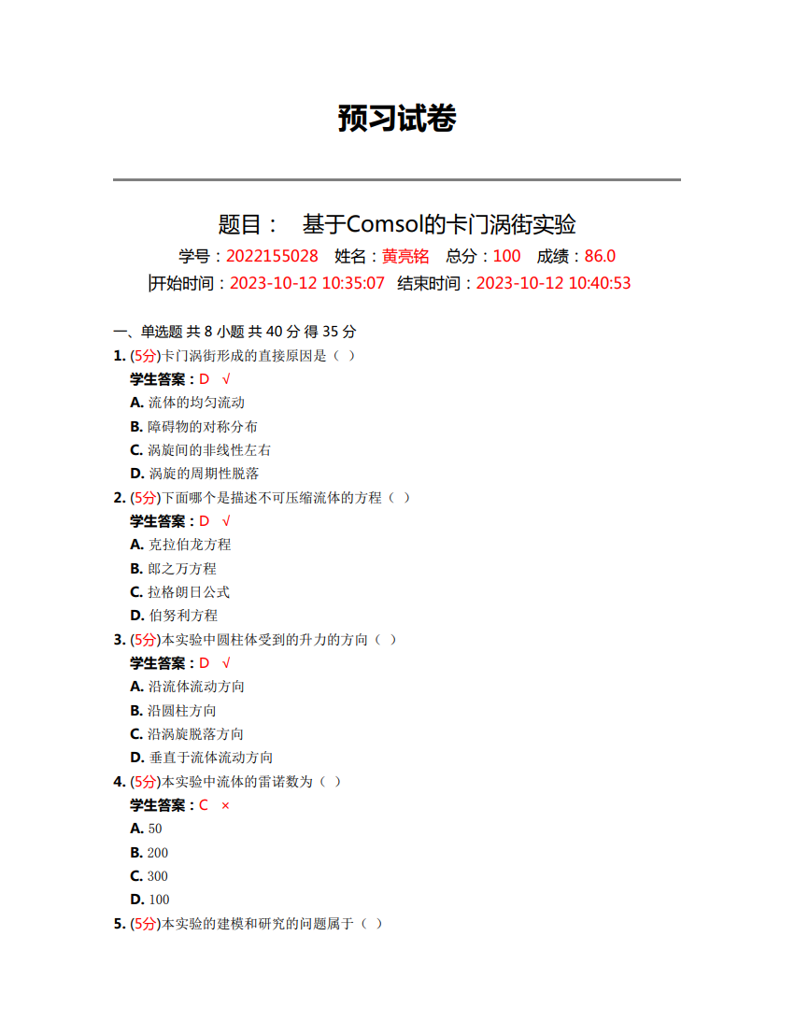

原始数据记录：

组号： 19 ；姓名 黄亮铭

|  |  |  |  |  |  |  |
| --- | --- | --- | --- | --- | --- | --- |
| t/s |  |  |  |  |  |  |
| $$C_{L}$$ |  |  |  |  |  |  |
| $$F_{L}/mN$$ |  |  |  |  |  |  |