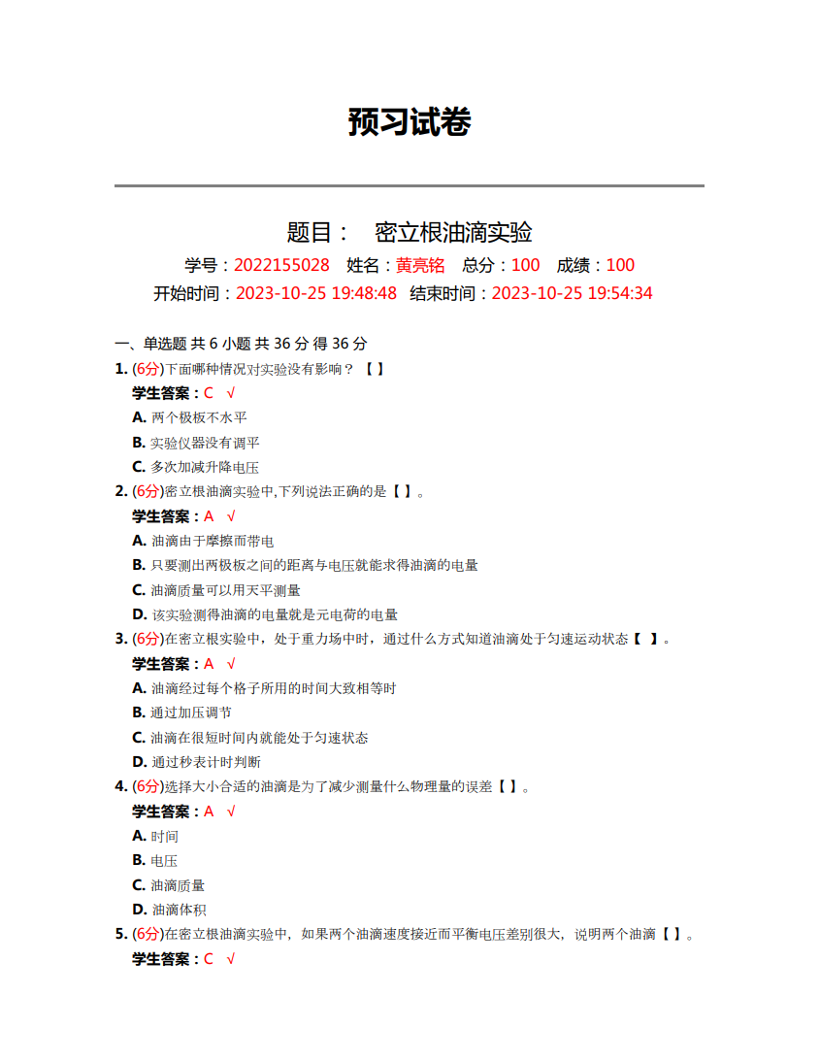

**原始数据记录表**

组号： 19 ；姓名 黄亮铭

|  |  |  |  |  |  |  |  |  |  |  |  |
| --- | --- | --- | --- | --- | --- | --- | --- | --- | --- | --- | --- |
| 油滴 | 次数 |  |  | 油滴 | 次数 |  |  | 油滴 | 次数 |  |  |
| 1 |  |  |  | 2 |  |  |  | 3 |  |  |  |
|  |  |  |  |  |  |  |  |  |
|  |  |  |  |  |  |  |  |  |
|  |  |  |  |  |  |  |  |  |
|  |  |  |  |  |  |  |  |  |
|  |  |  |  |  |  |  |  |  |
|  |  |  |  |  |  |  |  |  |
|  |  |  |  |  |  |  |  |  |
|  |  |  |  |  |  |  |  |  |
| 油滴 | 次数 |  |  | 油滴 | 次数 |  |  | 油滴 | 次数 |  |  |
| 4 |  |  |  | 5 |  |  |  | 6 |  |  |  |
|  |  |  |  |  |  |  |  |  |
|  |  |  |  |  |  |  |  |  |
|  |  |  |  |  |  |  |  |  |
|  |  |  |  |  |  |  |  |  |
|  |  |  |  |  |  |  |  |  |
|  |  |  |  |  |  |  |  |  |
|  |  |  |  |  |  |  |  |  |
|  |  |  |  |  |  |  |  |  |