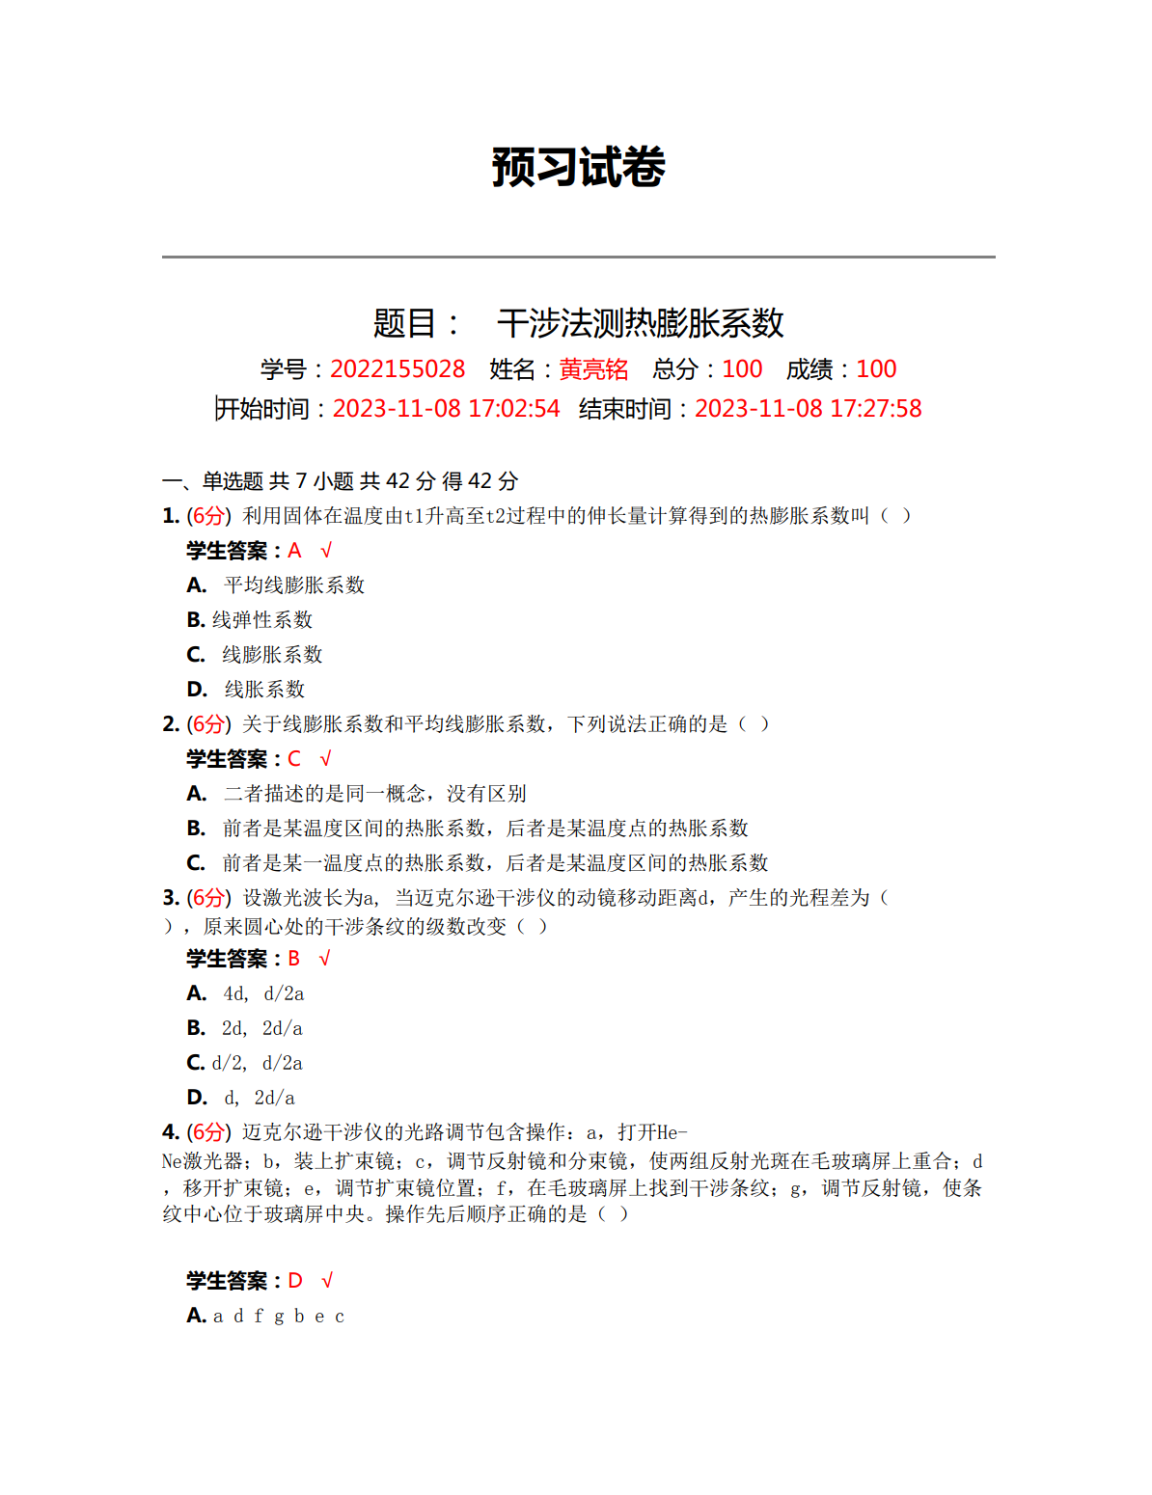

原始数据记录：

组号： 19 ；姓名 黄亮铭

|  |  |  |  |  |  |  |  |
| --- | --- | --- | --- | --- | --- | --- | --- |
| 温度℃  (T1=25.0℃) | T2 | T3 | T4 | T5 | T6 | T7 | T |
|  |  |  |  |  |  |  |
| 干涉环变化数N |  |  |  |  |  |  |  |

实验激光波长λ:

试件原长L1: