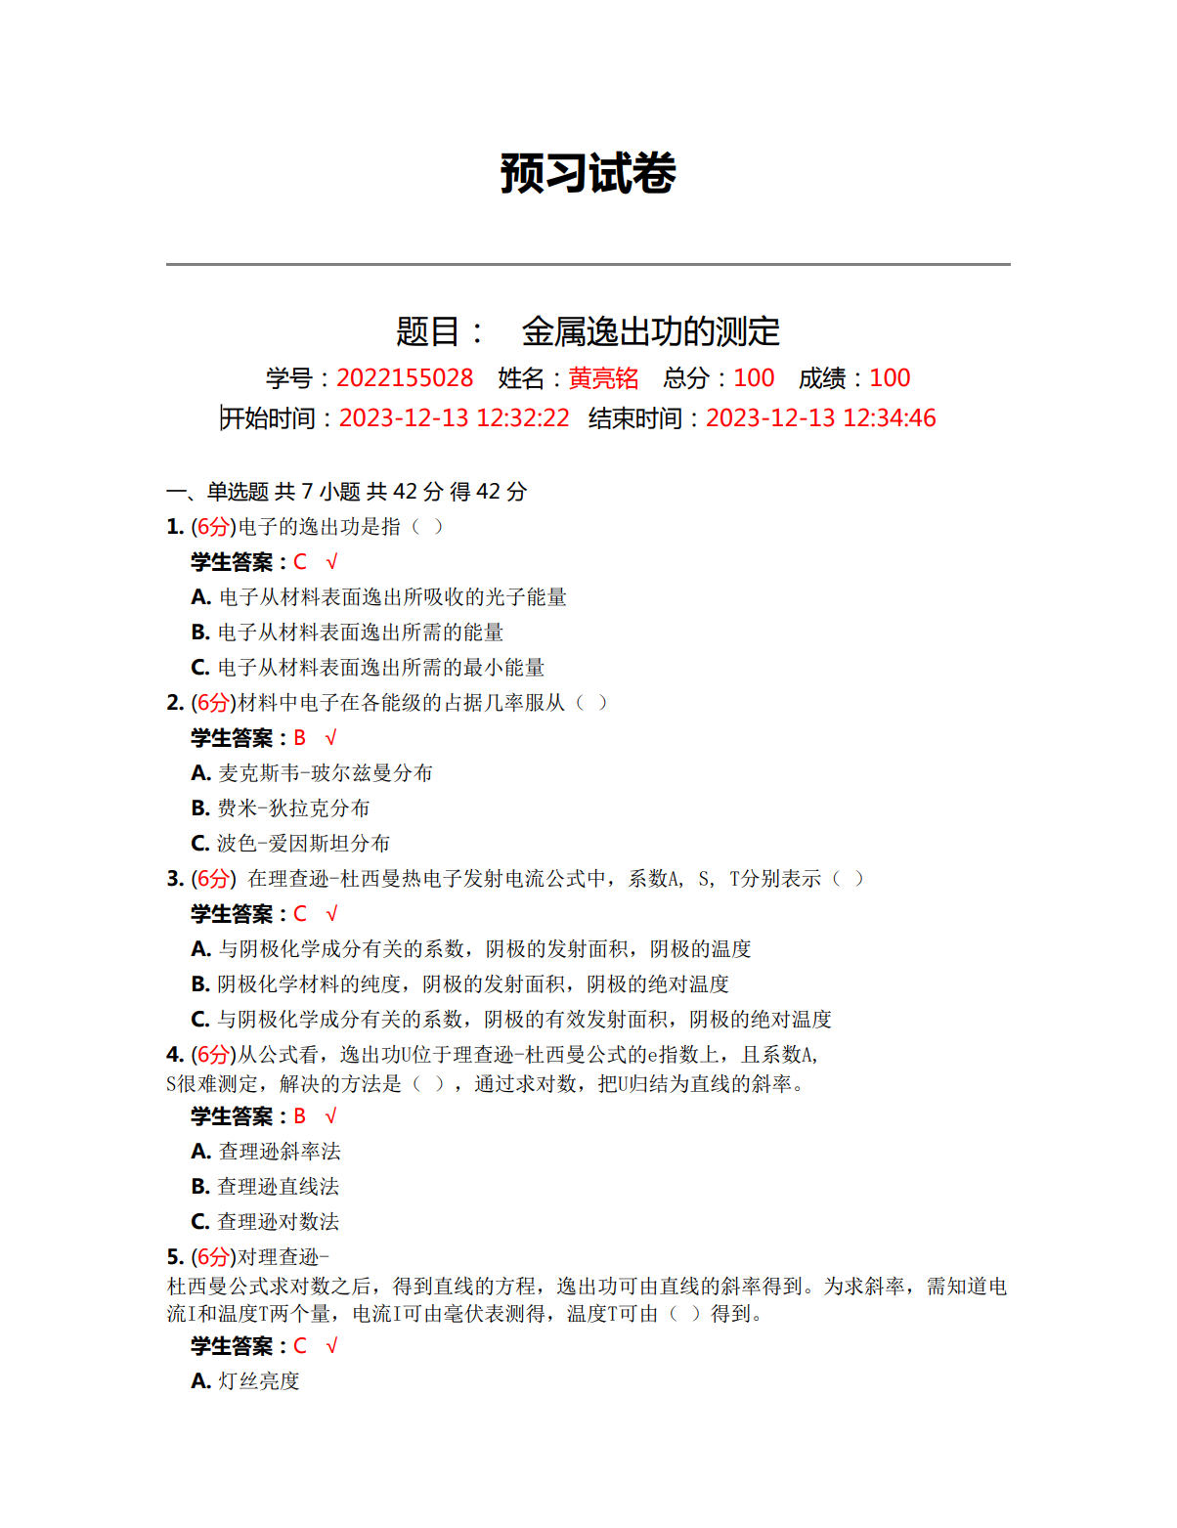

原始数据记录表：

组号： 19 ；姓名 黄亮铭

表1：二极管灯丝电流*If*和灯丝温度*T*的关系

|  |  |  |  |  |  |  |  |
| --- | --- | --- | --- | --- | --- | --- | --- |
| *If*（A） | 0.50 | 0.55 | 0.60 | 0.65 | 0.70 | 0.75 | 0.80 |
| *T*（103K） | 1.72 | 1.80 | 1.88 | 1.96 | 2.04 | 2.12 | 2.20 |

表2：不同灯丝电流和阳极电压*Ua*时测得的阳极电流值*Ia*

|  |  |  |  |  |  |  |  |  |
| --- | --- | --- | --- | --- | --- | --- | --- | --- |
| *Ua*  *Ia*  *If* | 16 | 25 | 36 | 49 | 64 | 81 | 100 | 121 |
| 0.55 |  |  |  |  |  |  |  |  |
| 0.6 |  |  |  |  |  |  |  |  |
| 0.65 |  |  |  |  |  |  |  |  |
| 0.7 |  |  |  |  |  |  |  |  |
| 0.75 |  |  |  |  |  |  |  |  |