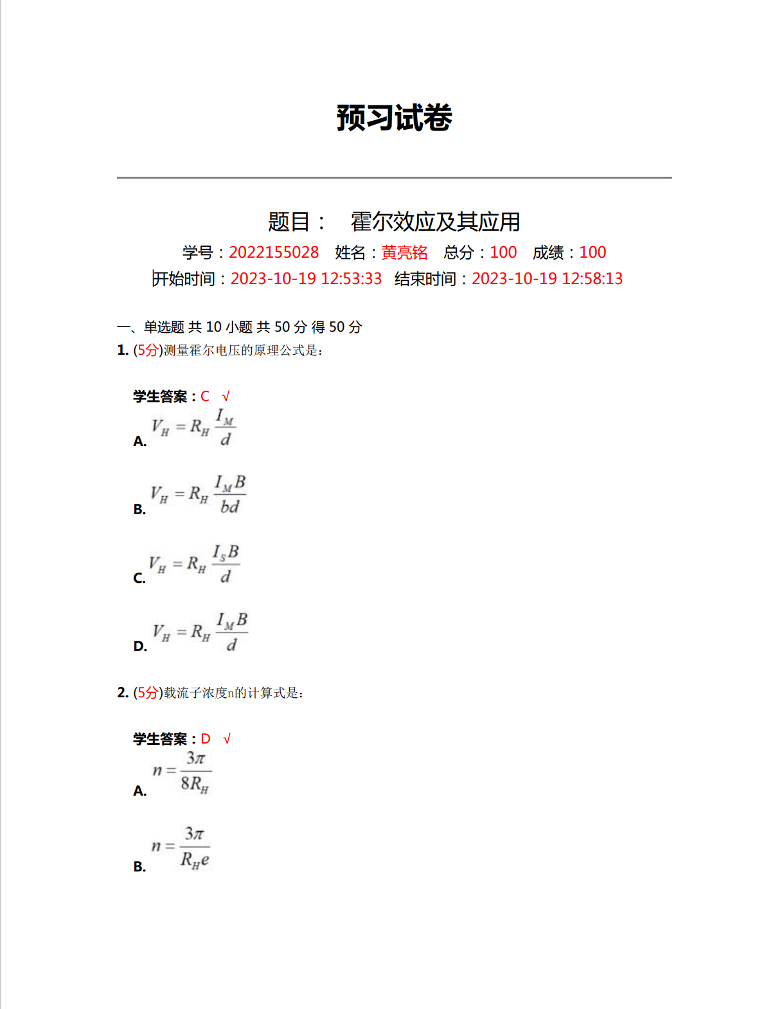

组号： 19 姓名 黄亮铭 实验名称：霍尔效应

实验1、测量霍尔片的输出特性，确定样品的霍尔系数

1. 保持励磁电流*IM*（*IM*=0.500A）不变,将实验仪双刀开关倒向“*VH* ”，测试仪功能选择置于“*VH* ”，测绘*VH*—*IS* 曲线．

励磁线圈参数*K*= KGS.A-1

霍尔片厚度 *d*  = mm

|  |  |  |  |  |  |
| --- | --- | --- | --- | --- | --- |
| *IS/*mA | *V*1*/*mV | *V*2*/*mV | *V*3*/*mV | *V*4*/*mV |  |
| +*B*,+*Is* | -*B*,+*Is* | -*B*,-*Is* | +*B*,-*Is* |
| 1.00 |  |  |  |  |  |
| 1.50 |  |  |  |  |  |
| 2.00 |  |  |  |  |  |
| 2.50 |  |  |  |  |  |
| 3.00 |  |  |  |  |  |
| 3.50 |  |  |  |  |  |
| 4.00 |  |  |  |  |  |

（2）、保持霍尔片工作电流*IS*的值不变（ *IS**=*3.00mA），测绘曲线*VH*—*IＭ*

|  |  |  |  |  |  |
| --- | --- | --- | --- | --- | --- |
| *IM/*A | *V*1*/*mV | *V*2*/*mV | *V*3*/*mV | *V*4*/*mV |  |
| +*B*,+*Is* | -*B*,+*Is* | -*B*,-*Is* | +*B*,-*Is* |
| 0.300 |  |  |  |  |  |
| 0.400 |  |  |  |  |  |
| 0.500 |  |  |  |  |  |
| 0.600 |  |  |  |  |  |
| 0.700 |  |  |  |  |  |
| 0.800 |  |  |  |  |  |

实验2：用霍尔片测量螺线管轴线上磁场分布

霍尔片工作电流*IS*= 3.00 mA , 励磁电流*IM*= 0.500 A,

霍尔元件灵敏度*KH*= mv/mA.KGS

|  |  |  |  |  |  |  |
| --- | --- | --- | --- | --- | --- | --- |
| X/cm | *V*1*/*mV | *V*2*/*mV | *V*3*/*mV | *V*4*/*mV | *VH*/mV | *B*/KGS |
| +*B*,+*Is* | -*B*,+*Is* | -*B*,-*Is* | +*B*,-*Is* |
|  |  |  |  |  |  |  |
|  |  |  |  |  |  |  |
|  |  |  |  |  |  |  |
|  |  |  |  |  |  |  |
|  |  |  |  |  |  |  |
|  |  |  |  |  |  |  |
|  |  |  |  |  |  |  |
|  |  |  |  |  |  |  |
|  |  |  |  |  |  |  |
|  |  |  |  |  |  |  |
|  |  |  |  |  |  |  |
|  |  |  |  |  |  |  |
|  |  |  |  |  |  |  |
|  |  |  |  |  |  |  |
|  |  |  |  |  |  |  |
|  |  |  |  |  |  |  |
|  |  |  |  |  |  |  |
|  |  |  |  |  |  |  |
|  |  |  |  |  |  |  |