World Energy Exploratory Data Analysis Report
KQC7016 DATA ANALYTICS
Github: https://github.com/HuangLingxiaoCN/KQC7016_LAB

Group11 | HUANGLINGXIAO | 25081394
 | SHILIN | 24221134

1. Report Overview
This report conducts a systematic Exploratory Data Analysis (EDA) based on the global energy dataset. Focusing on three core dimensions: the evolution of global electricity structure, the correlation between per capita GDP and energy consumption, and the electricity sources of major economies, it adopts methods including univariate time trend analysis, bivariate correlation analysis, and multivariate grouping & aggregation analysis. Based on the report, the phased trends of global energy transition are deeply analyzed for the Python visualization and data distribution feature mining technologies, the law of variable correlation and characteristics of regional differentiation. The report also demonstrates the commercial application value, which translates the data analysis results into two commercial scenarios, namely policy consulting for international organizations and think tanks, and overseas market expansion of power equipment and new energy equipment.

2. Detailed Exploratory Data Analysis (EDA) of Global Energy
2.1 Evolution of Global Electricity Structure (Univariate Time Trend Analysis) 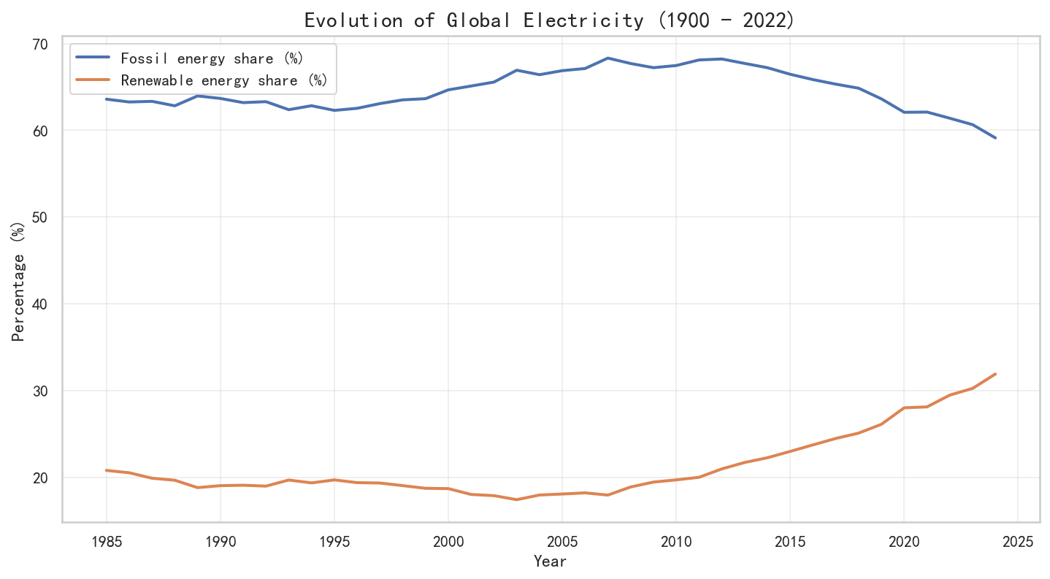
Technical Application: This section adopts time-based pattern recognition. Line plots generated via Python are used to observe the dynamic changes of two key variables, "fossil energy share" and "renewable energy share", over time.
Analysis:
Trends and Turning Points: The global power system presents obvious phased characteristics. The share of fossil energy remained at a high plateau of approximately 63% to 68% from 1985 to 2011, and then entered a steady decline phase until 2025. Meanwhile, renewable energy broke through the 25-year-long "20% stagnation period" around 2010, showing a significant growth trend.
Smoothing and Noise Reduction: Rolling means can be applied in subsequent analyses to eliminate minor annual fluctuations (e.g., the impact of extreme climates on hydropower), so as to extract the long-term energy transition trend more clearly.
Shape of Distribution: The historical share data of renewable energy is significantly positively skewed. This is because for most of the observation period its value was extremely low and the explosive growth in recent years has created a long tail on the right side of the distribution. This variable may need to be standardized in a later analysis.
2.2 Per Capita GDP and Energy Consumption (Bivariate Correlation Analysis)
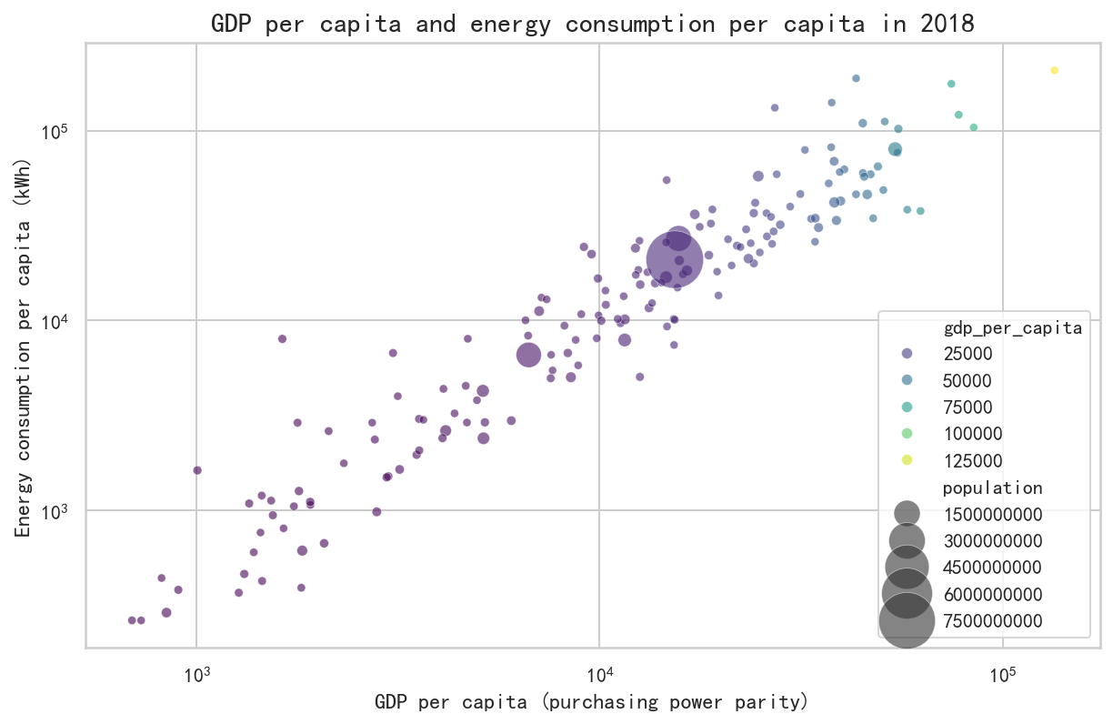
Technical Application: This section applies bivariate analysis, using scatterplots to represent the correlations between numerical variables.
Analysis:
Correlation: The chart displays a strong positive correlation between economic level and energy demand on a logarithmic scale. Observing the chart, most data points extend diagonally from the bottom-left (low income, low energy consumption) to the top-right (high income, high energy consumption), which strongly proves the strong binding relationship between economic output and energy input. Although the chart covers countries with vastly different population sizes (represented by the size of dots), almost all points follow this upward-sloping path regardless of the country's scale. This consistency across different social backgrounds enhances the reliability of the conclusion of "positive correlation".
Significance of Logarithmic Scale: Per capita GDP and energy consumption vary greatly across countries (ranging from 10² to over 10⁵). Without a logarithmic scale, data points would cluster in one corner of the axis, making observation impossible. Meanwhile, in a log-log coordinate system, the originally exponential growth relationship is transformed into a linear one. The approximate linear arrangement of scatter points in the chart proves a stable power-law correlation between the two variables, making the positive correlation trend clearer and distinguishable.
Natural Clusters: The data shows an obvious phenomenon of natural groupings. The dense area in the bottom-left represents a cluster of low-income and energy-scarce countries, while the top-right forms a specific distribution of high-income and energy-intensive countries.

2.3 Electricity Sources of Major Economies (Multivariate Comparative Analysis)
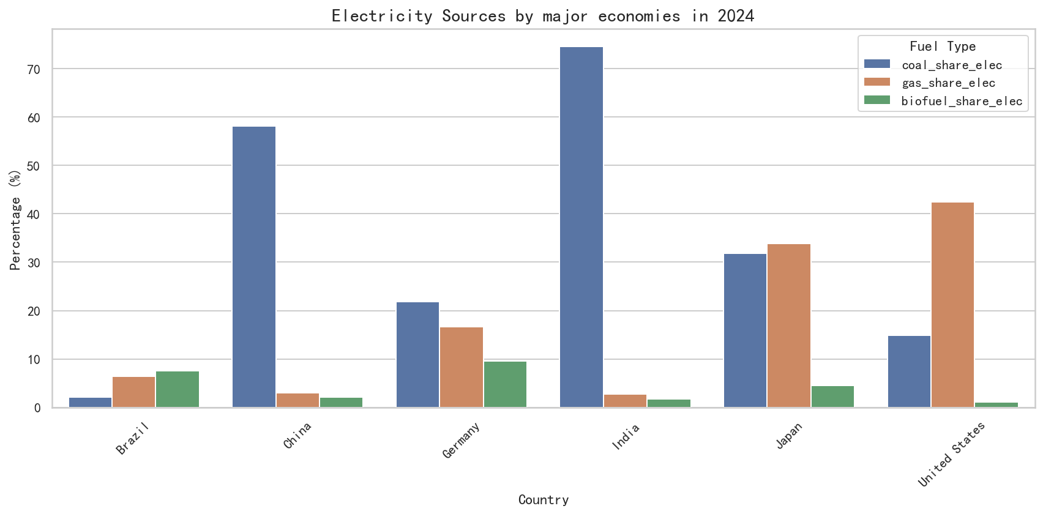
Technical Application: Energy composition under different categorical variables is extracted through grouping and aggregation. The generated bar charts can be used to compare the proportion of different fuel types.
Analysis:
Diversity of Energy Paths: The chart reveals huge differences in energy security and emission reduction paths among different economies. For example, India and China rely significantly more on coal than Europe, the United States, Japan and other countries (India and China's coal dependence reaches 80% and 57% respectively). The United States and Japan are more dependent on natural gas (accounting for 35%-45%). While this reduces carbon emissions, Japan's extreme dependence on natural gas imports makes it highly vulnerable to fluctuations in global liquefied natural gas prices. Brazil is less dependent on coal and natural gas and uses more bioenergy, which can be regarded as Brazil's emphasis on low-carbon emission reduction.
Extracting Business Insights: The huge coal-fired power base in China and India indicates huge commercial potential and investment space for carbon capture, utilization and storage (CCUS) technology and distributed photovoltaic replacement solutions in these markets. To reduce the carbon emissions of their products, global multinational corporations may tend to shift production lines to countries with greener energy structures (such as Brazil, which has a high proportion of biofuels and renewable energy).
3. Commercial Project Applications and Analysis Dimension Description Based on the Dataset
3.1 Commercial Project Applications
3.1.1 Policy Consulting Projects for International Organizations and Think Tanks
For governments and international organizations, these global energy analysis reports are the core for formulating macro policies and drafting industry white papers.
In terms of commercial value, the analysis results can be directly applied to policy consulting projects for international organizations and think tanks: it provides objective evidence for modern consulting firms to conduct assessments, verifying the alignment between countries' actual emission reduction data and low-carbon commitments. If the slope of the line shows a gentle decline rather than a steep drop, consulting firms can alert stakeholders that the country's current policy efforts are insufficient to support its climate commitments.
It also provides a concise and intuitive decision-making benchmark for non-technical decision-makers such as policymakers, enabling them to quickly understand the urgency of energy transition and adjust the proportion of clean energy transition in the next budget report.
For example, consulting firms benchmark a country's energy transition curve against the "global average" in the report. If the global renewable energy share has entered an "explosive growth phase" while the country is still in a plateau period, it is necessary to increase subsidies or adjust feed-in tariff policies. Using correlation analysis: if GDP growth of 5% is predicted in the next five years, consulting firms need to inform policymakers to use the model to estimate the resulting power shortage and formulate policies to accelerate the construction of power plants to avoid economic growth being hindered by power shortages.
3.1.2 Overseas Market Expansion Projects for Power Equipment/New Energy Equipment
This project aims to comprehensively analyze the current status, trends, influencing factors and energy inequality of per capita energy consumption worldwide and in various countries, and provide data support and decision-making references for market entry timing recommendations and product regional adaptation strategies.
In terms of commercial value, overseas market expansion projects for new energy equipment rely on the quantitative analysis capability of global energy monitoring. It needs to convert the scattered energy data of various countries and regions into energy indicators, and then transform the energy indicators into actionable overseas market expansion strategies, helping enterprises of new energy equipment such as photovoltaic modules, wind turbines, energy storage, inverters and power grid equipment accurately target high-growth overseas markets, seize the optimal entry timing, optimize global resource allocation, and achieve efficient overseas business expansion.
For example, for high renewable energy markets such as Brazil, there is a huge potential demand gap for equipment such as distributed photovoltaics, wind turbine blades and grid stabilizers, because of its high share of non-fossil energy and high demand for grid volatility tolerance. Therefore, the company can give priority to this country for its next overseas expansion projects. At the same time, show overseas customers the structural turning point of fossil energy share since 2011. This proves that the global energy paradigm has shifted, and investing in traditional inefficient equipment now faces extremely high asset impairment risks, increasing the tendency of cooperation.
3.2 Description of Analysis Types
This project uses tools such as NumPy and Pandas to perform EDA, mainly involving the following four types of data analysis:
3.2.1 Descriptive Analytics
Univariate analysis is used to study data distribution. Basic statistical indicators such as Mean and Median, combined with Skewness and Kurtosis, are used to describe the shape of energy consumption distribution.
3.2.2 Diagnostic Analytics
Bivariate or multivariate analysis is performed. Correlation analysis and scatterplots are used to identify the linkage relationship between variables.
3.2.3 Predictive Analytics
Time-based pattern analysis is carried out. The historical energy structure data is smoothed by rolling means to identify the long-term growth trend.
3.2.4 Prescriptive Analytics
Hypothesis testing is used to verify the effectiveness of specific strategies. A series of hypotheses generated from exploratory analysis are compared to determine a statistically significant course of action.

4. Conclusion
Through Exploratory Data Analysis (EDA), this report clearly shows that the world power structure is in deep transition from traditional fossil fuel dominance to driven by renewable energy. This report not only quantitatively analyzes the energy evolution patterns from a technical perspective by employing diverse analysis methods like descriptive analysis, diagnostic analysis, and predictive analysis with the assistance of tools such as NumPy and Pandas, but also sets up a data-driven decision-making basis at the business level to offer data support for think tank policy consulting and the overseas expansion of new energy equipment. In the future global energy market, companies and leaders who can understand the differences in regional energy structures and keenly capture the "inflection points" of the transition will be able to stand out in the low-carbon transformation era and seize the initiative in competition.

