# Instruction

**Don’t move your cursor during the automation testing. Please wait until the report pops up.**

**How to prepare the automation ENV**

1. Download and install .Net4.8
2. Install MP+ with SK622 connected
3. Unzip the test package.
4. Find the CMTest.exe
5. Right-click it and run as administrator
6. Input 4 and Enter to Choose 4. MasterPlus+
7. Choose 3. Test
8. Choose SK622 SPACE GREY or SK622 SILVER
9. Wait for the Report pops up.

**How to review the Report**

1. Click “Allow blocked content” button to display full content.

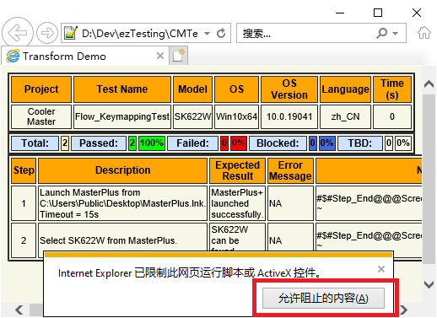

1. It is better to Check “Allow active content to run files on My computer” to avoid this button popping up. Find it from IE > Tool > Internet Options.

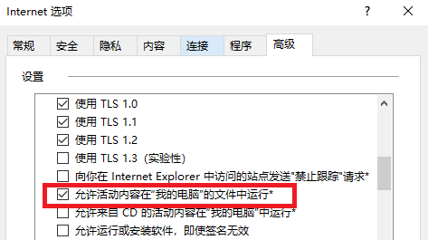

**How to review the Report again**

1. Find the “?:\Demo\Result\{created folder}\MasterPlusTestFlows.xml”
2. Right Click it and open with IE.

How to review the Report with Chrome or Edge

1. Add --allow-file-access-from-files to their shortcut and reopen them. 