Flood Inundation Analysis — Workflow Report
Generated: 2026-05-06 19:02

1. Synthetic DEM Generation
A 100×100 synthetic Digital Elevation Model was generated using Fractional Brownian Motion (FBM) with 6 octaves to produce realistic terrain features. A gentle sinusoidal ridge was added to mimic natural topography.
Elevation range: 30.00 – 80.00 m | Mean: 53.99 m | Grid: 100×100 cells
Method: fbm_noise() with octaves=6, lacunarity=2.0, gain=0.5, seed=42
Files: generate_dem.py, dem_synthetic_100x100.npy, dem_synthetic_100x100.csv

2. Flood Inundation Computation
Three core functions compute inundation from a DEM given a water level (WL):
- flood_mask(dem, WL): Boolean mask — True where elevation < WL
- flood_depth(dem, WL): Depth = WL – elevation for flooded cells, 0 elsewhere
- flood_area_pct(mask): Flooded cells / total cells x 100%
Convenience wrapper flood_stats() returns all metrics in one call.

Water Level (m) | Area (%) | Mean Depth (m) | Max Depth (m) | Volume (m³)
40 | 3.79 | 2.23 | 10.00 | 845
45 | 14.48 | 3.47 | 15.00 | 5,019
50 | 32.49 | 5.07 | 20.00 | 16,467
55 | 55.04 | 6.95 | 25.00 | 38,233
60 | 75.83 | 9.37 | 30.00 | 71,043
65 | 90.60 | 12.47 | 35.00 | 112,967
70 | 98.15 | 16.35 | 40.00 | 160,523
Table: Flood statistics across water levels

3. Visualization
A 3x3 grid figure was generated comparing water levels 45, 55, and 65 m across three rows: (a) raw DEM in terrain colormap, (b) flood extent overlay (blue mask on grayscale DEM), and (c) flood depth heatmap (Blues colormap). Each subplot includes a color bar and title.
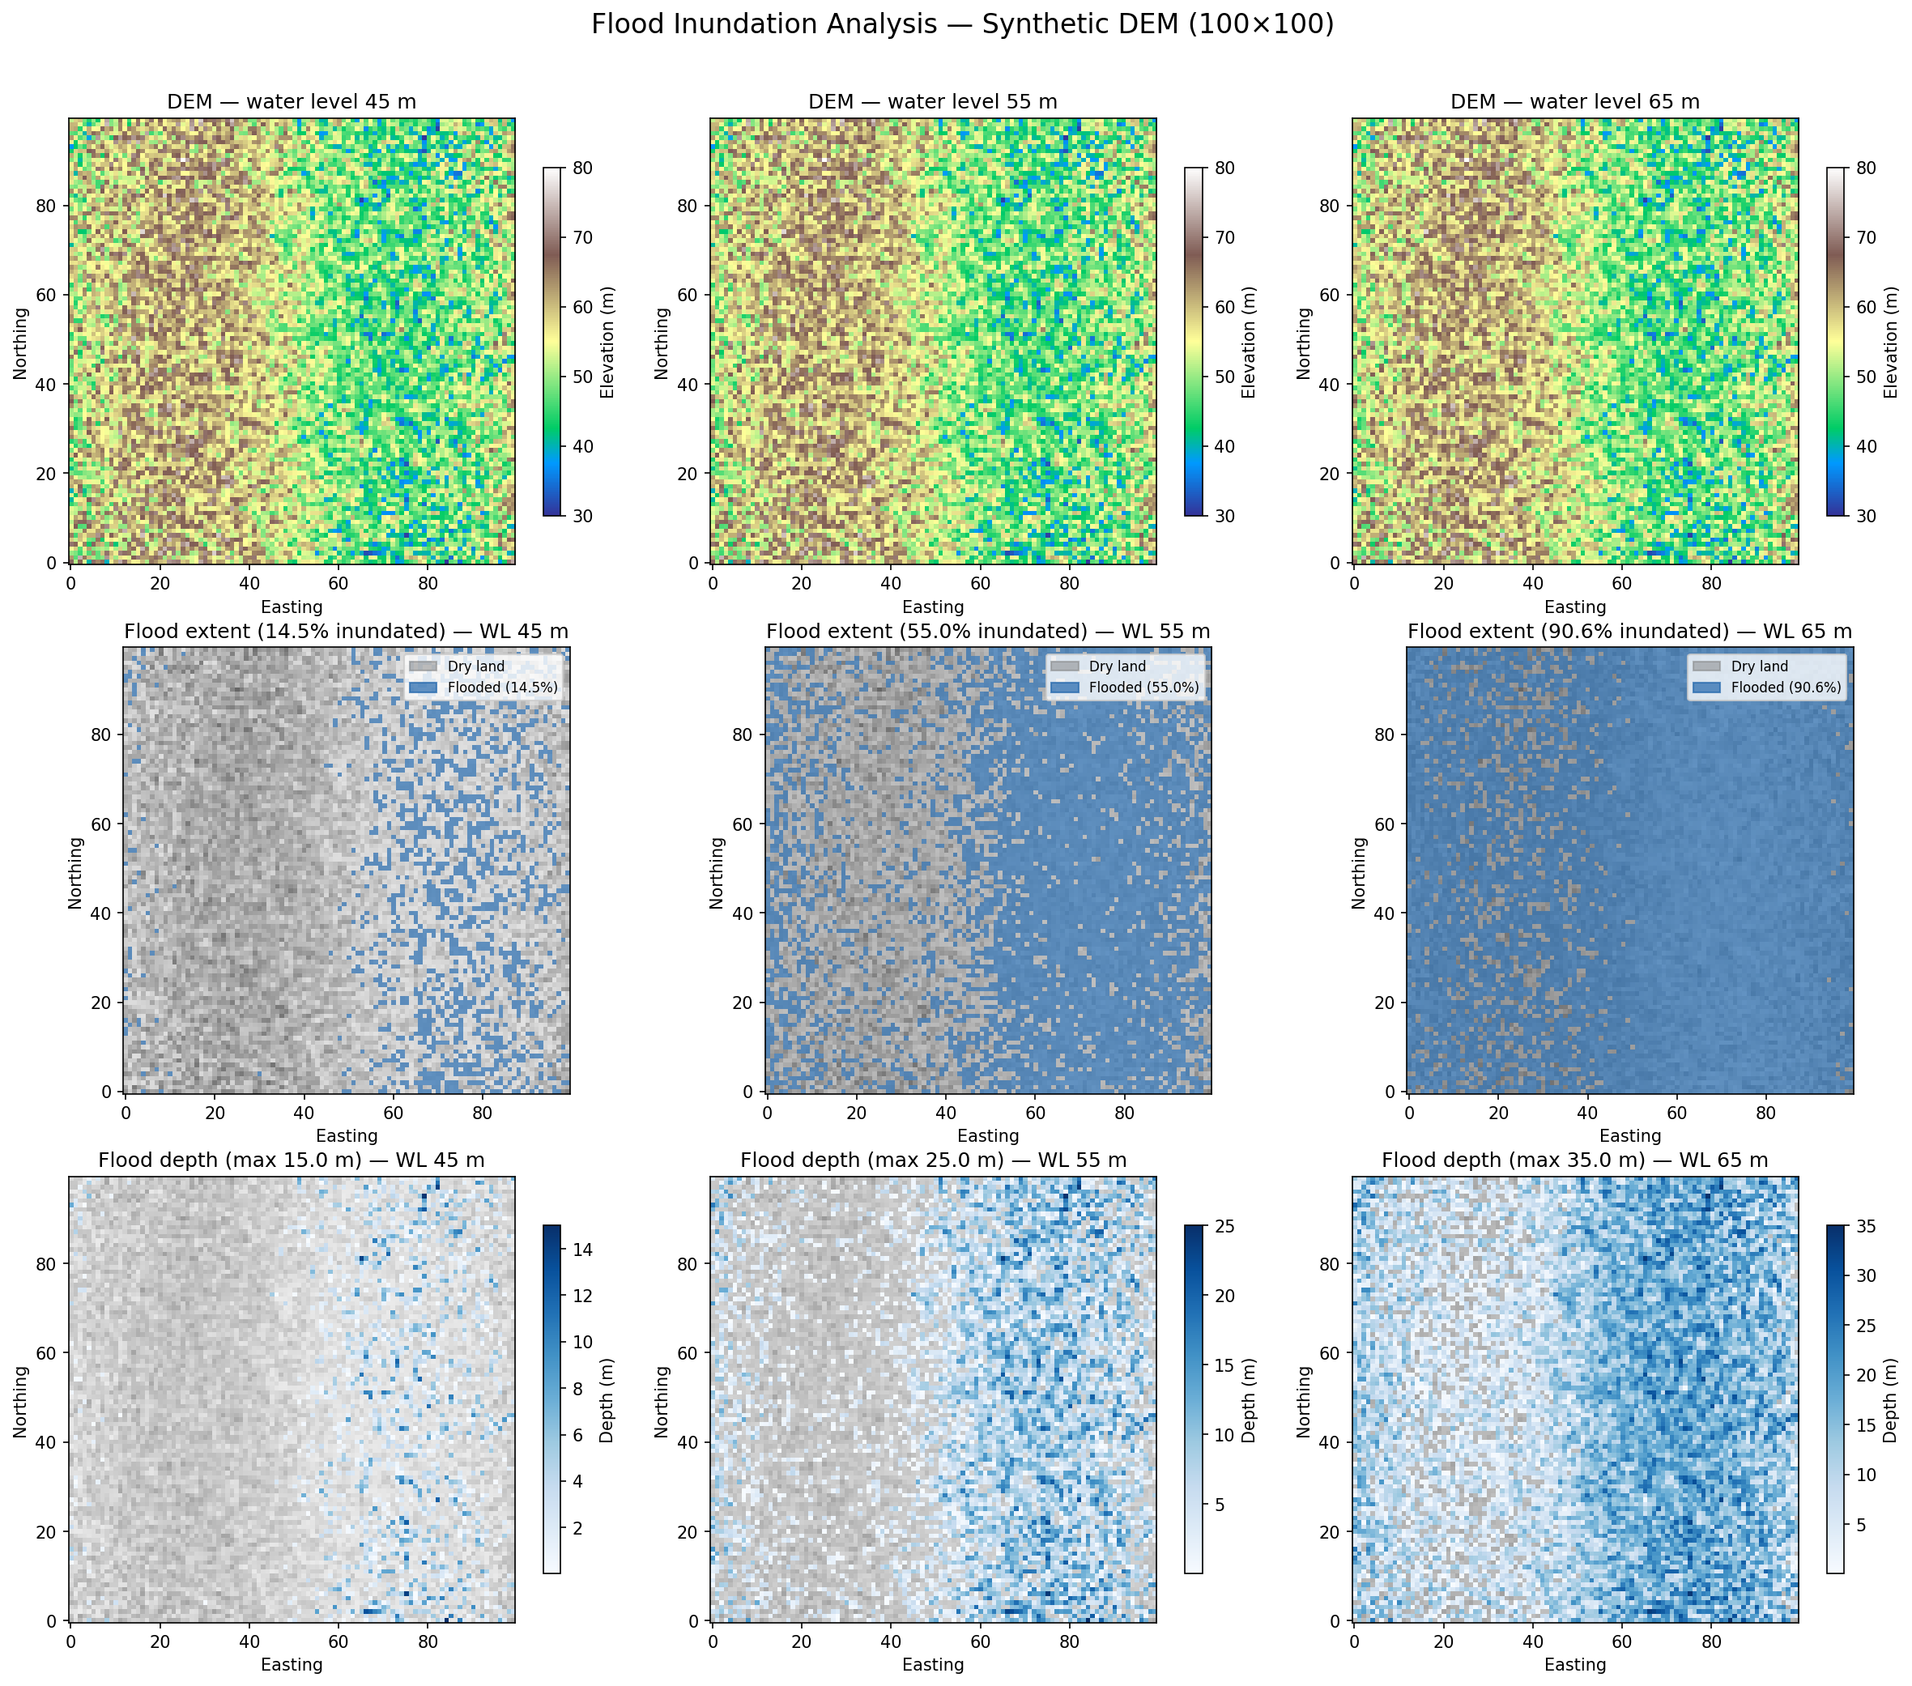
Figure 1: Flood inundation visualization at WL = 45, 55, 65 m

4. Rising-Water Trend Analysis
Water level was incremented from 40.0 m to 50.0 m in 0.5 m steps. At each step, the flooded area percentage was recorded and plotted.
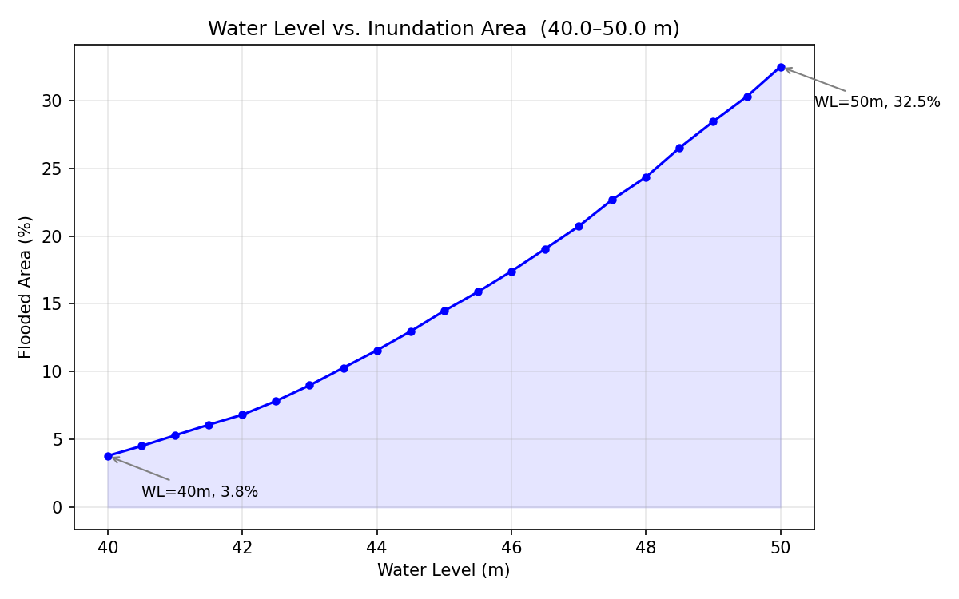
Figure 2: Water level vs. Inundation area curve
Key finding: area increased from 3.79% to 32.49% (8.6x) over a 10 m rise. A pronounced inflection between 47–48 m indicates a flat terrain band that is highly sensitive to small water-level changes.

5. Physical-Sense Validation
Five validation checks were performed across 101 water levels (30–80 m, step 0.5 m):
- Area percentage always in [0, 100]
- Maximum depth = water level – minimum elevation (when flooded)
- All depth values are non-negative
- Depth > 0 exactly where mask is True (mask/depth consistency)
- Depth values equal water level – DEM for all flooded cells
Monotonicity check: flood area must be non-decreasing with increasing water level.

Result: ALL 506 checks PASSED (101 levels x 5 + 1 monotonicity).

6. Output Files
- generate_dem.py — Synthetic DEM generator (FBM noise)
- dem_synthetic_100x100.npy — DEM data (NumPy binary, float32)
- dem_synthetic_100x100.csv — DEM data (CSV, 100x100 grid)
- flood_inundation.py — Flood computation functions
- visualize_flood.py — Matplotlib visualization (3x3 grid)
- flood_inundation_plot.png — Visualization output (419 KB, 150 DPI)
- flood_trend.py — Water-level vs. area curve analysis
- flood_trend_curve.png — Trend curve output
- validate_flood.py — Physical-sense validation suite
- validation_results.npz — Validation data archive
- write_report.py — This report generator

All validation passed. Results are physically consistent.

