Table of Contents

Strain2bScan: strain-level profiling from 2bRAD markers across microbiomes
Yufeng Zhang1,2, Shi Huang1,2,*
1 Faculty of Dentistry, The University of Hong Kong, Hong Kong SAR, China; 2 The University of Hong Kong Shenzhen Institute of Research and Innovation, China. *Correspondence: Shi Huang, shihuang@hku.hk.

Abstract
Strain-level variation underlies clinically important microbial phenotypes, but 16S rRNA surveys usually resolve species rather than strains, whereas shotgun profilers can scale poorly and lose signal in host-dominated, low-biomass samples. We present Strain2bScan, a Rust profiler that clusters conspecific reference genomes and scores unique 25–33 bp type-IIB restriction markers. It profiles native BcgI 2bRAD-M libraries and in-silico-digested shotgun reads in one marker framework. Across 15 species, 2bRAD-marker distances tracked whole-genome strain distances more closely than 16S distances (median Spearman ρ = 0.94 versus 0.36). Native BcgI profiling retained F1 = 1.0 at an abundance threshold of 10⁻⁴ in the 99%-human-DNA mock. In shotgun comparisons, Strain2bScan was the only tested tool that preserved detection and abundance at 99% host. In a run-level StrainScan rerun, accuracy was comparable: species-median precision was 1.0 for both tools, median recall/F1 were 0.733/0.844 versus 0.667/0.800, and paired-difference intervals included zero in completed-pair and failure-aware analyses. Archived cross-environment runs reduced database-construction cost by 249–614× in wall time and 43–138× in memory. A supplementary StrainGST rerun used a different 0.90-reference space; StrainGR was not run. In eight saliva subjects, a leave-one-timepoint-out classifier reached 100% with strain features versus 78.1% with species features; the paired difference interval included zero. This was a small within-subject classification result, not independent strain-accuracy validation. Accuracy depends on reference completeness and niche-matched panel design.
Availability. Rust source: https://github.com/HuangShiLab/Strain2bScan. Public reads: PRJNA1131785, PRJNA288562, PRJNA1517970, PRJNA1191223 and PRJNA1191225. Derived outputs: https://github.com/HuangShiLab/Strain2bScan-paper.

Introduction
Microbial strains of the same species can differ sharply in phenotype; virulence, antibiotic resistance, metabolic capacity and host interaction; so resolving which strains are present, and at what abundance, is central to microbiome and clinical metagenomics. The 16S rRNA gene, the workhorse of community surveys, cannot see this variation: its between-strain distances are essentially uncorrelated with genome-wide divergence, so 16S resolves species but not strains (below, and Fig 2). Shotgun metagenomes do carry strain information, and a family of tools now recovers it; reference k-mer methods such as StrainScan [1] and StrainGE [2], marker-gene methods such as StrainPhlAn [3], and sketch-based abundance estimators such as sylph [4]; making strain-level profiling routine for individual samples and species.
Two obstacles keep shotgun-based strain profiling from two increasingly important settings.
Scale. Modern studies span hundreds of samples and aim to resolve strains across the dozens-to-hundreds of species in a community. Full k-mer methods index and query the entire k-mer content of every reference genome; per-sample cost is dominated by counting the sample’s k-mers, and is paid again for every species database queried. For S species across N samples this scales as N × S × (k-mer count + search); hours-to-days of compute and hundreds of megabytes to gigabytes of memory; a practical ceiling for population-scale, multi-species strain surveillance.
Low biomass and host contamination. Many host-rich, low-input specimen types; saliva and other oral sites, tumour and FFPE tissue, skin; yield little microbial DNA against a large human background (often ≥90–99 % host). Shotgun sequencing spends most of its reads on the host, so the informative bacterial fraction, and with it the rarer strains, is lost; strain resolution collapses exactly where it would be most valuable.
sparse, reproducible set of fixed-length tags (roughly 1–2 % of the genome) [5]. Applied as a wet-lab protocol (2bRAD-M / Fast2bRAD-M) [6,7], it enriches these informative markers before host DNA can swamp the library, giving accurate profiles from picogram inputs, heavily host-contaminated samples and degraded material. To date, however, 2bRAD has mainly been used for species-level profiling. Yet strain-resolution methods do not need the whole genome; they score samples on unique markers that distinguish a strain or a cluster of near-identical strains; and a 2bRAD tag set is exactly this kind of low-redundancy, taxonomically informative marker set, 50–100× smaller than the full k-mer set.
We present Strain2bScan, which ports the StrainScan [1] resolution framework; within-species clustering into a search structure, followed by unique-marker scoring and abundance estimation; onto 2bRAD tags, in Rust. Its tag lengths and recognition patterns match Fast2bRAD-M / 2bRADExtraction.pl [7] exactly, so the tags are interoperable with the Fast2bRAD-M species layer, and Strain2bScan accepts two input modes that map onto the two obstacles above:
- Native BcgI 2bRAD experimental libraries, enabling strain-level analysis of low-biomass and high-host microbiomes. In a controlled native BcgI mock, the reduction happens at the bench and Strain2bScan retained precision 1.0 and full strain recall at 99% host DNA; the primary comparator test under the same host ladder used in-silico-digested shotgun reads. On real saliva, it resolved individual-specific, within-day strain signatures and produced candidate low-abundance calls that require independent validation.
- In-silico digestion of conventional shotgun metagenomes, enabling community-scale strain profiling. The sample is digested once and matched against every per-species database, so per-sample cost is independent of the number of species and linear in the number of samples: ~8× faster and ~11× lighter per sample than StrainScan, and projected to be 121–146× lower in cost on a 55-species community, while matching StrainScan’s precision, its 0.5× detection onset and its recall on its own databases; and completing near-clonal Mycobacterium tuberculosis in ~1 s where StrainScan does not finish.
The two modes are directionally concordant: in three usable paired samples, 65/65 shotgun strain-cluster calls were contained in native calls. Thus a single tool, on one 2bRAD tag space, spans both host-rich, low-input profiling and cohort-scale shotgun analysis.

Results

Overview of Strain2bScan and its two data modes (Fig 1)
Strain2bScan reduces reference genomes to canonical, single-copy 2bRAD tags, clusters genomes within each species at 0.95 Jaccard similarity, and builds a compact cluster-by-marker database. Profiling digests a sample once, gates species on panel-specific markers, and scores strain-resolved clusters on unique markers. The same tag space accepts two entry points: in-silico digestion of conventional shotgun reads and native BcgI 2bRAD-M libraries whose reads are already tags. The tag definitions match Fast2bRAD-M, so its species layer and the Strain2bScan strain layer share one marker space.

2bRAD tags carry strain-level signal that 16S cannot (Fig 2)
We compared pairwise strain distances in whole-genome, 2bRAD-tag and 16S spaces across 15 species with complete or near-complete genomes. Per species, 2bRAD distances tracked whole-genome distances in every case (median Spearman ρ = 0.94; range 0.59–0.99), whereas 16S distances were much weaker (median ρ = 0.36), with several confidence intervals overlapping zero (Fig 2). The rank-rank matrices show the mechanism: 2bRAD preserved the ordering of genome-wide strain pairs, whereas 16S collapsed many unrelated pairs to a few conserved-gene distances. Thus, 16S resolved species but the 2bRAD marker set retained genome-wide strain signal.

Accurate and robust strain profiling (Fig 3–4)
On simulated mixtures from curated reference panels, Strain2bScan achieved precision 1.0 for Cutibacterium acnes, Staphylococcus aureus and Staphylococcus epidermidis, with high recall and Bray–Curtis dissimilarity of 0.24, 0.33 and 0.02, respectively (Fig 3A). A single C. acnes strain was detected at 0.5× per-strain coverage, matching the StrainScan detection onset (Fig 3B). Precision therefore remained high even when many genomes collapsed to few 0.95-similarity clusters.
In the co-varying reference-degradation gradient, completeness was the dominant accuracy constraint. Degrading truth-strain references from 100% to 70% completeness while holding sample reads fixed reduced median Jaccard-mode precision from 1.0 to 0.71 and recall from 0.96 to 0.74 across 14 resolvable species, because incomplete genomes fragmented from complete relatives (Fig 4). The optional --containment mode, which links genomes by maximum marker-set containment, restored precision to 0.92–0.98 and recall to 0.92–0.95 at 90–95% completeness. It also kept the near-clonal M. tuberculosis cluster intact to 90% completeness, whereas Jaccard recall collapsed to approximately 0.05. Because containment can coarsen complete panels, it remains opt-in for uneven-completeness references.

Part I; Native 2bRAD-M for low-biomass, high-host microbiomes

A tunable enzyme set enables native BcgI 2bRAD operation (Fig 5)
Across 14 resolvable simulation-pool species, increasing the enzyme set from 1 to 14 left precision at 1.0 while increasing median recall monotonically from 0.50 to 1.00 and the median strain-specific marker yield from 976 to 12,647 (Fig 5). Cluster count was invariant, so additional enzymes increased marker density and recall rather than resolution. BcgI alone under-resolved near-clonal species, whereas approximately four enzymes recovered most recall at much lower marker cost. Single-enzyme BcgI operation nevertheless enables direct profiling of native BcgI 2bRAD-M libraries.

Strain-level identification and quantification across four DNA mocks (Fig 6)
We next profiled four ATCC whole-cell mocks against a unified 28-species, 164-genome tree in which each mock species was represented by its ATCC genome and up to five conspecific decoys (ANI > 95%). Native BcgI reads were clustered with --containment and profiled with --min-abundance 0 --min-coverage 0.2; the primary detection threshold was abundance ≥ 10⁻⁴. At 90, 95 and 99% human DNA, F1 was 0.976–1.0 and Bray–Curtis similarity was 0.745–0.756 (Fig 6). In the DNA-input ladder, F1 was 0.952 at 0.1 ng (precision 0.909, recall 1.0), 1.0 at 1 ng and 0.625 at 0.01 ng; AUPR fell to 0.50 at 0.01 ng, and 0.001 ng was below the practical detection floor. On staggered MSA-1003, F1 was 0.703–0.824 and AUPR was 0.65–0.70. MSA-1005 retained F1 = 1.0; MSA-1007 had F1 = 0.667–1.0 because a small number of abundance-negligible calls crossed the presence threshold, although AUPR was 1.0. Together, the mocks reveal a ~1× marker-depth noise floor: true strains were deeply covered, whereas spurious near-sibling calls occurred near 1× and approximately 0.02% relative abundance. This floor was larger on the unified 28-species database than on a per-mock 20-species tree (Fig S3).

Real saliva: individual-specific, within-day strain signatures (Fig 7)
We profiled native BcgI 2bRAD saliva from 8 subjects sampled at four times of day (32 libraries) against a 19-species oral reference panel. Subject PERMANOVA R² was similar for strain and species profiles (0.757 versus 0.755; both p = 2 × 10⁻⁴). Leave-one-timepoint-out nearest-neighbour classification identified the host with 100% accuracy from strain features versus 78.1% from species features (Fig 7), but this was a small within-subject classification result across eight subjects and does not constitute independent strain-identity validation. The strongest single-species association was Neisseria subflava (subject R² = 0.808); all 13 testable species were significant at nominal p values. Within-subject Bray–Curtis distance was lower than between-subject distance (0.327 versus 0.696; p = 8.05 × 10⁻¹⁹), indicating a stable, person-specific strain signature.

Native 2bRAD detects candidate low-abundance strains missed by truncated shotgun (Fig 8)
Paired shotgun allowed a directional comparison of input modalities, not an independent accuracy validation. Only three subjects had usable paired bacterial recovery, and the shotgun comparison used R1 prefix subsamples. In those samples, all 65 shotgun strain-cluster calls were also present in native BcgI 2bRAD-M (65/65). Native BcgI 2bRAD-M yielded 128–163 additional candidate strain-cluster calls per sample. Calls unique to 2bRAD had lower median community relative abundance than shared calls (0.0029 versus 0.0097; Mann–Whitney p = 1.2 × 10⁻²³, with calls treated as observations rather than independent subjects; Fig 8). The pattern is consistent with greater sensitivity to low-abundance strains on native high-host material, but the additional calls require independent validation. Strain2bScan also profiled four exploratory oral libraries, producing 15–17 species and 115–158 strain-cluster calls per sample in approximately 2 s (Table S3).

Part II; Conventional metagenomes at community scale

Fast, light, and scalable to whole communities (Fig 9)
For shotgun input, Strain2bScan profiled the C. acnes panel in 0.86 s and 78 MB per sample, versus 7.06 s and 828 MB for StrainScan, an approximately 8× runtime and 11× memory advantage (Fig 9A). Database build and profiling parallelised to 4.6× and 5.8× speed at 16 threads (Fig 9B). Community profiling was approximately flat in species count: on a 55-species panel, Strain2bScan profiled samples in 2.6–3.1 s. Because StrainScan has no multi-species mode, its projected cost was the measured single-species runtime multiplied by species and sample count; the projected advantage was 121–146× (Fig 9C).

Matches or exceeds StrainScan on its own databases (Supplementary Fig S5)
On StrainScan-curated reference sets [1], both tools reached precision 1.0 for A. muciniphila and P. copri (Supplementary Fig S5). Strain2bScan matched or exceeded recall (0.93 versus 0.24 and 0.94 versus 0.90), was 17–23× faster and 15–24× lighter, and completed near-clonal M. tuberculosis in 0.89 s, whereas StrainScan did not complete. Its low M. tuberculosis recall reflects the resolution limit of a panel that collapses to five 0.95-similarity clusters.
The shotgun mode was then stress-tested in ATCC mocks and compared with saliva. It preserved detection and abundance under host contamination in the primary MSA-1002 comparison (Fig 11), and its saliva calls were contained in the native-2bRAD call set (Fig 8). These are concordance and stress-test results, not independent validations of strain identity.

Systematic head-to-head on a 15-species simulated benchmark (Fig 10, Tables 1–3)
On a common 15-species simulation pool, both tools built databases from the same genomes and profiled the same simulated reads. Each tool was scored in its own 0.95-similarity cluster space. The reproducible comparator rerun comprised 225 matched single-species entries; 204 completed and were paired to the corresponding Strain2bScan runs, whereas 21 ended without calls, including all Salmonella enterica entries. Across the 204 completed runs from 14 species, species-median precision was 1.0 for both tools; species-median recall and F1 were 0.733 and 0.844 for Strain2bScan versus 0.667 and 0.800 for StrainScan (Fig 10, Table 1). In a species-cluster bootstrap, the paired mean differences in recall (−0.014; 95% CI −0.065 to 0.033) and F1 (−0.023; 95% CI −0.062 to 0.013) included zero. Strain2bScan reached full median recall at 3× and remained there, whereas StrainScan’s depth profile was non-monotonic (Table 2). Multi-species F1 was lower for Strain2bScan at medium and high depth but higher at low depth (Table 3).
A prespecified failure-aware sensitivity retained all 225 intended entries and scored each of the 21 absent StrainScan reports as zero detection. This analysis shifted the mean Strain2bScan-minus-StrainScan differences to +0.065 recall (95% species-cluster bootstrap CI −0.034 to 0.197) and +0.062 F1 (−0.036 to 0.202); both intervals included zero. Fifteen S. enterica and five P. dorei entries accounted for the no-call runs (Table S4). The two tools did not impose identical 0.95 partitions on the common pool: database cluster counts ranged from 1 to 39 for Strain2bScan and 1 to 39 for StrainScan, with species-specific differences documented in Table 1 and results/strainscan_rerun/database_cluster_resolution.tsv.
The cost differences were largest during database construction: Strain2bScan used 0.7–5.1 s and 0.1–0.4 GB per species, versus 5–43 min and 8–28 GB for StrainScan, a 249–614× runtime and 43–138× memory advantage (Table 1). In the same emulated container, per-sample profiling was 4–33× faster and 5–39× lighter (Table 2). Because StrainScan lacks a multi-species mode, its community cost was the sum of 14 runs (100–398 s), versus 1–9 s for one digest-once pass (46–105× faster). StrainScan also failed to build Klebsiella pneumoniae in the archived timing run; in the reproducible accuracy rerun, however, StrainScan built and profiled this species. This discrepancy underscores resource sensitivity. StrainScan build times were obtained under linux/amd64 emulation and are upper bounds.

Strain-level profiling on shotgun, and the advantage under host contamination (Fig 11)
We compared Strain2bScan, StrainScan v1.0.14 [1] and inStrain 1.9.1 [8] on shotgun reads from the same four ATCC mocks. Strain2bScan used the all-enzyme 164-genome tree; StrainScan used per-species databases; inStrain used a dereplicated 98%-ANI reference, as its documentation requires. Each tool was scored in its own 0.95-similarity cluster space. StrainScan and inStrain were therefore the executed strain-resolved comparators. A supplementary StrainGST rerun [2] was added separately because it uses StrainGE-specific 0.90-reference databases and was not part of the frozen primary configuration; StrainGR was not run (Tables 8–9).
At the primary 10⁻⁴ threshold, each tool scored well on the MSA-1002 0%-host sample. The tools then separated under host contamination. Strain2bScan retained F1 = 1.0 at 90, 95 and 99% human DNA; Bray–Curtis similarity was 0.777, 0.772 and 0.698, and L2 similarity was at least 0.839. At 99% host, StrainScan had F1 = 0.095 because thresholded recall collapsed to 0.05 and its abundance diverged (Bray–Curtis similarity 0.026); inStrain had F1 = 0.333 because recall fell to 0.20. In this primary comparison, Strain2bScan was the only tested tool that retained both strain detection and abundance at 99% host. Clean-mock behaviour was more mixed. On MSA-1003, Strain2bScan had F1 at 1e-4 = 0.909, 1.0, 1.0 and Bray–Curtis similarity 0.773–0.780. On MSA-1005/1007 it retained full recall and AUPR = 1.0, but F1 was 0.60–0.75 because many abundance-negligible clusters crossed the threshold; StrainScan had higher thresholded precision on those two mocks. The host-contamination result therefore should not be read as uniform clean-sample superiority.

Exploratory public WGS cohorts: longitudinal observations, low-biomass specificity, and isolate-derived panels (Tables 4–6)
To test feasibility on public human metagenomes, we profiled representative WGS subsets from PRJNA288562, PRJNA1517970, PRJNA1191223 and PRJNA1191225. These were application-oriented subsets, not complete epidemiological cohorts. Twenty-two libraries profiled against a legacy 20-species MSA panel completed in 100.6 s with 343 MiB peak RSS (4.57 s per sample).
In PRJNA288562, one pregnancy subject had saliva, vaginal and distal-gut WGS at two gestational ages. Five of six libraries produced 34 strain-cluster calls across six panel species. Saliva was cluster-rich (13 and 11 calls at the two timepoints), whereas vaginal signal was sparse and gut calls changed over time. Four Neisseria and four Schaalia clusters were shared between early and late saliva; a gut Bifidobacterium adolescentis cluster persisted, while other Bifidobacterium and E. coli clusters were detected only early (Table 4).
PRJNA1517970 tested vaginal and meconium libraries plus one extraction blank. Neither the generic panel nor a newly built 13-species body-site panel produced a strain call. The blank yielded 340 distinct markers, whereas selected vaginal and meconium libraries yielded 7,394–86,980; a one-marker diagnostic gate found only three C. acnes markers in the largest meconium library. This negative result therefore localises the failure to sparse strain-marker input and incomplete niche coverage rather than runtime failure: even the largest library provided only three markers for a candidate species, far below any strain-resolution gate, and the blank supports specificity at low marker input. These low-biomass cohorts require body-site-complete pangenome panels and deeper marker coverage before absence calls can be interpreted biologically.
For direct gut tracking, we assembled six public isolates from PRJNA1191225 (three E. coli, one B. longum, one B. breve and one B. bifidum) and built a cohort-specific panel. All six isolate read sets produced their expected panel unit (6/6 panel/read compatibility result) with breadth 0.9995–1.0, depth 9.8–25.6× and within-species abundance 0.80–0.96; profiling took 9.53 s and 55.7 MiB (Table 5). Because the same reads generated the assemblies and the panel, this was a compatibility check rather than an independent classification benchmark.
Reprofiling preterm-infant P08 across weeks 1–3 with the cohort panel detected a persistent Bifidobacterium bifidum LHCA82 strain-resolved cluster (breadth 0.764/0.773/0.792; depth 237×/214×/238×; within-panel abundance 64.6%/58.3%/61.0%). E. coli was detected only in week 2 at 0.029× depth and sample fraction 1.40 × 10⁻⁴; because coverage did not distinguish the three study isolates, the tool conservatively reported the merged unit C0|C1|C2. The generic MSA panel detected the week-2 E. coli signal but lacked the cohort-specific B. bifidum reference. Because the panel and metagenomes came from the same cohort and no independent strain truth was available, these are within-panel longitudinal observations. Leave-one- isolate-out E. coli tests reinforced this boundary: reads from an absent isolate covered the remaining relatives broadly (0.799–0.911) and were reported as merged C0|C1 rather than creating a false third cluster. Thus, closed panels can misassign conspecific signal, and absence of a true strain cannot be inferred from a nearest-relative call (Table 7).

Comparator scope
The primary strain-resolved comparisons used StrainScan [1] and inStrain [8] because both operate directly on the frozen shotgun benchmark reads and could be scored under the frozen cluster-space or read-level workflow. StrainScan is the closest methodological comparator because it uses reference-guided strain-cluster resolution. inStrain represents widely used read-level shotgun profiling. A supplementary StrainGST rerun covers the related reference-guided StrainGE workflow [2]; because StrainGE’s documented input is WMS rather than native BcgI 2bRAD, and StrainGR variant calling was not run, this rerun is reported separately rather than pooled with the primary same-assay comparisons (Table 8).

StrainGST rerun on simulations and ATCC WMS mocks (Table 9)
StrainGST completed all 237 simulation runs and all four ATCC WMS mocks. On the 225 matched single-species simulations, median precision, recall and F1 were 1.000 in StrainGE’s 0.90-reference space; median cost was 18.66 s and 1.30 GB per sample. On the 12 multi-species communities, median precision was 0.901, recall was 1.000 and F1 was 0.941; median cost was 236.98 s and 7.90 GB. This runtime comparison is specific to the recommended species-database StrainGST workflow and includes one sample k-merization plus searches against all relevant species databases. On the same matched simulations, Strain2bScan medians were 0.35 s and 0.051 GB for single-species samples and 4.33 s and 0.662 GB for communities. StrainGST therefore used 53.31× more wall time and 25.49× more peak RSS for single-species samples, and 54.73× more wall time and 12.07× more peak RSS for multi-species communities. Accuracy was not pooled because the two tools use different cluster spaces.
ATCC behaviour was mock dependent. At the 1e-4 abundance threshold, StrainGST F1 was 0.700 on MSA-1002 at 99% host, 0.542 on MSA-1003, 0.476 on MSA-1005 and 0.600 on MSA-1007. Cost was 1007.22-2158.75 s and 14.36-21.52 GB peak RSS per sample, including one sample k-merization and 28 species searches. These results are not directly pooled with the primary comparator curves because each tool is scored in its own reference space and StrainGR was not run; they show that the reference-guided StrainGST workflow is feasible on these shotgun mocks but does not remove the input-scope distinction from native 2bRAD analysis.

Discussion
Strain2bScan couples a sparse 2bRAD marker space to a StrainScan-style [1] clustering and unique-marker framework in a fast Rust implementation. Across the tested settings, 2bRAD tags preserved genome-wide strain ordering that 16S did not (median Spearman 0.94 versus 0.36), precision was 1.0 in simulated single-species benchmarks, and detection matched StrainScan at 0.5× coverage. In a run-level 15-species StrainScan rerun, species-median precision was 1.0 for both tools and the confidence intervals for paired recall/F1 differences included zero, although Strain2bScan had higher species-median point estimates (0.733/0.844 versus 0.667/0.800). Its consistent advantages were database-construction cost, single-pass community profiling, and retention under high host DNA (Figs 2, 3, S5, 10, 11).
Native 2bRAD for low-biomass, high-host microbiomes. Native reduction occurs before host DNA dominates a library. In the primary MSA-1002 comparison at 99% human DNA and a 10⁻⁴ abundance threshold, Strain2bScan retained F1 = 1.0 with Bray–Curtis dissimilarity 0.302; StrainScan [1] had thresholded recall 0.05 and abundance dissimilarity 0.974, whereas inStrain [8] had F1 = 0.333 (Fig 11). In eight saliva subjects, leave-one-timepoint-out host identification reached 100% for strain profiles versus 78.1% for species profiles, although PERMANOVA R² was similar (0.757 versus 0.755). That classifier result was within-subject and involved only eight subjects; it should not be interpreted as independent strain-identity accuracy. In three usable paired samples, 65/65 shotgun strain-cluster calls were present in native 2bRAD-M, which produced 128–163 additional candidate strain-cluster calls per sample (Fig 8). These are concordance and sensitivity observations, not independent validation. Tumour, FFPE and skin applications remain untested but are natural targets because host content and degradation can limit shotgun sequencing.
Conventional metagenomes at community scale. In shotgun mode, Strain2bScan was approximately 8× faster and 11× lighter in single-panel testing. Its main structural advantage is that one digest serves all species, so the marginal cost of another species is a hash lookup. In a 55-species analysis, measured Strain2bScan runtime was 121–146× lower than the corresponding projected per-species StrainScan cost (Fig 9C). The primary high-host mock supported detection and abundance retention (Fig 11), and saliva calls were contained in the native-2bRAD call set (Fig 8), but the clean-mock precision trade-off means these results support a shared framework rather than uniform superiority.
Cluster resolution is the honest unit of strain analysis. Short reads cannot separate strains that share almost all of their sequence, so both StrainScan [1] and Strain2bScan resolve to clusters of near-identical strains and we evaluate at that resolution. The clusters-to-genomes ratio at the 0.95 cut is a per-species property; for diverse species (C. acnes) clusters are essentially single strains, whereas for near-clonal M. tuberculosis (5 clusters from 40 genomes) the cluster is the honest level of claim. Resolving to clusters does not cost precision (it stayed 1.0 even for low-diversity S. epidermidis); what varies with diversity is recall.
Design choices. Occurrence-based uniqueness; a marker is cluster-unique only if absent, at any copy number, from every other cluster; eliminates false-unique markers from single-copy filtering and keeps precision 1.0 in similar-strain species. MinHash-sketch [9,10] clustering scales database construction while producing partitions identical to exact Jaccard and to StrainScan’s own pre-built P. copri clustering (112 → 51 clusters; results/panelsize_prevotella.tsv). In the degradation-gradient experiment, reference incompleteness was the dominant factor that genuinely degraded strain identification under Jaccard; an incomplete genome’s markers are a subset of a complete relative’s, so the two fall below the 0.95 similarity cut and split (Fig 4). We address this two ways: the built-in assembly-quality filter drops low-quality genomes before clustering (--min-tag-fraction/--max-contigs), and the optional --containment clustering mode (max-containment) keeps subset genomes with their complete relatives, restoring precision/recall down to ~80 % completeness and removing the near-clonal M. tuberculosis cluster-fragmentation artifact (Fig 4). The same completeness concern motivated restricting the Fig 2 motivation panel to complete/near-complete genomes, where the 2bRAD-over-16S advantage is unchanged (median 0.90→0.94), confirming it is not a draft-assembly artifact. The enzyme count is an explicit resolution/cost control (~4 enzymes captures most recall; Fig 5), and single-enzyme BcgI operation is what enables native 2bRAD-M libraries.
Limitations and future work. (i) Near-clonality caps recall on species where short reads cannot distinguish strains (M. tuberculosis); this limit is intrinsic and shared by all short-read tools; and where it bites hardest StrainScan failed to complete (>3.3 h, >25 GB) while Strain2bScan finished in ~1 s at precision 1.0 (Fig 10). Layering a within-cluster overlap/regression step on top of occurrence-based uniqueness is the clearest algorithmic target for raising near-clonal recall. (ii) Reference panels must be niche-appropriate and genome-rich for real communities: a generic pathogen panel with few genomes per species gave no saliva signal because real strains map uniformly across arbitrary clusters, whereas a genome-rich oral panel recovered the full individual-discrimination signal; panel design is a real determinant of strain-level performance on open-world data. (iii) Host-limited shotgun cannot reach the low-abundance strain tail on high-host samples; this is a property of the input, not the tool, and is precisely the gap the native-2bRAD mode fills. (iv) Reference incompleteness is improved but not fully solved. The --containment clustering mode recovers accuracy when an incomplete genome has a complete relative in the panel (Fig 4), but it cannot recover markers that are simply absent (a strain whose only reference is a partial assembly) nor undo contamination that injects foreign tags, so it converges with Jaccard below ~70 % completeness; and because it merges more aggressively it trades a little resolution on complete panels (hence opt-in, not the default). Making strain identification more resistant to incomplete references is a clear direction: a completeness-aware detection gate (scale the unique-marker floor by each genome’s estimated completeness, or gate on a fraction of a cluster’s available markers rather than an absolute count; analogous to the Layer-1 breadth term) so incomplete strains are not gated out; a best-quality-representative marker set per cluster (define the cluster’s markers from its most-complete member); upstream completeness/contamination estimation and decontamination (CheckM2 [11] / GUNC [12]) feeding the quality filter; and pangenome-based imputation of missing markers from complete conspecifics. The irreducible case (a strain represented only by a low-completeness, contaminated genome) is a data limit no clustering can overcome. (v) The public-cohort experiment in Table 4 adds real WGS profiling of longitudinal, multi-site and low-biomass samples, and Table 5 adds an isolate-derived panel compatibility check. These are application-oriented subsets rather than closed-world truth benchmarks: read sets used to build the isolate panel were also used for self-recovery, and the real metagenomes lack exhaustive strain truth. The comparator scope in Table 8 separates the executed StrainScan [1] and inStrain [8] comparisons from the supplementary StrainGST [2] rerun; StrainGR variant calling and native-2bRAD input for StrainGE remain untested, and a full StrainGR benchmark is required before claiming StrainGE-equivalent genomic resolution. Deeper external validation, oral-cancer case/control analysis, FFPE and degraded material, broader multi-tool comparison (sylph), and completing the Fast2bRAD-M species layer remain future work.
- The PRJNA1517970 body-site panel still produced no calls. This finding shows that species choice alone does not solve low-marker input: the negative result reflects sparse strain-marker evidence and incomplete body-site coverage, with panel completeness and sequencing depth remaining limiting. (vii) Leave-one-isolate-out E. coli tests showed that reads from an absent isolate were assigned to a merged cluster formed by the two closest available relatives. This behaviour avoids inventing a false isolate-specific call but also means that absence of the true strain cannot be inferred from a nearest-relative assignment. Future work therefore requires broader pangenome panels and explicit absent-strain models.
- Strain-level profiling did not improve case/control prediction over species-level on two native BcgI 2bRAD-M oral datasets (ECC caries vs healthy, and Lim_ORPI clean vs unclean denture; results/real_data_strain_benchmark.md). Species-level classifiers outperformed strain-level (AUROC 0.81 vs 0.59 for ECC, 0.72 vs 0.52 for Lim_ORPI), largely because BcgI single-enzyme marker density produced too few strain calls (9–18 prevalent clusters) for stable ML, and the phenotypes appeared driven more by species presence than by strain identity. This is a marker-density limit of the native BcgI protocol, not a failure of the resolution framework: in-silico multi-enzyme or k-mer marker sources would be needed to test whether strain-level resolution can outperform species-level classification on these phenotypes.
Conclusion. Reduced-representation 2bRAD markers, combined with a StrainScan-style [1] resolution framework and a fast Rust implementation, make accurate strain-level profiling practical at a fraction of the compute and memory of full-k-mer methods. The same tool spans two regimes: native 2bRAD-M for strain-level analysis of low-biomass, high-host microbiomes, and in-silico-digested shotgun for strain profiling across communities of many species and many samples.

Methods

Overview
Strain2bScan reimplements the two-layer StrainScan strategy [1]; cluster near-identical strains, then score samples on markers unique to a strain or cluster; but replaces the full k-mer set with 2bRAD tags, and implemented in Rust for speed and parallelism. The primary benchmark used the dependency-free release benchmark-v0.1.0-f26f234; later development versions are not part of that frozen configuration. The pipeline is: (i) digest reference genomes and sample reads into 2bRAD-tag markers; (ii) build, per species, a within-species cluster database annotated with unique markers; (iii) profile a sample by detecting present clusters from their unique markers and estimating their abundance; (iv) at the community level, digest each sample once and match it against every per-species database, gated by a species-level Layer-1 check.

2bRAD tag extraction
Type-IIB restriction enzymes cut on both sides of their recognition site, releasing a fixed-length fragment (the 2bRAD tag, 25–33 bp depending on enzyme). Each of the 16 enzymes in the Fast2bRAD-M table [7] is modelled as a set of anchored sequence patterns; literal motifs at fixed offsets within the tag window, plus, for the three IUPAC-degenerate enzymes (BaeI, HaeIV, Hin4I), single positions restricted to a base class; unanchored positions are unconstrained but must be A/C/G/T, which excludes tags spanning ambiguity codes. Scanning every offset and testing the anchors reproduces the enzyme’s digestion sites. Only the forward strand is scanned: each enzyme carries forward and reverse patterns that are exact reverse-complement pairs at its tag length (the palindromic enzymes BplI, FalI and AlfI carry a single self-complementary pattern), so one pass finds sites in either orientation. Digestion is therefore strand-invariant (digest(S) = digest(revcomp(S))) without scanning both strands and without doubling the marker set; this is asserted for every enzyme by a regression test. Each tag is canonicalised (the lexicographically smaller of the tag and its reverse complement) and hashed to a 64-bit integer marker (FNV-1a; genome and sample tags use the same hash, so marker values are internally consistent). Two input modes are supported: BcgI only for 2bRAD experimental libraries whose reads already are tags, or a user-chosen enzyme set (--enzyme all for all 16) for in-silico digestion of conventional shotgun reads, which enriches the marker set ~n-fold for n enzymes. Pooling several enzymes requires care: ten of the sixteen emit 27 bp tags and their recognition sites genuinely coincide (every AloI site with a C at offset 16 is also a BsaXI site, and a PpiI site as well if offset 19 is C; on 2 Mb of sequence 64 of 257 AloI sites are all three). A locus is therefore counted once however many enzymes recognise it, deduplicating on (position, tag length) rather than on the marker, since two enzymes of different tag lengths at the same offset cut genuinely different loci. Counting per enzyme instead gives such a locus an apparent copy number of 2–3, and the single-copy filter then discards it; a systematic 6–7% hole in multi-enzyme panels. For reference genomes we retain only single-copy tags (occurring exactly once in the genome), following StrainScan’s and Fast2bRAD-M’s use of single-copy markers for unbiased quantification.

An alternative marker source: FracMinHash sketching
Everything downstream of extraction consumes only a set of 64-bit marker identities and their per-sample counts; nothing in clustering, the search tree, detection or abundance refers to restriction sites. Strain2bScan therefore accepts a second, purely computational marker source (--marker-source kmer): every canonical k-mer (default k = 31) is hashed with the same function used for tags, and kept iff its hash falls below 2^64 / S for a user-chosen scale S, so approximately 1 / S of the k-mers survive. This is the FracMinHash rule, and like restriction digestion (but unlike minimizers) it is context-free: whether a locus is selected depends on that locus alone, never on its neighbours, so marker identity is stable across genomes. The single-copy restriction, clustering, tree construction and both identification layers are applied unchanged.
The two sources are not interchangeable in practice and are not offered as competitors. 2bRAD is a wet-lab protocol that delivers markers directly from a mixed sample without assembly; FracMinHash is an in-silico rule that needs assembled genomes for the reference side. The sketch is therefore for shotgun analysis, not for native 2bRAD libraries.
What it buys is density. An enzyme panel offers 1, 2, 4 or at most 16 discrete steps; the sketch scale is continuous. This matters because the Cluster Search Tree’s internal nodes are defined by intersection over a subtree minus the union of everything outside it, and are squeezed from both sides as a panel grows: a marker absent from any one member of the subtree is lost from the intersection, and the union to subtract only grows. On a 28-genome panel, where every cluster comfortably clears the support floor on its own markers, the internal nodes do not:
marker source | markers per cluster (median) | internal-node group-specific markers (median) | tree usable?
BcgI (1 enzyme) | 650 | 2 | no
recommended (14) | 11,711 | 32 | marginal
all (16; the ceiling) | 16,008 | 45 | marginal
sketch S = 100 | 18,991 | 40 | marginal
sketch S = 30 | 63,554 | 134 | yes
sketch S = 10 | 189,986 | 372 | yes
Two things follow. At matched density the two sources are equivalent (16,008 markers → 45 versus 18,991 → 40), which is the expected result if the tree mathematics is a property of the metric rather than of restriction enzymes. But the enzyme path has a ceiling; all is all sixteen enzymes and there is nothing above it; and that ceiling sits below the density at which the tree becomes descendable. The sketch has no ceiling, and reaches it at S = 30 for ~3.5× the database size (76 MB versus 22 MB for all, on 28 genomes). This is the mechanism behind the tree being inert on dense same-species panels, reported in Results.
The sketch was verified to behave as FracMinHash [10] requires. Marker count tracks 1 / S to within sampling noise across three decades of scale (ratios 0.995–1.008 relative to the unsketched set, on E. coli K-12), and the FNV-1a hash produces no collisions on the 989,962 distinct canonical 31-mers of a 1 Mb window, against 0.027 expected for a uniform 64-bit hash. The apparent shortfall against genome length (4,523,995 markers from 4,641,622 windows) is entirely the single-copy filter removing the 30,274 multi-copy 31-mers, matching an independent count exactly.

Reference database construction
Within-species clustering. For each species, genomes are grouped by single-linkage hierarchical clustering at 0.95 marker-set similarity (0.05 distance), matching StrainScan’s [1] hclsMap_95. Single-linkage at threshold τ is exactly the connected components of the graph whose edges join genome pairs with Jaccard ≥ τ, computed with union-find. For panels of ≤96 genomes we use exact all-pairs Jaccard on the tag sets; above that we estimate Jaccard from bottom-k MinHash [9] sketches (k = 2000) of each genome’s markers, which reduces the pairwise cost from O(n²·m) to O(n²·k) with k ≪ m and yields partitions identical to exact on real data (Results), without the multiple whole-genome alignments used by tools such as SibeliaZ [13]. Clusters are the finest reliable resolution unit: strains within one cluster are too similar to separate from short reads.
Containment clustering for uneven-completeness panels (--containment). Jaccard penalises incompleteness: an incomplete genome’s markers are approximately a subset of a complete relative’s, so |A∩B|/|A∪B| falls below τ and the two spuriously split. The optional --containment mode instead links on max-containment, |A∩B| / min(|A|,|B|), which stays ≈ 1 when one marker set is contained in the other; the containment estimator used by Mash-screen [14] and sourmash [10] for uneven-completeness genomes. It is exact for small panels; for large panels the intersection is estimated from the MinHash-sketch Jaccard and the exact set sizes (|A∩B| = J·(|A|+|B|)/(1+J)), then divided by min(|A|,|B|). Because max-containment ≥ Jaccard it merges at least as much, so it is opt-in (for reference sets of mixed completeness) while the default stays Jaccard; the assembly-quality filter below is the complementary first line of defence.
Marker classification. Within a species, each tag is labelled by its within-species incidence; present in all clusters (species-core; detects the species, not strains), in one cluster with ≥2 genomes (cluster-specific), in a single genome (strain-specific), or in several but not all clusters (shared-partial). Cluster- and strain-specific tags are the Layer-2 markers. Crucially these are derived from all tags of the species’ genomes, not from a pre-built species-unique database: species-unique markers (a genome compared against genomes of other species) are computed for species detection and are orthogonal to within-species strain structure. Each cluster’s database is the union of its member genomes’ single-copy tags. A marker is unique to a cluster iff it is absent (at any copy number) from every other cluster’s genomes. The weaker test (degree 1 over the single-copy sets alone) mislabels a tag as unique when it is multi-copy, and therefore filtered, in another cluster while still being reachable from that cluster’s reads.
Assembly-quality filtering. Variable reference completeness biases Jaccard clustering toward spurious splits: an incomplete genome’s marker set is approximately a subset of its complete twin’s, so their Jaccard falls below 1 and they fail to cluster. Because CheckM [15] is not run in-line, two dependency-free proxies computed from data already at hand are used; contig count (--max-contigs), and single-copy tag count relative to the conspecific median (--min-tag-fraction, a completeness proxy). Genomes far below the median are always flagged; they are removed only when a threshold is set.

Layer-2: detection and abundance
Sample reads are digested with the database’s enzyme set (recorded in the database header) to give per-marker counts cm. For cluster j with discriminating panel Uj:
Nj = |Uj| (panel size), Dj = |{m ∈ Uj : cm ≥ 1}|, coveragej = Dj / Nj
Depth-adaptive singleton policy. Evidence is counted at a threshold tj that depends on the estimated depth: t = 2 at or above 3 reads/tag, t = 1 below it. At high depth a genuine marker is essentially never observed exactly once, so c = 1 is dominated by sequencing error and is filtered, as in StrainScan. At low depth the reverse holds; under Poisson(λ) the share of detected markers seen exactly once is λ/(eλ − 1), 78 % at λ = 0.5; so a fixed c ≥ 2 rule discards most of the signal precisely where signal is scarce. Sequencing errors generate essentially random tags, which almost never coincide with one specific cluster’s panel, so admitting singletons there costs little specificity while the support floor still requires many independent hits on that one panel.
Detection. A cluster is called present when supportj = |{m ∈ Uj : cm ≥ tj}| ≥ 8 (--min-support) and coveragej ≥ 0.1 (--min-coverage). The support floor follows from the arithmetic of the marker space rather than being chosen round: support tracks N · (1 − e−λ), and on 2bRAD both factors are small; a discriminating panel is a few dozen tags (median 53 across a 419-cluster C. acnes panel), and a strain at 5 % of a sample sequenced to ~5× per tag sits at λ ≈ 0.27, where only ~24 % of any panel is observable, giving ~8 expected observations.
Depth–breadth consistency. A cluster is rejected when
coveragej / (1 − e−depthj) < 0.5 (--min-consistency)
Under Poisson sampling a genuinely present cluster at depth λ must show breadth 1 − e−λ, so this ratio is ≈ 1 for a real cluster at any depth. It is ≈ f for a shadow. a cluster called because the strain in the sample happens to carry a fraction f of its distinguishing loci, so those markers appear at the sample strain’s full depth across only f of the panel. No coverage floor can separate the two, because a shadow and a genuinely rare strain have the same breadth and differ only in depth: on a constructed shadow the spurious cluster showed breadth 0.350 against 0.392 for a genuinely present cluster at 0.4×, while their depths were 7.68× and 0.44×. Swept synthetically, genuine clusters scored 0.949–1.018 across 0.3×–20× and shadows 0.200/0.300/0.495/0.691/0.897 at f = 0.2/0.3/0.5/0.7/0.9.
Abundance. Each called cluster’s depth is the zero-inclusive mean count over its whole discriminating panel, with the top 1 % of non-zero observations winsorized to the 99th percentile:
depthj = (1/Nj) Σm ∈ Uj min(cm, κj)
Both halves are load-bearing. Averaging over the whole panel (zeros included) is what keeps the estimate proportional to true depth; an estimator restricted to detected markers (for example their median) pins a rare cluster near 1 read/tag however rare it is, compressing the ratio between an abundant and a rare cluster and flattening the whole composition. Winsorizing rather than discarding, and taking the fraction of the non-zero observations rather than of the panel, prevents the guard against collapsed repeats from deleting real signal when few markers are detected. Because single-copy tags are one per genome copy, reads-per-tag cancels genome size, so depth is proportional to cell (taxonomic) abundance and depth × Gj; where Gj is the cluster’s tag count; is proportional to DNA mass.
Three abundance scopes are reported, because per-species fractions cannot be concatenated into a community composition:
column | definition | denominator | interpretation
abundance | depthj / Σk ∈ species depthk | this species | within-species split (primary)
global_abundance | depthj / Σk depthk | clusters this run resolved | community composition, cell fraction
sample_fraction | depthj · Gj / Σm cm | all tag observations | share of the sequencing, DNA fraction
The first two compose exactly; global_abundancej = species_abundances(j) × abundancej; so an externally computed species layer (for example Fast2bRAD-M’s) can be substituted for the species term. sample_fraction is the only column whose denominator is fixed by the sequencing rather than by how well profiling went, and is therefore the only one comparable between samples; the unclassified remainder is reported rather than hidden. Ground truth stated as taxonomic abundance (as in the ATCC MSA standards) should be compared against global_abundance, and truth stated as genomic DNA against sample_fraction; the two differ by genome size, which spans >6× within a single mock community.
When no cluster passes, Strain2bScan reports the species as detectable but not strain-resolvable with the given enzyme set.

Multi-species profiling and species selection
For community samples, the reads are digested once into a shared set of tag counts, matched against every per-species cluster database in parallel; the per-species marginal cost is a hash-set lookup rather than a re-count, so the total cost is independent of the number of species.
Which species to strain-profile; the Layer-1 gate. Strain markers are unique only within a species, so a species absent from a sample can be spuriously hit by a present relative’s shared tags. Strain2bScan therefore decides per species from absolute species-specific marker evidence, never relative abundance (which conflates community composition with sequencing depth). Let total be the species-specific markers a species carries; tags unique to a single species across the panel, the same tag space as the Fast2bRAD-M species layer; and present the subset observed in the sample at count ≥ 2. The gate is
r = max(1 − e−λs, 0.25) (the reachable fraction of the panel)
resolve_gate = max(⌈G·r⌉, ⌈f·total·r⌉, d, 1), detect_gate = min(d, resolve_gate)
where λs is the species’ estimated per-tag depth, taken as the zero-inclusive mean count over its species-specific markers; a quantity that does not presuppose the species passed any gate, so the rule is not circular. Scaling by r is what keeps a fixed 200-marker bar from being unreachable by construction in a low-input or high-host sample: at 0.05× depth only ~5 % of any panel is observable, so an unscaled floor files a genuinely present species as absent however clean the data is. The scaling is clamped at 25 % of the configured floor because an unbounded version is self-cancelling; the observed count is itself proportional to r, so present ≥ G·r reduces to total ≥ G at every depth, leaving d as the only real threshold.
with an absolute floor G (--min-species-markers, default 200), a breadth fraction f (--min-species-marker-frac, default 0) that scales the bar to each species’ panel size, and a low detection floor d (--min-species-detect, default 10). This yields three outcomes per species: strain-resolved (present ≥ resolve_gate; Layer-2 runs), detected but not strain-resolvable (detect_gate ≤ present < resolve_gate; reported at species level with its observed marker breadth, no strain claim), or absent. The middle tier is the honest treatment of a low-abundance species (present but too faint to support strain calls) rather than a binary drop or an over-call. All inputs are computed by Strain2bScan from its own databases and a single digest of the reads, so the gate needs no external abundance input; for open-world samples the species presence call can instead be taken from an upstream Fast2bRAD-M step whose species database is far broader than the strain panel.
Gate calibration. On the 55-species panel across normal and low (median 0.62×) depth, the default floor gives species precision 1.0 at both depths, with leakage species correctly held in the middle tier; at this panel the breadth term only trades recall, so f = 0 is optimal and is the shipped default. The breadth term is scale insurance: when the floor is relaxed; or the panel grows large enough for a fixed floor to be outrun by leakage; a small f (≈0.02) restores precision to 1.0 at negligible recall cost, because it raises the bar in proportion to panel size, where large-panel leakage concentrates (Results; docs/gate_calibration.md).

Cross-species restriction on quantification
Cluster-uniqueness is defined only within one species database, so a tag can be unique to a cluster there and still occur in a congener’s genomes. When that congener is co-present, its reads land on the tag and inflate the cluster’s depth. Panels routinely contain such pairs; S. aureus/S. epidermidis, three streptococci and two lactobacilli in ATCC MSA-1002, and most oral communities; so this is a systematic abundance error rather than a rare accident.
Under multi-profile, detection and depth are therefore restricted to markers that are specific to their species across the whole panel, using the same species-degree index the Layer-1 gate is built from. On a two-congener mock the affected cluster’s depth was overstated 3× (29.9× against a true 10×); with the restriction it is 10.2×. The proportion of markers excluded is reported per run, and --no-cross-species-filter disables it for comparison. Single-species profile carries no such information and cannot apply it; a database on its own knows nothing about the rest of the panel.

Ported StrainScan layers, and why neither is the default
Both stages of StrainScan’s [1] resolution framework are implemented and selectable, so the architectural choice can be tested rather than asserted. Neither is default, on measurement.
Layer-1; Cluster Search Tree (--layer1 cst). A strictly binary hierarchy is built above the clusters; each node stores the markers core to its subtree and absent from every genome outside it. The descent prunes a whole subtree on one test and, at a leaf, pools the markers of every ancestor whose sibling branch was never entered; which is what lets a leaf with too few markers of its own be called at all. --layer1 defaults to auto, which reads off the database whether a tree can help here: descend only if some cluster falls below the support floor (the only case pooling can change an outcome) and some internal node carries enough markers to pool. On a dense conspecific panel the second condition fails; of 542 internal nodes on 543 C. acnes genomes, 373 carry zero group-specific markers, because clustering at τ has already merged anything similar enough for a clade to have a distinct core. Whether a tree helps is a property of the panel, not of the software, so the decision is made per database and printed with the counts behind it.
Layer-2; joint non-negative ElasticNet (--layer2 enet). A design matrix over the shared markers, which the unique-only estimator discards, fitted jointly across co-present clusters. It can in principle resolve a cluster whose tag set is contained in a relative’s; one with no unique markers at all, invisible to the flat path. Measured on identical detections it is worse: Bray–Curtis 0.035 → 0.127 and mean absolute relative error 0.183 → 0.794. The cause is structural collinearity rather than tuning; each cluster carries ~33 100 markers of which only 29–115 are unique, so design columns are ~99.7 % identical and the shared rows constrain the sum of two near-identical clusters while saying almost nothing about the split. Penalising makes it monotonically worse (Bray–Curtis 0.127 / 0.145 / 0.223 / 0.330 / 0.360 at α = 0 / 0.001 / 0.01 / 0.1 / 1.0).
These are results about the marker space, not about the implementation: both mechanisms assume a dense k-mer set, and their preconditions do not hold on a ~1–2 % genomic subsample. The few unique markers carry the split directly; the many shared ones do not.
The sketch marker source lets that claim be tested rather than argued, by sweeping density with the panel, the clustering and both layers held fixed. It holds for Layer-1: internal-node marker counts rise monotonically with density and the tree crosses from unusable to usable between sketch scales 100 and 30 (median 40 → 134 group-specific markers), a density the enzyme path cannot reach at all. The Layer-2 result was not re-measured at higher density and no claim is made about it here; the collinearity that defeats the ElasticNet is a property of how much of each cluster’s marker set is shared, which denser sampling need not change.

Implementation
The benchmark release benchmark-v0.1.0-f26f234 is written in Rust with no third-party dependencies, making that frozen binary self-contained. Current development versions may use additional dependencies and are not part of the frozen benchmark. Data-parallelism (genome digestion, sketch construction, the pairwise similarity scan, read digestion) uses scoped std threads (STRAIN2BSCAN_THREADS; default = all cores).
Database. Sparse: per cluster, the set of marker hashes it carries, plus an inverted marker → cluster-degree index and the enzyme set in the header. A dense strain × marker matrix reaches tens of GB at real panel sizes.
Digestion hot path. Allocation-free end to end. Enzyme scanning is case-insensitive, so sequences are read directly from the input buffer with no upper-cased copy per read (this also handles soft-masked reference genomes correctly); canonicalisation chooses the orientation by comparing the forward strand against its reverse complement one base at a time and hashes the winner in place, with no reverse-complement buffer; counts land directly in a hash map with no intermediate vector per sequence. Because marker keys are u64, the maps use an inlined FxHash rather than the default SipHash; marker values are unchanged (FNV-1a of the canonical tag), so only in-memory bucket assignment differs and databases remain readable across versions.
I/O. FASTA and FASTQ are streamed, plain or gzipped, with decompression piped through gzip so the zero-dependency property is preserved. Peak memory is one batch rather than the whole file, which is what makes multi-GB samples tractable.
Measured. On 4 M reads (289 MB) against a two-species panel with all 16 enzymes, wall time is 0.51 s and peak resident memory 11 MB (1.71 s / 282 MB before these optimisations); gzipped input costs no additional wall-clock. Tree construction scales as ~O(n1.6) after replacing a per-merge recomputation of max-linkage with an incrementally updated cluster-level similarity matrix, and a per-node set-subtraction with a single carrier-set index; on 543 genomes the pairwise similarity scan that dominates a large build is parallel, taking the build from 71.4 s to 58.4 s. Every optimisation was verified to leave output unchanged; for the tree, node for node against the serial build at n = 543.
Two intuitive optimisations were rejected on measurement and are recorded here because both are commonly assumed to help: replacing the hash-set Jaccard with a sorted-vector two-pointer intersection is 0.82×; slower, because a hash lookup on u64 is cheap while the two-pointer must traverse both arrays; although it would halve the memory; and fusing the multi-enzyme scan into a single pass is 1.43× on a 2.5 Mb contig but 0.93× on 150 bp reads, so it would have to be dispatched on sequence length rather than applied globally.

Benchmarking
Datasets. (i) A real C. acnes benchmark: a 64-genome reference panel (14 ground-truth strains + 50 background, NCBI accessions pinned) and five paired-end mock samples from MockMetagenomes4Benchmark [16,17] (~100k read pairs each, ~12× total). (ii) A simulated multi-species benchmark: 55 real species × ~4 strains (218 NCBI genomes) and 30 samples, each mixing strains from twelve species at log-normal depth ≥1× (plus a low-depth variant, median 0.62×, used for gate calibration). (iii) Cross-species mocks for Staphylococcus aureus and S. epidermidis (60-genome panels each; 2–5 strains/sample, log-normal ≥1×, matching the C. acnes design). (iv) A reference-degradation gradient in which the truth strains’ database genomes are degraded to completeness 100→50 % (with co-varying contamination 0→10 % and fragmentation), samples held fixed. Simulated reads were generated with ART [18] rather than treated as error-free. The systematic 15-species benchmark used art_illumina -p -l 250 -m 600 -s 150, producing 250 bp paired-end reads with the ART Illumina quality-error model. Earlier diagnostic datasets may have used different read configurations; the systematic comparison and its figures are defined by this ART configuration.
Real-data and motivation datasets. (v) 2bRAD-vs-16S motivation (Fig 2): 15 pathogenic/commensal species, ~50 genomes each from NCBI accession lists (ENA FASTA), restricted to complete/near-complete assemblies (CheckM [15] completeness ≥ 97 %, contamination ≤ 5 %, assembly level Complete Genome/Chromosome, consistent with high-quality MISAG/MIMAG criteria [19]; data/genome_qc_16s_panel.tsv). Between-strain distance was computed in three spaces; whole-genome (bottom-3000 canonical 21-mer MinHash), 2bRAD (Strain2bScan build BcgI tags) and 16S (longest gene per genome via barrnap [20] 0.9 + HMMER [21], 21-mer Jaccard); all with the Mash [9] transform D(J) = −ln(2J/(1+J)); per species the 2bRAD and 16S pairwise vectors were correlated (Spearman) against the whole-genome vector, with 95 % CIs from 500 genome subsamples. (vi) ATCC DNA mocks, strain-level (Fig 6, Fig 11, Fig S3, Fig S4): four whole-cell mocks; MSA-1002 (20 strains, even; native BcgI 2bRAD and shotgun WMS across a 0/90/95/99/99.9 % human-DNA ladder and a 1→0.001 ng low-biomass ladder, SRA PRJNA1131785), MSA-1003 (20 strains, staggered), MSA-1005 and MSA-1007 (6 strains each). A single unified combined tree was built from 28 species × up to 6 genomes = 164 genomes (each mock species = its ATCC genome + up to 5 high-quality conspecific decoys, CheckM [15] completeness ≥ 90 %, contamination ≤ 5 %, within-species ANI 95–99.9 % to the ATCC reference by skani [22]), clustered at 0.95 similarity with --containment; native 2bRAD used the BcgI tree and shotgun used the all-enzyme tree. Strain2bScan was run with --min-abundance 0 --min-coverage 0.2. On the shotgun samples it was compared against StrainScan 1.0.14 [1] (per-species databases, linux/amd64 container) and inStrain 1.9.1 [8]. Reads were aligned with Bowtie2 [23] using default paired-end settings, sorted and indexed with samtools, and profiled with inStrain profile against single-linkage skani dereplicated references (98% ANI threshold, ATCC representative retained). The MSA-1002/1003 pool was reduced from 120 genomes to 32 references; the MSA-1005/1007 pool was reduced from 164 to 47. Genome-level calls required breadth ≥ 0.5 and reference popANI ≥ 0.99999; their coverage values were then normalized for abundance scoring and the manuscript-level 10⁻⁴ detection threshold was applied. The non-dereplicated reference is shown as a control in Fig S4. These exact filters were fixed before metric scoring; raw genome-table threshold sensitivity was not rerun. Each tool was scored in its own 0.95-similarity cluster space against the mock ground truth (Ground_truth/*, sequence abundance), reporting precision, recall, F1, AUPR (abundance-threshold sweep, Ye et al. [25]), and Bray–Curtis and L2 similarity to the truth profile; scorer scripts/score_all.py, figures scripts/plot_figs_h.py. The primary frozen comparators were therefore StrainScan and inStrain. A separate StrainGST rerun [2] was added after the frozen run because it requires StrainGE-specific 0.90-reference databases and a WMS-oriented workflow; it is described under StrainGST rerun. StrainGR was not run. (vii) Real saliva (Fig 7, Fig 8): native BcgI 2bRAD (and paired shotgun WMS) saliva from PRJNA1131785, 8 subjects × 4 within-day timepoints, profiled against a 19-species oral-commensal panel (up to 25 genomes/species). Strain- and species-level relative abundances → Bray–Curtis → PERMANOVA [26] (adonis, subject/timepoint factors) and leave-one-timepoint-out 1-NN host classification; shotgun R1 (in-silico BcgI) compared to native 2bRAD calls per sample. Full per-dataset procedures and accessions are in docs/ (motivation_16s.md, saliva_individual_discrimination.md, saliva_temporal_ml.md, saliva_concordance.md).
Systematic head-to-head on a 15-species simulated benchmark (Fig 10, Table 1–3). A common benchmark was built from a fixed pool of 15 pathogenic/commensal species (15–50 complete/near-complete NCBI genomes each; figure_raw_data/sim_pool_manifest.tsv). Single-species samples were generated for every species as 2/3/5 co-present strains drawn either from the same or from different 0.95 clusters, at per-strain coverages 0.5/1/3/5/10× with uneven abundance ratios (following StrainScan’s simulation design), 5 replicates per cell; 2 025 samples. Multi-species samples mixed ~18 co-present species (one to a few strains each) across three community depth gradients; 60 samples. Reads were simulated with ART [18] (art_illumina -p -l 250 -m 600 -s 150, error-modelled 250-bp paired-end reads) from the truth genomes; truth tables record each strain’s species, genome accession and 0.95-cluster assignment.
Both tools [1] built their databases from the same genome pool and profiled the same reads. Strain2bScan databases were built with cluster --enzyme all --similarity 0.95 and profiled with profile / multi-profile --enzyme all (reads decompressed, R1+R2 concatenated). StrainScan (v1.0.14, bioconda) is Linux-x86-only; it ships Dashing [27] and jellyfish [28] executables, a Python-3.7 .so, and an R reclustering step; so it was run inside a Docker linux/amd64 container (QEMU emulation on Apple Silicon; strainscan_build, then strainscan -i R1 -j R2 -d DB). Because the two tools cluster genomes independently, each tool was scored in its own cluster space: predicted clusters were compared against the truth strains mapped into that tool’s clusters; for Strain2bScan via the truth cluster column, for StrainScan via its Cluster_Result/hclsMap_95_recls.txt (report Cluster_ID = C+cluster id); and precision/recall/F1 computed over the cluster sets per sample. Strain2bScan profiled all 2 025 + 60 samples; the reproducible StrainScan rerun used a matched subset (different-cluster mixtures, k = 2/3/5, one replicate, all depths; near-clonal M. tuberculosis via its same-cluster samples). Of these 225 intended entries, 204 produced a final report and were paired; 21 ended without a final report, including all S. enterica entries. no_call therefore denotes an absent final report rather than a biologically interpretable absence call. The completed-pair accuracy set comprised 14 species. In a prespecified failure-aware sensitivity, each no-call was retained in its intended pair and assigned precision, recall and F1 of zero; Strain2bScan metrics were unchanged. Database resolution was audited from each tool’s own 0.95 clustering of the common genome pool.
For communities, 12 samples were rerun and 158 of 180 possible species-by-sample final reports were generated; absent reports were treated as no detection. StrainScan has no multi-species mode, so archived cost was the sum of wall-clock over species databases (peak RSS as the maximum).
StrainGST rerun. We additionally ran StrainGST 1.3.9, the reference-search component of StrainGE [2], on the 225 matched single-species simulations, the 12 multi-species communities and the four primary ATCC WMS mocks. For each species panel, all genomes were k-merized with StrainGE’s default k = 23, near-subset references were removed, remaining references were clustered at Jaccard 0.90, and one StrainGST species-level pan-genome database was created with the recommended workflow. Each sample was k-merized once and searched against every relevant species database (maximum five iterations for single-species samples, eight for communities and 32 for mocks). Calls used StrainGST score >= 0.02. Accuracy was scored by mapping truth genomes and reported references through StrainGE’s 0.90-reference clusters; DNA-mock detection additionally used abundance >= 1e-4, as in the primary comparison. Wall time is the sum of one sample k-merization and all species searches, and peak RSS is the maximum across those stages. StrainGR was not run, so these are StrainGST identification and abundance results rather than full StrainGE variant calling.
Software and timing provenance. The primary ATCC mock benchmark was frozen at Strain2bScan commit f26f234b817ba7772a3f1df59ce720751e9b45b9 (release-build SHA-256 a4cf7a4043a06c55a99d6abf1e9fd312f6243aa5a5ca021bd41915636fb56b18, Rust 1.97.0); later software commits were not used for those mock outputs. The primary configuration, database hashes, metric definitions, and per-run outputs are in results/benchmark_configuration.json and results/mock_benchmark_f26f234/. Strain2bScan build and profile times for the 15-species benchmark were native arm64. To reduce the emulation confound in profiling speed, a linux/amd64 Strain2bScan binary was run in the same container on the same subset, giving the same-environment ratio in Fig 10E/Table 2. StrainScan build times were obtained under linux/amd64 QEMU emulation and are therefore upper bounds. DB build for K. pneumoniae did not complete in the archived timing run but did complete in the reproducible accuracy rerun; these results are therefore reported separately rather than pooled. Original scratchpad/eval drivers were not retained, but the new comparator rerun has a manifest, container-derived database mappings, logs, run outputs, run-level scores, and aggregate tables in work/strainscan_headtohead_rerun/ and results/strainscan_rerun/. Uncertainty was estimated by resampling species with replacement for 20 000 replicates and reporting 2.5th and 97.5th percentiles of paired mean Strain2bScan-minus-StrainScan differences.
Comparison to StrainScan (curated-DB and per-sample benchmarks). In addition to the common benchmark above, StrainScan v1.0.14 [1] was run on its own reference databases (Supplementary Fig S5) and on the same C. acnes per-sample profiling comparison (Fig 9A), using its low-depth modes for the depth series.
Primary ATCC mock configuration. The primary Strain2bScan variant was the default flat path on the 164-genome containment tree, with no trace-gap filter and no Layer-1/Layer-2 override. Native BcgI libraries used the BcgI database and shotgun libraries used the all-enzyme database. Optional trace-gap and port-layer runs were retained as sensitivity artifacts but are not primary evidence and are not shown in Figures 6 or 11. The primary detection threshold was abundance ≥ 10⁻⁴.
Metrics. For the primary ATCC mock comparison, detection precision, recall and F1 use an abundance threshold of 10⁻⁴; AUPR is the threshold-free abundance-ranking summary. Abundance error is Bray–Curtis dissimilarity or L2 distance against sequence-abundance truth, and corresponding similarities are reported as one minus dissimilarity where noted. All mock metrics are evaluated at 0.95-similarity cluster resolution. Simulation detection metrics are computed over each tool’s predicted and truth cluster sets. Wall-clock time and peak resident set size were measured with /usr/bin/time on a 16-core Apple-silicon machine. Primary ATCC predictions, commands, database hashes, and checksums are archived in results/mock_benchmark_f26f234/ and results/benchmark_configuration.json. Available figure recipes are in the repository; the complete 15-species run-driver provenance limitation is stated above. #### Public real-metagenome cohorts and isolate-derived panels
To supplement the controlled analyses, we profiled representative paired-end WGS subsets from four public BioProjects: PRJNA288562 (pregnancy saliva/vagina/distal-gut time series), PRJNA1517970 (preterm vaginal and meconium metagenomes), PRJNA1191223 (preterm-infant stool time series) and PRJNA1191225 (preterm-infant isolate WGS). The 22 run accessions, SRA spot/base counts, mean read lengths, instruments, sample roles and generic-panel outcomes are enumerated in results/realworld_cohort_benchmark/public_run_manifest.tsv. These were exploratory application subsets selected to test multi-site stability, low-biomass specificity and isolate-derived strain recovery; they were not complete epidemiological cohorts. Reads were supplied directly to Strain2bScan as paired FASTQ without an external host-removal or trimming step; the tool’s own streaming I/O and marker-count gates were used as described above. For the generic-panel screen we used the existing 20-species MSA database in all-enzyme mode with --min-species-markers 20 --min-species-detect 2 --min-support 2 --min-coverage 0.01 --min-abundance 0. PRJNA288562 analyses used subject T23 at gestational days 84 and 273 for all three body sites. PRJNA1517970 analyses used three vaginal, three meconium and one negative extraction-control library.
For cohort-specific compatibility testing, six PRJNA1191225 isolate read sets were assembled with SPAdes 4.3.0 [29] (--isolate, 8 threads). Three E. coli assemblies were clustered at 0.95 similarity into three resolvable units; one assembly each from B. longum, B. breve and B. bifidum was built as a single-genome species database. Panels used --enzyme recommended. All six isolate read sets were then profiled with the cohort panel using --min-species-markers 50 --min-species-detect 3 --min-support 2 --min-coverage 0.01 --min-abundance 0. Because these reads also generated the assemblies, the 6/6 self-recovery is a panel/read compatibility check, not an independent classification benchmark. P08 W1–W3 metagenomes were reprofiled with the same cohort panel using --min-species-markers 20 --min-species-detect 2 and otherwise the gates above. Timings were measured on a local Apple Silicon workstation; full command lines and per-sample outputs are provided in results/realworld_cohort_benchmark/. To avoid reference mismatch in PRJNA1517970, we built a body-site-oriented panel from 13 species commonly representing vaginal, neonatal-gut and meconium communities: Bifidobacterium adolescentis, Cutibacterium acnes, Enterococcus faecalis, Escherichia coli, Gardnerella vaginalis, Lactobacillus gasseri, Lactobacillus jensenii, Prevotella bivia, Staphylococcus aureus, Staphylococcus epidermidis, Streptococcus agalactiae, Streptococcus mitis and Streptococcus mutans. We used up to six RefSeq or ATCC genomes per species (74 genomes across the 13 species; two S. mitis genomes were available). Databases were built with --enzyme recommended and profiled with the same thresholds as the generic-panel screen. To test behaviour when a true strain is absent from the panel, we also built three leave-one-isolate-out E. coli databases, each containing only the other two E. coli assemblies plus the three Bifidobacterium controls, and profiled the held-out isolate reads.

Author contributions
[xxxx]

Funding
This work was supported by award 32572519.

Data and code availability
The Strain2bScan source code is available at https://github.com/HuangShiLab/Strain2bScan. Derived tables, benchmark configurations, checksums and assembly scripts are available at https://github.com/HuangShiLab/Strain2bScan-paper (paper-2026-10-12 tag). Public human metagenome reads used in the exploratory analyses are from PRJNA1131785, PRJNA288562, PRJNA1517970, PRJNA1191223 and PRJNA1191225. Commercial ATCC mock standards are identified by their catalogue names in the manuscript. No new human subject data were generated for this study.

Main figures

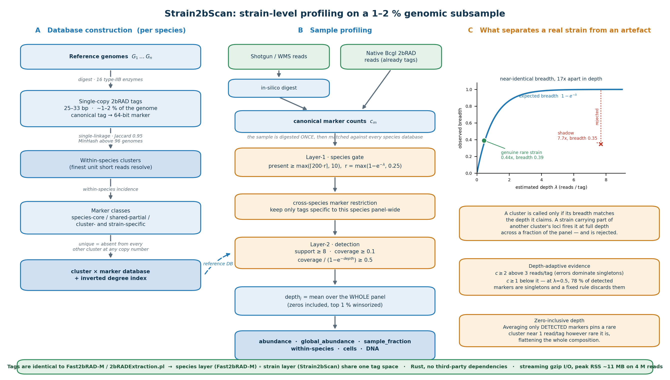
Figure 1. Strain2bScan overview and quality control. (A) Reference construction: type-IIB (2bRAD) digestion into single-copy 25–33 bp tags, within-species clustering at 0.95 Jaccard, marker classification and a cluster × marker database. (B) Profiling: one sample digest, species-level marker gating, cross-species marker restriction, cluster detection and abundance estimation for conventional shotgun or native BcgI input. (C) Depth-breadth consistency separates a genuine low-depth strain from a partial-marker shadow.

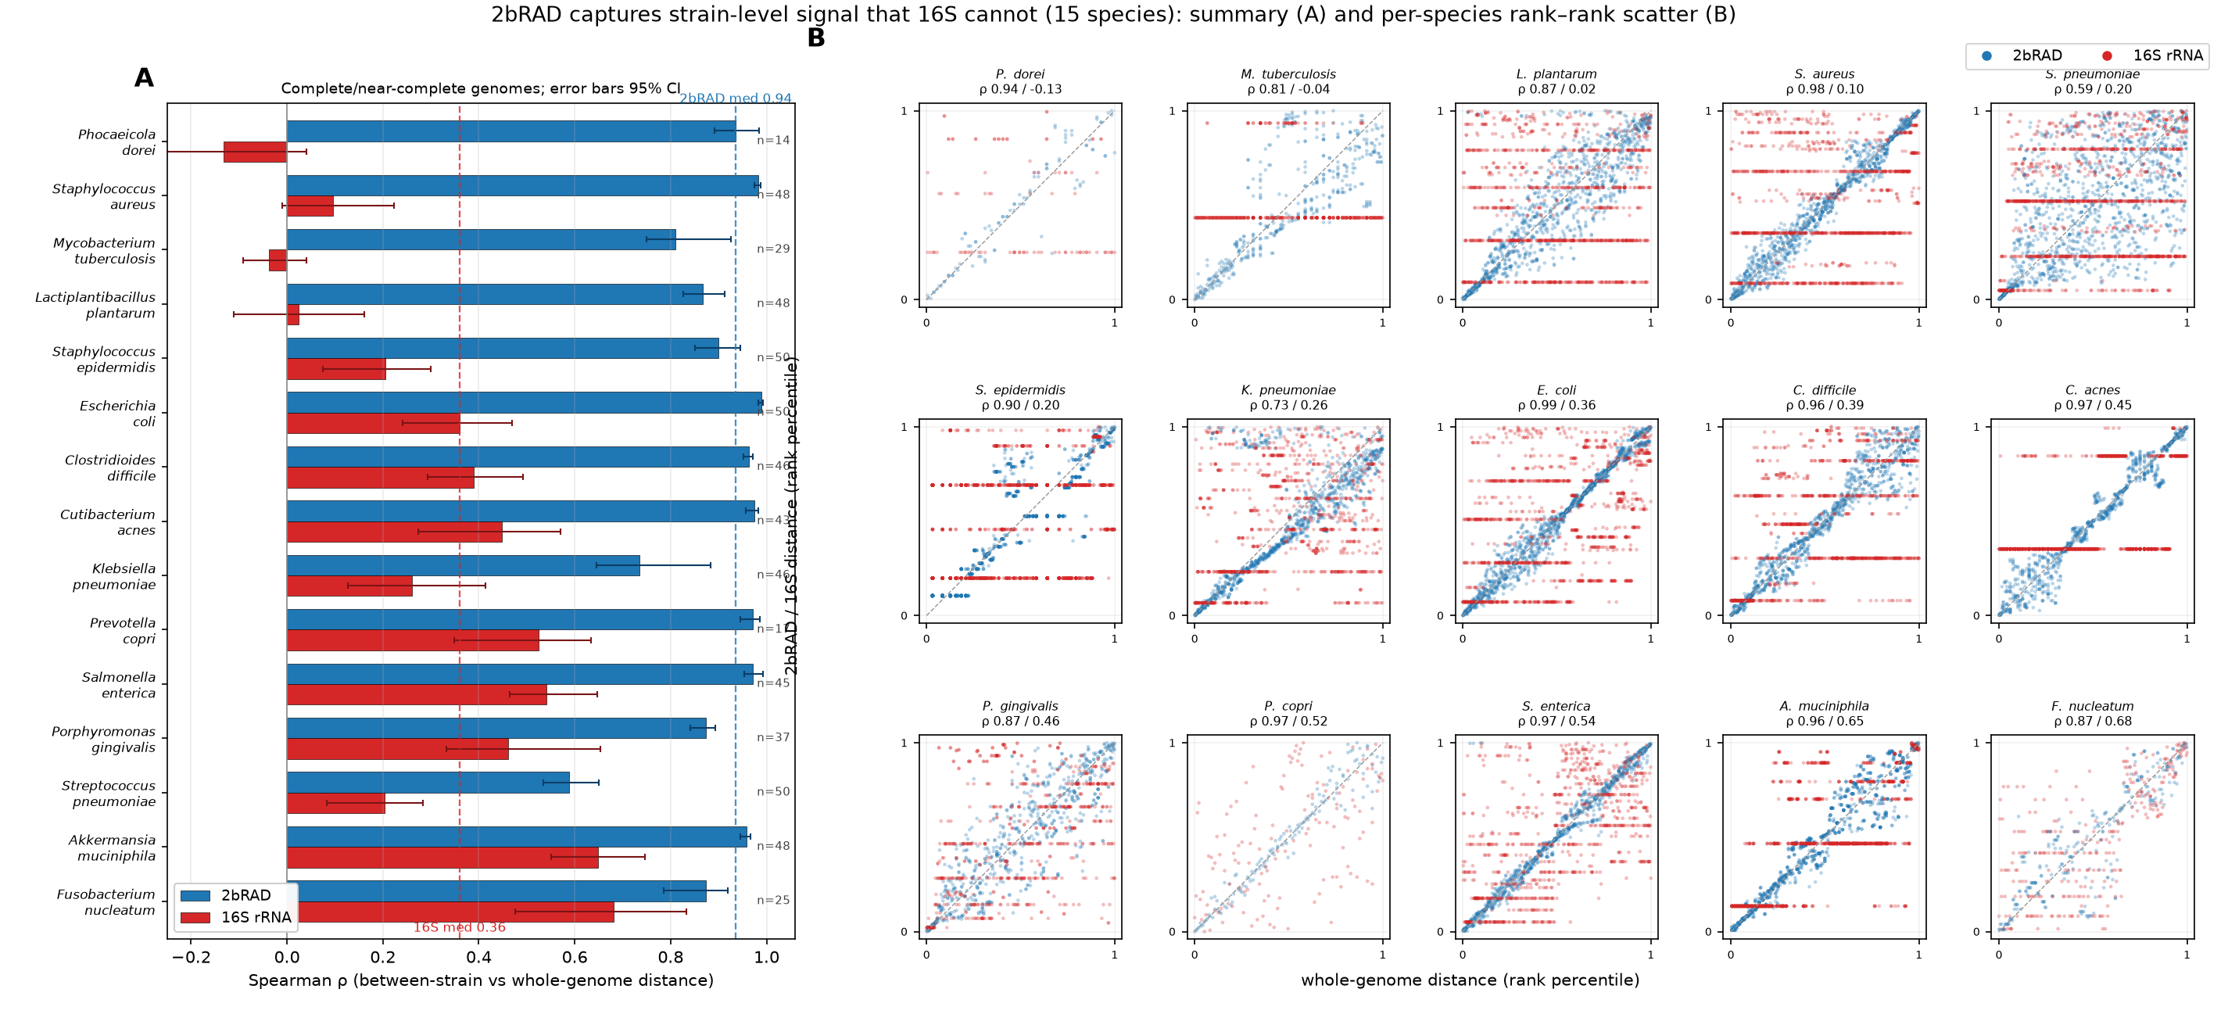
Figure 2. 2bRAD tags track genome-wide strain distance; 16S does not. (A) Per-species Spearman correlation between whole-genome (bottom-3000 21-mer MinHash) between-strain distance and the corresponding 2bRAD-tag (blue) or 16S rRNA (red) distance, across 15 species (complete/near-complete genomes only, CheckM ≥97 %/≤5 %; 14–50 genomes per species, shown at right); error bars are 95 % CIs over genome subsamples; genus and species on separate label lines; 2bRAD median 0.94 vs 16S median 0.36. (B) 3×5 matrix of per-species rank–rank scatters; rank of each strain pair’s whole-genome distance (x) vs its 2bRAD (blue) or 16S (red) distance (y): 2bRAD hugs the diagonal in every species, 16S forms flat rank-bands (most extreme in P. dorei, M. tuberculosis).

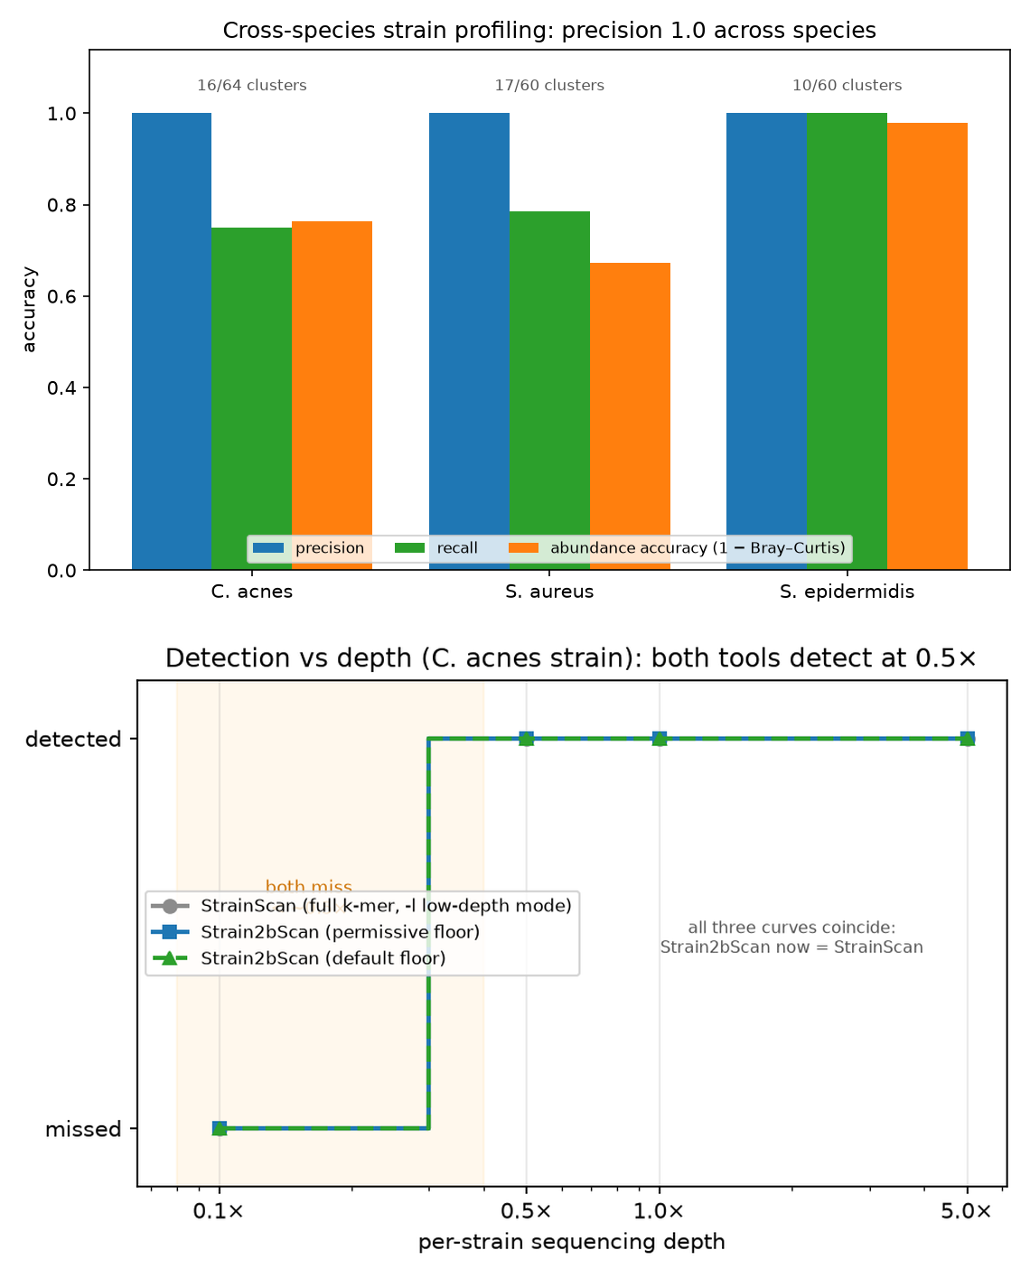
Figure 3. Accurate strain profiling and depth sensitivity. (A) Precision, recall and abundance accuracy across simulated C. acnes, S. aureus and S. epidermidis mixtures. (B) Detection of a single C. acnes strain across a coverage ladder; Strain2bScan and StrainScan both detect at 0.5×.

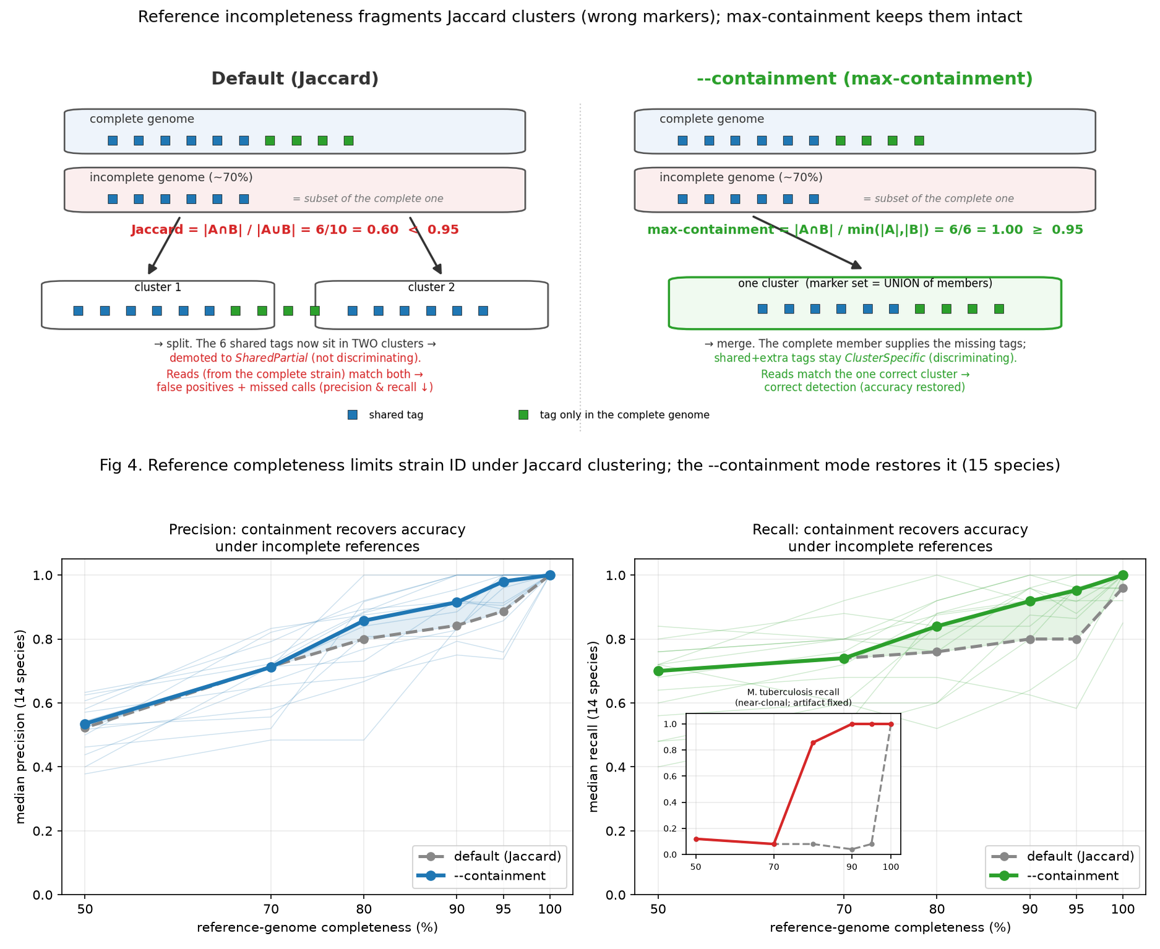
Figure 4. Reference degradation reduces strain-identification accuracy (all 15 species). Sample reads held fixed while the truth strains’ reference genomes are degraded (completeness 100→50 %, with co-varying contamination + fragmentation), DB rebuilt and re-profiled. Problem → mechanism → solution. (A) (containment-mechanism schematic): an incomplete genome’s tags are a subset of a complete relative’s, so Jaccard (6/10 = 0.60) drops below the 0.95 cut and splits them; the shared tags land in two clusters and are demoted to non-discriminating SharedPartial; max-containment (6/6 = 1.0) merges them into one cluster whose marker set is the union of members, so the discriminating ClusterSpecific tags (and the complete member’s markers) are preserved. (B) median precision, (C) median recall vs reference completeness (14 resolvable species; faint lines = per-species containment), comparing default Jaccard clustering (grey dashed) with the --containment mode (solid, shaded gap). Degrading references collapses Jaccard accuracy (precision 1.0→0.84→0.71, recall 0.96→0.80→0.74 at 100→90→70 %) because incomplete genomes split from complete relatives; --containment (max-containment) keeps them together, restoring precision to 0.98/0.92 and recall to 0.95/0.92 at 95/90 %, converging with Jaccard only at ≤70 % (genuinely low-quality). Inset (C): near-clonal M. tuberculosis recall; Jaccard collapses to ≈0.05 on any degradation (single cluster shatters), containment holds 1.0 to 90 % (artifact fixed).

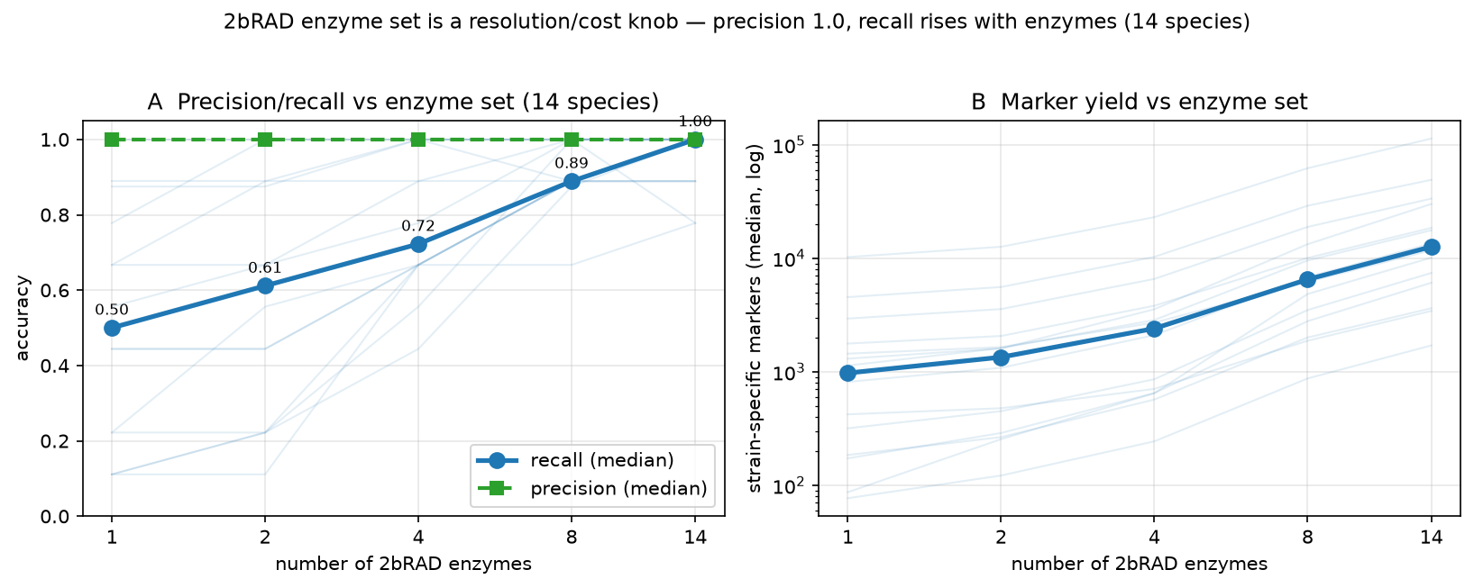
Figure 5. The 2bRAD enzyme set is a resolution/cost knob (14 species). Enzyme ladder 1/2/4/8/14 across all 14 resolvable sim-pool species. (A) median precision (1.0 throughout) and recall (0.50→1.00) vs enzyme number, faint lines per species. (B) strain-specific marker yield vs enzyme number (median 976→12 647). Cluster count is invariant. Single-enzyme BcgI enables native BcgI 2bRAD-M.

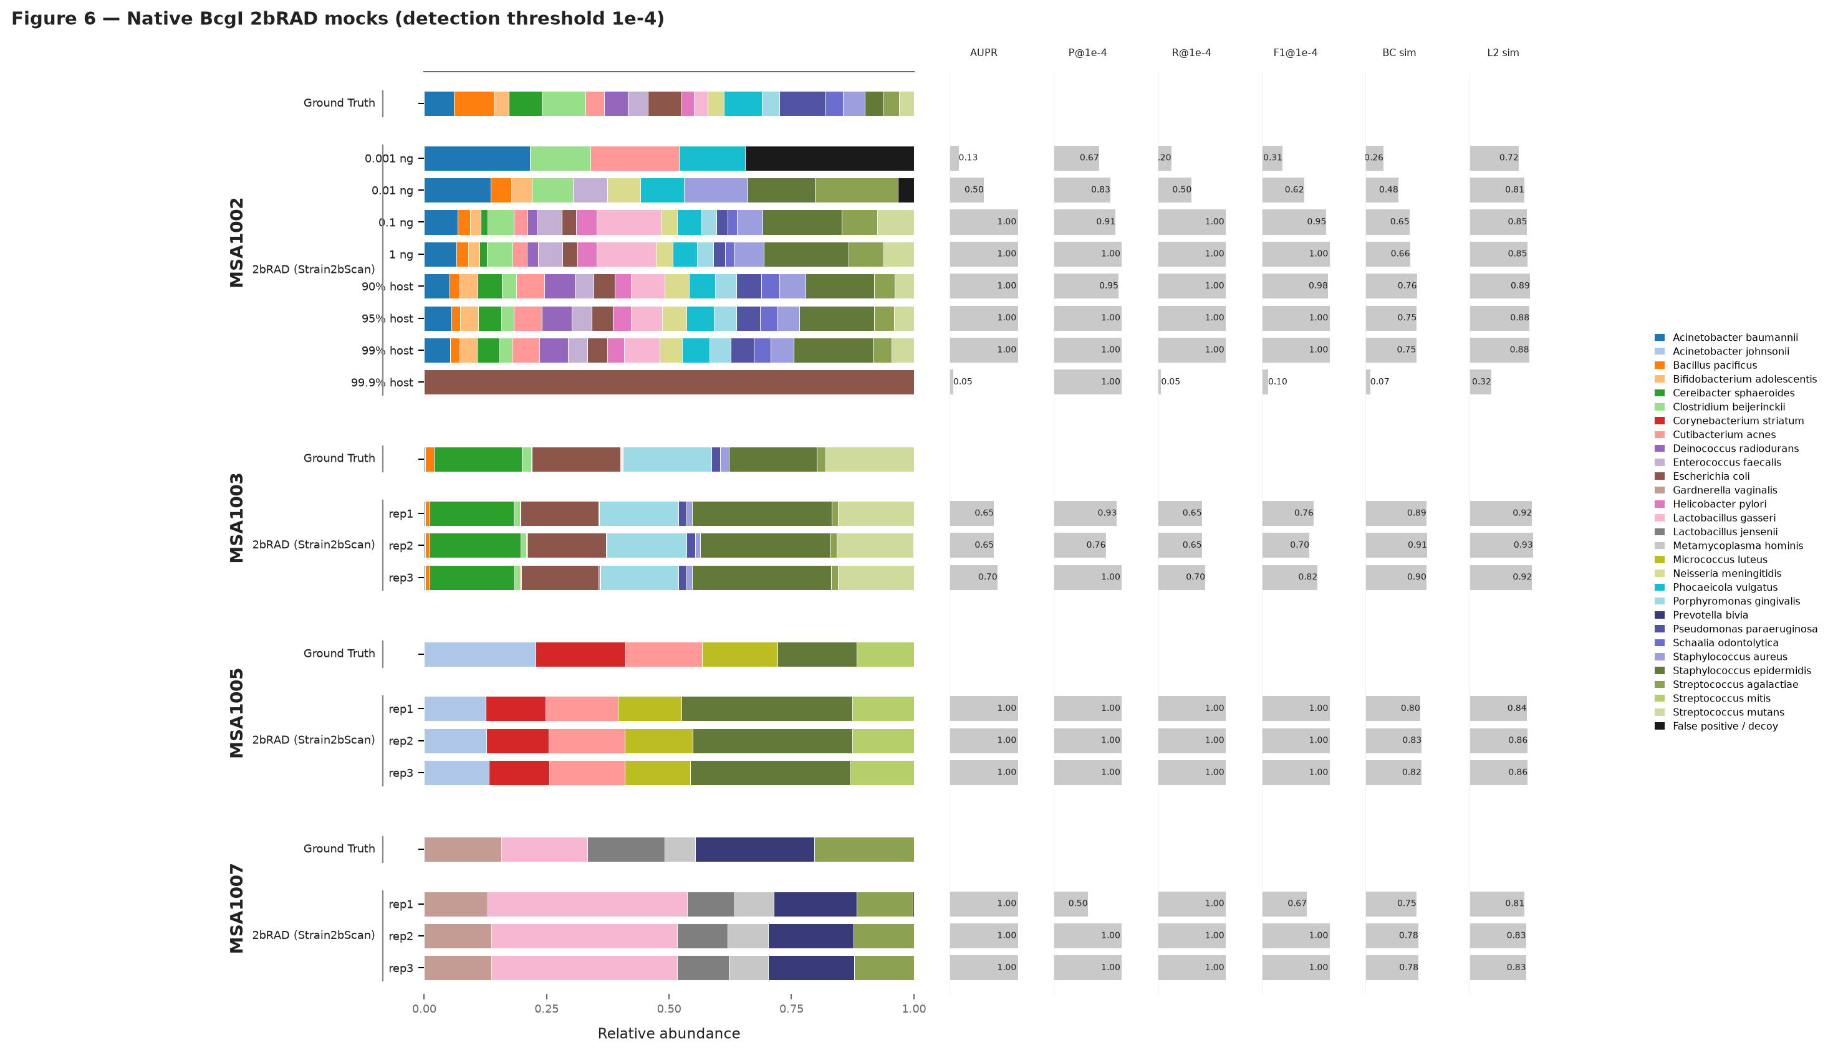
Figure 6. Native BcgI 2bRAD strain-level identification and abundance across four ATCC DNA mocks. Native BcgI reads were profiled against the primary 28-species, 164-genome containment tree (--min-abundance 0 --min-coverage 0.2), with one Strain2bScan row per sample. Right-hand columns show AUPR, precision/recall/F1 at abundance >= 1e-4, Bray-Curtis similarity and L2 similarity. At 1e-4, F1 was 0.952 at 0.1 ng and 0.625 at 0.01 ng; it remained 1.0 at 99% host. MSA-1003 showed the 1x marker-depth noise floor, and MSA-1005/1007 retained recall and AUPR = 1.0.

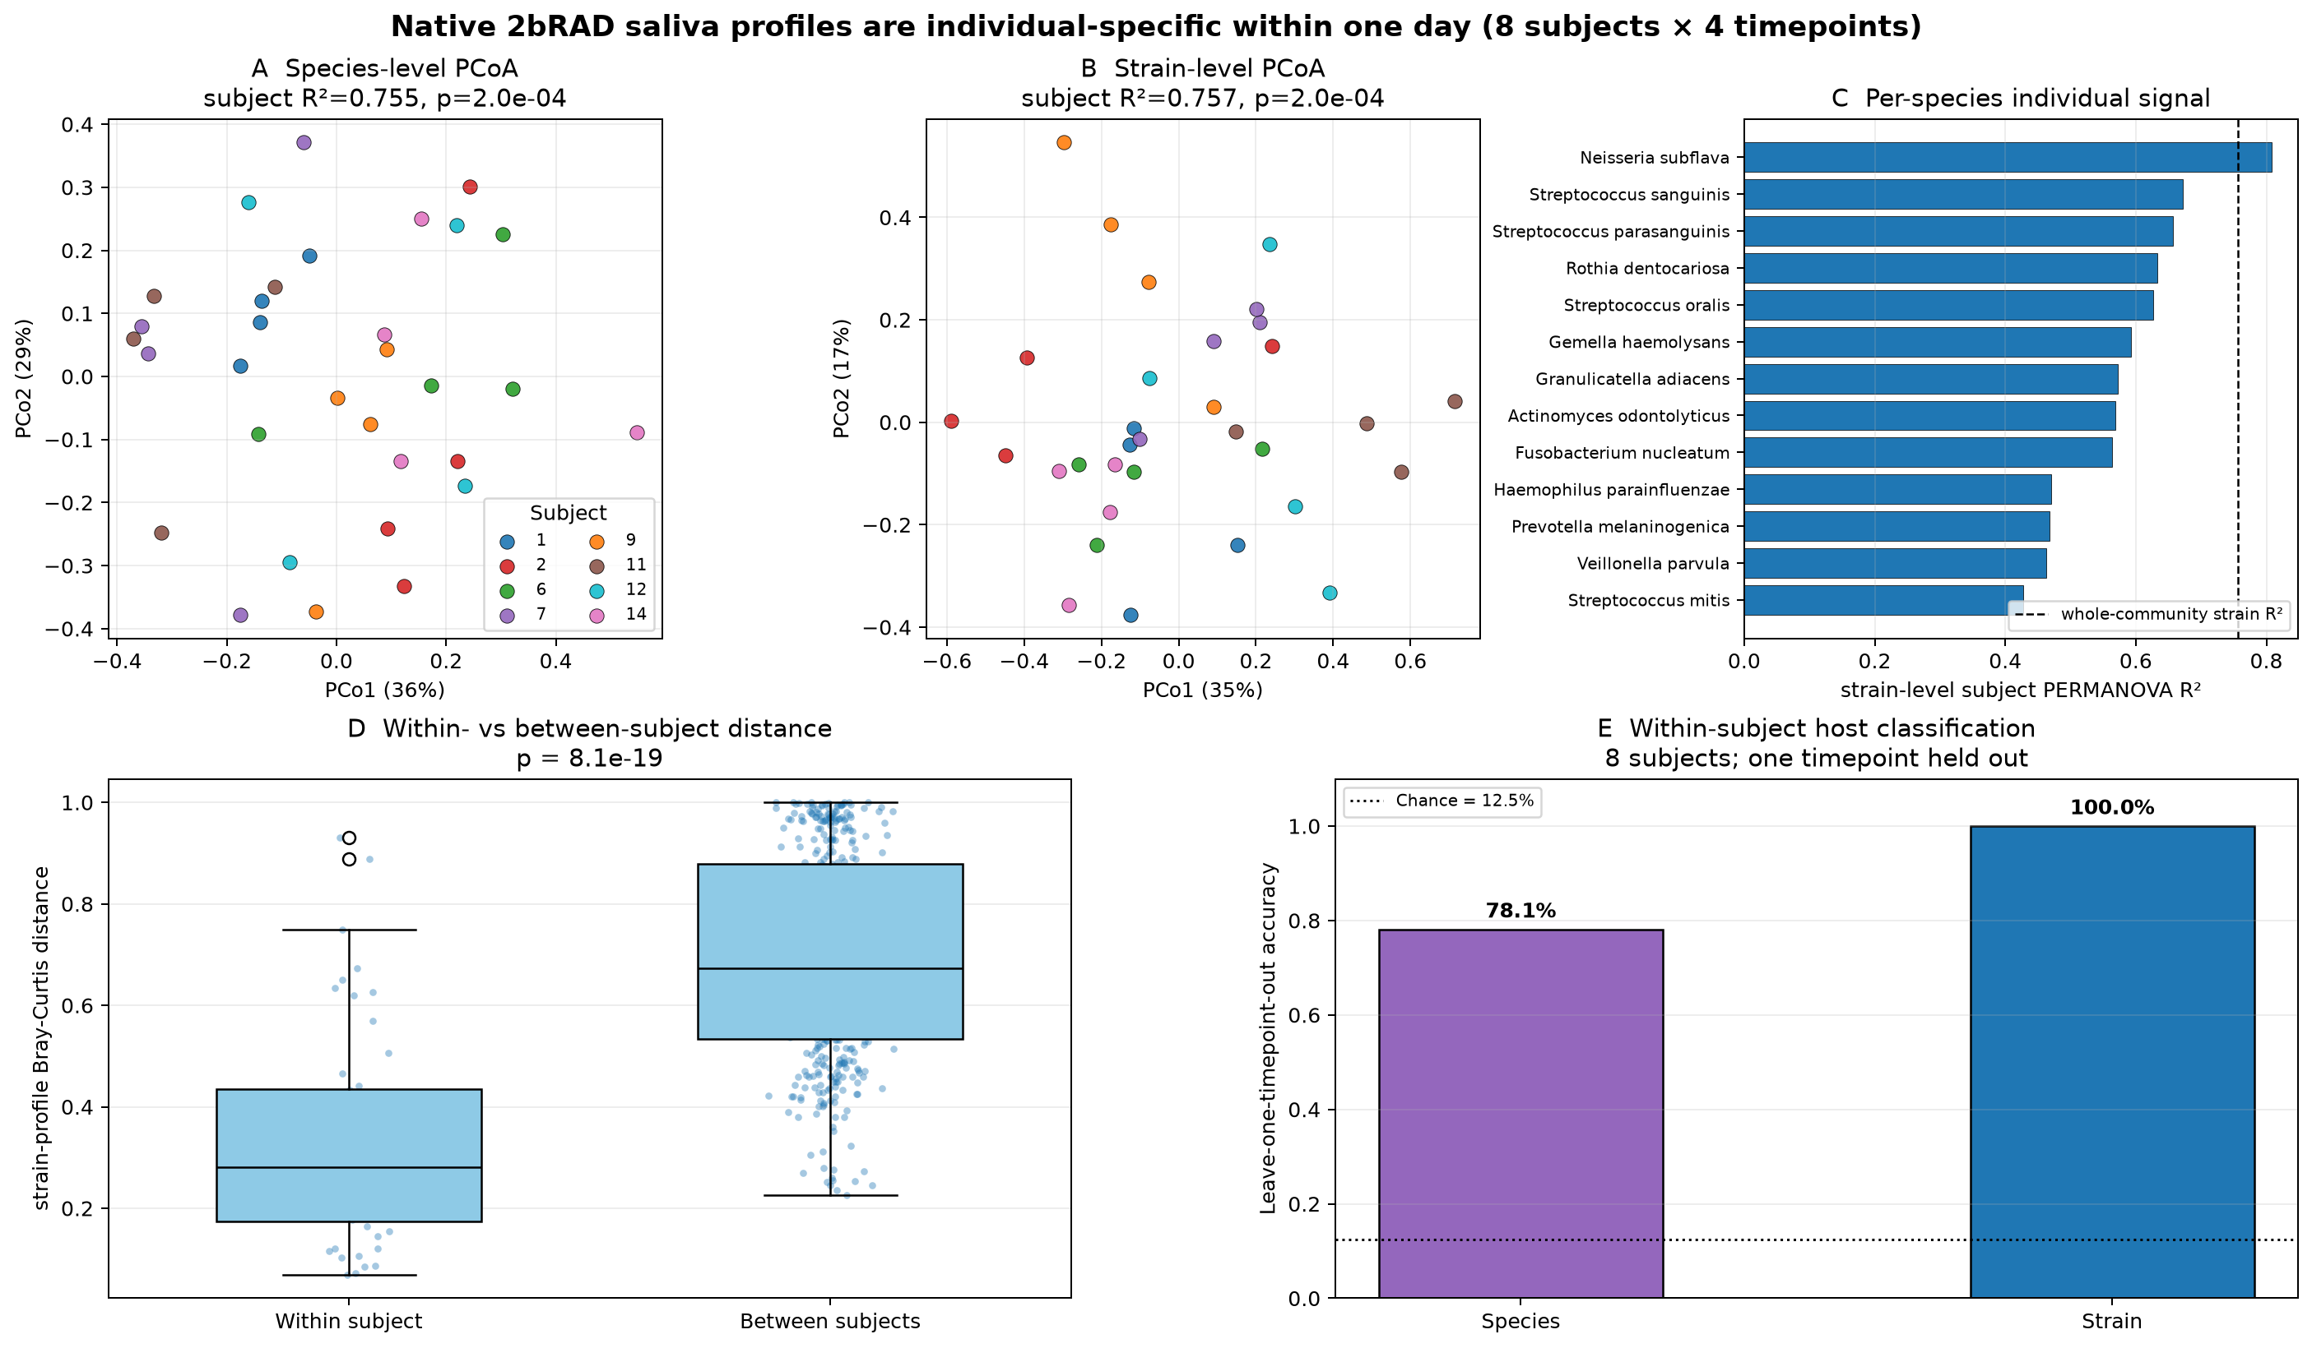
Figure 7. Real saliva: individual-specific, within-day strain signatures. (A,B) Species- and strain-level PCoA coloured by subject. (C) Per-species strain-level subject R². (D) Within- versus between-subject strain Bray-Curtis distance. (E) Leave-one-timepoint-out host classification in eight subjects. This is a small within-subject classifier comparison, not independent strain-identity validation.

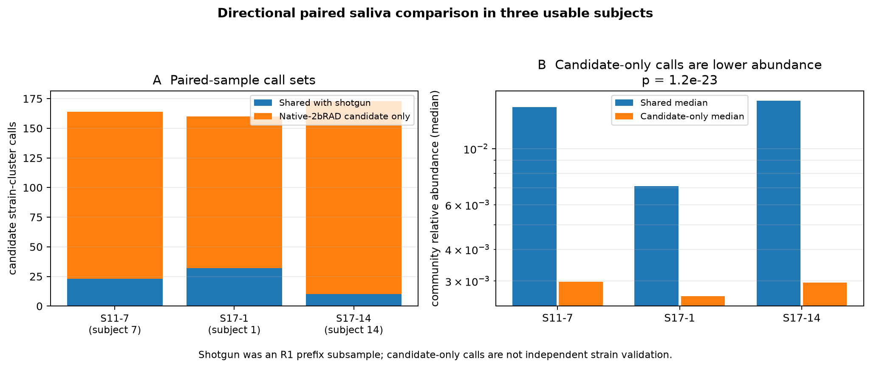
Figure 8. Directional shotgun-native saliva concordance. (A) Per sample, shotgun calls shared with native 2bRAD and additional native-2bRAD candidate calls. (B) Median community relative abundance of shared versus candidate-only native calls. Shotgun was an R1 prefix subsample; candidate calls are not independent strain validation.

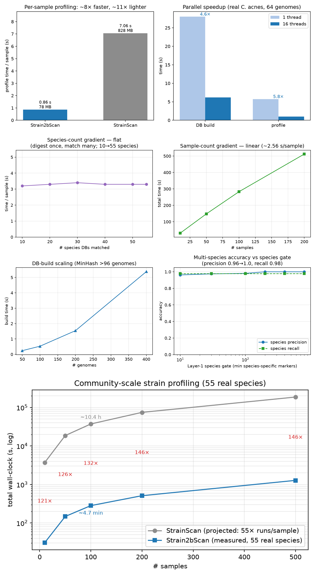
Figure 9. Fast, light, and scalable to whole communities. (A) Per-sample time and memory versus StrainScan. (B) Database-build and profile speedups with 16 threads. (C) Strain2bScan time across a 10-to-55-species gradient. (D) Time across sample counts. (E) MinHash database-build scaling above 96 genomes. (F) Multi-species precision and recall versus the Layer-1 species gate. (G) Measured Strain2bScan community time versus projected per-species StrainScan cost; the 500-sample point is a linear extrapolation.

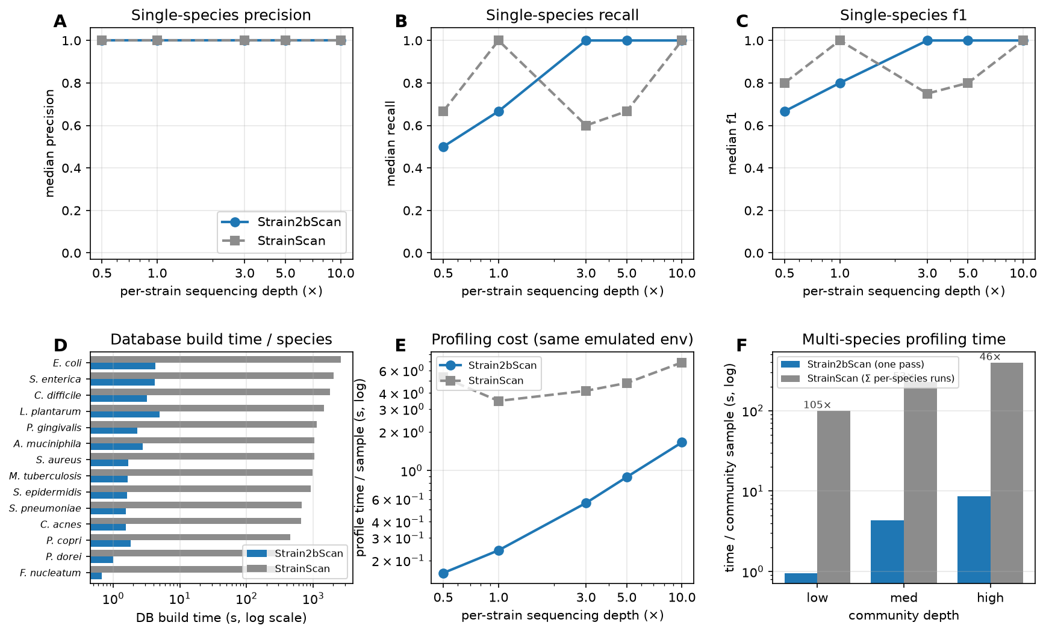
Figure 10. Systematic head-to-head on the 15-species simulated benchmark. Both tools build databases from the same genome pool and profile the same simulated reads, each scored in its own cluster space. (A–C) median single-species precision/recall/F1 vs per-strain sequencing depth (204 completed paired samples across 14 species): both have median precision 1.0; Strain2bScan reaches full median recall at 3× and remains there, whereas StrainScan is non-monotonic. (D) per-species database build time (log): Strain2bScan 0.7–5.1 s vs StrainScan 5–43 min (249–614×). (E) per-sample profile time vs depth in the same emulated container (4–33× faster). (F) multi-species profiling time per community sample; Strain2bScan’s one digest-once pass vs StrainScan’s sum over 14 per-species runs (46–105×).

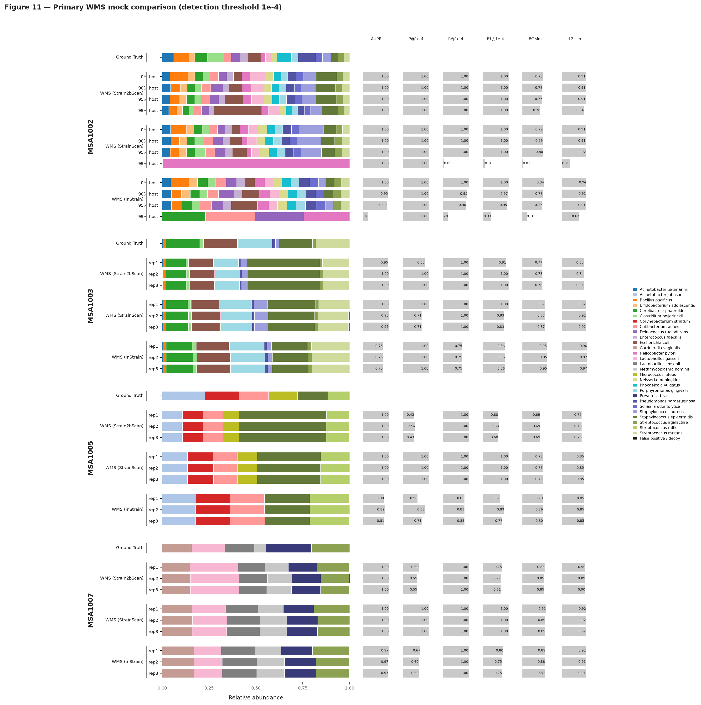
Figure 11. Primary WMS mock comparison: Strain2bScan, StrainScan and inStrain. Whole-metagenome shotgun reads from four ATCC mocks were profiled by the three named tools. Strain2bScan used the primary all-enzyme 164-genome tree; StrainScan used its per-species databases; inStrain used a dereplicated 98%-ANI reference. Each tool was scored in its own 0.95-similarity cluster space, and right-hand columns use abundance >= 1e-4 for P/R/F1. At 99% host, Strain2bScan retained F1 = 1.0 and Bray-Curtis dissimilarity 0.302, whereas StrainScan had F1 = 0.095 and inStrain F1 = 0.333. MSA-1005/1007 show that Strain2bScan retained recall and AUPR = 1.0 but had F1 = 0.60-0.75 because trace-abundance clusters crossed the threshold. Optional trace-gap and port-layer runs are archived as sensitivity outputs but are not shown. ## Supplementary figures and tables

Supplementary figures

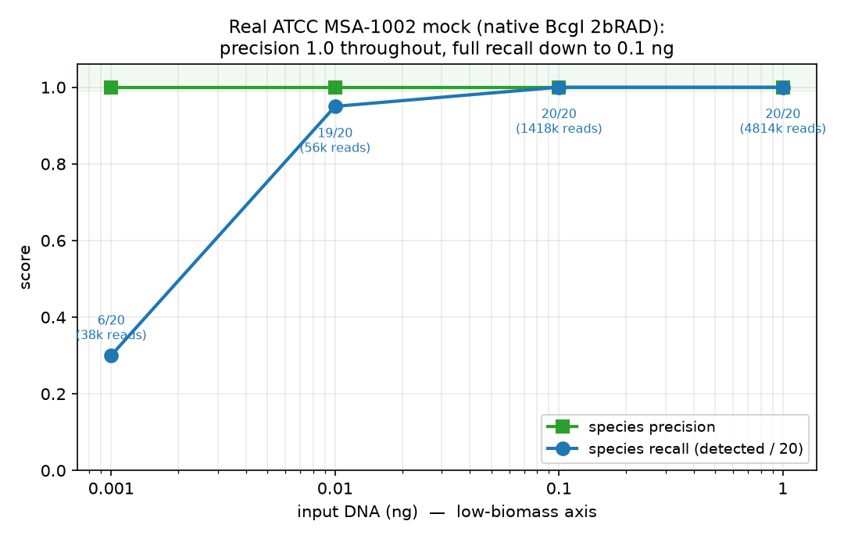
Figure S1. ATCC MSA-1002 DNA-input titration (native BcgI 2bRAD-M). precision 1.0 and full recall to 0.1 ng input.

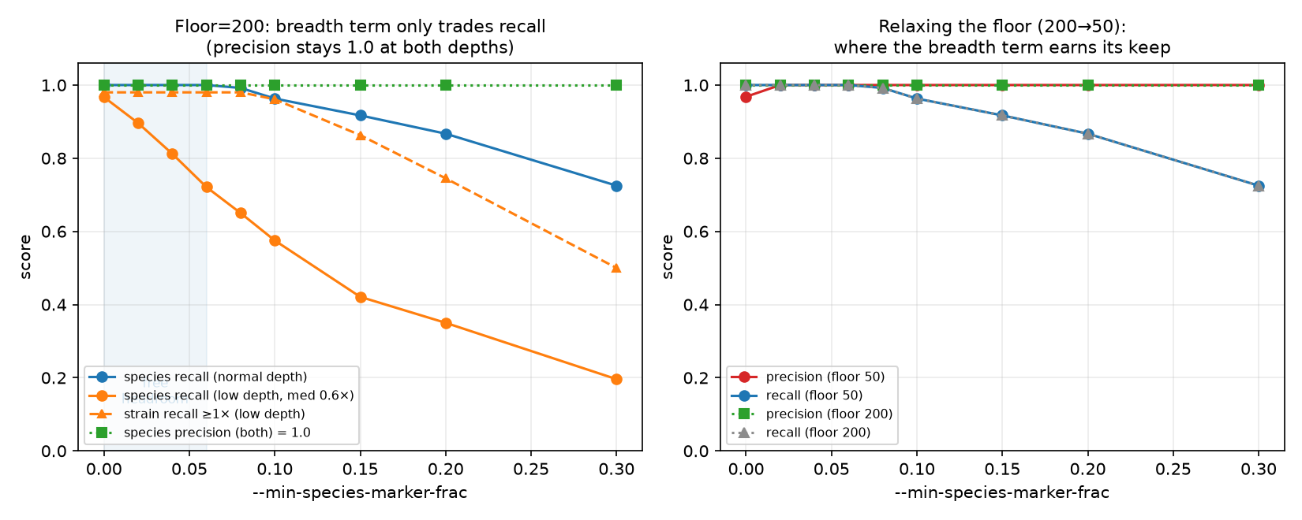
Figure S2. Layer-1 gate calibration on the 55-species panel. species precision/recall vs the marker floor at normal and low depth.

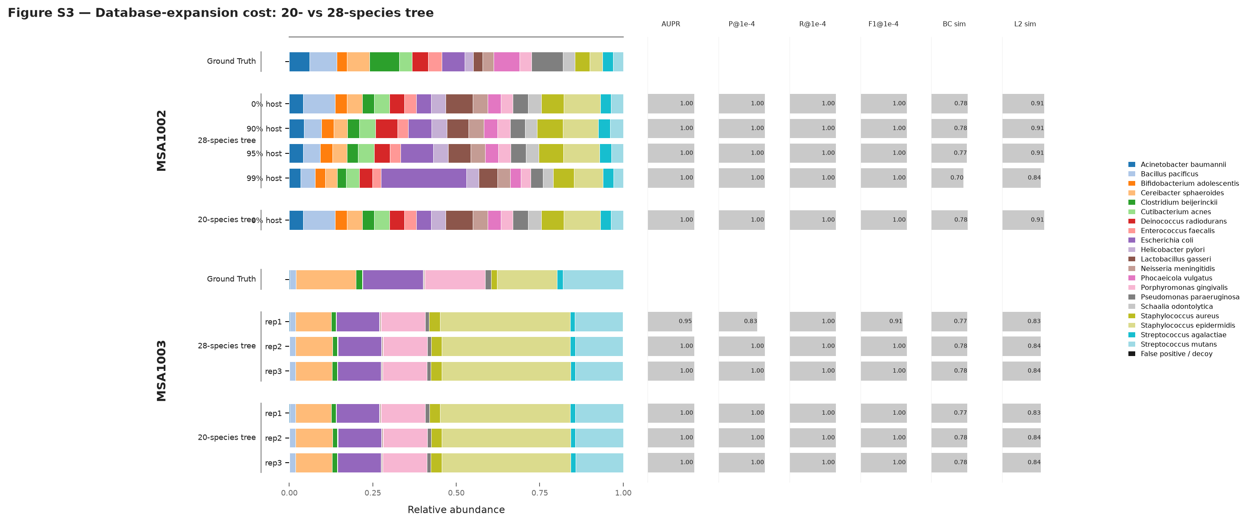
Figure S3. Cost of unified-database expansion (20- vs 28-species combined tree). Same row-per-sample layout as Fig 6/11, WMS modality: Strain2bScan on the 20-species (120) vs 28-species (164) combined tree, for the mocks present in both (MSA-1002, MSA-1003). MSA-1002 (even) is identical on both trees; DB expansion costs nothing when strains are well above the marker-depth floor, even under host. MSA-1003 (staggered) has one lower-threshold replicate on the 28-species tree (precision 0.83), whereas all three 20-species-tree replicates remain at 1.00; AUPR stays approximately 0.95–1.00 either way; the cost is confined to the ~1× noise floor.

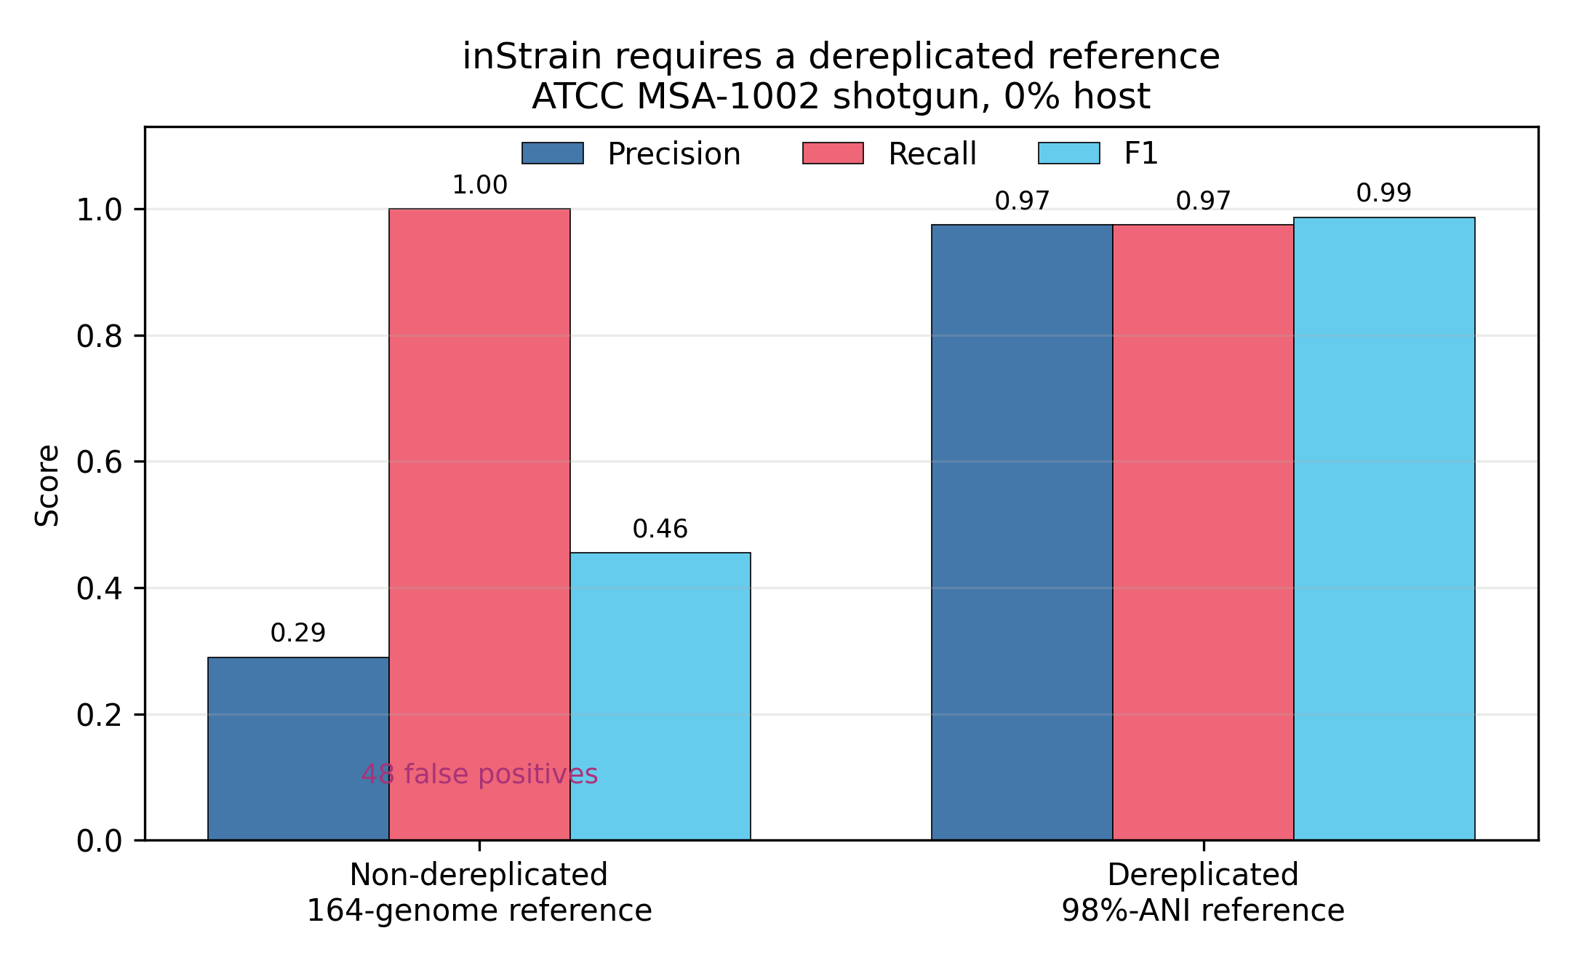
Figure S4. inStrain requires a dereplicated reference (MSA-1002 shotgun). (generated 2026-10-02 from the archived metrics table and the non-dereplicated reference control). inStrain on the non-dereplicated 164-genome reference vs a 98 %-ANI dereplicated reference in the MSA-1002 0%-host shotgun control. The non-dereplicated reference multi-maps reads across the > 95 %-ANI decoys and inflates false positives (precision 0.29; recall 1.00; F1 0.46); dereplication restores precision to 0.97, recall to 0.97 and F1 to 0.99. This is why Fig 11 reports inStrain on its documented dereplicated reference.

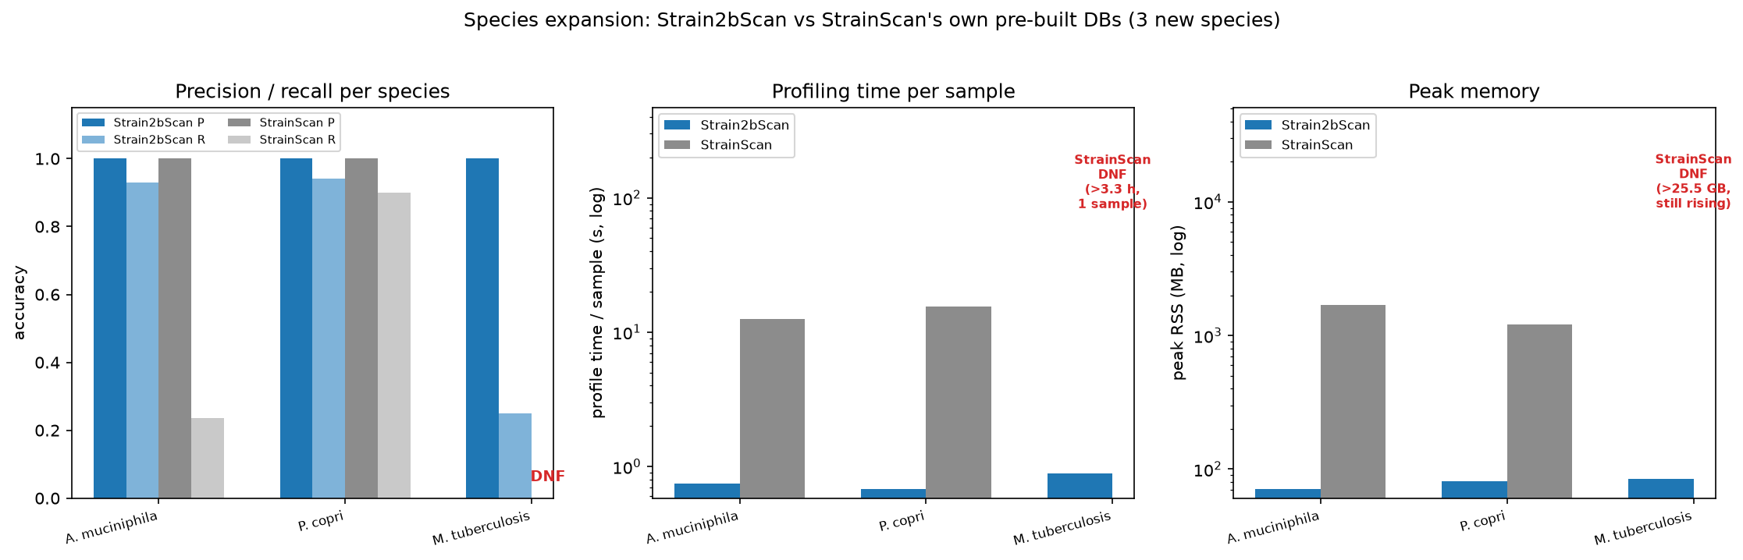
Figure S5. Matches or exceeds StrainScan on its own databases. (demoted from the former main Figure 10): head-to-head on StrainScan’s reference sets: A. muciniphila, P. copri (precision 1.0 both; recall 0.93 vs 0.24, 0.94 vs 0.90; ~17–23× faster, ~15–24× lighter) and near-clonal M. tuberculosis, where StrainScan did not complete (>3.3 h, >25 GB) and Strain2bScan finished in 0.89 s.

Tables

Table 1. Reproducible StrainScan-rerun accuracy on the 15-species simulated benchmark. Accuracy is the median over completed run-level paired samples (different-cluster mixtures for 14 species; same-cluster mixtures for near-clonal M. tuberculosis; k = 2/3/5; depths 0.5–10×); each tool was scored in its own 0.95-similarity cluster space. Cluster-count columns are each tool’s own 0.95 partitions of the common species pool. Build cost is the archived timing benchmark (Strain2bScan native arm64; StrainScan linux/amd64 under emulation). S. enterica produced no completed StrainScan calls in the rerun; K. pneumoniae, which did not finish in the archived timing run, was successfully built and profiled in the reproducible rerun.
Species | Paired n | Pool genomes | S2B clusters | SS clusters | S2B P | S2B R | S2B F1 | SS P | SS R | SS F1 | S2B build | SS build
A. muciniphila | 14 | 50 | 24 | 24 | 1.000 | 0.800 | 0.889 | 1.000 | 1.000 | 1.000 | 2.8 s / 0.16 GB | 17 min / 16 GB
C. difficile | 15 | 47 | 27 | 24 | 1.000 | 0.800 | 0.889 | 1.000 | 0.667 | 0.800 | 3.2 s / 0.28 GB | 30 min / 14 GB
C. acnes | 15 | 43 | 8 | 8 | 1.000 | 0.667 | 0.800 | 1.000 | 0.800 | 0.889 | 1.5 s / 0.17 GB | 11 min / 8 GB
E. coli | 15 | 50 | 30 | 27 | 1.000 | 1.000 | 1.000 | 1.000 | 0.800 | 0.889 | 4.3 s / 0.34 GB | 43 min / 28 GB
F. nucleatum | 15 | 25 | 19 | 19 | 1.000 | 1.000 | 1.000 | 1.000 | 0.667 | 0.800 | 0.7 s / 0.10 GB | 5 min / 8 GB
K. pneumoniae | 15 | 47 | 28 | 27 | 1.000 | 0.600 | 0.750 | 1.000 | 0.800 | 0.889 | 5.1 s / 0.40 GB | DNF (timing run)
L. plantarum | 15 | 50 | 39 | 39 | 1.000 | 1.000 | 1.000 | 1.000 | 0.800 | 0.889 | 5.0 s / 0.24 GB | 24 min / 18 GB
M. tuberculosis | 15 | 29 | 1 | 1 | 1.000 | 1.000 | 1.000 | 1.000 | 1.000 | 1.000 | 1.6 s / 0.25 GB | 16 min / 15 GB
P. dorei | 10 | 15 | 10 | 10 | 1.000 | 0.667 | 0.800 | 1.000 | 0.667 | 0.800 | 1.0 s / 0.25 GB | 5 min / 13 GB
P. gingivalis | 15 | 43 | 27 | 31 | 1.000 | 0.667 | 0.800 | 1.000 | 0.667 | 0.800 | 2.3 s / 0.15 GB | 19 min / 11 GB
P. copri | 15 | 19 | 19 | 19 | 1.000 | 1.000 | 1.000 | 1.000 | 0.667 | 0.800 | 1.8 s / 0.19 GB | 8 min / 26 GB
S. enterica | 0 | 45 | 19 | 12 | – | – | – | – | – | – | 4.2 s / 0.37 GB | 34 min / 16 GB
S. aureus | 15 | 48 | 13 | 12 | 1.000 | 0.667 | 0.800 | 1.000 | 0.667 | 0.800 | 1.7 s / 0.17 GB | 17 min / 12 GB
S. epidermidis | 15 | 50 | 9 | 9 | 1.000 | 0.667 | 0.800 | 1.000 | 0.667 | 0.800 | 1.6 s / 0.14 GB | 15 min / 8 GB
S. pneumoniae | 15 | 50 | 38 | 38 | 1.000 | 0.667 | 0.800 | 1.000 | 0.667 | 0.800 | 1.5 s / 0.16 GB | 11 min / 11 GB
Median across 14 species with completed paired runs: Strain2bScan P 1.000 / R 0.733 / F1 0.844; StrainScan P 1.000 / R 0.667 / F1 0.800. The species-cluster bootstrap paired mean differences and 95% intervals are in results/uncertainty_summary.tsv.

Table S4. Failure-aware sensitivity for all 225 matched single-species entries. Absent StrainScan final reports were retained and scored as zero detection. Mean paired differences use the same species-cluster bootstrap as the completed-pair analysis. Source: results/strainscan_rerun/single_all225_persample.tsv and results/strainscan_rerun/sensitivity_failure_as_absence.tsv.
Analysis | n | No-calls | S2B median P/R/F1 | SS median P/R/F1 | Mean recall difference (95% CI) | Mean F1 difference (95% CI)
Completed pairs | 204 | 0 | 1.000/0.733/0.844 | 1.000/0.667/0.800 | −0.014 (−0.065 to 0.033) | −0.023 (−0.062 to 0.013)
Failure as absence | 225 | 21 | 1.000/0.800/0.889 | 1.000/0.667/0.800 | +0.065 (−0.034 to 0.197) | +0.062 (−0.036 to 0.202)

Table 2. Accuracy and archived per-sample cost vs sequencing depth (single-species rerun; medians). Accuracy is restricted to the 204 completed run-level StrainScan pairs. Cost comes from the archived same-environment emulation subset (Strain2bScan linux/amd64 vs StrainScan).
Depth (×) | n | S2B P/R/F1 | SS P/R/F1 | S2B time/mem | SS time/mem
0.5 | 40 | 1.000/0.500/0.667 | 1.000/0.667/0.800 | 0.16 s / 21 MB | 5.30 s / 831 MB
1 | 41 | 1.000/0.667/0.800 | 1.000/1.000/1.000 | 0.24 s / 30 MB | 3.48 s / 831 MB
3 | 41 | 1.000/1.000/1.000 | 1.000/0.600/0.750 | 0.56 s / 60 MB | 4.17 s / 831 MB
5 | 41 | 1.000/1.000/1.000 | 1.000/0.667/0.800 | 0.89 s / 91 MB | 4.79 s / 831 MB
10 | 41 | 1.000/1.000/1.000 | 1.000/1.000/1.000 | 1.66 s / 161 MB | 6.92 s / 832 MB
Strain2bScan reached median recall 1.0 at 3× and remained there; StrainScan was non-monotonic (full median recall at 1× and 10×, but not at intermediate depths). The depth table aggregates heterogeneous strain mixtures and is not a causal depth-onset estimate.

Table 3. Multi-species community accuracy (reproducible rerun; medians) and archived profiling cost. Four samples per depth. Strain2bScan profiles each community in one digest-once pass; StrainScan has no multi-species mode, so archived cost is the sum over per-species runs.
Community depth | S2B P/R/F1 | SS P/R/F1 | S2B time/mem | SS time/mem
low | 0.872/0.650/0.741 | 0.938/0.702/0.798 | 1.0 s / 311 MB | 100 s / 1112 MB
med | 0.857/0.868/0.860 | 0.954/0.903/0.927 | 4.3 s / 670 MB | 228 s / 1696 MB
high | 0.778/0.884/0.827 | 0.972/0.958/0.965 | 8.7 s / 1119 MB | 398 s / 2028 MB
Of 180 species-by-community opportunities (15 databases × 12 samples), 158 StrainScan final reports were generated; absent reports were treated as no detection. The per-sample coverage audit is in results/strainscan_rerun/multi_persample.tsv.

Table 4. Public real-metagenome application subsets profiled with Strain2bScan. These were informative application subsets rather than complete cohort analyses. The generic panel was the legacy 20-species MSA database; calls used all-enzyme mode with --min-species-markers 20 --min-species-detect 2 --min-support 2 --min-coverage 0.01 --min-abundance 0.
Project | Design and selected libraries | Calls | Observation
PRJNA288562 | Pregnancy subject T23; saliva, vaginal swab and distal gut at GD84 and GD273 (6 WGS libraries) | 34 calls in 5/6 libraries | Saliva was cluster-rich; four Neisseria and four Schaalia clusters were shared across timepoints. Gut B. adolescentis C4 persisted, whereas three other Bifidobacterium clusters and three E. coli clusters were GD84-only.
PRJNA1517970 | Preterm-birth vaginal/meconium subset plus extraction blank (7 WGS libraries) | 0 calls with the MSA panel; 0 calls with a 13-species body-site panel | The blank had 340 distinct markers, and selected libraries had 7,394–86,980. At a one-marker diagnostic gate, one meconium library showed only three C. acnes markers, supporting specificity while also indicating incomplete niche coverage.
PRJNA1191223 | Preterm infant P08 stool at W1, W2 and W3 (3 WGS libraries) | 9 generic-panel calls | Generic panel showed weekly turnover: one S. aureus cluster (W1), two E. coli clusters (W2), and six E. faecalis clusters (W3).
PRJNA1191225 | Six preterm-infant isolate WGS read sets used for cohort-panel validation | 6/6 expected self-calls | The cohort-specific panel recovered all expected E. coli clusters or Bifidobacterium species units.

Table 5. Isolate assemblies and cohort-specific panel validation. Isolates were assembled with SPAdes --isolate. E. coli assemblies were clustered at 0.95 similarity; each Bifidobacterium species was built as a single-genome database. All isolate read sets recovered the expected panel unit.
Isolate | Species | Contigs | Assembly (Mb) | N50 (kb) | Panel unit | Panel markers | Self-call
LHCA45 | Escherichia coli | 185 | 4.96 | 240.0 | C0 | 7,786 unique | ✓
LHCA56 | Escherichia coli | 448 | 5.15 | 222.6 | C1 | 5,466 unique | ✓
LHCA72 | Escherichia coli | 457 | 5.04 | 159.2 | C2 | 5,665 unique | ✓
LHCA43 | Bifidobacterium longum | 164 | 2.36 | 55.6 | LHCA43 | 18,426 | ✓
LHCA81 | Bifidobacterium breve | 90 | 2.39 | 228.3 | LHCA81 | 19,214 | ✓
LHCA82 | Bifidobacterium bifidum | 180 | 2.30 | 75.6 | LHCA82 | 17,985 | ✓

Table 6. P08 weekly stool profiling with the cohort-specific isolate panel. Breadth is database coverage; abundance is within-species abundance in Strain2bScan output.
Week | Species | Panel unit | Breadth | Depth (×) | Abundance | Fraction of sample
W1 | Bifidobacterium bifidum | LHCA82 | 0.764 | 236.7 | 1.000 | 0.6456
W2 | Bifidobacterium bifidum | LHCA82 | 0.773 | 213.9 | 1.000 | 0.5834
W2 | Escherichia coli | C0|C1|C2 | 0.026 | 0.029 | 1.000 | 0.000140
W3 | Bifidobacterium bifidum | LHCA82 | 0.792 | 238.2 | 1.000 | 0.6099
The generic MSA panel detected the W2 E. coli signal as two low-abundance generic clusters (fraction 6.1 × 10⁻⁵ and 5.7 × 10⁻⁵) but did not contain the persistent B. bifidum LHCA82 unit. This contrast illustrates why body-site- or cohort-specific panels are needed for biological interpretation.

Table 7. Leave-one-isolate-out behaviour for the three Escherichia coli panel isolates. For each test, the held-out isolate was absent from the database. Reads were profiled against a panel containing the other two E. coli assemblies and the three Bifidobacterium species controls.
Held-out isolate | E. coli genomes in panel | Observed E. coli unit | Breadth | Depth (×) | Fraction of sample | Interpretation
LHCA45 | 2 | C0|C1 | 0.799 | 7.87 | 0.612 | Reads from the absent isolate were assigned to merged relatives rather than creating a false third cluster.
LHCA56 | 2 | C0|C1 | 0.911 | 10.55 | 0.649 | Same conspecific-assignment behaviour.
LHCA72 | 2 | C0|C1 | 0.891 | 7.25 | 0.729 | Same conspecific-assignment behaviour.
This test shows that closed panels can misattribute a truly absent conspecific strain to near relatives. It therefore supports the paper’s conservative treatment of the low-coverage W2 E. coli signal as an unresolved C0|C1|C2 unit rather than assigning it to one isolate.

Table 8. Comparator and assay scope. This table distinguishes tools executed in the benchmark from related tools discussed for context. It is a scope statement, not a performance comparison. Native 2bRAD denotes BcgI-derived experimental libraries; shotgun denotes conventional WMS reads, which Strain2bScan can also process after in-silico digestion.
Tool | Executed here | Input scope | Typical resolution | Scope and role
Strain2bScan | Yes | Native BcgI 2bRAD reads and in-silico-digested shotgun reads | Strain clusters | Method under test; one marker framework supports both reduced-representation and shotgun input.
StrainScan v1.0.14 | Yes | Shotgun reads against per-species reference databases | Strain clusters | Direct reference-guided comparator on shotgun reads (Fig 10–11, Supplementary Fig S5; Tables 1–3).
inStrain v1.9.1 | Yes | Shotgun reads aligned to a dereplicated reference | Strain and SNV | Direct read-level shotgun comparator (Fig 11 and Fig S4).
StrainGE / StrainGST / StrainGR | StrainGST only | Shotgun WMS reads against StrainGE 0.90-reference databases; native BcgI 2bRAD is not documented input | Strain level, reference guided | Related shotgun comparator rerun in Table 9; StrainGR was not run.
2bRAD-M / Fast2bRAD-M | No | Native BcgI 2bRAD reads | Mainly species | Same restriction-assay family; provides the species-level upstream context for Strain2bScan.
sylph | No | Shotgun sketches | Mainly species and ANI | Context for rapid species-level profiling; not a strain-resolved benchmark here.
StrainPhlAn | No | Shotgun marker genes | Strain types | Context for marker-gene strain profiling; not rerun here.

Table 9. StrainGST (StrainGE 1.3.9) rerun accuracy and efficiency. Simulations are the matched _rep1_ subset and all 12 multi-species communities. Mocks are the primary WMS replicate used in Figure 11; MSA-1002 is the 99%-host sample. Accuracy is in StrainGE’s 0.90-reference space; mock calls use abundance >= 1e-4. Wall time is one sample k-merization plus all per-species StrainGST searches; RSS is the maximum across those stages. StrainGR was not run.
Dataset | n | Precision | Recall | F1 | Median wall time/sample (s) | Median peak RSS/sample (GB)
Simulated single-species | 225 | 1.000 | 1.000 | 1.000 | 18.66 | 1.30
Simulated multi-species | 12 | 0.901 | 1.000 | 0.941 | 236.98 | 7.90
MSA-1002, 99% host | 1 | 0.700 | 0.700 | 0.700 | 1007.22 | 14.36
MSA-1003 | 1 | 0.464 | 0.650 | 0.542 | 2158.75 | 21.52
MSA-1005 | 1 | 0.333 | 0.833 | 0.476 | 1784.50 | 20.10
MSA-1007 | 1 | 0.429 | 1.000 | 0.600 | 1555.76 | 17.69

Table S3. Exploratory native BcgI 2bRAD-M oral-library profiling. Four libraries from the PRJNA1131785 exploratory oral cohort were profiled against the same 19-species panel used for the saliva analysis. No case/control labels were available in public metadata. Values are from results/clinical_exploratory.tsv.
Sample | Distinct markers | Species resolved | Strain calls | Runtime (s) | Top species
S_0313206 | 271,322 | 15 | 115 | 2.3 | Neisseria subflava; Haemophilus parainfluenzae; Actinomyces odontolyticus
S_1413231 | 288,019 | 17 | 129 | 1.8 | Neisseria subflava; Streptococcus mitis; Actinomyces odontolyticus
S_8123213 | 370,379 | 16 | 149 | 2.0 | Actinomyces odontolyticus; Neisseria subflava; Haemophilus parainfluenzae
S_8221232 | 488,180 | 17 | 158 | 1.8 | Actinomyces odontolyticus; Neisseria subflava; Rothia mucilaginosa

Table S5. Public-run manifest and exploratory profiling outcomes. SRA spots, bases and instrument metadata were retrieved from NCBI on 2026-10-11. Marker and call counts are from the generic MSA screen; body-site-panel calls are shown for PRJNA1517970. P08 run-to-week mapping follows SRA submitter titles. Source: results/realworld_cohort_benchmark/public_run_manifest.tsv.
Run | Project | Role/site | SRA spots | SRA bases | MSA markers | MSA strain calls | Body-site calls
SRR32121885 | PRJNA1191223 | preterm infant P08 stool W1 | 4,862,900 | 1,215,725,000 | 748,209 | 1 | –
SRR32121884 | PRJNA1191223 | preterm infant P08 stool W2 | 4,684,342 | 1,171,085,500 | 694,111 | 2 | –
SRR32121883 | PRJNA1191223 | preterm infant P08 stool W3 | 4,403,456 | 1,100,864,000 | 830,986 | 6 | –
SRR32076429 | PRJNA1191225 | Bifidobacterium bifidum LHCA82 isolate WGS | 265,039 | 78,810,882 | 129,681 | 0 | –
SRR32076422 | PRJNA1191225 | Bifidobacterium breve LHCA81 isolate WGS | 292,272 | 87,006,759 | 142,707 | 0 | –
SRR32076444 | PRJNA1191225 | Bifidobacterium longum LHCA43 isolate WGS | 117,024 | 34,917,748 | 65,183 | 0 | –
SRR32076385 | PRJNA1191225 | Escherichia coli LHCA45 isolate WGS | 530,692 | 157,695,345 | 219,245 | 0 | –
SRR32076393 | PRJNA1191225 | Escherichia coli LHCA56 isolate WGS | 694,301 | 206,230,492 | 242,121 | 0 | –
SRR32076407 | PRJNA1191225 | Escherichia coli LHCA72 isolate WGS | 405,951 | 120,852,478 | 183,313 | 0 | –
SRR40410776 | PRJNA1517970 | extraction blank | 969 | 181,397 | 464 | 0 | 0
SRR40410528 | PRJNA1517970 | meconium | 130,092 | 35,779,278 | 116,410 | 0 | 0
SRR40410657 | PRJNA1517970 | meconium | 63,704 | 12,967,250 | 31,171 | 0 | 0
SRR40410851 | PRJNA1517970 | meconium | 37,274 | 8,265,014 | 23,718 | 0 | 0
SRR40410567 | PRJNA1517970 | vagina | 29,852 | 5,373,843 | 9,693 | 0 | 0
SRR40410734 | PRJNA1517970 | vagina | 123,942 | 24,263,782 | 24,067 | 0 | 0
SRR40410753 | PRJNA1517970 | vagina | 71,724 | 13,985,625 | 14,802 | 0 | 0
SRR6748033 | PRJNA288562 | subject T23 distal gut GD273 | 3,803,560 | 1,120,072,205 | 1,595,769 | 2 | –
SRR6748028 | PRJNA288562 | subject T23 distal gut GD84 | 2,804,411 | 824,219,750 | 1,918,932 | 7 | –
SRR6748088 | PRJNA288562 | subject T23 saliva GD273 | 771,556 | 226,981,334 | 876,200 | 11 | –
SRR6748097 | PRJNA288562 | subject T23 saliva GD84 | 377,872 | 111,169,454 | 533,573 | 13 | –
SRR6747958 | PRJNA288562 | subject T23 vagina GD273 | 636,817 | 186,911,987 | 226,983 | 1 | –
SRR6748207 | PRJNA288562 | subject T23 vagina GD84 | 243,062 | 71,385,301 | 45,805 | 0 | –

References
- Liao H, Ji Y, Sun Y. High-resolution strain-level microbiome composition analysis from short reads. Microbiome 2023; 11:183. doi:10.1186/s40168-023-01615-w.
- van Dijk LR, Walker BJ, Straub TJ, et al. StrainGE: a toolkit to track and characterize low-abundance strains in complex microbial communities. Genome Biology 2022; 23:74. doi:10.1186/s13059-022-02630-0.
- Truong DT, Tett A, Pasolli E, Huttenhower C, Segata N. Microbial strain-level population structure and genetic diversity from metagenomes. Genome Research 2017; 27(4):626–638.
- Shaw J, Yu YW. Rapid species-level metagenome profiling and containment estimation with sylph. Nature Biotechnology 2024; 43(8):1348–1359. doi:10.1038/s41587-024-02412-y.
- Wang S, Meyer E, McKay JK, Matz MV. 2b-RAD: a simple and flexible method for genome-wide genotyping. Nature Methods 2012; 9(8):808–810.
- Sun Z, Huang S, Zhu P, et al. Species-resolved sequencing of low-biomass or degraded microbiomes using 2bRAD-M. Genome Biology 2022; 23:36.
- Huang S. Fast2bRAD-M: high-performance Rust reimplementation of the 2bRAD-M microbiome profiling pipeline. Software, https://github.com/HuangShiLab/Fast2bRAD-M.
- Olm MR, Crits-Christoph A, Bouma-Gregson K, Firek BA, Morowitz MJ, Banfield JF. inStrain profiles population microdiversity from metagenomic data and sensitively detects shared microbial strains. Nature Biotechnology 2021; 39(6):727–736. doi:10.1038/s41587-020-00797-0.
- Ondov BD, Treangen TJ, Melsted P, et al. Mash: fast genome and metagenome distance estimation using MinHash. Genome Biology 2016; 17:132.
- Brown CT, Irber L. sourmash: a library for MinHash sketching of DNA. Journal of Open Source Software 2016; 1(5):27.
- Chklovski A, Parks DH, Woodcroft BJ, Tyson GW. CheckM2: a rapid, scalable and accurate tool for assessing microbial genome quality using machine learning. Nature Methods 2023; 20(8):1203–1212. doi:10.1038/s41592-023-01940-w.
- Orakov A, Fullam A, Coelho LP, et al. GUNC: detection of chimerism and contamination in prokaryotic genomes. Genome Biology 2021; 22:178. doi:10.1186/s13059-021-02393-0.
- Minkin I, Medvedev P. Scalable multiple whole-genome alignment and locally collinear block construction with SibeliaZ. Nature Communications 2020; 11:6327. doi:10.1038/s41467-020-19777-8.
- Ondov BD, Starrett GJ, Sappington A, et al. Mash Screen: high-throughput sequence containment estimation for genome discovery. Genome Biology 2019; 20:232. doi:10.1186/s13059-019-1841-x.
- Parks DH, Imelfort M, Skennerton CT, Hugenholtz P, Tyson GW. CheckM: assessing the quality of microbial genomes recovered from isolates, single cells, and metagenomes. Genome Research 2015; 25(7):1043–1055. doi:10.1101/gr.186072.114.
- Sun Z, Huang S, Zhang M, et al. Challenges in benchmarking metagenomic profilers. Nature Methods 2021; 18(6):618–626. doi:10.1038/s41592-021-01141-3.
- Meyer F, Fritz A, Deng ZL, et al. Critical Assessment of Metagenome Interpretation: the second round of challenges. Nature Methods 2022; 19(4):429–440. doi:10.1038/s41592-022-01431-4.
- Huang W, Li L, Myers JR, Marth GT. ART: a next-generation sequencing read simulator. Bioinformatics 2012; 28(4):593–594.
- Bowers RM, Kyrpides NC, Stepanauskas R, et al. Minimum information about a single amplified genome (MISAG) and a metagenome-assembled genome (MIMAG) of bacteria and archaea. Nature Biotechnology 2017; 35(8):725–731. doi:10.1038/nbt.3893.
- Seemann T. Barrnap: basic rapid ribosomal RNA predictor. Software, https://github.com/tseemann/barrnap.
- Eddy SR. Accelerated profile HMM searches. PLoS Computational Biology 2011; 7(10):e1002195. doi:10.1371/journal.pcbi.1002195.
- Shaw J, Yu YW. Fast and robust metagenomic sequence comparison through sparse chaining with skani. Nature Methods 2023; 20(11):1661–1665. doi:10.1038/s41592-023-02018-3.
- Langmead B, Salzberg SL. Fast gapped-read alignment with Bowtie 2. Nature Methods 2012; 9(4):357–359. doi:10.1038/nmeth.1923.
- Li H. Aligning sequence reads, clone sequences and assembly contigs with BWA-MEM. arXiv:1303.3997 (2013).
- Ye SH, Siddle KJ, Park DJ, Sabeti PC. Benchmarking metagenomics tools for taxonomic classification. Cell 2019; 178(4):779–794. doi:10.1016/j.cell.2019.07.010.
- Anderson MJ. A new method for non-parametric multivariate analysis of variance. Austral Ecology 2001; 26(1):32–46. doi:10.1046/j.1442-9993.2001.01070.x.
- Baker DN, Langmead B. Dashing: fast and accurate genomic distances with HyperLogLog. Genome Biology 2019; 20:265. doi:10.1186/s13059-019-1875-0.
- Marçais G, Kingsford C. A fast, lock-free approach for efficient parallel counting of occurrences of k-mers. Bioinformatics 2011; 27(6):764–770. doi:10.1093/bioinformatics/btr011.
- Bankevich A, Nurk S, Antipov D, et al. SPAdes: a new genome assembly algorithm and its applications to single-cell sequencing. Journal of Computational Biology 2012; 19(5):455–477. doi:10.1089/cmb.2012.0021.

