Strain2bScan: strain-level 2bRAD-marker profiling of microbiomes
Yufeng Zhang1,2, Shi Huang1,2,*
1 Faculty of Dentistry, The University of Hong Kong, Hong Kong SAR, China; 2 The University of Hong Kong Shenzhen Institute of Research and Innovation, China. *Correspondence: Shi Huang, shihuang@hku.hk.

Abstract
Strain-level variation underlies clinically important microbial phenotypes, but 16S rRNA surveys resolve species rather than strains, whereas full-k-mer strain profilers can incur repeated per-species search costs and lose signal in host-rich samples. We present Strain2bScan, a Rust profiler that converts type-IIB 2bRAD restriction markers into a strain-cluster-resolved, digest-once search framework for native BcgI 2bRAD-M libraries and conventional shotgun reads. Across 15 species, 2bRAD markers preserved genome-wide strain relationships that 16S markers did not (median Spearman ρ = 0.94 versus 0.36). Native BcgI profiling retained F1 = 1.0 at a 10⁻⁴ abundance threshold in the MSA-1002 99% human-DNA mock, where the primary shotgun comparators did not retain both detection and abundance. In 225 matched simulations, Strain2bScan matched StrainScan species-median precision and had higher failure-as-absence recall (+0.127; 95% CI 0.007–0.248), although multi-species F1 was lower. In 32 gate-matched saliva pairs, full-depth WMS and native profiles shared 495 strain-cluster calls, with additional calls unique to each modality. In a 148-sample rhesus macaque GI spatial cohort, a cohort-specific MAG panel resolved strain clusters in 88.3% of GI samples, identified large-intestinal luminal-enriched strain reservoirs, and showed sample-level coupling to bile-acid classes and SCFA/glycan-associated pathways. Pairwise dominant-cluster sharing was higher within subjects across saliva timepoints and within monkeys across GI sites than between hosts. Across the matched 225-sample simulation set, Strain2bScan used median 0.56 s and 0.059 GB per sample versus 4.79 s and 0.811 GB for StrainScan; StrainGST and inStrain used larger peak memory in their respective workflows. Accuracy depended on reference completeness and niche-matched panel design. Strain2bScan therefore extends reduced-representation sequencing from species profiles to scalable strain-cluster resolution.
Availability. Rust source: https://github.com/HuangShiLab/Strain2bScan. Public reads: PRJNA1131785, PRJNA288562, PRJNA1517970, PRJNA1191223 and PRJNA1191225. Derived outputs: https://github.com/HuangShiLab/Strain2bScan-paper. The rhesus macaque cohort was generated by the authors; processed summary tables are in the paper repository.

Introduction
Microbial strains within a species can differ in virulence, antibiotic resistance, metabolic capacity and host interaction. Resolving which strains are present, and at what abundance, is therefore central to microbiome and clinical metagenomics. The 16S rRNA gene, the workhorse of community surveys, resolves species but not strains because its between-strain distances are essentially uncorrelated with genome-wide divergence (below, and Fig 2). Shotgun metagenomes retain this signal, and reference k-mer methods such as StrainScan [1] and StrainGE [2], marker-gene methods such as StrainPhlAn [3], and sketch-based abundance estimators such as sylph [4] now make strain-level profiling routine for individual samples and species.
Two constraints restrict broad use of shotgun-based strain profiling. The first is scale: full k-mer methods index and query the k-mer content of each reference genome, and a sample’s k-mers are counted again for every species database. For S species across N samples, cost therefore grows approximately as N × S × (k-mer count + search), creating a practical barrier to population-scale, multi-species surveillance. The second is host-rich, low-biomass material. Saliva and other oral sites, tumour and FFPE tissue, and skin often contain 90–99% host DNA, so shotgun sequencing spends most reads on the host and the informative bacterial fraction is depleted precisely where strain resolution would be most valuable.
Reduced-representation sequencing offers a route through both constraints. Type-IIB restriction (“2bRAD”) digestion releases a sparse, reproducible set of fixed-length tags that represent roughly 1–2% of the genome [5]. As a wet-lab protocol (2bRAD-M / Fast2bRAD-M) [6,7], it enriches informative markers before host DNA dominates the library and supports profiling of picogram inputs, heavily host-contaminated samples and degraded material. This marker space has mainly supported species-level profiling, but strain-resolved methods do not require the whole genome. They score samples on unique markers that distinguish a strain or a cluster of near-identical strains, and a 2bRAD tag set is exactly such a low-redundancy, taxonomically informative marker set, 50–100× smaller than the full k-mer set.
We present Strain2bScan, which ports the StrainScan [1] resolution framework of within-species clustering, unique-marker scoring and abundance estimation onto 2bRAD tags in Rust. Its tag lengths and recognition patterns match Fast2bRAD-M / 2bRADExtraction.pl [7] exactly, so the species and strain layers share one marker space. The implementation supports two entry points. Native BcgI 2bRAD experimental libraries enable strain-level analysis of low-biomass, high-host microbiomes. In-silico digestion of conventional shotgun metagenomes enables digest-once, cohort-scale analysis, in which the marginal cost of another species is a search against a compact panel rather than a second pass over sample k-mers. We evaluate marker information content, strain detection and abundance accuracy, comparator performance, computational scaling and application to real oral, vaginal, meconium, infant-gut and rhesus GI spatial metagenomes.

Results

Overview of Strain2bScan and its two data modes (Fig 1)
Strain2bScan converts single-copy type-IIB 2bRAD tags into a strain-cluster-resolved marker database and supports both native BcgI 2bRAD-M reads and in-silico digested shotgun reads (Fig 1). The same canonical marker counts feed species gating, cluster detection, depth–breadth consistency filtering and abundance estimation. This overview motivates the two evaluation streams below: native 2bRAD-M data first, followed by shotgun data.

Part I. Native 2bRAD data

2bRAD tags retain strain-level signal that 16S does not (Fig 2)
Across 15 species with complete or near-complete genomes, between-strain 2bRAD-tag distance tracked whole-genome distance (median Spearman ρ = 0.94), whereas 16S distance did not (median ρ = 0.36; Fig 2A). Per-species rank–rank scatter plots showed the same separation (Supplementary Fig S7): 2bRAD preserved within-species strain ordering, whereas 16S collapsed divergent strains into discrete 16S-distance bands. Thus, the reduced 2bRAD marker space retained information that is lost by 16S.

DNA mock communities (Fig 3, Supplementary Fig S1)
Native BcgI 2bRAD-M profiling of four ATCC DNA mocks recovered strain-cluster composition in high-host and low-input settings. In MSA-1002, F1 was 0.976–1.0 at 90–99% human DNA and Bray–Curtis similarity was 0.745–0.756 (Fig 3). A 0.1-ng input retained F1 = 0.952, whereas 0.01 ng approached the marker-depth noise floor and 0.001 ng was below the detection floor. At 90–99% host DNA, AUPR = 1.0. Supplementary Fig S1 shows the separate 62-species species-level titration and is not directly comparable with the primary cluster-resolved benchmark. Clean MSA-1003/1005/1007 profiles tested composition rather than the host ladder. The species-to-strain mapping for all mock communities is provided in Supplementary Table S14.

Real saliva contains individual-specific strain signatures (Fig 4)
Thirty-two native BcgI 2bRAD-M saliva libraries from eight subjects and four within-day timepoints were profiled against a 19-species oral panel. Species- and strain-level Bray–Curtis profiles gave similar community-level subject associations (PERMANOVA R² = 0.755 and 0.757), but strain features identified the subject in every leave-one-timepoint-out test (100% versus 78.1% for species; Fig 4). Within-subject Bray–Curtis distance was 0.327 versus 0.696 between subjects. At the species level, 15 species had at least ten detectable samples; strain profiles explained 43–85% of subject-level variation, with the largest R² for Rothia mucilaginosa (0.852), indicating that much of the individual signal was species- and strain-resolved. Pairwise sharing gave the same conclusion: dominant-cluster sharing was 0.538 within subjects across timepoints versus 0.217 between subjects (difference +0.320; pair-level bootstrap 95% CI 0.264–0.375), and any-cluster sharing was 0.801 versus 0.568 (Supplementary Table S11).

Part II. Shotgun data

Accuracy across the complete 15-species simulation pool (Fig 5, Supplementary Table S15)
Strain2bScan was evaluated on all 2,025 ART error-modelled shotgun simulations from 15 species, followed by in-silico 2bRAD digestion. The pool comprised 2/3/5 co-present 0.95-cluster strains per species, five depth levels (0.5–10× per strain) and five replicates; Supplementary Table S15 enumerates the complete design. Median precision, recall and F1 were 1.000. Mean precision, recall and F1 were 0.890, 0.846 and 0.862, and mean F1 increased from 0.786 at 0.5× to 0.888 at 10×. Mean F1 was lowest for Klebsiella pneumoniae (0.519) and Salmonella enterica (0.725), whereas 11 species exceeded 0.90 (Fig 5).

Enzyme ladder is a marker-density control (Fig 6)
A cumulative enzyme ladder on 225 matched simulations asked whether additional restriction sites improve strain resolution. Increasing enzymes from one to 14 increased median strain-specific markers from 816 to 12,298 while median cluster count remained 19. Median precision/recall/F1 improved from 0.667/0.333/0.500 to 1.000/1.000/1.000; four enzymes reached median precision 1.000 and F1 0.667 (Fig 6). This experiment identifies marker density as a design constraint; the native 2bRAD and primary shotgun comparisons below use the prespecified BcgI and all-enzyme settings, respectively.

Matched 225-sample multi-tool comparison (Fig 7, Tables 1–3)
On 225 matched single-species shotgun simulations generated in all-enzyme marker space, Strain2bScan, StrainScan, StrainGST and inStrain were compared in their own reference or call spaces. Strain2bScan and StrainScan both achieved species-median precision 1.0 across the 204 completed StrainScan pairs. Strain2bScan reached full median recall from 1× onward, whereas StrainScan was non-monotonic. Among completed pairs, paired mean differences included zero (+0.063 recall; 95% CI −0.037 to 0.133; +0.005 F1; 95% CI −0.091 to 0.069). StrainGST had precision and recall 1.0 at all depths in its 0.90-reference space, including 0.5×, because its strain-search reference set retained more separate low-divergence references than the 0.95-cluster panels. inStrain showed high recall but reduced precision at ≥1× because mappings to the full genome pool were assigned to 0.95 truth clusters (Fig 7A–C). In a failure-as-absence sensitivity for StrainScan, Strain2bScan had +0.127 higher recall (95% CI 0.007 to 0.248). Multi-species F1 was lower for Strain2bScan than StrainScan at all three depths, so the scale advantage should not be interpreted as a uniform accuracy advantage.

Opt-in FracMinHash mode
An opt-in FracMinHash k-mer mode (k = 31; scale 100) was evaluated on all 225 matched simulations. Mean precision, recall and F1 were 0.824, 0.750 and 0.776; medians were 1.000, 1.000 and 0.889. Mean F1 was 0.626 at 0.5× and reached 0.830–0.835 at ≥3×. This mode retained full-k-mer sensitivity for many high-diversity panels but was less robust than the 2bRAD primary mode across low-diversity and near-clonal species.

Computational performance across 225 simulations and 15 species (Fig 8)
Computational performance was summarized from the 15-species simulation design rather than a single-species panel (Fig 8). Across the matched per-depth Strain2bScan/StrainScan runs, median wall time and peak RSS were 0.56 s and 0.059 GB for Strain2bScan versus 4.79 s and 0.811 GB for StrainScan. StrainGST required 18.66 s and 1.241 GB per single-species sample because it k-merized the sample and searched species pan-genome databases. inStrain BAM profiling required a median 1.80 s but 18.8 GB peak RSS; this timing excludes Bowtie2 alignment and is therefore not an end-to-end runtime. Database construction showed the same pattern across the 15 species panels, and multi-species profiling remained approximately flat in species count for Strain2bScan, whereas per-species comparator workflows scaled with the number of species searched.

Shotgun DNA mocks separate tools under host contamination (Fig 9, Table 9)
Four ATCC shotgun mocks were profiled with Strain2bScan, StrainScan and inStrain in their own call units. In MSA-1002 at 99% host, Strain2bScan retained F1 1.0 and Bray–Curtis dissimilarity 0.302, whereas StrainScan and inStrain had F1 0.095 and 0.333 (Fig 9). These are descriptive tool-specific contrasts, not pooled estimates. Clean-mock thresholded precision varied with input composition.

Real shotgun saliva shows dense calls but not denser strain-level host discrimination (Fig 10)
The complete 32-pair PRJNA1131785 WMS/native comparison used the same oral panel and gates. Full-depth WMS produced 2,487 strain-cluster calls (median 79 per sample) versus 1,368 native calls (median 35.5); 495 calls were shared (Fig 10A). Thus, 19.9% of WMS calls were present in native profiles and 36.2% of native calls were recovered in WMS. Unique calls were abundance-poor: WMS-only calls represented 80.1% of WMS calls but only 14.8% of WMS-detected sample fraction, whereas native-only calls represented 63.8% of native calls but 26.6% of native-detected sample fraction (Fig 10B).
Full-depth WMS also reproduced the saliva time-course analysis. WMS species and strain profiles gave subject PERMANOVA R² of 0.628 and 0.572, respectively, and leave-one-timepoint-out subject accuracy of 78.1% and 84.4%. Thus, denser WMS calling did not produce stronger strain-level host discrimination than native 2bRAD. Because sequencing depth, representation and host content differ, this is a modality-scope comparison rather than accuracy validation.

Real shotgun cohorts (Tables 4–7)
Public WGS cohorts showed three application boundaries (Supplementary Table S3). A pregnancy multi-site subset produced 34 strain-cluster calls across five of six libraries, with saliva cluster-rich two-time-point descriptive profiles. Preterm vaginal/meconium libraries produced no strain calls because strain-marker evidence was sparse and panels were incomplete. Preterm-infant stool profiling detected weekly turnover with a generic panel and persistent Bifidobacterium bifidum LHCA82 with a cohort-specific panel. Six isolate WGS read sets recovered their expected panel units (6/6), but this was a panel/read compatibility result rather than independent classification.

Real rhesus macaque GI cohort combines 2bRAD and shotgun evidence (Fig 11, Supplementary Tables S5–S13)
A 148-library rhesus macaque GI cohort included 128 spatial samples (66 luminal and 62 mucosal) and 20 body controls. A cohort-specific panel built from 315 study MAGs represented 18 gut species and 303 0.95 strain-cluster units; after cross-species marker restriction, 29,162 of 30,008 BcgI markers remained available. Strain calls were recovered in 113/128 GI samples (88.3%): 56/66 luminal and 57/62 mucosal. Only two body controls produced calls, with three total calls (Supplementary Table S5).
Strain calls partitioned along the GI axis. Eighty-nine clusters met the LI-enrichment screen; in 50 matched mucosal/luminal positions, 13 clusters remained luminal-enriched after Bonferroni correction (Fig 11C,D; Supplementary Tables S7–S8). Among 51 luminal samples with calls in both modalities, species profiles were more concordant than exact cluster profiles (median Jaccard 0.889 versus 0.605), and shotgun yielded more calls per sample (median 123 versus 84), while only 234/580 dominant-cluster comparisons matched exactly (Supplementary Table S9).
In matched LI samples, strain composition was coupled to bile-acid composition and metabolic pathways after residualizing monkey identity and GI position (Supplementary Table S10). Among 219 clusters and four bile-acid classes, 410/876 associations passed BH FDR < 0.05; 409 were negative, consistent with an LI luminal strain reservoir tracking a lower conjugated/high-mass bile-acid state. Functional coupling was cluster-specific for butyrate, propionate and N-acetyl-sugar pathways. Pairwise sharing showed spatial structure: within-monkey between-position dominant-cluster sharing was 0.379 versus 0.159 between monkeys at same-age same-region/compartment sites (difference +0.220; 95% CI 0.176–0.262). Between old and young monkeys, LI luminal any-cluster sharing was 0.870 but LI mucosal dominant sharing was 0.071 (Fig 11G,H; Supplementary Tables S12–S13). These patterns support spatial retention of strain reservoirs but do not establish SNV/popANI-level transmission.

Comparator scope
The executed strain-resolved comparators were StrainScan, StrainGST and inStrain. StrainPhlAn was not included in precision/recall/F1 benchmarking because it infers strain phylogeny and types rather than cluster abundance calls. Accuracies are descriptive within prespecified, tool-specific resolution spaces and are not pooled.
Conclusion. Together, these benchmarks show that 2bRAD markers retain strain-resolved signal, that native 2bRAD-M remained robust in high-host and low-input DNA mocks and saliva, and that Strain2bScan extends reduced-representation sequencing to scalable shotgun strain-cluster profiling with lower computational cost.

Discussion
Strain2bScan couples a sparse 2bRAD marker space to StrainScan-style [1] strain-cluster resolution in a compact Rust implementation. The resulting capability is not another full-k-mer profiler with a faster engine. It is a single marker framework in which native reduction precedes host depletion for low-biomass libraries and one in-silico digest serves every species panel for cohort-scale shotgun analysis. Across the benchmarks, 2bRAD markers preserved genome-wide strain relationships, precision matched StrainScan in completed paired simulations, and the strongest operational gains appeared in database construction, multi-species runtime and retention at 99% host DNA (Figs 2, 5–9).
Native 2bRAD-M addresses the setting in which shotgun coverage is most constrained. Because reduction occurs before host DNA dominates the library, the primary MSA-1002 comparison retained both detection and abundance at 99% human DNA, whereas the primary shotgun comparators lost one or both quantities in their own call spaces (Fig 9). The saliva analysis extended this observation from a synthetic host ladder to person-specific profiles: strain features identified the subject in every leave-one-timepoint-out test, compared with 78.1% for species features, although the subject-aware improvement interval included zero (Fig 4). The full-depth 32-pair comparison showed both modality-specific sensitivity and modality-specific omissions, reinforcing that these real-data comparisons describe assay scope rather than validate either modality (Fig 10).
A rhesus macaque GI spatial cohort extended this logic from person-specific stability to spatial ecology. A cohort-specific panel built from 315 study MAGs recovered strain calls in 113/128 GI samples and 56/66 luminal samples, whereas only two body controls produced calls. Eighty-nine clusters were LI-enriched and thirteen remained luminal-enriched after matched-position Bonferroni correction (Supplementary Tables S5–S10). In shotgun/HUMAnN/bile-acid subsets, strain composition was associated with bile-acid classes, butyrate and propionate programs and N-acetyl-sugar degradation. These are cohort-level ecological associations rather than assignments of individual pathway genes to strains, but they show that reduced-representation strain calls can support spatial and metabolic hypotheses in real animal cohorts. Dominant-cluster sharing followed the same ecological logic: it was higher within monkeys between GI positions than between monkeys, and old/young sharing was higher for LI luminal than LI mucosal calls (Fig 11). This cluster-sharing summary is a population-resolution ecological measure rather than SNV/popANI-level transmission proof.
In shotgun mode, the structural advantage is a change in search economics. A sample is digested once and the resulting tags index against all species, so adding species increases panel searches rather than sample k-mer counting. This design produced the 121–146× projected cohort-level advantage on the 55-species analysis and made the marginal cost of community profiling approximately flat in species count (Fig 8). The head-to-head timing comparison measures the combined effect of the sparse marker space, Rust implementation and compact data structures; it was not designed to apportion these contributions causally. Clean-mock precision depended on input composition and threshold semantics, so the scale claim should be read together with the accuracy and cluster-space conditions in Tables 1–3. The framework’s strongest current position is therefore scalable strain resolution across mixed cohorts, rather than uniform higher precision on every mock.
The biological unit of the claim is the strain cluster. At a 0.95 similarity cut, diverse species can resolve close to individual genomes, whereas near-clonal populations resolve to fewer clusters. This is an inherent property of short-read evidence shared by StrainScan [1] and Strain2bScan, not a loss introduced by reduced-representation markers. Precision remained high in low-diversity species, while near-clonal recall defined the most important algorithmic boundary (Fig 7). A within-cluster overlap or regression layer that uses read placement after occurrence-based uniqueness would directly test whether near-clonal recall can increase without sacrificing precision.
Panel and reference quality control the transportability of all strain calls. A niche-appropriate, genome-rich oral panel recovered individual-specific structure that a generic pathogen panel did not, and body-site-complete pangenomes are needed before sparse vaginal or meconium marker evidence can support biological absence calls (Tables 4–7). The containment mode addresses incomplete genomes that have a more complete relative, but markers absent from every reference remain unavailable. Broader pangenome panels, completeness-aware gating and explicit absent-strain models are therefore the next tests for open-world surveillance rather than optional engineering refinements.
The comparator scope is also explicit. StrainScan [1] and inStrain [8] were executed on the shotgun benchmarks, whereas StrainGST [2] was analyzed in StrainGE’s 0.90-reference space and reported separately because those calls cannot be pooled with 0.95-space Strain2bScan or StrainScan metrics (Tables 8–9). The other comparators likewise used their own call units, so cross-tool accuracy panels are descriptive rather than pooled estimates. This StrainGST analysis covered the primary simulations and ATCC shotgun mocks, but native BcgI input for StrainGE, StrainGR and the supplementary curated-database subset remain untested. The comparison therefore establishes cost and feasibility boundaries for the tested StrainGST workflow without claiming equivalence to the full StrainGE family.
Two applications follow directly from the evidence. Native 2bRAD-M is appropriate when host content, input mass or degradation limits shotgun recovery, with tumour, FFPE and skin as priority targets that remain to be tested. In-silico digestion is appropriate for large shotgun cohorts in which repeated per-species k-mer searches dominate cost. The rhesus GI analysis illustrates the second use: one panel spans multiple species and links strain-cluster structure to regional, mucosal/luminal and metabolic contrasts. Resolving those regimes in one marker space turns reduced-representation sequencing from a species-profile protocol into a practical route to strain-resolved microbiome analysis.

Methods

Overview
Strain2bScan reimplements the two-layer StrainScan strategy [1]; cluster near-identical strains, then score samples on markers unique to a strain or cluster; but replaces the full k-mer set with 2bRAD tags, and implemented in Rust for speed and parallelism. The pipeline is: (i) digest reference genomes and sample reads into 2bRAD-tag markers; (ii) build, per species, a within-species cluster database annotated with unique markers; (iii) profile a sample by detecting present clusters from their unique markers and estimating their abundance; (iv) at the community level, digest each sample once and match it against every per-species database, gated by a species-level Layer-1 check.

2bRAD tag extraction
Type-IIB restriction enzymes cut on both sides of their recognition site, releasing a fixed-length fragment (the 2bRAD tag, 25–33 bp depending on enzyme). Each of the 16 enzymes in the Fast2bRAD-M table [7] is modelled as a set of anchored sequence patterns; literal motifs at fixed offsets within the tag window, plus, for the three IUPAC-degenerate enzymes (BaeI, HaeIV, Hin4I), single positions restricted to a base class; unanchored positions are unconstrained but must be A/C/G/T, which excludes tags spanning ambiguity codes. Scanning every offset and testing the anchors reproduces the enzyme’s digestion sites. Only the forward strand is scanned: each enzyme carries forward and reverse patterns that are exact reverse-complement pairs at its tag length (the palindromic enzymes BplI, FalI and AlfI carry a single self-complementary pattern), so one pass finds sites in either orientation. Digestion is therefore strand-invariant (digest(S) = digest(revcomp(S))) without scanning both strands and without doubling the marker set; this is asserted for every enzyme by a regression test. Each tag is canonicalised (the lexicographically smaller of the tag and its reverse complement) and hashed to a 64-bit integer marker (FNV-1a; genome and sample tags use the same hash, so marker values are internally consistent). Two input modes are supported: BcgI only for 2bRAD experimental libraries whose reads already are tags, or a user-chosen enzyme set (--enzyme all for all 16) for in-silico digestion of conventional shotgun reads, which enriches the marker set ~n-fold for n enzymes. Pooling several enzymes requires care: ten of the sixteen emit 27 bp tags and their recognition sites genuinely coincide (every AloI site with a C at offset 16 is also a BsaXI site, and a PpiI site as well if offset 19 is C; on 2 Mb of sequence 64 of 257 AloI sites are all three). A locus is therefore counted once however many enzymes recognise it, deduplicating on (position, tag length) rather than on the marker, since two enzymes of different tag lengths at the same offset cut genuinely different loci. Counting per enzyme instead gives such a locus an apparent copy number of 2–3, and the single-copy filter then discards it; a systematic 6–7% hole in multi-enzyme panels. For reference genomes we retain only single-copy tags (occurring exactly once in the genome), following StrainScan’s and Fast2bRAD-M’s use of single-copy markers for unbiased quantification.

An alternative marker source: FracMinHash sketching
Everything downstream of extraction consumes only a set of 64-bit marker identities and their per-sample counts; nothing in clustering, the search tree, detection or abundance refers to restriction sites. Strain2bScan therefore accepts a second, purely computational marker source (--marker-source kmer): every canonical k-mer (default k = 31) is hashed with the same function used for tags, and kept iff its hash falls below 2^64 / S for a user-chosen scale S, so approximately 1 / S of the k-mers survive. This is the FracMinHash rule, and like restriction digestion (but unlike minimizers) it is context-free: whether a locus is selected depends on that locus alone, never on its neighbours, so marker identity is stable across genomes. The single-copy restriction, clustering, tree construction and both identification layers are applied unchanged.
The two sources are not interchangeable in practice and are not offered as competitors. 2bRAD is a wet-lab protocol that delivers markers directly from a mixed sample without assembly; FracMinHash is an in-silico rule that needs assembled genomes for the reference side. The sketch is therefore for shotgun analysis, not for native 2bRAD libraries.
What it buys is density. An enzyme panel offers 1, 2, 4 or at most 16 discrete steps; the sketch scale is continuous. This matters because the Cluster Search Tree’s internal nodes are defined by intersection over a subtree minus the union of everything outside it, and are squeezed from both sides as a panel grows: a marker absent from any one member of the subtree is lost from the intersection, and the union to subtract only grows. On a 28-genome panel, where every cluster comfortably clears the support floor on its own markers, the internal nodes do not:
marker source | markers per cluster (median) | internal-node group-specific markers (median) | tree usable?
BcgI (1 enzyme) | 650 | 2 | no
recommended (14) | 11,711 | 32 | marginal
all (16; the ceiling) | 16,008 | 45 | marginal
sketch S = 100 | 18,991 | 40 | marginal
sketch S = 30 | 63,554 | 134 | yes
sketch S = 10 | 189,986 | 372 | yes
Two things follow. At matched density the two sources are equivalent (16,008 markers → 45 versus 18,991 → 40), which is the expected result if the tree mathematics is a property of the metric rather than of restriction enzymes. But the enzyme path has a ceiling; all is all sixteen enzymes and there is nothing above it; and that ceiling sits below the density at which the tree becomes descendable. The sketch has no ceiling, and reaches it at S = 30 for ~3.5× the database size (76 MB versus 22 MB for all, on 28 genomes). This is the mechanism behind the tree being inert on dense same-species panels, reported in Results.
The sketch was verified to behave as FracMinHash [10] requires. Marker count tracks 1 / S to within sampling noise across three decades of scale (ratios 0.995–1.008 relative to the unsketched set, on E. coli K-12), and the FNV-1a hash produces no collisions on the 989,962 distinct canonical 31-mers of a 1 Mb window, against 0.027 expected for a uniform 64-bit hash. The apparent shortfall against genome length (4,523,995 markers from 4,641,622 windows) is entirely the single-copy filter removing the 30,274 multi-copy 31-mers, matching an independent count exactly.

Reference database construction
Within-species clustering. For each species, genomes are grouped by single-linkage hierarchical clustering at 0.95 marker-set similarity (0.05 distance), matching StrainScan’s [1] hclsMap_95. Single-linkage at threshold τ is exactly the connected components of the graph whose edges join genome pairs with Jaccard ≥ τ, computed with union-find. For panels of ≤96 genomes we use exact all-pairs Jaccard on the tag sets; above that we estimate Jaccard from bottom-k MinHash [9] sketches (k = 2000) of each genome’s markers, which reduces the pairwise cost from O(n²·m) to O(n²·k) with k ≪ m and yields partitions identical to exact on real data (Results), without the multiple whole-genome alignments used by tools such as SibeliaZ [13]. Clusters are the finest reliable resolution unit: strains within one cluster are too similar to separate from short reads.
Containment clustering for uneven-completeness panels (--containment). Jaccard penalises incompleteness: an incomplete genome’s markers are approximately a subset of a complete relative’s, so |A∩B|/|A∪B| falls below τ and the two spuriously split. The optional --containment mode instead links on max-containment, |A∩B| / min(|A|,|B|), which stays ≈ 1 when one marker set is contained in the other; the containment estimator used by Mash-screen [14] and sourmash [10] for uneven-completeness genomes. It is exact for small panels; for large panels the intersection is estimated from the MinHash-sketch Jaccard and the exact set sizes (|A∩B| = J·(|A|+|B|)/(1+J)), then divided by min(|A|,|B|). Because max-containment ≥ Jaccard it merges at least as much, so it is opt-in (for reference sets of mixed completeness) while the default stays Jaccard; the assembly-quality filter below is the complementary first line of defence.
Marker classification. Within a species, each tag is labelled by its within-species incidence; present in all clusters (species-core; detects the species, not strains), in one cluster with ≥2 genomes (cluster-specific), in a single genome (strain-specific), or in several but not all clusters (shared-partial). Cluster- and strain-specific tags are the Layer-2 markers. Crucially these are derived from all tags of the species’ genomes, not from a pre-built species-unique database: species-unique markers (a genome compared against genomes of other species) are computed for species detection and are orthogonal to within-species strain structure. Each cluster’s database is the union of its member genomes’ single-copy tags. A marker is unique to a cluster iff it is absent (at any copy number) from every other cluster’s genomes. The weaker test (degree 1 over the single-copy sets alone) mislabels a tag as unique when it is multi-copy, and therefore filtered, in another cluster while still being reachable from that cluster’s reads.
Assembly-quality filtering. Variable reference completeness biases Jaccard clustering toward spurious splits: an incomplete genome’s marker set is approximately a subset of its complete twin’s, so their Jaccard falls below 1 and they fail to cluster. Because CheckM [15] is not run in-line, two dependency-free proxies computed from data already at hand are used; contig count (--max-contigs), and single-copy tag count relative to the conspecific median (--min-tag-fraction, a completeness proxy). Genomes far below the median are always flagged; they are removed only when a threshold is set.

Layer-2: detection and abundance
Sample reads are digested with the database’s enzyme set (recorded in the database header) to give per-marker counts cm. For cluster j with discriminating panel Uj:
Nj = |Uj| (panel size), Dj = |{m ∈ Uj : cm ≥ 1}|, coveragej = Dj / Nj
Depth-adaptive singleton policy. Evidence is counted at a threshold tj that depends on the estimated depth: t = 2 at or above 3 reads/tag, t = 1 below it. At high depth a genuine marker is essentially never observed exactly once, so c = 1 is dominated by sequencing error and is filtered, as in StrainScan. At low depth the reverse holds; under Poisson(λ) the share of detected markers seen exactly once is λ/(eλ − 1), 78 % at λ = 0.5; so a fixed c ≥ 2 rule discards most of the signal precisely where signal is scarce. Sequencing errors generate essentially random tags, which almost never coincide with one specific cluster’s panel, so admitting singletons there costs little specificity while the support floor still requires many independent hits on that one panel.
Detection. A cluster is called present when supportj = |{m ∈ Uj : cm ≥ tj}| ≥ 8 (--min-support) and coveragej ≥ 0.1 (--min-coverage). The support floor follows from the arithmetic of the marker space rather than being chosen round: support tracks N · (1 − e−λ), and on 2bRAD both factors are small; a discriminating panel is a few dozen tags (median 53 across a 419-cluster C. acnes panel), and a strain at 5 % of a sample sequenced to ~5× per tag sits at λ ≈ 0.27, where only ~24 % of any panel is observable, giving ~8 expected observations.
Depth–breadth consistency. A cluster is rejected when
coveragej / (1 − e−depthj) < 0.5 (--min-consistency)
Under Poisson sampling a genuinely present cluster at depth λ must show breadth 1 − e−λ, so this ratio is ≈ 1 for a real cluster at any depth. It is ≈ f for a shadow. a cluster called because the strain in the sample happens to carry a fraction f of its distinguishing loci, so those markers appear at the sample strain’s full depth across only f of the panel. No coverage floor can separate the two, because a shadow and a genuinely rare strain have the same breadth and differ only in depth: on a constructed shadow the spurious cluster showed breadth 0.350 against 0.392 for a genuinely present cluster at 0.4×, while their depths were 7.68× and 0.44×. Swept synthetically, genuine clusters scored 0.949–1.018 across 0.3×–20× and shadows 0.200/0.300/0.495/0.691/0.897 at f = 0.2/0.3/0.5/0.7/0.9.
Abundance. Each called cluster’s depth is the zero-inclusive mean count over its whole discriminating panel, with the top 1 % of non-zero observations winsorized to the 99th percentile:
depthj = (1/Nj) Σm ∈ Uj min(cm, κj)
Both halves are load-bearing. Averaging over the whole panel (zeros included) is what keeps the estimate proportional to true depth; an estimator restricted to detected markers (for example their median) pins a rare cluster near 1 read/tag however rare it is, compressing the ratio between an abundant and a rare cluster and flattening the whole composition. Winsorizing rather than discarding, and taking the fraction of the non-zero observations rather than of the panel, prevents the guard against collapsed repeats from deleting real signal when few markers are detected. Because single-copy tags are one per genome copy, reads-per-tag cancels genome size, so depth is proportional to cell (taxonomic) abundance and depth × Gj; where Gj is the cluster’s tag count; is proportional to DNA mass.
Three abundance scopes are reported, because per-species fractions cannot be concatenated into a community composition:
column | definition | denominator | interpretation
abundance | depthj / Σk ∈ species depthk | this species | within-species split (primary)
global_abundance | depthj / Σk depthk | clusters this run resolved | community composition, cell fraction
sample_fraction | depthj · Gj / Σm cm | all tag observations | share of the sequencing, DNA fraction
The first two compose exactly; global_abundancej = species_abundances(j) × abundancej; so an externally computed species layer (for example Fast2bRAD-M’s) can be substituted for the species term. sample_fraction is the only column whose denominator is fixed by the sequencing rather than by how well profiling went, and is therefore the only one comparable between samples; the unclassified remainder is reported rather than hidden. Ground truth stated as taxonomic abundance (as in the ATCC MSA standards) should be compared against global_abundance, and truth stated as genomic DNA against sample_fraction; the two differ by genome size, which spans >6× within a single mock community.
When no cluster passes, Strain2bScan reports the species as detectable but not strain-resolvable with the given enzyme set.

Multi-species profiling and species selection
For community samples, the reads are digested once into a shared set of tag counts, matched against every per-species cluster database in parallel; the per-species marginal cost is a hash-set lookup rather than a re-count. The marginal work of an additional species is one compact database lookup/search, while total cost remains weakly dependent on panel content; throughput was approximately flat over the tested 20–55-species range.
Which species to strain-profile; the Layer-1 gate. Strain markers are unique only within a species, so a species absent from a sample can be spuriously hit by a present relative’s shared tags. Strain2bScan therefore decides per species from absolute species-specific marker evidence, never relative abundance (which conflates community composition with sequencing depth). Let total be the species-specific markers a species carries; tags unique to a single species across the panel, the same tag space as the Fast2bRAD-M species layer; and present the subset observed in the sample at count ≥ 2. The gate is
r = max(1 − e−λs, 0.25) (the reachable fraction of the panel)
resolve_gate = max(⌈G·r⌉, ⌈f·total·r⌉, d, 1), detect_gate = min(d, resolve_gate)
where λs is the species’ estimated per-tag depth, taken as the zero-inclusive mean count over its species-specific markers; a quantity that does not presuppose the species passed any gate, so the rule is not circular. Scaling by r is what keeps a fixed 200-marker bar from being unreachable by construction in a low-input or high-host sample: at 0.05× depth only ~5 % of any panel is observable, so an unscaled floor files a genuinely present species as absent however clean the data is. The scaling is clamped at 25 % of the configured floor because an unbounded version is self-cancelling; the observed count is itself proportional to r, so present ≥ G·r reduces to total ≥ G at every depth, leaving d as the only real threshold.
with an absolute floor G (--min-species-markers, default 200), a breadth fraction f (--min-species-marker-frac, default 0) that scales the bar to each species’ panel size, and a low detection floor d (--min-species-detect, default 10). This yields three outcomes per species: strain-resolved (present ≥ resolve_gate; Layer-2 runs), detected but not strain-resolvable (detect_gate ≤ present < resolve_gate; reported at species level with its observed marker breadth, no strain claim), or absent. The middle tier is the honest treatment of a low-abundance species (present but too faint to support strain calls) rather than a binary drop or an over-call. All inputs are computed by Strain2bScan from its own databases and a single digest of the reads, so the gate needs no external abundance input; for open-world samples the species presence call can instead be taken from an upstream Fast2bRAD-M step whose species database is far broader than the strain panel.
Gate calibration. On the 55-species panel across normal and low (median 0.62×) depth, the default floor gives species precision 1.0 at both depths, with leakage species correctly held in the middle tier; at this panel the breadth term only trades recall, so f = 0 is optimal and is the shipped default. The breadth term is scale insurance: when the floor is relaxed; or the panel grows large enough for a fixed floor to be outrun by leakage; a small f (≈0.02) restores precision to 1.0 at negligible recall cost, because it raises the bar in proportion to panel size, where large-panel leakage concentrates (Results; docs/gate_calibration.md).

Cross-species restriction on quantification
Cluster-uniqueness is defined only within one species database, so a tag can be unique to a cluster there and still occur in a congener’s genomes. When that congener is co-present, its reads land on the tag and inflate the cluster’s depth. Panels routinely contain such pairs; S. aureus/S. epidermidis, three streptococci and two lactobacilli in ATCC MSA-1002, and most oral communities; so this is a systematic abundance error rather than a rare accident.
Under multi-profile, detection and depth are therefore restricted to markers that are specific to their species across the whole panel, using the same species-degree index the Layer-1 gate is built from. On a two-congener mock the affected cluster’s depth was overstated 3× (29.9× against a true 10×); with the restriction it is 10.2×. The proportion of markers excluded is reported per run, and --no-cross-species-filter disables it for comparison. Single-species profile carries no such information and cannot apply it; a database on its own knows nothing about the rest of the panel.

Ported StrainScan layers, and why neither is the default
Both stages of StrainScan’s [1] resolution framework are implemented and selectable, so the architectural choice can be tested rather than asserted. Neither is default, on measurement.
Layer-1; Cluster Search Tree (--layer1 cst). A strictly binary hierarchy is built above the clusters; each node stores the markers core to its subtree and absent from every genome outside it. The descent prunes a whole subtree on one test and, at a leaf, pools the markers of every ancestor whose sibling branch was never entered; which is what lets a leaf with too few markers of its own be called at all. --layer1 defaults to auto, which reads off the database whether a tree can help here: descend only if some cluster falls below the support floor (the only case pooling can change an outcome) and some internal node carries enough markers to pool. On a dense conspecific panel the second condition fails; of 542 internal nodes on 543 C. acnes genomes, 373 carry zero group-specific markers, because clustering at τ has already merged anything similar enough for a clade to have a distinct core. Whether a tree helps is a property of the panel, not of the software, so the decision is made per database and printed with the counts behind it.
Layer-2; joint non-negative ElasticNet (--layer2 enet). A design matrix over the shared markers, which the unique-only estimator discards, fitted jointly across co-present clusters. It can in principle resolve a cluster whose tag set is contained in a relative’s; one with no unique markers at all, invisible to the flat path. Measured on identical detections it is worse: Bray–Curtis 0.035 → 0.127 and mean absolute relative error 0.183 → 0.794. The cause is structural collinearity rather than tuning; each cluster carries ~33 100 markers of which only 29–115 are unique, so design columns are ~99.7 % identical and the shared rows constrain the sum of two near-identical clusters while saying almost nothing about the split. Penalising makes it monotonically worse (Bray–Curtis 0.127 / 0.145 / 0.223 / 0.330 / 0.360 at α = 0 / 0.001 / 0.01 / 0.1 / 1.0).
These are results about the marker space, not about the implementation: both mechanisms assume a dense k-mer set, and their preconditions do not hold on a ~1–2 % genomic subsample. The few unique markers carry the split directly; the many shared ones do not.
The sketch marker source lets that claim be tested rather than argued, by sweeping density with the panel, the clustering and both layers held fixed. It holds for Layer-1: internal-node marker counts rise monotonically with density and the tree crosses from unusable to usable between sketch scales 100 and 30 (median 40 → 134 group-specific markers), a density the enzyme path cannot reach at all. The Layer-2 result was not re-measured at higher density and no claim is made about it here; the collinearity that defeats the ElasticNet is a property of how much of each cluster’s marker set is shared, which denser sampling need not change.

Implementation
Strain2bScan is written in Rust with no required third-party runtime dependencies. Data-parallelism (genome digestion, sketch construction, the pairwise similarity scan, read digestion) uses scoped std threads (STRAIN2BSCAN_THREADS; default = all cores).
Database. Sparse: per cluster, the set of marker hashes it carries, plus an inverted marker → cluster-degree index and the enzyme set in the header. A dense strain × marker matrix reaches tens of GB at real panel sizes.
Digestion hot path. Allocation-free end to end. Enzyme scanning is case-insensitive, so sequences are read directly from the input buffer with no upper-cased copy per read (this also handles soft-masked reference genomes correctly); canonicalisation chooses the orientation by comparing the forward strand against its reverse complement one base at a time and hashes the winner in place, with no reverse-complement buffer; counts land directly in a hash map with no intermediate vector per sequence. Because marker keys are u64, the maps use an inlined FxHash rather than the default SipHash; marker values are unchanged (FNV-1a of the canonical tag), so only in-memory bucket assignment differs and databases remain readable across versions.
I/O. FASTA and FASTQ are streamed, plain or gzipped, with decompression piped through gzip so the zero-dependency property is preserved. Peak memory is one batch rather than the whole file, which is what makes multi-GB samples tractable.

Benchmarking

Overview
All simulated reads were generated with ART [18] using art_illumina -p -l 250 -m 600 -s 150; this 250 bp paired-end configuration includes the ART Illumina quality-error model and was used for every primary simulation. Reference panels were restricted to complete or near-complete genomes unless stated otherwise. Detection metrics use cluster-set precision, recall and F1 in each tool’s own reference or call space; abundance error uses Bray–Curtis dissimilarity or L2 distance against sequence-abundance truth. Timing used the resource manager or /usr/bin/time and reports wall-clock time and maximum resident set size.

2bRAD versus 16S reference panels
For the 15-species motivation analysis, ~50 genomes per species were obtained from NCBI through ENA and restricted to CheckM [15] completeness ≥ 97%, contamination ≤ 5% and assembly level Complete Genome/Chromosome. Whole-genome distance used bottom-3000 canonical 21-mer MinHash; 2bRAD distance used BcgI tags built by Strain2bScan; 16S distance used the longest barrnap [20] gene, HMMER [21] alignment and 21-mer Jaccard. Mash [9] distances were converted with D(J) = −ln(2J/(1+J)), and per-species Spearman correlations against whole-genome distance used 95% CIs from 500 genome subsamples.

Native and shotgun ATCC DNA mock communities
The four ATCC whole-cell mocks were MSA-1002 (20 even strains), MSA-1003 (20 staggered strains), MSA-1005 and MSA-1007 (six strains each). A combined reference tree contained 28 species and up to six genomes per species (164 genomes), including the ATCC strain and up to five high-quality conspecific decoys per species; genomes were clustered at 0.95 similarity with --containment. Native BcgI used the BcgI tree; shotgun used the all-enzyme tree. Strain2bScan used default gates (--min-support 8, --min-coverage 0.1, --min-abundance 0, --min-consistency 0.5). Shotgun StrainScan 1.0.14 [1] used per-species databases in a linux/amd64 container. inStrain 1.9.1 [8] used Bowtie2 [23] alignments, sorted BAM files and skani [22]-dereplicated references at 98% ANI. Genome-level calls required breadth ≥ 0.5 and reference popANI ≥ 0.99999; abundance was normalized and detection thresholded at 10⁻⁴. Supplementary Fig S4 shows the non-dereplicated control. Mock species-to-ATCC-strain mappings are in Supplementary Table S14.

Real saliva time-course
Native BcgI 2bRAD and paired shotgun WMS saliva from PRJNA1131785 comprised eight subjects and four within-day timepoints. Libraries were profiled against a 19-species oral-commensal panel (up to 25 genomes/species) with species gates of 20 panel-specific markers and two detected species markers and call gates of two supporting markers and 0.01 coverage. Strain- and species-level cross-species matrices used sample_fraction; within-species analyses used within-species relative abundance. Bray–Curtis dissimilarities were tested by PERMANOVA with 4,999 label permutations (seed 42) [25]. Host assignment used leave-one-timepoint-out 1-nearest-neighbour classification, and subject-aware cluster bootstrap with 20,000 resamples provided uncertainty. Full-depth paired comparisons used all 32 WMS/native pairs.

Simulation pool and comparator workflows
A fixed 15-species pool containing 15–50 complete or near-complete NCBI genomes per species was used for single-species and multi-species simulations. Single-species samples contained 2, 3 or 5 co-present strains from the same or different 0.95 clusters at per-strain depths of 0.5, 1, 3, 5 and 10×, with five replicates per cell (2,025 samples). Multi-species samples mixed approximately 18 species across three community depth gradients (60 samples). Truth tables recorded genome accession and 0.95-cluster assignment. Supplementary Table S15 enumerates the single-species design.
Strain2bScan databases were built with --enzyme all --similarity 0.95 (16 enzymes) and samples were profiled with profile or multi-profile --enzyme all using default depth-adaptive gates. StrainScan v1.0.14 [1] clustered the same genome pool independently and was run in a linux/amd64 Docker container. Because clustering differs, each tool was scored against truth genomes mapped to its own clusters. The matched subset contained 225 intended single-species entries; 204 produced StrainScan final reports and 21 were scored as absent final reports in the failure-aware sensitivity. Multi-species analyses used 12 samples, and absent StrainScan species reports were treated as no detection.
StrainGST 1.3.9 [2], the reference-search component of StrainGE, used default k = 23, StrainGE’s near-subset removal and 0.90 Jaccard reference clustering. One species-level pan-genome database was built for each panel. Each sample was k-merized once and searched against every relevant species database; calls used StrainGST score ≥ 0.02. Accuracy was mapped through StrainGE’s 0.90-reference clusters. Wall time summed sample k-merization and all species searches; peak RSS was the maximum across those stages.
inStrain 1.11.0 [8] aligned reads to full species genome pools with Bowtie2 and scored genomeCoverage detections at coverage ≥ 0.1 and breadth ≥ 0.05 after mapping references to truth 0.95 clusters. Profiling runtime used the same matched simulation set.

FracMinHash marker mode
The optional k-mer marker mode was benchmarked with k = 31 and FracMinHash scale 100. Species databases were clustered from the same genome pool at 0.95 similarity, and all 225 matched single-species samples were profiled with --marker-source kmer. Calls were scored against truth strains mapped to the k-mer-mode 0.95 clusters.

Computational profiling
The 225-sample matched simulation set was used for runtime and memory summaries. Strain2bScan/StrainScan same-container comparisons report median wall time and peak RSS by depth for the 190 completed matched pairs. StrainGST reports 225 samples as the sum of sample k-merization and species searches. inStrain reports 225 quick-profile runs from sorted BAM files; Bowtie2 alignment was not included in this stage. Database-build cost was summarized across the 15 species panels. Multi-species throughput used 55 real species panels and the projection described in Results.

Metrics and mock scoring
For primary mock comparisons, precision, recall and F1 use abundance ≥ 10⁻⁴; AUPR summarizes the threshold-free abundance ranking. Abundance error is Bray–Curtis dissimilarity or L2 distance, and corresponding similarities are reported as one minus dissimilarity. All mock metrics are evaluated at 0.95-cluster resolution for Strain2bScan/StrainScan and 98%-ANI dereplicated genome references for inStrain. StrainGST uses its own 0.90-reference space. Metrics were therefore not pooled across tools.

Rhesus macaque GI spatial cohort
The final real-cohort application used an author-generated rhesus macaque GI spatial cohort of 148 libraries: 128 GI samples (66 luminal and 62 mucosal) and 20 body controls. Four additional vendor throat/trachea files were excluded. Clean native BcgI libraries contained 32-bp tags. We selected 18 prevalent gut species and 315 study MAGs from the cohort assembly catalogue, clustered genomes within species at 0.95 Jaccard similarity, and built per-species BcgI databases representing 303 strain-cluster units. Cross-species marker filtering retained 29,162 of 30,008 markers. All 148 libraries were profiled with --enzyme BcgI --min-species-markers 20 --min-species-detect 2 --min-support 2 --min-coverage 0.01 --min-consistency 0.5. Sample-level, species-level and cluster-level summaries were calculated for GI, luminal, mucosal and body-control groups. LI-enriched clusters required peak LI prevalence >= 0.3 and region specificity >= 0.8.
For mucosal/luminal tests, luminal and mucosal samples were matched within monkey, GI region and GI position. Missing strain-cluster values were represented as zero, and within-species global-abundance compositions were compared with two-sided Wilcoxon signed-rank tests followed by Bonferroni correction. The 66 luminal libraries were also profiled from processed shotgun reads in the same BcgI marker space. Species and strain-call concordance used Jaccard distances; dominant clusters were compared only where both modalities detected the species.
For metabolic coupling, targeted bile-acid SRM chromatograms were extracted from mzML files, peak areas were normalized to internal standards, and negative-mode precursor classes were grouped by precursor mass into LCA-like, dihydroxy, cholate-like and conjugated/high-mass categories. HUMAnN pathabundance-cpm tables were aggregated and screened for butyrate/SCFA, propionate, lactate, mixed-acid, sialic-acid, N-acetyl-sugar, fucose/rhamnose and glucarate pathways. In LI samples, strain composition and BA or functional composition were residualized against monkey identity and LI position before Spearman correlation; Benjamini–Hochberg FDR was estimated separately for BA and functional tests. Because BA names were not available from the vendor quantification table, BA features were interpreted at precursor-class rather than individual-compound resolution. Associations are ecological and do not assign pathway genes to individual strain clusters.

Strain-sharing rates
Pairwise strain sharing was computed only among samples with at least one species-level call and used the same gate-filtered 0.95 cluster calls as the preceding analyses. For each sample pair, species detected in both samples formed the denominator, following the strain-sharing-rate framework used in epidemiological microbiome studies [29,30]. A species contributed to the primary dominant-cluster rate when its highest-within-species-abundance cluster label was identical in both samples. A species contributed to the secondary any-cluster rate when at least one cluster label was shared; this secondary metric is more sensitive to multi-strain coexistence but less conservative. Exact merged labels (for example, C0|C1|C2) were considered shared only when the identical label occurred in both samples.
Saliva comparisons comprised 496 pairs from 32 native BcgI libraries (eight subjects and four within-day timepoints) and contrasted same-subject between-timepoint pairs with between-subject pairs. Rhesus GI comparisons comprised 8,128 pairs from 128 spatial libraries. Groups distinguished within-monkey adjacent-position, within-monkey mucosal/luminal, between-monkey same-age same-site and old/young corresponding-site comparisons. O1/O2 were 20-year-old animals and Y1/Y2 were 8-year-old animals. Differences between prespecified groups used 10,000 pair-level bootstrap resamples with seed 20261105. Because samples are nested within subjects or monkeys, these intervals describe pairwise-rate variability rather than independent-host inference. Sharing of a 0.95 marker-cluster label is not, without SNV or popANI validation, evidence of strain identity at nucleotide resolution.

Public real-metagenome cohorts and isolate-derived panels
To supplement the controlled analyses, we profiled representative paired-end WGS subsets from four public BioProjects: PRJNA288562 (pregnancy saliva/vagina/distal-gut time series), PRJNA1517970 (preterm vaginal and meconium metagenomes), PRJNA1191223 (preterm-infant stool time series) and PRJNA1191225 (preterm-infant isolate WGS). The 22 run accessions, SRA spot/base counts, mean read lengths, instruments, sample roles and generic-panel outcomes are enumerated in results/realworld_cohort_benchmark/public_run_manifest.tsv. These were exploratory application subsets selected to test multi-site stability, low-biomass specificity and isolate-derived strain recovery; they were not complete epidemiological cohorts. Reads were supplied directly to Strain2bScan as paired FASTQ without an external host-removal or trimming step; the tool’s own streaming I/O and marker-count gates were used as described above. For the generic-panel screen we used the existing 20-species MSA database in all-enzyme mode with --min-species-markers 20 --min-species-detect 2 --min-support 2 --min-coverage 0.01 --min-abundance 0. PRJNA288562 analyses used subject T23 at gestational days 84 and 273 for all three body sites. PRJNA1517970 analyses used three vaginal, three meconium and one negative extraction-control library.
For cohort-specific compatibility testing, six PRJNA1191225 isolate read sets were assembled with SPAdes 4.3.0 [28] (--isolate, 8 threads). Three E. coli assemblies were clustered at 0.95 similarity into three resolvable units; one assembly each from B. longum, B. breve and B. bifidum was built as a single-genome species database. Panels used --enzyme recommended. All six isolate read sets were then profiled with the cohort panel using --min-species-markers 50 --min-species-detect 3 --min-support 2 --min-coverage 0.01 --min-abundance 0. Because these reads also generated the assemblies, the 6/6 self-recovery is a panel/read compatibility check, not an independent classification benchmark. P08 W1–W3 metagenomes were profiled with the same cohort panel using --min-species-markers 20 --min-species-detect 2 and otherwise the gates above. Timings were measured on a local Apple Silicon workstation; full command lines and per-sample outputs are provided in results/realworld_cohort_benchmark/. To avoid reference mismatch in PRJNA1517970, we built a body-site-oriented panel from 13 species commonly representing vaginal, neonatal-gut and meconium communities: Bifidobacterium adolescentis, Cutibacterium acnes, Enterococcus faecalis, Escherichia coli, Gardnerella vaginalis, Lactobacillus gasseri, Lactobacillus jensenii, Prevotella bivia, Staphylococcus aureus, Staphylococcus epidermidis, Streptococcus agalactiae, Streptococcus mitis and Streptococcus mutans. We used up to six RefSeq or ATCC genomes per species (74 genomes across the 13 species; two S. mitis genomes were available). Databases were built with --enzyme recommended and profiled with the same thresholds as the generic-panel screen. To test behaviour when a true strain is absent from the panel, we also built three leave-one-isolate-out E. coli databases, each containing only the other two E. coli assemblies plus the three Bifidobacterium controls, and profiled the held-out isolate reads.

Author contributions
Y.Z.: Conceptualization, Methodology, Software, Validation, Formal analysis, Investigation, Data curation, Visualization, and Writing – original draft. S.H.: Conceptualization, Resources, Supervision, Funding acquisition, Writing – review & editing, and Project administration. Both authors read and approved the final manuscript.

Funding
This work was supported by award 32572519. The funder had no role in study design, data analysis, decision to publish, or manuscript preparation.

Acknowledgements
We thank the developers of the public benchmarking tools and the investigators who deposited the public metagenomic datasets used here.

Competing interests
The authors declare no competing interests.

Ethics
Benchmarking used publicly deposited sequencing data and ATCC commercial mock communities. The rhesus macaque spatial cohort was generated by the authors from non-human samples. No new human participants were recruited, and no new human subject data were generated by this study.

Data and code availability
The Strain2bScan source code is available at https://github.com/HuangShiLab/Strain2bScan. The simulation benchmark used commit 6ae760c2f3bd2f39efc0e6aa06c53a84366cb16e (tag benchmark-v0.1.1-6ae760c); the ATCC mock benchmark used commit f26f234b817ba7772a3f1df59ce720751e9b45b9 (tag benchmark-v0.1.0-f26f234). Derived tables, benchmark configurations, checksums and assembly scripts are available at https://github.com/HuangShiLab/Strain2bScan-paper (tag results-simplified-2026-10-19 and subsequent history). Public human metagenome reads used in the exploratory analyses are from PRJNA1131785, PRJNA288562, PRJNA1517970, PRJNA1191223 and PRJNA1191225. Commercial ATCC mock standards are identified by their catalogue names in the manuscript. The rhesus macaque spatial cohort was generated by the authors; curated metadata and strain/BA/function summary tables are provided in results/monkey_spatial_148/, and raw sequencing, metabolomics and full processed outputs are available from the corresponding author on reasonable request. No new human subject data were generated for this study.

Main figures

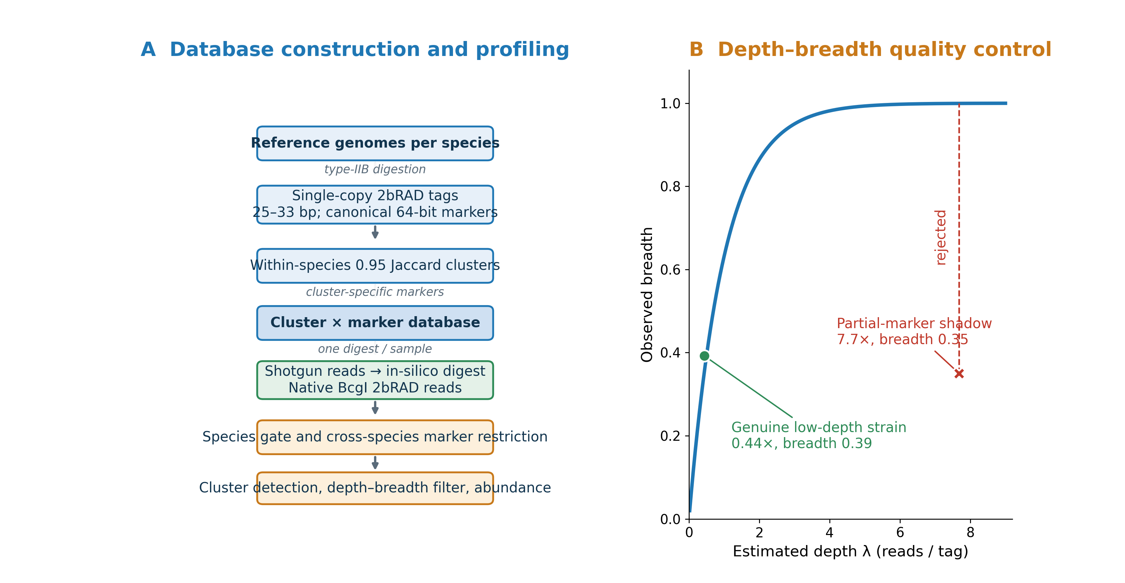
Figure 1. Strain2bScan overview and quality control. (A) Reference construction: type-IIB (2bRAD) digestion into single-copy 25–33 bp tags, within-species clustering at 0.95 Jaccard, marker classification and a cluster × marker database. (B) Profiling: one sample digest, species-level marker gating, cross-species marker restriction, cluster detection and abundance estimation for conventional shotgun or native BcgI input. (C) Depth–breadth consistency separates a genuine low-depth strain from a partial-marker shadow.

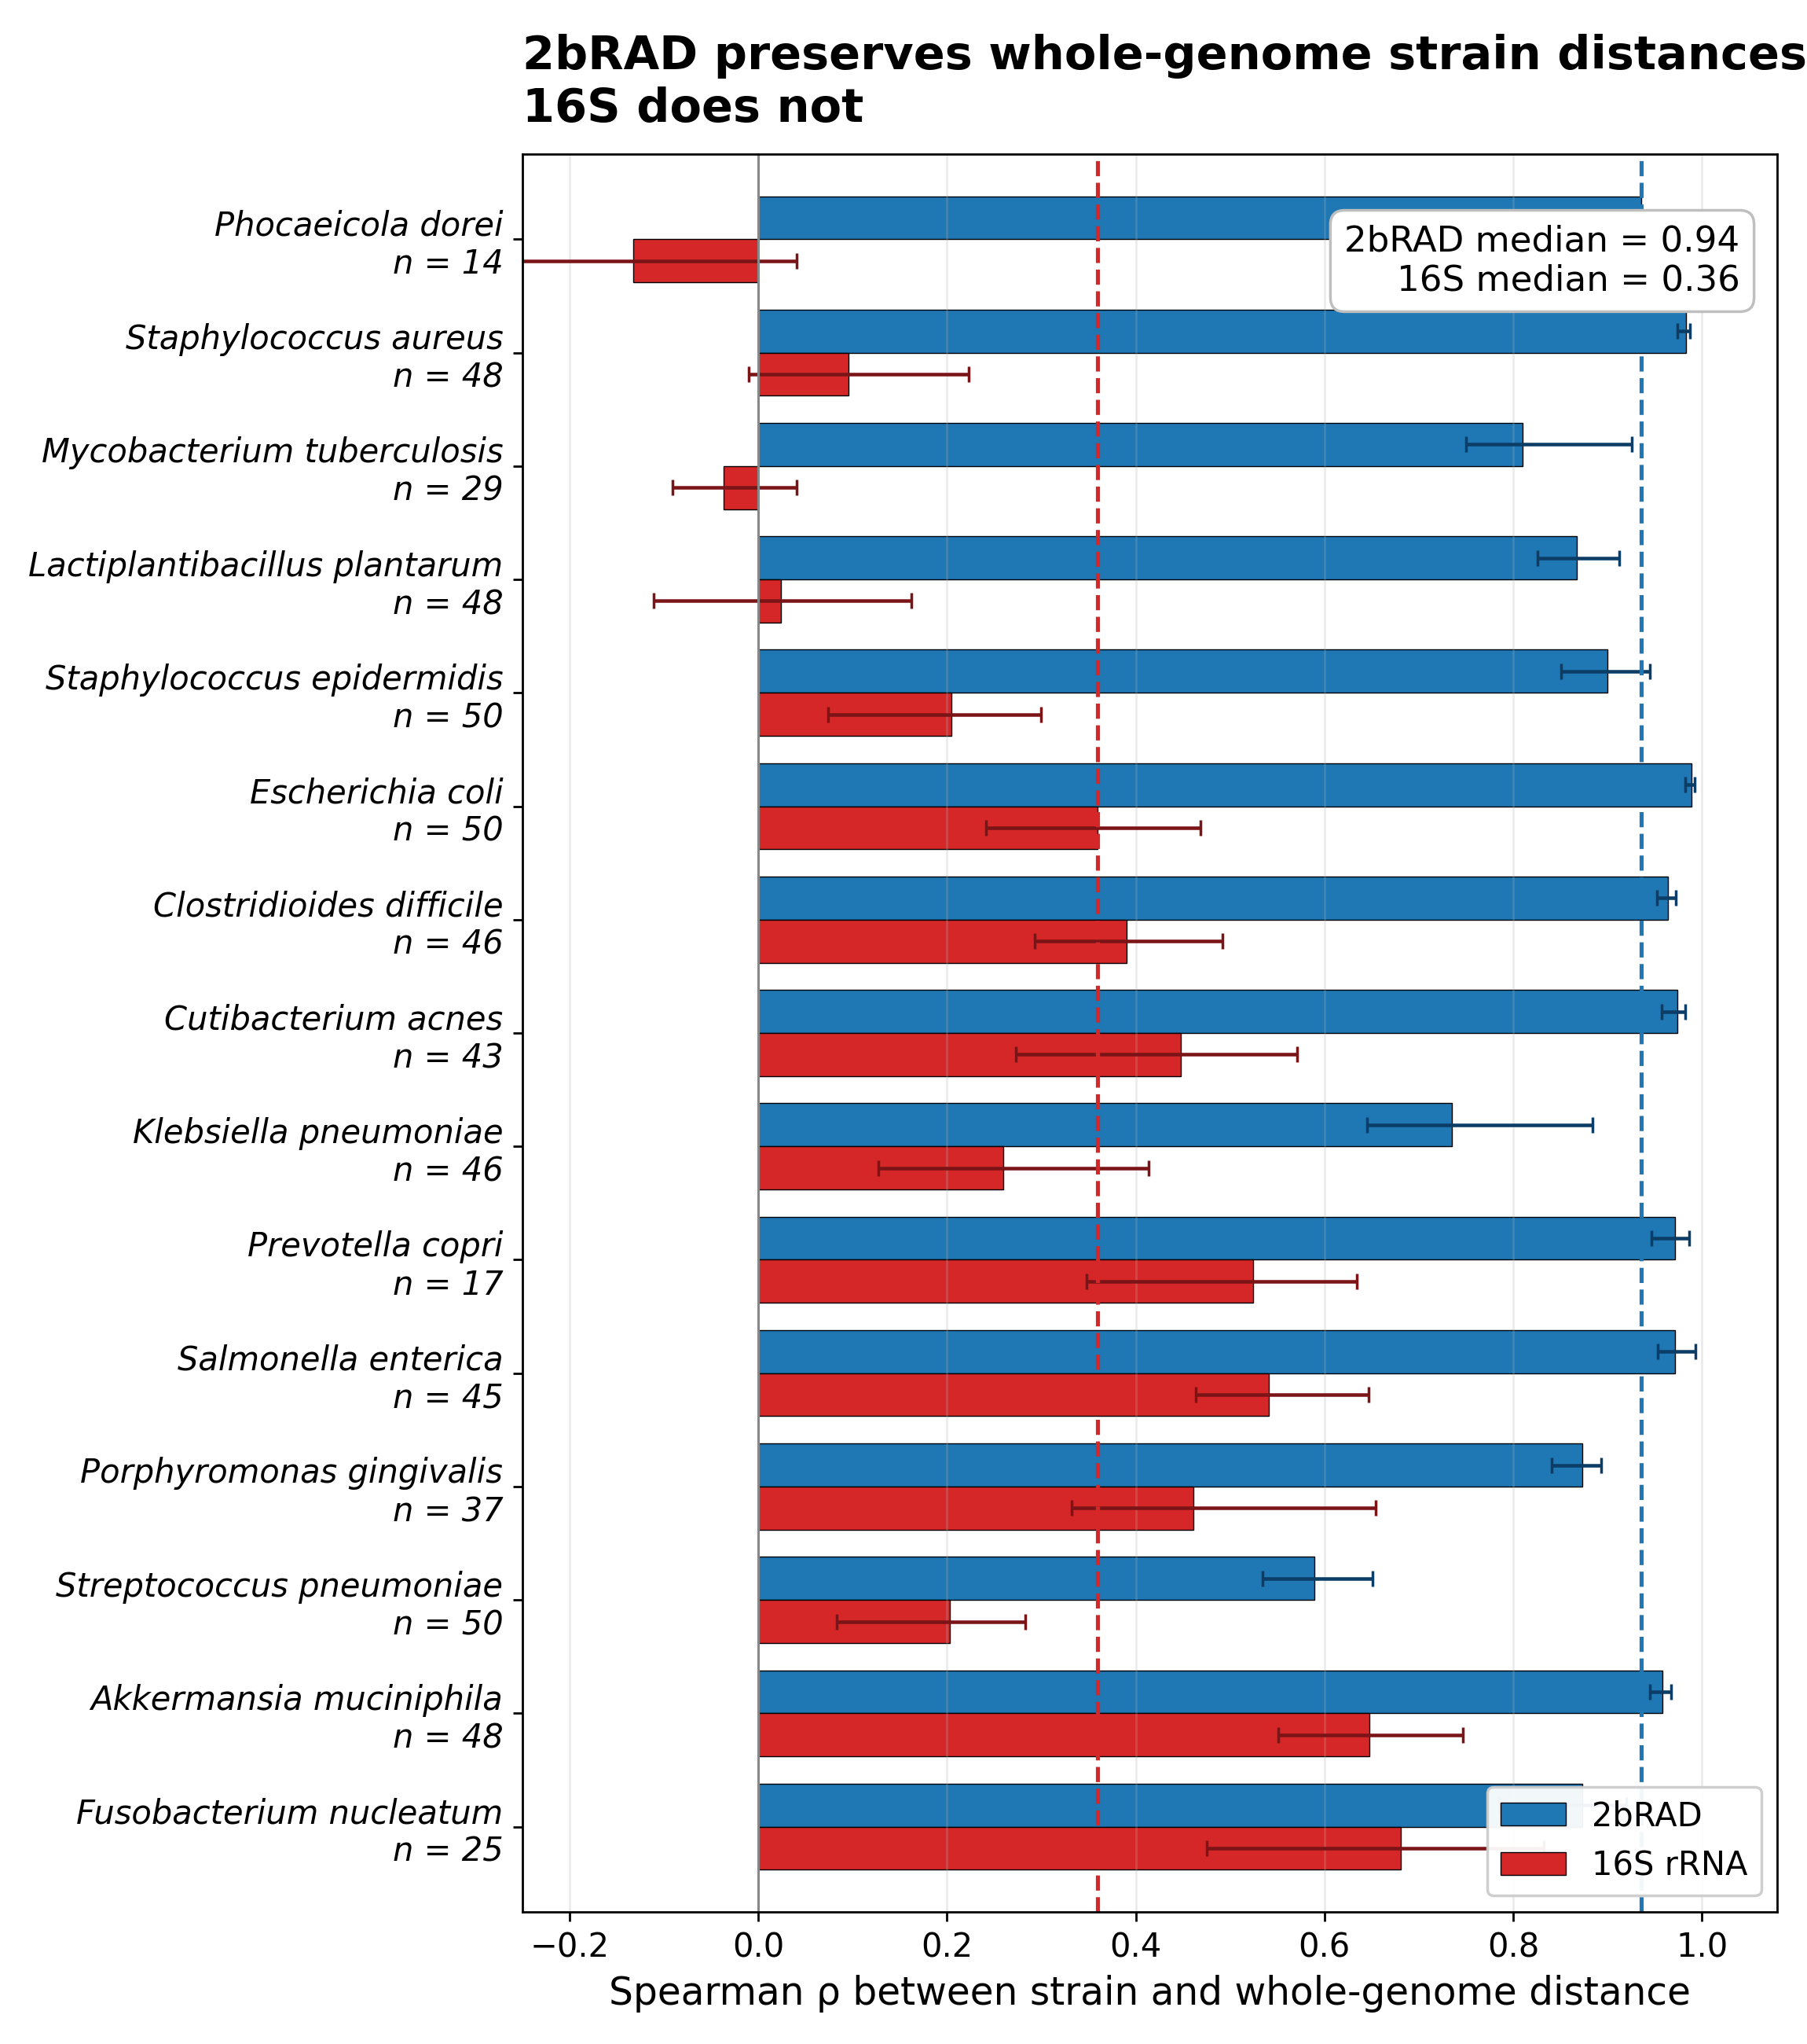
Figure 2. 2bRAD tags track genome-wide strain distance; 16S does not. (A) Per-species Spearman correlation between whole-genome strain distance and 2bRAD-tag or 16S distance across 15 complete/near-complete genome panels; 2bRAD median 0.94 versus 16S median 0.36. (B) Rank-rank scatter plots show that 2bRAD preserves genome-wide strain ordering whereas 16S collapses many unrelated pairs.

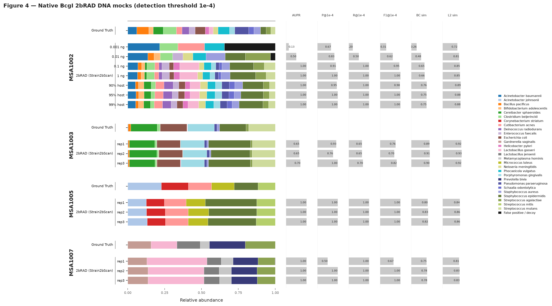
Figure 3. Native BcgI 2bRAD-M across four ATCC DNA mocks. MSA-1002, MSA-1003, MSA-1005 and MSA-1007 were profiled against a 28-species, 164-genome containment tree. At 90, 95 and 99% human DNA, F1 was 0.976–1.0 and Bray–Curtis similarity 0.745–0.756. A 0.1-ng input retained F1 0.952; 0.01 ng approached the marker-depth noise floor and 0.001 ng was below the detection floor. Species-level colour keys correspond to the ATCC strain identifiers listed in Supplementary Table S14.

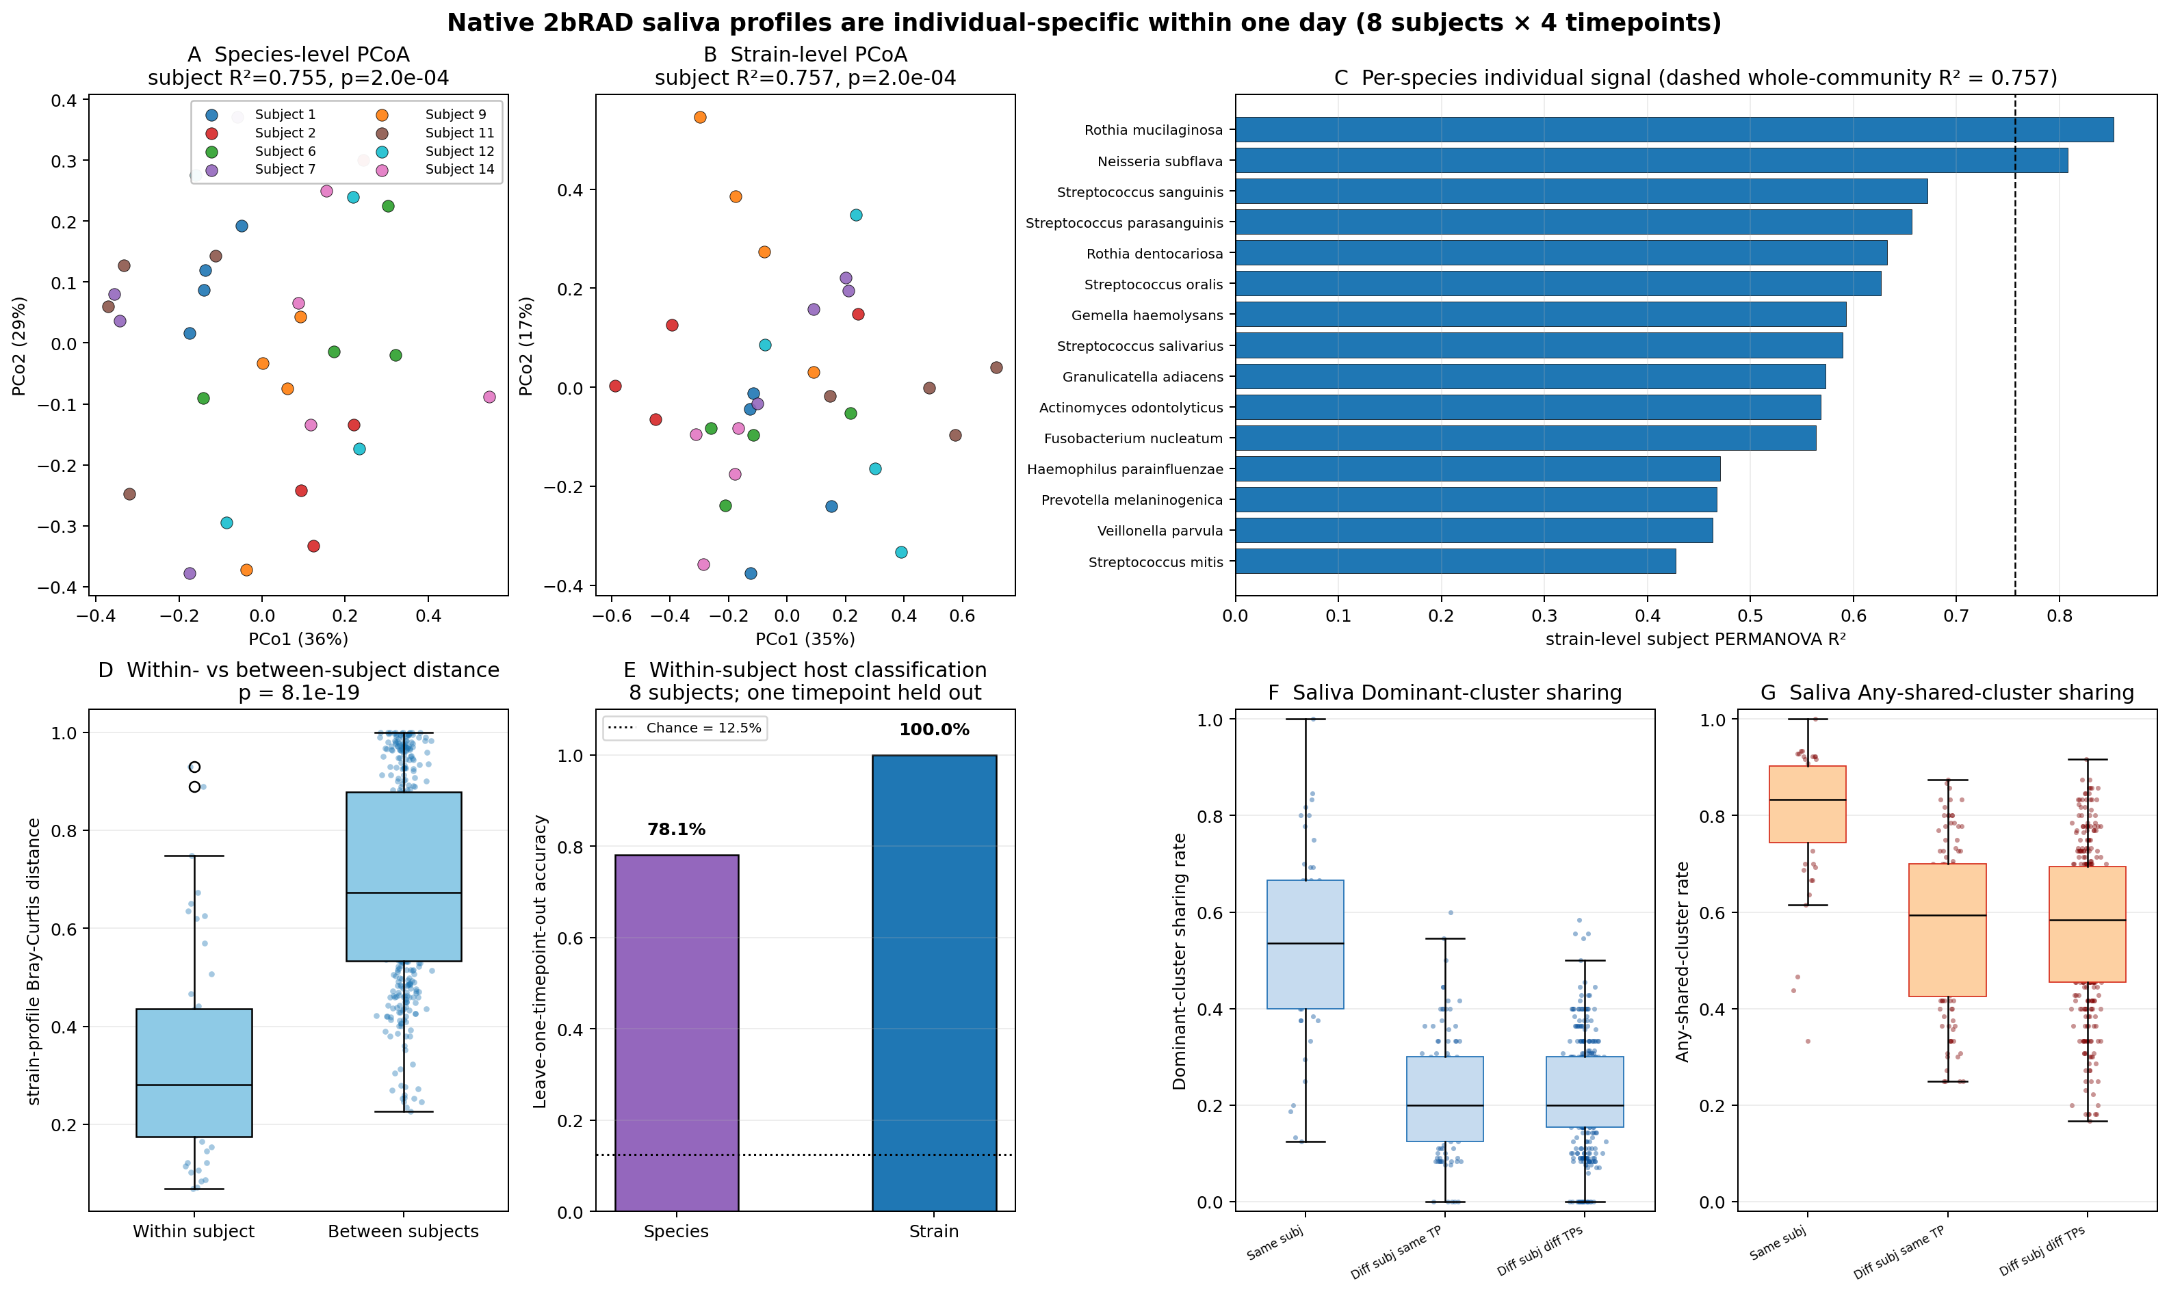
Figure 4. Real saliva contains individual-specific strain signatures. (A,B) Bray–Curtis PCoA of species-level and strain-level profiles coloured by subject. (C) Per-species strain-level subject R² for the 15 species with at least ten samples; the dashed line marks whole-community strain signal. (D) Within- versus between-subject Bray–Curtis distance. (E) Leave-one-timepoint-out subject classification. (F,G) Dominant-cluster and any-shared-cluster rates for pairwise saliva comparisons; denominators were species with calls in both samples. Thirty-two native BcgI 2bRAD-M libraries from eight subjects sampled four times in one day were profiled against a 19-species oral panel.

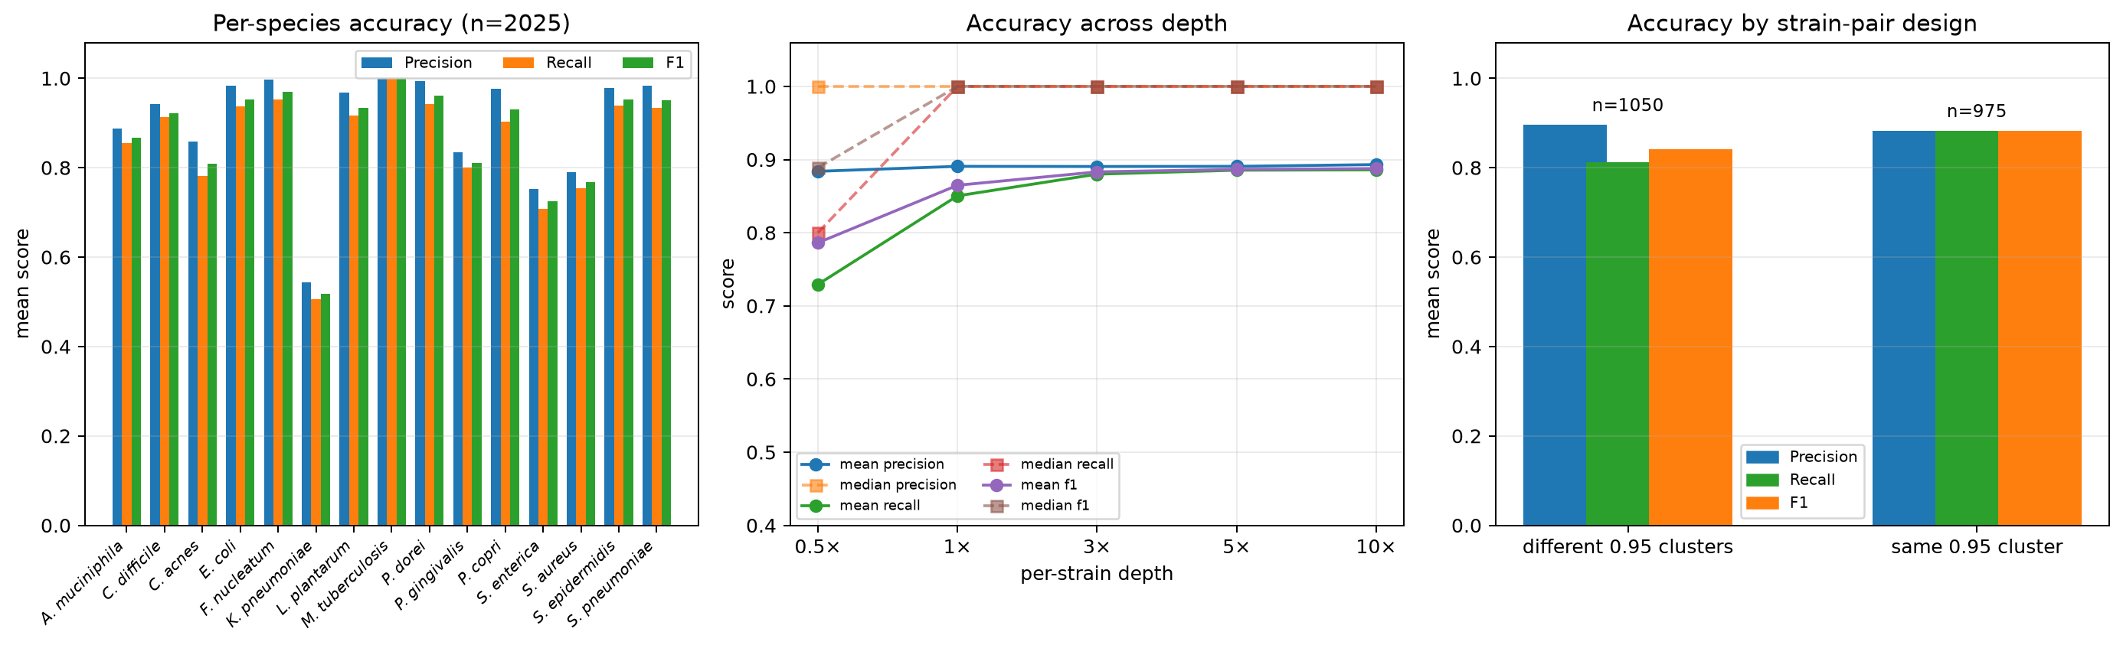
Figure 5. Accuracy across the complete 2,025-sample single-species simulation pool. (A) Per-species mean accuracy. (B) Accuracy across per-strain depth. (C) Accuracy by different-cluster versus same-cluster design. Strain2bScan was evaluated on all 2,025 ART error-modelled shotgun simulations from 15 species, followed by in-silico 2bRAD digestion. Median precision, recall and F1 were 1.000; mean precision, recall and F1 were 0.890, 0.846 and 0.862. Mean F1 increased from 0.786 at 0.5× to 0.888 at 10×.

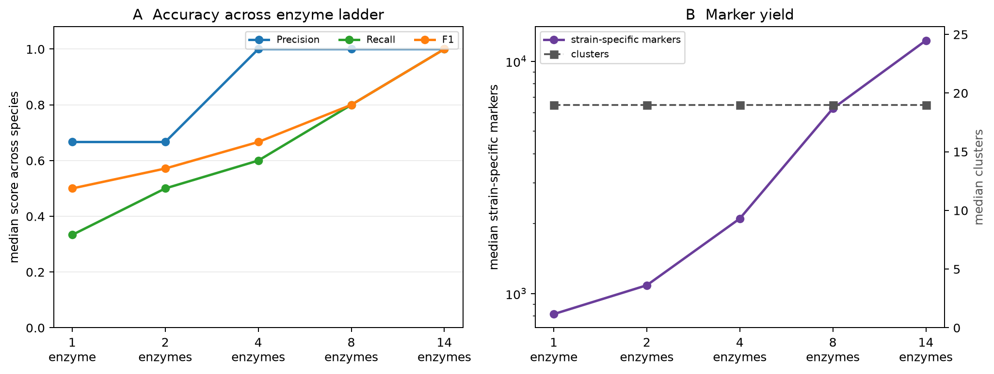
Figure 6. The 2bRAD enzyme set is a marker-density and recall control. (A) Species-median precision, recall and F1 across the cumulative enzyme ladder. (B) Median strain-specific marker yield and cluster count. On 225 matched simulations per enzyme level (1,125 sample-level predictions across 15 species), increasing enzymes from 1 to 14 raised median strain-specific markers from 816 to 12,298 while median cluster count stayed 19. Median precision/recall/F1 improved from 0.667/0.333/0.500 to 1.000/1.000/1.000; four enzymes reached median precision 1.000 and F1 0.667. This is an in-silico design experiment, not a native wet-lab library benchmark.

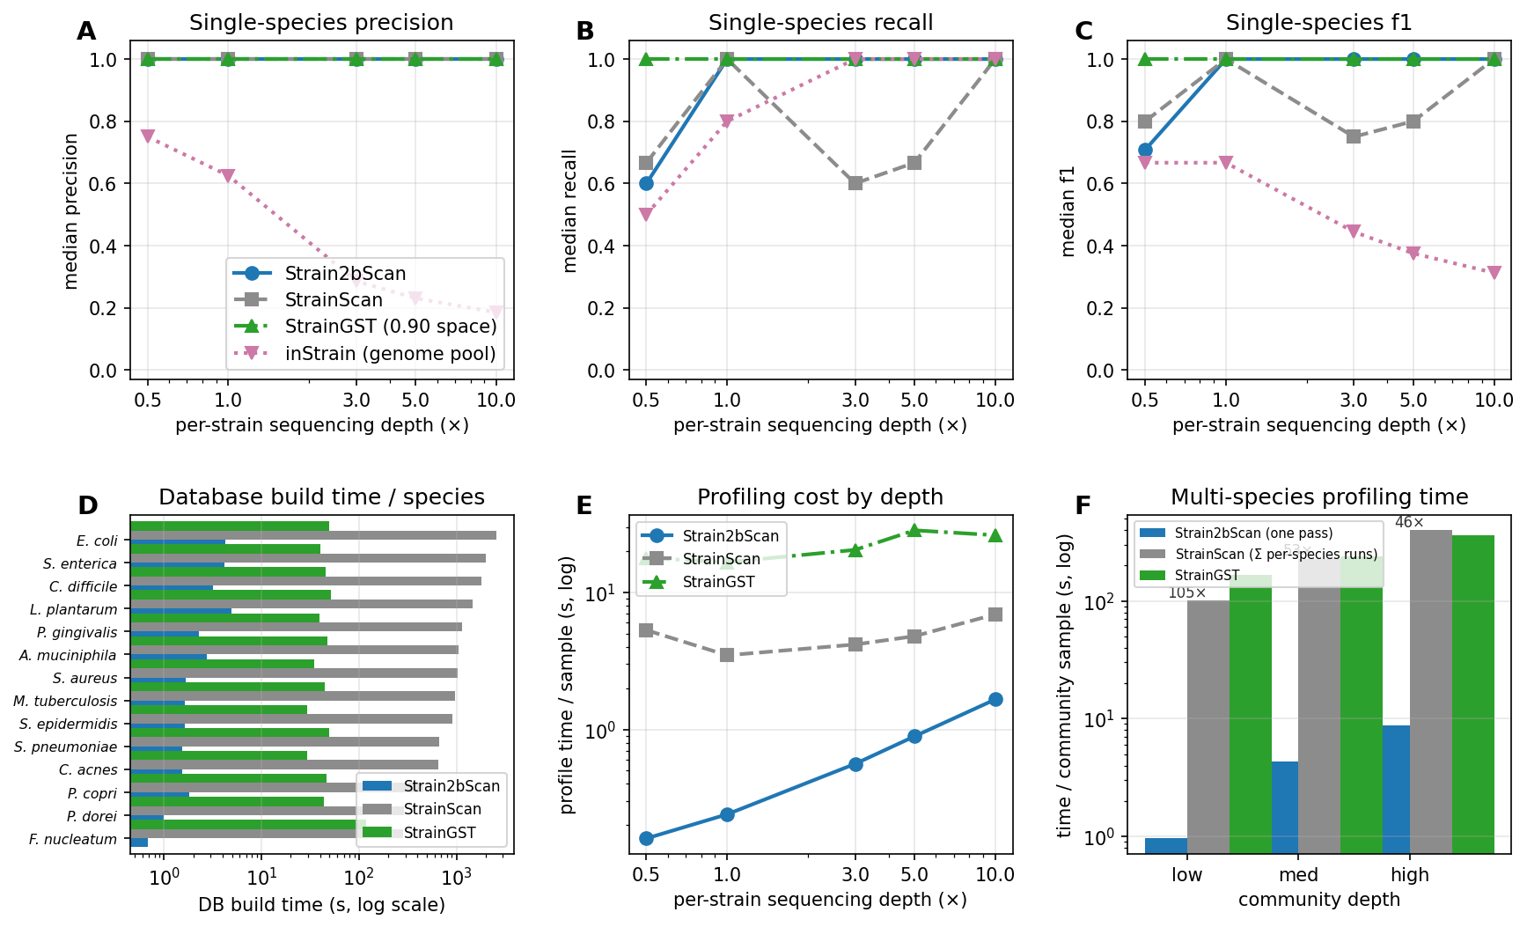
Figure 7. Matched 225-sample simulation comparison. (A-C) Single-species precision, recall and F1 across per-strain depth for Strain2bScan, StrainScan, StrainGST and inStrain. Strain2bScan/StrainScan use 0.95 clusters, StrainGST uses 0.90 references and inStrain uses full genome pools mapped to truth 0.95 clusters; accuracy is not pooled across these units. StrainGST remained accurate at 0.5× because its 0.90 reference space retained more separate low-divergence references. (D) Database-build time per species. (E) Same-container profiling cost. (F) Multi-species profiling time.

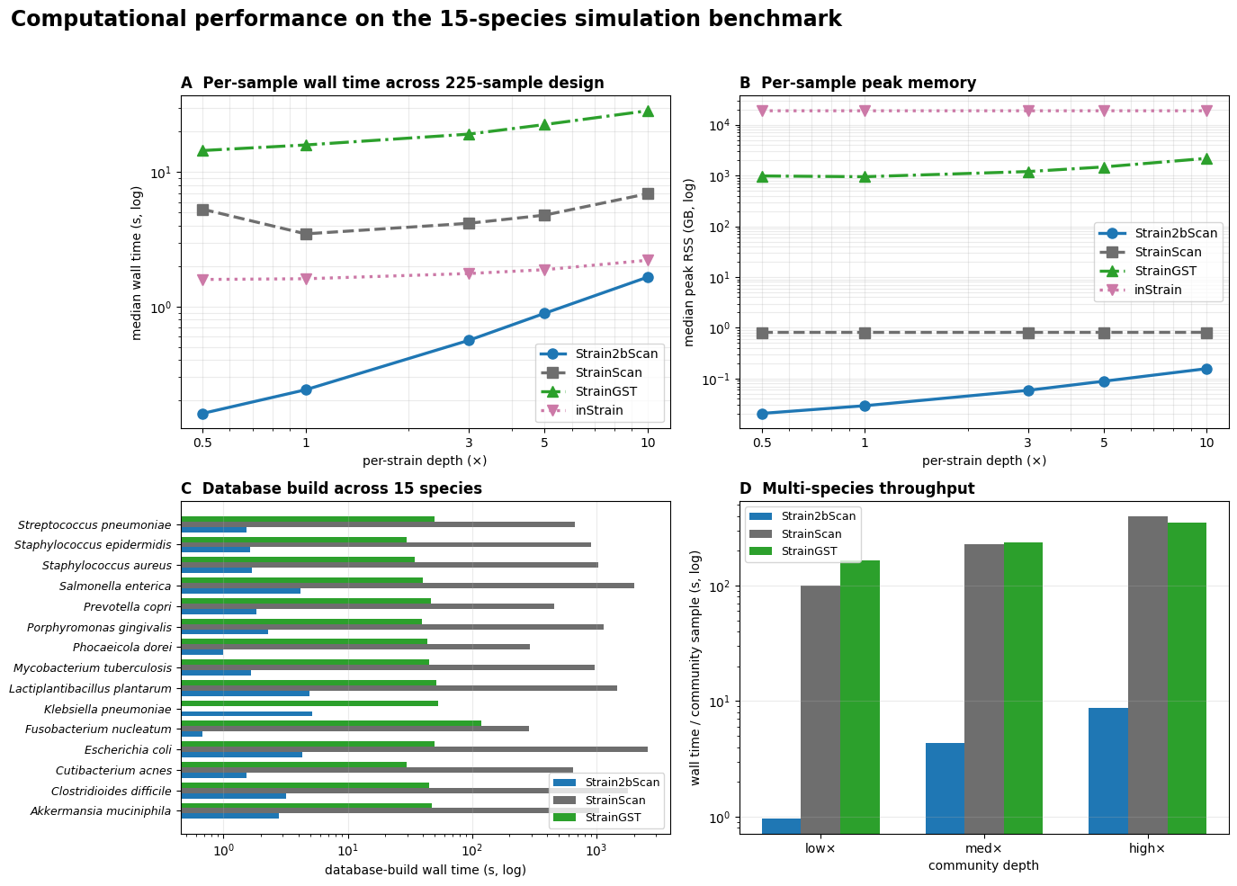
Figure 8. Computational performance across 225 simulations and 15 species. The panels summarize median per-sample wall time and peak RSS across depth, database-build cost across the 15 species panels and multi-species throughput. Strain2bScan remained faster and lighter than StrainScan across matched per-depth runs. StrainGST included sample k-merization and species searches. inStrain points show BAM profiling only and exclude Bowtie2 alignment.

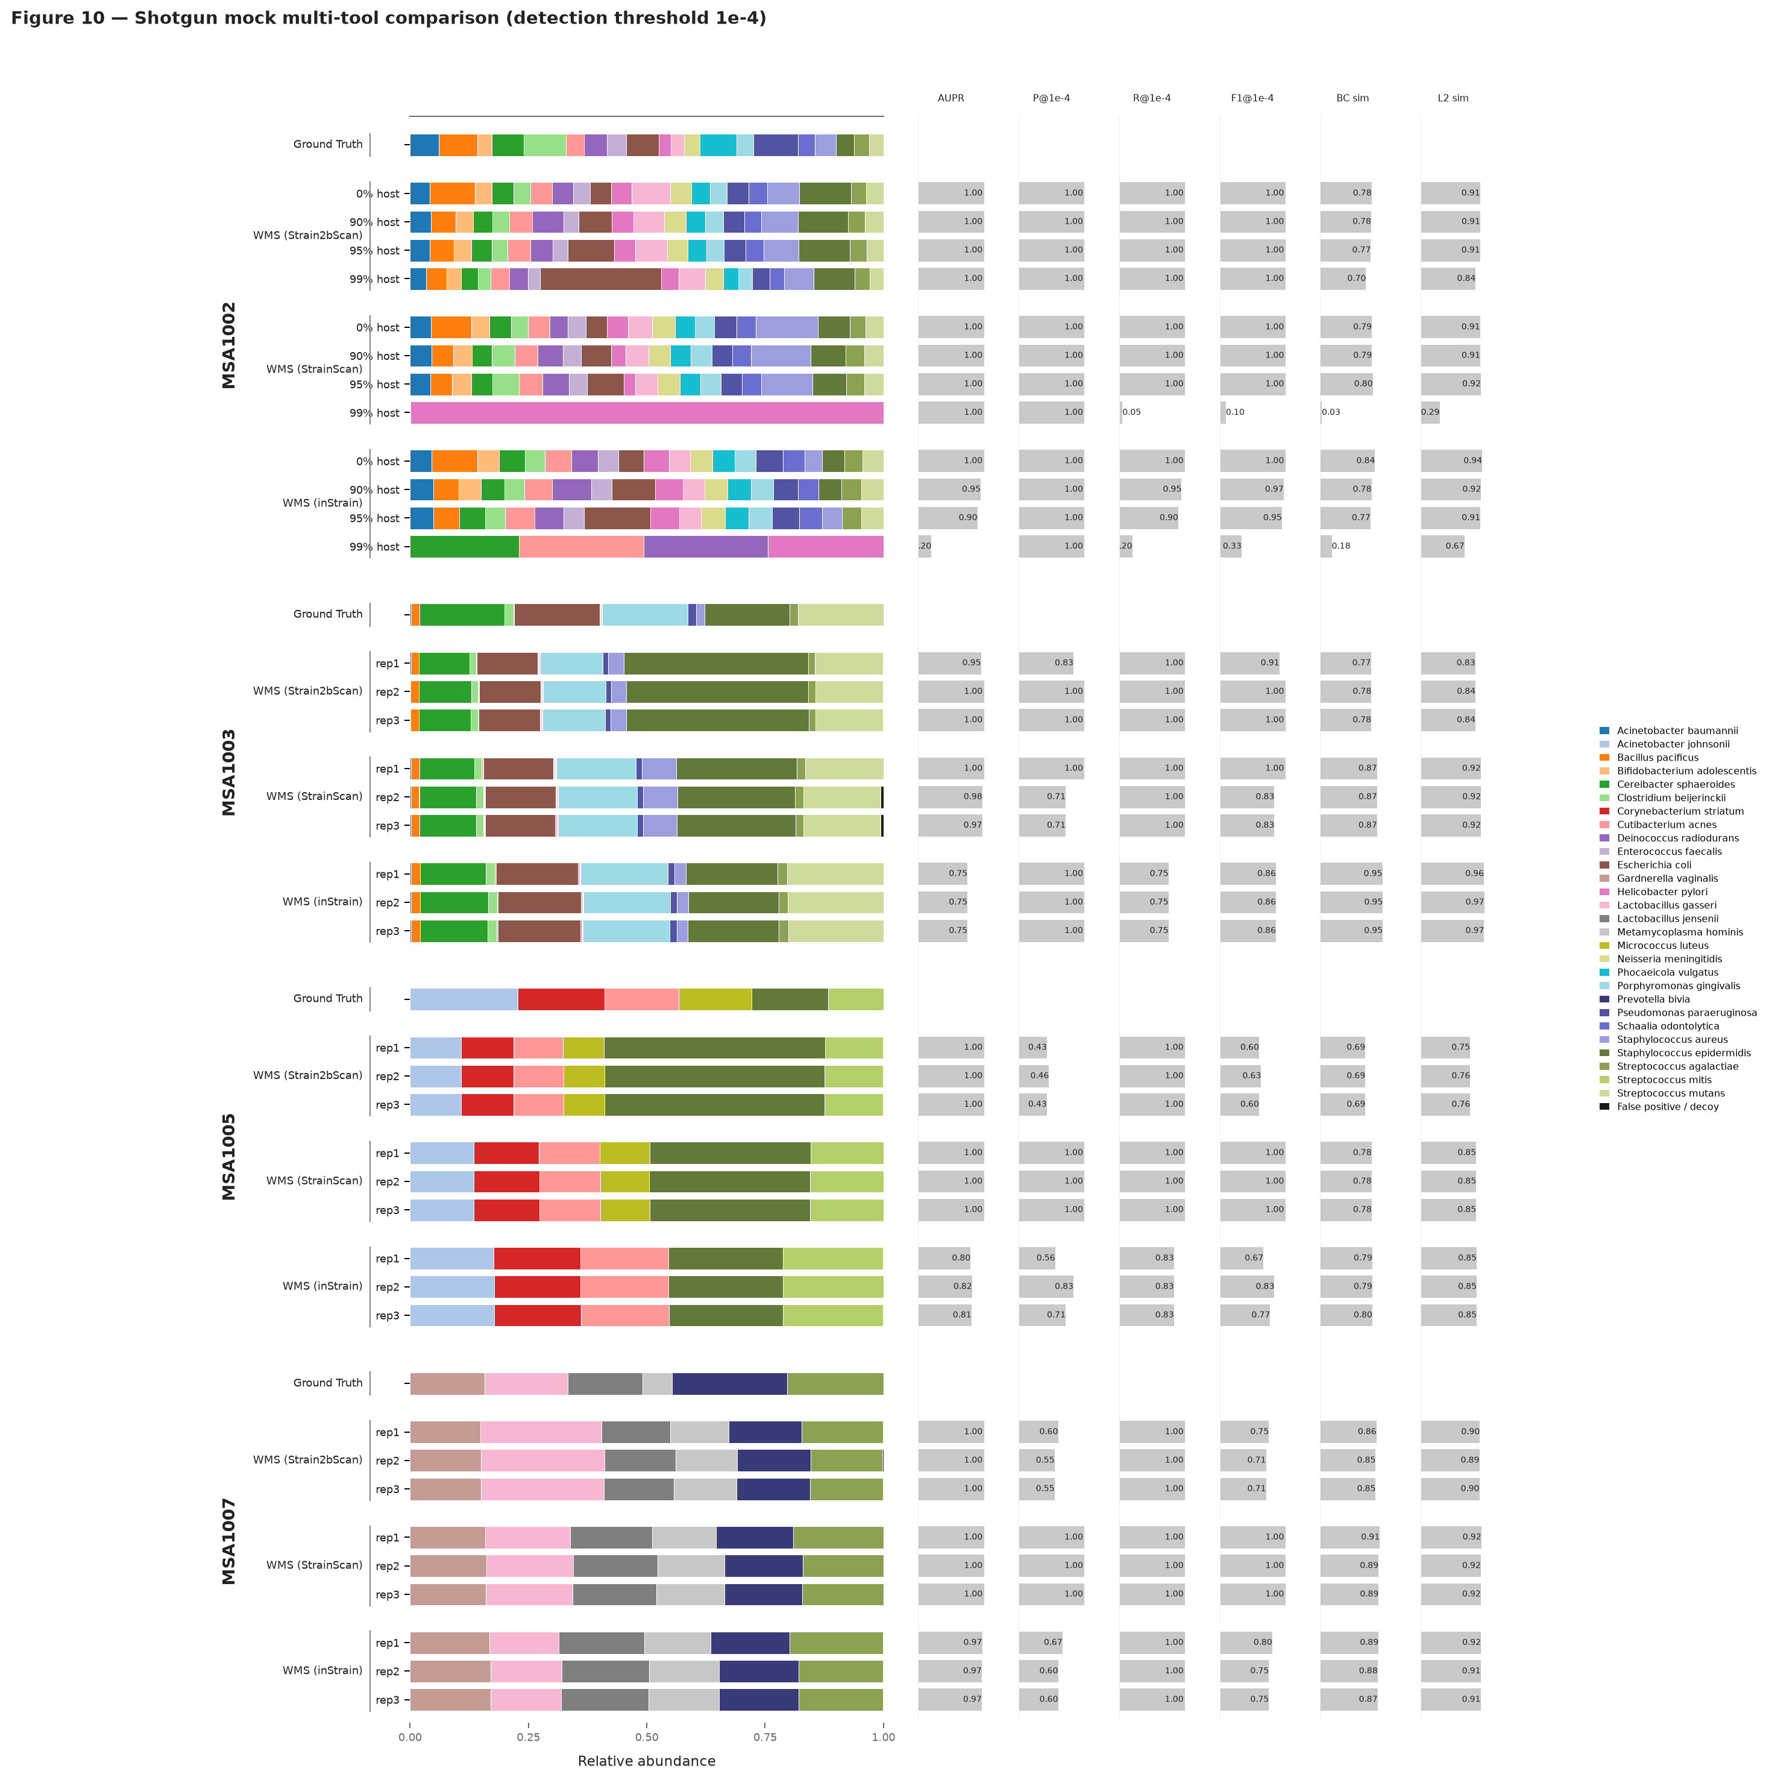
Figure 9. Shotgun DNA mocks separate tools under host contamination. Four ATCC shotgun mocks were profiled with Strain2bScan, StrainScan and inStrain in their own call units. In MSA-1002 at 99% host, Strain2bScan retained F1 1.0 and Bray–Curtis dissimilarity 0.302, whereas StrainScan and inStrain had F1 0.095 and 0.333. These are descriptive tool-specific contrasts, not pooled estimates.

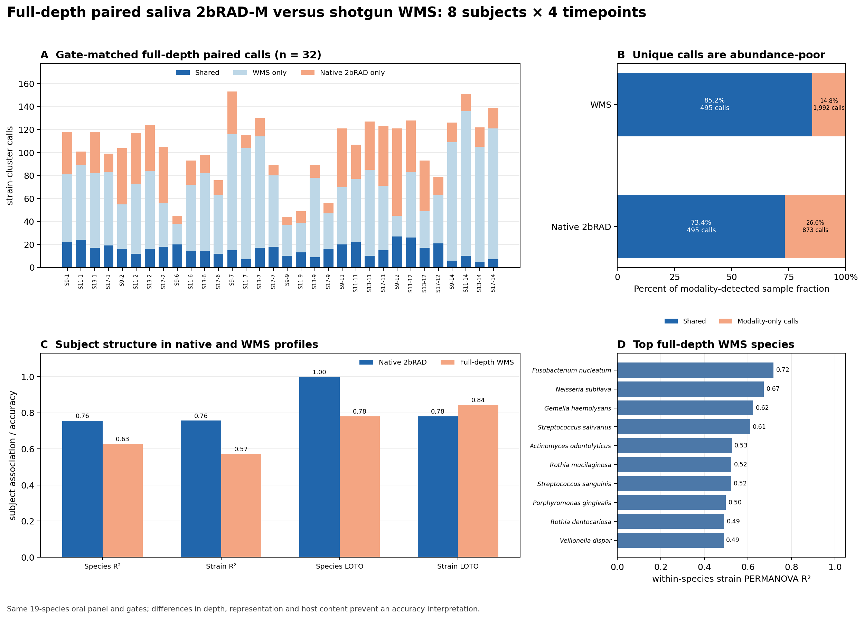
Figure 10. Full-depth paired saliva WMS reanalysis. (A) Shared, WMS-only and native-2bRAD-only strain-cluster calls for all 32 gate-matched WMS/native pairs. (B) Within-modality partition of detected sample fraction: WMS-only calls represented 80.1% of WMS calls but only 14.8% of WMS-detected sample fraction; native-only calls represented 63.8% of native calls but 26.6% of native-detected sample fraction. (C,D) Full-depth WMS time-course reanalysis shows subject-specific structure but lower strain-level community resolution than native 2bRAD.

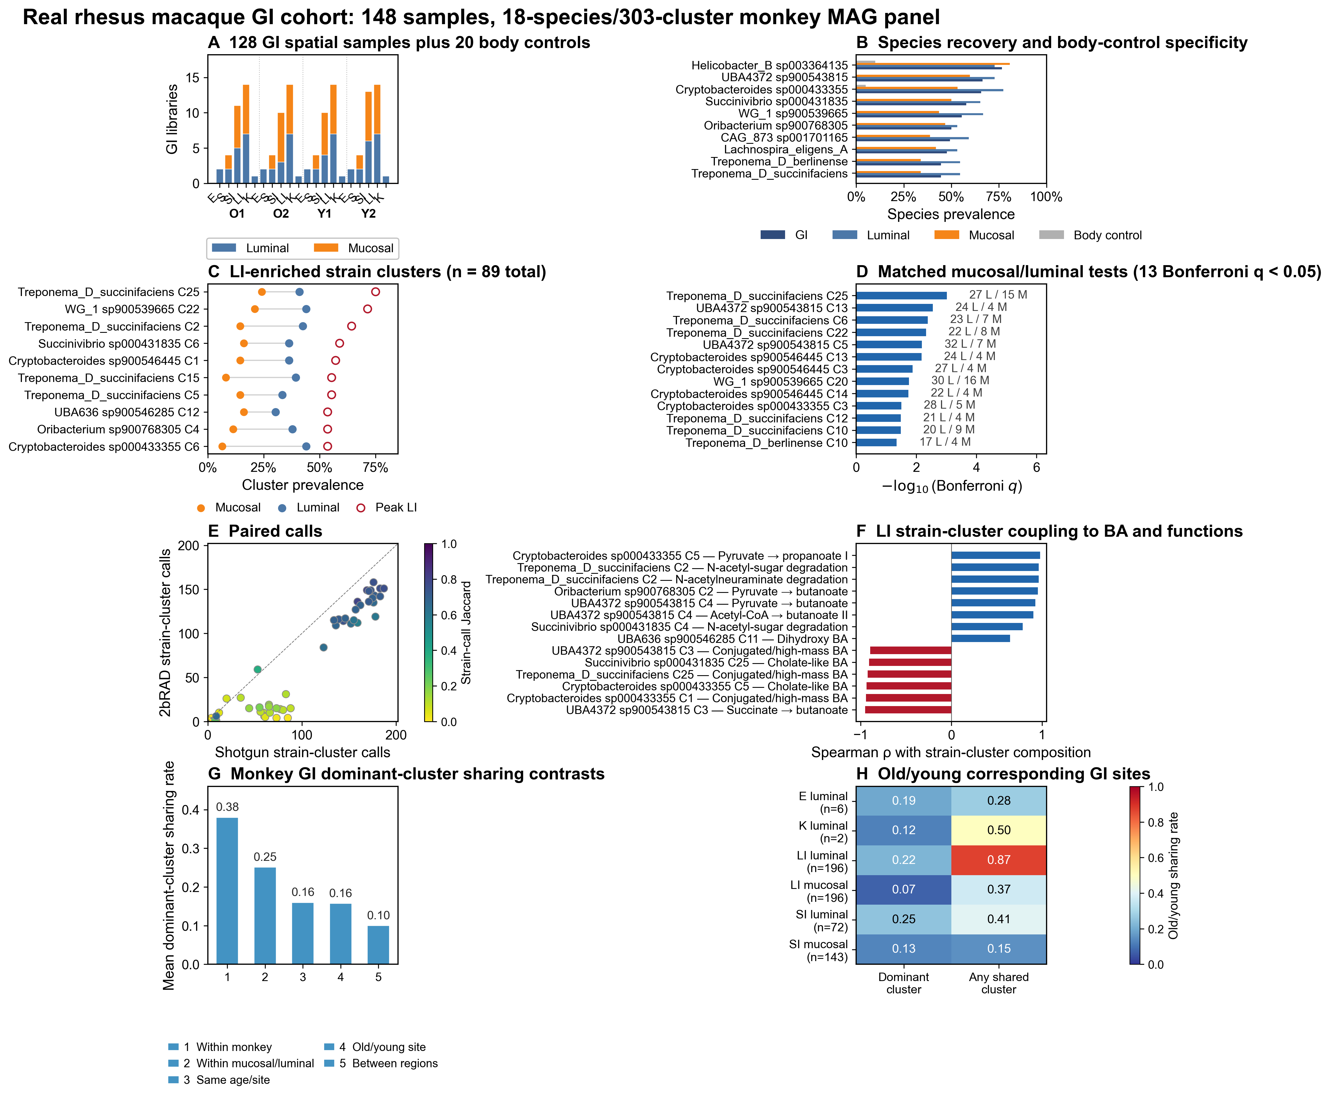
Figure 11. Real rhesus macaque GI cohort reveals LI-luminal strain reservoirs. (A) Distribution of 128 GI libraries across four rhesus macaques and five GI regions. (B) Species prevalence in GI, luminal, mucosal and body-control libraries. (C) Ten representative LI-enriched clusters; the open red circle marks peak LI prevalence. (D) Thirteen matched mucosal/luminal strain clusters that remained significant after Bonferroni correction. (E) Paired luminal shotgun and native 2bRAD strain-call counts; colour gives strain-call Jaccard (median strain-call Jaccard 0.605; species Jaccard 0.889). (F) Representative Spearman associations between LI strain-cluster composition and bile-acid classes or HUMAnN pathways; BH q values are in Supplementary Table S10. (G) Mean dominant-cluster sharing for prespecified rhesus GI comparisons. (H) Old/young corresponding-site sharing by GI region and compartment. Exact label sharing describes 0.95 marker-cluster resolution, not SNV/popANI-validated strain identity or transmission.

Supplementary figures

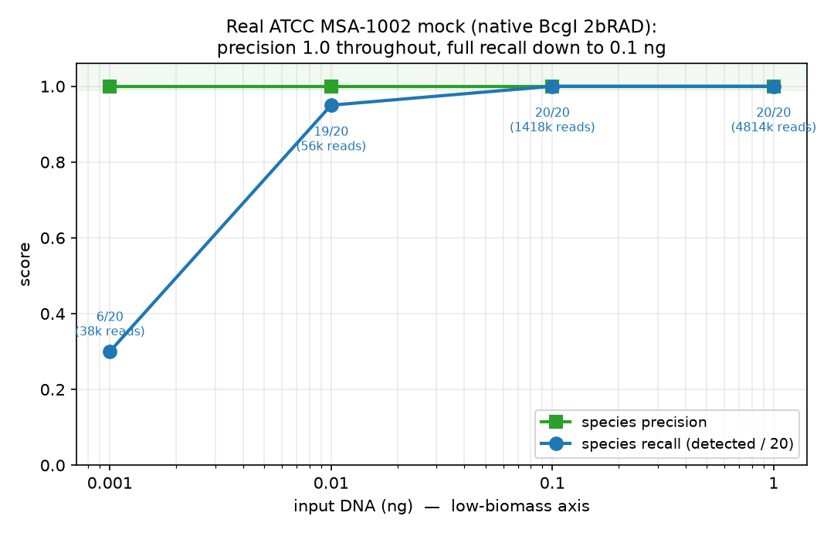
Figure S1. ATCC MSA-1002 DNA-input titration uses native BcgI 2bRAD-M reads. Native-input species precision and recall are shown for 0.001, 0.01, 0.1 and 1 ng DNA in the original 62-species species-level analysis; precision was 1.0, 0.01-ng recall was 0.95, and recall was complete at 0.1 ng and above. This titration is not directly comparable with the Figure 3 164-genome, 0.95-cluster primary benchmark.

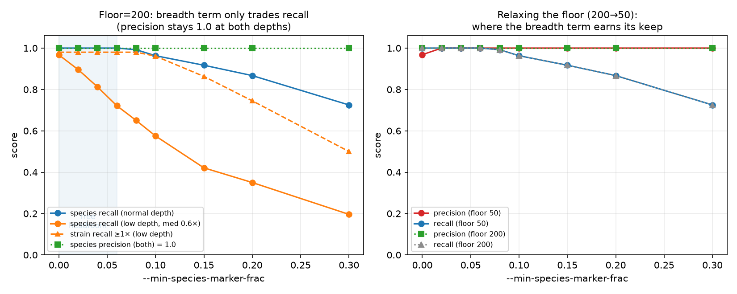
Figure S2. Layer-1 gate calibration uses the 55-species panel. Species precision and recall are plotted against the minimum species-marker floor at normal and low depth.

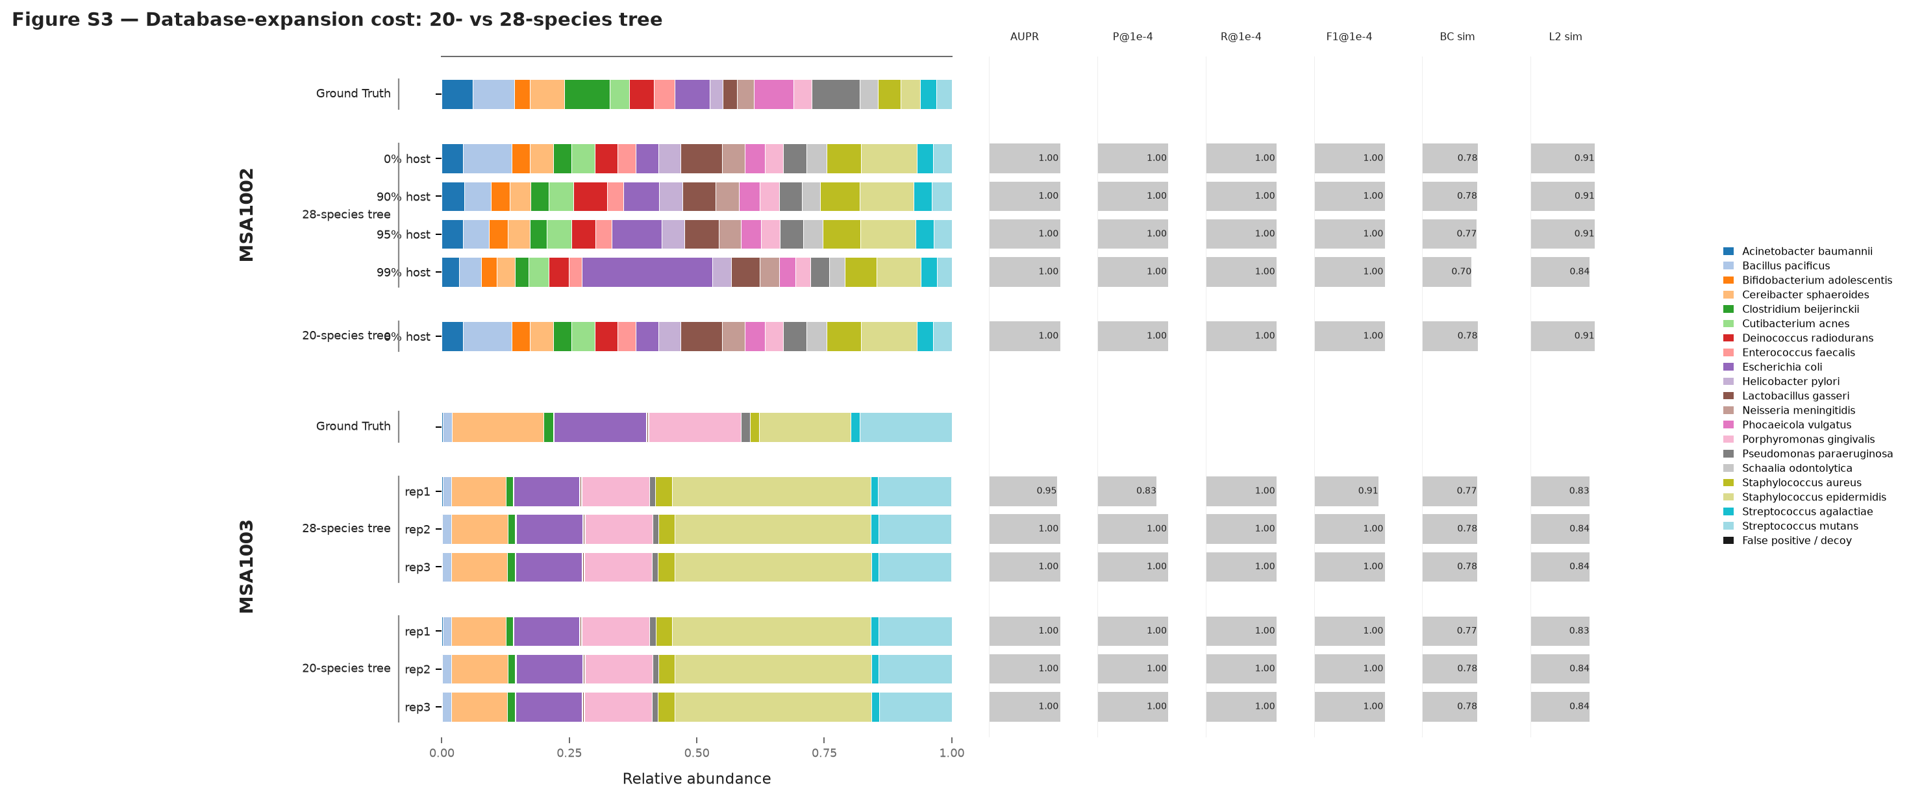
Figure S3. Cost of unified-database expansion (20- versus 28-species combined tree). MSA-1002 is unchanged by tree expansion; MSA-1003 has one lower-threshold replicate on the larger tree, confining cost to the approximately 1× marker-depth noise floor.

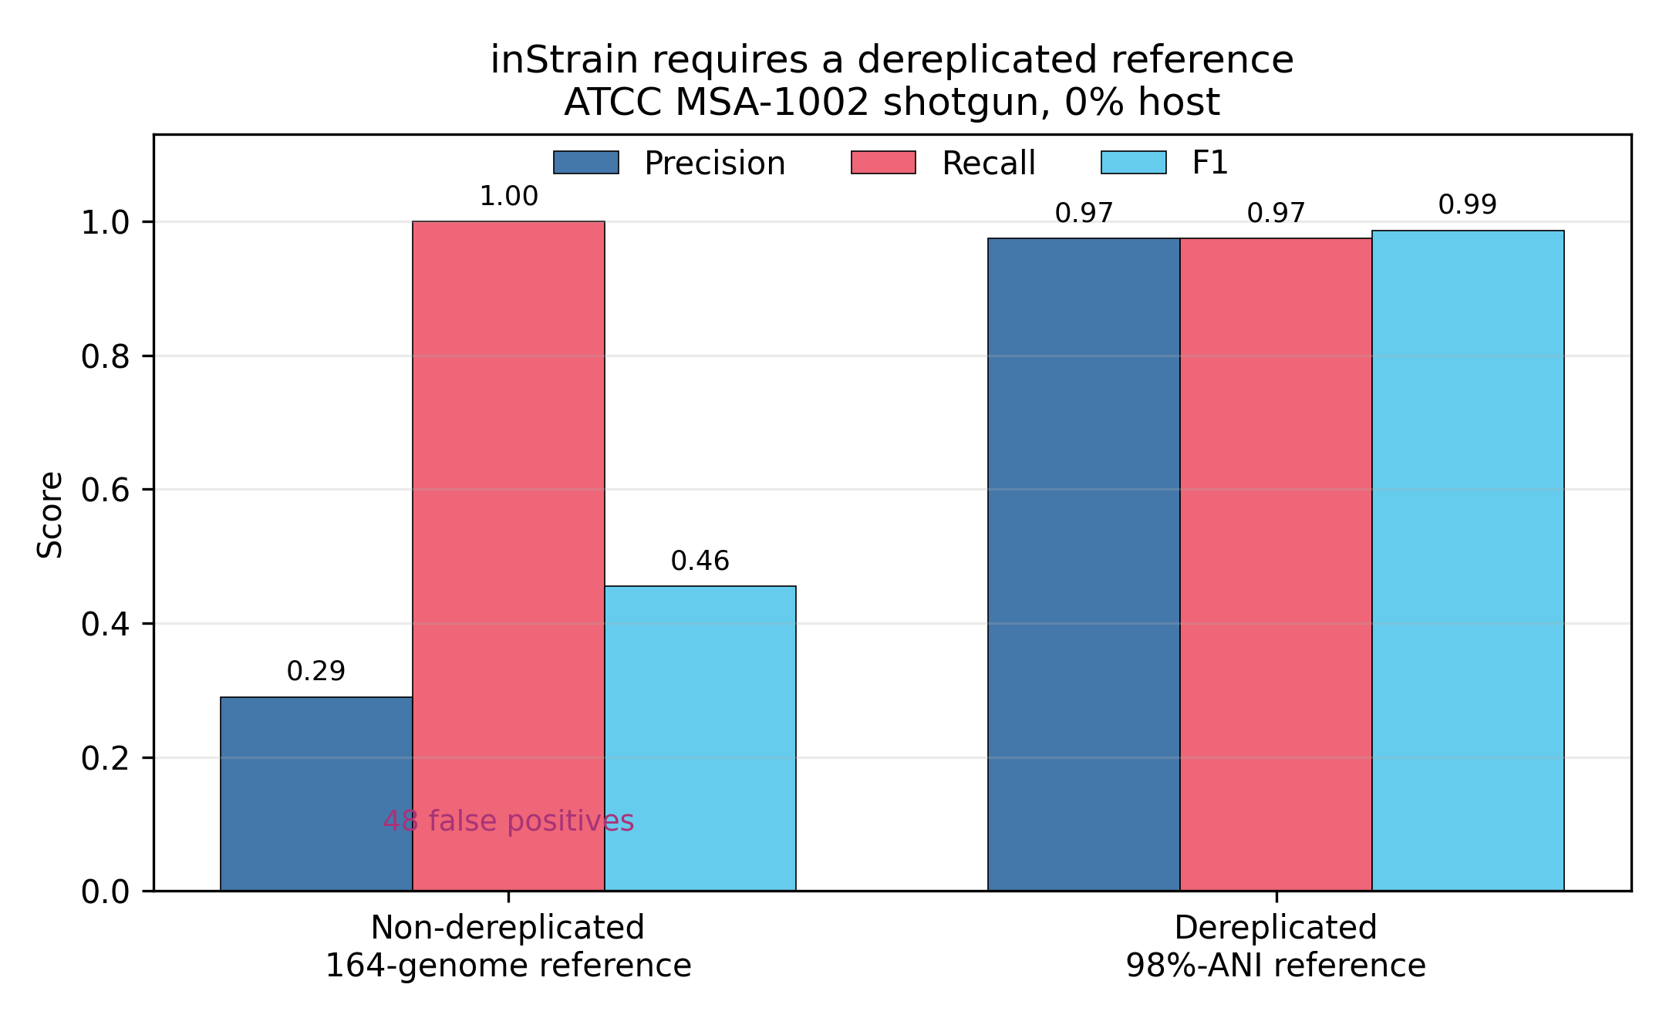
Figure S4. inStrain requires a dereplicated reference (MSA-1002 shotgun). The non-dereplicated 164-genome reference inflates false positives; 98%-ANI dereplication restores precision to 0.97, recall to 0.97 and F1 to 0.99.

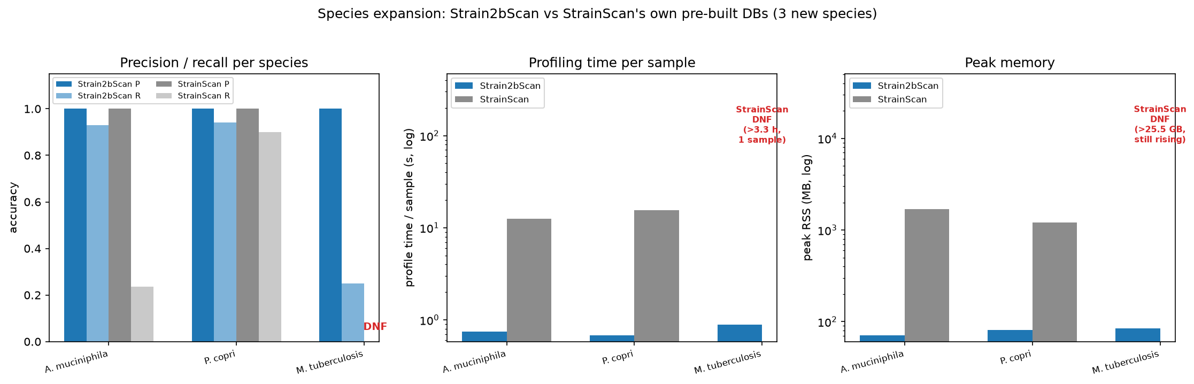
Figure S5. Strain2bScan versus StrainScan on three StrainScan-curated reference sets. Both tools reached precision 1.0 for A. muciniphila and P. copri; Strain2bScan matched or exceeded recall and was faster and lighter. Strain2bScan completed near-clonal M. tuberculosis in 0.89 s, whereas StrainScan did not complete.

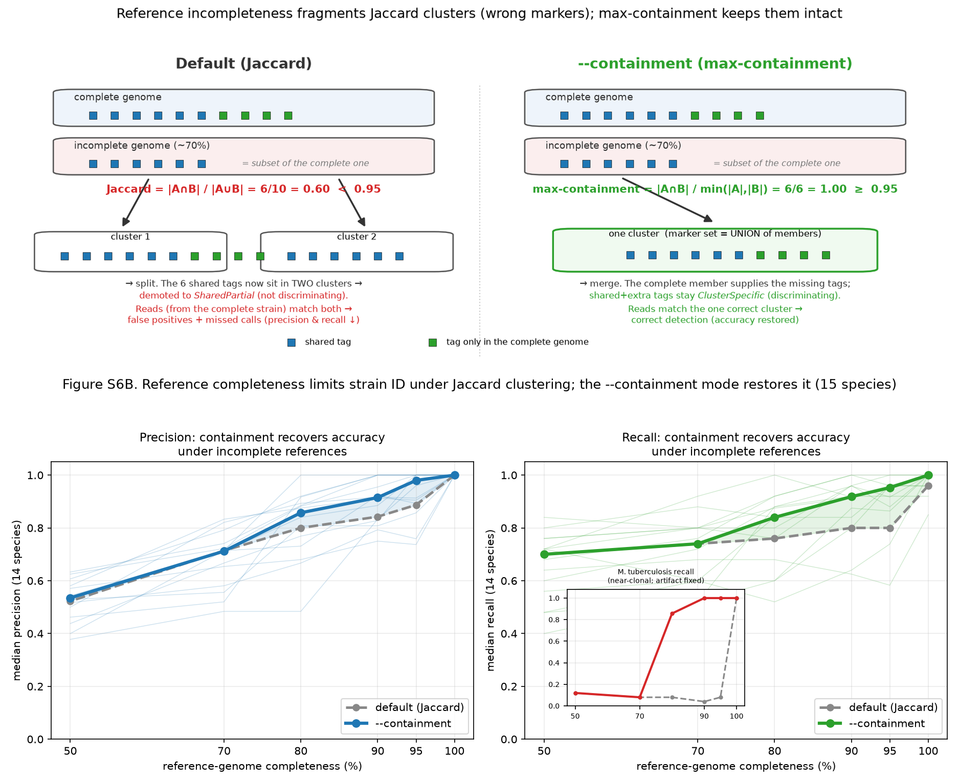
Figure S6. Reference-completeness optimization with Jaccard and containment clustering. (A) Mechanism by which an incomplete genome becomes a Jaccard outlier and maximum containment merges it with its complete relative. (B) Median precision and recall across 14 resolvable species after reference degradation under Jaccard versus opt-in containment clustering, with near-clonal M. tuberculosis inset.

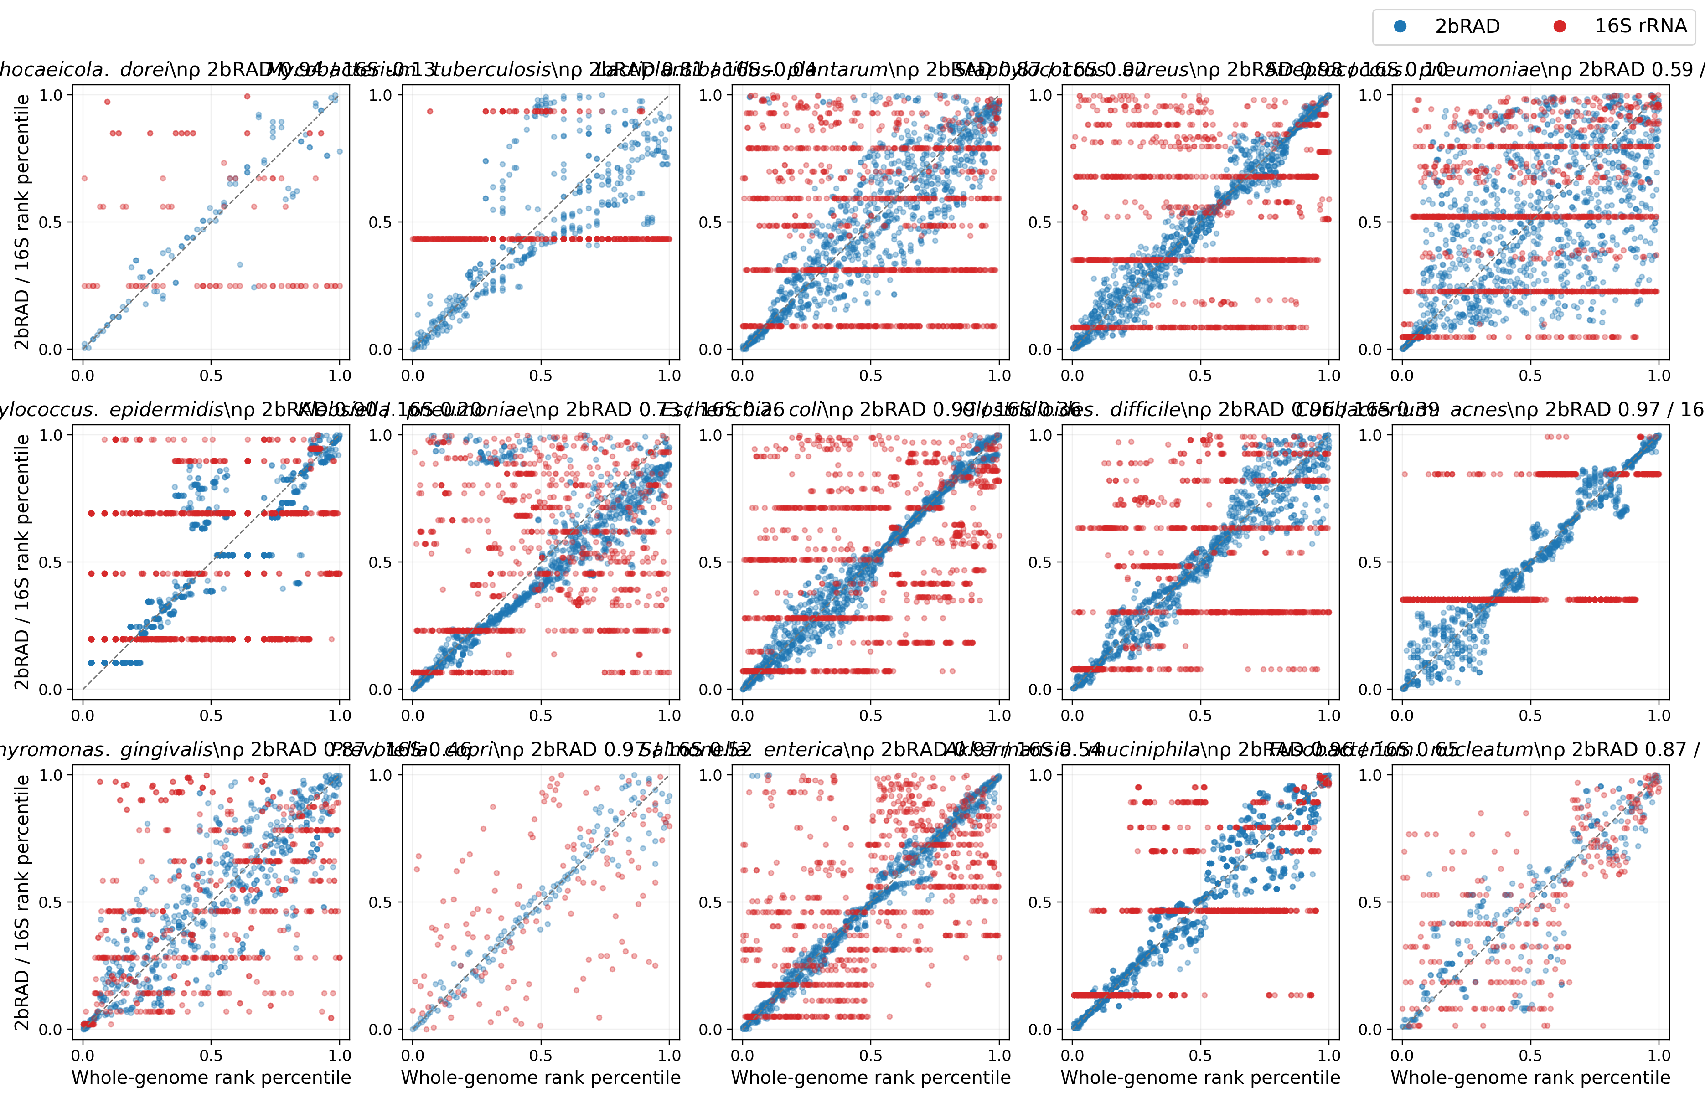
Figure S7. Per-species rank–rank comparison of 2bRAD and 16S distances. For each of the 15 complete/near-complete genome panels, whole-genome distances are compared with 2bRAD and 16S distances. 2bRAD follows the diagonal; 16S forms discrete bands for many species.

Tables

Table 1. Strain2bScan versus StrainScan on the 15-species simulated benchmark. Accuracy is the median over completed run-level paired samples (different-cluster mixtures for 14 species; same-cluster mixtures for near-clonal M. tuberculosis; k = 2/3/5; depths 0.5–10×); each tool was scored in its own 0.95-similarity cluster space. Cluster-count columns are each tool’s own 0.95 partitions of the common species pool. StrainGST F1 uses all 15 species-specific tests in its own 0.90-reference space and is not pooled with the 0.95-space columns. Strain2bScan values are from source commit 6ae760c2f3bd2f39efc0e6aa06c53a84366cb16e; source table: results/strainscan_rerun/current_single_persample.tsv. Build cost is the cross-platform timing benchmark (Strain2bScan native arm64; StrainScan linux/amd64 under emulation). S. enterica produced no completed StrainScan calls; K. pneumoniae was successfully built and profiled in the final cross-platform analysis.
Species | Paired n | Pool genomes | S2B clusters | SS clusters | S2B P | S2B R | S2B F1 | SS P | SS R | SS F1 | Separate StrainGST F1 (0.90-space)† | S2B build | SS build
A. muciniphila | 14 | 50 | 24 | 24 | 0.900 | 0.900 | 0.900 | 1.000 | 1.000 | 1.000 | 1.000 | 2.8 s / 0.16 GB | 17 min / 16 GB
C. difficile | 15 | 47 | 27 | 24 | 1.000 | 1.000 | 1.000 | 1.000 | 0.667 | 0.800 | 1.000 | 3.2 s / 0.28 GB | 30 min / 14 GB
C. acnes | 15 | 43 | 8 | 8 | 1.000 | 0.800 | 0.800 | 1.000 | 0.800 | 0.889 | 1.000 | 1.5 s / 0.17 GB | 11 min / 8 GB
E. coli | 15 | 50 | 30 | 27 | 1.000 | 1.000 | 1.000 | 1.000 | 0.800 | 0.889 | 1.000 | 4.3 s / 0.34 GB | 43 min / 28 GB
F. nucleatum | 15 | 25 | 19 | 19 | 1.000 | 1.000 | 1.000 | 1.000 | 0.667 | 0.800 | 1.000 | 0.7 s / 0.10 GB | 5 min / 8 GB
K. pneumoniae | 15 | 47 | 28 | 27 | 0.333 | 0.333 | 0.286 | 1.000 | 0.800 | 0.889 | 1.000 | 5.1 s / 0.40 GB | DNF (timing run)
L. plantarum | 15 | 50 | 39 | 39 | 1.000 | 1.000 | 1.000 | 1.000 | 0.800 | 0.889 | 1.000 | 5.0 s / 0.24 GB | 24 min / 18 GB
M. tuberculosis | 15 | 29 | 1 | 1 | 1.000 | 1.000 | 1.000 | 1.000 | 1.000 | 1.000 | 1.000 | 1.6 s / 0.25 GB | 16 min / 15 GB
P. dorei | 10 | 15 | 10 | 10 | 1.000 | 1.000 | 1.000 | 1.000 | 0.667 | 0.800 | 1.000 | 1.0 s / 0.25 GB | 5 min / 13 GB
P. gingivalis | 15 | 43 | 27 | 31 | 1.000 | 1.000 | 1.000 | 1.000 | 0.667 | 0.800 | 1.000 | 2.3 s / 0.15 GB | 19 min / 11 GB
P. copri | 15 | 19 | 19 | 19 | 1.000 | 1.000 | 1.000 | 1.000 | 0.667 | 0.800 | 1.000 | 1.8 s / 0.19 GB | 8 min / 26 GB
S. enterica | 0 | 45 | 19 | 12 | – | – | – | – | – | – | 1.000 | 4.2 s / 0.37 GB | 34 min / 16 GB
S. aureus | 15 | 48 | 13 | 12 | 1.000 | 1.000 | 1.000 | 1.000 | 0.667 | 0.800 | 1.000 | 1.7 s / 0.17 GB | 17 min / 12 GB
S. epidermidis | 15 | 50 | 9 | 9 | 1.000 | 1.000 | 1.000 | 1.000 | 0.667 | 0.800 | 0.800 | 1.6 s / 0.14 GB | 15 min / 8 GB
S. pneumoniae | 15 | 50 | 38 | 38 | 1.000 | 1.000 | 1.000 | 1.000 | 0.667 | 0.800 | 1.000 | 1.5 s / 0.16 GB | 11 min / 11 GB
Median across 14 species with completed paired runs: Strain2bScan P 1.000 / R 1.000 / F1 1.000; StrainScan P 1.000 / R 0.667 / F1 0.800. Species medians conceal a precision/recall trade-off for K. pneumoniae. Mean paired differences and 95% intervals are in results/strainscan_rerun/current_uncertainty_summary.tsv.

Table 2. Accuracy and same-container per-sample cost by sequencing depth (single-species medians). Accuracy uses final Strain2bScan and StrainScan on the 204 completed paired runs from results/strainscan_rerun/current_single_by_depth.tsv; StrainGST accuracy uses its separate 0.90-reference space from results/strainge_rerun/simulation_single_by_depth.tsv and is not pooled. Cost is the median of the same-container subset in results/sim_headtohead_profile_sameenv.tsv; both tools ran as linux/amd64 containers. Cost n is reported separately from accuracy n.
Depth (×) | Accuracy n | S2B P/R/F1 | StrainScan P/R/F1 | StrainGST P/R/F1† | Cost n | S2B time / RSS | StrainScan time / RSS
0.5 | 40 | 1.000/0.600/0.708 | 1.000/0.667/0.800 | 1.000/1.000/1.000 | 37 | 0.160 s / 21.1 MB | 5.300 s / 830.9 MB
1 | 41 | 1.000/1.000/1.000 | 1.000/1.000/1.000 | 1.000/1.000/1.000 | 38 | 0.240 s / 29.9 MB | 3.475 s / 830.8 MB
3 | 41 | 1.000/1.000/1.000 | 1.000/0.600/0.750 | 1.000/1.000/1.000 | 38 | 0.560 s / 60.0 MB | 4.165 s / 830.9 MB
5 | 41 | 1.000/1.000/1.000 | 1.000/0.667/0.800 | 1.000/1.000/1.000 | 38 | 0.890 s / 90.8 MB | 4.790 s / 830.9 MB
10 | 41 | 1.000/1.000/1.000 | 1.000/1.000/1.000 | 1.000/1.000/1.000 | 38 | 1.655 s / 160.7 MB | 6.915 s / 831.8 MB
Strain2bScan reached median recall 1.0 from 1× onward; StrainScan was non-monotonic and did not exceed 0.800 median F1 at 0.5× or intermediate depths. The depth table aggregates heterogeneous strain mixtures and is not a causal depth-onset estimate.

Table 3. Multi-species community accuracy and profiling cost. Accuracy is the mean of four samples per depth. Strain2bScan and StrainScan use 0.95-cluster spaces from results/strainscan_rerun/current_multi_by_depth.tsv and results/strainscan_rerun/multi_by_depth.tsv; StrainGST uses its separate 0.90-reference space from results/strainge_rerun/simulation_multi_by_depth.tsv. Costs are medians from the timing tables (results/sim_headtohead_multi.tsv and results/strainge_rerun/simulation_run_efficiency.tsv) and are not pooled with accuracy. Strain2bScan profiles each community in one digest-once pass; StrainScan and StrainGST costs are medians of per-sample totals across species searches.
Community depth | S2B P/R/F1 | StrainScan P/R/F1 | StrainGST P/R/F1† | S2B time / RSS | StrainScan time / RSS | StrainGST time / RSS
low | 0.748/0.667/0.699 | 0.938/0.702/0.798 | 0.918/1.000/0.944 | 0.96 s / 311 MB | 100.4 s / 1112 MB | 163.8 s / 2.923 GB
med | 0.838/0.838/0.837 | 0.954/0.903/0.927 | 0.901/1.000/0.934 | 4.33 s / 670 MB | 228.2 s / 1696 MB | 237.0 s / 7.896 GB
high | 0.806/0.806/0.806 | 0.972/0.958/0.965 | 0.908/1.000/0.951 | 8.70 s / 1119 MB | 397.9 s / 2028 MB | 350.0 s / 10.705 GB
Of 180 species-by-community opportunities (15 databases × 12 samples), 158 StrainScan final reports were generated; absent reports were treated as no detection. The per-sample coverage audit is in results/strainscan_rerun/multi_persample.tsv.

Table 4. Public real-metagenome application subsets profiled with Strain2bScan. These were informative application subsets rather than complete cohort analyses. The generic panel was the legacy 20-species MSA database; calls used all-enzyme mode with --min-species-markers 20 --min-species-detect 2 --min-support 2 --min-coverage 0.01 --min-abundance 0.
Project | Design and selected libraries | Calls | Observation
PRJNA288562 | Pregnancy subject T23; saliva, vaginal swab and distal gut at GD84 and GD273 (6 WGS libraries) | 34 calls in 5/6 libraries | Saliva was cluster-rich; four Neisseria and four Schaalia clusters were shared across timepoints. Gut B. adolescentis C4 persisted, whereas three other Bifidobacterium clusters and three E. coli clusters were GD84-only.
PRJNA1517970 | Preterm-birth vaginal/meconium subset plus extraction blank (7 WGS libraries) | 0 calls with the MSA panel; 0 calls with a 13-species body-site panel | The blank had 340 distinct markers, and selected libraries had 7,394–86,980. At a one-marker diagnostic gate, one meconium library showed only three C. acnes markers, supporting specificity while also indicating incomplete niche coverage.
PRJNA1191223 | Preterm infant P08 stool at W1, W2 and W3 (3 WGS libraries) | 9 generic-panel calls | Generic panel showed weekly turnover: one S. aureus cluster (W1), two E. coli clusters (W2), and six E. faecalis clusters (W3).
PRJNA1191225 | Six preterm-infant isolate WGS read sets used for cohort-panel validation | 6/6 expected self-calls | The cohort-specific panel recovered all expected E. coli clusters or Bifidobacterium species units.

Table 5. Isolate assemblies and cohort-specific panel validation. Isolates were assembled with SPAdes --isolate. E. coli assemblies were clustered at 0.95 similarity; each Bifidobacterium species was built as a single-genome database. All isolate read sets recovered the expected panel unit.
Isolate | Species | Contigs | Assembly (Mb) | N50 (kb) | Panel unit | Panel markers | Self-call
LHCA45 | Escherichia coli | 185 | 4.96 | 240.0 | C0 | 7,786 unique | ✓
LHCA56 | Escherichia coli | 448 | 5.15 | 222.6 | C1 | 5,466 unique | ✓
LHCA72 | Escherichia coli | 457 | 5.04 | 159.2 | C2 | 5,665 unique | ✓
LHCA43 | Bifidobacterium longum | 164 | 2.36 | 55.6 | LHCA43 | 18,426 | ✓
LHCA81 | Bifidobacterium breve | 90 | 2.39 | 228.3 | LHCA81 | 19,214 | ✓
LHCA82 | Bifidobacterium bifidum | 180 | 2.30 | 75.6 | LHCA82 | 17,985 | ✓

Table 6. P08 weekly stool profiling with the cohort-specific isolate panel. Breadth is database coverage; abundance is within-species abundance in Strain2bScan output.
Week | Species | Panel unit | Breadth | Depth (×) | Abundance | Fraction of sample
W1 | Bifidobacterium bifidum | LHCA82 | 0.764 | 236.7 | 1.000 | 0.6456
W2 | Bifidobacterium bifidum | LHCA82 | 0.773 | 213.9 | 1.000 | 0.5834
W2 | Escherichia coli | C0|C1|C2 | 0.026 | 0.029 | 1.000 | 0.000140
W3 | Bifidobacterium bifidum | LHCA82 | 0.792 | 238.2 | 1.000 | 0.6099
The generic MSA panel detected the W2 E. coli signal as two low-abundance generic clusters (fraction 6.1 × 10⁻⁵ and 5.7 × 10⁻⁵) but did not contain the persistent B. bifidum LHCA82 unit. This contrast illustrates why body-site- or cohort-specific panels are needed for biological interpretation.

Table 7. Leave-one-isolate-out behaviour for the three Escherichia coli panel isolates. For each test, the held-out isolate was absent from the database. Reads were profiled against a panel containing the other two E. coli assemblies and the three Bifidobacterium species controls.
Held-out isolate | E. coli genomes in panel | Observed E. coli unit | Breadth | Depth (×) | Fraction of sample | Interpretation
LHCA45 | 2 | C0|C1 | 0.799 | 7.87 | 0.612 | Reads from the absent isolate were assigned to merged relatives rather than creating a false third cluster.
LHCA56 | 2 | C0|C1 | 0.911 | 10.55 | 0.649 | Same conspecific-assignment behaviour.
LHCA72 | 2 | C0|C1 | 0.891 | 7.25 | 0.729 | Same conspecific-assignment behaviour.
This test shows that closed panels can misattribute a truly absent conspecific strain to near relatives. It therefore supports the paper’s conservative treatment of the low-coverage W2 E. coli signal as an unresolved C0|C1|C2 unit rather than assigning it to one isolate.

Table 8. Comparator and assay scope. This table distinguishes tools executed in the benchmark from related tools discussed for context. It is a scope statement, not a performance comparison. Native 2bRAD denotes BcgI-derived experimental libraries; shotgun denotes conventional WMS reads, which Strain2bScan can also process after in-silico digestion.
Tool | Executed here | Input scope | Typical resolution | Scope and role
Strain2bScan | Yes | Native BcgI 2bRAD reads and in-silico-digested shotgun reads | Strain clusters | Method under test; one marker framework supports both reduced-representation and shotgun input.
StrainScan v1.0.14 | Yes | Shotgun reads against per-species reference databases | Strain clusters | Direct reference-guided comparator on shotgun reads (Fig 7, Fig 9, Supplementary Fig S5; Tables 1–3).
inStrain v1.9.1 (mocks) and v1.11.0 (simulations) | Yes | Shotgun reads aligned to dereplicated mock references or full species simulation pools | Strain, SNV and genome coverage | Direct read-level shotgun comparator (Fig 7, Fig 9, Fig S4; simulation outputs in results/instrain_sim225/).
StrainGE / StrainGST / StrainGR | StrainGST only | Shotgun WMS reads against StrainGE 0.90-reference databases; native BcgI 2bRAD is not documented input | Strain level, reference guided | StrainGST completed 225 single-species simulations, 12 multi-species communities and four ATCC WMS mocks (Tables 1–3 and 9); StrainGR was not run.
2bRAD-M / Fast2bRAD-M | No | Native BcgI 2bRAD reads | Mainly species | Same restriction-assay family; provides the species-level upstream context for Strain2bScan.
sylph | No | Shotgun sketches | Mainly species and ANI | Context for rapid species-level profiling; not a strain-resolved benchmark here.
StrainPhlAn | No | Shotgun marker genes | Strain types | Context for marker-gene strain profiling; not evaluated here.

Table 9. StrainGST (StrainGE 1.3.9) accuracy and efficiency. Simulations are the matched _rep1_ subset and all 12 multi-species communities. Mocks are the primary WMS replicate used in Figure 9; MSA-1002 is the 99%-host sample. Accuracy is in StrainGE’s 0.90-reference space; mock calls use abundance >= 1e-4. Wall time is one sample k-merization plus all per-species StrainGST searches; RSS is the maximum across those stages. StrainGR was not run.
Dataset | n | Precision | Recall | F1 | Median wall time/sample (s) | Median peak RSS/sample (GB)
Simulated single-species | 225 | 1.000 | 1.000 | 1.000 | 18.66 | 1.30
Simulated multi-species | 12 | 0.901 | 1.000 | 0.941 | 236.98 | 7.90
MSA-1002, 99% host | 1 | 0.700 | 0.700 | 0.700 | 1007.22 | 14.36
MSA-1003 | 1 | 0.464 | 0.650 | 0.542 | 2158.75 | 21.52
MSA-1005 | 1 | 0.333 | 0.833 | 0.476 | 1784.50 | 20.10
MSA-1007 | 1 | 0.429 | 1.000 | 0.600 | 1555.76 | 17.69

Table S1. Exploratory native BcgI 2bRAD-M oral-library profiling. Four libraries from the PRJNA1131785 exploratory oral cohort were profiled against the same 19-species panel used for the saliva analysis. No case/control labels were available in public metadata. Values are from results/clinical_exploratory.tsv.
Sample | Distinct markers | Species resolved | Strain calls | Runtime (s) | Top species
S_0313206 | 271,322 | 15 | 115 | 2.3 | Neisseria subflava; Haemophilus parainfluenzae; Actinomyces odontolyticus
S_1413231 | 288,019 | 17 | 129 | 1.8 | Neisseria subflava; Streptococcus mitis; Actinomyces odontolyticus
S_8123213 | 370,379 | 16 | 149 | 2.0 | Actinomyces odontolyticus; Neisseria subflava; Haemophilus parainfluenzae
S_8221232 | 488,180 | 17 | 158 | 1.8 | Actinomyces odontolyticus; Neisseria subflava; Rothia mucilaginosa

Table S2. Failure-aware sensitivity for all 225 matched single-species entries. Absent StrainScan final reports were retained and scored as zero detection. Failure-as-absence assigns zero recall to absent reports and uses a species-cluster bootstrap; precision and F1 are not assigned to no-report failures. Source: results/strainscan_rerun/current_single_persample.tsv and results/strainscan_rerun/current_uncertainty_summary.tsv.
Analysis | n | No-calls | Mean recall difference (95% CI) | No-call rate
Completed pairs | 204 | 0 | +0.063 (−0.037 to 0.133) | 0%
Failure as absence | 225 | 21 | +0.127 (0.007 to 0.248) | 9.33%

Table S3. Public-run manifest and exploratory profiling outcomes. SRA spots, bases and instrument metadata were retrieved from NCBI on 2026-10-11. Marker and call counts are from the generic MSA screen; body-site-panel calls are shown for PRJNA1517970. P08 run-to-week mapping follows SRA submitter titles. Source: results/realworld_cohort_benchmark/public_run_manifest.tsv.
Run | Project | Role/site | SRA spots | SRA bases | MSA markers | MSA strain calls | Body-site calls
SRR32121885 | PRJNA1191223 | preterm infant P08 stool W1 | 4,862,900 | 1,215,725,000 | 748,209 | 1 | –
SRR32121884 | PRJNA1191223 | preterm infant P08 stool W2 | 4,684,342 | 1,171,085,500 | 694,111 | 2 | –
SRR32121883 | PRJNA1191223 | preterm infant P08 stool W3 | 4,403,456 | 1,100,864,000 | 830,986 | 6 | –
SRR32076429 | PRJNA1191225 | Bifidobacterium bifidum LHCA82 isolate WGS | 265,039 | 78,810,882 | 129,681 | 0 | –
SRR32076422 | PRJNA1191225 | Bifidobacterium breve LHCA81 isolate WGS | 292,272 | 87,006,759 | 142,707 | 0 | –
SRR32076444 | PRJNA1191225 | Bifidobacterium longum LHCA43 isolate WGS | 117,024 | 34,917,748 | 65,183 | 0 | –
SRR32076385 | PRJNA1191225 | Escherichia coli LHCA45 isolate WGS | 530,692 | 157,695,345 | 219,245 | 0 | –
SRR32076393 | PRJNA1191225 | Escherichia coli LHCA56 isolate WGS | 694,301 | 206,230,492 | 242,121 | 0 | –
SRR32076407 | PRJNA1191225 | Escherichia coli LHCA72 isolate WGS | 405,951 | 120,852,478 | 183,313 | 0 | –
SRR40410776 | PRJNA1517970 | extraction blank | 969 | 181,397 | 464 | 0 | 0
SRR40410528 | PRJNA1517970 | meconium | 130,092 | 35,779,278 | 116,410 | 0 | 0
SRR40410657 | PRJNA1517970 | meconium | 63,704 | 12,967,250 | 31,171 | 0 | 0
SRR40410851 | PRJNA1517970 | meconium | 37,274 | 8,265,014 | 23,718 | 0 | 0
SRR40410567 | PRJNA1517970 | vagina | 29,852 | 5,373,843 | 9,693 | 0 | 0
SRR40410734 | PRJNA1517970 | vagina | 123,942 | 24,263,782 | 24,067 | 0 | 0
SRR40410753 | PRJNA1517970 | vagina | 71,724 | 13,985,625 | 14,802 | 0 | 0
SRR6748033 | PRJNA288562 | subject T23 distal gut GD273 | 3,803,560 | 1,120,072,205 | 1,595,769 | 2 | –
SRR6748028 | PRJNA288562 | subject T23 distal gut GD84 | 2,804,411 | 824,219,750 | 1,918,932 | 7 | –
SRR6748088 | PRJNA288562 | subject T23 saliva GD273 | 771,556 | 226,981,334 | 876,200 | 11 | –
SRR6748097 | PRJNA288562 | subject T23 saliva GD84 | 377,872 | 111,169,454 | 533,573 | 13 | –
SRR6747958 | PRJNA288562 | subject T23 vagina GD273 | 636,817 | 186,911,987 | 226,983 | 1 | –
SRR6748207 | PRJNA288562 | subject T23 vagina GD84 | 243,062 | 71,385,301 | 45,805 | 0 | –

Table S4. Gate-matched full-depth saliva comparison across all 32 PRJNA1131785 pairs. WMS and native BcgI 2bRAD libraries were profiled with the same 19-species oral panel, species gate (20 panel-specific markers and two detected markers), support threshold (two markers) and coverage threshold (0.01). Cluster calls were matched by species and cluster label. Differences in sequencing depth, read layout and representation prevent interpretation as accuracy validation. Source: results/wms32_rebuild/per_sample_summary.tsv.
Sample | WMS calls | Native calls | Shared | WMS-only | Native-only | WMS species
S11-1 | 89 | 36 | 24 | 65 | 12 | 16
S11-11 | 77 | 52 | 22 | 55 | 30 | 19
S11-12 | 83 | 71 | 26 | 57 | 45 | 15
S11-14 | 136 | 25 | 10 | 126 | 15 | 18
S11-2 | 73 | 56 | 12 | 61 | 44 | 16
S11-6 | 72 | 35 | 14 | 58 | 21 | 16
S11-7 | 104 | 18 | 7 | 97 | 11 | 18
S11-9 | 39 | 23 | 13 | 26 | 10 | 11
S13-1 | 82 | 53 | 17 | 65 | 36 | 17
S13-11 | 85 | 52 | 10 | 75 | 42 | 14
S13-12 | 49 | 61 | 17 | 32 | 44 | 13
S13-14 | 105 | 22 | 5 | 100 | 17 | 17
S13-2 | 84 | 56 | 16 | 68 | 40 | 14
S13-6 | 82 | 30 | 14 | 68 | 16 | 17
S13-7 | 114 | 33 | 17 | 97 | 16 | 18
S13-9 | 78 | 20 | 9 | 69 | 11 | 17
S17-1 | 83 | 35 | 19 | 64 | 16 | 17
S17-11 | 71 | 67 | 15 | 56 | 52 | 13
S17-12 | 63 | 37 | 21 | 42 | 16 | 16
S17-14 | 121 | 25 | 7 | 114 | 18 | 18
S17-2 | 56 | 67 | 18 | 38 | 49 | 15
S17-6 | 63 | 25 | 12 | 51 | 13 | 17
S17-7 | 80 | 27 | 18 | 62 | 9 | 15
S17-9 | 47 | 25 | 16 | 31 | 9 | 15
S9-1 | 81 | 59 | 22 | 59 | 37 | 18
S9-11 | 70 | 71 | 20 | 50 | 51 | 15
S9-12 | 45 | 103 | 27 | 18 | 76 | 10
S9-14 | 109 | 23 | 6 | 103 | 17 | 17
S9-2 | 55 | 65 | 16 | 39 | 49 | 15
S9-6 | 38 | 27 | 20 | 18 | 7 | 12
S9-7 | 116 | 52 | 15 | 101 | 37 | 17
S9-9 | 37 | 17 | 10 | 27 | 7 | 11

Table S5. Rhesus macaque 148-sample cohort and monkey MAG panel. The cohort contains 128 GI spatial samples (66 luminal and 62 mucosal) plus 20 body controls. The monkey-specific panel used 315 selected study MAGs across 18 species and 303 0.95 strain-cluster units. Counts use the same BcgI gates listed in Methods. Source: results/monkey_spatial_148/cohort_panel_summary.tsv.
Metric | Value
Full cohort samples | 148
GI spatial samples | 128
GI luminal samples | 66
GI mucosal samples | 62
Body-control samples | 20
Excluded vendor extra samples | 4
Panel species | 18
Selected study MAGs | 315
Strain-cluster units | 303
Panel markers before cross-species filtering | 30,008
Usable markers after cross-species filtering | 29,162
GI samples with ≥1 2bRAD strain call | 113/128 (88.3%)
Luminal samples with ≥1 call | 56/66 (84.8%)
Mucosal samples with ≥1 call | 57/62 (91.9%)
Body controls with ≥1 call | 2/20 (10.0%)
Total body-control calls | 3

Table S6. Species prevalence in the rhesus macaque GI cohort. Prevalence is the fraction of samples in the indicated group with at least one strain call for the species. Source: results/monkey_spatial_148/species_GI_control_prevalence.tsv.
Species | GI | Luminal | Mucosal | Body control
Helicobacter_B_sp003364135 | 0.766 | 0.727 | 0.806 | 0.100
UBA4372_sp900543815 | 0.664 | 0.727 | 0.597 | 0.000
Cryptobacteroides_sp000433355 | 0.656 | 0.773 | 0.532 | 0.050
Succinivibrio_sp000431835 | 0.578 | 0.652 | 0.500 | 0.000
WG_1_sp900539665 | 0.555 | 0.667 | 0.435 | 0.000
Oribacterium_sp900768305 | 0.500 | 0.530 | 0.468 | 0.000
CAG_873_sp001701165 | 0.492 | 0.591 | 0.387 | 0.000
Lachnospira_eligens_A | 0.477 | 0.530 | 0.419 | 0.000
Treponema_D_succinifaciens | 0.445 | 0.545 | 0.339 | 0.000
Treponema_D_berlinense | 0.445 | 0.545 | 0.339 | 0.000
Ligilactobacillus_animalis | 0.422 | 0.545 | 0.290 | 0.000
Cryptobacteroides_sp900546445 | 0.422 | 0.485 | 0.355 | 0.000
Ornithospirochaeta_sp934247875 | 0.414 | 0.500 | 0.323 | 0.000
Onthomorpha_sp900545215 | 0.414 | 0.470 | 0.355 | 0.000
UBA636_sp900546285 | 0.383 | 0.455 | 0.306 | 0.000
UBA1724_sp900548225 | 0.367 | 0.424 | 0.306 | 0.000
CAG_349_sp003539515 | 0.344 | 0.424 | 0.258 | 0.000
Ruminococcus_E_sp934476515 | 0.312 | 0.379 | 0.242 | 0.000

Table S7. Representative LI-enriched strain clusters. LI enrichment required peak LI prevalence ≥ 0.3 and region specificity ≥ 0.8. Ten high-confidence examples are shown. Source: results/monkey_spatial_148/LI_enriched_cluster_examples.tsv.
Species | Cluster | GI prevalence | Luminal prevalence | Mucosal prevalence | Peak LI prevalence | Region specificity
Treponema_D_succinifaciens | C25 | 0.328 | 0.409 | 0.242 | 0.750 | 1.000
WG_1_sp900539665 | C22 | 0.328 | 0.439 | 0.210 | 0.714 | 0.936
Treponema_D_succinifaciens | C2 | 0.289 | 0.424 | 0.145 | 0.643 | 0.963
Succinivibrio_sp000431835 | C6 | 0.266 | 0.364 | 0.161 | 0.589 | 0.960
Cryptobacteroides_sp900546445 | C1 | 0.258 | 0.364 | 0.145 | 0.571 | 0.959
Treponema_D_succinifaciens | C15 | 0.242 | 0.394 | 0.081 | 0.554 | 1.000
Treponema_D_succinifaciens | C5 | 0.242 | 0.333 | 0.145 | 0.554 | 1.000
UBA636_sp900546285 | C12 | 0.234 | 0.303 | 0.161 | 0.536 | 1.000
Oribacterium_sp900768305 | C4 | 0.250 | 0.379 | 0.113 | 0.536 | 0.917
Cryptobacteroides_sp000433355 | C6 | 0.258 | 0.439 | 0.065 | 0.536 | 0.880

Table S8. Matched mucosal/luminal strain clusters after Bonferroni correction. Samples were matched within monkey, GI region and position; absent cluster calls were treated as zero within-species abundance. Only clusters with Bonferroni q < 0.05 are shown. Source: results/monkey_spatial_148/mucosal_luminal_bonferroni.tsv.
Species | Cluster | Matched pairs | Mucosal positive | Luminal positive | p | Bonferroni q
Treponema_D_succinifaciens | C25 | 50 | 15 | 27 | 6.0 × 10⁻⁶ | 9.6 × 10⁻⁴
UBA4372_sp900543815 | C13 | 50 | 4 | 24 | 1.8 × 10⁻⁵ | 2.8 × 10⁻³
Treponema_D_succinifaciens | C6 | 50 | 7 | 23 | 2.7 × 10⁻⁵ | 4.1 × 10⁻³
Treponema_D_succinifaciens | C22 | 50 | 8 | 22 | 3.1 × 10⁻⁵ | 4.7 × 10⁻³
UBA4372_sp900543815 | C5 | 50 | 7 | 32 | 4.2 × 10⁻⁵ | 6.5 × 10⁻³
Cryptobacteroides_sp900546445 | C13 | 50 | 4 | 24 | 4.4 × 10⁻⁵ | 6.7 × 10⁻³
Cryptobacteroides_sp900546445 | C3 | 50 | 4 | 27 | 8.7 × 10⁻⁵ | 1.3 × 10⁻²
WG_1_sp900539665 | C20 | 50 | 16 | 30 | 1.2 × 10⁻⁴ | 1.8 × 10⁻²
Cryptobacteroides_sp900546445 | C14 | 50 | 4 | 22 | 1.2 × 10⁻⁴ | 1.8 × 10⁻²
Cryptobacteroides_sp000433355 | C3 | 50 | 5 | 28 | 2.1 × 10⁻⁴ | 3.1 × 10⁻²
Treponema_D_succinifaciens | C10 | 50 | 9 | 20 | 2.1 × 10⁻⁴ | 3.3 × 10⁻²
Treponema_D_succinifaciens | C12 | 50 | 4 | 21 | 2.1 × 10⁻⁴ | 3.3 × 10⁻²
Treponema_D_berlinense | C10 | 50 | 4 | 17 | 2.9 × 10⁻⁴ | 4.5 × 10⁻²

Table S9. Paired luminal 2bRAD/shotgun concordance on the monkey cohort. Both modalities used the same BcgI marker space and cluster gates. Concordance is restricted to 51 luminal samples with calls in both modalities; differences in depth, representation and host content prevent accuracy interpretation. Source: results/monkey_spatial_148/paired_modality_concordance_summary.tsv.
Metric | Mean | Median
2bRAD strain calls | 72.2 | 84
Shotgun strain calls | 106.0 | 123
Shared strain calls | 64.0 | 81
Strain-call Jaccard | 0.420 | 0.605
Species Jaccard | 0.735 | 0.889
Dominant-cluster agreement was 234/580 comparisons (40.3%).

Table S10. Representative LI strain-cluster associations with bile acids and functions. LI strain composition was residualized against monkey identity and LI position, then associated with bile-acid class composition or HUMAnN pathway composition using Spearman correlation and Benjamini–Hochberg FDR. These are sample-level ecological associations, not gene-to-cluster assignments. Source: results/monkey_spatial_148/bileacid_coupling_key_results.tsv and results/monkey_spatial_148/function_coupling_key_results.tsv.
Strain cluster | Feature | rho | p | BH q
Cryptobacteroides_sp000433355 C1 | Conjugated/high-mass bile acids | −0.943 | 1.8 × 10⁻¹¹ | 1.0 × 10⁻⁸
Cryptobacteroides_sp000433355 C5 | Cholate-like bile acids | −0.935 | 6.6 × 10⁻¹¹ | 1.4 × 10⁻⁸
Treponema_D_succinifaciens C25 | Conjugated/high-mass bile acids | −0.923 | 3.6 × 10⁻¹⁰ | 5.2 × 10⁻⁸
Succinivibrio_sp000431835 C25 | Cholate-like bile acids | −0.909 | 1.9 × 10⁻⁹ | 1.4 × 10⁻⁷
UBA4372_sp900543815 C3 | Conjugated/high-mass bile acids | −0.895 | 8.1 × 10⁻⁹ | 2.7 × 10⁻⁷
UBA636_sp900546285 C11 | Dihydroxy bile acids | 0.648 | 8.2 × 10⁻⁴ | 2.5 × 10⁻³
UBA4372_sp900543815 C4 | Pyruvate fermentation to butanoate | 0.926 | 1.2 × 10⁻¹¹ | 4.0 × 10⁻¹⁰
UBA4372_sp900543815 C4 | Acetyl-CoA fermentation to butanoate II | 0.905 | 2.2 × 10⁻¹⁰ | 4.9 × 10⁻⁹
Oribacterium_sp900768305 C2 | Pyruvate fermentation to butanoate | 0.955 | 3.7 × 10⁻¹⁴ | 2.9 × 10⁻¹²
Cryptobacteroides_sp000433355 C5 | Pyruvate fermentation to propanoate I | 0.981 | 1.5 × 10⁻¹⁸ | 5.6 × 10⁻¹⁶
UBA4372_sp900543815 C3 | Succinate fermentation to butanoate | −0.951 | 1.0 × 10⁻¹³ | 7.1 × 10⁻¹²
Treponema_D_succinifaciens C2 | N-acetylneuraminate degradation | 0.964 | 2.2 × 10⁻¹⁵ | 2.6 × 10⁻¹³
Treponema_D_succinifaciens C2 | N-acetylglucosamine/mannosamine/neuraminate degradation | 0.965 | 1.8 × 10⁻¹⁵ | 2.1 × 10⁻¹³
Succinivibrio_sp000431835 C4 | N-acetylglucosamine/mannosamine/neuraminate degradation | 0.789 | 2.0 × 10⁻⁶ | 1.2 × 10⁻⁵

Table S11. Strain-sharing groups in the 32-sample saliva time-course. Rates are pairwise and were calculated only over species with calls in both samples. Dominant-cluster sharing is the primary StrainPhlAn-compatible metric; any-cluster sharing is the coexistence-aware secondary metric. Source: results/strain_sharing_20261105/saliva_strain_sharing_group_summary.tsv.
Comparison | Pairs | Mean any-cluster rate | Mean dominant-cluster rate | Pooled any-cluster rate
Same subject, between timepoints | 48 | 0.801 | 0.538 | 0.800
Different subject, same timepoint | 112 | 0.574 | 0.216 | 0.578
Different subject, different timepoints | 336 | 0.566 | 0.218 | 0.567

Table S12. Strain-sharing groups in the 128-sample rhesus macaque GI spatial cohort. Rates are pairwise and restricted to GI samples. Pooled rates divide shared species-pairs by all analyzable species-pairs. Source: results/strain_sharing_20261105/monkey_strain_sharing_group_summary.tsv.
Comparison | Analyzable pairs | Mean any-cluster rate | Mean dominant-cluster rate | Pooled any-cluster rate
Within monkey, between positions, same region/compartment | 260 | 0.649 | 0.379 | 0.819
Within monkey, mucosal/luminal, same region | 297 | 0.680 | 0.251 | 0.838
Between monkeys, same age, same region/compartment | 289 | 0.535 | 0.159 | 0.728
Between ages, corresponding region/compartment | 589 | 0.495 | 0.157 | 0.679
Between monkeys, between regions, same compartment | 1,321 | 0.336 | 0.100 | 0.457
Between compartments | 2,222 | 0.382 | 0.102 | 0.546

Table S13. Old/young rhesus strain sharing at corresponding GI sites. Corresponding-site pairs matched GI region and compartment across O/Y monkey IDs. Region codes are retained from cohort metadata; rates use only pairs with at least one species detected in both samples. Source: results/strain_sharing_20261105/monkey_between_age_corresponding_site_summary.tsv.
Region | Compartment | Pairs | Analyzable pairs | Mean any-cluster rate | Mean dominant-cluster rate
E | Luminal | 6 | 4 | 0.275 | 0.194
K | Luminal | 2 | 2 | 0.500 | 0.125
LI | Luminal | 196 | 196 | 0.870 | 0.222
LI | Mucosal | 196 | 196 | 0.368 | 0.071
SI | Luminal | 72 | 72 | 0.408 | 0.253
SI | Mucosal | 143 | 119 | 0.149 | 0.131
S | Luminal | 2 | 0 | – | –
S | Mucosal | 6 | 0 | – | –

Table S14. ATCC strain identifiers represented in the four DNA mock communities. Each row maps the species-level colour key used in mock figures to the ATCC strain/reference genome and its 0.95-cluster representative. For MSA-1003, only staggered taxonomic abundance was provided; sequence abundance is therefore not shown. Source: results/mock_benchmark_f26f234/mock_strain_identifiers.tsv.
Mock | Species | ATCC strain/reference | Truth abundance | 0.95 cluster
MSA1002 | Acinetobacter baumannii | ATCC Acinetobacter baumannii ATCC 17978 | 0.06079 | C0
MSA1002 | Bacillus pacificus | ATCC Bacillus pacificus ATCC 10987 | 0.08117 | C12
MSA1002 | Bifidobacterium adolescentis | ATCC Bifidobacterium adolescentis ATCC 15703 | 0.03116 | C18
MSA1002 | Cereibacter sphaeroides | ATCC Cereibacter sphaeroides ATCC 17029 | 0.06694 | C24
MSA1002 | Clostridium beijerinckii | ATCC Clostridium beijerinckii ATCC 35702 | 0.0896 | C28
MSA1002 | Cutibacterium acnes | ATCC Cutibacterium acnes ATCC 11828 | 0.03725 | C35
MSA1002 | Deinococcus radiodurans | ATCC Deinococcus radiodurans ATCC BAA 816 | 0.04892 | C40
MSA1002 | Enterococcus faecalis | ATCC Enterococcus faecalis ATCC 47077 | 0.04084 | C41
MSA1002 | Escherichia coli | ATCC Escherichia coli ATCC 700926 | 0.06924 | C47
MSA1002 | Helicobacter pylori | ATCC Helicobacter pylori ATCC 700392 | 0.02487 | C56
MSA1002 | Lactobacillus gasseri | ATCC Lactobacillus gasseri ATCC 33323 | 0.02765 | C58
MSA1002 | Neisseria meningitidis | ATCC Neisseria meningitidis ATCC BAA 335 | 0.03347 | C78
MSA1002 | Phocaeicola vulgatus | ATCC Phocaeicola vulgatus ATCC 8482 | 0.077 | C84
MSA1002 | Porphyromonas gingivalis | ATCC Porphyromonas gingivalis ATCC 33277 | 0.03579 | C90
MSA1002 | Pseudomonas paraeruginosa | ATCC Pseudomonas paraeruginosa ATCC 9027 | 0.09507 | C100
MSA1002 | Schaalia odontolytica | ATCC Schaalia odontolytica ATCC 17982 | 0.0357 | C105
MSA1002 | Staphylococcus aureus | ATCC Staphylococcus aureus ATCC BAA 1556 | 0.0436 | C110
MSA1002 | Staphylococcus epidermidis | ATCC Staphylococcus epidermidis ATCC 12228 | 0.03842 | C115
MSA1002 | Streptococcus agalactiae | ATCC Streptococcus agalactiae ATCC BAA 611 | 0.03221 | C121
MSA1002 | Streptococcus mutans | ATCC Streptococcus mutans ATCC 700610 | 0.0303 | C129
MSA1003 | Acinetobacter baumannii | ATCC Acinetobacter baumannii ATCC 17978 | – | C0
MSA1003 | Bacillus pacificus | ATCC Bacillus pacificus ATCC 10987 | – | C12
MSA1003 | Bifidobacterium adolescentis | ATCC Bifidobacterium adolescentis ATCC 15703 | – | C18
MSA1003 | Cereibacter sphaeroides | ATCC Cereibacter sphaeroides ATCC 17029 | – | C24
MSA1003 | Clostridium beijerinckii | ATCC Clostridium beijerinckii ATCC 35702 | – | C28
MSA1003 | Cutibacterium acnes | ATCC Cutibacterium acnes ATCC 11828 | – | C35
MSA1003 | Deinococcus radiodurans | ATCC Deinococcus radiodurans ATCC BAA 816 | – | C40
MSA1003 | Enterococcus faecalis | ATCC Enterococcus faecalis ATCC 47077 | – | C41
MSA1003 | Escherichia coli | ATCC Escherichia coli ATCC 700926 | – | C47
MSA1003 | Helicobacter pylori | ATCC Helicobacter pylori ATCC 700392 | – | C56
MSA1003 | Lactobacillus gasseri | ATCC Lactobacillus gasseri ATCC 33323 | – | C58
MSA1003 | Neisseria meningitidis | ATCC Neisseria meningitidis ATCC BAA 335 | – | C78
MSA1003 | Phocaeicola vulgatus | ATCC Phocaeicola vulgatus ATCC 8482 | – | C84
MSA1003 | Porphyromonas gingivalis | ATCC Porphyromonas gingivalis ATCC 33277 | – | C90
MSA1003 | Pseudomonas paraeruginosa | ATCC Pseudomonas paraeruginosa ATCC 9027 | – | C100
MSA1003 | Schaalia odontolytica | ATCC Schaalia odontolytica ATCC 17982 | – | C105
MSA1003 | Staphylococcus aureus | ATCC Staphylococcus aureus ATCC BAA 1556 | – | C110
MSA1003 | Staphylococcus epidermidis | ATCC Staphylococcus epidermidis ATCC 12228 | – | C115
MSA1003 | Streptococcus agalactiae | ATCC Streptococcus agalactiae ATCC BAA 611 | – | C121
MSA1003 | Streptococcus mutans | ATCC Streptococcus mutans ATCC 700610 | – | C129
MSA1005 | Acinetobacter johnsonii | ATCC Acinetobacter johnsonii ATCC 17909 | 0.227 | C6
MSA1005 | Corynebacterium striatum | ATCC Corynebacterium striatum ATCC 6940 | 0.1841 | C29
MSA1005 | Cutibacterium acnes | ATCC Cutibacterium acnes ATCC 11828 | 0.1564 | C35
MSA1005 | Micrococcus luteus | ATCC Micrococcus luteus ATCC 4698 | 0.1541 | C72
MSA1005 | Staphylococcus epidermidis | ATCC Staphylococcus epidermidis ATCC 12228 | 0.1613 | C115
MSA1005 | Streptococcus mitis | ATCC Streptococcus mitis ATCC 49456 | 0.117 | C127
MSA1007 | Gardnerella vaginalis | ATCC Gardnerella vaginalis ATCC 14019 | 0.1576 | C50
MSA1007 | Lactobacillus gasseri | ATCC Lactobacillus gasseri ATCC 33323 | 0.1753 | C58
MSA1007 | Lactobacillus jensenii | ATCC Lactobacillus jensenii ATCC 25258 | 0.1577 | C64
MSA1007 | Metamycoplasma hominis | ATCC Metamycoplasma hominis ATCC 23114 | 0.0633 | C68
MSA1007 | Prevotella bivia | ATCC Prevotella bivia ATCC 29303 | 0.242 | C96
MSA1007 | Streptococcus agalactiae | ATCC Streptococcus agalactiae ATCC BAA 611 | 0.2042 | C121
The source table also contains representative-genome accessions and taxonomic abundance.

Table S15. Composition of the 2,025-sample single-species simulation pool. Each species contained 2, 3 or 5 co-present truth strains from the same or different 0.95 clusters at five per-strain depths and five replicates. Cells show sample counts. M. tuberculosis contributed only same-cluster 5-strain samples and P. copri contributed only different-cluster 5-strain samples. Source: results/sim2025_current_summary/sample_composition.tsv.
Species | Design | Truth strains | 0.5× | 1× | 3× | 5× | 10× | Total
Akkermansia muciniphila | same/different | 2/3/5 | 5 each | 5 each | 5 each | 5 each | 5 each | 150
Clostridioides difficile | same/different | 2/3/5 | 5 each | 5 each | 5 each | 5 each | 5 each | 150
Cutibacterium acnes | same/different | 2/3/5 | 5 each | 5 each | 5 each | 5 each | 5 each | 150
Escherichia coli | same/different | 2/3/5 | 5 each | 5 each | 5 each | 5 each | 5 each | 150
Fusobacterium nucleatum | same/different | 2/3/5 | 5 each | 5 each | 5 each | 5 each | 5 each | 150
Klebsiella pneumoniae | same/different | 2/3/5 | 5 each | 5 each | 5 each | 5 each | 5 each | 150
Lactiplantibacillus plantarum | same/different | 2/3/5 | 5 each | 5 each | 5 each | 5 each | 5 each | 150
Mycobacterium tuberculosis | same only | 2/3/5 | 5 each | 5 each | 5 each | 5 each | 5 each | 150
Phocaeicola dorei | same/different | 2/3/5 | 5 each | 5 each | 5 each | 5 each | 5 each | 150
Porphyromonas gingivalis | same/different | 2/3/5 | 5 each | 5 each | 5 each | 5 each | 5 each | 150
Prevotella copri | different only | 2/3 | 5 each | 5 each | 5 each | 5 each | 5 each | 100
Salmonella enterica | same/different | 2/3/5 | 5 each | 5 each | 5 each | 5 each | 5 each | 150
Staphylococcus aureus | same/different | 2/3/5 | 5 each | 5 each | 5 each | 5 each | 5 each | 150
Staphylococcus epidermidis | same/different | 2/3/5 | 5 each | 5 each | 5 each | 5 each | 5 each | 150
Streptococcus pneumoniae | same/different | 2/3/5 | 5 each | 5 each | 5 each | 5 each | 5 each | 150
Total |  |  | 405 | 405 | 405 | 405 | 405 | 2,025

References
- Liao H, Ji Y, Sun Y. High-resolution strain-level microbiome composition analysis from short reads. Microbiome 2023; 11:183. doi:10.1186/s40168-023-01615-w.
- van Dijk LR, Walker BJ, Straub TJ, et al. StrainGE: a toolkit to track and characterize low-abundance strains in complex microbial communities. Genome Biology 2022; 23:74. doi:10.1186/s13059-022-02630-0.
- Truong DT, Tett A, Pasolli E, Huttenhower C, Segata N. Microbial strain-level population structure and genetic diversity from metagenomes. Genome Research 2017; 27(4):626–638. doi:10.1101/gr.215087.116
- Shaw J, Yu YW. Rapid species-level metagenome profiling and containment estimation with sylph. Nature Biotechnology 2025; 43(8):1348–1359 (published online 2024). doi:10.1038/s41587-024-02412-y.
- Wang S, Meyer E, McKay JK, Matz MV. 2b-RAD: a simple and flexible method for genome-wide genotyping. Nature Methods 2012; 9(8):808–810. doi:10.1038/nmeth.2028
- Sun Z, Huang S, Zhu P, et al. Species-resolved sequencing of low-biomass or degraded microbiomes using 2bRAD-M. Genome Biology 2022; 23:36. doi:10.1186/s13059-022-02624-y
- Huang S. Fast2bRAD-M: high-performance Rust reimplementation of the 2bRAD-M microbiome profiling pipeline. Software, https://github.com/HuangShiLab/Fast2bRAD-M.
- Olm MR, Crits-Christoph A, Bouma-Gregson K, Firek BA, Morowitz MJ, Banfield JF. inStrain profiles population microdiversity from metagenomic data and sensitively detects shared microbial strains. Nature Biotechnology 2021; 39(6):727–736. doi:10.1038/s41587-020-00797-0.
- Ondov BD, Treangen TJ, Melsted P, et al. Mash: fast genome and metagenome distance estimation using MinHash. Genome Biology 2016; 17:132.
- Brown CT, Irber L. sourmash: a library for MinHash sketching of DNA. Journal of Open Source Software 2016; 1(5):27.
- Chklovski A, Parks DH, Woodcroft BJ, Tyson GW. CheckM2: a rapid, scalable and accurate tool for assessing microbial genome quality using machine learning. Nature Methods 2023; 20(8):1203–1212. doi:10.1038/s41592-023-01940-w.
- Orakov A, Fullam A, Coelho LP, et al. GUNC: detection of chimerism and contamination in prokaryotic genomes. Genome Biology 2021; 22:178. doi:10.1186/s13059-021-02393-0.
- Minkin I, Medvedev P. Scalable multiple whole-genome alignment and locally collinear block construction with SibeliaZ. Nature Communications 2020; 11:6327. doi:10.1038/s41467-020-19777-8.
- Ondov BD, Starrett GJ, Sappington A, et al. Mash Screen: high-throughput sequence containment estimation for genome discovery. Genome Biology 2019; 20:232. doi:10.1186/s13059-019-1841-x.
- Parks DH, Imelfort M, Skennerton CT, Hugenholtz P, Tyson GW. CheckM: assessing the quality of microbial genomes recovered from isolates, single cells, and metagenomes. Genome Research 2015; 25(7):1043–1055. doi:10.1101/gr.186072.114.
- Sun Z, Huang S, Zhang M, et al. Challenges in benchmarking metagenomic profilers. Nature Methods 2021; 18(6):618–626. doi:10.1038/s41592-021-01141-3.
- Meyer F, Fritz A, Deng ZL, et al. Critical Assessment of Metagenome Interpretation: the second round of challenges. Nature Methods 2022; 19(4):429–440. doi:10.1038/s41592-022-01431-4.
- Huang W, Li L, Myers JR, Marth GT. ART: a next-generation sequencing read simulator. Bioinformatics 2012; 28(4):593–594.
- Bowers RM, Kyrpides NC, Stepanauskas R, et al. Minimum information about a single amplified genome (MISAG) and a metagenome-assembled genome (MIMAG) of bacteria and archaea. Nature Biotechnology 2017; 35(8):725–731. doi:10.1038/nbt.3893.
- Seemann T. Barrnap: basic rapid ribosomal RNA predictor. Software, https://github.com/tseemann/barrnap.
- Eddy SR. Accelerated profile HMM searches. PLoS Computational Biology 2011; 7(10):e1002195. doi:10.1371/journal.pcbi.1002195.
- Shaw J, Yu YW. Fast and robust metagenomic sequence comparison through sparse chaining with skani. Nature Methods 2023; 20(11):1661–1665. doi:10.1038/s41592-023-02018-3.
- Langmead B, Salzberg SL. Fast gapped-read alignment with Bowtie 2. Nature Methods 2012; 9(4):357–359. doi:10.1038/nmeth.1923.
- Ye SH, Siddle KJ, Park DJ, Sabeti PC. Benchmarking metagenomics tools for taxonomic classification. Cell 2019; 178(4):779–794. doi:10.1016/j.cell.2019.07.010.
- Anderson MJ. A new method for non-parametric multivariate analysis of variance. Austral Ecology 2001; 26(1):32–46. doi:10.1046/j.1442-9993.2001.01070.x.
- Baker DN, Langmead B. Dashing: fast and accurate genomic distances with HyperLogLog. Genome Biology 2019; 20:265. doi:10.1186/s13059-019-1875-0.
- Marçais G, Kingsford C. A fast, lock-free approach for efficient parallel counting of occurrences of k-mers. Bioinformatics 2011; 27(6):764–770. doi:10.1093/bioinformatics/btr011.
- Bankevich A, Nurk S, Antipov D, et al. SPAdes: a new genome assembly algorithm and its applications to single-cell sequencing. Journal of Computational Biology 2012; 19(5):455–477. doi:10.1089/cmb.2012.0021.
- Beghini F, Pullman J, Alexander M, et al. Gut microbiome strain-sharing within isolated village social networks. Nature 2025; 637(8044):167–175. doi:10.1038/s41586-024-08222-1.
- Heidrich V, Fackelmann G, Ricci L, et al. Strain transmission links human microbiomes along the oral-gut axis and across cohabiting individuals. Cell Press Blue 2026; 1(3):100034. doi:10.1016/j.cpblue.2026.100034.

