Strain2bScan: strain-level 2bRAD-marker profiling of microbiomes
Yufeng Zhang1,2, Shi Huang1,2,*
1 Faculty of Dentistry, The University of Hong Kong, Hong Kong SAR, China; 2 The University of Hong Kong Shenzhen Institute of Research and Innovation, China. *Correspondence: Shi Huang, shihuang@hku.hk.

Abstract
Strain-level variation underlies clinically important microbial phenotypes, but 16S rRNA surveys resolve species rather than strains, whereas full-k-mer strain profilers incur repeated per-species search costs and lose signal in host-rich samples. We present Strain2bScan, a Rust profiler that converts type-IIB 2bRAD restriction markers into a strain-resolved, digest-once search framework for native BcgI 2bRAD-M libraries and conventional shotgun reads. Across 15 species, 2bRAD markers preserved genome-wide strain relationships that 16S markers did not (median Spearman ρ = 0.94 versus 0.36). Native BcgI profiling retained F1 = 1.0 at a 10⁻⁴ abundance threshold in a 99% human-DNA mock, where Strain2bScan was the only tested tool preserving both detection and abundance. In 225 matched simulations, it matched StrainScan precision and had higher failure-as-absence recall (+0.127; 95% CI 0.007–0.248). Database construction used 249–614× less wall time and 43–138× less memory than StrainScan. In saliva, strain features supported within-subject discrimination (100% versus 78.1% leave-one-timepoint-out classification). Accuracy depended on reference completeness and niche-matched panel design. Strain2bScan therefore extends reduced-representation sequencing from species profiles to scalable strain resolution.
Availability. Rust source: https://github.com/HuangShiLab/Strain2bScan. Public reads: PRJNA1131785, PRJNA288562, PRJNA1517970, PRJNA1191223 and PRJNA1191225. Derived outputs: https://github.com/HuangShiLab/Strain2bScan-paper.

Introduction
Microbial strains within a species can differ in virulence, antibiotic resistance, metabolic capacity and host interaction. Resolving which strains are present, and at what abundance, is therefore central to microbiome and clinical metagenomics. The 16S rRNA gene, the workhorse of community surveys, resolves species but not strains because its between-strain distances are essentially uncorrelated with genome-wide divergence (below, and Fig 2). Shotgun metagenomes retain this signal, and reference k-mer methods such as StrainScan [1] and StrainGE [2], marker-gene methods such as StrainPhlAn [3], and sketch-based abundance estimators such as sylph [4] now make strain-level profiling routine for individual samples and species.
Two constraints restrict broad use of shotgun-based strain profiling. The first is scale: full k-mer methods index and query the k-mer content of each reference genome, and a sample’s k-mers are counted again for every species database. For S species across N samples, cost therefore grows approximately as N × S × (k-mer count + search), creating a practical barrier to population-scale, multi-species surveillance. The second is host-rich, low-biomass material. Saliva and other oral sites, tumour and FFPE tissue, and skin often contain 90–99% host DNA, so shotgun sequencing spends most reads on the host and the informative bacterial fraction is depleted precisely where strain resolution would be most valuable.
Reduced-representation sequencing offers a route through both constraints. Type-IIB restriction (“2bRAD”) digestion releases a sparse, reproducible set of fixed-length tags that represent roughly 1–2% of the genome [5]. As a wet-lab protocol (2bRAD-M / Fast2bRAD-M) [6,7], it enriches informative markers before host DNA dominates the library and supports profiling of picogram inputs, heavily host-contaminated samples and degraded material. This marker space has mainly supported species-level profiling, but strain-resolved methods do not require the whole genome. They score samples on unique markers that distinguish a strain or a cluster of near-identical strains, and a 2bRAD tag set is exactly such a low-redundancy, taxonomically informative marker set, 50–100× smaller than the full k-mer set.
We present Strain2bScan, which ports the StrainScan [1] resolution framework of within-species clustering, unique-marker scoring and abundance estimation onto 2bRAD tags in Rust. Its tag lengths and recognition patterns match Fast2bRAD-M / 2bRADExtraction.pl [7] exactly, so the species and strain layers share one marker space. The implementation supports two entry points. Native BcgI 2bRAD experimental libraries enable strain-level analysis of low-biomass, high-host microbiomes. In-silico digestion of conventional shotgun metagenomes enables digest-once, cohort-scale analysis, in which the marginal cost of another species is a search against a compact panel rather than a second pass over sample k-mers. We evaluate marker information content, strain detection and abundance accuracy, comparator performance, computational scaling and application to real oral, vaginal, meconium and infant-gut metagenomes.

Results

Overview of Strain2bScan and its two data modes (Fig 1)
Strain2bScan reduces reference genomes to canonical, single-copy 2bRAD tags, clusters genomes within each species at 0.95 Jaccard similarity, and builds a compact cluster-by-marker database. Profiling digests a sample once, gates species on panel-specific markers, and scores strain-resolved clusters on unique markers. The same tag space accepts two entry points: in-silico digestion of conventional shotgun reads and native BcgI 2bRAD-M libraries whose reads are already tags. The tag definitions match Fast2bRAD-M, so its species layer and the Strain2bScan strain layer share one marker space.

2bRAD tags carry strain-level signal that 16S cannot (Fig 2)
We compared pairwise strain distances in whole-genome, 2bRAD-tag and 16S spaces across 15 species with complete or near-complete genomes. Per species, 2bRAD distances tracked whole-genome distances in every case (median Spearman ρ = 0.94; range 0.59–0.99), whereas 16S distances were much weaker (median ρ = 0.36), with several confidence intervals overlapping zero (Fig 2). The rank-rank matrices show the mechanism: 2bRAD preserved the ordering of genome-wide strain pairs, whereas 16S collapsed many unrelated pairs to a few conserved-gene distances. Thus, 16S resolved species but the 2bRAD marker set retained genome-wide strain signal.
Part I. Native 2bRAD-M for low-biomass, high-host microbiomes.

In-silico marker-density simulation (Fig 3)
Across 14 resolvable simulation-pool species, increasing the enzyme set from 1 to 14 left precision at 1.0 while increasing median recall monotonically from 0.50 to 1.00 and the median strain-specific marker yield from 976 to 12,647 (Fig 3). Cluster count was invariant, so additional enzymes increased marker density and recall rather than resolution. BcgI alone under-resolved near-clonal species, whereas approximately four enzymes recovered most recall at much lower marker cost. Single-enzyme BcgI operation nevertheless enables direct profiling of native BcgI 2bRAD-M libraries.

DNA mocks: MSA-1002, MSA-1003, MSA-1005 and MSA-1007 (Fig 4)
We next profiled four ATCC whole-cell mocks against a unified 28-species, 164-genome tree in which each mock species was represented by its ATCC genome and up to five conspecific decoys (ANI > 95%). Native BcgI reads were clustered with --containment and profiled with --min-abundance 0 --min-coverage 0.2; the primary detection threshold was abundance ≥ 10⁻⁴. At 90, 95 and 99% human DNA, F1 was 0.976–1.0 and Bray–Curtis similarity was 0.745–0.756 (Fig 4). In the DNA-input ladder, F1 was 0.952 at 0.1 ng (precision 0.909, recall 1.0), 1.0 at 1 ng and 0.625 at 0.01 ng; AUPR fell to 0.50 at 0.01 ng, and 0.001 ng was below the practical detection floor. On staggered MSA-1003, F1 was 0.703–0.824 and AUPR was 0.65–0.70. MSA-1005 retained F1 = 1.0; MSA-1007 had F1 = 0.667–1.0 because a small number of abundance-negligible calls crossed the presence threshold, although AUPR was 1.0. Together, the mocks show a ~1× marker-depth noise floor: true strains were deeply covered, whereas spurious near-sibling calls occurred near 1× and approximately 0.02% relative abundance. This floor was larger on the unified 28-species database than on a per-mock 20-species tree (Fig S3).

Real metagenomes: saliva time-course (Fig 5)
We profiled native BcgI 2bRAD saliva from 8 subjects sampled at four times of day (32 libraries) against a 19-species oral reference panel. Subject PERMANOVA R² was similar for strain and species profiles (0.757 versus 0.755; both p = 2 × 10⁻⁴). Leave-one-timepoint-out nearest-neighbour classification identified the host with 100% accuracy from strain features versus 78.1% from species features (Fig 5), but this was a small within-subject classification result across eight subjects and does not constitute independent strain-identity validation. The strongest single-species association was Neisseria subflava (subject R² = 0.808); all 13 testable species were significant at nominal p values. Within-subject Bray–Curtis distance was lower than between-subject distance (0.327 versus 0.696; p = 8.05 × 10⁻¹⁹), indicating a stable, person-specific strain signature.

Real paired 2bRAD-M/shotgun saliva comparison (Fig 6)
Paired shotgun allowed a directional comparison of input modalities, not an independent accuracy validation. Only three subjects had usable paired bacterial recovery, and the shotgun comparison used R1 prefix subsamples. In those samples, all 65 shotgun strain-cluster calls were also present in native BcgI 2bRAD-M (65/65). Native BcgI 2bRAD-M yielded 128–163 additional candidate strain-cluster calls per sample. Calls unique to 2bRAD had lower median community relative abundance than shared calls (0.0029 versus 0.0097; Mann–Whitney p = 1.2 × 10⁻²³, with calls treated as observations rather than independent subjects; Fig 6). The pattern is consistent with greater sensitivity to low-abundance strains on native high-host material, but the additional calls require independent validation. Strain2bScan also profiled four exploratory oral libraries, producing 15–17 species and 115–158 strain-cluster calls per sample in approximately 2 s (Table S3).
Part II. Conventional metagenomes at community scale.

In-silico simulation across the complete 15-species pool (Fig 7)
We evaluated Strain2bScan on all 2,025 single-species simulated metagenomes generated from the same 15-species, complete/near-complete genome pool used below. These were ART error-modelled 250-bp paired-end shotgun reads; Strain2bScan digested them in silico into the 2bRAD marker space. Each sample contained 2, 3 or 5 co-present strains at per-strain depths of 0.5, 1, 3, 5 or 10×, with 5 replicates per feasible design cell. Feasibility depended on the available 0.95-cluster structure: 10 species had both different-cluster and same-cluster samples (150 samples each), three lacked one five-strain same-cluster combination (125 samples each), near-clonal M. tuberculosis was represented by same-cluster samples (75), and P. copri, whose panel collapsed to singleton clusters, was represented by different-cluster samples (75). Across all 2,025 samples, median precision, recall and F1 were 1.000, with mean precision 0.890, mean recall 0.846 and mean F1 0.862. Mean F1 rose from 0.786 at 0.5× to 0.888 at 10×, while median precision remained 1.000 across depths (Fig 7; results/sim2025_current_summary/). This current-source full-pool rerun supersedes the archived 2,025-sample table, which differed for 512 of 2,025 metric triplets.

Matched 225-sample multi-tool simulation benchmark (Fig 8, Tables 1–3)
On a common 15-species simulation pool, both tools built databases from the same genomes and profiled the same simulated reads. The comparator used a prespecified non-random matched subset: one replicate per design cell (225 of 2,025 single-species samples; 11.1%) and four of 15 communities per depth (12 of 60). Each tool was scored in its own 0.95-similarity cluster space. The current Strain2bScan rerun comprised 225 matched single-species entries; StrainScan produced reports for 204, which were paired to the corresponding Strain2bScan runs, whereas 21 ended without calls, including all Salmonella enterica entries. Across the 204 completed runs from 14 species, species-median precision was 1.0 for both tools; species-median recall and F1 were 1.000 for Strain2bScan versus 0.667 and 0.800 for StrainScan (Fig 8, Table 1). Species-specific resolution differed: Strain2bScan had lower precision and recall on K. pneumoniae (0.333/0.333 versus 1.000/0.800). In a species-cluster bootstrap, the paired mean differences in recall (+0.063; 95% CI −0.037 to 0.133) and F1 (+0.005; 95% CI −0.091 to 0.069) included zero. Strain2bScan reached full median recall from 1× onward, whereas StrainScan’s depth profile was non-monotonic (Table 2). Multi-species F1 was lower for Strain2bScan at all three depths (Table 3). StrainGST was also run for every primary StrainScan-covered simulation benchmark and all four ATCC WMS mocks; Fig 8 and Tables 1–3 show its 0.90-space metrics alongside the 0.95-space comparisons without pooling. The supplementary StrainScan-curated-database subset in Supplementary Fig S5 was not rerun with StrainGE. inStrain was likewise extended to all 225 matched single-species samples. Because its output is genome-resolved rather than 0.95-cluster-resolved, detected genomes were mapped to the truth 0.95 clusters after genomeCoverage filtering (coverage ≥ 0.1, breadth ≥ 0.05). It retained high recall but precision declined with depth, with median precision/recall/F1 of 0.750/0.500/0.667 at 0.5× and 0.185/1.000/0.313 at 10× (Fig 8; results/instrain_sim225/).
A prespecified failure-as-absence sensitivity retained all 225 intended entries and scored recall for each of the 21 absent StrainScan reports as zero. This analysis shifted the mean recall difference to +0.127 (95% species-cluster bootstrap CI 0.007 to 0.248); the no-call rate was 9.33%. Current-source outputs differed from the archived 2025 Strain2bScan table for 101 of 225 metric triplets, motivating use of the current rerun rather than the historical accuracy columns. Precision and F1 were not assigned to no-report failures. Fifteen S. enterica and five P. dorei entries accounted for the no-call runs (Table S4). The two tools did not impose identical 0.95 partitions on the common pool: database cluster counts ranged from 1 to 39 for Strain2bScan and 1 to 39 for StrainScan, with species-specific differences documented in Table 1 and results/strainscan_rerun/database_cluster_resolution.tsv.
The cost differences were largest during database construction: Strain2bScan used 0.7–5.1 s and 0.1–0.4 GB per species, versus 5–43 min and 8–28 GB for StrainScan, a 249–614× runtime and 43–138× memory advantage (Table 1). In the same emulated container, per-sample profiling was 4–33× faster and 5–39× lighter (Table 2). Because StrainScan lacks a multi-species mode, its community cost was the sum of 14 runs (100–398 s), versus 1–9 s for one digest-once pass (46–105× faster). StrainScan also failed to build Klebsiella pneumoniae in the archived timing run; in the reproducible accuracy rerun, however, StrainScan built and profiled this species. This discrepancy illustrates resource sensitivity. StrainScan build times were obtained under linux/amd64 emulation and are upper bounds.

Computational scaling on simulated communities (Fig 9)
For shotgun input, Strain2bScan profiled the C. acnes panel in 0.86 s and 78 MB per sample, versus 7.06 s and 828 MB for StrainScan, an approximately 8× runtime and 11× memory advantage (Fig 9A). Database build and profiling parallelised to 4.6× and 5.8× speed at 16 threads (Fig 9B). Community profiling was approximately flat in species count: on a 55-species panel, Strain2bScan profiled samples in 2.6–3.1 s. Because StrainScan has no multi-species mode, its projected cost was the measured single-species runtime multiplied by species and sample count; the projected advantage was 121–146× (Fig 9C).

Supplementary curated-reference analysis (Supplementary Fig S5)
On StrainScan-curated reference sets [1], both tools reached precision 1.0 for A. muciniphila and P. copri (Supplementary Fig S5). Strain2bScan matched or exceeded recall (0.93 versus 0.24 and 0.94 versus 0.90), was 17–23× faster and 15–24× lighter, and completed near-clonal M. tuberculosis in 0.89 s, whereas StrainScan did not complete. Its low M. tuberculosis recall reflects the resolution limit of a panel that collapses to five 0.95-similarity clusters.
These results established computational portability across curated reference sets. The shotgun mode was then stress-tested in ATCC shotgun communities (Fig 10).

DNA mocks: ATCC shotgun communities and comparator stress test (Fig 10)
We compared Strain2bScan, StrainScan v1.0.14 [1] and inStrain 1.9.1 [8] on shotgun reads from the same four ATCC mocks. Strain2bScan used the all-enzyme 164-genome tree; StrainScan used per-species databases; inStrain used a dereplicated 98%-ANI reference, as its documentation requires. Each tool was scored in its own 0.95-similarity cluster space. StrainScan and inStrain were therefore the executed strain-resolved comparators. A supplementary StrainGST rerun [2] was added separately because it uses StrainGE-specific 0.90-reference databases and was not part of the frozen primary configuration; StrainGR was not run (Tables 8–9).
At the primary 10⁻⁴ threshold, each tool scored well on the MSA-1002 0%-host sample. The tools then separated under host contamination. Strain2bScan retained F1 = 1.0 at 90, 95 and 99% human DNA; Bray–Curtis similarity was 0.777, 0.772 and 0.698, and L2 similarity was at least 0.839. At 99% host, StrainScan had F1 = 0.095 because thresholded recall collapsed to 0.05 and its abundance diverged (Bray–Curtis similarity 0.026); inStrain had F1 = 0.333 because recall fell to 0.20. In this primary comparison, Strain2bScan was the only tested tool that retained both strain detection and abundance at 99% host. Clean-mock thresholded precision varied by input composition. On MSA-1003, Strain2bScan had F1 at 1e-4 = 0.909, 1.0, 1.0 and Bray–Curtis similarity 0.773–0.780. On MSA-1005/1007 it retained full recall and AUPR = 1.0, but F1 was 0.60–0.75 because many abundance-negligible clusters crossed the threshold; StrainScan had higher thresholded precision on those two mocks. Host retention and clean-mock precision therefore represent distinct performance axes.

Real metagenomes: pregnancy, low-biomass and infant-gut cohorts (Tables 4–6)
To test feasibility on public human metagenomes, we profiled representative WGS subsets from PRJNA288562, PRJNA1517970, PRJNA1191223 and PRJNA1191225. These were application-oriented subsets, not complete epidemiological cohorts. Twenty-two libraries profiled against a legacy 20-species MSA panel completed in 100.6 s with 343 MiB peak RSS (4.57 s per sample).
In PRJNA288562, one pregnancy subject had saliva, vaginal and distal-gut WGS at two gestational ages. Five of six libraries produced 34 strain-cluster calls across six panel species. Saliva was cluster-rich (13 and 11 calls at the two timepoints), whereas vaginal signal was sparse and gut calls changed over time. Four Neisseria and four Schaalia clusters were shared between early and late saliva; a gut Bifidobacterium adolescentis cluster persisted, while other Bifidobacterium and E. coli clusters were detected only early (Table 4).
PRJNA1517970 tested vaginal and meconium libraries plus one extraction blank. Neither the generic panel nor a newly built 13-species body-site panel produced a strain call. The blank yielded 340 distinct markers, whereas selected vaginal and meconium libraries yielded 7,394–86,980; a one-marker diagnostic gate found only three C. acnes markers in the largest meconium library. The result localised the constraint to sparse strain-marker evidence and incomplete niche coverage rather than runtime: even the largest library provided only three markers for a candidate species, far below any strain-resolution gate, and the blank supported specificity at low marker input. These low-biomass cohorts require body-site-complete pangenome panels and deeper marker coverage before absence calls can be interpreted biologically.
For direct gut tracking, we assembled six public isolates from PRJNA1191225 (three E. coli, one B. longum, one B. breve and one B. bifidum) and built a cohort-specific panel. All six isolate read sets produced their expected panel unit (6/6 panel/read compatibility result) with breadth 0.9995–1.0, depth 9.8–25.6× and within-species abundance 0.80–0.96; profiling took 9.53 s and 55.7 MiB (Table 5). Because the same reads generated the assemblies and the panel, this was a compatibility check rather than an independent classification benchmark.
Reprofiling preterm-infant P08 across weeks 1–3 with the cohort panel detected a persistent Bifidobacterium bifidum LHCA82 strain-resolved cluster (breadth 0.764/0.773/0.792; depth 237×/214×/238×; within-panel abundance 64.6%/58.3%/61.0%). E. coli was detected only in week 2 at 0.029× depth and sample fraction 1.40 × 10⁻⁴; because coverage did not distinguish the three study isolates, the tool conservatively reported the merged unit C0|C1|C2. The generic MSA panel detected the week-2 E. coli signal but lacked the cohort-specific B. bifidum reference. Because the panel and metagenomes came from the same cohort and no independent strain truth was available, these are within-panel longitudinal observations. Leave-one- isolate-out E. coli tests reinforced this boundary: reads from an absent isolate covered the remaining relatives broadly (0.799–0.911) and were reported as merged C0|C1 rather than creating a false third cluster. Thus, closed panels can misassign conspecific signal, and absence of a true strain cannot be inferred from a nearest-relative call (Table 7).

Comparator scope
The primary strain-resolved comparisons used StrainScan [1] and inStrain [8] because both operate directly on the frozen shotgun benchmark reads and could be scored under the frozen cluster-space or read-level workflow. StrainScan is the closest methodological comparator because it uses reference-guided strain-cluster resolution. inStrain represents widely used read-level shotgun profiling. A supplementary StrainGST rerun covers the related reference-guided StrainGE workflow [2]; because StrainGE’s documented input is WMS rather than native BcgI 2bRAD, and StrainGR variant calling was not run, this rerun is reported separately rather than pooled with the primary same-assay comparisons (Table 8).

StrainGST rerun on simulations and ATCC WMS mocks (Table 9)
StrainGST completed all 237 simulation runs and all four ATCC WMS mocks. On the 225 matched single-species simulations, median precision, recall and F1 were 1.000 in StrainGE’s 0.90-reference space; median cost was 18.66 s and 1.30 GB per sample. On the 12 multi-species communities, median precision was 0.901, recall was 1.000 and F1 was 0.941; median cost was 236.98 s and 7.90 GB. This runtime comparison is specific to the recommended species-database StrainGST workflow and includes one sample k-merization plus searches against all relevant species databases. On the same matched simulations, Strain2bScan medians were 0.35 s and 0.051 GB for single-species samples and 4.33 s and 0.662 GB for communities. StrainGST therefore used 53.31× more wall time and 25.49× more peak RSS for single-species samples, and 54.73× more wall time and 12.07× more peak RSS for multi-species communities. Accuracy was not pooled because the two tools use different cluster spaces.
ATCC behaviour was mock dependent. At the 1e-4 abundance threshold, StrainGST F1 was 0.700 on MSA-1002 at 99% host, 0.542 on MSA-1003, 0.476 on MSA-1005 and 0.600 on MSA-1007. Cost was 1007.22-2158.75 s and 14.36-21.52 GB peak RSS per sample, including one sample k-merization and 28 species searches. These results are not directly pooled with the primary comparator curves because each tool is scored in its own reference space and StrainGR was not run; they show that the reference-guided StrainGST workflow is feasible on these shotgun mocks but does not remove the input-scope distinction from native 2bRAD analysis.

Discussion
Strain2bScan couples a sparse 2bRAD marker space to StrainScan-style [1] strain-cluster resolution in a compact Rust implementation. The resulting capability is not another full-k-mer profiler with a faster engine. It is a single marker framework in which native reduction precedes host depletion for low-biomass libraries and one in-silico digest serves every species panel for cohort-scale shotgun analysis. Across the benchmarks, 2bRAD markers preserved genome-wide strain relationships, precision matched StrainScan in completed paired simulations, and the strongest operational gains appeared in database construction, multi-species runtime and retention at 99% host DNA (Figs 2, 7–10).
Native 2bRAD-M addresses the setting in which shotgun coverage is most constrained. Because reduction occurs before host DNA dominates the library, the primary MSA-1002 comparison retained both detection and abundance at 99% human DNA, whereas the tested shotgun profilers lost one or both quantities (Fig 10). The saliva analysis extended this observation from synthetic host ladders to person-specific profiles: strain features identified the subject in every leave-one-timepoint-out test, compared with 78.1% for species features (Fig 5). This is a small within-subject classification result rather than independent strain-identity validation. Its value lies in showing that native libraries carry enough strain-specific structure to support subject-level discrimination, a property that 65/65 concordant shotgun calls and 128–163 additional candidate strain-cluster calls per sample further support on usable paired libraries (Fig 6).
In shotgun mode, the structural advantage is a change in search economics. A sample is digested once and the resulting tags index against all species, so adding species increases panel searches rather than sample k-mer counting. This design produced the 121–146× projected cohort-level advantage on the 55-species analysis and made the marginal cost of community profiling approximately flat in species count (Fig 9). Clean-mock precision depended on input composition and threshold semantics, so the scale claim should be read together with the accuracy and cluster-space conditions in Tables 1–3. The framework’s strongest current position is therefore scalable strain resolution across mixed cohorts, rather than uniform precision superiority on every mock.
The biological unit of the claim is the strain cluster. At a 0.95 similarity cut, diverse species can resolve close to individual genomes, whereas near-clonal populations resolve to fewer clusters. This is an inherent property of short-read evidence shared by StrainScan [1] and Strain2bScan, not a loss introduced by reduced-representation markers. Precision remained high in low-diversity species, while near-clonal recall defined the most important algorithmic boundary (Fig 7). A within-cluster overlap or regression layer that uses read placement after occurrence-based uniqueness would directly test whether near-clonal recall can increase without sacrificing precision.
Panel and reference quality control the transportability of all strain calls. A niche-appropriate, genome-rich oral panel recovered individual-specific structure that a generic pathogen panel did not, and body-site-complete pangenomes are needed before sparse vaginal or meconium marker evidence can support biological absence calls (Tables 4–7). The containment mode addresses incomplete genomes that have a more complete relative, but markers absent from every reference remain unavailable. Broader pangenome panels, completeness-aware gating and explicit absent-strain models are therefore the next tests for open-world surveillance rather than optional engineering refinements.
The comparator scope is also explicit. StrainScan [1] and inStrain [8] were executed on the frozen shotgun benchmarks, whereas StrainGST [2] was rerun in StrainGE’s 0.90-reference space and reported separately because those calls cannot be pooled with 0.95-space Strain2bScan or StrainScan metrics (Tables 8–9). This rerun covered the primary simulations and ATCC shotgun mocks, but native BcgI input for StrainGE, StrainGR and the supplementary curated-database subset remain untested. The comparison therefore establishes cost and feasibility boundaries for the tested StrainGST workflow without claiming equivalence to the full StrainGE family.
Two applications follow directly from the evidence. Native 2bRAD-M is appropriate when host content, input mass or degradation limits shotgun recovery, with tumour, FFPE and skin as priority targets that remain to be tested. In-silico digestion is appropriate for large shotgun cohorts in which repeated per-species k-mer searches dominate cost. Resolving those two regimes in one marker space turns reduced-representation sequencing from a species-profile protocol into a practical route to strain-resolved microbiome analysis.

Methods

Overview
Strain2bScan reimplements the two-layer StrainScan strategy [1]; cluster near-identical strains, then score samples on markers unique to a strain or cluster; but replaces the full k-mer set with 2bRAD tags, and implemented in Rust for speed and parallelism. The primary benchmark used the dependency-free release benchmark-v0.1.0-f26f234; later development versions are not part of that frozen configuration. The pipeline is: (i) digest reference genomes and sample reads into 2bRAD-tag markers; (ii) build, per species, a within-species cluster database annotated with unique markers; (iii) profile a sample by detecting present clusters from their unique markers and estimating their abundance; (iv) at the community level, digest each sample once and match it against every per-species database, gated by a species-level Layer-1 check.

2bRAD tag extraction
Type-IIB restriction enzymes cut on both sides of their recognition site, releasing a fixed-length fragment (the 2bRAD tag, 25–33 bp depending on enzyme). Each of the 16 enzymes in the Fast2bRAD-M table [7] is modelled as a set of anchored sequence patterns; literal motifs at fixed offsets within the tag window, plus, for the three IUPAC-degenerate enzymes (BaeI, HaeIV, Hin4I), single positions restricted to a base class; unanchored positions are unconstrained but must be A/C/G/T, which excludes tags spanning ambiguity codes. Scanning every offset and testing the anchors reproduces the enzyme’s digestion sites. Only the forward strand is scanned: each enzyme carries forward and reverse patterns that are exact reverse-complement pairs at its tag length (the palindromic enzymes BplI, FalI and AlfI carry a single self-complementary pattern), so one pass finds sites in either orientation. Digestion is therefore strand-invariant (digest(S) = digest(revcomp(S))) without scanning both strands and without doubling the marker set; this is asserted for every enzyme by a regression test. Each tag is canonicalised (the lexicographically smaller of the tag and its reverse complement) and hashed to a 64-bit integer marker (FNV-1a; genome and sample tags use the same hash, so marker values are internally consistent). Two input modes are supported: BcgI only for 2bRAD experimental libraries whose reads already are tags, or a user-chosen enzyme set (--enzyme all for all 16) for in-silico digestion of conventional shotgun reads, which enriches the marker set ~n-fold for n enzymes. Pooling several enzymes requires care: ten of the sixteen emit 27 bp tags and their recognition sites genuinely coincide (every AloI site with a C at offset 16 is also a BsaXI site, and a PpiI site as well if offset 19 is C; on 2 Mb of sequence 64 of 257 AloI sites are all three). A locus is therefore counted once however many enzymes recognise it, deduplicating on (position, tag length) rather than on the marker, since two enzymes of different tag lengths at the same offset cut genuinely different loci. Counting per enzyme instead gives such a locus an apparent copy number of 2–3, and the single-copy filter then discards it; a systematic 6–7% hole in multi-enzyme panels. For reference genomes we retain only single-copy tags (occurring exactly once in the genome), following StrainScan’s and Fast2bRAD-M’s use of single-copy markers for unbiased quantification.

An alternative marker source: FracMinHash sketching
Everything downstream of extraction consumes only a set of 64-bit marker identities and their per-sample counts; nothing in clustering, the search tree, detection or abundance refers to restriction sites. Strain2bScan therefore accepts a second, purely computational marker source (--marker-source kmer): every canonical k-mer (default k = 31) is hashed with the same function used for tags, and kept iff its hash falls below 2^64 / S for a user-chosen scale S, so approximately 1 / S of the k-mers survive. This is the FracMinHash rule, and like restriction digestion (but unlike minimizers) it is context-free: whether a locus is selected depends on that locus alone, never on its neighbours, so marker identity is stable across genomes. The single-copy restriction, clustering, tree construction and both identification layers are applied unchanged.
The two sources are not interchangeable in practice and are not offered as competitors. 2bRAD is a wet-lab protocol that delivers markers directly from a mixed sample without assembly; FracMinHash is an in-silico rule that needs assembled genomes for the reference side. The sketch is therefore for shotgun analysis, not for native 2bRAD libraries.
What it buys is density. An enzyme panel offers 1, 2, 4 or at most 16 discrete steps; the sketch scale is continuous. This matters because the Cluster Search Tree’s internal nodes are defined by intersection over a subtree minus the union of everything outside it, and are squeezed from both sides as a panel grows: a marker absent from any one member of the subtree is lost from the intersection, and the union to subtract only grows. On a 28-genome panel, where every cluster comfortably clears the support floor on its own markers, the internal nodes do not:
marker source | markers per cluster (median) | internal-node group-specific markers (median) | tree usable?
BcgI (1 enzyme) | 650 | 2 | no
recommended (14) | 11,711 | 32 | marginal
all (16; the ceiling) | 16,008 | 45 | marginal
sketch S = 100 | 18,991 | 40 | marginal
sketch S = 30 | 63,554 | 134 | yes
sketch S = 10 | 189,986 | 372 | yes
Two things follow. At matched density the two sources are equivalent (16,008 markers → 45 versus 18,991 → 40), which is the expected result if the tree mathematics is a property of the metric rather than of restriction enzymes. But the enzyme path has a ceiling; all is all sixteen enzymes and there is nothing above it; and that ceiling sits below the density at which the tree becomes descendable. The sketch has no ceiling, and reaches it at S = 30 for ~3.5× the database size (76 MB versus 22 MB for all, on 28 genomes). This is the mechanism behind the tree being inert on dense same-species panels, reported in Results.
The sketch was verified to behave as FracMinHash [10] requires. Marker count tracks 1 / S to within sampling noise across three decades of scale (ratios 0.995–1.008 relative to the unsketched set, on E. coli K-12), and the FNV-1a hash produces no collisions on the 989,962 distinct canonical 31-mers of a 1 Mb window, against 0.027 expected for a uniform 64-bit hash. The apparent shortfall against genome length (4,523,995 markers from 4,641,622 windows) is entirely the single-copy filter removing the 30,274 multi-copy 31-mers, matching an independent count exactly.

Reference database construction
Within-species clustering. For each species, genomes are grouped by single-linkage hierarchical clustering at 0.95 marker-set similarity (0.05 distance), matching StrainScan’s [1] hclsMap_95. Single-linkage at threshold τ is exactly the connected components of the graph whose edges join genome pairs with Jaccard ≥ τ, computed with union-find. For panels of ≤96 genomes we use exact all-pairs Jaccard on the tag sets; above that we estimate Jaccard from bottom-k MinHash [9] sketches (k = 2000) of each genome’s markers, which reduces the pairwise cost from O(n²·m) to O(n²·k) with k ≪ m and yields partitions identical to exact on real data (Results), without the multiple whole-genome alignments used by tools such as SibeliaZ [13]. Clusters are the finest reliable resolution unit: strains within one cluster are too similar to separate from short reads.
Containment clustering for uneven-completeness panels (--containment). Jaccard penalises incompleteness: an incomplete genome’s markers are approximately a subset of a complete relative’s, so |A∩B|/|A∪B| falls below τ and the two spuriously split. The optional --containment mode instead links on max-containment, |A∩B| / min(|A|,|B|), which stays ≈ 1 when one marker set is contained in the other; the containment estimator used by Mash-screen [14] and sourmash [10] for uneven-completeness genomes. It is exact for small panels; for large panels the intersection is estimated from the MinHash-sketch Jaccard and the exact set sizes (|A∩B| = J·(|A|+|B|)/(1+J)), then divided by min(|A|,|B|). Because max-containment ≥ Jaccard it merges at least as much, so it is opt-in (for reference sets of mixed completeness) while the default stays Jaccard; the assembly-quality filter below is the complementary first line of defence.
Marker classification. Within a species, each tag is labelled by its within-species incidence; present in all clusters (species-core; detects the species, not strains), in one cluster with ≥2 genomes (cluster-specific), in a single genome (strain-specific), or in several but not all clusters (shared-partial). Cluster- and strain-specific tags are the Layer-2 markers. Crucially these are derived from all tags of the species’ genomes, not from a pre-built species-unique database: species-unique markers (a genome compared against genomes of other species) are computed for species detection and are orthogonal to within-species strain structure. Each cluster’s database is the union of its member genomes’ single-copy tags. A marker is unique to a cluster iff it is absent (at any copy number) from every other cluster’s genomes. The weaker test (degree 1 over the single-copy sets alone) mislabels a tag as unique when it is multi-copy, and therefore filtered, in another cluster while still being reachable from that cluster’s reads.
Assembly-quality filtering. Variable reference completeness biases Jaccard clustering toward spurious splits: an incomplete genome’s marker set is approximately a subset of its complete twin’s, so their Jaccard falls below 1 and they fail to cluster. Because CheckM [15] is not run in-line, two dependency-free proxies computed from data already at hand are used; contig count (--max-contigs), and single-copy tag count relative to the conspecific median (--min-tag-fraction, a completeness proxy). Genomes far below the median are always flagged; they are removed only when a threshold is set.

Layer-2: detection and abundance
Sample reads are digested with the database’s enzyme set (recorded in the database header) to give per-marker counts cm. For cluster j with discriminating panel Uj:
Nj = |Uj| (panel size), Dj = |{m ∈ Uj : cm ≥ 1}|, coveragej = Dj / Nj
Depth-adaptive singleton policy. Evidence is counted at a threshold tj that depends on the estimated depth: t = 2 at or above 3 reads/tag, t = 1 below it. At high depth a genuine marker is essentially never observed exactly once, so c = 1 is dominated by sequencing error and is filtered, as in StrainScan. At low depth the reverse holds; under Poisson(λ) the share of detected markers seen exactly once is λ/(eλ − 1), 78 % at λ = 0.5; so a fixed c ≥ 2 rule discards most of the signal precisely where signal is scarce. Sequencing errors generate essentially random tags, which almost never coincide with one specific cluster’s panel, so admitting singletons there costs little specificity while the support floor still requires many independent hits on that one panel.
Detection. A cluster is called present when supportj = |{m ∈ Uj : cm ≥ tj}| ≥ 8 (--min-support) and coveragej ≥ 0.1 (--min-coverage). The support floor follows from the arithmetic of the marker space rather than being chosen round: support tracks N · (1 − e−λ), and on 2bRAD both factors are small; a discriminating panel is a few dozen tags (median 53 across a 419-cluster C. acnes panel), and a strain at 5 % of a sample sequenced to ~5× per tag sits at λ ≈ 0.27, where only ~24 % of any panel is observable, giving ~8 expected observations.
Depth–breadth consistency. A cluster is rejected when
coveragej / (1 − e−depthj) < 0.5 (--min-consistency)
Under Poisson sampling a genuinely present cluster at depth λ must show breadth 1 − e−λ, so this ratio is ≈ 1 for a real cluster at any depth. It is ≈ f for a shadow. a cluster called because the strain in the sample happens to carry a fraction f of its distinguishing loci, so those markers appear at the sample strain’s full depth across only f of the panel. No coverage floor can separate the two, because a shadow and a genuinely rare strain have the same breadth and differ only in depth: on a constructed shadow the spurious cluster showed breadth 0.350 against 0.392 for a genuinely present cluster at 0.4×, while their depths were 7.68× and 0.44×. Swept synthetically, genuine clusters scored 0.949–1.018 across 0.3×–20× and shadows 0.200/0.300/0.495/0.691/0.897 at f = 0.2/0.3/0.5/0.7/0.9.
Abundance. Each called cluster’s depth is the zero-inclusive mean count over its whole discriminating panel, with the top 1 % of non-zero observations winsorized to the 99th percentile:
depthj = (1/Nj) Σm ∈ Uj min(cm, κj)
Both halves are load-bearing. Averaging over the whole panel (zeros included) is what keeps the estimate proportional to true depth; an estimator restricted to detected markers (for example their median) pins a rare cluster near 1 read/tag however rare it is, compressing the ratio between an abundant and a rare cluster and flattening the whole composition. Winsorizing rather than discarding, and taking the fraction of the non-zero observations rather than of the panel, prevents the guard against collapsed repeats from deleting real signal when few markers are detected. Because single-copy tags are one per genome copy, reads-per-tag cancels genome size, so depth is proportional to cell (taxonomic) abundance and depth × Gj; where Gj is the cluster’s tag count; is proportional to DNA mass.
Three abundance scopes are reported, because per-species fractions cannot be concatenated into a community composition:
column | definition | denominator | interpretation
abundance | depthj / Σk ∈ species depthk | this species | within-species split (primary)
global_abundance | depthj / Σk depthk | clusters this run resolved | community composition, cell fraction
sample_fraction | depthj · Gj / Σm cm | all tag observations | share of the sequencing, DNA fraction
The first two compose exactly; global_abundancej = species_abundances(j) × abundancej; so an externally computed species layer (for example Fast2bRAD-M’s) can be substituted for the species term. sample_fraction is the only column whose denominator is fixed by the sequencing rather than by how well profiling went, and is therefore the only one comparable between samples; the unclassified remainder is reported rather than hidden. Ground truth stated as taxonomic abundance (as in the ATCC MSA standards) should be compared against global_abundance, and truth stated as genomic DNA against sample_fraction; the two differ by genome size, which spans >6× within a single mock community.
When no cluster passes, Strain2bScan reports the species as detectable but not strain-resolvable with the given enzyme set.

Multi-species profiling and species selection
For community samples, the reads are digested once into a shared set of tag counts, matched against every per-species cluster database in parallel; the per-species marginal cost is a hash-set lookup rather than a re-count, so the total cost is independent of the number of species.
Which species to strain-profile; the Layer-1 gate. Strain markers are unique only within a species, so a species absent from a sample can be spuriously hit by a present relative’s shared tags. Strain2bScan therefore decides per species from absolute species-specific marker evidence, never relative abundance (which conflates community composition with sequencing depth). Let total be the species-specific markers a species carries; tags unique to a single species across the panel, the same tag space as the Fast2bRAD-M species layer; and present the subset observed in the sample at count ≥ 2. The gate is
r = max(1 − e−λs, 0.25) (the reachable fraction of the panel)
resolve_gate = max(⌈G·r⌉, ⌈f·total·r⌉, d, 1), detect_gate = min(d, resolve_gate)
where λs is the species’ estimated per-tag depth, taken as the zero-inclusive mean count over its species-specific markers; a quantity that does not presuppose the species passed any gate, so the rule is not circular. Scaling by r is what keeps a fixed 200-marker bar from being unreachable by construction in a low-input or high-host sample: at 0.05× depth only ~5 % of any panel is observable, so an unscaled floor files a genuinely present species as absent however clean the data is. The scaling is clamped at 25 % of the configured floor because an unbounded version is self-cancelling; the observed count is itself proportional to r, so present ≥ G·r reduces to total ≥ G at every depth, leaving d as the only real threshold.
with an absolute floor G (--min-species-markers, default 200), a breadth fraction f (--min-species-marker-frac, default 0) that scales the bar to each species’ panel size, and a low detection floor d (--min-species-detect, default 10). This yields three outcomes per species: strain-resolved (present ≥ resolve_gate; Layer-2 runs), detected but not strain-resolvable (detect_gate ≤ present < resolve_gate; reported at species level with its observed marker breadth, no strain claim), or absent. The middle tier is the honest treatment of a low-abundance species (present but too faint to support strain calls) rather than a binary drop or an over-call. All inputs are computed by Strain2bScan from its own databases and a single digest of the reads, so the gate needs no external abundance input; for open-world samples the species presence call can instead be taken from an upstream Fast2bRAD-M step whose species database is far broader than the strain panel.
Gate calibration. On the 55-species panel across normal and low (median 0.62×) depth, the default floor gives species precision 1.0 at both depths, with leakage species correctly held in the middle tier; at this panel the breadth term only trades recall, so f = 0 is optimal and is the shipped default. The breadth term is scale insurance: when the floor is relaxed; or the panel grows large enough for a fixed floor to be outrun by leakage; a small f (≈0.02) restores precision to 1.0 at negligible recall cost, because it raises the bar in proportion to panel size, where large-panel leakage concentrates (Results; docs/gate_calibration.md).

Cross-species restriction on quantification
Cluster-uniqueness is defined only within one species database, so a tag can be unique to a cluster there and still occur in a congener’s genomes. When that congener is co-present, its reads land on the tag and inflate the cluster’s depth. Panels routinely contain such pairs; S. aureus/S. epidermidis, three streptococci and two lactobacilli in ATCC MSA-1002, and most oral communities; so this is a systematic abundance error rather than a rare accident.
Under multi-profile, detection and depth are therefore restricted to markers that are specific to their species across the whole panel, using the same species-degree index the Layer-1 gate is built from. On a two-congener mock the affected cluster’s depth was overstated 3× (29.9× against a true 10×); with the restriction it is 10.2×. The proportion of markers excluded is reported per run, and --no-cross-species-filter disables it for comparison. Single-species profile carries no such information and cannot apply it; a database on its own knows nothing about the rest of the panel.

Ported StrainScan layers, and why neither is the default
Both stages of StrainScan’s [1] resolution framework are implemented and selectable, so the architectural choice can be tested rather than asserted. Neither is default, on measurement.
Layer-1; Cluster Search Tree (--layer1 cst). A strictly binary hierarchy is built above the clusters; each node stores the markers core to its subtree and absent from every genome outside it. The descent prunes a whole subtree on one test and, at a leaf, pools the markers of every ancestor whose sibling branch was never entered; which is what lets a leaf with too few markers of its own be called at all. --layer1 defaults to auto, which reads off the database whether a tree can help here: descend only if some cluster falls below the support floor (the only case pooling can change an outcome) and some internal node carries enough markers to pool. On a dense conspecific panel the second condition fails; of 542 internal nodes on 543 C. acnes genomes, 373 carry zero group-specific markers, because clustering at τ has already merged anything similar enough for a clade to have a distinct core. Whether a tree helps is a property of the panel, not of the software, so the decision is made per database and printed with the counts behind it.
Layer-2; joint non-negative ElasticNet (--layer2 enet). A design matrix over the shared markers, which the unique-only estimator discards, fitted jointly across co-present clusters. It can in principle resolve a cluster whose tag set is contained in a relative’s; one with no unique markers at all, invisible to the flat path. Measured on identical detections it is worse: Bray–Curtis 0.035 → 0.127 and mean absolute relative error 0.183 → 0.794. The cause is structural collinearity rather than tuning; each cluster carries ~33 100 markers of which only 29–115 are unique, so design columns are ~99.7 % identical and the shared rows constrain the sum of two near-identical clusters while saying almost nothing about the split. Penalising makes it monotonically worse (Bray–Curtis 0.127 / 0.145 / 0.223 / 0.330 / 0.360 at α = 0 / 0.001 / 0.01 / 0.1 / 1.0).
These are results about the marker space, not about the implementation: both mechanisms assume a dense k-mer set, and their preconditions do not hold on a ~1–2 % genomic subsample. The few unique markers carry the split directly; the many shared ones do not.
The sketch marker source lets that claim be tested rather than argued, by sweeping density with the panel, the clustering and both layers held fixed. It holds for Layer-1: internal-node marker counts rise monotonically with density and the tree crosses from unusable to usable between sketch scales 100 and 30 (median 40 → 134 group-specific markers), a density the enzyme path cannot reach at all. The Layer-2 result was not re-measured at higher density and no claim is made about it here; the collinearity that defeats the ElasticNet is a property of how much of each cluster’s marker set is shared, which denser sampling need not change.

Implementation
The benchmark release benchmark-v0.1.0-f26f234 is written in Rust with no third-party dependencies, making that frozen binary self-contained. Current development versions may use additional dependencies and are not part of the frozen benchmark. Data-parallelism (genome digestion, sketch construction, the pairwise similarity scan, read digestion) uses scoped std threads (STRAIN2BSCAN_THREADS; default = all cores).
Database. Sparse: per cluster, the set of marker hashes it carries, plus an inverted marker → cluster-degree index and the enzyme set in the header. A dense strain × marker matrix reaches tens of GB at real panel sizes.
Digestion hot path. Allocation-free end to end. Enzyme scanning is case-insensitive, so sequences are read directly from the input buffer with no upper-cased copy per read (this also handles soft-masked reference genomes correctly); canonicalisation chooses the orientation by comparing the forward strand against its reverse complement one base at a time and hashes the winner in place, with no reverse-complement buffer; counts land directly in a hash map with no intermediate vector per sequence. Because marker keys are u64, the maps use an inlined FxHash rather than the default SipHash; marker values are unchanged (FNV-1a of the canonical tag), so only in-memory bucket assignment differs and databases remain readable across versions.
I/O. FASTA and FASTQ are streamed, plain or gzipped, with decompression piped through gzip so the zero-dependency property is preserved. Peak memory is one batch rather than the whole file, which is what makes multi-GB samples tractable.
Measured. On 4 M reads (289 MB) against a two-species panel with all 16 enzymes, wall time is 0.51 s and peak resident memory 11 MB (1.71 s / 282 MB before these optimisations); gzipped input costs no additional wall-clock. Tree construction scales as ~O(n1.6) after replacing a per-merge recomputation of max-linkage with an incrementally updated cluster-level similarity matrix, and a per-node set-subtraction with a single carrier-set index; on 543 genomes the pairwise similarity scan that dominates a large build is parallel, taking the build from 71.4 s to 58.4 s. Every optimisation was verified to leave output unchanged; for the tree, node for node against the serial build at n = 543.
Two intuitive optimisations were rejected on measurement and are recorded here because both are commonly assumed to help: replacing the hash-set Jaccard with a sorted-vector two-pointer intersection is 0.82×; slower, because a hash lookup on u64 is cheap while the two-pointer must traverse both arrays; although it would halve the memory; and fusing the multi-enzyme scan into a single pass is 1.43× on a 2.5 Mb contig but 0.93× on 150 bp reads, so it would have to be dispatched on sequence length rather than applied globally.

Benchmarking
Datasets. (i) A real C. acnes benchmark: a 64-genome reference panel (14 ground-truth strains + 50 background, NCBI accessions pinned) and five paired-end mock samples from MockMetagenomes4Benchmark [16,17] (~100k read pairs each, ~12× total). (ii) A simulated multi-species benchmark: 55 real species × ~4 strains (218 NCBI genomes) and 30 samples, each mixing strains from twelve species at log-normal depth ≥1× (plus a low-depth variant, median 0.62×, used for gate calibration). (iii) Cross-species mocks for Staphylococcus aureus and S. epidermidis (60-genome panels each; 2–5 strains/sample, log-normal ≥1×, matching the C. acnes design). (iv) A reference-degradation gradient in which the truth strains’ database genomes are degraded to completeness 100→50 % (with co-varying contamination 0→10 % and fragmentation), samples held fixed. Simulated reads were generated with ART [18] rather than treated as error-free. The systematic 15-species benchmark used art_illumina -p -l 250 -m 600 -s 150, producing 250 bp paired-end reads with the ART Illumina quality-error model. Earlier diagnostic datasets may have used different read configurations; the systematic comparison and its figures are defined by this ART configuration.
Real-data and motivation datasets. (v) 2bRAD-vs-16S motivation (Fig 2): 15 pathogenic/commensal species, ~50 genomes each from NCBI accession lists (ENA FASTA), restricted to complete/near-complete assemblies (CheckM [15] completeness ≥ 97 %, contamination ≤ 5 %, assembly level Complete Genome/Chromosome, consistent with high-quality MISAG/MIMAG criteria [19]; data/genome_qc_16s_panel.tsv). Between-strain distance was computed in three spaces; whole-genome (bottom-3000 canonical 21-mer MinHash), 2bRAD (Strain2bScan build BcgI tags) and 16S (longest gene per genome via barrnap [20] 0.9 + HMMER [21], 21-mer Jaccard); all with the Mash [9] transform D(J) = −ln(2J/(1+J)); per species the 2bRAD and 16S pairwise vectors were correlated (Spearman) against the whole-genome vector, with 95 % CIs from 500 genome subsamples. (vi) ATCC DNA mocks, strain-level (Fig 4, Fig 10, Fig S3, Fig S4): four whole-cell mocks; MSA-1002 (20 strains, even; native BcgI 2bRAD and shotgun WMS across a 0/90/95/99 % human-DNA ladder and a 1→0.001 ng low-biomass ladder, SRA PRJNA1131785), MSA-1003 (20 strains, staggered), MSA-1005 and MSA-1007 (6 strains each). A single unified combined tree was built from 28 species × up to 6 genomes = 164 genomes (each mock species = its ATCC genome + up to 5 high-quality conspecific decoys, CheckM [15] completeness ≥ 90 %, contamination ≤ 5 %, within-species ANI 95–99.9 % to the ATCC reference by skani [22]), clustered at 0.95 similarity with --containment; native 2bRAD used the BcgI tree and shotgun used the all-enzyme tree. Strain2bScan was run with --min-abundance 0 --min-coverage 0.2. On the shotgun samples it was compared against StrainScan 1.0.14 [1] (per-species databases, linux/amd64 container) and inStrain 1.9.1 [8]. Reads were aligned with Bowtie2 [23] using default paired-end settings, sorted and indexed with samtools, and profiled with inStrain profile against single-linkage skani dereplicated references (98% ANI threshold, ATCC representative retained). The MSA-1002/1003 pool was reduced from 120 genomes to 32 references; the MSA-1005/1007 pool was reduced from 164 to 47. Genome-level calls required breadth ≥ 0.5 and reference popANI ≥ 0.99999; their coverage values were then normalized for abundance scoring and the manuscript-level 10⁻⁴ detection threshold was applied. The non-dereplicated reference is shown as a control in Fig S4. These exact filters were fixed before metric scoring; raw genome-table threshold sensitivity was not rerun. Each tool was scored in its own 0.95-similarity cluster space against the mock ground truth (Ground_truth/*, sequence abundance), reporting precision, recall, F1, AUPR (abundance-threshold sweep, Ye et al. [24]), and Bray–Curtis and L2 similarity to the truth profile; scorer scripts/score_all.py, figures scripts/plot_figs_h.py. The primary frozen comparators were therefore StrainScan and inStrain. A separate StrainGST rerun [2] was added after the frozen run because it requires StrainGE-specific 0.90-reference databases and a WMS-oriented workflow; it is described under StrainGST rerun. StrainGR was not run. (vii) Real saliva (Fig 5, Fig 6): native BcgI 2bRAD and paired shotgun WMS saliva from PRJNA1131785 (8 subjects × 4 within-day timepoints) were profiled against a 19-species oral-commensal panel (up to 25 genomes/species). The BioProject contains 32 paired WMS saliva runs (figure_raw_data/Fig08_saliva_shotgun/full_sra_wms_manifest.tsv); the frozen shotgun-native comparison used the four libraries for which R1 prefixes had been downloaded. Strain- and species-level relative abundances were converted to Bray–Curtis dissimilarities and tested by PERMANOVA [25] (adonis, subject/timepoint factors). Leave-one-timepoint-out 1-NN host classification was compared between feature types; uncertainty used a subject-aware cluster bootstrap with 20,000 resamples, retaining all four timepoints together and summarizing the strain-minus-species accuracy difference with a 95% percentile interval. Shotgun R1 reads were digested in silico with BcgI and compared with native 2bRAD calls per sample. Full per-dataset procedures and accessions are in docs/ (motivation_16s.md, saliva_individual_discrimination.md, saliva_temporal_ml.md, saliva_concordance.md).
Complete 15-species simulation pool and matched subset (Fig 7, Fig 8, Tables 1–3). A common benchmark was built from a fixed pool of 15 pathogenic/commensal species (15–50 complete/near-complete NCBI genomes each; figure_raw_data/sim_pool_manifest.tsv). Single-species samples were generated for every species as 2/3/5 co-present strains drawn either from the same or from different 0.95 clusters, at per-strain coverages 0.5/1/3/5/10× with uneven abundance ratios (following StrainScan’s simulation design), 5 replicates per cell; 2 025 samples. Multi-species samples mixed ~18 co-present species (one to a few strains each) across three community depth gradients; 60 samples. Reads were simulated with ART [18] (art_illumina -p -l 250 -m 600 -s 150, error-modelled 250-bp paired-end reads) from the truth genomes; truth tables record each strain’s species, genome accession and 0.95-cluster assignment.
Figure 7 summarizes a current-source Strain2bScan rerun of all 2,025 single-species samples (results/sim2025_current/current_single_persample.tsv; aggregate tables in results/sim2025_current_summary/). This complete-pool analysis characterizes the depth and cluster-strategy accuracy envelope and supersedes the archived n=2025 table, which differed for 512 of 2,025 metric triplets. The multi-tool comparison in Fig 8 and Tables 1–3 uses the same current-source matched subset.
Both tools [1] built their databases from the same genome pool and profiled the same reads. The Strain2bScan matched current-source rerun used source commit 6ae760c2f3bd2f39efc0e6aa06c53a84366cb16e (tag benchmark-v0.1.1-6ae760c) (release binary SHA-256 a14a831a3b67c29de583d48eecf30001d8d7d5dc0f51775dea2ce95a4586329f) with its current default depth-adaptive gates. Databases were rebuilt with cluster --enzyme all --similarity 0.95; samples were profiled with profile or multi-profile --enzyme all (reads decompressed, R1+R2 concatenated). The rerun and set-level scoring are implemented by scripts/regression_strain2bscan_current.py and scripts/aggregate_strain2bscan_regression.py. StrainScan (v1.0.14, bioconda) is Linux-x86-only; it ships Dashing [26] and jellyfish [27] executables, a Python-3.7 .so, and an R reclustering step; so it was run inside a Docker linux/amd64 container (QEMU emulation on Apple Silicon; strainscan_build, then strainscan -i R1 -j R2 -d DB). Because the two tools cluster genomes independently, each tool was scored in its own cluster space: predicted clusters were compared against the truth strains mapped into that tool’s clusters; for Strain2bScan via the truth cluster column, for StrainScan via its Cluster_Result/hclsMap_95_recls.txt (report Cluster_ID = C+cluster id); and precision/recall/F1 computed over the cluster sets per sample. Strain2bScan profiled all 2 025 + 60 samples; the reproducible StrainScan rerun used a matched subset (different-cluster mixtures, k = 2/3/5, one replicate, all depths; near-clonal M. tuberculosis via its same-cluster samples). Of these 225 intended entries, 204 produced a final report and were paired; 21 ended without a final report, including all S. enterica entries. no_call therefore denotes an absent final report rather than a biologically interpretable absence call. The completed-pair accuracy set comprised 14 species. In a prespecified failure-aware sensitivity, each no-call was retained in its intended pair and assigned precision, recall and F1 of zero; Strain2bScan metrics were unchanged. Database resolution was audited from each tool’s own 0.95 clustering of the common genome pool.
For communities, 12 samples were rerun and 158 of 180 possible species-by-sample final reports were generated; absent reports were treated as no detection. StrainScan has no multi-species mode, so archived cost was the sum of wall-clock over species databases (peak RSS as the maximum).
StrainGST rerun. We additionally ran StrainGST 1.3.9, the reference-search component of StrainGE [2], on the 225 matched single-species simulations, the 12 multi-species communities and the four primary ATCC WMS mocks. For each species panel, all genomes were k-merized with StrainGE’s default k = 23, near-subset references were removed, remaining references were clustered at Jaccard 0.90, and one StrainGST species-level pan-genome database was created with the recommended workflow. Each sample was k-merized once and searched against every relevant species database (maximum five iterations for single-species samples, eight for communities and 32 for mocks). Calls used StrainGST score >= 0.02. Accuracy was scored by mapping truth genomes and reported references through StrainGE’s 0.90-reference clusters; DNA-mock detection additionally used abundance >= 1e-4, as in the primary comparison. Wall time is the sum of one sample k-merization and all species searches, and peak RSS is the maximum across those stages. StrainGR was not run, so these are StrainGST identification and abundance results rather than full StrainGE variant calling.
Software and timing provenance. The primary ATCC mock benchmark was frozen at Strain2bScan commit f26f234b817ba7772a3f1df59ce720751e9b45b9 (release-build SHA-256 a4cf7a4043a06c55a99d6abf1e9fd312f6243aa5a5ca021bd41915636fb56b18, Rust 1.97.0); later software commits were not used for those mock outputs. The primary configuration, database hashes, metric definitions, and per-run outputs are in results/benchmark_configuration.json and results/mock_benchmark_f26f234/. Strain2bScan build and profile times for the 15-species benchmark were native arm64. To reduce the emulation confound in profiling speed, a linux/amd64 Strain2bScan binary was run in the same container on the same subset, giving the same-environment ratio in Fig 8E/Table 2. StrainScan build times were obtained under linux/amd64 QEMU emulation and are therefore upper bounds. DB build for K. pneumoniae did not complete in the archived timing run but did complete in the reproducible accuracy rerun; these results are therefore reported separately rather than pooled. Original scratchpad/eval drivers were not retained, but the new comparator rerun has a manifest, container-derived database mappings, logs, run outputs, run-level scores, and aggregate tables in work/strainscan_headtohead_rerun/ and results/strainscan_rerun/. Uncertainty was estimated by resampling species with replacement for 20 000 replicates and reporting 2.5th and 97.5th percentiles of paired mean Strain2bScan-minus-StrainScan differences.
Comparison to StrainScan (curated-DB and per-sample benchmarks). In addition to the common benchmark above, StrainScan v1.0.14 [1] was run on its own reference databases (Supplementary Fig S5) and on the same C. acnes per-sample profiling comparison (Fig 9A), using its low-depth modes for the depth series.
Primary ATCC mock configuration. The primary Strain2bScan variant was the default flat path on the 164-genome containment tree, with no trace-gap filter and no Layer-1/Layer-2 override. Native BcgI libraries used the BcgI database and shotgun libraries used the all-enzyme database. Optional trace-gap and port-layer runs were retained as sensitivity artifacts but are not primary evidence and are not shown in Figures 4 or 10. The primary detection threshold was abundance ≥ 10⁻⁴.
Metrics. For the primary ATCC mock comparison, detection precision, recall and F1 use an abundance threshold of 10⁻⁴; AUPR is the threshold-free abundance-ranking summary. Abundance error is Bray–Curtis dissimilarity or L2 distance against sequence-abundance truth, and corresponding similarities are reported as one minus dissimilarity where noted. All mock metrics are evaluated at 0.95-similarity cluster resolution. Simulation detection metrics are computed over each tool’s predicted and truth cluster sets. Wall-clock time and peak resident set size were measured with /usr/bin/time on a 16-core Apple-silicon machine. Primary ATCC predictions, commands, database hashes, and checksums are archived in results/mock_benchmark_f26f234/ and results/benchmark_configuration.json. Available figure recipes are in the repository; the complete 15-species run-driver provenance limitation is stated above. #### Public real-metagenome cohorts and isolate-derived panels
To supplement the controlled analyses, we profiled representative paired-end WGS subsets from four public BioProjects: PRJNA288562 (pregnancy saliva/vagina/distal-gut time series), PRJNA1517970 (preterm vaginal and meconium metagenomes), PRJNA1191223 (preterm-infant stool time series) and PRJNA1191225 (preterm-infant isolate WGS). The 22 run accessions, SRA spot/base counts, mean read lengths, instruments, sample roles and generic-panel outcomes are enumerated in results/realworld_cohort_benchmark/public_run_manifest.tsv. These were exploratory application subsets selected to test multi-site stability, low-biomass specificity and isolate-derived strain recovery; they were not complete epidemiological cohorts. Reads were supplied directly to Strain2bScan as paired FASTQ without an external host-removal or trimming step; the tool’s own streaming I/O and marker-count gates were used as described above. For the generic-panel screen we used the existing 20-species MSA database in all-enzyme mode with --min-species-markers 20 --min-species-detect 2 --min-support 2 --min-coverage 0.01 --min-abundance 0. PRJNA288562 analyses used subject T23 at gestational days 84 and 273 for all three body sites. PRJNA1517970 analyses used three vaginal, three meconium and one negative extraction-control library.
For cohort-specific compatibility testing, six PRJNA1191225 isolate read sets were assembled with SPAdes 4.3.0 [28] (--isolate, 8 threads). Three E. coli assemblies were clustered at 0.95 similarity into three resolvable units; one assembly each from B. longum, B. breve and B. bifidum was built as a single-genome species database. Panels used --enzyme recommended. All six isolate read sets were then profiled with the cohort panel using --min-species-markers 50 --min-species-detect 3 --min-support 2 --min-coverage 0.01 --min-abundance 0. Because these reads also generated the assemblies, the 6/6 self-recovery is a panel/read compatibility check, not an independent classification benchmark. P08 W1–W3 metagenomes were reprofiled with the same cohort panel using --min-species-markers 20 --min-species-detect 2 and otherwise the gates above. Timings were measured on a local Apple Silicon workstation; full command lines and per-sample outputs are provided in results/realworld_cohort_benchmark/. To avoid reference mismatch in PRJNA1517970, we built a body-site-oriented panel from 13 species commonly representing vaginal, neonatal-gut and meconium communities: Bifidobacterium adolescentis, Cutibacterium acnes, Enterococcus faecalis, Escherichia coli, Gardnerella vaginalis, Lactobacillus gasseri, Lactobacillus jensenii, Prevotella bivia, Staphylococcus aureus, Staphylococcus epidermidis, Streptococcus agalactiae, Streptococcus mitis and Streptococcus mutans. We used up to six RefSeq or ATCC genomes per species (74 genomes across the 13 species; two S. mitis genomes were available). Databases were built with --enzyme recommended and profiled with the same thresholds as the generic-panel screen. To test behaviour when a true strain is absent from the panel, we also built three leave-one-isolate-out E. coli databases, each containing only the other two E. coli assemblies plus the three Bifidobacterium controls, and profiled the held-out isolate reads.

Author contributions
Y.Z.: Conceptualization, Methodology, Software, Validation, Formal analysis, Investigation, Data curation, Visualization, and Writing – original draft. S.H.: Conceptualization, Resources, Supervision, Funding acquisition, Writing – review & editing, and Project administration. Both authors read and approved the final manuscript.

Funding
This work was supported by award 32572519.

Data and code availability
The Strain2bScan source code is available at https://github.com/HuangShiLab/Strain2bScan. Derived tables, benchmark configurations, checksums and assembly scripts are available at https://github.com/HuangShiLab/Strain2bScan-paper (paper-2026-10-13-submission tag). Public human metagenome reads used in the exploratory analyses are from PRJNA1131785, PRJNA288562, PRJNA1517970, PRJNA1191223 and PRJNA1191225. Commercial ATCC mock standards are identified by their catalogue names in the manuscript. No new human subject data were generated for this study.

Main figures

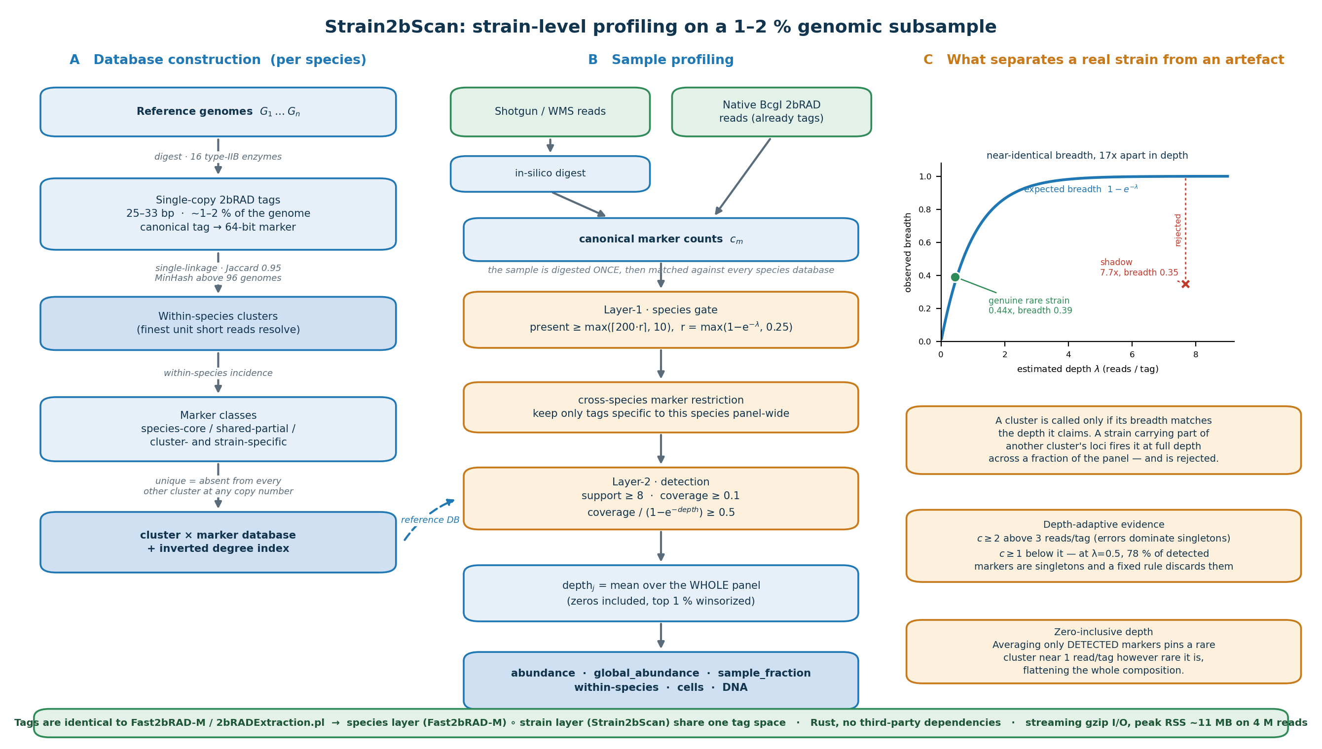
Figure 1. Strain2bScan overview and quality control. (A) Reference construction: type-IIB (2bRAD) digestion into single-copy 25–33 bp tags, within-species clustering at 0.95 Jaccard, marker classification and a cluster × marker database. (B) Profiling: one sample digest, species-level marker gating, cross-species marker restriction, cluster detection and abundance estimation for conventional shotgun or native BcgI input. (C) Depth-breadth consistency separates a genuine low-depth strain from a partial-marker shadow.

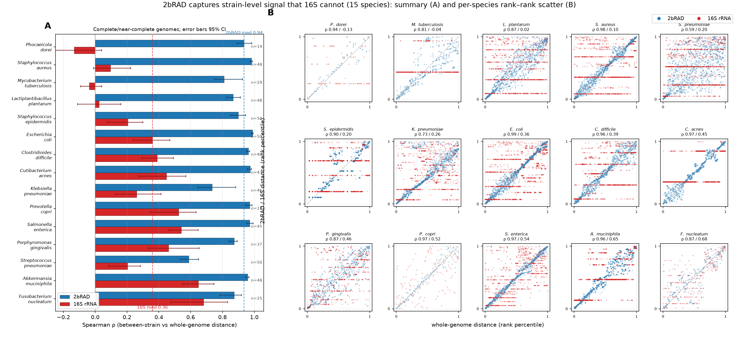
Figure 2. 2bRAD tags track genome-wide strain distance; 16S does not. (A) Per-species Spearman correlation between whole-genome strain distance and 2bRAD-tag or 16S distance across 15 complete/near-complete genome panels; 2bRAD median 0.94 versus 16S median 0.36. (B) Rank-rank matrices show that 2bRAD preserves genome-wide strain ordering whereas 16S collapses many unrelated pairs. # Part I — native BcgI 2bRAD-M performance

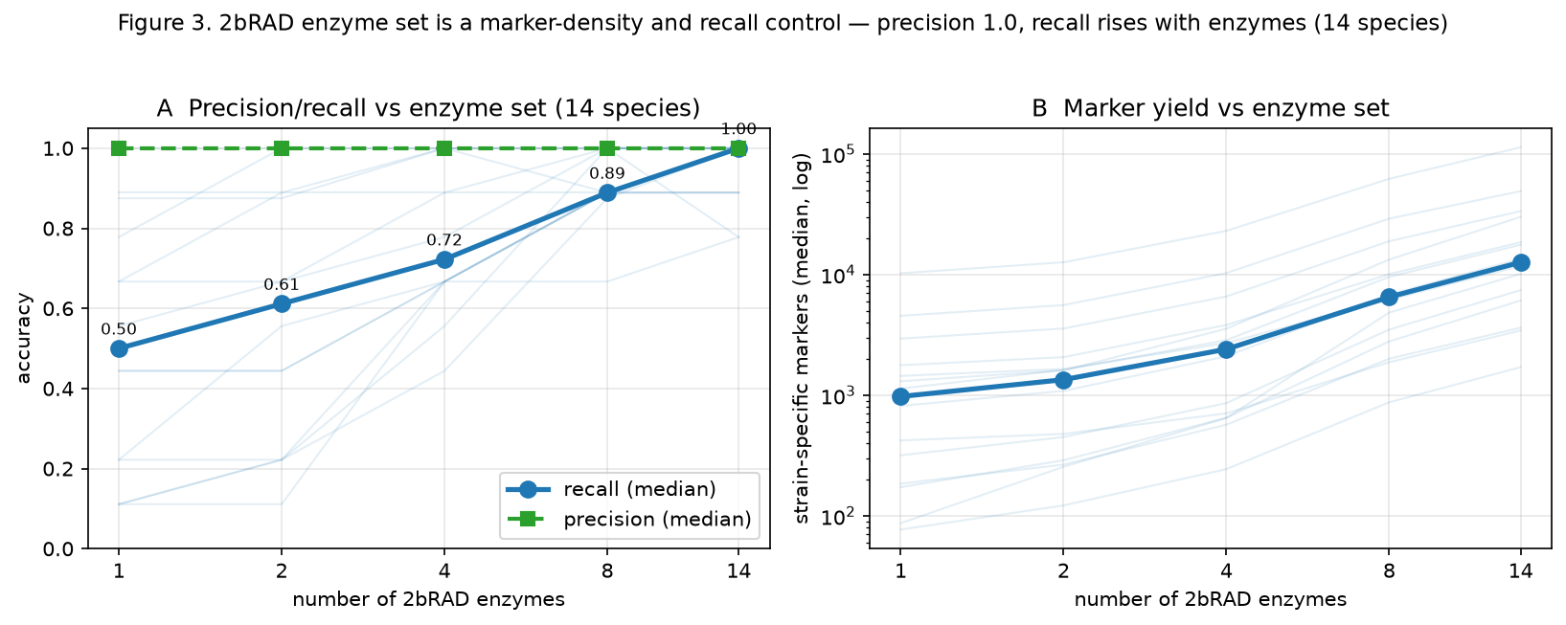
Figure 3. The 2bRAD enzyme set is a marker-density and recall control. In simulated samples from 14 resolvable species of the 15-species pool, increasing the enzyme set from 1 to 14 leaves precision at 1.0 while increasing median recall from 0.50 to 1.00 and strain-specific marker yield from 976 to 12,647. Approximately four enzymes recover most recall; BcgI alone supports native 2bRAD-M libraries. The sweep is an in-silico design experiment, not a native wet-lab library benchmark.

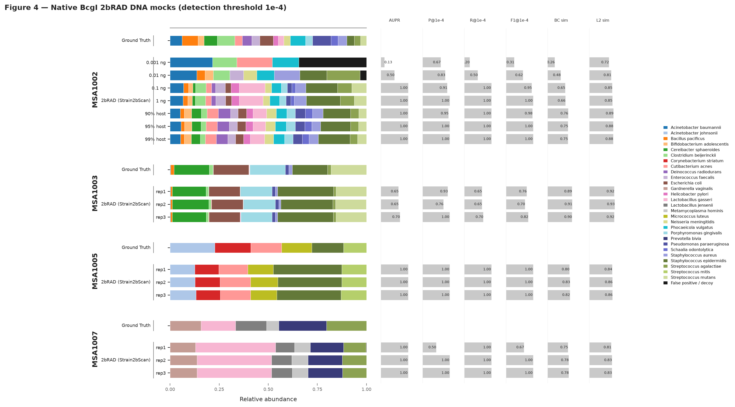
Figure 4. Native BcgI 2bRAD-M across four ATCC DNA mocks. MSA-1002, MSA-1003, MSA-1005 and MSA-1007 were profiled against a 28-species, 164-genome containment tree. At 90, 95 and 99% human DNA, F1 was 0.976–1.0 and Bray–Curtis similarity 0.745–0.756. A 0.1-ng input retained F1 0.952; 0.01 ng approached the marker-depth noise floor and 0.001 ng was below the detection floor.

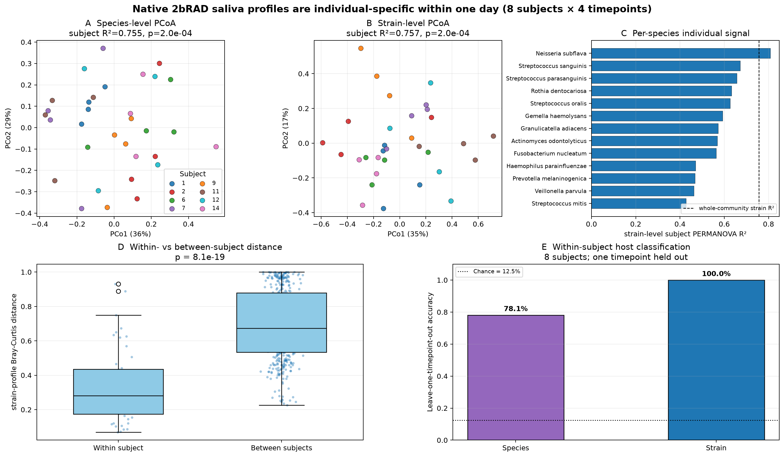
Figure 5. Real saliva contains individual-specific, within-day strain signatures. Thirty-two native BcgI 2bRAD-M saliva libraries from eight subjects sampled four times in one day were profiled against a 19-species oral panel. Leave-one-timepoint-out subject classification reached 100% with strain features versus 78.1% with species features. Within-subject Bray–Curtis distance was 0.327 versus 0.696 between subjects. This is a small within-subject result, not independent strain-identity validation.

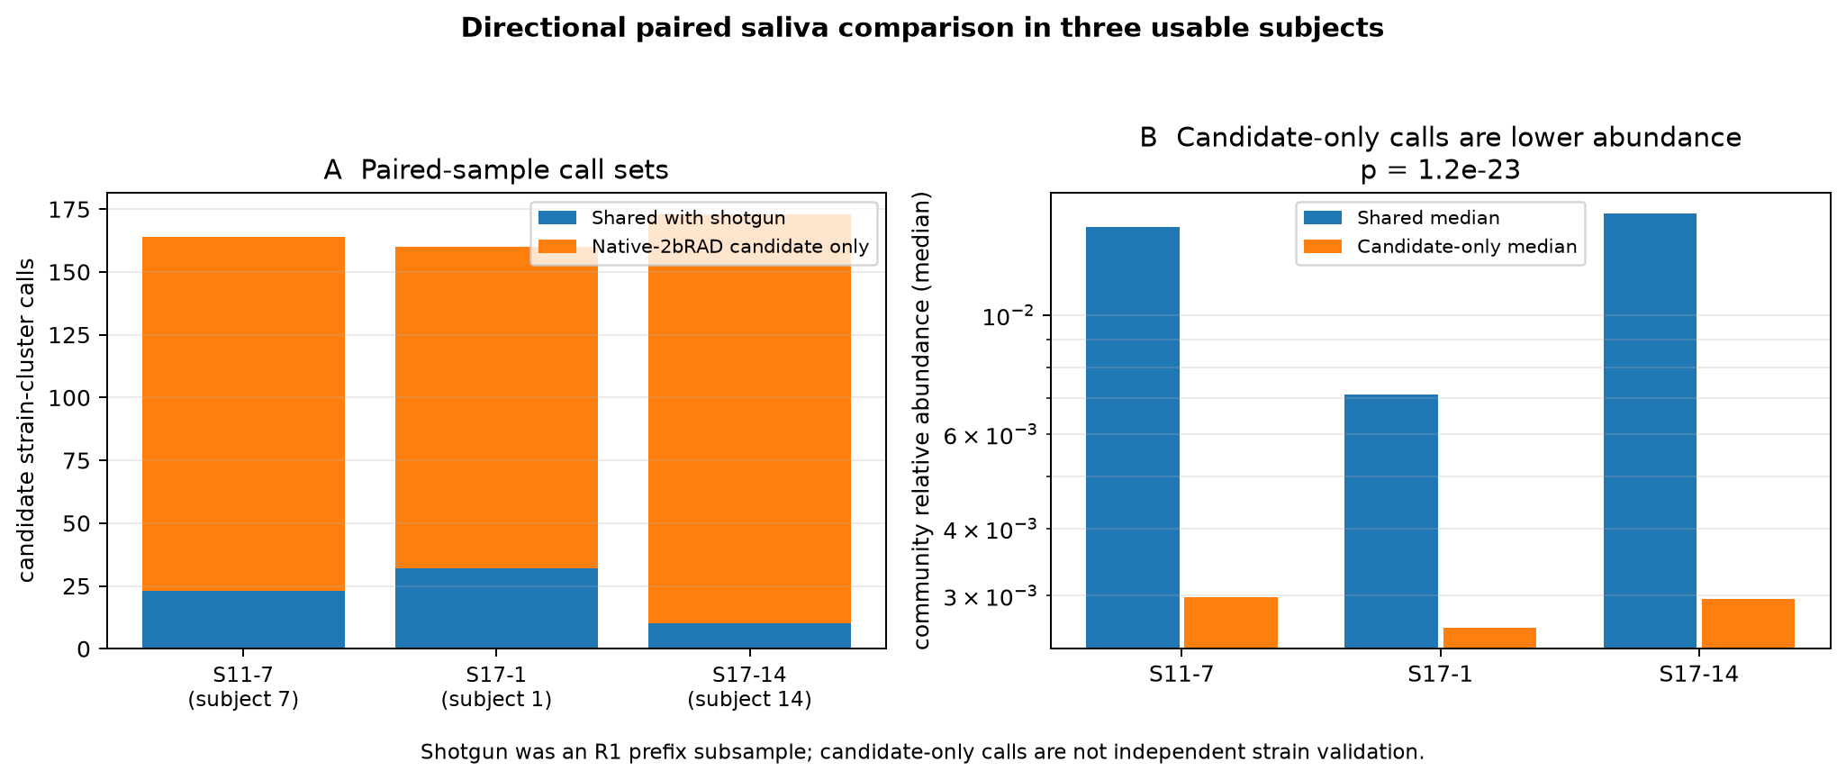
Figure 6. Paired saliva comparison shows directional recovery of low-abundance strains. Shotgun R1 prefix libraries from usable paired samples were digested in silico and compared with matched native BcgI libraries. All 65 shotgun strain-cluster calls were present in native calls; native 2bRAD-M yielded 128–163 additional candidate calls per sample. Additional calls had lower median relative abundance and require independent validation. # Part II — conventional shotgun metagenome performance

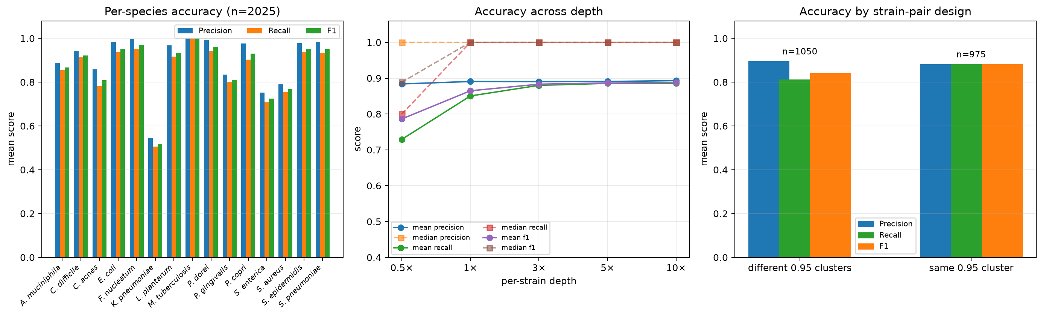
Figure 7. Accuracy across the complete 2,025-sample single-species simulation pool. Strain2bScan was evaluated on all 2,025 ART error-modelled shotgun simulations from 15 species, followed by in-silico 2bRAD digestion. Median precision, recall and F1 were 1.000; mean precision, recall and F1 were 0.890, 0.846 and 0.862. Mean F1 increased from 0.786 at 0.5× to 0.888 at 10×. Panels show per-species means, depth dependence and different-cluster versus same-cluster design.

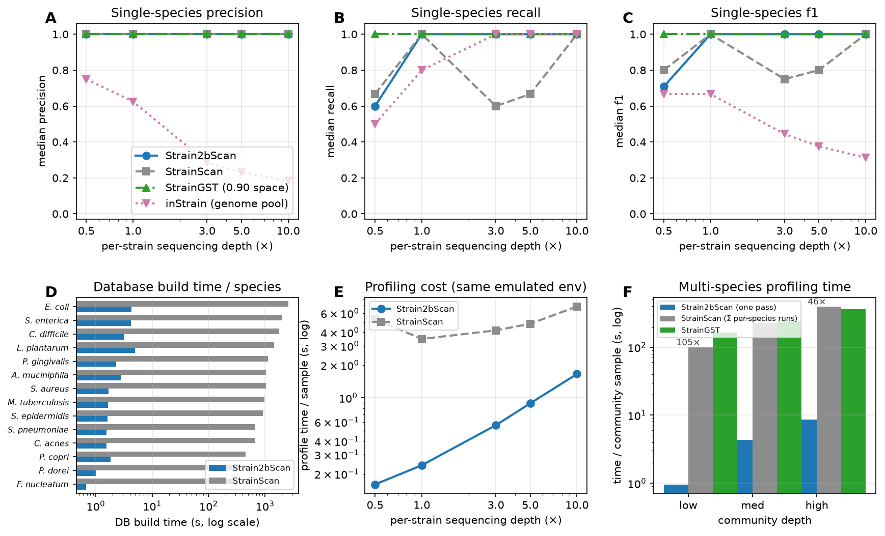
Figure 8. Matched 225-sample simulation comparison. Strain2bScan, StrainScan, StrainGST and inStrain were compared on 225 matched single-species simulations and 12 multi-species communities. Accuracy panels use each tool’s own reference/cluster space: 0.95 for Strain2bScan/StrainScan, 0.90 for StrainGST, and full species genome pools for inStrain, so accuracy is not pooled. Panels also show database-build cost, same-environment profiling cost and multi-species profiling time.

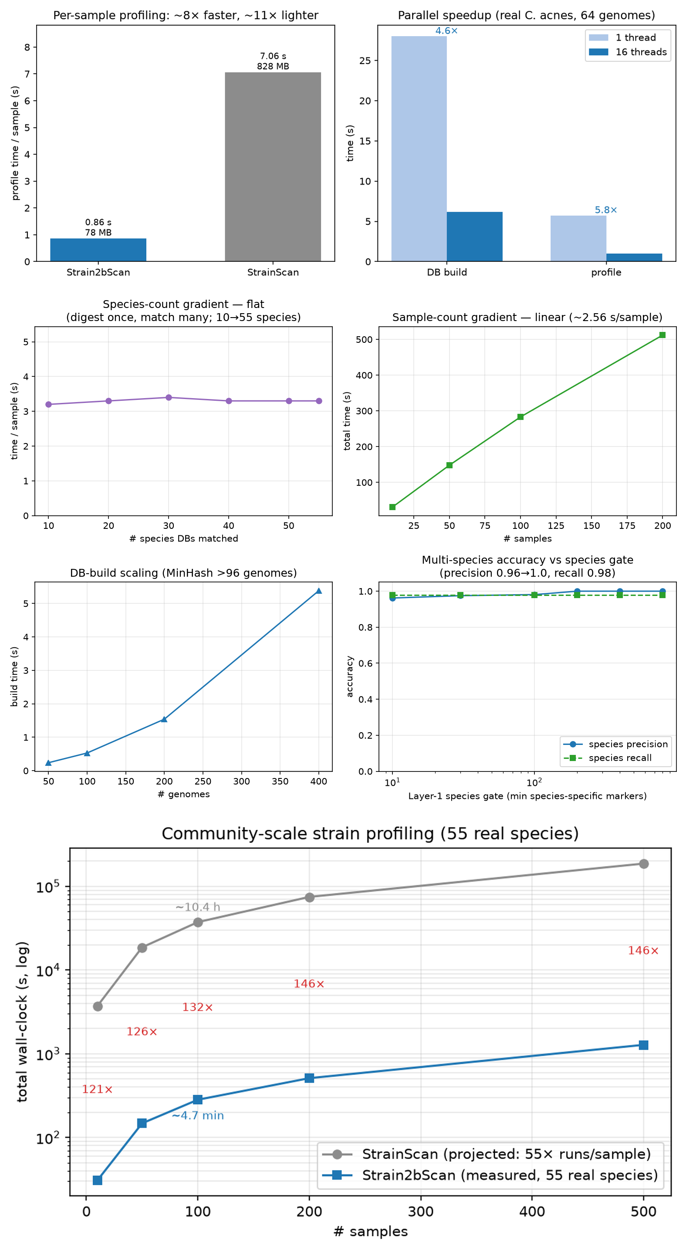
Figure 9. Computational scaling and community throughput. For C. acnes shotgun input, Strain2bScan was 8× faster and 11× lighter than StrainScan. Database build and profiling parallelised to 4.6× and 5.8× speed at 16 threads. Community profiling was approximately flat in species count; on a 55-species panel the projected cohort advantage over per-species StrainScan was 121–146×.

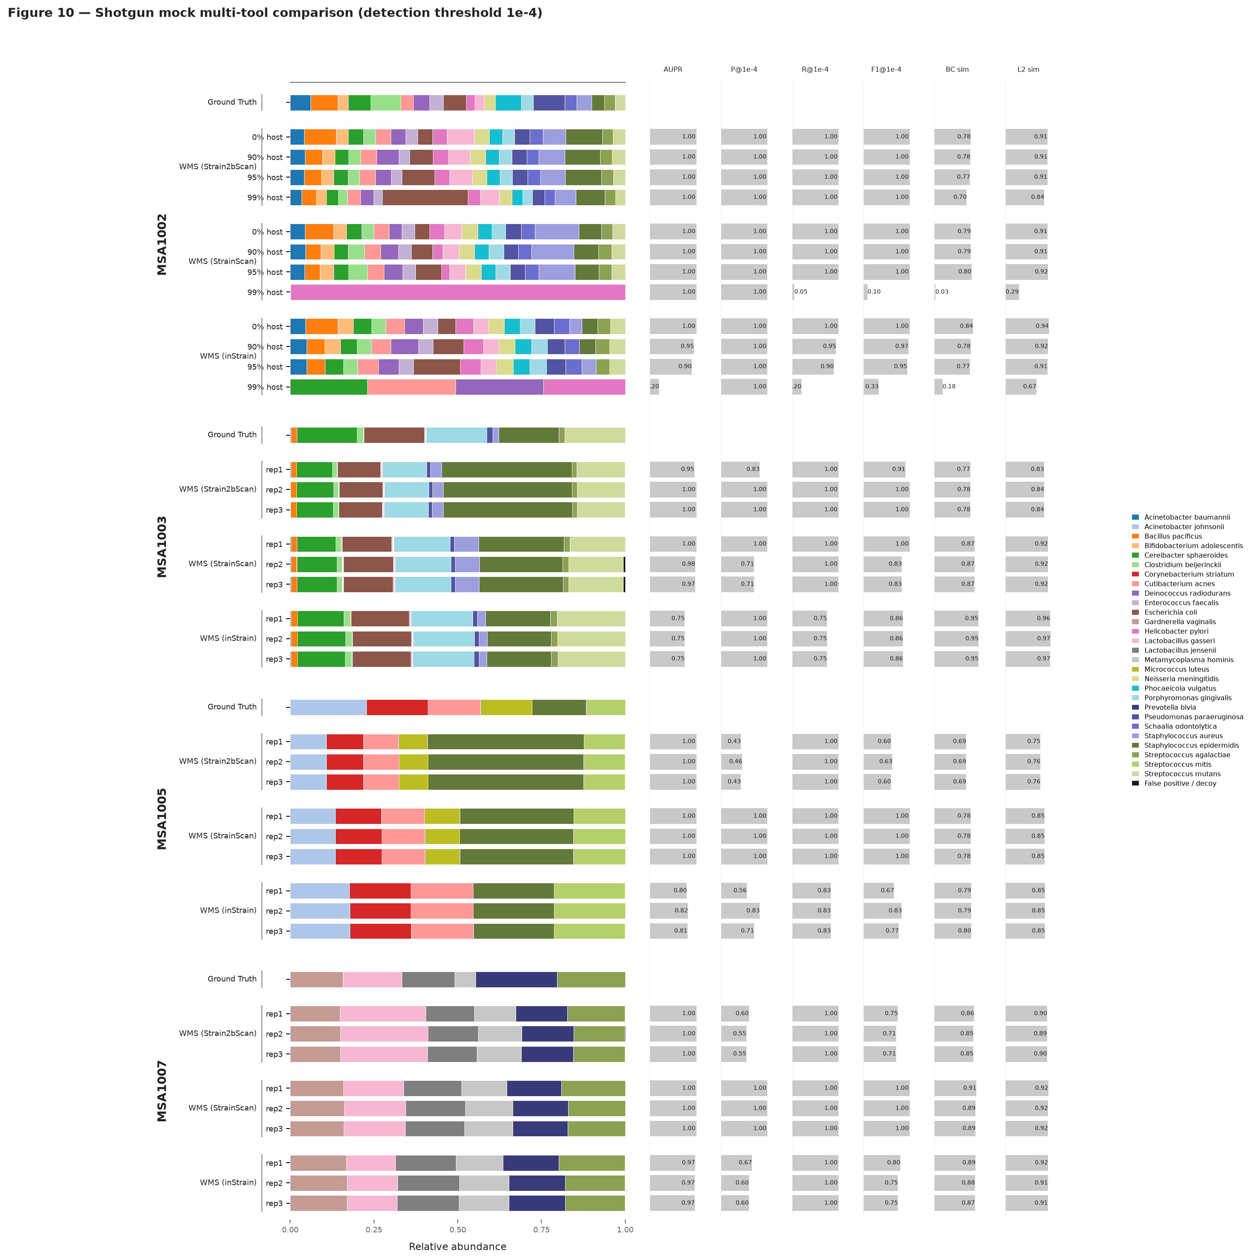
Figure 10. Shotgun DNA mocks separate tools under host contamination. Four ATCC shotgun mocks were profiled with Strain2bScan, StrainScan and inStrain, each in its own 0.95 cluster space. In MSA-1002 at 99% host, Strain2bScan retained F1 1.0 and Bray–Curtis dissimilarity 0.302, whereas StrainScan and inStrain had F1 0.095 and 0.333. Clean-mock thresholded precision varied with input composition. ## Supplementary figures

Supplementary figures

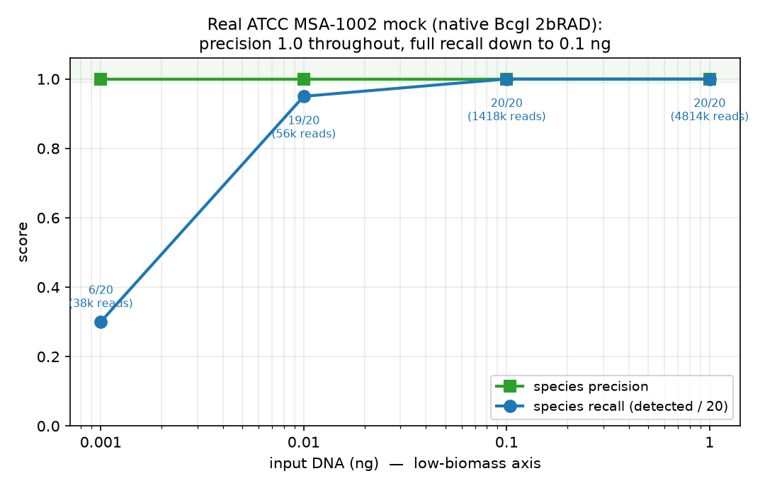
Figure S1. ATCC MSA-1002 DNA-input titration (native BcgI 2bRAD-M). precision 1.0 and full recall to 0.1 ng input.

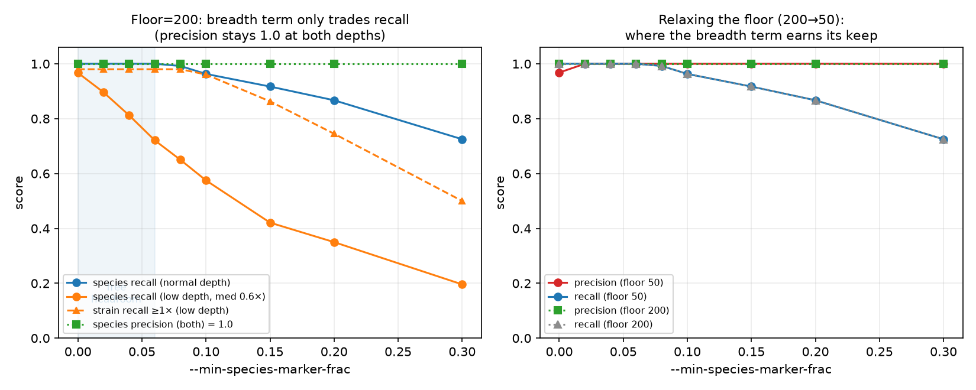
Figure S2. Layer-1 gate calibration on the 55-species panel. species precision/recall versus the marker floor at normal and low depth.

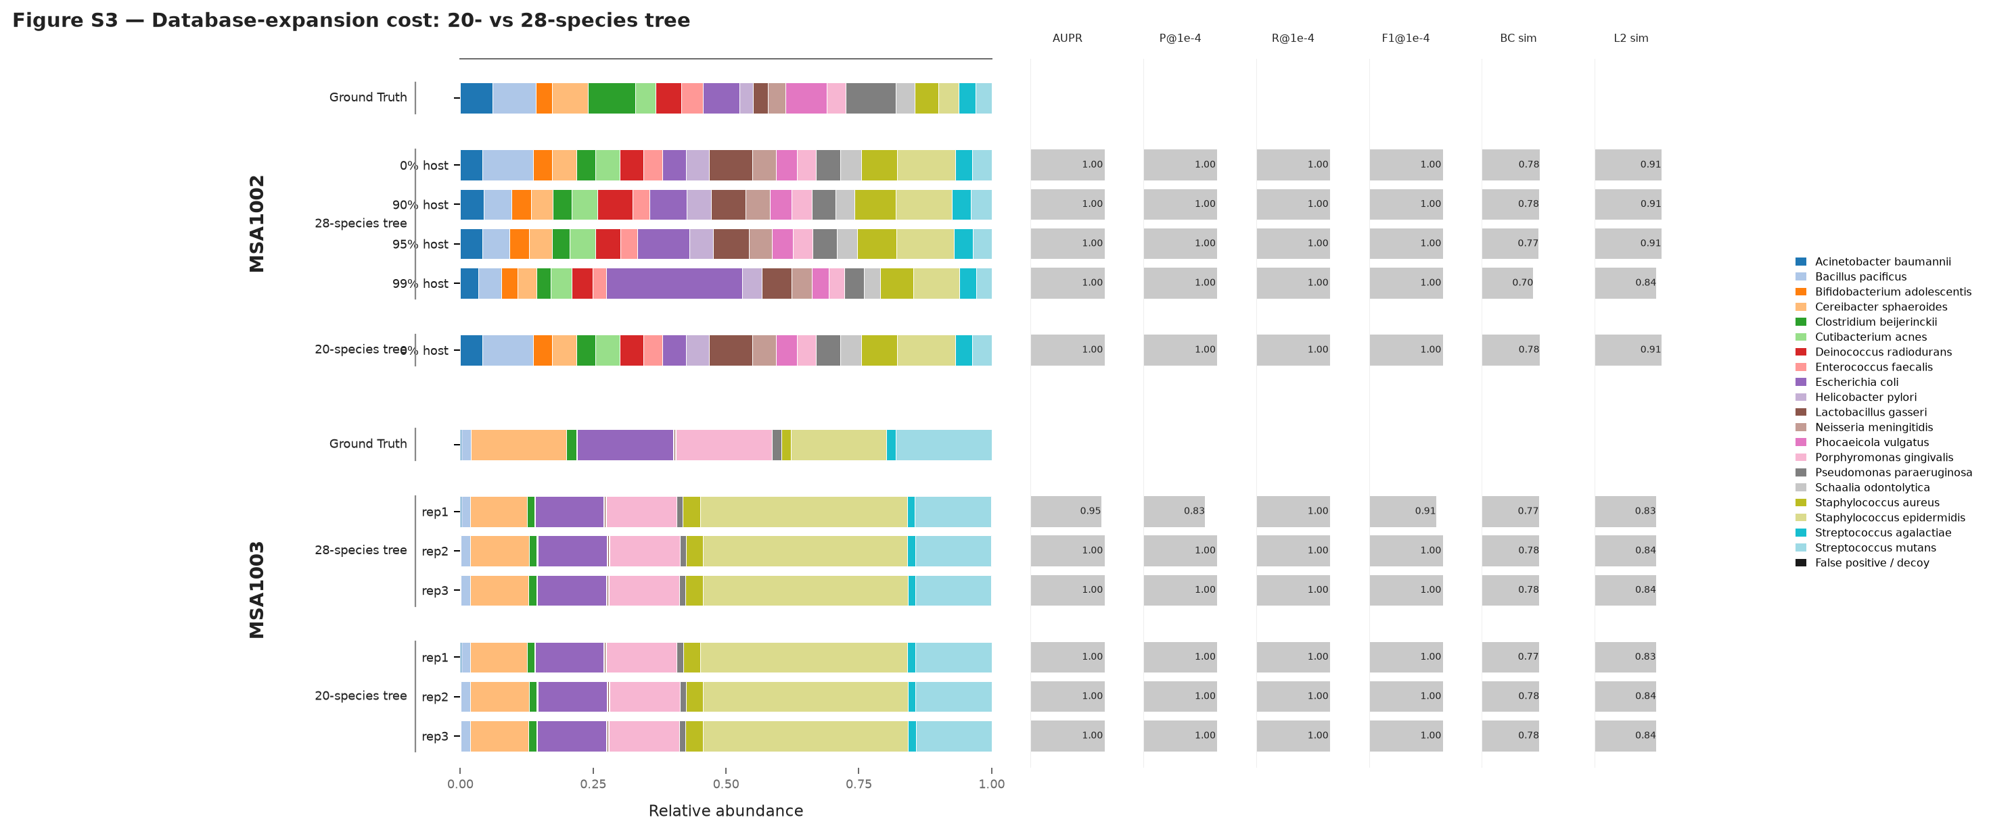
Figure S3. Cost of unified-database expansion (20- versus 28-species combined tree). MSA-1002 is unchanged by tree expansion; MSA-1003 has one lower-threshold replicate on the larger tree, confining cost to the approximately 1× marker-depth noise floor.

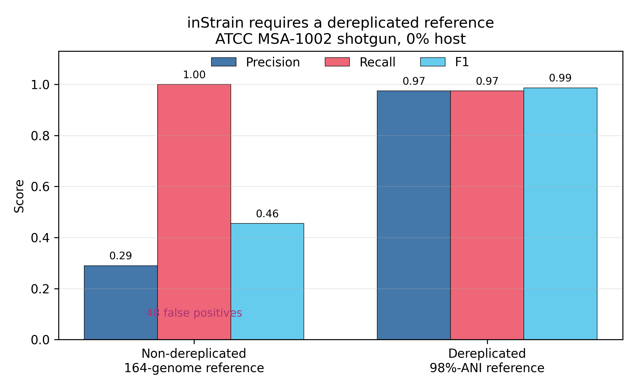
Figure S4. inStrain requires a dereplicated reference (MSA-1002 shotgun). The non-dereplicated 164-genome reference inflates false positives; 98%-ANI dereplication restores precision to 0.97, recall to 0.97 and F1 to 0.99.

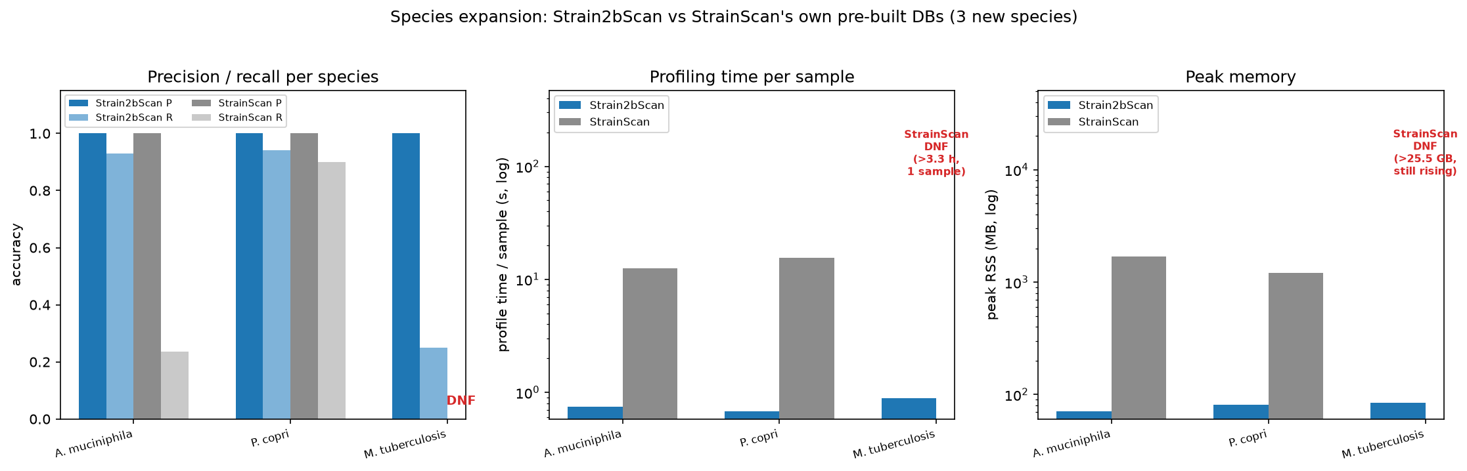
Figure S5. Strain2bScan versus StrainScan on three StrainScan-curated reference sets. Both tools reached precision 1.0 for A. muciniphila and P. copri; Strain2bScan matched or exceeded recall and was faster and lighter. Strain2bScan completed near-clonal M. tuberculosis in 0.89 s, whereas StrainScan did not complete.

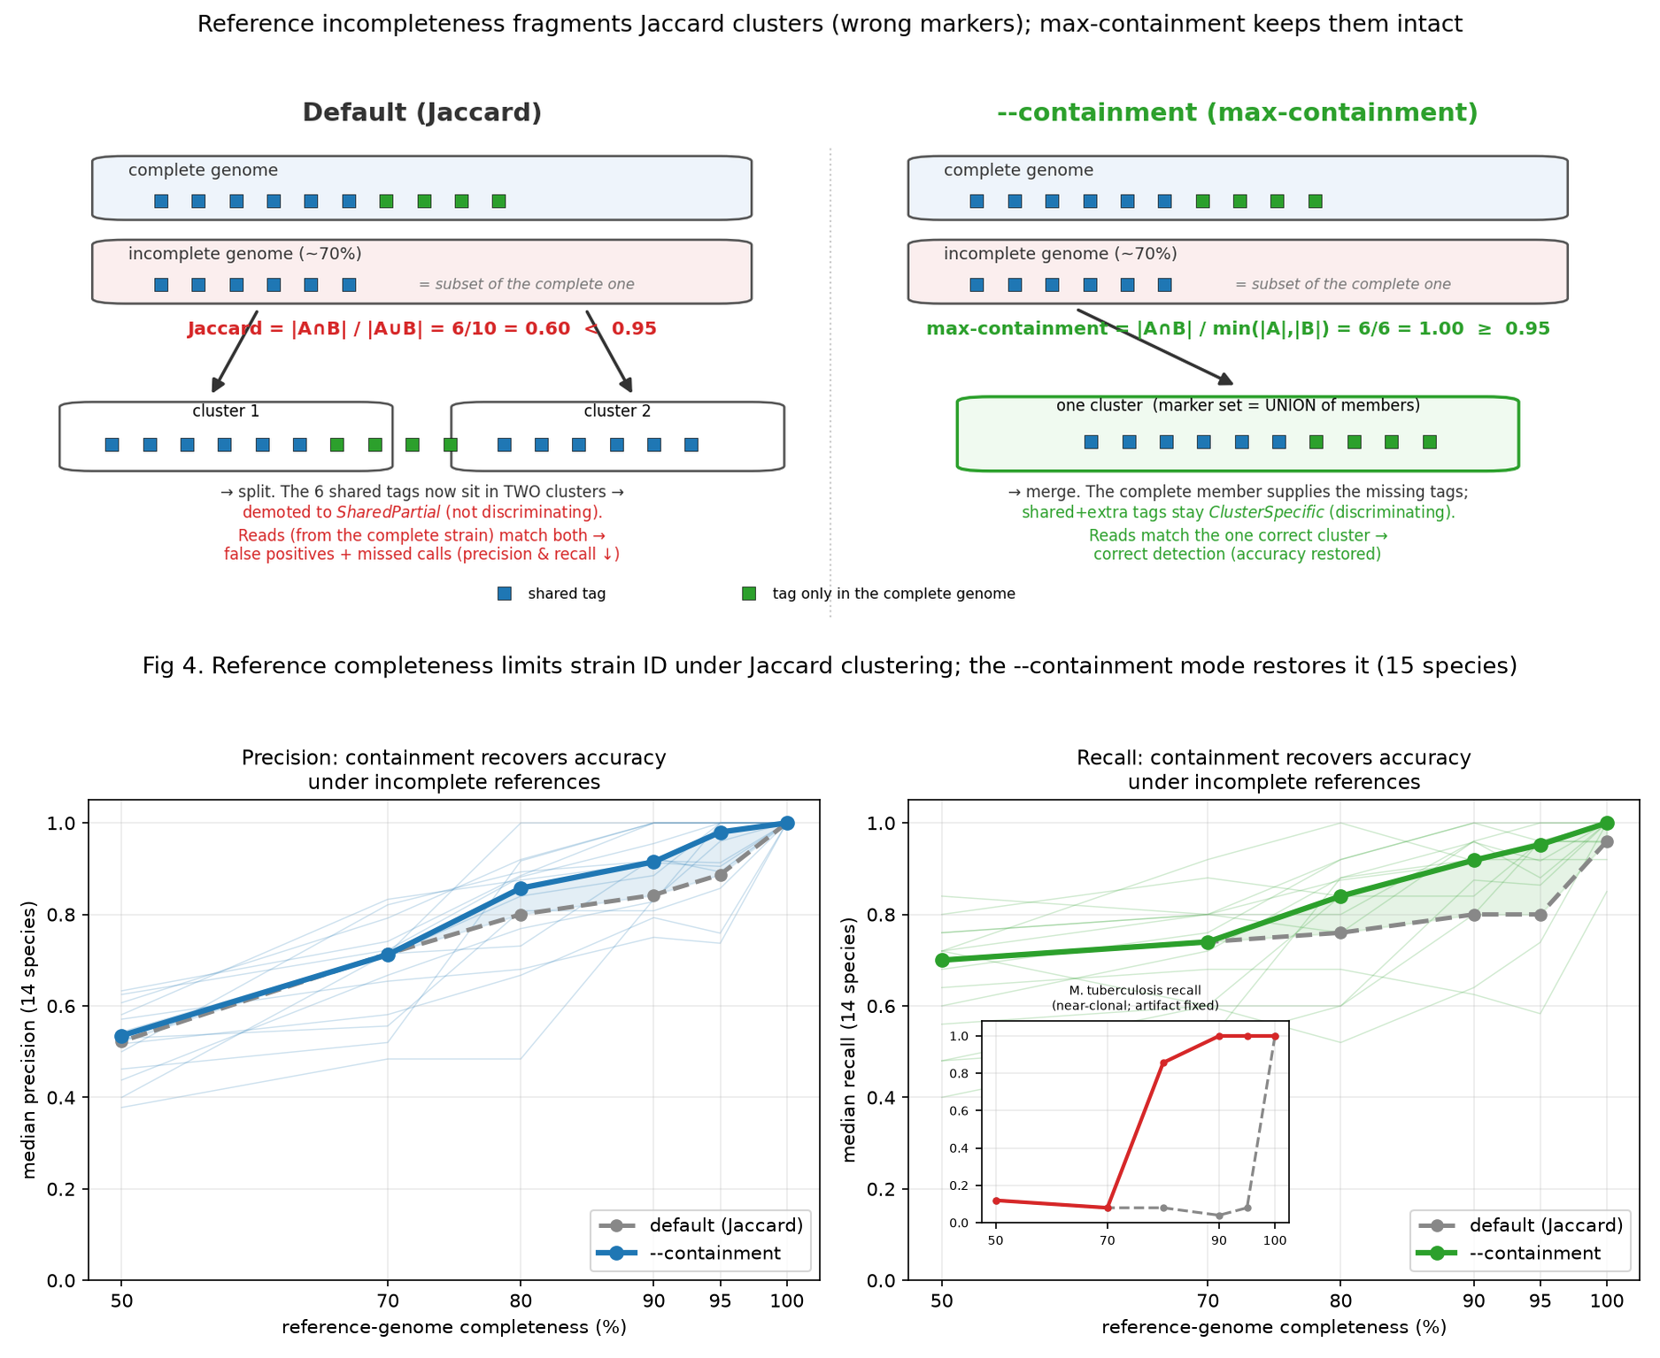
Figure S6. Reference-completeness optimization with Jaccard and containment clustering. Fixed simulated reads were profiled while truth-strain references were degraded. Default Jaccard clustering lost precision and recall as completeness fell; opt-in maximum-containment clustering restored accuracy at 90–95% completeness and prevented near-clonal M. tuberculosis fragmentation. This is an algorithmic optimization analysis and is therefore supplementary to the primary performance benchmarks.

Tables

Table 1. Current Strain2bScan regression versus the reproducible StrainScan rerun on the 15-species simulated benchmark. Accuracy is the median over completed run-level paired samples (different-cluster mixtures for 14 species; same-cluster mixtures for near-clonal M. tuberculosis; k = 2/3/5; depths 0.5–10×); each tool was scored in its own 0.95-similarity cluster space. Cluster-count columns are each tool’s own 0.95 partitions of the common species pool. StrainGE F1 uses all 15 species-specific tests in its own 0.90-reference space and is not pooled with the 0.95-space columns. Current Strain2bScan values are from source commit 6ae760c2f3bd2f39efc0e6aa06c53a84366cb16e; current source: results/strainscan_rerun/current_single_persample.tsv. Build cost is the archived timing benchmark (Strain2bScan native arm64; StrainScan linux/amd64 under emulation). S. enterica produced no completed StrainScan calls in the rerun; K. pneumoniae, which did not finish in the archived timing run, was successfully built and profiled in the reproducible rerun.
Species | Paired n | Pool genomes | S2B clusters | SS clusters | S2B P | S2B R | S2B F1 | SS P | SS R | SS F1 | Separate StrainGE F1 (0.90-space)† | S2B build | SS build
A. muciniphila | 14 | 50 | 24 | 24 | 0.900 | 0.900 | 0.900 | 1.000 | 1.000 | 1.000 | 1.000 | 2.8 s / 0.16 GB | 17 min / 16 GB
C. difficile | 15 | 47 | 27 | 24 | 1.000 | 1.000 | 1.000 | 1.000 | 0.667 | 0.800 | 1.000 | 3.2 s / 0.28 GB | 30 min / 14 GB
C. acnes | 15 | 43 | 8 | 8 | 1.000 | 0.800 | 0.800 | 1.000 | 0.800 | 0.889 | 1.000 | 1.5 s / 0.17 GB | 11 min / 8 GB
E. coli | 15 | 50 | 30 | 27 | 1.000 | 1.000 | 1.000 | 1.000 | 0.800 | 0.889 | 1.000 | 4.3 s / 0.34 GB | 43 min / 28 GB
F. nucleatum | 15 | 25 | 19 | 19 | 1.000 | 1.000 | 1.000 | 1.000 | 0.667 | 0.800 | 1.000 | 0.7 s / 0.10 GB | 5 min / 8 GB
K. pneumoniae | 15 | 47 | 28 | 27 | 0.333 | 0.333 | 0.286 | 1.000 | 0.800 | 0.889 | 1.000 | 5.1 s / 0.40 GB | DNF (timing run)
L. plantarum | 15 | 50 | 39 | 39 | 1.000 | 1.000 | 1.000 | 1.000 | 0.800 | 0.889 | 1.000 | 5.0 s / 0.24 GB | 24 min / 18 GB
M. tuberculosis | 15 | 29 | 1 | 1 | 1.000 | 1.000 | 1.000 | 1.000 | 1.000 | 1.000 | 1.000 | 1.6 s / 0.25 GB | 16 min / 15 GB
P. dorei | 10 | 15 | 10 | 10 | 1.000 | 1.000 | 1.000 | 1.000 | 0.667 | 0.800 | 1.000 | 1.0 s / 0.25 GB | 5 min / 13 GB
P. gingivalis | 15 | 43 | 27 | 31 | 1.000 | 1.000 | 1.000 | 1.000 | 0.667 | 0.800 | 1.000 | 2.3 s / 0.15 GB | 19 min / 11 GB
P. copri | 15 | 19 | 19 | 19 | 1.000 | 1.000 | 1.000 | 1.000 | 0.667 | 0.800 | 1.000 | 1.8 s / 0.19 GB | 8 min / 26 GB
S. enterica | 0 | 45 | 19 | 12 | – | – | – | – | – | – | 1.000 | 4.2 s / 0.37 GB | 34 min / 16 GB
S. aureus | 15 | 48 | 13 | 12 | 1.000 | 1.000 | 1.000 | 1.000 | 0.667 | 0.800 | 1.000 | 1.7 s / 0.17 GB | 17 min / 12 GB
S. epidermidis | 15 | 50 | 9 | 9 | 1.000 | 1.000 | 1.000 | 1.000 | 0.667 | 0.800 | 0.800 | 1.6 s / 0.14 GB | 15 min / 8 GB
S. pneumoniae | 15 | 50 | 38 | 38 | 1.000 | 1.000 | 1.000 | 1.000 | 0.667 | 0.800 | 1.000 | 1.5 s / 0.16 GB | 11 min / 11 GB
Median across 14 species with completed paired runs: Strain2bScan P 1.000 / R 1.000 / F1 1.000; StrainScan P 1.000 / R 0.667 / F1 0.800. Species medians conceal a precision/recall trade-off for K. pneumoniae. Mean paired differences and 95% intervals are in results/strainscan_rerun/current_uncertainty_summary.tsv.

Table 2. Accuracy and archived per-sample cost vs sequencing depth (single-species rerun; medians). Current Strain2bScan accuracy is from results/strainscan_rerun/current_single_persample.tsv on the 204 completed StrainScan pairs. †StrainGE/StrainGST metrics use the separate 0.90-reference space and are not pooled across tools. Cost comes from a smaller archived same-environment emulation subset whose per-depth n values differ from the accuracy n values (Strain2bScan linux/amd64 vs StrainScan).
Depth (×) | n | S2B P/R/F1 | SS P/R/F1 | S2B time/mem | Separate StrainGE P/R/F1 (0.90-space)† | SS time/mem
0.5 | 40 | 1.000/0.600/0.708 | 1.000/0.667/0.800 | 1.000/1.000/1.000 | 0.16 s / 21 MB | 5.30 s / 831 MB
1 | 41 | 1.000/1.000/1.000 | 1.000/1.000/1.000 | 1.000/1.000/1.000 | 0.24 s / 30 MB | 3.48 s / 831 MB
3 | 41 | 1.000/1.000/1.000 | 1.000/0.600/0.750 | 1.000/1.000/1.000 | 0.56 s / 60 MB | 4.17 s / 831 MB
5 | 41 | 1.000/1.000/1.000 | 1.000/0.667/0.800 | 1.000/1.000/1.000 | 0.89 s / 91 MB | 4.79 s / 831 MB
10 | 41 | 1.000/1.000/1.000 | 1.000/1.000/1.000 | 1.000/1.000/1.000 | 1.66 s / 161 MB | 6.92 s / 832 MB
Strain2bScan reached median recall 1.0 from 1× onward; StrainScan was non-monotonic and did not exceed 0.800 median F1 at 0.5× or intermediate depths. The depth table aggregates heterogeneous strain mixtures and is not a causal depth-onset estimate.

Table 3. Multi-species community accuracy (reproducible rerun; medians) and archived profiling cost. Current Strain2bScan values are from results/strainscan_rerun/current_multi_persample.tsv. †StrainGE/StrainGST metrics use the separate 0.90-reference space and are not pooled across tools. Four samples per depth. Strain2bScan profiles each community in one digest-once pass; StrainScan has no multi-species mode, so archived cost is the sum over per-species runs.
Community depth | S2B P/R/F1 | SS P/R/F1 | S2B time/mem | Separate StrainGE P/R/F1 (0.90-space)† | SS time/mem
low | 0.748/0.667/0.699 | 0.938/0.702/0.798 | 0.918/1.000/0.944 | 1.0 s / 311 MB | 100 s / 1112 MB
med | 0.838/0.838/0.837 | 0.954/0.903/0.927 | 0.901/1.000/0.934 | 4.3 s / 670 MB | 228 s / 1696 MB
high | 0.806/0.806/0.806 | 0.972/0.958/0.965 | 0.908/1.000/0.951 | 8.7 s / 1119 MB | 398 s / 2028 MB
Of 180 species-by-community opportunities (15 databases × 12 samples), 158 StrainScan final reports were generated; absent reports were treated as no detection. The per-sample coverage audit is in results/strainscan_rerun/multi_persample.tsv.

Table 4. Public real-metagenome application subsets profiled with Strain2bScan. These were informative application subsets rather than complete cohort analyses. The generic panel was the legacy 20-species MSA database; calls used all-enzyme mode with --min-species-markers 20 --min-species-detect 2 --min-support 2 --min-coverage 0.01 --min-abundance 0.
Project | Design and selected libraries | Calls | Observation
PRJNA288562 | Pregnancy subject T23; saliva, vaginal swab and distal gut at GD84 and GD273 (6 WGS libraries) | 34 calls in 5/6 libraries | Saliva was cluster-rich; four Neisseria and four Schaalia clusters were shared across timepoints. Gut B. adolescentis C4 persisted, whereas three other Bifidobacterium clusters and three E. coli clusters were GD84-only.
PRJNA1517970 | Preterm-birth vaginal/meconium subset plus extraction blank (7 WGS libraries) | 0 calls with the MSA panel; 0 calls with a 13-species body-site panel | The blank had 340 distinct markers, and selected libraries had 7,394–86,980. At a one-marker diagnostic gate, one meconium library showed only three C. acnes markers, supporting specificity while also indicating incomplete niche coverage.
PRJNA1191223 | Preterm infant P08 stool at W1, W2 and W3 (3 WGS libraries) | 9 generic-panel calls | Generic panel showed weekly turnover: one S. aureus cluster (W1), two E. coli clusters (W2), and six E. faecalis clusters (W3).
PRJNA1191225 | Six preterm-infant isolate WGS read sets used for cohort-panel validation | 6/6 expected self-calls | The cohort-specific panel recovered all expected E. coli clusters or Bifidobacterium species units.

Table 5. Isolate assemblies and cohort-specific panel validation. Isolates were assembled with SPAdes --isolate. E. coli assemblies were clustered at 0.95 similarity; each Bifidobacterium species was built as a single-genome database. All isolate read sets recovered the expected panel unit.
Isolate | Species | Contigs | Assembly (Mb) | N50 (kb) | Panel unit | Panel markers | Self-call
LHCA45 | Escherichia coli | 185 | 4.96 | 240.0 | C0 | 7,786 unique | ✓
LHCA56 | Escherichia coli | 448 | 5.15 | 222.6 | C1 | 5,466 unique | ✓
LHCA72 | Escherichia coli | 457 | 5.04 | 159.2 | C2 | 5,665 unique | ✓
LHCA43 | Bifidobacterium longum | 164 | 2.36 | 55.6 | LHCA43 | 18,426 | ✓
LHCA81 | Bifidobacterium breve | 90 | 2.39 | 228.3 | LHCA81 | 19,214 | ✓
LHCA82 | Bifidobacterium bifidum | 180 | 2.30 | 75.6 | LHCA82 | 17,985 | ✓

Table 6. P08 weekly stool profiling with the cohort-specific isolate panel. Breadth is database coverage; abundance is within-species abundance in Strain2bScan output.
Week | Species | Panel unit | Breadth | Depth (×) | Abundance | Fraction of sample
W1 | Bifidobacterium bifidum | LHCA82 | 0.764 | 236.7 | 1.000 | 0.6456
W2 | Bifidobacterium bifidum | LHCA82 | 0.773 | 213.9 | 1.000 | 0.5834
W2 | Escherichia coli | C0|C1|C2 | 0.026 | 0.029 | 1.000 | 0.000140
W3 | Bifidobacterium bifidum | LHCA82 | 0.792 | 238.2 | 1.000 | 0.6099
The generic MSA panel detected the W2 E. coli signal as two low-abundance generic clusters (fraction 6.1 × 10⁻⁵ and 5.7 × 10⁻⁵) but did not contain the persistent B. bifidum LHCA82 unit. This contrast illustrates why body-site- or cohort-specific panels are needed for biological interpretation.

Table 7. Leave-one-isolate-out behaviour for the three Escherichia coli panel isolates. For each test, the held-out isolate was absent from the database. Reads were profiled against a panel containing the other two E. coli assemblies and the three Bifidobacterium species controls.
Held-out isolate | E. coli genomes in panel | Observed E. coli unit | Breadth | Depth (×) | Fraction of sample | Interpretation
LHCA45 | 2 | C0|C1 | 0.799 | 7.87 | 0.612 | Reads from the absent isolate were assigned to merged relatives rather than creating a false third cluster.
LHCA56 | 2 | C0|C1 | 0.911 | 10.55 | 0.649 | Same conspecific-assignment behaviour.
LHCA72 | 2 | C0|C1 | 0.891 | 7.25 | 0.729 | Same conspecific-assignment behaviour.
This test shows that closed panels can misattribute a truly absent conspecific strain to near relatives. It therefore supports the paper’s conservative treatment of the low-coverage W2 E. coli signal as an unresolved C0|C1|C2 unit rather than assigning it to one isolate.

Table 8. Comparator and assay scope. This table distinguishes tools executed in the benchmark from related tools discussed for context. It is a scope statement, not a performance comparison. Native 2bRAD denotes BcgI-derived experimental libraries; shotgun denotes conventional WMS reads, which Strain2bScan can also process after in-silico digestion.
Tool | Executed here | Input scope | Typical resolution | Scope and role
Strain2bScan | Yes | Native BcgI 2bRAD reads and in-silico-digested shotgun reads | Strain clusters | Method under test; one marker framework supports both reduced-representation and shotgun input.
StrainScan v1.0.14 | Yes | Shotgun reads against per-species reference databases | Strain clusters | Direct reference-guided comparator on shotgun reads (Fig 10–11, Supplementary Fig S5; Tables 1–3).
inStrain v1.9.1 | Yes | Shotgun reads aligned to a dereplicated reference | Strain and SNV | Direct read-level shotgun comparator (Fig 11 and Fig S4).
StrainGE / StrainGST / StrainGR | StrainGST only | Shotgun WMS reads against StrainGE 0.90-reference databases; native BcgI 2bRAD is not documented input | Strain level, reference guided | StrainGST completed 225 single-species simulations, 12 multi-species communities and four ATCC WMS mocks (Tables 1–3 and 9); StrainGR was not run.
2bRAD-M / Fast2bRAD-M | No | Native BcgI 2bRAD reads | Mainly species | Same restriction-assay family; provides the species-level upstream context for Strain2bScan.
sylph | No | Shotgun sketches | Mainly species and ANI | Context for rapid species-level profiling; not a strain-resolved benchmark here.
StrainPhlAn | No | Shotgun marker genes | Strain types | Context for marker-gene strain profiling; not rerun here.

Table 9. StrainGST (StrainGE 1.3.9) rerun accuracy and efficiency. Simulations are the matched _rep1_ subset and all 12 multi-species communities. Mocks are the primary WMS replicate used in Figure 11; MSA-1002 is the 99%-host sample. Accuracy is in StrainGE’s 0.90-reference space; mock calls use abundance >= 1e-4. Wall time is one sample k-merization plus all per-species StrainGST searches; RSS is the maximum across those stages. StrainGR was not run.
Dataset | n | Precision | Recall | F1 | Median wall time/sample (s) | Median peak RSS/sample (GB)
Simulated single-species | 225 | 1.000 | 1.000 | 1.000 | 18.66 | 1.30
Simulated multi-species | 12 | 0.901 | 1.000 | 0.941 | 236.98 | 7.90
MSA-1002, 99% host | 1 | 0.700 | 0.700 | 0.700 | 1007.22 | 14.36
MSA-1003 | 1 | 0.464 | 0.650 | 0.542 | 2158.75 | 21.52
MSA-1005 | 1 | 0.333 | 0.833 | 0.476 | 1784.50 | 20.10
MSA-1007 | 1 | 0.429 | 1.000 | 0.600 | 1555.76 | 17.69

Table S3. Exploratory native BcgI 2bRAD-M oral-library profiling. Four libraries from the PRJNA1131785 exploratory oral cohort were profiled against the same 19-species panel used for the saliva analysis. No case/control labels were available in public metadata. Values are from results/clinical_exploratory.tsv.
Sample | Distinct markers | Species resolved | Strain calls | Runtime (s) | Top species
S_0313206 | 271,322 | 15 | 115 | 2.3 | Neisseria subflava; Haemophilus parainfluenzae; Actinomyces odontolyticus
S_1413231 | 288,019 | 17 | 129 | 1.8 | Neisseria subflava; Streptococcus mitis; Actinomyces odontolyticus
S_8123213 | 370,379 | 16 | 149 | 2.0 | Actinomyces odontolyticus; Neisseria subflava; Haemophilus parainfluenzae
S_8221232 | 488,180 | 17 | 158 | 1.8 | Actinomyces odontolyticus; Neisseria subflava; Rothia mucilaginosa

Table S4. Failure-aware sensitivity for all 225 matched single-species entries. Absent StrainScan final reports were retained and scored as zero detection. Failure-as-absence assigns zero recall to absent reports and uses a species-cluster bootstrap; precision and F1 are not assigned to no-report failures. Source: results/strainscan_rerun/current_single_persample.tsv and results/strainscan_rerun/current_uncertainty_summary.tsv.
Analysis | n | No-calls | Mean recall difference (95% CI) | No-call rate
Completed pairs | 204 | 0 | +0.063 (−0.037 to 0.133) | 0%
Failure as absence | 225 | 21 | +0.127 (0.007 to 0.248) | 9.33%

Table S5. Public-run manifest and exploratory profiling outcomes. SRA spots, bases and instrument metadata were retrieved from NCBI on 2026-10-11. Marker and call counts are from the generic MSA screen; body-site-panel calls are shown for PRJNA1517970. P08 run-to-week mapping follows SRA submitter titles. Source: results/realworld_cohort_benchmark/public_run_manifest.tsv.
Run | Project | Role/site | SRA spots | SRA bases | MSA markers | MSA strain calls | Body-site calls
SRR32121885 | PRJNA1191223 | preterm infant P08 stool W1 | 4,862,900 | 1,215,725,000 | 748,209 | 1 | –
SRR32121884 | PRJNA1191223 | preterm infant P08 stool W2 | 4,684,342 | 1,171,085,500 | 694,111 | 2 | –
SRR32121883 | PRJNA1191223 | preterm infant P08 stool W3 | 4,403,456 | 1,100,864,000 | 830,986 | 6 | –
SRR32076429 | PRJNA1191225 | Bifidobacterium bifidum LHCA82 isolate WGS | 265,039 | 78,810,882 | 129,681 | 0 | –
SRR32076422 | PRJNA1191225 | Bifidobacterium breve LHCA81 isolate WGS | 292,272 | 87,006,759 | 142,707 | 0 | –
SRR32076444 | PRJNA1191225 | Bifidobacterium longum LHCA43 isolate WGS | 117,024 | 34,917,748 | 65,183 | 0 | –
SRR32076385 | PRJNA1191225 | Escherichia coli LHCA45 isolate WGS | 530,692 | 157,695,345 | 219,245 | 0 | –
SRR32076393 | PRJNA1191225 | Escherichia coli LHCA56 isolate WGS | 694,301 | 206,230,492 | 242,121 | 0 | –
SRR32076407 | PRJNA1191225 | Escherichia coli LHCA72 isolate WGS | 405,951 | 120,852,478 | 183,313 | 0 | –
SRR40410776 | PRJNA1517970 | extraction blank | 969 | 181,397 | 464 | 0 | 0
SRR40410528 | PRJNA1517970 | meconium | 130,092 | 35,779,278 | 116,410 | 0 | 0
SRR40410657 | PRJNA1517970 | meconium | 63,704 | 12,967,250 | 31,171 | 0 | 0
SRR40410851 | PRJNA1517970 | meconium | 37,274 | 8,265,014 | 23,718 | 0 | 0
SRR40410567 | PRJNA1517970 | vagina | 29,852 | 5,373,843 | 9,693 | 0 | 0
SRR40410734 | PRJNA1517970 | vagina | 123,942 | 24,263,782 | 24,067 | 0 | 0
SRR40410753 | PRJNA1517970 | vagina | 71,724 | 13,985,625 | 14,802 | 0 | 0
SRR6748033 | PRJNA288562 | subject T23 distal gut GD273 | 3,803,560 | 1,120,072,205 | 1,595,769 | 2 | –
SRR6748028 | PRJNA288562 | subject T23 distal gut GD84 | 2,804,411 | 824,219,750 | 1,918,932 | 7 | –
SRR6748088 | PRJNA288562 | subject T23 saliva GD273 | 771,556 | 226,981,334 | 876,200 | 11 | –
SRR6748097 | PRJNA288562 | subject T23 saliva GD84 | 377,872 | 111,169,454 | 533,573 | 13 | –
SRR6747958 | PRJNA288562 | subject T23 vagina GD273 | 636,817 | 186,911,987 | 226,983 | 1 | –
SRR6748207 | PRJNA288562 | subject T23 vagina GD84 | 243,062 | 71,385,301 | 45,805 | 0 | –

References
- Liao H, Ji Y, Sun Y. High-resolution strain-level microbiome composition analysis from short reads. Microbiome 2023; 11:183. doi:10.1186/s40168-023-01615-w.
- van Dijk LR, Walker BJ, Straub TJ, et al. StrainGE: a toolkit to track and characterize low-abundance strains in complex microbial communities. Genome Biology 2022; 23:74. doi:10.1186/s13059-022-02630-0.
- Truong DT, Tett A, Pasolli E, Huttenhower C, Segata N. Microbial strain-level population structure and genetic diversity from metagenomes. Genome Research 2017; 27(4):626–638.
- Shaw J, Yu YW. Rapid species-level metagenome profiling and containment estimation with sylph. Nature Biotechnology 2025; 43(8):1348–1359 (published online 2024). doi:10.1038/s41587-024-02412-y.
- Wang S, Meyer E, McKay JK, Matz MV. 2b-RAD: a simple and flexible method for genome-wide genotyping. Nature Methods 2012; 9(8):808–810.
- Sun Z, Huang S, Zhu P, et al. Species-resolved sequencing of low-biomass or degraded microbiomes using 2bRAD-M. Genome Biology 2022; 23:36.
- Huang S. Fast2bRAD-M: high-performance Rust reimplementation of the 2bRAD-M microbiome profiling pipeline. Software, https://github.com/HuangShiLab/Fast2bRAD-M.
- Olm MR, Crits-Christoph A, Bouma-Gregson K, Firek BA, Morowitz MJ, Banfield JF. inStrain profiles population microdiversity from metagenomic data and sensitively detects shared microbial strains. Nature Biotechnology 2021; 39(6):727–736. doi:10.1038/s41587-020-00797-0.
- Ondov BD, Treangen TJ, Melsted P, et al. Mash: fast genome and metagenome distance estimation using MinHash. Genome Biology 2016; 17:132.
- Brown CT, Irber L. sourmash: a library for MinHash sketching of DNA. Journal of Open Source Software 2016; 1(5):27.
- Chklovski A, Parks DH, Woodcroft BJ, Tyson GW. CheckM2: a rapid, scalable and accurate tool for assessing microbial genome quality using machine learning. Nature Methods 2023; 20(8):1203–1212. doi:10.1038/s41592-023-01940-w.
- Orakov A, Fullam A, Coelho LP, et al. GUNC: detection of chimerism and contamination in prokaryotic genomes. Genome Biology 2021; 22:178. doi:10.1186/s13059-021-02393-0.
- Minkin I, Medvedev P. Scalable multiple whole-genome alignment and locally collinear block construction with SibeliaZ. Nature Communications 2020; 11:6327. doi:10.1038/s41467-020-19777-8.
- Ondov BD, Starrett GJ, Sappington A, et al. Mash Screen: high-throughput sequence containment estimation for genome discovery. Genome Biology 2019; 20:232. doi:10.1186/s13059-019-1841-x.
- Parks DH, Imelfort M, Skennerton CT, Hugenholtz P, Tyson GW. CheckM: assessing the quality of microbial genomes recovered from isolates, single cells, and metagenomes. Genome Research 2015; 25(7):1043–1055. doi:10.1101/gr.186072.114.
- Sun Z, Huang S, Zhang M, et al. Challenges in benchmarking metagenomic profilers. Nature Methods 2021; 18(6):618–626. doi:10.1038/s41592-021-01141-3.
- Meyer F, Fritz A, Deng ZL, et al. Critical Assessment of Metagenome Interpretation: the second round of challenges. Nature Methods 2022; 19(4):429–440. doi:10.1038/s41592-022-01431-4.
- Huang W, Li L, Myers JR, Marth GT. ART: a next-generation sequencing read simulator. Bioinformatics 2012; 28(4):593–594.
- Bowers RM, Kyrpides NC, Stepanauskas R, et al. Minimum information about a single amplified genome (MISAG) and a metagenome-assembled genome (MIMAG) of bacteria and archaea. Nature Biotechnology 2017; 35(8):725–731. doi:10.1038/nbt.3893.
- Seemann T. Barrnap: basic rapid ribosomal RNA predictor. Software, https://github.com/tseemann/barrnap.
- Eddy SR. Accelerated profile HMM searches. PLoS Computational Biology 2011; 7(10):e1002195. doi:10.1371/journal.pcbi.1002195.
- Shaw J, Yu YW. Fast and robust metagenomic sequence comparison through sparse chaining with skani. Nature Methods 2023; 20(11):1661–1665. doi:10.1038/s41592-023-02018-3.
- Langmead B, Salzberg SL. Fast gapped-read alignment with Bowtie 2. Nature Methods 2012; 9(4):357–359. doi:10.1038/nmeth.1923.
- Ye SH, Siddle KJ, Park DJ, Sabeti PC. Benchmarking metagenomics tools for taxonomic classification. Cell 2019; 178(4):779–794. doi:10.1016/j.cell.2019.07.010.
- Anderson MJ. A new method for non-parametric multivariate analysis of variance. Austral Ecology 2001; 26(1):32–46. doi:10.1046/j.1442-9993.2001.01070.x.
- Baker DN, Langmead B. Dashing: fast and accurate genomic distances with HyperLogLog. Genome Biology 2019; 20:265. doi:10.1186/s13059-019-1875-0.
- Marçais G, Kingsford C. A fast, lock-free approach for efficient parallel counting of occurrences of k-mers. Bioinformatics 2011; 27(6):764–770. doi:10.1093/bioinformatics/btr011.
- Bankevich A, Nurk S, Antipov D, et al. SPAdes: a new genome assembly algorithm and its applications to single-cell sequencing. Journal of Computational Biology 2012; 19(5):455–477. doi:10.1089/cmb.2012.0021.

