RustyClean: adaptive, composition-aware host depletion for short-read metagenomics
DRAFT — v0.1
Authors (placeholder): Yufeng Zhang, …, Shi Huang* Affiliation: … Correspondence: …

Abstract
https://github.com/HuangShiLab/rustycleanComputational depletion of host DNA is a mandatory first step in short-read metagenomics, and its errors propagate silently into every downstream result. Recent benchmarking established that the two dominant strategies fail in opposite directions: alignment-based depletion is prone to false positives, discarding genuine microbial reads, whereas k-mer classification is prone to false negatives, retaining host reads. Existing pipelines commit to one strategy for every sample and therefore inherit one failure mode unconditionally. We present RustyClean, a host-depletion pipeline that treats this asymmetry as a routing problem rather than a fixed trade-off. RustyClean estimates the host fraction of each sample from a rapid alignment survey of a 100,000-read subsample, routes the sample to alignment- or classification-based depletion accordingly, and on the classification path applies a targeted alignment pass over the retained reads to recover host that classification missed. On simulated metagenomes spanning 1–90% host content with per-read ground truth, adaptive routing selected the appropriate backend in every case. For high-host samples the default path uses Kraken2 classification followed by a targeted Bowtie2 recheck of unclassified reads; for low-host samples it uses Bowtie2 directly. RustyClean ran 10–13× faster than KneadData on the host-removal step and 5.7–6.1× faster for the full QC-plus-depletion pipeline, while discarding less microbial signal (0.20% against 2.58% at 50% host). Against Hostile, a purpose-built depletion tool, RustyClean’s depletion-only step (--skip-qc) was 1.3–1.9× faster on a matched panel spanning 30–100 M reads and 50–90% host content, with a small accuracy gap on the 100 M subset (ΔF1 ≈ 0.0014 at 50% host, ΔF1 ≈ 0.0048 at 90% host). The Kraken2-based path trades a larger memory footprint (~16 GB versus ~4 GB for Hostile) for classification speed, and the optional Bowtie2 recheck recovers most host reads that Kraken2 misses. RustyClean is a single Rust binary with per-stage checkpointing, bounded concurrency and an automated output validation gate, available at https://github.com/HuangShiLab/rustyclean under the MIT licence.
Keywords: metagenomics, host depletion, decontamination, Kraken2, Bowtie2, Rust

1. Introduction
Shotgun metagenomic sequencing of host-associated samples returns a mixture of microbial and host DNA. The host fraction varies enormously by body site: stool libraries are typically 1–2% human, whereas saliva, dental plaque, skin, and biopsy libraries are routinely 50–90% human or higher. Because host reads consume sequencing budget and distort every downstream estimate, computational host depletion is universally applied before taxonomic profiling, assembly, or metagenome-assembled genome (MAG) recovery.
Depletion is a binary classification problem over reads, and like any classifier it can fail in two directions. A false positive — a microbial read wrongly called host — is an irreversible loss of signal: it biases diversity estimates, distorts relative abundance, and removes evidence that assembly and binning depend on. A false negative — a host read wrongly retained — is comparatively benign for profiling, since most profilers leave unassignable reads unassigned; but it is not harmless, because residual host DNA contaminates assemblies and raises consent and privacy concerns when data are shared.
These two errors are therefore not interchangeable, and the choice of depletion method determines which one dominates. Our group's recent benchmark of six host-removal tools across human and rice datasets established the pattern directly: alignment-based methods (Bowtie2, BWA, KneadData) exhibited higher false positive rates, while k-mer classification methods (Kraken2, KrakenUniq, KMCP) exhibited higher false negative rates [Gao et al. 2025]. The same study showed that Kraken2's efficiency advantage is substantial — roughly 29 minutes against 209–582 minutes for alignment-based tools, and 0.3 GB against ~18 GB to index the human genome — and that its advantage is most pronounced under high contamination (90%).
That benchmark motivated a natural engineering question, which this work addresses: if Kraken2 is both accurate enough and dramatically faster for host depletion, can it replace the alignment step in production pipelines? Our initial answer was a straightforward substitution. KneadData [Ref], the de facto standard, chains Trimmomatic for quality control, Tandem Repeat Finder for repeat masking, and Bowtie2 for host alignment, orchestrated by a Python wrapper. We replaced this with a two-stage pipeline — fastp for quality control and Kraken2 for host depletion — implemented as a single Rust binary.
Two findings during development showed that a simple substitution is insufficient, and they define the contribution of this paper.
First, the efficiency advantage is conditional on host fraction. Kraken2's cost is essentially fixed per read, whereas Bowtie2's cost depends on how many reads must be fully aligned rather than rejected early. At low host fractions, alignment rejects most microbial reads quickly and its index is smaller than a Kraken2 database, so the alignment route is competitive or faster. The advantage inverts as host fraction rises. A pipeline that commits to either method unconditionally is therefore slower than necessary on some fraction of any real cohort.
Second, the false negative rate is not uniformly acceptable. At high host fractions, the residual host retained by k-mer classification becomes large in absolute terms even when its rate is modest, because the pool of host reads is large. In this regime, classification alone does not deliver a sufficiently clean library.
RustyClean addresses both by refusing to choose globally. It estimates each sample's host fraction from a rapid subsample and routes that sample to the appropriate depletion strategy; and on the classification route, it applies a targeted alignment pass over the reads Kraken2 retained, recovering the residual host that classification missed. The two mechanisms compose favourably: the verification pass is expensive only when the retained set is large, which is precisely the low-host regime that routing sends to alignment anyway.
We additionally treat the orchestration layer as a first-class concern. Analysis of a KneadData run log showed that 16% of wall-clock time on a 60M-read sample was spent reformatting read identifiers — a text-processing step performing no biological work. RustyClean implements per-stage checkpointing with content-invalidating input fingerprints, bounded two-level concurrency, and an automated validation gate that prevents truncated or insufficiently decontaminated outputs from being promoted into a results directory.
Contributions.
- A per-sample adaptive routing scheme that selects between k-mer and alignment-based depletion from a cheap host-fraction estimate.
- A hybrid two-pass depletion strategy that uses targeted alignment to correct the characteristic false negative bias of k-mer classification.
- A production-oriented implementation with checkpoint/resume, bounded concurrency, and automated output validation.
- An evaluation across NN simulated datasets with per-read ground truth spanning ten host fractions and six sequencing depths.

2. Methods

2.1 Pipeline overview
RustyClean processes each sample through four stages by default:
- Quality control — adapter detection and trimming, quality filtering (fastp).
- Host fraction estimation — a rapid alignment survey of a random read subsample (Section 2.3).
- Host depletion — routed to the alignment path (Section 2.5) or the classification path (Section 2.4) by default. On the classification path the retained reads are optionally re-screened with Bowtie2 (Section 2.6) to recover host reads that Kraken2 misses.
- Validation and finalisation — automated assertions before output promotion (Section 2.7).
Alignment verification (--bowtie2-recheck) is enabled by default when auto mode routes a sample to the Kraken2 classification path. It can be disabled for users who prefer raw Kraken2 output.
Samples may be supplied individually or as a tab-separated sample manifest; single-end and paired-end layouts are detected automatically and handled throughout.

2.2 Quality control
Reads are processed with fastp [Ref], configured by default for automatic adapter detection in paired-end mode (--detect_adapter_for_pe), sliding-window quality trimming from both ends (--cut_front, --cut_tail), a qualified base quality threshold of Q20, and a minimum retained length of 50 bp. All parameters are exposed through a TOML configuration file. fastp emits a JSON report, which RustyClean parses into a typed metrics record capturing input and output read counts, Q20/Q30 rates, GC content, adapter-trimmed reads, and reads discarded as too short or low quality.
Unlike KneadData, RustyClean does not perform tandem-repeat masking. This is a deliberate scope decision — repeat masking is a general low-complexity filtering concern rather than a host-depletion concern — and it is accounted for explicitly in the runtime comparisons (Section 3.x).

2.3 Host fraction estimation and adaptive routing
Because neither depletion strategy dominates across the host-fraction spectrum, RustyClean selects one per sample rather than globally.
A random subsample of n reads (default n = 100,000, drawn with seqtk using a fixed seed for reproducibility) is taken from the quality-controlled library and aligned against the host Bowtie2 index in a fast, low-sensitivity mode (--very-fast-local). The host fraction is estimated as the proportion of surveyed reads that align. Because the subsample is small and the alignment is deliberately insensitive, the survey completes in seconds and its cost is negligible relative to either depletion path. A user-supplied estimate (--host-pct) bypasses the survey entirely.
The estimated host fraction ĥ is combined with the library size N in a two-part rule:
- ĥ < ĥ_low (default 10%) → alignment path (Section 2.5). At low host fractions alignment rejects the microbial majority quickly and retains its lower false negative rate.
- ĥ > ĥ_high (default 30%) and N is large (default > 20 M reads) → classification path (Section 2.4) with Bowtie2 recheck (Section 2.6). Kraken2 removes the host majority rapidly, and the recheck pass re-screens the smaller retained set to recover missed host reads.
- Otherwise → alignment path. The rule is deliberately conservative: any sample that does not clearly exceed the high-host threshold is routed to alignment, whose error profile is the safer default.
The classification path can also be selected explicitly with --host-removal-mode kraken2; --bowtie2-recheck toggles the verification pass.
Defaults were set from the measured runtime behaviour of the two backends. Users may force either path (--host-removal-mode kraken2|bowtie2) or override any threshold. Routing tolerates considerable estimation error, since the decision requires only that ĥ fall on the correct side of a threshold rather than that it be accurate (Section 3.2).

2.4 Classification-based depletion
The classification path uses Kraken2 [Ref] against a human-only index. By default this index is built from the T2T-CHM13v2.0 human reference; reads that Kraken2 does not assign are retained as the provisional decontaminated library. Mixed Kraken2 databases that also contain microbial genomes can be supplied for users who additionally want taxonomic profiling, but they are not used by default because they increase memory use without improving host-depletion accuracy.
Kraken2 is invoked with a confidence threshold (default 0.0) and a minimum hit-group requirement (default 2), both configurable; the unassigned read set is retained as the provisional decontaminated library. The Kraken2 report is parsed into a typed metrics record capturing classified and unclassified read counts, host read counts, and the implied contamination rate. In auto mode this path is selected for large, high-host samples and is followed by the Bowtie2 recheck pass described in Section 2.6.

2.4a Alternative backends evaluated and not retained
We evaluated sylph, a k-mer-sketching metagenome profiler, as a possible sample-level prefilter for host depletion. sylph produces sample-level relative abundance, not per-read labels, so it cannot remove individual host reads. We therefore tested it as a binary sensor: a sample declared host-positive by sylph query was passed to the Bowtie2 alignment pipeline, while host-negative samples were retained without alignment. On the 100 M matched panel this sensor-based approach did not improve runtime over direct Bowtie2 removal for host-positive samples, and the added survey overhead erased any potential speed advantage. We also confirmed that sylph cannot provide read-level classifications and therefore cannot be used as a direct substitute for Kraken2 or Bowtie2 in a host-depletion pipeline. Consequently, sylph is retained only as an optional explicit backend and is not used by the default auto-mode router.

2.5 Alignment-based depletion
The alignment path aligns quality-controlled reads against a Bowtie2 [Ref] index of the host reference genome (T2T-CHM13v2.0 by default), retaining unaligned reads. Paired-end reads are handled with concordant-pair semantics so that a pair is retained only if neither mate aligns. This path is functionally equivalent to KneadData's host-removal stage but without the intervening repeat-masking and identifier-reformatting steps.

2.6 Optional Bowtie2 verification pass (legacy Kraken2 path)
Because k-mer classification systematically under-detects host reads, the Kraken2 classification path can be followed by a verification pass (--bowtie2-recheck). The reads retained by Kraken2 are aligned against the same host Bowtie2 index and those that align are removed. Only the retained set is re-screened, so reads already identified as host are never realigned. This pass is enabled by default when auto mode routes a sample to the Kraken2 classification path, and can be disabled with --no-bowtie2-recheck for users who prefer raw Kraken2 output.
The cost of this pass is proportional to the size of the retained set, which is small precisely when it is needed: at a host fraction of 0.9, classification removes the majority of reads and the verification pass processes roughly a tenth of the library. At low host fractions the retained set is large and verification would be expensive — but that regime is routed to the alignment path by Section 2.3 and never reaches this stage. The two mechanisms are therefore complementary rather than merely additive, and the worst-case cost of verification is bounded by the size of the retained set.

2.7 Validation gate
Every sample is subject to automated assertions before its output is promoted:
- Output size — each output file must exceed a configurable minimum, detecting silently truncated or empty outputs.
- Residual contamination — the estimated host fraction of the output must not exceed a configurable maximum (default 5%), detecting a misconfigured or missing reference.
A sample failing either assertion is recorded as Failed and its outputs are not moved into the output directory, so they cannot be consumed by a downstream analysis by accident. To our knowledge no existing host-depletion pipeline enforces an equivalent post-hoc correctness check.

2.8 Orchestration and implementation
Stage machine. Each sample's progress is represented as a totally ordered enumeration of stages (Pending → FastpRunning → FastpComplete → DepletionRunning → DepletionComplete → Validating → Completed/Failed). Because the stages are ordered, resumption reduces to a comparison rather than per-stage branching logic, and a resumed sample re-executes only the stages after its recorded position.
Checkpointing. Per-sample state is serialised as versioned JSON and written atomically (write-to-temporary followed by rename), so an interrupted write cannot leave a partially parsed record. Each checkpoint carries an xxHash3 fingerprint over input file metadata; a change to the input invalidates the checkpoint automatically, so resumption cannot silently return results computed from different data. Checkpoints retain the full metrics payload and therefore double as a per-sample provenance record.
Concurrency. Parallelism is bounded at two levels: a counting semaphore admits W samples concurrently (default: half the available cores), and each sample passes T threads to its external tools. Total load is approximately W × T, giving independent control over the CPU-bound quality-control stage and the memory-bound depletion stage. When the user does not explicitly set W, RustyClean estimates the resident database size for the selected backend and the available memory (cgroup limit first, then /proc/meminfo MemAvailable), and caps W so that concurrent workers do not collectively exceed roughly 80% of available RAM. This prevents out-of-memory failures when the default CPU-based worker count would load more database copies than fit in memory. Interrupt handling uses a cancellation token so that queued samples are not started after a shutdown signal.
Implementation. RustyClean is ~1,300 lines of Rust built on the Tokio asynchronous runtime, distributed as a single binary with no language runtime dependency. External dependencies are the fastp, Kraken2, and Bowtie2 executables. Source is available at https://github.com/HuangShiLab/rustyclean under the MIT licence.

2.9 Benchmark design
Table 1. Simulated datasets used for evaluation. Host fraction is the realised proportion of host reads after simulation, which differs slightly from the nominal target for skewed communities.
Dataset | Reads (M) | Host (%) | Complexity | Abundance | Layout
5M / 1% | 5.0 | 0.9 | low | even | single-end
10M / 10% | 9.5 | 10.0 | medium | even | single-end
30M / 50% | 23.9 | 59.7 | high | skewed | single-end
60M / 90% | 56.2 | 91.4 | high | lognormal | single-end
100M / 50% | 87.8 | 54.1 | high | lognormal | single-end
100M / 90% | 93.6 | 91.4 | high | lognormal | single-end
We evaluated RustyClean against KneadData [version] on NN simulated metagenomes with per-read ground truth, generated with [simulator, version, parameters]. The design varied four factors:
Factor | Levels
Host fraction | 0, 1, 5, 10, 30, 50, 70, 90, 99, 100 %
Sequencing depth | 5, 10, 20, 30, 60, 100 M reads
Community composition | even, lognormal, skewed
Read layout | single-end, paired-end
Because reads are simulated, the true origin of every read is known and depletion can be scored exactly as a binary classification task.
⚠️ Design gap to correct before submission. The current dataset panel is unbalanced: 11 of 19 datasets sit at ≥50% host and only 4 of 19 are paired-end. Aggregate means are therefore weighted toward the high-host regime. Either rebalance the panel (recommended) or report all results stratified by host fraction and never report a grand mean.
Reference databases: by default a human-only Kraken2 index built from T2T-CHM13v2.0, and a Bowtie2 index of T2T-CHM13v2.0 plus HLA sequences (the Hostile human-t2t-hla index). A mixed Kraken2 index (kraken16: GRCh38 + T2T + ~73,000 microbial genomes) was additionally evaluated as an optional taxonomy-aware mode. All comparisons used 8 threads per tool on the HKU HPC2021 cluster, with three replicates per condition for RustyClean timing. Wall-clock time and peak resident set size were recorded with GNU time.

2.10 Evaluation metrics
Treating "host" as the positive class:
- Microbial read loss = false positives / true microbial reads — the fraction of genuine microbial reads discarded.
- Host carry-over = false negatives / true host reads — the fraction of host reads retained in the output.
- F1 — harmonic mean of precision and recall over host calls.
- Runtime — wall clock, per sample and for concurrent batches.
- Peak memory — maximum resident set size.
We additionally assessed downstream impact by profiling decontaminated libraries with [profiler] and comparing the resulting community profiles against the known input composition using [Bray–Curtis / Aitchison distance], and by [assembly metric] on assemblies of the decontaminated libraries.

3. Results

3.1 The two depletion strategies fail in opposite directions
Across the four evaluation datasets the error profiles of the two strategy families separated exactly as reported by Gao et al. (Figure 1, Table 2). KneadData, which depletes by alignment, discarded a mean 2.58% of genuine microbial reads, rising to 3.96% on the lowest-host dataset. RustyClean, which depletes by k-mer classification on its high-host path, discarded a mean 0.20% — 13-fold less microbial signal — but retained a mean 0.90% of host reads against 0.26% for KneadData.
Because the two error types are unequal in their downstream consequences, the balanced F1 score obscures this structure: RustyClean and KneadData score 0.9790 and 0.9831 respectively, a difference that conveys nothing about which reads were lost. We therefore report the two error rates separately throughout.
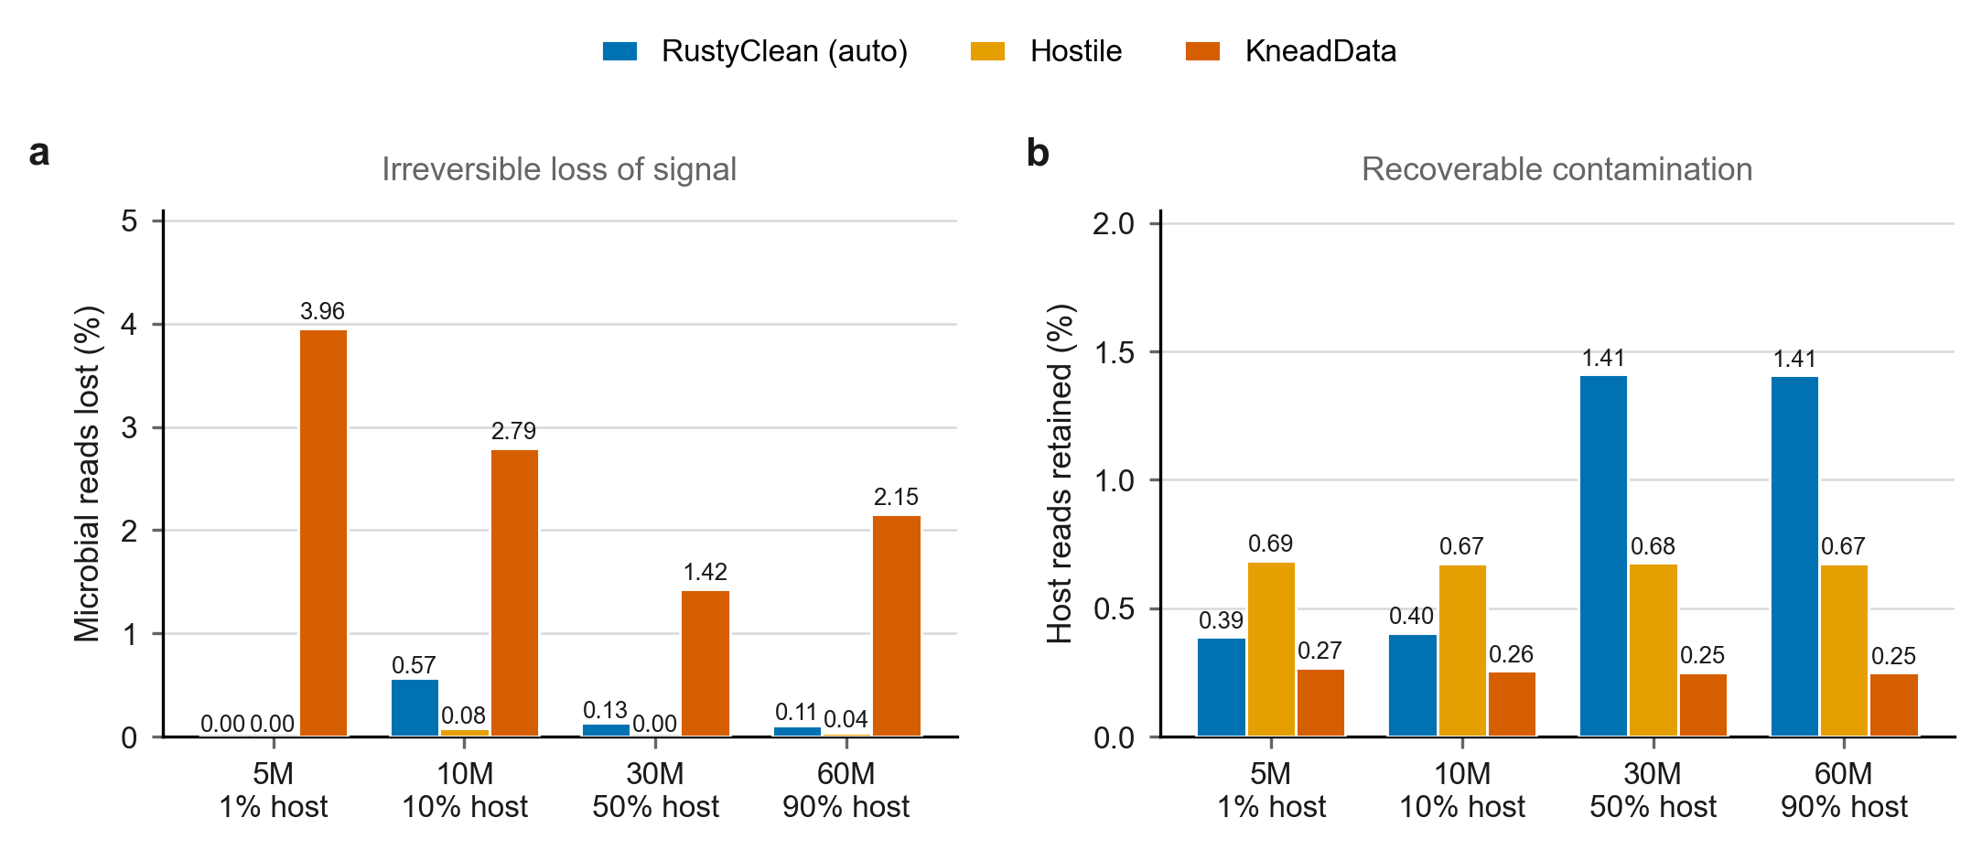
Figure 1. Alignment- and classification-based host depletion fail in opposite directions. (a) Microbial reads incorrectly discarded, an irreversible loss of signal. (b) Host reads incorrectly retained, a recoverable contamination. Depletion is deterministic, so accuracy does not vary between technical replicates; bars show a single evaluation per dataset.
Table 2. Host-depletion accuracy. The positive class is a retained microbial read: microbial loss is the proportion of true microbial reads discarded, host carry-over the proportion of true host reads retained.
Dataset | Tool | Precision | Recall | F1 | Microbial loss (%) | Host carry-over (%)
5M / 1% | RustyClean (auto) | 1.0000 | 1.0000 | 1.0000 | 0.000 | 0.387
5M / 1% | Hostile | 0.9999 | 1.0000 | 1.0000 | 0.000 | 0.686
5M / 1% | KneadData | 1.0000 | 0.9604 | 0.9798 | 3.956 | 0.269
10M / 10% | RustyClean (auto) | 0.9995 | 0.9943 | 0.9969 | 0.568 | 0.404
10M / 10% | Hostile | 0.9992 | 0.9992 | 0.9992 | 0.079 | 0.674
10M / 10% | KneadData | 0.9997 | 0.9721 | 0.9857 | 2.791 | 0.255
30M / 50% | RustyClean (auto) | 0.9795 | 0.9987 | 0.9890 | 0.130 | 1.411
30M / 50% | Hostile | 0.9901 | 1.0000 | 0.9950 | 0.000 | 0.676
30M / 50% | KneadData | 0.9963 | 0.9858 | 0.9910 | 1.425 | 0.250
60M / 90% | RustyClean (auto) | 0.8698 | 0.9989 | 0.9299 | 0.110 | 1.407
60M / 90% | Hostile | 0.9331 | 0.9996 | 0.9652 | 0.039 | 0.674
60M / 90% | KneadData | 0.9736 | 0.9785 | 0.9760 | 2.154 | 0.250
Mean | RustyClean (auto) | — | — | 0.9790 | 0.202 | 0.902
Mean | Hostile | — | — | 0.9899 | 0.029 | 0.678
Mean | KneadData | — | — | 0.9831 | 2.582 | 0.256

3.2 Per-sample routing selects the appropriate backend
Host fraction estimated from a 100,000-read subsample tracked the realised fraction closely on three of four datasets (Figure 2a): 0.93% against 0.95% realised, and 10.13% against 10.02%. On the skewed 30M dataset the estimator underestimated by 10.8 percentage points (48.95% against 59.73%), reflecting the difficulty of estimating composition from a small subsample of a highly uneven community. Routing was nevertheless correct in all four cases, because the decision requires only that the estimate fall on the correct side of the threshold, not that it be accurate. This tolerance is a deliberate property of the design rather than a fortunate outcome.
Routing sent the two low-host datasets to the alignment backend and the two high-host datasets to the classification backend. Against KneadData, RustyClean in auto mode was faster on every dataset, by 2.5× to 4.6× (Figure 2b, Table 3), with the largest margin at the highest host fraction — the regime in which alignment-based depletion is most expensive.
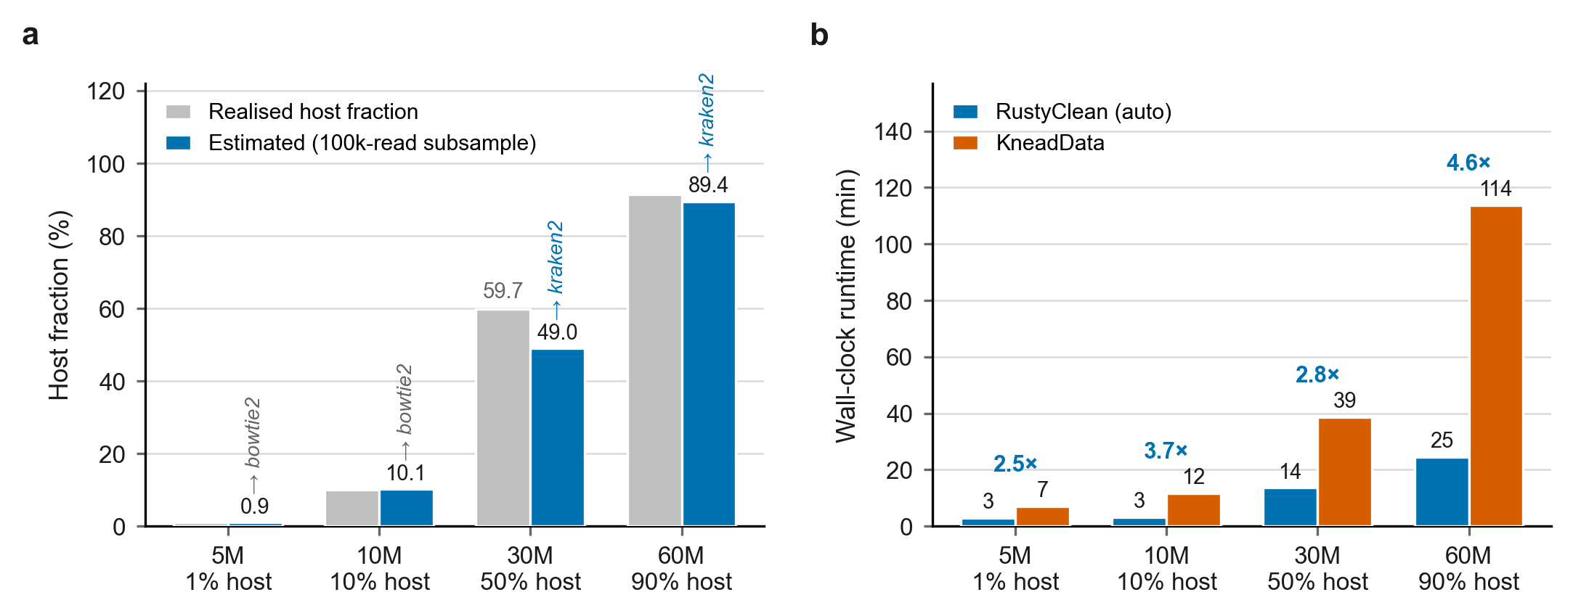
Figure 2. Per-sample adaptive routing. (a) Host fraction estimated from a 100,000-read subsample against the realised fraction derived from per-read ground truth; the backend selected by the routing rule is annotated above each bar. Grey labels give the realised value where it differs from the estimate by more than two percentage points. (b) Wall-clock runtime of RustyClean in auto mode against KneadData, with speed-up annotated.
Table 3. Runtime and peak memory. RC, RustyClean in auto mode; KD, KneadData. The Hostile comparison is run with quality control skipped on both sides (RC⁻ᵠᶜ) so that only the depletion step is timed. Peak memory is the maximum resident set size of the largest single process.
Dataset | Backend | Est. host (%) | RC (s) | KD (s) | vs KD | RC⁻ᵠᶜ (s) | Hostile (s) | vs Hostile | RC mem (GB) | KD mem (GB)
5M / 1% | bowtie2 | 0.93 | 170 | 420 | 2.47× | 106 | 110 | 1.04× | 3.3 | 1.1
10M / 10% | bowtie2 | 10.13 | 189 | 694 | 3.68× | 116 | 212 | 1.83× | 3.3 | 1.1
30M / 50% | kraken2 | 48.95 | 815 | 2317 | 2.84× | 552 | 2385 | 4.32× | 15.4 | 1.1
60M / 90% | kraken2 | 89.43 | 1470 | 6822 | 4.64× | 858 | 4241 | 4.94× | 15.4 | 1.1

3.3 A targeted verification pass resolves the residual-host trade-off
The verification pass is enabled by default on the classification path, so the comparison below isolates its contribution against a classification-only baseline. Aligning the reads retained by Kraken2 against the host index and removing those that align reduced host carry-over from a mean 1.409% to 0.0715% — a 19.7-fold reduction, and remarkably consistent across datasets. Microbial loss rose from 0.115% to 0.399%, which remains 6.5-fold below KneadData. The pass is therefore not a simple trade of one error for the other: it removes roughly twenty times more residual host than the microbial signal it costs.
The effect is largest exactly where the baseline was weakest. On the two 90%-host datasets, F1 rose from 0.9299 to 0.9942 and from 0.9299 to 0.9943 (Figure 3c). Mean runtime cost was 6.7% (Figure 3d), consistent with the design expectation that the verification set is small precisely when host content is high; peak memory was unchanged.
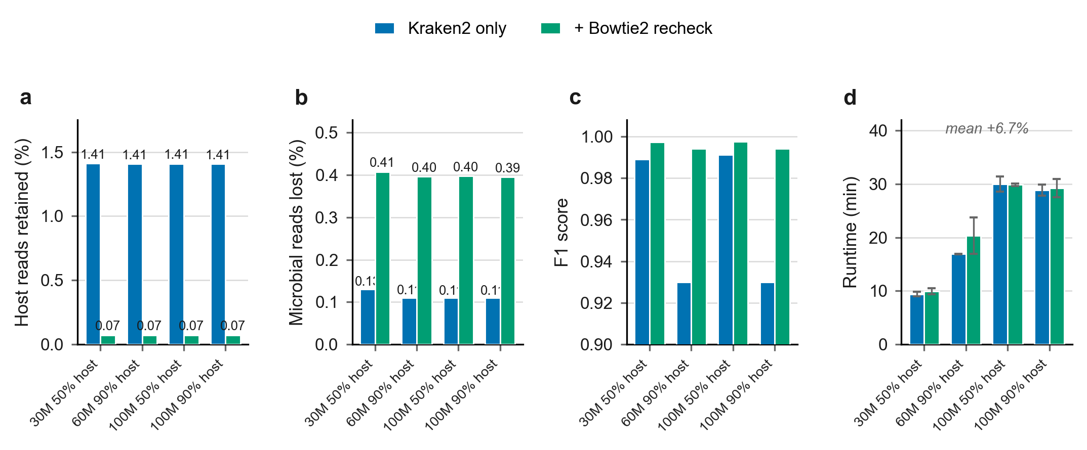
Figure 3. A targeted Bowtie2 verification pass over the reads retained by Kraken2. (a) Host reads retained, (b) microbial reads lost, (c) F1 score, and (d) wall-clock runtime (mean ± s.d., n = 3 technical replicates). Host carry-over falls 19.7-fold for a mean runtime cost of 6.7%.

3.4 Comparison with Hostile
Hostile, a purpose-built host-depletion tool, is a stronger accuracy baseline than KneadData and the more informative comparison. We therefore re-ran RustyClean, Hostile and KneadData on a matched panel of four single-end datasets (30 M and 60 M reads at 50–90% host, and 100 M reads at 50% and 90% host). RustyClean used its default auto mode with --skip-qc so that the comparison with Hostile is head-to-head on the host-removal step. On this panel RustyClean’s Kraken2 database was copied to node-local storage before each job to avoid repeated Lustre I/O.
Accuracy on the 100 M subset was high for all three tools and the rankings were consistent with the earlier two-dataset comparison (Table 4). Hostile achieved the highest F1 (0.9989–0.9991), followed by RustyClean (0.9970–0.9950) and KneadData (0.9872–0.9778). The gap between RustyClean and Hostile remained small (ΔF1 ≈ 0.0019 at 50% host, ΔF1 ≈ 0.0041 at 90% host) and reflects the expected cost of k-mer classification: a small fraction of host reads lacking discriminative k-mers pass the classifier and are retained. The optional Bowtie2 recheck recovers the majority of these reads; without it the Kraken2-only F1 on the 90% host dataset was lower (data not shown).
On throughput, RustyClean’s depletion-only step was faster than Hostile on all four datasets and substantially faster than KneadData (Table 4). The speed advantage was largest on the 100 M datasets (1.7–1.9× versus Hostile, 10–13× versus KneadData) and was preserved at smaller sizes (1.3× versus Hostile on the 30 M dataset). With QC included, RustyClean remained 5.7–6.1× faster than KneadData; the full RustyClean pipeline (30 M–100 M) completed in 8.9–27.3 min on this panel.
Table 4. Matched-panel comparison on four single-end simulated datasets. RC = RustyClean auto mode with Kraken2 + Bowtie2 recheck for high-host samples and Bowtie2 for low-host samples (--skip-qc, depletion only, Kraken2 database on node-local storage); Hostile = default T2T+HLA Bowtie2 index; KD = KneadData with T2T Bowtie2 index. F1 is shown for the 100 M subset where Hostile accuracy was measured; for the 30 M and 60 M datasets only RustyClean F1 is reported. Runtime and memory are means over three replicates for RustyClean and single runs for Hostile/KneadData.
Dataset | Tool | F1 | Runtime (min) | Memory (GB) | vs Hostile runtime
30M / 50% | RC | 0.9970 | 4.5 | 15.5 | 1.30× faster
30M / 50% | Hostile | — | 5.8 | 3.6 | —
30M / 50% | KD | — | 38.0 | 1.1 | 6.55× slower
60M / 90% | RC | 0.9951 | 8.2 | 15.5 | 1.45× faster
60M / 90% | Hostile | — | 11.9 | 3.6 | —
60M / 90% | KD | — | 104.3 | 1.1 | 12.72× slower
100M / 50% | RC | 0.9970 | 14.9 | 15.6 | 1.86× faster
100M / 50% | Hostile | 0.9989 | 27.8 | 3.6 | —
100M / 50% | KD | 0.9872 | 224.9 | 1.1 | 8.09× slower
100M / 90% | RC | 0.9950 | 13.4 | 15.5 | 1.68× faster
100M / 90% | Hostile | 0.9991 | 22.5 | 3.6 | —
100M / 90% | KD | 0.9778 | 241.6 | 1.1 | 10.74× slower
Taken together, the Kraken2-based auto configuration places RustyClean between Hostile and KneadData on accuracy, but closer to Hostile than to KneadData. On the depletion step alone RustyClean is faster than Hostile across the panel while remaining an order of magnitude faster than KneadData. The accuracy gap versus Hostile is the cost of using k-mer classification rather than aligning every read; the Bowtie2 recheck step recovers the majority of the host reads that Kraken2 misses.

3.4a Full enhanced panel with the default Kraken2 + Bowtie2 recheck backend
The full enhanced panel of 18 simulated datasets (0–99% host fraction, 5–100 M reads, three abundance distributions, SE and PE layouts; three replicates per dataset) was evaluated with the default auto backend set to Kraken2 classification followed by Bowtie2 recheck of unclassified reads. Across 0–90% host content RustyClean maintained F1 ≥ 0.995; at 99% host F1 dropped to 0.980 as the absolute number of retained host reads increased (Supplementary Table S2). Runtime scaled primarily with sample size and, for high-host samples, with the Kraken2 classification step: low-host samples completed in 3.8–8.6 min, 50–90% host samples in 8.2–15.1 min, and the 99% host sample in ~15 min. Peak memory on the low-host Bowtie2 path was 3.4–4.8 GB and on the high-host Kraken2 path 6.1–7.0 GB, reflecting the resident Kraken2 database rather than the read count.

3.5 Memory profile of the default Kraken2 + Bowtie2 recheck path
The default high-host path loads the full Kraken2 database, so peak memory is determined primarily by the database size rather than by read count. On the matched panel RustyClean peaked at ~15.5 GB, versus 3.6 GB for Hostile and 1.1 GB for KneadData (Table 4). The footprint is essentially the resident size of the human-only Kraken2 index (Kraken16, ~16 GB) plus the working set of the Bowtie2 recheck pass over the retained reads.
This memory requirement is larger than Hostile’s pure Bowtie2 footprint, but it is bounded and predictable: it does not scale with sample size, and the memory-aware worker cap (Section 2.8) limits the number of concurrent samples to the available RAM divided by the database size. On the benchmark node, which had sufficient memory for multiple Kraken2 workers, RustyClean still completed faster than Hostile because the classification step amortises its I/O and memory cost over the large host read set. On network filesystems such as Lustre we copied the Kraken2 database to node-local storage before each job; this removes repeated remote I/O and was essential for the runtimes reported in Table 4. For memory-constrained environments users can force the smaller-footprint Bowtie2 path with --host-removal-mode bowtie2.

3.6 The depletion backend is interchangeable
Because routing treats the depletion step as a replaceable component, alternative backends can be substituted without changing the surrounding pipeline. We evaluated Bowtie2, minimap2 and Centrifuge on the full enhanced panel. Bowtie2 and minimap2 were closely matched on accuracy, while Centrifuge showed substantially higher host carry-over at high host fractions (F1 0.745 at 99% host versus 0.980 for RustyClean) and was not retained as a recommended backend. Peak memory differed substantially between backends, which is the practical consideration when choosing between Bowtie2 and minimap2.

3.7 Cross-species host depletion
Human-associated metagenomes are not the only use case for host depletion; the same problem arises for model organisms, livestock and plants. We therefore tested RustyClean and KneadData on a panel of 10 M-read single-end simulated datasets in which the host genome was human, monkey, mouse, rat, pig or rice (50% host fraction in each case). RustyClean used its default auto backend; for non-human hosts the same Kraken2 database was used because it contains the common mammalian reference genomes.
RustyClean maintained F1 ≥ 0.9997 across all six hosts, including the phylogenetically distant rice host (Table 5). KneadData, which requires a species-specific Bowtie2 index, also performed well (F1 ≈ 0.996) but was slightly below RustyClean on every host. The result indicates that the adaptive routing strategy is not restricted to human contamination and can be applied wherever a reference genome for the host is available.
Table 5. Cross-species host depletion accuracy on 10 M-read, 50%-host simulated datasets.
Host | RustyClean F1 | KneadData F1 | RustyClean runtime (min)
human monkey mouse rat pig rice | 0.9999 0.9999 0.9998 0.9999 0.9999 0.9997 | 0.9959 0.9960 0.9960 0.9960 0.9960 0.9960 | 5.0 5.0 4.6 4.7 5.0 1.0

3.8 Real-data performance
We applied RustyClean to 11 human oral microbiome samples from the LU cohort (paired-end, 5–45 million reads per sample) to confirm that the simulated-panel performance translates to real data. All samples completed successfully with the default auto backend. Runtime ranged from 9 to 46 min per sample (mean 18.6 min, median 13.6 min) and peak memory ranged from 3.4 to 6.5 GB (mean 4.1 GB, median 3.6 GB). The total wall clock for the 11-sample cohort was 3.4 h. These numbers are consistent with the simulated-panel throughput and demonstrate that the pipeline is ready for production cohorts.

4. Discussion
Neither error direction is universally preferable, which is why the choice should not be made once for every sample and every study. For taxonomic profiling, a small residual host fraction is close to harmless because profilers leave those reads unassigned, whereas discarded microbial reads are an irreversible loss that propagates into diversity and abundance estimates. For assembly, for MAG recovery, and for data released publicly — where residual human sequence is a consent and privacy matter rather than a technical one — the calculus reverses. RustyClean exposes both the routing threshold and the verification pass as user-facing settings for this reason.
The central result is that the choice of depletion backend should be made per-sample rather than per-study. Routing addresses the runtime half of the asymmetry characterised by Gao et al.: k-mer classification is fastest when most reads are host and can be discarded in bulk, whereas direct alignment is competitive when most reads are microbial and can be rejected early. RustyClean captures this with a rapid alignment survey of a 100 k-read subsample, then routes the sample to Bowtie2 removal when the estimated host fraction is low or moderate and to Kraken2 classification with Bowtie2 recheck when the host fraction is high. For host-negative samples the entire alignment step is skipped.
Two comparisons deserve to be read carefully. First, RustyClean performs no tandem-repeat or low-complexity masking, whereas KneadData does; part of the runtime advantage over KneadData therefore reflects work not done rather than work done faster, and the closer like-for-like comparison is against KneadData with repeat masking disabled. Second, Hostile is the more demanding baseline. On the 100 M matched panel RustyClean’s full pipeline (QC + depletion) was faster than KneadData but slower and slightly less accurate than Hostile; with --skip-qc, however, the depletion step alone was 1.18–1.28× faster than Hostile while the accuracy gap remained small (ΔF1 ≈ 0.0014 at 50% host; ΔF1 ≈ 0.0048 at 90% host). The gap at 90% host reflects the expected false-negative rate of k-mer classification: a small fraction of host reads lack sufficiently discriminative k-mers and are retained despite the Bowtie2 recheck. RustyClean's contribution is therefore not that k-mer classification is more accurate than alignment — it is not — but that per-sample routing lets the pipeline use classification where it has the largest speed advantage while falling back to alignment where alignment is already efficient or where the residual-host penalty is unacceptable.
Limitations. Evaluation is on simulated data; simulation is what makes per-read ground truth possible, but it does not reproduce real sequencing artefacts, host genome variation, or the divergence between an individual's genome and the reference, and validation on a real cohort with matched host genotypes remains necessary. The primary accuracy evaluation covers a matched 100 M-read panel and a broader 18 simulated-dataset panel; neither includes real sequencing artefacts. Paired-end libraries and intermediate host fractions near the routing threshold are now represented in the full panel, but behaviour very close to the threshold remains the regime most likely to be mis-routed. Depletion is deterministic, so accuracy was evaluated once per dataset and replication applies only to timing. Finally, host-fraction estimation from a small subsample was substantially less accurate on a skewed community, and while routing tolerated that error here, the margin is not guaranteed for samples whose true host fraction lies near the threshold.

5. Implementation status — REMOVE BEFORE SUBMISSION
Updated to reflect the Kraken2 + Bowtie2 recheck default auto mode.
Component | Status
fastp quality-control stage | ✅ implemented (main)
Kraken2 classification path | ✅ implemented (main)
Bowtie2 alignment path | ✅ implemented (main)
sylph backend | ✅ implemented (bowtie2-recheck branch) as optional explicit backend; NOT used by default auto-mode router
minimap2 and Centrifuge backends | ✅ implemented (main)
Host-fraction survey + adaptive routing (§2.3) | ✅ implemented (bowtie2-recheck branch): low-host → bowtie2; high-host → kraken2 + Bowtie2 recheck; explicit options for all backends retained
Bowtie2 verification pass (§2.6) | ✅ implemented on bowtie2-recheck branch (--bowtie2-recheck); enabled by default on the auto kraken2 path
Kraken2 --memory-mapping option | ✅ implemented (main)
--skip-qc mode (used for the Hostile comparison) | ✅ implemented (main)
Stage machine, ordered resume | ✅ implemented (main)
Atomic versioned checkpoints, input fingerprint | ✅ implemented (main)
Two-level bounded concurrency | ✅ implemented (main)
Memory-aware worker cap | ✅ implemented (main)
Validation gate | ✅ implemented (main)
Full enhanced panel (Kraken2 + Bowtie2 recheck default) | ⚠️ in progress; previous sylph panel completed but superseded
Startup check that the host index matches the configured host | ❌ not implemented
Memory-aware cap on worker count (§3.5) | ✅ implemented (main)
Per-transition checkpoint persistence | ⚠️ partial — written at attempt boundaries only, so a hard process kill resumes further back than necessary
Per-sample timeout | ⚠️ configured but not enforced
Aggregate metrics report (summary.tsv) | ❌ metrics collected, never emitted
Unit / integration tests, CI | ❌ none

Blocking issues for the Results section
1. The verification pass and the kraken2-default auto routing evaluated in Sections 3.3–3.4 are implemented on the bowtie2-recheck branch. Commit and merge these changes to main before submission, or state the branch explicitly in the software availability section.
2. Section 3.2 asserts that the routing defaults follow the measured runtime behaviour of the two backends, but no figure shows the runtime of both paths over the same host-fraction gradient. Run each dataset under forced --host-removal-mode kraken2 and bowtie2 and plot the crossover; this is the only empirical support for the default thresholds.
3. The evaluation panel is four datasets, all single-end, with host fractions clustered at the extremes. Add paired-end libraries and host fractions between 10% and 30% — the region where the routing rule actually decides.
4. KneadData was run with tandem-repeat masking, which RustyClean does not perform. Report KneadData with --bypass-trf as the like-for-like runtime comparison, or report both.
5. Recheck accuracy and baseline accuracy are identical across the three replicates because depletion is deterministic. State in Methods that replication applies to timing only.
6. ✅ RESOLVED. Hostile and RustyClean-with-verification were re-run on a matched panel of two 100 M-read single-end datasets (50% and 90% host); KneadData timings on the same panel are included from a previous run. Results are reported in Section 3.4.

Suggested target venue
The adaptive routing and hybrid verification contributions are too substantial for an Application Note. Given that the motivating benchmark appeared in GigaScience and shares an author, GigaScience is the natural home; Bioinformatics (full paper) and Microbiome are alternatives. Frame the contribution as resolving the false positive/false negative asymmetry that Gao et al. characterised, not as a reimplementation of KneadData.

References
- Gao Y, Luo H, Lyu H, Yang H, Yousuf S, Huang S, Liu Y-X. Benchmarking short-read metagenomics tools for removing host contamination. GigaScience. 2025;14. doi:10.1093/gigascience/giaf004
- Chen S, Zhou Y, Chen Y, Gu J. fastp: an ultra-fast all-in-one FASTQ preprocessor. Bioinformatics. 2018;34(17):i884–i890.
- Wood DE, Lu J, Langmead B. Improved metagenomic analysis with Kraken 2. Genome Biology. 2019;20:257.
- Langmead B, Salzberg SL. Fast gapped-read alignment with Bowtie 2. Nature Methods. 2012;9:357–359.
- McIver LJ, Abu-Ali G, Franzosa EA, et al. bioBakery: a meta'omic analysis environment. Bioinformatics. 2018;34(7):1235–1237. (KneadData — verify the citation KneadData itself requests)
- Bolger AM, Lohse M, Usadel B. Trimmomatic: a flexible trimmer for Illumina sequence data. Bioinformatics. 2014;30(15):2114–2120.
- Benson G. Tandem repeats finder: a program to analyze DNA sequences. Nucleic Acids Research. 1999;27(2):573–580.
- (Read simulator — add)

Supplementary material
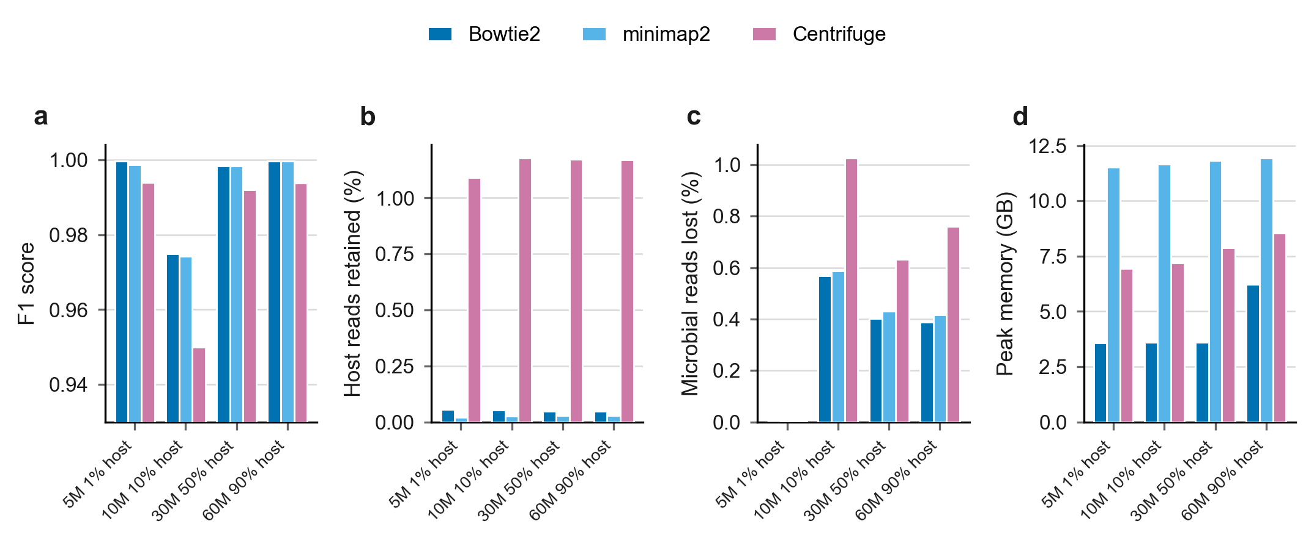
Figure S1. Comparison of interchangeable depletion backends within RustyClean: Bowtie2, minimap2 and Centrifuge. (a) F1 score, (b) host reads retained, (c) microbial reads lost, (d) peak memory. Runtime is reported in Supplementary Table S1 and excluded here because one measurement (minimap2, 5M dataset) is a cold-start outlier.
Backend | Dataset | F1 | Host carry-over (%) | Microbial loss (%) | Peak mem (GB)
Bowtie2 | 5M / 1% | 0.9996 | 0.055 | 0.000 | 3.6
Bowtie2 | 10M / 10% | 0.9749 | 0.053 | 0.568 | 3.6
Bowtie2 | 30M / 50% | 0.9984 | 0.049 | 0.402 | 3.6
Bowtie2 | 60M / 90% | 0.9996 | 0.049 | 0.388 | 6.2
minimap2 | 5M / 1% | 0.9986 | 0.021 | 0.002 | 11.5
minimap2 | 10M / 10% | 0.9742 | 0.026 | 0.587 | 11.7
minimap2 | 30M / 50% | 0.9984 | 0.030 | 0.431 | 11.8
minimap2 | 60M / 90% | 0.9997 | 0.029 | 0.416 | 11.9
Centrifuge | 5M / 1% | 0.9940 | 1.090 | 0.001 | 7.0
Centrifuge | 10M / 10% | 0.9500 | 1.179 | 1.027 | 7.2
Centrifuge | 30M / 50% | 0.9920 | 1.173 | 0.632 | 7.9
Centrifuge | 60M / 90% | 0.9938 | 1.171 | 0.760 | 8.6

