RustyClean: a Rust pipeline for adaptive minimizer depletion and conditional alignment verification in short-read metagenomics
APPLICATION NOTE
Yufeng Zhang¹ and Shi Huang^{1,*}
¹Faculty of Dentistry, The University of Hong Kong, Hong Kong SAR, China
*Correspondence: qdu_zyf@163.com

Abstract
Summary: Host-read depletion must retain microbial signal while removing abundant host DNA. RustyClean is a Rust workflow that combines fastp quality control, Deacon minimizer-based depletion and conditional Bowtie2 verification. Verification is triggered only when Deacon reports a removed fraction above a configurable threshold. On six simulated metagenomes spanning 1–90% host, RustyClean AUTO was 3.45–10.19-fold faster than KneadData and 1.29–2.30-fold faster than fastp+Hostile. On high-host libraries, it achieved F1 ≥0.998, 0.0000% host carry-over and ≤0.31% microbial loss.
Availability and implementation: RustyClean is implemented in Rust, uses fastp, Deacon, Bowtie2 and samtools, and is available under the MIT licence at https://github.com/HuangShiLab/rustyclean. Benchmark source data are available at https://github.com/HuangShiLab/rustyclean-paper.
Supplementary information: Full benchmark tables and figure-generation code are available in the project repository. A detailed benchmark manuscript is available as a separate bioRxiv-ready submission.
Contact: qdu_zyf@163.com

1 Introduction
Short-read metagenomes from host-associated sites often contain abundant host DNA. Alignment-based depletion is sensitive but can remove genuine microbial reads, whereas rapid classifier- or minimizer-based filters are faster but may retain host reads (Gao et al., 2025). Deacon is a minimizer-based sequence filter with near-alignment accuracy and host-fraction-independent speed (Constantinides et al., 2025). However, it is a depletion primitive rather than a complete cohort workflow. RustyClean addresses this gap by adding quality control, adaptive verification, checkpointing, memory-aware concurrency and output validation.

2 Features and implementation
RustyClean AUTO processes each sample in four ordered stages. fastp first performs paired-end adapter detection and quality trimming (Chen et al., 2018). Deacon v0.17.0 then depletes host reads against a compact pangenome index. RustyClean parses the Deacon summary and passes the retained reads to Bowtie2 only when the reported removed fraction is at least 0.30; below this threshold, the Deacon output is accepted without a second alignment pass (Langmead and Salzberg, 2012). Finally, automated checks reject truncated outputs or samples exceeding a configurable residual-host limit.
The workflow is implemented as a single Rust binary and provides sample manifests, atomic checkpoints, content-invalidating input fingerprints, bounded sample-level concurrency and memory-aware worker capping. Each worker maps the same read-only Deacon index, so additional workers add little index memory. The streamlined interface intentionally exposes the production AUTO pipeline and a Deacon-only benchmarking mode rather than multiple deprecated depletion backends.

3 Results
On six simulated single-end metagenomes generated with InSilicoSeq and scored with per-read ground truth, RustyClean AUTO required 90.4–2396.7 s across 5–100 million reads (Gourlé et al., 2019). This was 3.45–10.19-fold faster than KneadData v0.12.3 and 1.29–2.30-fold faster than fastp+Hostile (Constantinides et al., 2023; McIver et al., 2018). Deacon depletion alone took 9.6–202.4 s and was 40.9–130.2-fold faster than the complete KneadData pipeline. Peak memory was 4.54 GiB and was bounded by the pangenome index rather than sample size (Fig. 1).
On four high-host datasets (50–90%), Bowtie2 verification reduced host carry-over to 0.0000% of retained output, whereas fastp+Hostile retained 0.17–0.68% and KneadData retained 0.25% (Table 1). RustyClean AUTO maintained F1 ≥0.998 and lost at most 0.31% of microbial reads. Verification therefore provides a practical route to zero measured host carry-over without applying an alignment pass to every low-host sample.
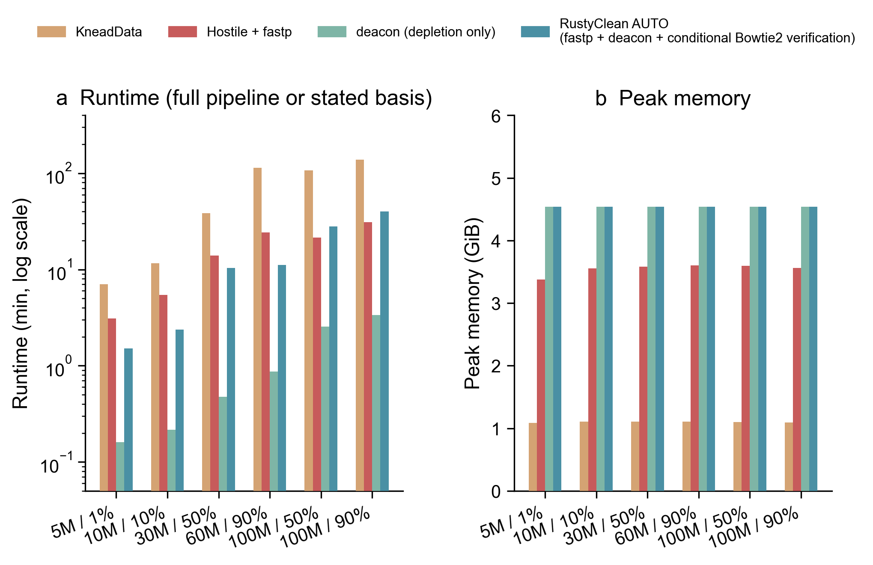
Fig. 1. Runtime and peak memory for four depletion workflows on six simulated metagenomes. Runtime is shown on a logarithmic scale; KneadData, fastp+Hostile and RustyClean AUTO are full pipelines, whereas Deacon is depletion only.
Table 1. Accuracy on four high-host simulated datasets.
Workflow | F1 range | Microbial loss (%) | Host carry-over (%)
KneadData | 0.97603–0.99098 | 1.425–2.154 | 0.2493–0.2500
fastp+Hostile | 0.96522–0.99878 | 0.000–0.039 | 0.1734–0.6758
Deacon only | 0.99920–0.99997 | 0.000–0.121 | 0.0035–0.0037
RustyClean AUTO | 0.99845–1.00000 | 0.000–0.310 | 0.0000

4 Conclusion
RustyClean turns rapid minimizer depletion into a reproducible host-depletion workflow. Conditional Bowtie2 verification preserves the speed advantage of Deacon while removing residual host signal precisely in the high-host samples where it matters most.

Availability and implementation
RustyClean is available under the MIT licence at https://github.com/HuangShiLab/rustyclean. The benchmarked research source is archived at commit 7ab1a4b; the streamlined AUTO interface is at commit 55f93af. Figure source data and analysis code are available at https://github.com/HuangShiLab/rustyclean-paper.

Acknowledgements
The authors thank colleagues at The University of Hong Kong for discussions and computational support.

References
Chen S. et al. (2018) fastp: an ultra-fast all-in-one FASTQ preprocessor. Bioinformatics, 34, i884–i890.
Constantinides B. et al. (2023) Hostile: accurate decontamination of microbial host sequences. Bioinformatics, 39, btad728.
Constantinides B. et al. (2025) Deacon: fast sequence filtering and contaminant depletion. bioRxiv, 2025.06.09.658732.
Gao Y. et al. (2025) Benchmarking short-read metagenomics tools for removing host contamination. GigaScience, 14, giaf004.
Gourlé H. et al. (2019) Simulating Illumina metagenomic data with InSilicoSeq. Bioinformatics, 35, 521–522.
Langmead B. and Salzberg S.L. (2012) Fast gapped-read alignment with Bowtie 2. Nature Methods, 9, 357–359.
McIver L.J. et al. (2018) bioBakery: a meta’omic analysis environment. Bioinformatics, 34, 1235–1237.

