sk2bGrow: coordinate-aware PTR estimation from deterministic 2bRAD anchors
2026-09-14
Table of Contents

Coordinate-aware peak-to-trough estimation from deterministic 2bRAD anchors
Assembly draft 2026-09-10. Results §1–§3 converted from outline bullets to prose (author polish pending); §4–§8 reuse the drafted prose. Bracketed citations like (Korem 2015) are placeholders.

Abstract
Peak-to-trough ratio (PTR) inference from metagenomes is a culture-independent proxy for bacterial growth rates, but the current sketch-based estimator requires a depth that metagenomic per-strain coverage rarely reaches, and its shipped coverage gates return no estimate at all below ~10×. We present sk2bGrow, which counts Type IIB restriction-enzyme (2bRAD) anchors — motif-defined loci whose genome coordinates are known a priori and identical across samples — and fits the replication gradient with a coordinate-aware windowed V-fit. On the Zheng E. coli growth-rate panel, sk2bGrow returned usable PTR estimates at 1–2× sequencing depth, where Pilea’s shipped defaults return nothing, with r = 0.92 at 1× and 0.96 at 2× against measured growth rates (n = 16). The accuracy comes from the coordinate-aware estimator, not the landmark source — at matched density the two landmark sources are indistinguishable at every depth — while the multi-enzyme panel contributes what a hash sketch cannot: a wet-lab-realizable landmark set and consistency strata whose heterogeneous biases exposed our own counting defect. The estimates are not unbiased — the fitted slope compresses the dynamic range at low coverage, and the mechanism is unresolved. On three fecal metagenomes, sk2bGrow and Pilea agreed (bias +0.22–+0.25 log2; n = 58–78 species×sample pairs per sample). As a process-level finding, exact deduplication of 2bRAD libraries before counting destroys the PTR signal — a PCR copy-number artefact we localize per anchor. sk2bGrow is 89.5–240.8× slower than Pilea at MAG-panel scale; mismatch-1 counting narrows the gap to roughly one order of magnitude (measured end-to-end on all nine samples: 20.5–38.8× faster counting than the mismatch-2 baseline, no genome lost), and a containment pre-screen — measured to clear the absent-reference false-positive floor, and required at database scale where an unrestricted index would emit estimates for absent references — completes the fix.

Introduction
The peak-to-trough ratio (PTR) of a replicating bacterial chromosome — the coverage ratio between the replication origin and the terminus — is a culture-independent proxy for growth rate: in an exponentially growing population, log₂PTR equals the ratio of the replication period to the doubling time, and is therefore proportional to the growth rate at a fixed replication period (Korem 2015). Because the signal lives in the shotgun sequencing data itself, PTR inference has been applied to growth estimation directly from metagenomes (Korem 2015; CoPTR; Pilea), removing the need to culture the organisms of interest.
A recent alignment-free turn made such profiling tractable at the scale of thousands of reference genomes: instead of aligning reads, methods count k-mers surviving a random subsample of the k-mer universe, such as a FracMinHash sketch (Pilea). That convenience has a cost the PTR problem is unusually sensitive to. A random sketch discards position: the genome coordinates of the surviving k-mers are arbitrary, and no two references share them in any usable way. A sketch-based PTR estimator must therefore regress coverage on sorted rank rather than on genome position. Sorted-rank regression rides on extreme order statistics — its estimate is set by the largest and smallest surviving windows — and is fragile exactly where metagenomic data live: one dropout window can move the estimate from 1.86 to 2.51 (Fig. 1c). The shipped tools also protect the estimator with coverage gates that return no estimate at all below roughly 10× depth.
Type IIB restriction-enzyme anchors, the markers of the 2bRAD family of reduced-representation protocols, are a sketch with a different geometry. Each enzyme recognises a short degenerate motif and excises a fixed-length tag, so the landmark loci are motif-defined, enumerable per reference, and — the property this paper exploits — their coordinates are known before any read is seen and are identical in every sample. That makes coordinates usable: coverage can be regressed directly on position along the chromosome, in fixed-anchor windows, with a windowed V-fit and inverse-variance fusion across enzymes. A panel of enzymes additionally provides internal-consistency strata (here, sixteen) that a single hash-prefix sketch does not. And because the same loci are physically produced by the 2bRAD protocol, the landmark set is wet-lab realizable as well as computational.
We present sk2bGrow, built on this observation. We state the claim honestly up front, because our own attribution data constrain it: the accuracy at low depth comes from fitting on coordinates, not from which landmarks are counted — the coordinate-aware estimator beats sorted-rank regression by wide margins at 0.5–1× on both enzyme anchors and a density-matched FracMinHash sketch, and the two landmark sources are statistically indistinguishable at every depth once density is matched (paired bootstrap over 48 media × subsampling-instance units; §4). What the motif-defined panel contributes is not accuracy but things a hash sketch cannot provide: a landmark set the 2bRAD protocol physically produces; enzyme strata whose heterogeneous biases make cross-stratum consistency a test of systematic error — Cochran’s Q caught this project’s own double-counting defect; and fusion redundancy at very low input (F1 harness). The results below report slope and RMSE beside correlation throughout, include a negative control the incumbent excluded, and carry the bias caveats the data impose.
In short, this paper contributes (i) usable PTR estimates at 1–2× sequencing depth, with the low-coverage bias stated rather than hidden; (ii) a controlled 2 × 2 attribution localising the gain in the coordinate-aware estimator rather than in which landmarks are counted — the two landmark sources are indistinguishable once density is matched; and (iii) real-metagenome concordance with the incumbent and process-level findings — a deduplication recommendation and a per-anchor capture-efficiency measurement — that others can cite.

Results

1. sk2bGrow overview
sk2bGrow estimates the peak-to-trough ratio of a genome from the replication-associated gradient in read coverage, using landmarks whose coordinates are known before any read is seen. The pipeline (Methods §1) has six stages: an in-silico digest of each reference genome with a panel of 16 Type IIB restriction enzymes produces anchors — fixed-length tags with genomic coordinates; sample reads are matched to anchors by strand-canonical, mismatch-tolerant counting; anchors shared between reference genomes are apportioned by expectation-maximisation; windows holding a fixed number of anchors are fitted with a zero-truncated Poisson mixture to obtain a window rate with a standard error; a replication origin is placed once per genome from all enzymes pooled; and a piecewise-linear V is fitted to the window log-rates against circular distance from the origin, with per-enzyme estimates fused by inverse-variance weighting and cross-enzyme consistency tested by Cochran’s Q. Fig. 1a shows the workflow. Fig. 1b shows window rates against genome coordinate for one 2× sample, with the fitted V. Fig. 1c shows the same windows under sorted-rank regression, where a single dropout window moves the estimate from 1.86 to 2.51 — the fragility, in one panel, of an estimator that rides on extreme order statistics. Fig. 1d is a forest plot of the 16 per-enzyme estimates with the fused value and I² for the same sample. Panels b–d are real output from one 2× sample; the figure shows the method working on real data, not a cartoon (Fig. 1).

2. Accuracy on bacterial isolates

2.1 Accuracy across the coverage titration
Accuracy is usable throughout the 1–2× band on a growth-rate panel where the incumbent’s shipped defaults return nothing at all. We benchmarked sk2bGrow on the Zheng et al. 2020 E. coli K-12 MG1655 panel (PRJNA615952): 16 defined media with independently measured growth rates λ spanning 0.40–1.72 h⁻¹, titrated to nominal 0.5×, 1×, 2×, 5× and 10× depth. The titration is a deliberate deviation from Pilea, which ran full depth only; it is the axis this paper is about, because metagenomic per-strain coverage is typically 1–2×, not isolate depth. sk2bGrow reached r = 0.919 against measured λ at 1× (95% media-bootstrap CI [0.819, 0.972]; n = 16), 0.959 at 2× and 0.971 at 5× — essentially matching Pilea’s published full-depth r of 0.976 from 5× onward; at 0.5× r = 0.941 (CI [0.882, 0.975]). Magnitude was usable but compressed: RMSE 0.346 with fitted slope 0.79 at 1×, degrading to RMSE 0.407 and slope 0.62 at 0.5× (Fig. 2a–c; Table 2). Two scope caveats apply here and throughout the isolate benchmark: every real-data result in this section is one strain against a single complete reference, and Pilea at its shipped defaults returned no estimate below 10× at any point in the titration.

2.2 A negative control that Pilea excluded
A stationary-phase replication run-out that sorted regression fails badly on was recovered by sk2bGrow. Pilea excluded the run-out samples from its benchmark; we kept one (E.coli_gDNA_RUN_OUT, CON-C). In a replication run-out, ongoing rounds are allowed to finish while new initiation is blocked, so every chromosome in the population ends fully replicated and log₂PTR must be ≈ 0; a method that reports a large PTR here is reading noise as a gradient. sk2bGrow returned 0.061–0.301 across the titration, while sorted-rank regression on the same windows returned 1.80 at 0.5× — six times any sk2bGrow estimate, and in exactly the direction of reading noise as growth (Fig. 2d).

2.3 Which gate suppresses Pilea, and is it right to?
The coverage gate, not the estimator, is what suppresses Pilea below 10× — and the gate is partly right. Re-applying each of Pilea’s default thresholds to its own gates-off output (an exact ablation that requires no extra runs) shows that --min-cove 5 alone accounts for 68 of 68 suppressed E. coli estimates and 167 of 172 in the multi-strain simulation. Because a 150 bp read yields 120 31-mers, a threshold of 5 on k-mer coverage corresponds to ≈6.25× read coverage (5 × 150/120), so the gate fires at 5× nominal even where the estimator behind it is still informative. At 0.5× the gate is correctly refusing to report: Pilea’s gates-off output there is fully degenerate — measured coverage exactly 1.000 and log₂PTR exactly 0.000 in all 17 samples. Between 1× and 5×, however, the gates-off estimator is informative (r = 0.78, 0.85, 0.99 against λ) and is nevertheless suppressed. The honest claim is therefore not that Pilea is over-conservative, but that its gate is calibrated to the point where the FracMinHash estimator breaks — ≈6.25× read coverage — whereas sk2bGrow’s break point is below 1× (Fig. 2; Table 5).

3. Multi-strain communities
sk2bGrow recalled every strain at every cell of a multi-strain community benchmark, at half the RMSE of gates-off Pilea and with bias reduced to negligible. Following Pilea’s Fig. 3 design at a scale a laptop can run, we simulated communities of 4, 8 or 16 strains — 16 complete reference genomes deliberately including E. coli K-12, E. coli O157:H7 and Shigella dysenteriae as a shared-anchor stress test for the EM attribution — at 1/2/4/8× per-strain coverage, with V-shaped replication profiles and log₂PTR ~ U[0,2]. Recall was 1.000 for sk2bGrow at every cell, against 0.224 for Pilea at its shipped defaults. Aggregate RMSE was 0.134 for sk2bGrow versus 0.265 for Pilea gates-off, and the two methods showed opposite signed bias — sk2bGrow’s now negligible (−0.013) against Pilea’s +0.168. Two scope caveats: the grid is laptop-scale and does not establish behaviour at Pilea’s full 32 strains / 32× / 400 samples; and because Pilea’s shipped gates skip fitting below 5× entirely, per-sample timings from this benchmark are not a fair cost comparison — the properly controlled timing is in §8 (Fig. 3; Table 3; Table 4).

4. What do the landmarks contribute?
The coordinate-aware estimator, not the deterministic landmark set, is what carries the low-coverage result; at matched landmark density the two landmark sources are indistinguishable at ≥ 1×, and the panel’s residual advantage below 1× comes from multi-strata fusion redundancy, not from landmark determinism. We tested this in three layers on the Zheng E. coli grid (HPC; data/f1_sketch/).
First, at Pilea’s own operating point (FracMinHash arm E at scale 250, a 2.4× lower landmark density than the panel — the shipped comparison), the 2 × 2 attribution (landmark source × estimator) stands as measured at that operating point:
coverage | anchors + V-fit | FracMinHash + V-fit | anchors + rank | FracMinHash + rank (Pilea)
0.5× | 0.941 | 0.883 | 0.517 | — (degenerate)
1× | 0.919 | 0.912 | 0.775 | 0.778
2× | 0.959 | 0.958 | 0.925 | 0.848
5× | 0.971 | 0.990 | 0.947 | 0.988
10× | 0.970 | 0.987 | 0.938 | 0.973
Bold marks the nominal maximum per row; at 5× and 10× the top rows are statistically tied — the bootstrap CIs of all four estimates overlap (Table 2 carries the intervals).
Arm E was constructed by rewriting Pilea’s sketch into sk2bGrow’s count-table format and running the unmodified sk2bGrow estimator, so the only difference from arm A is which loci are counted (Methods §4).
Second, matching density removes the sketch’s apparent 0.5× deficit: at 9,645 (sketch, scale 104) versus 9,422 (panel, k = 16) landmarks/Mb — within 2% — the two landmark sources are indistinguishable at 1–10×: a paired media bootstrap (10,000 resamples of the media) bounds the 95% CI of the accuracy difference at ±0.16 r at every depth ≥ 1× (−0.00 [−0.16, +0.12] at 1×; data/ci_bootstrap/f1_ci.tsv). The formal source × estimator interaction, tested on the main grid across three independent subsampling instances (48 media × instance units; two additional fixed-seed instances of the full five-arm grid), is significantly negative at 2× (interaction z = −0.49, 95% CI [−0.73, −0.28], negative in all three instances) and null at 1×, 5× and 10×; it is untestable at 0.5×, where the gates-off sketch cell is degenerate (data/repro_check/multiseed/INTERACTION_REPORT.md). The 2× sign means the estimator’s edge over sorted-rank is larger on sketch landmarks than on enzyme anchors — there is no evidence the panel amplifies the estimator’s value. Pooling the same 48 units, anchors and matched-density sketch are indistinguishable at every depth, 0.5× included (paired Δz CIs cross zero everywhere). At 0.5× the single-stratum sketch is actually ahead of the panel on surviving cells (r 0.82–0.84, n = 10–11, vs panel r 0.50–0.57, n = 15–16, in the same harness), but it loses 6/17 cells at the “no downhill origin” gate. The sketch’s 0.5× r is computed on those survivors, so the comparison carries a survivor-selection effect; because the dropped cells fail for absence of a fittable gradient — the hard cells, not easy ones — the selection acts conservatively. Two caveats apply, both now measured rather than pending. First, the historical parity-flag asymmetry (A with --windows, E without) is a no-op: the current code parses --windows but never consumes it, and a symmetric rerun — both arms with and without the flag — gives byte-identical outputs (255/255 cells; data/f1_symm/), so the harness is symmetric in effect. Second, cross-harness comparisons of absolute r remain invalid, for a measured reason: the F1 harness counted single-end reads only, so its 0.5× arm-A baseline (r = 0.568) carries half the reads of the committed paired-end grid (r = 0.941; Table 2), and the F1 harness at 1× single-end (≈ the same read count as 0.5× paired-end) returns r = 0.906 — the driver is read count, not estimator or code drift (count tables recount md5-identical; the grid itself was regenerated end-to-end on the current code, data/repro_check/). Only within-harness A-versus-E contrasts are used here, and the committed grid numbers (Table 2) are produced by the paired-end pipeline of Methods §3.1.
Third, the mechanism is density, not determinism: per-window observed landmark counts (17.3–17.5 sketch vs 14.1–21.3 panel) and detected fractions (0.175 vs 0.185) are near-identical at matched density. The sentence “deterministic anchors are what keeps windows populated at 0.5×” is therefore retired. What actually keeps the panel working at 0.5× is fusion redundancy: a single-stratum sketch that finds no downhill origin has no second stratum to rescue it (6/17 cells), whereas sixteen strata need only a subset of per-enzyme fits to succeed. A property-by-property comparison of the two landmark sources, with each row carrying its evidence, is given in Table 9.
(Fig. 4)

5. How many enzymes are needed, and over what GC range?
Four to eight enzymes, not sixteen, are sufficient; the recommendation holds across the measured GC range of 25.4–72.0%, with a measured instrument boundary at GC ≲ 30% combined with 0.5× depth.
Ranking the sixteen enzymes by standalone accuracy (each per-enzyme output is already an independent V-shape fit, so the ranking is free), we find it dominated by anchor yield without being dictated by it: the top six by accuracy all carry > 1,900 anchors — BslFI, with 2,501 anchors, is the yield exception outside them at rank nine — and the bottom four by accuracy (FalI, AloI, BplI, PsrI; 687/441/379/419 anchors) are near-zero or negative at 0.5×. The sparsest enzyme of all, PpiI (336 anchors), is the accuracy exception, holding r = 0.61 at 0.5×. Sweeping panel size k ∈ {2, 4, 8, 12, 16} (accuracy averaged over ≤ 2× on the Zheng grid) gives:
enzymes | anchors | r | RMSE | run-out bias | s/sample
2 | 17,055 | 0.951 | 0.188 | 0.073 | 3.2
4 | 24,753 | 0.959 | 0.165 | 0.074 | 4.4
8 | 37,232 | 0.969 | 0.171 | 0.123 | 6.5
12 | 41,662 | 0.969 | 0.183 | 0.132 | 7.8
16 | 43,735 | 0.959 | 0.196 | 0.145 | 8.2
accuracy is statistically indistinguishable across 4–12 enzymes (bootstrap 95% CIs overlap), with the point estimate peaking at k = 8 and RMSE at k = 4; the four sparsest enzymes add no accuracy and double the run-out bias, while cost is linear in k. The benchmarks in this paper all run the full 16-enzyme panel; for routine use we recommend 4–8 enzymes, with k = 8 as the suggested default (point-estimate peak, statistically tied with 4–12; the 16-enzyme panel remains the right choice only where maximum anchor density at extreme GC is the binding constraint, §5 GC sweep). A two-enzyme panel still carries 17,055 anchors — comparable to Pilea’s 18,261 sketch k-mers, the like-for-like sketch-size comparison — and delivers r = 0.960 at 1×, where Pilea’s shipped gates report nothing. We report this as an empirical result, not a mechanism: sparse enzymes are not more biased than dense ones (mean bias at 0.5×, −0.319 vs −0.312), and forcing fixed-effect fusion weights does not recover the loss (RMSE 0.581 vs 0.506 at 0.5×). This analysis is also what exposed a double-counting bug (Bsp24I corrupting CjePI at k ≥ 8; Methods §1.2); the sweep was repeated with the corrected ranking.
We then asked whether the 8-enzyme recommendation, derived at E. coli GC (50.8%), holds across genomes. On 18 near-complete genomes spanning GC 25.4–72.0% (GTDB R232 metadata standing in for the planned R226 release; reads were simulated with planted replication gradients, n = 8 per cell), three results emerged. (i) Panel density rises monotonically with GC — ~4.5k landmarks/Mb at 26% GC, ~9.4k at 50.8%, ~12.4k/Mb at 72% — with depression only at the low-GC end; the both-ends-fall expectation and Syn2b’s non-monotonic peak were not observed. (ii) The recommendation holds at ≥ 1×: k8 and k16 accuracy differ by < 0.07 r across the whole GC range at 1× and deeper, and even at 72% GC — where k8 density falls to 0.64× k16 — accuracy is unharmed (r 0.98–0.99 for both). At 0.5× the k8–k16 gap grows toward the low-GC boundary (Δr 0.12 at 33.0% GC, 0.21 at 30.6% GC), an explicit caveat for the shallowest depth near the boundary. (iii) At matched density (≤ 4% difference, recomputed per genome) FracMinHash is flat across GC and ties the panel everywhere, so the F1 verdict generalises out of E. coli. The instrument boundary is measured, not assumed: at GC ≤ 30% and 0.5× depth both modes fail (r −0.5–0.7, RMSE 0.6–0.9); the two failing genomes are 0.65 Mb Buchnera, so the boundary is confounded with genome size and is flagged, not resolved. The stated operating range is GC ≳ 30% at depth ≳ 1× (all cells at GC ≥ 30% and depth ≥ 1× give r ≥ 0.85; at 2×/5× r ≥ 0.95/0.98).
(Fig. 5)

6. Fragmented references and MAGs

6.1 Fragmentation removes the coordinate, and the collapse is landmark-agnostic
Shuffling a closed chromosome into 100 lognormal contigs does not add noise to the estimate; it removes the coordinate signal, and it does so identically for enzyme and FracMinHash landmarks. On the Zheng protocol (complete chromosome vs 100 shuffled contigs vs scaffolded contigs; n = 16 media per cell, identical reads throughout, 43,707 of 43,735 anchors surviving the cut so that only the coordinate changes), fragmented references give r = 0.550 and slope 0.103 at 1× (complete: r 0.981, slope 0.779): every estimate lands at about a fifth of truth, and the r = 0.859 at 10× (slope 0.210) makes the failure look far more survivable than it is — the clearest case in the paper for reporting slope beside correlation. Pilea, by contrast, wins outright on unscaffolded contigs (r 0.827 vs 0.550 at 1×; its rank regression loses almost nothing, 0.889 → 0.827): a genuine architectural advantage of the sorted estimator that we report as such. Re-running the protocol with matched-density FracMinHash landmarks (data/f4_fragment_sketch/) gave an identical collapse — slope ≈ 1.0 → 0.26–0.38 and RMSE 0.02 → 0.84–0.87 at 5× in both arms — so the mechanism is coordinate loss, full stop. Moreover, a permutation test (200 shuffled-coordinate refits) shows the residual high r on fragmented references is partly a search artifact: the origin grid search fits a fake V to a flat profile, and shuffled profiles return the same estimates, scaled with the planted value. Slope and RMSE against truth are the honest metrics on fragmented references; the r column of the original experiment was itself inflated by this artifact. There is no safe contig count, and r cannot find one: across 1–100 contigs at 10×, r stays 0.86–0.97 while the slope falls 0.95 → 0.21 and bias grows to −0.81; at 50 contigs (N50 156 kb, a good draft) r reads 0.96 while every estimate is 44% of truth. Degradation is smooth and monotone, so the rule is “scaffold anything not closed” (Fig. 6).
Table 8 (inline). Fragmentation experiment on the Zheng protocol (n = 16 media per cell, identical reads throughout; 43,707 of 43,735 anchors survive the cut, so only the coordinate changes). Provenance: the complete-reference column is from the earlier laptop-side analysis instance and therefore differs at 1× from the regenerated paired-end grid of Table 2 (r 0.981 vs 0.919); the fragmentation protocol is on the re-run queue behind the estimator decision (Methods §6 provenance note). The load-bearing contrasts in this section are within-experiment — complete vs fragmented vs scaffolded on identical reads — and do not depend on which instance the complete column came from.
coverage |  | complete | 100 contigs | scaffolded vs O157:H7 | Pilea on 100 contigs
1× | r | 0.981 | 0.550 | 0.977 | 0.827
 | slope | 0.779 | 0.103 | 0.755 | 0.628
10× | r | 0.968 | 0.859 | 0.967 | 0.960
 | RMSE | 0.063 | 0.862 | 0.086 | 0.077
 | slope | 0.951 | 0.210 | 0.984 | 0.820
 | QC pass | 75% | 100% | 88% | —

6.2 scaffold restores the complete-reference result, with either landmark source
sk2bGrow scaffold recovers the complete-reference accuracy essentially exactly: contig order returns with Spearman 1.0000 against the E. coli O157:H7 reference, orientation is 99/99 correct, and the 712 kb raw placement error is a rigid rotation, invisible to a fit that searches for the origin rather than assuming it (scaffolded vs complete: r 0.977 vs 0.981, slope 0.755 vs 0.779 at 1×; RMSE 0.086 vs 0.063 at 10×). The method is therefore not restricted to closed genomes. The F4 experiment shows scaffolding is also landmark-source-agnostic: with FracMinHash landmarks, self-scaffolding ties the enzyme arm item-for-item (98–100/100 contigs placed, Spearman 1.0000, 5× RMSE 0.017–0.033 vs 0.017–0.030), and scaffolding against a 0.1%-divergence relative places 100/100 with full PTR recovery in both arms. Against genuinely divergent relatives, placement partially succeeds and the sketch arm is slightly better than the enzyme arm (5× RMSE 0.223 vs 0.644 on Bacillus; directional only, n = 6) — so “scaffolding needs the enzyme panel” is dropped as an argument for the panel in the all-computational route; it remains a capability unique to the enzyme route when only 2bRAD data exist. One caveat: the shipped scaffold CLI digests enzyme tags only; the FracMinHash placement used a 1:1 Python port of the Rust placement algorithm, validated by the near-perfect self-arm, so sketch scaffolding is demonstrated, not shipped (Fig. 6).

6.3 The coordinate is sufficient for our estimator, not necessary in principle — and the QC cannot see this failure
A spread-fit prototype recovers PTR from fragmented references without any coordinate: because log₂ coverage is uniform across the genome with width log₂(PTR), the spread alone determines the value, and fitting that distribution with the per-window standard error in the model takes RMSE on contigs from 0.87 to 0.14 at 5×, returning 0.000 (rather than Pilea’s 1.153) on the stationary control at 1×. Below 5× it carries too little information (bias −0.98 at 1×) and it does not match Pilea at depth (RMSE 0.227 vs 0.077 at 10×); we report it as a prototype whose main argument is architectural — two estimators chosen by whether a coordinate exists. The fragmentation failure also exposes a blind spot in the enzyme-consistency QC: 100% of fragmented estimates pass at 5–10×, against 75% of correct complete-reference ones. Cochran’s Q asks whether the enzymes agree, and a destroyed coordinate makes all sixteen agree that there is no gradient. A contig-count guard, not a better Q, is the fix.
(Fig. 6; Table 8)

7. Real metagenomes

7a. Cross-method concordance in a fecal cohort
Two independently implemented methods agree on species-level growth rates in a real community. On three fecal samples from Sun et al. (PRJNA689204; 125–135 Gb per sample), comparing sk2bGrow (WGS) against Pilea at its shipped defaults on common-denominator species × sample pairs (n = 58/68/78 per sample), the bias is stable at +0.22–+0.25 log₂ (Pilea higher by ~17%) with limits of agreement ±0.4–0.9, r 0.34–0.51, and CCC 0.25–0.37. The low CCC is deflation from a narrow observed dynamic range (span ~1.4 log₂ in both methods), not broken agreement — every coefficient is printed beside its observed range. A gates-off control arm shows Pilea’s gate does real work: with its thresholds removed, Pilea’s outputs against sk2bGrow decorrelate entirely (r 0.00–0.10, LoA ±6), symmetrically confirming on an independent dataset the recall caveat of §7c.
Subsampling the same WGS libraries to 5 and 10 Gb (~4% and ~8% of the original depth; fixed-seed seqtk, exact read counts recorded, Methods §3.5) tests the use case the paper exists for, on real error and a real strain mixture — and the concordance survives: pooled over the three samples, 5 Gb gives n = 41 common-denominator species with r = 0.504 (CCC 0.364, bias +0.136) and 10 Gb gives n = 59 with r = 0.363 (CCC 0.278, bias +0.201), the same magnitude as at full depth (r 0.34–0.51, bias +0.22–+0.25), with the gates-off arm still decorrelated (r ≈ 0). What breaks at shallow depth is the gate, not the estimator: the common denominator collapses (6–21 species at 5 Gb, 11–28 at 10 Gb, against 58–78 at full depth) because Pilea’s shipped gate rejects most species, whereas sk2bGrow retains usable estimates for 3–4× as many species (QC-pass 38–68 vs Pilea’s 8–22 at 5 Gb; 63–84 vs 15–32 at 10 Gb). At full depth we frame the three-sample comparison as concordance validation, not a biological discovery; the shallow-depth arm upgrades it to a use-case demonstration (Fig. 7; Table 10; data/sun_shallow/).

7b. Real 2bRAD libraries: exact deduplication destroys the PTR signal
On the same cohort, comparing in-silico WGS against the real 2bRAD libraries (same estimator, two preparations; BcgI only, so the single-stratum data cannot exercise cross-enzyme fusion or the Q-based QC), exact deduplication before counting destroys the PTR signal. Raw counts against the WGS arm reach r = 0.797 (CCC 0.728, bias +0.60) in the best sample, while awk-exact dedup — which collapses 95.7% of reads to unique sequences — drops agreement to r 0.30–0.60 with bias −0.6 to −1.2 and flattens the dynamic range. A cap-dedup sensitivity scan (cap ∈ {1, 2, 3, 5, ∞}) finds no robust intermediate: cap 2 is the best deduplicating condition in one sample (r 0.831) and the worst in another (r 0.205). The process recommendation is therefore to not exactly deduplicate 2bRAD libraries before counting — and the mechanism is now measured rather than inferred: per-anchor duplication fraction (1 − dedup/raw) declines with circular distance from the origin in exactly the direction PCR copy-number bias predicts, in 64–71% of species per library (188/263, 216/336, 206/311); among the 125 species shared across all three libraries, 42 carry the predicted sign in every sample against 5 with the opposite sign in all three. Near-ori anchors approach duplication fraction ≈ 1 (nearly every read a duplicate, because origin-proximal sequence is multi-copy in a replicating population) while terminus-proximal anchors approach 0 — so exact dedup divides out exactly the gradient being measured. The per-anchor R² is small (median ~0.004): the conclusion rests on sign consistency across ~300 species × 3 libraries, not on individual fits. Boundary conditions stand (one enzyme, one centre, one library-prep history; transferability to other 2bRAD protocols is stated future work, with an independent batch in preparation), but the recommendation now carries a mechanism and a testable boundary. The same paired data yield the first measurement of per-anchor capture-efficiency dispersion in 2bRAD: σ_eff ≈ 1.53 (Pilea cannot produce this quantity; it requires paired 2bRAD and WGS). An ICC decomposition attributes a median 74.8% of the dispersion to correctable within-batch effects; the residual (~0.7) is diluted by √99 window averaging to ~0.07–0.10 against gradients of 1.0–1.7 — measured, correctable, and negligible after correction, but so far within-batch reproducible only: cross-laboratory transferability awaits an independent batch (Hou, in preparation) (Fig. 7).

7c. MAG-scale application: recall under a common protocol, and a QC that works on real data
On the time-series rotating biological contactor (RBC) biofilm of PRJNA974210 — the dataset of Pilea’s own MAG-scale benchmark (522 MAGs × 9 samples) — sk2bGrow’s QC-pass recall and Pilea’s reported recall are overlapping under a common denominator: sk2bGrow QC-pass 3.8–13.8% (20–72 of 522 MAGs) versus Pilea 5.0–11.1% (26–58 of 522), with every Pilea-passed MAG falling inside sk2bGrow’s output set. The headline raw figure of 522/522 (recall 1.00) is a denominator artefact — this path has no output gate — and is never reported unqualified; high yield includes wrong answers shipped. The enzyme-consistency QC demonstrably filters fragmented references on real data: QC pass rate anti-correlates with MAG contig count (ρ = −0.41; ρ = −0.34 controlling mean coverage, p < 1e-4), with the relationship strengthening inside the highest-coverage quartile (ρ = −0.432), so the association is not a power artefact of low coverage — coverage is the strongest single predictor (ρ = +0.516) and the two effects are partially entangled, which is the real structure of this MAG population rather than a scoring artefact. After QC filtering, cross-sample consistency of log₂PTR tightens ~4× (median std 0.030 vs 0.129). Cost, however, flips at this scale: sk2bGrow is 89.5–240.8× slower per sample than Pilea at default on these deep samples (measured per sample, c5_cost_per_sample.tsv), because the anchor-matching phase is 89.6% of count time and scales as reads × reference anchors — both factors two orders of magnitude larger than the isolate benchmark. Setting --max-mismatch 1 narrows the gap, measured end-to-end on all nine samples (Methods §3.6): the counting stage runs 20.5–38.8× faster than the mm = 2 baseline (median 27.7×; 38–51 min against 16.4–27.2 h per sample) and 12.1–28.3× end-to-end including the stats stage (median 19.2×), at a median ~4.7% loss of detected anchors (2.8–10.7% across samples) and no genome lost in any of the nine samples. The subset-based extrapolation (1.9–3.1 h) underestimated the gain because mm = 2 lookup cost grows superlinearly with read depth; measured against Pilea itself, the per-sample gap narrows from ~two orders of magnitude to 4.0–12.8× (median 8.1×). The M4 containment pre-screen clears the absent-genome false-positive floor of the unrestricted index (measured: 4,048 of 4,700 guaranteed-absent synthetic genomes received nonzero counts unrestricted; zero with the screen). The screen’s speedup value is conditional: at this dataset’s high reference presence (~90%) a direct A/B shows no speedup (wall-clock 0.99× on a matched read subset) and the current default threshold drops 65 of 522 real MAGs, concentrated in the low-abundance genomes this method is designed for; the projected ~21-fold shrink of the indexed anchor set applies to database-scale presence rates (< 1%). The flip is therefore real and partially fixed: mismatch-1 is measured end-to-end, the screen is measured on the false-positive side only.
(Fig. 8; Table 10)

8. Computational efficiency and scale
Per sample on the isolate benchmark, measured identically for both tools (/usr/bin/time -l, 8 threads, k-mer counting inside the timed region) and averaged over the five depths on the 85 E. coli cells, sk2bGrow takes 8.2 s and 195 MB at k = 16 (6.5 s at k = 8; 3.2 s at k = 2) against Pilea’s 11.5 s and 157 MB with gates off. The average understates the gap where it matters: at 1× and 2× Pilea takes 16.8 s and 21.0 s against our 6.8 s and 8.3 s, i.e. it is ~2.5× slower in the depth band this paper is about, and cheaper only at 0.5× and 10×. Pilea’s non-monotonic profile (5.6 s at 0.5×, 21.0 s at 2×, 5.6 s at 10×) reflects its ZTP-mixture EM being slowest exactly where the mixture is least identifiable. The earlier “Pilea is ~7× faster” claim did not survive this measurement — it came from the simulation, where Pilea’s shipped gates skip fitting below 5× and it reports nothing.
At scale, mismatch tolerance is a budget decision, not an accuracy one. In enzyme mode, empirical misassignment stays ≤ 1.4e-4 pooled at mm ≤ 2 (exact- first suppression plus the motif gate make tolerance nearly free), so the mm = 2 default stands and mm = 1 is safe if memory forces it (unmatched-window loss 0.44% → 0.42% at 0.1% error). In sketch mode the answer is the opposite: mm must lock at 0 — at scale ~100, the mm ≥ 1 rescue channel credits 1–2% of off-sketch k-mers to a neighbouring sketch key at the wrong coordinate, independent of sequencing error; a landmark–landmark census cannot see this channel (the FracMinHash empirical arm here is a rule-based simulation, as the sketch counting mode is not yet in the CLI; the enzyme arm is the measured Rust counter, validated anchor-by-anchor against an independent replica). Index cost is a wash between modes at matched density (~39 B per landmark either way, equal build speed); the earlier 752 GB figure was peak RSS, with true disk about a quarter of it. Projected to GTDB species representatives, a k16 enzyme index is ~232 GB, k8 ~184 GB, and a half-density FracMinHash index (scale 200, 0.53× landmarks) ~124 GB — the practical budget answer, since half density costs ≤ 0.007 r at ≥ 1×, with the only cost at 0.5× growing with GC (−0.03 r at 72%). One engineering gap is stated honestly: a merged --mode fracminhash index does not exist yet, so the half-density route is projected, not shipped.
(Fig. 8d)

Discussion
Where the gain comes from — and where it does not. The attribution experiment (§4) constrains the claim the data support: the coordinate-aware estimator is what carries the low-coverage result, on either landmark source — at 0.5–1× the V-fit beats sorted-rank regression by wide margins on both enzyme anchors and a density-matched FracMinHash sketch. The landmark source itself makes no detectable accuracy difference at any depth: pooling 48 media × subsampling-instance units, anchors and matched-density sketch are statistically indistinguishable, 0.5× included. The estimator × landmark interaction is null at 1× and significantly negative at 2× — there is no evidence the panel amplifies the estimator’s value, and some that the sketch benefits more from it. What the multi-enzyme panel contributes instead is structure a hash sketch cannot provide: a landmark set the 2bRAD protocol physically produces (wet-lab realizable, not only computational); motif strata with heterogeneous biases, so cross-enzyme agreement tests systematic error and not just sampling noise — Cochran’s Q caught this paper’s own double-counting defect, and the enzyme-consistency QC filters fragmented references on real MAG data; and at very low input, fusion redundancy: a single-stratum sketch that finds no downhill origin has no second stratum to rescue it (F1 harness, single-end), while sixteen strata need only a subset of per-enzyme fits to succeed. The honest one-line version: the estimator buys the low-depth accuracy; the panel buys realizability, heterogeneous QC strata, and fusion redundancy.
Limits of the biological model. Several assumptions of the PTR model remain untouched by this paper. The isolate benchmark is one strain per species against a complete reference; real communities mix strains, and within-species accessory-genome variation is contacted by any genome-wide landmark set. Relic (non-replicating) DNA flattens the gradient and biases PTR toward 1; multi-fork replication puts a genuine kink in the profile at PTR > 2 (the two-slope form exists for this but is exercised only weakly here); and plasmids, whose copy number does not follow the chromosome’s replication gradient, are counted by any whole-genome landmark scheme. The instrument boundary measured in §5 — GC ≳ 30% at depth ≳ 1×, in both landmark modes — should be read as part of these limits.
The panel should probably be ~8 enzymes, not 16. The four sparsest enzymes contribute no accuracy and double the negative-control (run-out) bias (§5). The recommendation holds across the measured GC range, and a two-enzyme panel already carries 17,055 anchors — comparable to Pilea’s 18,261 sketch k-mers — so the like-for-like comparison is favourable at every panel size.
The panel is what works at low depth, not any single fit. At 0.5× the mean per-enzyme V-fit has r² = −0.009 — individually worthless — yet fusing sixteen of them correlates 0.941 with measured growth rate. This is the clearest argument for a multi-enzyme panel over a single deterministic sketch, and it is measured rather than asserted.
Bsp24I ⊂ CjePI is a real dependency with no practical effect. Measured on three genomes, Bsp24I’s site set is 100% contained in CjePI’s (1,636/1,636, 891/891 and 2,910/2,910 tags), with an additional partial Bsp24I p0 ⊂ CjeI p1 relation (48.4/47.4/50.9%). The panel therefore offers at most ~15 independent strata, not 16, and “~15 independent strata” is an optimistic reading; the fusion does not yet act on this relation (the containment table is declared but unused in the weighting). Re-fusing every sample with the dependency handled moved the estimate by 0.007–0.011 on average and 0.050 at worst, and did not improve the Q rejection rate. We report the dependency and do not claim the correction matters.
An annotated origin is worth ~10% of RMSE below 2× and nothing above it (0.304 → 0.271 at 0.5×; 0.157 → 0.143 at 1×; identical at 5–10×). It does not explain the low-coverage slope compression: with the origin exactly right, the 0.5× slope is still 0.74. The compression is reported as unresolved. Read against measured λ, the OLS slope of ŷ on λ is 0.62 at 0.5×, 0.79 at 1×, and remains below 1 at depth (0.92 at 5×, 0.95 at 10×); read against the λC-predicted log₂PTR — a non-independent reference (Methods §3.1) — the same slopes come out 1.04 and 1.08 at 5× and 10×, so any over-estimation at depth is a magnitude-consistency statement rather than independent evidence of bias. Candidate mechanisms we tested — outlier trimming, inverse-variance fusion weighting, origin misplacement — do not account for the shortfall.
Cochran’s Q earned its keep, and has a blind spot. Before the double-counting defect of Methods §1.2 was fixed, Q was rejecting in 56–69% of samples (mean I² = 0.34–0.42); after the fix, the same samples give I² = 0.07–0.28 and Q rejects in 6–24%. A design whose QC can detect its own implementation defects is worth the complexity — and this is the honest way to present that, not as a clean-room result. But Q tests agreement between strata, so it cannot see a failure that is identical across them: on a fragmented reference every enzyme agrees there is no gradient, and 100% of the wrong answers pass. A contig-count guard, not a better Q, is the fix.
Failure is loud, not silent — and loud is not a compliment. sk2bGrow has no coverage gate: on the C5 MAG panel it emitted estimates for 522/522 MAGs (recall 1.00), including references the sample may not even contain; Pilea’s gate refuses silently. High yield therefore includes wrong answers shipped, which is why every yield number in this paper is paired with either that caveat or the QC-pass rate under a common denominator (3.8–13.8% vs Pilea’s 5.0–11.1%). The loudness is also what makes the M4 containment pre-screen necessary.
Two distinct SNP-sensitivity geometries. One SNP in a 150 bp read destroys 31 of its 120 31-mers (~26%) — FracMinHash containment decays smoothly with divergence. A SNP in a 6 bp recognition motif removes the whole site but leaves neighbours untouched — blocky loss, buffered by the other enzymes. The naive reading (“anchors tolerate divergence better”) is not what the measurement says: at 0.1% substitutions, four-enzyme retention is 89.5% against FMH’s 94.6%. We report both the mechanism and the number.
Strata heterogeneity is the real QC asset. A hash-prefix split of one FMH sketch could also run a Cochran-style test — but hash strata share every systematic bias of the sketch. The enzyme strata differ in motif, GC and (methylatable) base composition, so cross-enzyme agreement tests bias heterogeneity, not just sampling noise. This is also why the measured Bsp24I ⊂ CjePI containment shrinks the effective independence of the strata.
Coordinates make failure modes enumerable. A wrong reference → the estimate is emitted and wrong (C5). A destroyed coordinate → degradation is smooth, monotone, detectable from scaffold length, and repairable by scaffolding (Fig. 6). FracMinHash’s analogous failure — dilution by an unreferenced strain — is silent and has no coordinate to inspect. We do not overclaim here: this is a difference in the shape of failure, not in accuracy.
Why landmarks must be genome-wide. Single-copy markers (rpoB and the like) cover < 1% of a genome and cannot support a PTR fit at all; the quantity being estimated forces a genome-wide spread of loci, which in turn forces contact with within-species (accessory-genome) variation. No landmark scheme resolves this tension; it is inherent to PTR.
Dropped claims. Several natural-sounding claims were checked and refuted during this work, and we report their absence rather than letting them stand in citations of this paper: that the ori-adjacent gradient is steepest (the piecewise-linear model has constant slope per arm); that the anchor set is constant across samples unlike FMH (a reference sketch is deterministic under the same hash-prefix rule for both; read sampling is random for both); and that enzyme sites are enumerable while FMH is not (both rules are deterministic and enumerable).
Table 9 (inline). Landmark-source comparison: property by mode, every row with its evidence
property | fracminhash_pilea | enzyme_anchors_ours | evidence
landmark rule | hash-prefix subsample of all 31-mers | Type IIB recognition motifs, enumerated per reference | Table 1; manifest.json
coordinate enters estimator? | no — sorted ranks | yes — windowed V-fit | Fig 4 (2x2 attribution)
reference determinism | deterministic under the same hash-prefix rule | deterministic by motif enumeration | both modes; the determinism claim was dropped
internal-consistency strata | hash-prefix split possible, but shares every systematic bias of the sketch | ~15 motif strata with heterogeneous biases (motif / GC / methylatable bases) | Cochran’s Q; Bsp24I-CjePI containment
accuracy at matched density, >=1x | identical | identical | F1 (density-matched sweep, this study)
robustness at 0.5x | loses 6/17 cells at the no-gradient gate in the F1 single-end harness (single stratum, unrescuable); on paired-end 0.5× covers all cells (Table 2) | 15–16/17 cells via multi-strata fusion redundancy in F1; nominal r lead over matched sketch does not survive pooling across instances | F1 (mechanism cells: per-window fill equal; fusion redundancy); multiseed 48-unit Δz CI crosses 0
usable GC range | tied with panel; boundary GC <=30% at 0.5x | same boundary (instrument limit, both modes) | F2 (18 genomes, GC 25.4-72.0%)
divergence geometry | smooth: one SNP destroys ~26% of a read’s 31-mers | blocky: one SNP kills one site, neighbours intact | retention at 0.1% substitutions: 94.6% vs 89.5% (4 enzymes); F4 rel-arm
mismatch tolerance | must lock mm=0: mm>=1 opens a rescue channel crediting ~1% (mm1) / ~2% (mm2) of observations to the wrong coordinate, independent of sequencing error | mm<=2 safe: exact-first suppression + motif gate keep misassignment <=1.4e-4 | F3 (near-neighbor census + read-level test)
wrong / absent reference | silent — the gate refuses output | loud — the estimate is emitted and wrong | C5: reported_fraction 1.00 (denominator artifact) vs silent gate; common-denominator recall 3.8-13.8% vs 5.0-11.1%
fragmented reference | rank regression barely affected (r 0.889->0.827) | gradient destroyed, QC-blind, scaffold-repairable | Fig 6; F4: collapse identical across landmark types (slope 0.26-0.38, RMSE x40, winner’s-curse residue)
scaffolding | works — placement is landmark-source-agnostic | works — self-arm ties the sketch arm exactly | F4: 98-100/100 contigs placed, order Spearman 1.0, both modes; sketch placement is a 1:1 port of scaffold.rs, not shipped
density control | scale parameter (content-agnostic) | panel composition (biology-aware, per-clade tunable) | Table 6 ranking; per-clade panel survey: not measured
index cost at matched density | ~39 B/landmark if engineered into the same index format; merged FMH index (–mode fracminhash) not implemented | ~38.7-38.9 B/anchor; merged 300-genome DB builds 10M anchors in 86 s | F5
half-density option | scale 200: ~124 GB GTDB projection, <=0.007 r loss at >=1x | no equivalent knob (panel size is the knob; Table 7) | F5
wet-lab realization | computational only | physically produced by the 2bRAD protocol | route B
methylation-bias effect on yield | n/a | not measured | —
Rows marked “not measured” have no data in this study and must not be read as null results. The mismatch-tolerance row is asymmetric for a measured reason (F3): the enzyme mode’s exact-first counting rule suppresses the near-neighbor search that becomes the sketch mode’s rescue channel at scale ~100. Sketch-side scaffolding and sketch mismatch tolerance rest on a rule-based port/simulation respectively, not on shipped CLI modes (F3/F4 REVIEW caveats).

Methods
Section order follows Pilea (Microbiome 2026) so the two papers can be read side by side. Every number quoted here is reproduced by the scripts in sk2bGrow/benches from the tables in data/. Sections 3.5–3.6 and 6 report experiments that have no Pilea counterpart — the landmark-source, robustness and HPC-scale questions are new with this paper.

1. The sk2bGrow algorithm
sk2bGrow estimates the peak-to-trough ratio (PTR) of a genome from the replication gradient in read coverage. For an exponentially growing population with replication period C and doubling time τ,
$$\log_{2}PTR = C/τ = λC/ln2,$$
so log₂PTR is proportional to growth rate λ at fixed C. The pipeline (Fig. 1a) has six stages.

1.1 Anchor database construction (offline, once)
Reference genomes are digested in silico with a panel of 16 Type IIB restriction enzymes (§2). Each enzyme recognises a short degenerate motif and cleaves on both sides of it, excising a fixed-length tag of 25–33 bp. A anchor is one such tag together with its genomic coordinate.
The digest slides a window of the enzyme’s tag length along both strands and tests it against that enzyme’s IUPAC pattern set. Pattern sets are reverse-complement closed by construction (enforced by a unit test), so a locus is found from either strand and is reported once. Windows containing a non-ACGT base are rejected rather than resolved; soft-masked (lowercase) reference regions are kept, which is a deliberate divergence from Fast2bRAD-M, whose exact-byte matcher silently skips them.
Each anchor carries:
- its genome, contig and coordinate;
- the local GC fraction over ±250 bp, quantised to 0.5 % steps;
- uniqueness flags — unique within its genome, unique across the database, multi-copy, shared, non-chromosomal.
Multi-copy and shared anchors are flagged, not deleted; the flags are what the EM step (§1.2) and the QC layer act on. For E. coli K-12 MG1655 (GCF_000005845.2) the 16-enzyme panel yields 43,735 anchors, of which 42,234 are usable after masking: mean spacing 110 bp, median 59 bp, 99th percentile 647 bp, largest gap 6,007 bp (3 gaps > 5 kb). That is 227 usable anchors per 25 kb against 98 k-mers per 25 kb in a Pilea FracMinHash sketch of the same genome (18,261 k-mers; k = 31, s = 250) — 2.3× the density, before any difference in estimator.
The essential property is that anchor coordinates are motif-defined and therefore known before any read is seen, and are identical in every sample. A FracMinHash sketch is a random subset of k-mers whose positions carry no usable structure, which is why sketch-based PTR estimators regress on window rank rather than window position.

1.2 Read counting and anchor attribution
Reads are scanned exactly as reference genomes are: slide a window of each enzyme’s tag length and test the enzyme’s patterns. A 2bRAD tag is not an arbitrary k-mer but a fixed-length window under a motif constraint, so this is both the correct model and cheaper than hashing every k-mer. It also makes shotgun metagenome reads (route A) and bench-generated 2bRAD reads (route B) one code path — in route B the read is the tag.
Matching is strand-canonical and tolerates up to 2 mismatches. With a budget of m mismatches a tag is split into m+1 contiguous seeds; by the pigeonhole principle at least one seed survives intact, so probing all m+1 seed slots cannot miss a true match. Candidates are verified by full Hamming distance against the stored tag.
A tag is counted only when it lies wholly inside the read. For 150 bp reads and a 32 bp tag this retains (150 − 32 + 1)/150 ≈ 0.79 of the local depth — the same factor that applies to a k = 31 sketch, so the two methods are compared at matched effective depth rather than matched nominal coverage.
A single physical read window can satisfy two enzymes’ patterns, because the panel is not disjoint: every Bsp24I site is also a CjePI site (§2). Such a window is one observation and is credited once to each stratum it belongs to. The read is therefore scanned once per distinct tag length, not once per enzyme — scanning per enzyme visits the shared window twice and counts the locus twice for both enzymes. That is not hypothetical: it was a defect in this implementation, and it inflated CjePI’s total count on E. coli K-12 by 21.5 %, concentrated at 1,352 loci hit exactly 2.00× of which 94.7 % were Bsp24I sites. Because the inflation is local rather than uniform it distorts the coverage profile instead of cancelling in the fit’s intercept.
Anchors shared between reference genomes are split by expectation-maximisation, following the shared-k-mer reassignment Pilea borrows from sylph. Each shared count is apportioned in proportion to current genome abundances; abundances are re-estimated from unique anchors only on every iteration, which keeps the fixed point identifiable (a genome with no unique anchors cannot inflate itself without bound). Convergence is a relative abundance change below 10⁻⁶ or 100 iterations.

1.3 Windows and window rates
Windows are cut inside each (genome, enzyme) series, in coordinate order, holding a fixed number of anchors rather than a fixed number of base pairs. Equal-anchor windows equalise statistical power along the genome; equal-bp windows do not, because anchor density varies. Windows never straddle a contig boundary — two anchors on different contigs have no defined genomic distance.
Anchor density varies ~20-fold across the panel (CjeI 1,962/Mb, PpiI 74/Mb on E. coli), so a single window size cannot serve all sixteen enzymes: at a flat 100 anchors/window the three sparsest enzymes would get 3–4 windows each and drop out. The size is therefore chosen per enzyme as
anchors_per_window = clamp(n_anchors / 25, 25, 100)
targeting ≈25 windows per enzyme. Sparse enzymes get smaller, noisier windows and consequently earn less weight in the fusion (§1.6), which is the correct way for them to count less.
Within a window, counts are modelled as a zero-truncated Poisson (ZTP) mixture — parameters by EM, component count by BIC — and the highest-weight component’s rate is the window’s expected coverage. Truncation matters because systematic sequence divergence makes some reference anchors genuinely absent from a sample; counting those as true zeros drags an untruncated fit downward. A zero-truncated negative binomial (ZTNB) branch is available for residual overdispersion and is selected by BIC rather than by a coverage threshold; at low coverage NB is unidentifiable and BIC falls back to ZTP automatically.
Every window rate is returned with a standard error. That is what makes the inverse-variance fusion of §1.6 possible and is the piece a bootstrap has to approximate.
Numerical note. The NB log-likelihood needs the rising factorial lgamma(k+r) − lgamma(r) with r = 1/α. As α → 0 both terms diverge and their difference loses all precision in double arithmetic; the implementation instead accumulates Σᵢ log(r+i) directly. Without this, a degenerate α ≈ 0 fit gains ~12 spurious log-likelihood units and BIC selects NB everywhere.

1.4 GC bias correction
Every Type IIB recognition site has its own base composition, so the 16 enzymes sample sixteen different, individually narrow GC neighbourhoods. A single global correction curve averages them into a shape that fits none of them. sk2bGrow therefore fits a loess curve of log₂ efficiency against GC within each enzyme, and applies it at anchor resolution (each anchor’s own ±250 bp GC), averaging into the window only afterwards — correcting on a window’s mean GC would discard exactly the within-window variation the correction exists to remove.
The correction is an offset in log₂ space, never a rescaling of counts: the window models need integer counts, and a multiplicative fudge would silently break the zero-truncation.
A constant per-enzyme efficiency factor cannot bias PTR, because each enzyme is fitted separately and a constant offset is absorbed by that fit’s intercept. Only GC slope within an enzyme matters. Per-enzyme efficiency factors are still reported, for QC.

1.5 Origin placement and V-shape fitting
The origin is a property of the chromosome, not of an enzyme. It is estimated once per genome from all enzymes pooled, after median-centring each enzyme’s rates (which removes its efficiency offset while leaving the shared gradient intact). Fitting an origin separately per enzyme both wastes power and injects between-enzyme variance that has nothing to do with biology — two enzymes landing on origins 200 kb apart would make the consistency test of §1.6 report disagreement where the enzymes in fact agree. An externally supplied origin (DoriC, Ori-Finder, dnaA) is used when given.
With coordinates in hand, log₂ coverage is regressed directly on circular distance d from the origin:
$$\log_{2}μ(x) = a−b_{1}min(d,k)−b_{2}max(0, d−k), d=dist(x, ori)$$
With b₁ = b₂ this is the plain V that CoPTR-Ref shows to be the maximum likelihood model, and log₂PTR is the fitted drop from origin to terminus. The two-slope form exists for multi-fork replication, where overlapping rounds put a genuine kink in the profile at PTR > 2. Which of the two is used is decided by BIC, and the segmented form is only offered when ≥30 windows are available.
Standard errors are scaled by the reduced χ² of the fit. The window standard errors of §1.3 describe counting noise only; anchor efficiency noise, residual GC structure and profile misspecification all add scatter on top, and taking the residuals at face value is what keeps the error bars honest.
For comparison and for the attribution analysis, the sorted-rank regression of iRep/Pilea is implemented on the same windows: sort window log₂ rates, regress value on rank, multiply the slope by the window count. It needs no coordinates, which is why it works on fragmented references — and its estimate is set by the largest and smallest window, so it rides on two extreme order statistics (Fig. 1c).

1.6 Cross-enzyme fusion and quality control
Each of the 16 enzymes measures the same biological quantity through a different set of loci, with its own digestion efficiency and GC neighbourhood. That is a stratified design with real replication built in.
Fused estimate. Inverse-variance weighting is the minimum-variance linear combination of unbiased estimates, so enzymes with more anchors and cleaner fits count for more automatically. Enzymes with fewer than 30 usable anchors, no finite estimate, or no usable standard error are excluded and named in the output.
Consistency test. Under the null that every enzyme measures one common value, Cochran’s Q is χ² on k − 1 degrees of freedom. A significant Q (α = 0.05) means the enzymes disagree — too few anchors, a methylation-blocked site class, a mis-assembled region — and is a QC signal available at zero extra sequencing cost. I² is reported alongside.
Escalation. When Q rejects, the fixed-effect standard error is known to be too small, because it assumes the only scatter is sampling noise. The estimator then switches to DerSimonian–Laird random-effects weights 1/(sᵢ² + τ̂²), with τ̂² the moment estimator of the between-enzyme variance. Fig. 1d shows this firing on a real 2× sample (I² = 0.71).
A sample passes QC on estimated coverage, dispersion, the fraction of reference windows covered, and EM containment; failures are reported with a reason rather than dropped silently.
What the consistency test caught. Cross-enzyme heterogeneity was the signal that exposed the double-counting defect described in §1.2: before the fix, Cochran’s Q rejected in 56–69 % of samples with mean I² = 0.34–0.42, and the random-effects escalation was firing routinely. After the fix the same samples give mean I² = 0.07–0.28 and Q rejects in 6–24 %. The enzymes were correctly reporting that something was wrong with one of them.
Known gap. The fusion currently treats all 16 enzymes as independent strata. They are not: Bsp24I’s site set is totally contained in CjePI’s (1,636/1,636, 891/891 and 2,910/2,910 tags on three genomes — the two patterns, written in opposite strand orientations, differ at exactly one position), and about half of Bsp24I’s tags are also CjeI sites. The panel therefore offers at most ~15 independent strata, and Q is mildly conservative (positive dependence deflates Q, so cross-strata heterogeneity is under-detected rather than over-called). The containment relations are recorded in the code (enzyme::CONTAINMENTS) but are not yet consumed by the weighting.

1.7 Implementation
Digestion, counting, EM and windowing are Rust (rayon-parallel); the statistics layer is Python (numpy/scipy/statsmodels). The two communicate through TSV count tables, so either can be run alone — the A/B benchmarks in §4 exploit this to hold one layer fixed and vary the other.

2. Enzyme panel
The panel is the 16 Type IIB enzymes of the 2bRAD-M lineage: AlfI, AloI, BaeI, BcgI, BplI, BsaXI, BslFI, Bsp24I, CjeI, CjePI, CspCI, FalI, HaeIV, Hin4I, PpiI, PsrI.
Recognition patterns and flank offsets were transcribed from 2bRADExtraction.pl, the reference implementation, rather than from secondary tables; five of sixteen definitions we had initially taken from secondary sources were wrong. Correctness was then checked by comparing measured anchor density against the published per-genome densities on three genomes (E. coli K-12, B. subtilis 168, P. putida): 46 of 48 cells agree within 3 % (Table 1). HaeIV differs by exactly 2.00×, a locus-versus-window counting convention; Hin4I is unreconciled — no IUPAC variant, spacer length or deduplication convention we tried reproduces the published 1,650/2,010/1,057.
BslFI is a Type IIS enzyme (GGGAC, 10-11/14-15) that cuts on one side only; it is retained because a fixed-length tag is still excised, but it is not a Type IIB enzyme and is labelled as such.

3. Benchmark datasets

3.1 E. coli growth-rate panel (Zheng et al. 2020)
Source. BioProject PRJNA615952 — Escherichia coli K-12 MG1655 grown to steady state in a panel of defined media spanning a ~4.3-fold range of growth rate, each with an independently measured λ and an independently measured C + D period. This is the same dataset Pilea uses for isolate accuracy.
Samples used. One run per medium, first replicate: 16 growth media (λ = 0.399–1.721 h⁻¹, doubling time 0.40–1.74 h) plus one run-out sample. Accessions are in benches/zheng2020/picks.tsv.
Ground truth. Two references are used and kept distinct:
- λ, the directly measured growth rate — used for correlation, because it is measured, not modelled;
- the predicted log₂PTR = λ·C/ln 2, using the C period reported by the same study — used for RMSE and slope, because a correlation cannot detect a compressed dynamic range.
- This second reference is not fully independent of sequencing: C was determined in part by marker-frequency analysis, which is itself an ori:ter ratio. RMSE and slope against it are therefore a consistency check on magnitude, not an independent validation. The correlation against λ, an optical growth measurement, is independent, and is the number to read as validation.
Run-out sample. Pilea excluded the run-out samples. We keep one (E.coli_gDNA_RUN_OUT, sample alias CON-C) as a negative control. In a replication run-out, ongoing rounds are allowed to finish while new initiation is blocked, so every chromosome in the population ends fully replicated and log₂PTR must be ≈ 0. This tests a failure mode that correlation against a growth panel cannot see, and it costs nothing: a method that reports a large PTR here is reading noise as a gradient.
Coverage titration. The first 600,000 R1 reads per run were downloaded (≈19× of the 4.64 Mb genome); SRA preserves flowcell order, which is random with respect to genome position. Each sample was then truncated to nominal 0.5×, 1×, 2×, 5× and 10× (n = ⌈cov·L/150⌉ reads). All 16 media, plus the control, are present at every depth.
This titration is a deviation from Pilea, which ran full depth only. It is the axis the paper is about: PTR at metagenomic per-strain depth, not at isolate depth.
Reference. A single complete genome, GCF_000005845.2. Every real-data result in this paper is therefore one strain against a complete reference; nothing here establishes behaviour on a metagenome or a fragmented MAG.

3.2 Multi-strain simulation
Follows Pilea’s Fig. 3 design, at a scale a laptop can run.
Genomes. 16 complete RefSeq bacterial chromosomes (benches/accs.txt), deliberately including E. coli K-12, E. coli O157:H7 and Shigella dysenteriae as a shared-anchor stress test — those three share a large fraction of their tag sets, so the EM attribution of §1.2 is exercised rather than bypassed.
Generative model (Pilea’s, verbatim): replication initiates at position zero and terminates at the assembly midpoint; coverage decreases log₂-linearly from origin to terminus; log₂PTR ~ Uniform[0, 2] independently per strain. Reads are 150 bp single-end, drawn multinomially over 1 kb position bins with weights w(x) ∝ 2^(−log₂PTR · d(x)), d ∈ [0,1] the normalised distance from the origin, and reverse-complemented with probability 0.5. No sequencing error is added — which favours the exact-match k-mer method, not ours.
Grid. {4, 8, 16} strains × {1, 2, 4, 8}× per-strain coverage × 2 replicates = 24 cells and 224 genome-level truth values (Pilea’s gates-off arm returned 223 of them). Strains are sampled without replacement per cell.
Deviations from Pilea’s grid, all in the direction of a smaller experiment: Pilea used 120 genomes, up to 32 strains, up to 32× and 400 samples. The laptop-scale grid does not establish behaviour at 32 strains or 32×.

3.3 Reference fragmentation
The coordinate fit of §1.4 needs a genomic coordinate, which a draft assembly does not have. Following Pilea’s Fig 3, the E. coli reference is cut into 100 contigs with lognormal lengths (μ = 0, σ = 1, floor 500 bp — the indexer’s own minimum, so no contig is discarded), the order is shuffled and each contig is independently reverse-complemented with probability 0.5.
Sequence content is untouched: the fragmented database holds 43,707 anchors against the complete genome’s 43,735, the 28 lost being tags that straddled a cut. Reads are identical. The coordinate is the only variable.
Four reference conditions:
condition | reference
complete | the finished chromosome
frag | 100 contigs
scafSelf | frag re-ordered by sk2bgrow scaffold against the same genome
scafRel | frag re-ordered against E. coli O157:H7
scafSelf is circular by construction and is reported only to separate “scaffolding does not work” from “scaffolding does not work across strains”. scafRel is the case a MAG user faces.
Scaffolding places contigs by shared tags and is scored against the known layout. Against O157:H7 it places 99 of 100 contigs, orients 99 of 99 correctly, and recovers the contig order exactly (Spearman 1.0000 against the truth). Its median start error of 712 kb is almost entirely a rigid rotation — O157:H7’s origin sits elsewhere — and §1.5 searches for the origin rather than assuming it, so a rotation does not reach the estimate; after removing it the median residual is 73 kb, 1.6% of the chromosome, from O157:H7’s strain-specific insertions.
The scaffolded contigs are re-emitted as a single pseudo-contig with each contig written at its inferred start and the gaps filled with N, which the digester rejects as ambiguous and so contributes no anchors. Where two contigs are placed overlapping — possible when the coordinates come from another strain — the later write wins; against O157:H7 this loses 89,597 bp, 1.93% of the draft. The fragmentation results are therefore a slight under-estimate of what scaffolding delivers.

3.4 An order-free estimator, as a control on §3.3
Fragmentation is only fatal if the coordinate is necessary. It is not, in principle: since log₂(coverage) is a tent function of position with equal |slope| on both replichores, over a uniformly tiled genome the coverage values are uniform on [log₂ c_ter, log₂ c_ori] and the width of that uniform is log₂(PTR). Position never enters, which is exactly why the sorted-rank estimator of §4 is indifferent to fragmentation.
The reason not to adopt that estimator wholesale is that it reads the observed spread directly. Sorted values of any sample rise, so sampling noise is credited as growth; on the stationary control it returns log₂PTR = 1.15 at 1×.
As a control we therefore fit the same distributional model with the noise included. Window w contributes y_w = μ_w + e_w with μ_w ~ U(a, a+W) and e_w ~ N(0, s_w²), where s_w is the standard error §1.3 already reports. Marginalising μ_w,
p(y_w | a, W) = [Φ((a + W − y_w)/s_w) − Φ((a − y_w)/s_w)] / W
is maximised over (a, W) per enzyme and the per-enzyme widths are fused by the same inverse-variance scheme as §1.6. The estimator is order-free by construction and cannot manufacture a gradient from its own sampling error.
It is reported as a prototype, not as part of the method: it recovers most of what fragmentation destroys above 5× but carries too little information below, and it does not match the sorted-rank estimator at depth. Its role here is to separate “the coordinate is necessary” from “our estimator needs the coordinate”.
A contig-count sweep (2, 5, 10, 20, 50, 100 contigs at 10×, same 16 media) locates the threshold rather than assuming one. It finds that there is not one: degradation is smooth and monotone in bias from two contigs upward, and Pearson r stays between 0.86 and 0.97 across the whole range while the fitted slope falls from 0.88 to 0.21. Correlation is therefore not a usable diagnostic for fragmentation, which is the concrete case behind §5’s warning that r is invariant to affine transformation.

3.5 Faecal microbiome (Sun et al.)
Source. BioProject PRJNA689204 — deep shotgun sequencing of three human stool samples (SRR13371683, SRR13371682, SRR13371681; 2 × 150 bp, 125–135 Gb per sample, ≈394 Gb in total) with bench-generated 2bRAD libraries (BcgI) prepared from the same samples. This is the paper’s only real route-B data, and it bounds what the dataset can show: with a single enzyme, the cross-enzyme fusion, Cochran’s Q and the panel-level QC of §1.6 are not testable on it.
Observation unit. Species × sample; reads are attributed to species-level references with the EM step of §1.2. For the Pilea arm the abundance floor is set to p ≥ 0.015 % so that its coverage gate lands at the same effective depth as in shallower studies (the floor scales with the measured 125–135 Gb per-sample depth).
Three arms. (Arm labels here are local to this experiment and distinct from the attribution arms A/B/E of §4.)
arm | input | method
A | WGS reads | Pilea (§4), default gates and gates off
B | WGS reads | sk2bGrow
C | real 2bRAD library | sk2bGrow
Arm A vs B is the cross-method comparison on identical input; B vs C is the in-silico vs real-library comparison for one method.
Exact dedup. In the published 2bRAD data, reads were collapsed by exact sequence identity (an awk exact-match dedup; 95.7 % of reads fold onto a unique sequence). Because dedup status drives the arm-C result, arm C is run on the deduplicated counts, on the raw pre-dedup counts, and on a capped-dedup sensitivity series C′ = min(C, cap) with cap ∈ {1, 2, 3, 5}.
Shallow-depth subsampling. Each WGS library was subsampled to 5 Gb and 10 Gb (16,666,667 and 33,333,333 read pairs; 3.7–8.0% of the original depth) with seqtk sample -s42, the same seed and pair count applied to both mates (mate pairing verified on read names; the seed and the exact read counts are recorded in data/sun_shallow/subsample_manifest.tsv), and carried through the same three arms and the same common-denominator scoring as the full-depth data.
Dedup mechanism analysis. Per-anchor duplication fraction df = 1 − (dedup count)/(raw count) was computed on the BcgI libraries (raw and exact-dedup counts on the same db_bcgI index, ~7.3 M anchors per sample; no anchor with dedup > raw) and regressed unweighted on circular distance from the called origin (ori positions from the stats layer) per species × sample with ≥ 20 anchors; sign conventions and per-species slopes in data/dedup_mech/.
Per-anchor efficiency. For each species with ≥30 shared anchors observed in all three samples, the per-anchor relative counts define an empirical capture-efficiency profile eᵢ; its dispersion σ_eff and its between/within decomposition are defined in §5.

3.6 Rotating biological contactor metagenome (PRJNA974210, “C5”)
Source. BioProject PRJNA974210 — 9 biofilm samples from the flowpath of a rotating biological contactor (Hong Kong), the dataset of Pilea’s MAG-scale benchmark (67–79 M read pairs each). References: 522 MAGs. The project’s NCBI esummary lists 525 assemblies; 523 were collected as .fna, and 3 archaeal MAGs were removed by the domain filter, leaving 522 bacterial MAGs (24.1 M anchors at k16). MAG quality (completeness, contamination) is scored by CheckM2 1.1.0; contig counts and N50 are computed from the FASTA directly.
Reporting conventions. sk2bGrow has no output gate — every MAG gets a row — so recall is reported three ways: reported_fraction (rows returned / 522, always 1.00), estimate_fraction (rows with a finite PTR estimate / 522) and qc_recall (QC passes / 522, the denominator-matched counterpart of Pilea’s default-gate output). Where Pilea’s gates-off arm crashes (a min_samples failure on 6 of 9 samples, stably reproducible) it is reported as a property of the arm, not censored.
Cost instrumentation. Wall-clock and peak RSS per stage from /usr/bin/time -v; the count stage is further decomposed by phase timing on a 1 M read-pair subset (database load, index build, match, window write-out).
Mismatch-1 arm. --max-mismatch is a runtime parameter (§1.2), so the mm = 1 arm reruns counting against the same index (read-only). A posting-list diagnostic (seed_hist: key count and mean/hit posting length per seed slot) is used to explain where lookup time goes. The speedup is measured end-to-end on all nine samples — counting plus the identical stats stage, /usr/bin/time -v, 8 threads, two-stage protocol identical to the mm = 2 baseline — on the M4 build, which was verified mm = 2-equivalent to the src build on a matched 1 M read-pair subset (≤ 12% difference, biasing the measured speedup downward). Anchor retention is scored per genome against the mm = 2 windows census (the baseline per-anchor count tables are not retained); per-anchor retention on the 1 M subset shows 5.3% loss and zero genomes lost.
Containment screen and dilution experiment. To test whether a containment prefilter makes unrestricted-database counting feasible at GTDB scale, a diluted database was built: the 522 real MAGs plus 4,700 synthetic random genomes (3.5 Mb each, fixed seed, absent by construction), ≈242 M anchors in total, indexed with --screen-scale 2000. On an identical 1 M read-pair subset, counting is run unrestricted and with --screen. The synthetic genomes are a false-positive census (truth = zero counts); the real MAGs are an equivalence check (screened counts must be a subset of the unrestricted counts, with per-anchor ratios ≈ 1).

3.7 GC-spanning genome set
Eighteen complete NCBI assemblies selected from GTDB R232 metadata (a local GTDB R226 snapshot was substituted where R232 metadata was unavailable on the analysis machine; all measured quantities are FASTA-derived and unaffected) with: ≤5 contigs, CheckM2 completeness ≥98 %, contamination ≤1 %, 1–2 representatives per genus, and measured GC spanning 25.4–72.0 % in roughly even bands (25.4, 26.1, 30.6, 33.0–33.5, 43.5, 50.7–50.8, 57.0, 61.5, 65.3, 66.0–66.1, 72.0). The set feeds the F2–F4 experiments (§6). At its low-GC end the set contains two Buchnera genomes of only 0.65 Mb, so low GC and small genome size are confounded there and are read as a joint boundary, not separated.

4. Comparison methods
Pilea (v1.3.8, installed from source) was run on identical input files, single-end, 8 threads, with the database built from the same reference genomes. Sketch parameters are Pilea’s defaults: k = 31, s = 250, w = 25,000 bp.
Pilea is run in two configurations, and both are reported everywhere:
- defaults — --min-cove 5 --min-frac 0.75 --min-cont 0.25;
- gates off — -x 0 -z 0 -c 0.
The second configuration exists because at its shipped defaults Pilea returns no estimate at all below 10× nominal coverage, and a benchmark of “estimate vs no estimate” is not a comparison of accuracy. Reporting only the gates-off arm would be equally misleading in the other direction, since the gates are part of the shipped tool.
Which gate binds. The gates-off run still reports the three gated statistics per genome, so the ablation is exact and needs no extra runs: re-applying each default threshold to the gates-off output shows that --min-cove is responsible for 68 of 68 suppressed E. coli estimates and 167 of 172 in the simulation (sole cause in 145). --min-frac and --min-cont are essentially never binding at these depths. Because a 150 bp read yields 120 31-mers, Pilea’s threshold of 5 on k-mer coverage corresponds to ≈6.25× read coverage (5 × 150/120); at 5× nominal the measured median is 3.93 and the gate fires.
The gate is not arbitrary conservatism. At 0.5× nominal, Pilea’s gates-off output is fully degenerate — measured coverage exactly 1.000 and log₂PTR exactly 0.000 for all 17 samples — so the gate is correctly refusing to report. Between 1× and 5×, however, the gates-off estimator is informative (r = 0.89, 0.95, 0.95 against λ) and is nevertheless suppressed.
Attribution arms. sk2bGrow differs from Pilea in two places at once — what is counted (deterministic 2bRAD anchors vs a FracMinHash sketch) and how the gradient is fitted (a coordinate V-fit vs sorted-rank regression). Comparing the two end-to-end pipelines cannot say which change is responsible, so the two factors are crossed into a full 2 × 2 and all four cells are run on the same subsampled reads:
 | coordinate V-fit | sorted-rank regression
2bRAD anchors | sk2bGrow (arm A) | arm B
FracMinHash | arm E | Pilea, gates off (arm C)
Arm B takes sk2bGrow’s anchor counts and estimates from them exactly as Pilea does (25 kb fixed-bp windows, sorted-rank regression with RANSAC). Arm E is the transpose: Pilea’s own sketch output is rewritten into sk2bGrow’s count-table format — one row per hashed locus, with its genome coordinate — and then passed through the unmodified sk2bGrow estimator, so it receives the same zero-truncated mixture, the same GC and outlier handling, the same per-enzyme inverse-variance fusion, and the same standard errors. Building arm E by feeding raw window rates into the V-fit would not be a controlled comparison: an earlier attempt at that returned log₂PTR = 2.65 against a measured 1.73, because the surrounding machinery, not the fitting geometry, was what had been removed.
The 2 × 2 is what licenses any statement of the form “the gain comes from X”.
Faecal three-arm comparison. The Sun dataset (§3.5) adds a second, independent arm structure: A = Pilea on WGS, B = sk2bGrow on WGS, C = sk2bGrow on the real 2bRAD library. These labels are local to that experiment and unrelated to the attribution arms above. Pilea is run at both its default gates and gates off (thresholds as above); sk2bGrow is run on the deduplicated, raw and capped-dedup count tables (§3.5), because the effect of exact dedup on the 2bRAD route is itself one of the questions.

5. Evaluation metrics
Let ŷᵢ be an estimated log₂PTR and yᵢ the corresponding reference value, over the n genome-estimates a method actually returned.
metric | definition | what it detects | what it misses
Pearson r | corr(ŷ, λ) across media | whether the ranking of growth rates is recovered | a compressed or inflated scale — r is invariant to affine transformation
Spearman ρ | rank correlation | monotone recovery, robust to outliers | magnitude, as above
RMSE | √(mean(ŷᵢ − yᵢ)²) | magnitude error, in log₂PTR units | the direction of the error
bias | mean(ŷᵢ − yᵢ) | systematic over- or under-estimation | scatter (a method wrong by ±1 in equal measure has bias 0)
slope | OLS slope of ŷ on λ | dynamic-range compression | offset
recall | n reported / n truly present | silence — a method that reports nothing scores no error | whether what was reported is right
L2 | ‖ŷ − y‖₂ over reported genomes | Pilea’s own accuracy metric | it rewards silence: fewer terms, smaller norm
spurious | genomes reported that are not present | false positives | —
Three points of method:
- Recall and error must be read together. L2 (Pilea’s metric) is computed only over the genomes a tool chose to report, so a tool that reports 2 of 16 strains accurately scores better than one that reports all 16 with small errors. Every simulation table here reports recall beside RMSE for that reason, and RMSE (per-genome) is preferred to L2 (per-sample) because L2 grows with the number of genomes reported.
- RMSE and bias are computed against the predicted log₂PTR (λ·C/ln 2, from the source paper’s own measured C + D), not against λ, since λ and log₂PTR differ by a unit-bearing constant. Correlation uses λ directly.
- A constant output has no correlation. At 0.5× Pilea’s gates-off arm returns log₂PTR = 0 for every sample; Pearson r is undefined there and is reported as absent rather than as zero, which would read as “scored badly” instead of “produced no signal”.
Agreement between methods (faecal three-arm). Where two methods estimate the same genome in the same sample, agreement is quantified by:
- Bland–Altman — bias = mean(ŷ − y) and the 95 % limits of agreement bias ± 1.96·SD of the pairwise differences. Detects systematic offset; a narrow observed dynamic range depresses correlation-based agreement without implying mis-ranking.
- CCC — Lin’s concordance correlation coefficient, ρ_c = 2rσ_ŷσ_y / (σ_ŷ² + σ_y² + (μ_ŷ − μ_y)²): the Pearson correlation penalised for deviation from the 45° line. Low CCC together with tight limits of agreement indicates dynamic-range compression rather than disagreement.
Per-anchor efficiency dispersion σ_eff and ICC decomposition. On the Sun data, per-anchor relative counts eᵢ (observed counts normalised by the species mean, per sample) carry a capture-efficiency component beyond Poisson noise; its magnitude is σ_eff, the CV of eᵢ after Poisson correction, estimated per species (§3.5). A variance-components decomposition of eᵢ across the three samples splits the dispersion into a between-anchor component (a stable locus property, correctable by an empirical e_prior) and a within-anchor component (sample-specific residual); the intraclass correlation ICC = σ²_between / (σ²_between + σ²_within) is the correctable fraction. Because eᵢ is spatially uncorrelated along the genome, window averaging divides the residual by √(anchors per window): σ_eff bounds the window-level excess coefficient of variation, not the fitted PTR directly.
Computational cost. Wall-clock and peak resident set size are taken from /usr/bin/time -l. On macOS this propagates a grandchild’s ru_maxrss (verified explicitly), so the figure includes the Python statistics layer that the Rust binary spawns. Both tools were given 8 threads. Cost is reported per sample, with the one-off index/database build reported separately.
Uncertainty quantification and analysis provenance. Unless stated otherwise, correlations and fitted slopes are reported with 95% confidence intervals from a media bootstrap: the media are resampled with replacement 10,000 times, the statistic is recomputed on each resample, and the interval is the 2.5–97.5% percentile range. Comparisons between arms evaluated on the same cells (e.g. the two landmark sources in F1) use a paired bootstrap resampling the same media for both arms, and are reported as a difference with its bootstrap interval rather than as a hypothesis test. The source × estimator interaction of §4 is tested on the Fisher-z scale as (z_A − z_B) − (z_E − z_C) under the same paired resampling, with media resampled as 48 units — three independent subsampling instances of the full five-arm grid (seeds 20260912/20260913 plus the original C1 instance), instances carried together per medium; it is significantly negative at 2×, not significant at 1×, 5× or 10×, and untestable at 0.5×, where the gates-off sketch cell is degenerate (data/repro_check/multiseed/INTERACTION_REPORT.md). The Zheng titration, multi-strain simulation, fragmentation protocol and Sun three-arm analysis were pre-specified; the F1–F5 robustness experiments are post-hoc analyses undertaken after internal review, and are labelled as such at first mention. The Zheng-grid numbers of Table 2 were regenerated end-to-end on the HPC pipeline — current committed code, paired-end count tables, all five arms on the same subsampled-read instance (count tables recount byte-identical; the earlier laptop-side instance is archived at data/repro_check/results_raw_mac_backup.tsv; per-arm provenance in data/repro_check/PROVENANCE.md).

6. Landmark-source and robustness experiments (F1–F5)
All five experiments isolate the landmark source — deterministic 2bRAD anchors vs a density-matched FracMinHash sketch — from the estimator around it. F1 and F2 ask whether accuracy differences survive density matching; F3 quantifies the misassignment risk of mismatch-tolerant counting; F4 asks whether the fragmentation results of §3.3 are landmark-agnostic; F5 costs the two sources at GTDB-like scale. Throughout, a matched pair is only ever compared inside the same harness, and cross-harness numbers are never quoted against each other. The historical parity-flag asymmetry between enzyme arms (--windows) and sketch arms (not) was tested in a symmetric rerun and found to be a no-op in the current code — the flag is parsed but never consumed, and 255/255 paired outputs are byte-identical (data/f1_symm/) — so the harness is symmetric in effect.

6.1 Density matching on the Zheng grid (F1)
Purpose. Test whether the anchor-vs-sketch accuracy gap survives once landmark density is matched — i.e. whether the panel’s advantage is density or structure.
Inputs. The Zheng grid (§3.1) at 0.5–10× nominal coverage, counted from single-end reads in this harness (the committed grid of §2/Table 2 is paired-end; the consequences are quantified in §4).
Arms. Panel arms use nested enzyme subsets of increasing density (k2/k4/k8/k16); sketch arms use Pilea FracMinHash with the scale chosen so that landmarks per Mb agree with the matched panel arm within ≈2 % (s268/s184/s123/s104 against k2/k4/k8/k16), plus two over-density references (s30/s60, 3.5×/1.8× panel density) as controls. FMH counts are rewritten into armE count tables and pass through the sk2bGrow estimator (§4).
Outputs. Pearson r per (arm, depth) on the four matched pairs; per-window landmark counts and detection fraction; per-cell failure cause.

6.2 GC sweep (F2)
Purpose. Measure panel anchor density and PTR accuracy as functions of genome GC content.
Inputs. The 18 genomes of §3.7. Reads come from a purpose-built planted-gradient simulator: the reference simulator is count-level Monte Carlo with no read output, so a read-level simulator was written to the same model — 150 bp single-end, no sequencing error, GC-neutral, 50 % reverse-complement; log₂ copy(p) = −log₂PTR·dist(p, ori)/(L/2) with the origin planted at L/2; depth d is the mean per-base depth over the terminus half; start positions are drawn copy-weighted, an inhomogeneous Poisson process with shot noise included.
Grid. planted log₂PTR ∈ {0.5, 1.0, 1.5, 2.0} × 2 seeds (n = 8 truth replicates per cell) × depths {0.5, 1, 2, 5}× × arms {panel k8, panel k16, FMH matched to k8, FMH matched to k16}. The matching scale is recomputed per genome from its measured anchor density, scale = round(L/n_anchors), and the matched FMH density agrees with the panel within ≤4 %.
Outputs. r/RMSE/slope per GC band and depth; density per arm per genome (landmarks/Mb).

6.3 Mismatch tolerance and misassignment (F3)
Purpose. Quantify the risk that mismatch-tolerant counting credits an observation to the wrong landmark.
Census. For each of the 18 F2 genomes, every pair of indexed anchors in the same tag-length group at Hamming distance 1 or 2 is enumerated (distance-0 pairs are the multi-copy families themselves, §1.1). Multi-copy, shared and non-chromosomal anchors are included, because the counting layer can retrieve them; each pair is classified uu / um / mm by uniqueness flags (both unique / exactly one unique / neither).
Empirical, enzyme panel. Simulated reads — the F2 simulator with the gradient removed (misassignment needs no gradient), 0.5×, i.i.d. substitutions at 0, 0.1 and 1 %, no indels, no quality bias — are counted by the real Rust counting layer at --max-mismatch 0/1/2. A Python replica of the full counting rules (exact-first suppression, seed ranges, best-distance tie handling, multi-mapper retention) attributes each recorded observation — read names encode the true origin — as correct / wrong_tie / wrong_only. The replica is validated anchor-exact against the Rust output on every cell before use.
Sketch arm, stated plainly. sk2bGrow has no sketch counting mode in the CLI, so the FMH arm is a rule-level simulation: the same counting rules applied to the k16-matched sketch keys over a full k = 31 sliding window, with no motif gate — mirroring Pilea’s per-read k-mer counting. It answers what would happen were sketch counting to accept m mismatches, not what any shipped tool does.
Outputs. Census pairs per 1,000 landmarks (uu/um/mm × d ≤ 1 / d ≤ 2); misassigned fraction of recorded observations per (mode, error rate, m).

6.4 Fragmentation × sketch (F4)
Purpose. Two questions: does the coordinate-fit collapse of §3.3 recur identically on sketch landmarks, and can contigs be scaffolded on FMH landmarks as well as on enzyme tags?
Inputs. Three genomes from the F2 set (E. coli 50.8 % GC, B. subtilis 43.5 %, P. aeruginosa 65.3 %). The F2 genomes are 3–4 contigs and are first concatenated into a single pseudo-chromosome (the index’s coordinate system), then fragmented with the §3.3 protocol (100 lognormal contigs, shuffled, independently reverse-complemented, seed 0). P. aeruginosa has no close sister in the set, so its cross-strain scaffold reference is a synthetic 0.1 %-divergence SNP mutant (7,534 SNPs, fixed seed, labelled synthetic); the other two use real sister species with large-scale rearrangements. Reads are the F2 simulated FASTQ reused: planted log₂PTR ∈ {0.5, 1.0, 2.0} × 2 seeds × {1, 5}×, n = 6 per (genome, condition, depth).
Arms and conditions. Enzyme arm: sk2bGrow counting at C1 parity; sketch arm: Pilea-interpreted FMH counts at the k16-matched scale at armE parity. Reference conditions as in §3.3: complete, frag, scafSelf, scafRel.
Sketch scaffolding, stated plainly. The shipped sk2bgrow scaffold digests enzyme tags only; the FMH arm therefore runs a 1:1 Python port of the placement algorithm (scaffold.rs) onto Pilea FMH keys — same shared-tag mapping, Kendall-vote orientation, median start placement, min_tags = 3, min_concordance = 0.8, same output schema — so downstream scoring and pseudo-contig rebuild are unchanged. Sketch scaffolding here is a port, not the shipped binary; its correctness is supported by the near-perfect self-arm placements.
Permutation null. Whether an estimate on fragmented references exceeds chance is judged by shuffling window positions and refitting the identical V-fit 200 times per cell.
Outputs. PTR recovery (r/RMSE/slope) per condition and arm; placement rate, orientation accuracy and order Spearman; permutation null distributions.

6.5 Index cost at GTDB-like scale (F5)
Purpose. Cost the two landmark sources at matched density, feeding the GTDB-scale budget decision of §3.6.
Genomes. 300 genomes, 1–20 Mb, GC 24.3–73.2 %: 282 drawn at random from the local GTDB pool (2,200 random draws thinned to a GC-uniform 282) plus the 18 genomes of §3.7; merged 300-genome indexes are built in a single invocation.
Arms. sk2bGrow index at k16 (full panel) and k8 (top-8); an FMH arm of Pilea-style reference sketches (sketch_loci, k = 31, armE hash semantics) at the F2-matched scale, plus a half-density reference arm (s200, ≈0.53× the k16-matched landmark count). The binary index does not yet accept FMH anchors, so the FMH arm’s costs are those of the current Python implementation — a gap that is itself reported.
Measurement. Builds wrapped in /usr/bin/time -v (wall-clock, peak RSS); disk by du -sb; profile cost on the first 2 M single-end reads of two real WGS samples (PRJNA1280254), 8 threads, --no-stats, matching the F2 profile-cost convention.
Half-density accuracy. 3 genomes (50.8/65.3/72.0 % GC) × 4 arms (panel k16/k8, FMH matched, FMH s200) × 4 depths (0.5–5×) × 8 truth replicates.
Outputs. Bytes per landmark; build wall-clock/RSS and on-disk size per index; per-sample profile wall-clock/RSS; half-density accuracy against matched density.

7. Computational environment
Apple M3 Max, 16 cores, 48 GB RAM, macOS 14.7; Rust 1.92.0, Python 3.12.4. All benchmarks in this paper run on a single laptop. Runs deferred for scale — full-depth E. coli, the 45,529-assembly quality sweep, Pilea’s full 32-strain/32× grid, and the marine metagenome application — are marked as such where they appear. The F1–F5 experiments (§6) and the C5 deep-dive runs (§3.6) ran on an internal HPC cluster (SLURM scheduler, Intel partition, Lustre storage).

8. Data and code availability
sk2bGrow: https://github.com/HuangShiLab/sk2bGrow. Manuscript, figures and figure code: https://github.com/HuangShiLab/sk2bGrow-paper. Figures are a pure function of the tables in data/; python3 figures/make_figures.py regenerates all of them with no network access and no recomputation from reads. Sequencing data: PRJNA615952 (Zheng E. coli panel), PRJNA689204 (Sun faecal study), PRJNA974210 (rotating biological contactor metagenome).

Figures
- Fig. 1 — figures/out/fig1_overview.pdf (overview and worked example)
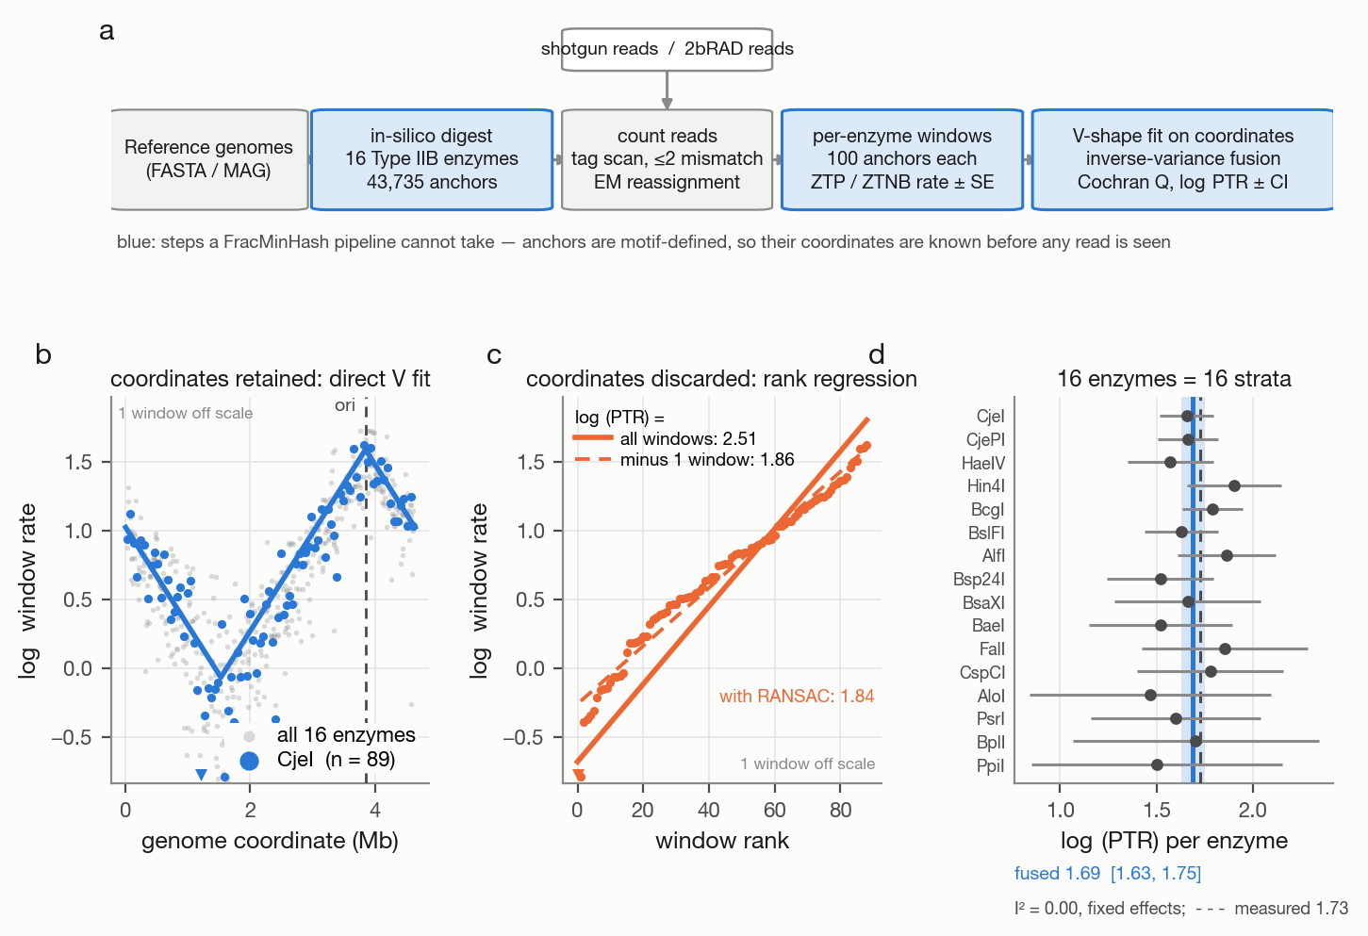 - Fig. 2 — figures/out/fig2_zheng_benchmark.pdf (Zheng isolate benchmark: accuracy vs coverage; magnitude at 1× and 10×; run-out negative control)
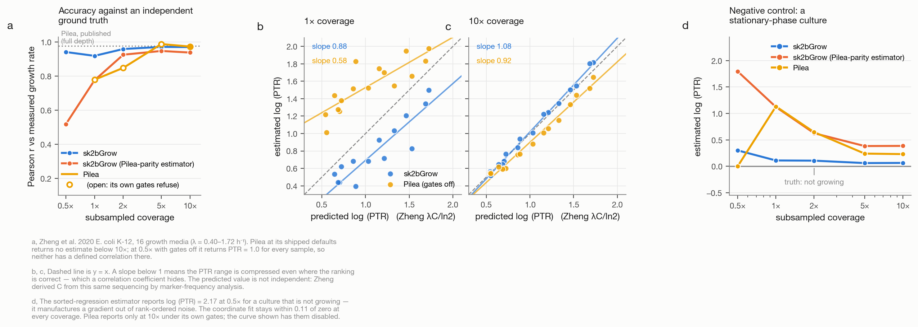 - Fig. 3 — figures/out/fig3_simulation.pdf (multi-strain simulation)
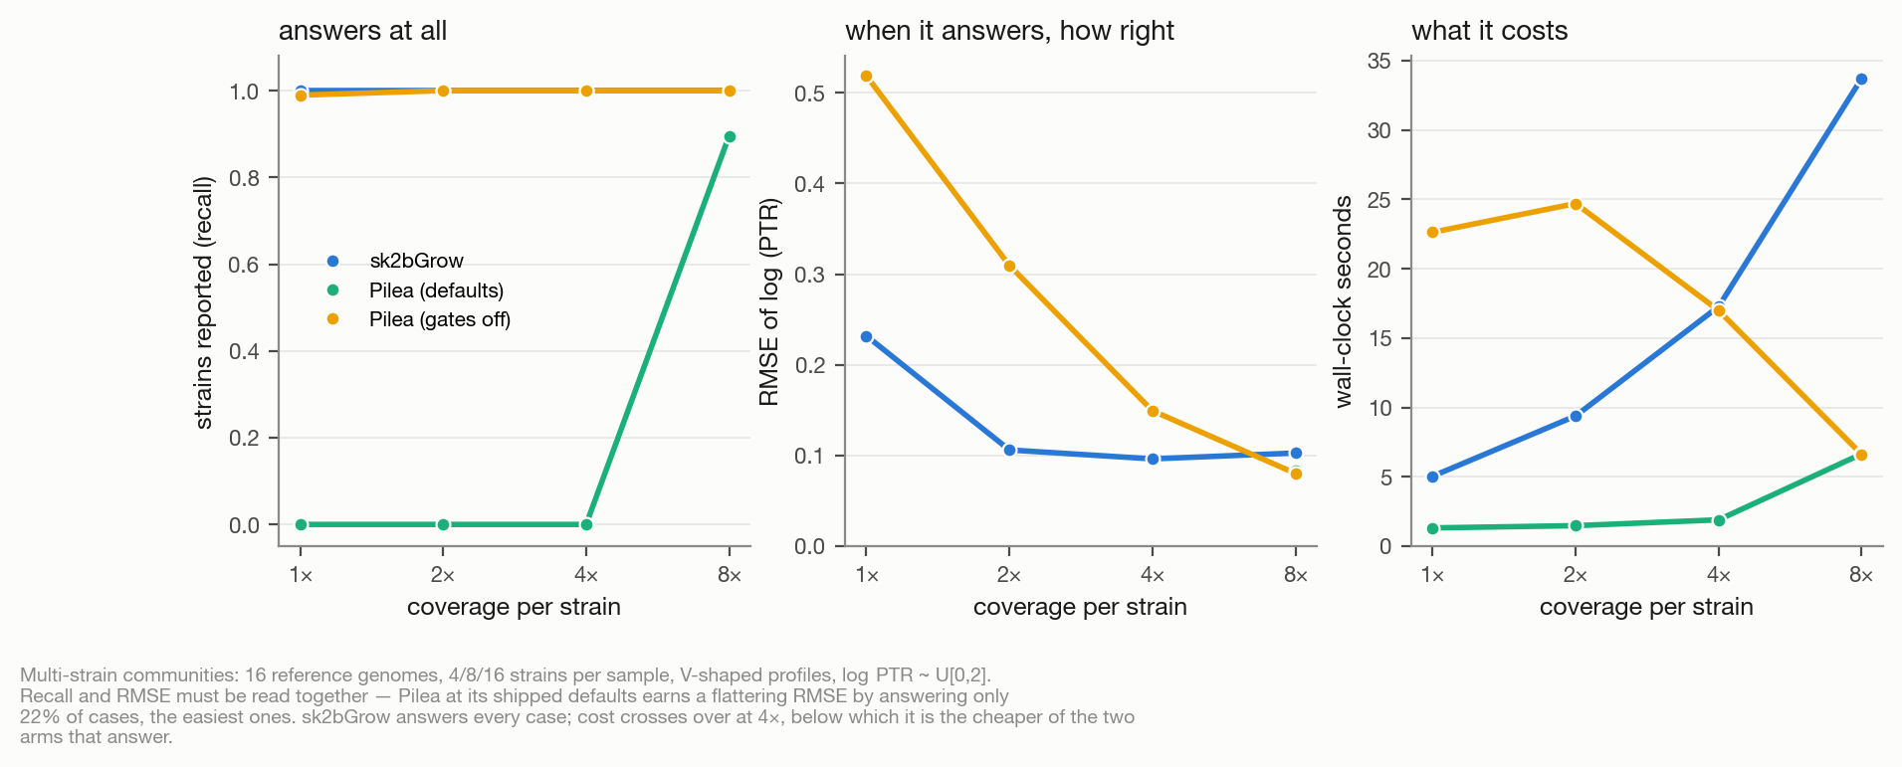 - Fig. 4 — figures/out/fig4_attribution.pdf (2 × 2 landmark attribution)
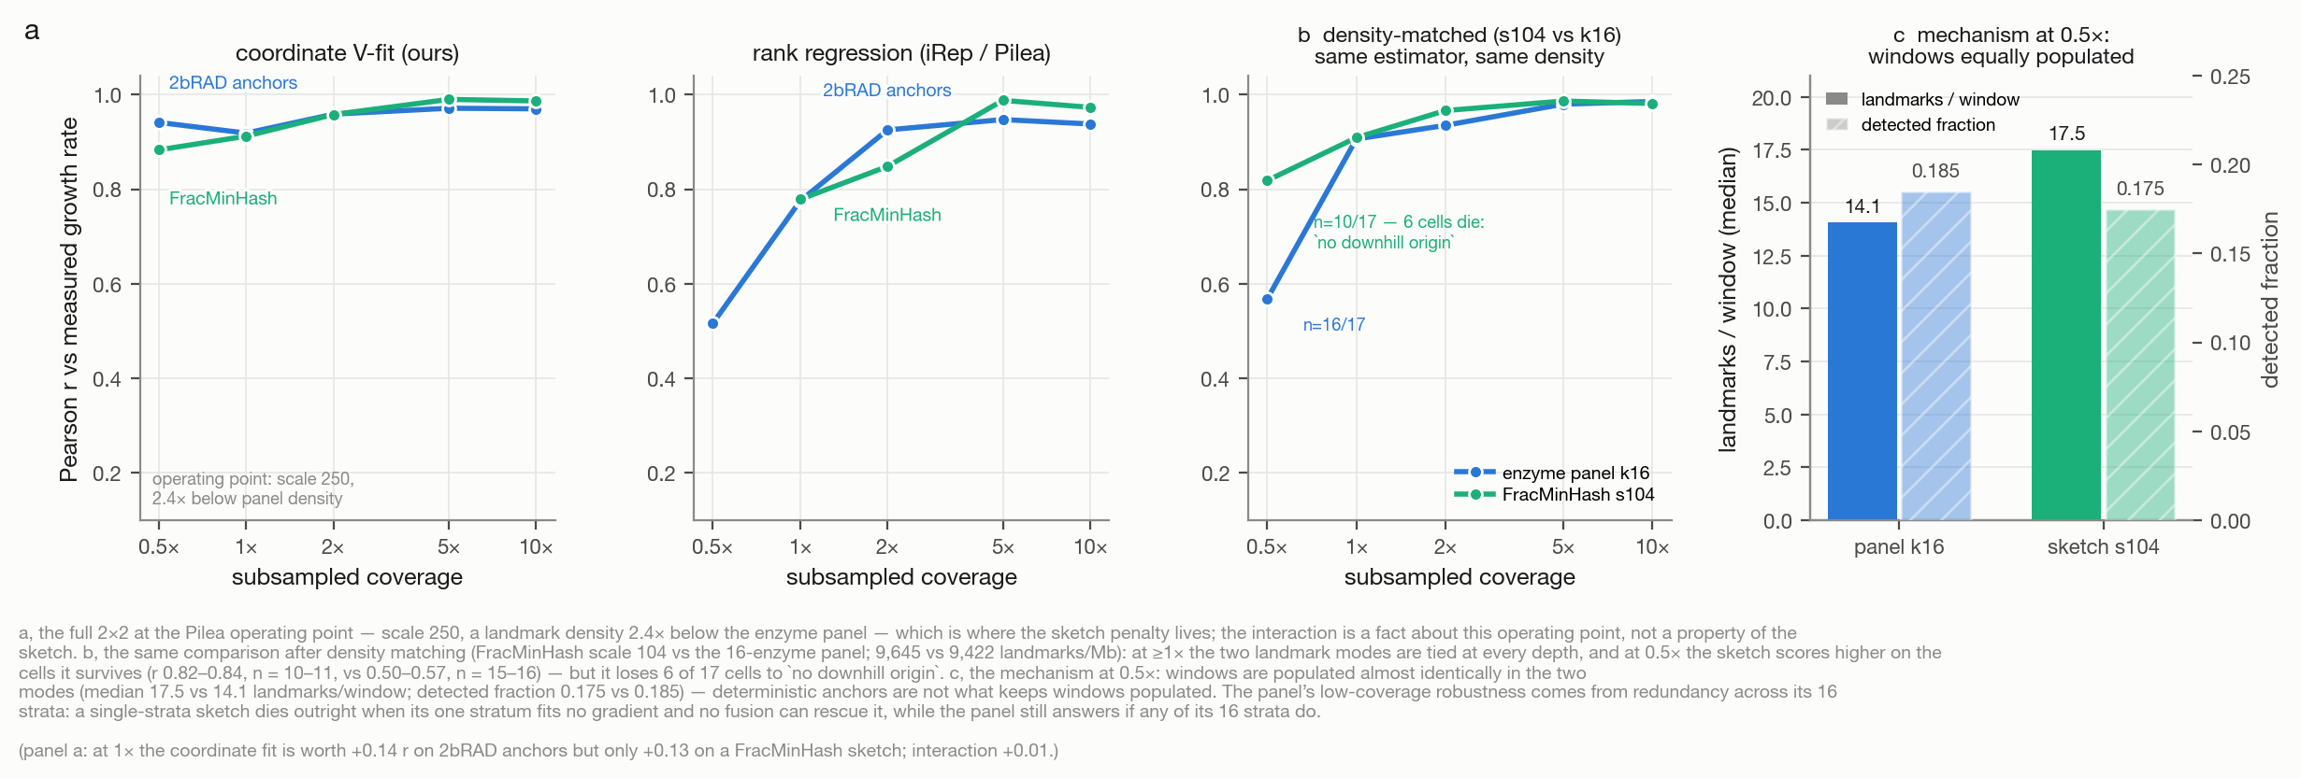 - Fig. 5 — figures/out/fig5_panel_design.pdf (panel-size sweep and GC range)
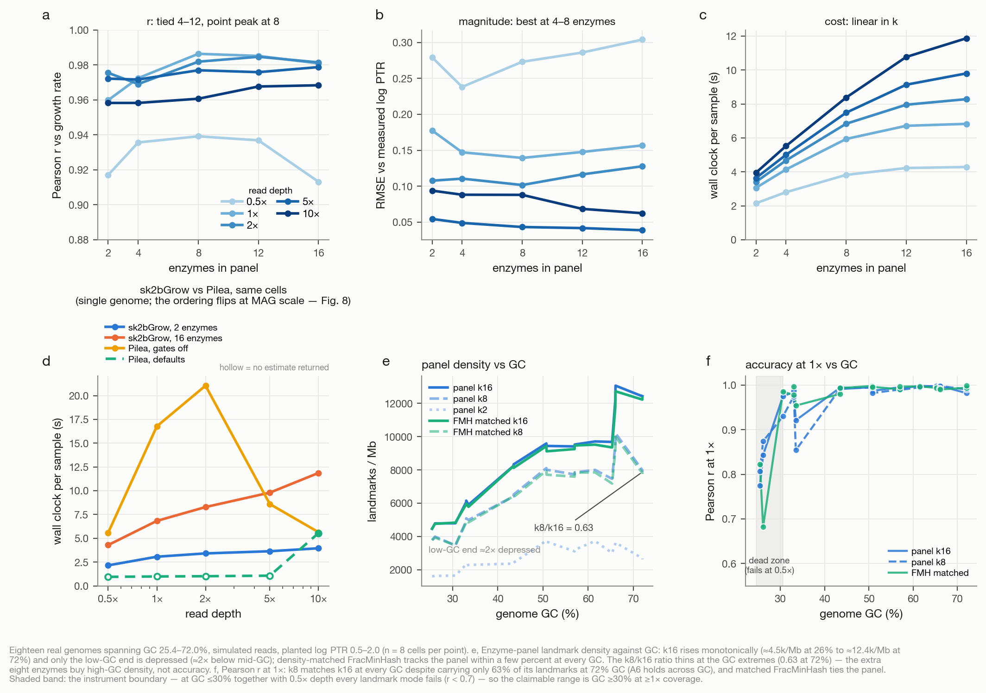 - Fig. 6 — figures/out/fig6_fragmentation.pdf (fragmentation and scaffolding)
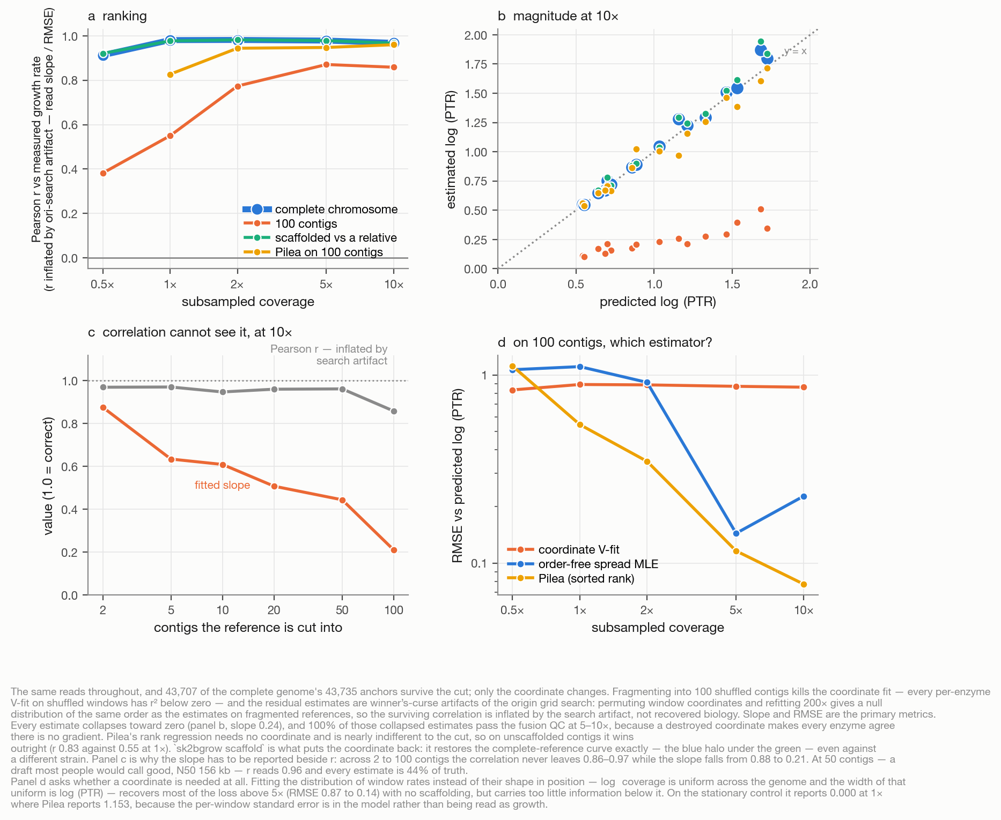 - Fig. 7 — figures/out/fig7_metagenome.pdf (fecal-cohort concordance)
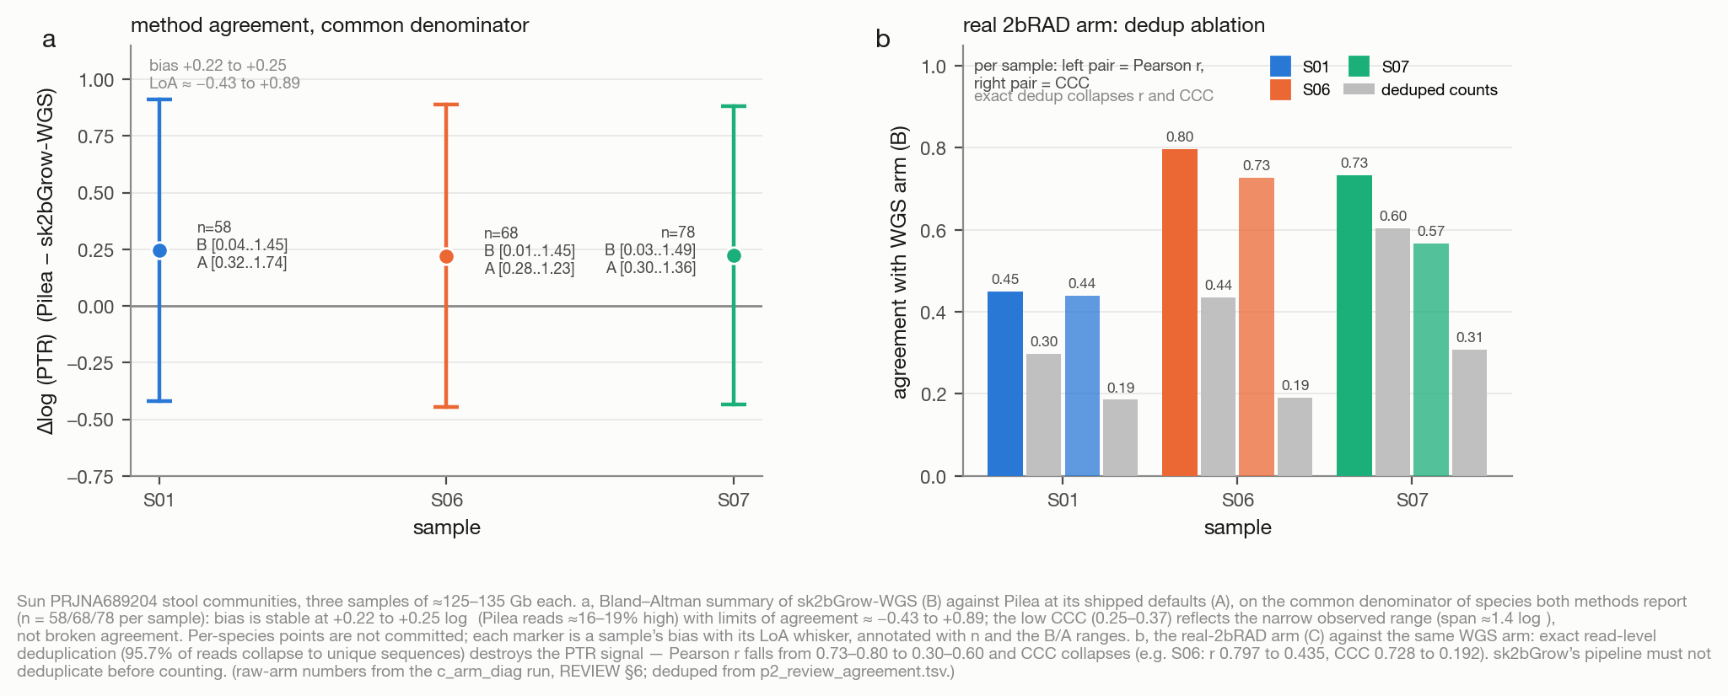 - Fig. 8 — figures/out/fig8_mag_qc_cost.pdf (MAG-scale QC and cost at scale)
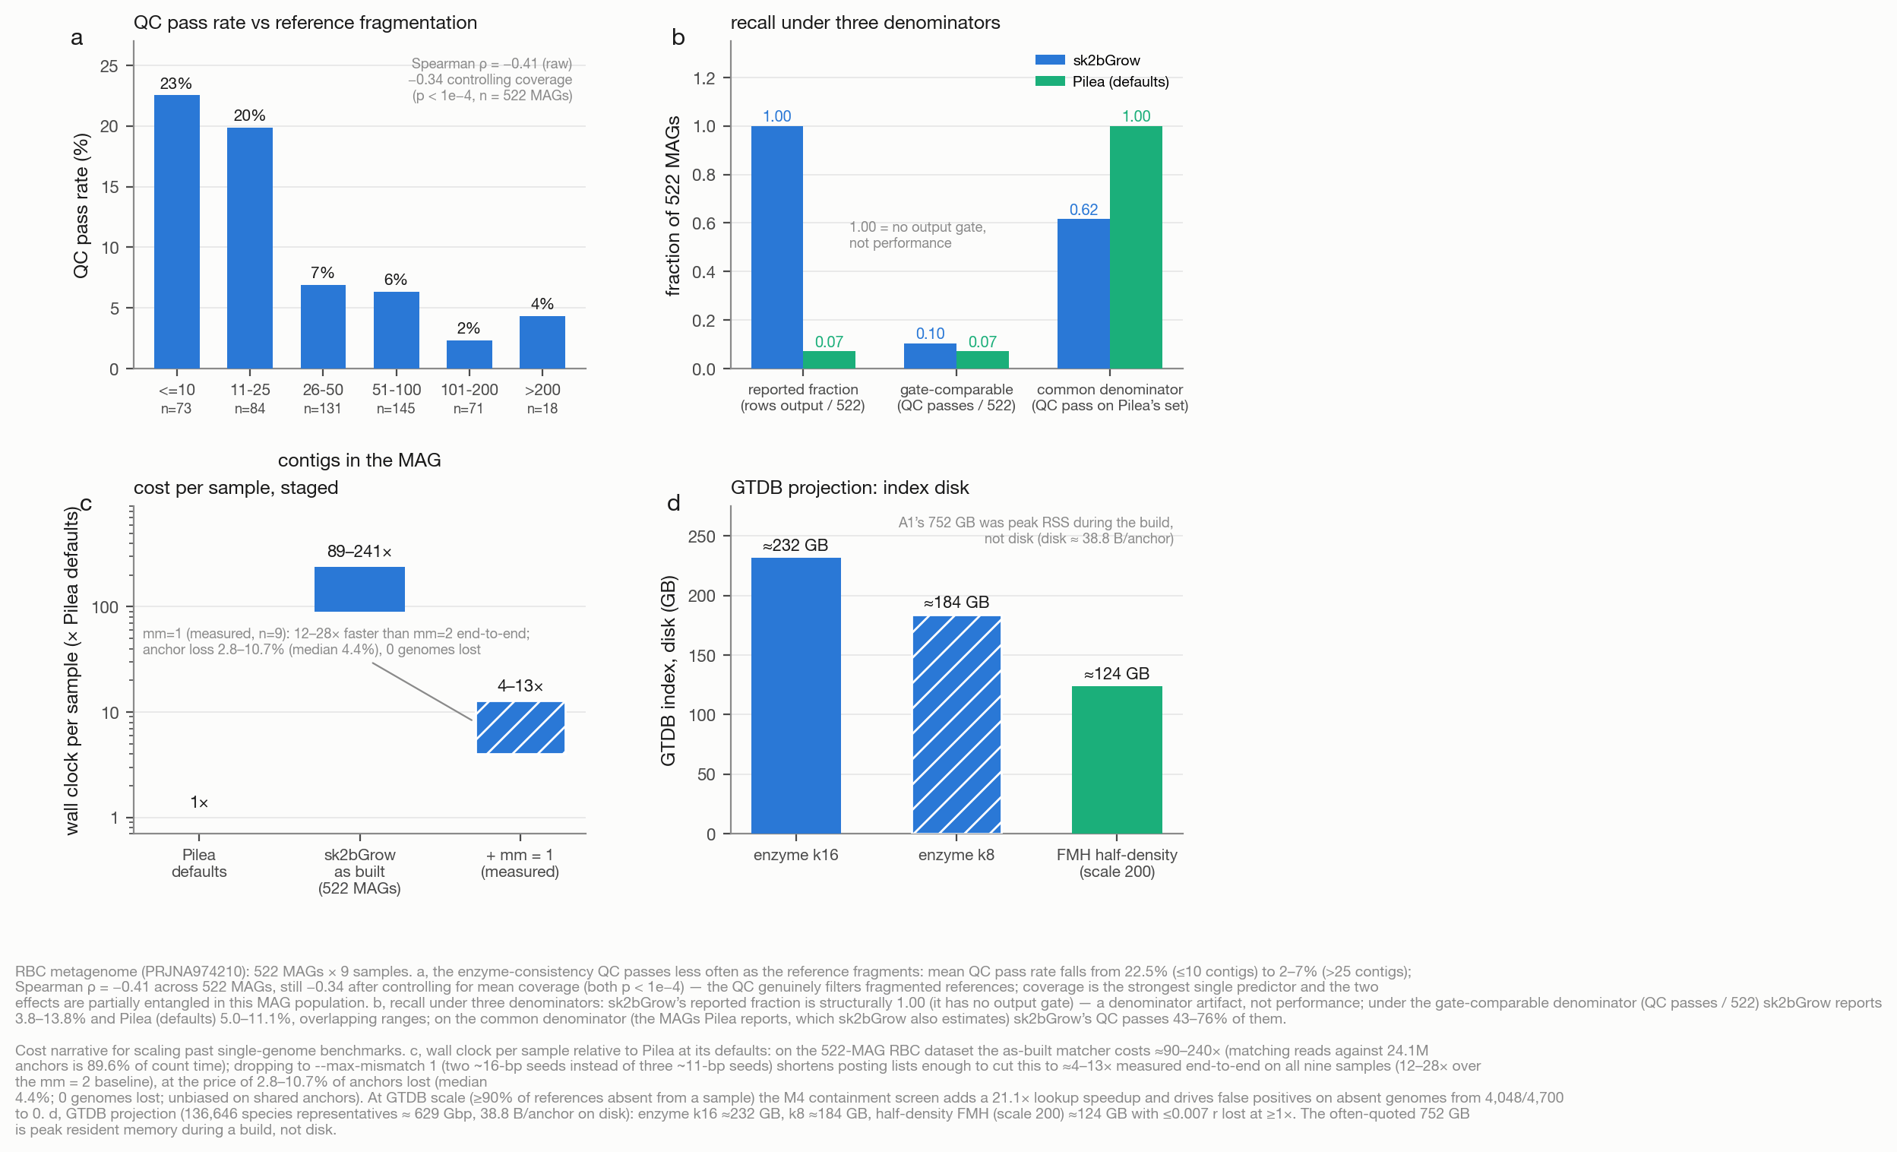

Tables
- Table 1 — tables/table1_enzyme_panel.md (enzyme panel)
- Table 2 — tables/table2_ecoli_accuracy.md (isolate accuracy)
- Table 3 — tables/table3_simulation.md (multi-strain simulation)
- Table 4 — tables/table4_simulation_aggregate.md (simulation aggregate)
- Table 5 — tables/table5_pilea_gate_ablation.md (Pilea gate ablation)
- Table 6 — tables/table6_enzyme_ranking.md (enzyme ranking)
- Table 7 — tables/table7_panel_size.md (panel-size sweep)
- Table 8 — tables/table8_fragmentation.md (fragmentation; also inlined in §6)
- Table 9 — tables/table9_landmark_comparison.md (landmark-source comparison; inlined in the Discussion)
- Table 10 — tables/table10_metagenome.md (metagenome concordance and MAG-scale results)

