Deterministic 2bRAD anchors enable coordinate-aware bacterial replication-rate estimation

Abstract
Peak-to-trough ratios report bacterial replication from coverage along the genome, but alignment-free sketches can discard genomic position and complicate quality control. We present sk2bGrow, a deterministic 2bRAD/TGT-anchor pipeline that indexes motif coordinates, estimates enzyme-stratified window rates, fits origin-to-terminus gradients, and separates all-finite from quality-controlled results. On the Zheng 2020 Escherichia coli benchmark, anchors with coordinate fitting reached mean Pearson r = 0.911 at 0.5× and r = 0.960 at 1×, whereas sorted regression on the same anchors reached r = 0.130 and 0.571. Shipped quality control nevertheless passed 0/16 media at both depths. Cross-species isolates exposed an important boundary: pooled correlations spanned 0.278–0.680 for sk2bGrow across 0.5–10×, while Pilea gates-off was higher at 1–10×. In 20 marine metagenomes, sk2bGrow produced fewer protocol-comparable MAGs than Pilea default (2/101 versus 18/101) and lower median correlation (0.438 versus 0.520). Conversely, in nine rotating-biological-contactor metagenomes, sk2bGrow recalled all 4,698 expected MAG-sample genome cells, returned no suspicious confident absent-genome estimates, and passed QC for 484 estimates, but averaged 76,866 s per sample versus 536 s for Pilea default. sk2bGrow therefore provides deterministic coordinate-aware signal and application-scale recall, while current cross-species accuracy, real-community coverage, QC and runtime set clear limits on deployability.
Keywords: bacterial growth rate; peak-to-trough ratio; replication rate; 2bRAD; metagenomics; sketching; benchmarking; microbiome

Background
Bacterial growth rate affects infection dynamics, microbiome ecology and experimental evolution. Marker-frequency methods estimate replication rate from the coverage gradient between the replication origin and terminus. Tools such as iRep, GRiD and CoPTR formalize this relationship for assembled genomes [1–3]. Pilea introduced an alignment-free FracMinHash strategy that scales to large read collections [4].
These advances expose three limitations. First, random sketches discard position. Once a k-mer is sampled, the estimator no longer knows where it lies on the genome, so trends must be recovered by sorting windows or ranks. This is efficient, but the fitted range depends on extreme order statistics. Second, arbitrary windows do not guarantee stable local information. A fixed number of k-mers can be sparse in extreme GC regions, while a fixed genomic interval can contain too few observations. Third, quality control is often aggregate. It is difficult to ask whether enzyme-specific loci, sequence contexts and coordinate regions support the same estimate.
Deterministic 2bRAD/TGT anchors provide a different design point. A restriction motif defines a short tag at a genomic coordinate. The same reference produces the same anchor set in every sample. Enzyme choice introduces sequence context, and the anchor table can be audited before profiling [5]. The central question is therefore whether retaining these coordinates and strata improves PTR estimation and quality control.
We asked three questions. First, does coordinate-aware fitting recover low-depth signal more reliably than sorted regression? Second, how much of the observed difference is estimator signal rather than shipped-QC deployment? Third, how do controlled advantages translate, or fail to translate, to real isolates, marine communities and application-scale microbiomes?
We addressed these questions with sk2bGrow. The implementation digests references into deterministic anchors, stores coordinates and enzyme strata, counts reads against those loci, estimates window rates with zero-truncated models, fits a signed origin-to-terminus gradient, fuses per-enzyme estimates, and reports explicit all-finite and quality-controlled results.
Contributions:
- A reproducible deterministic-anchor PTR benchmark with real isolates, real communities, simulated overdispersion, fragmented coordinates and mixed-strain tracks.
- A coordinate-aware estimator that distinguishes all-finite signal from shipped default-QC deployment.
- Diagnostics separating sorted-regression failure, window-rate compression and reference-coordinate destruction.
- A provenance-controlled dataset, result archive, figure code and statistical supplement.

Results

Benchmark design
We used five arms so that sketch and estimator effects could be separated:
arm | sketch | estimator
A | 16-enzyme anchors | adaptive windows + coordinate V-fit
E | FracMinHash | adaptive windows + coordinate V-fit
B | 16-enzyme anchors | 25 kb windows + sorted/RANSAC
C relaxed | FracMinHash | Pilea gates-off
C default | FracMinHash | Pilea shipped defaults
The primary controlled real-data target was independently measured growth rate lambda from Zheng 2020 [6]. RMSE against the paper’s predicted log2 PTR is reported as a same-reads comparison, not independent absolute accuracy. Unless otherwise stated, each medium-level estimate averages three sequencing-subsample seeds before metrics are calculated. We report both all-finite estimates and estimates passing shipped default QC.
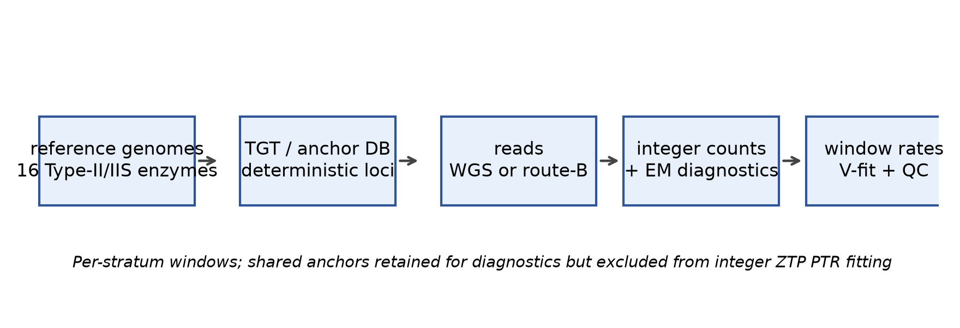
Figure 1
Figure 1. sk2bGrow preserves deterministic anchor coordinates from reference indexing through enzyme-stratified window fitting.

Low-depth signal is present, but shipped QC does not certify it
Across 16 growing-media conditions, anchors + V-fit reached mean Pearson r = 0.911 at 0.5× and r = 0.960 at 1×. Under the same all-finite rule, FracMinHash + V-fit reached r = 0.852 and 0.923. Coordinate-free sorted regression on anchors reached r = 0.130 and 0.571. Pilea gates-off was undefined at 0.5× because all 16 estimates collapsed to PTR = 1, and reached r = 0.875 at 1×.
Shipped default QC passed 0/16 A-arm media at 0.5× and 1×, a mean of 7/16 at 2×, 12.7/16 at 5× and 14/16 at 10×. Counts varied across seeds: A-arm pass counts were 8/8/5 at 2×, 14/11/13 at 5× and 14/15/13 at 10×. Thus deterministic anchors retain low-depth signal, but current default QC does not certify those estimates as deployable.
A 10,000-resample medium-level bootstrap gave A-arm Pearson intervals of 0.820–0.966 at 0.5× and 0.932–0.980 at 1×. The paired A-minus-E Pearson advantage was 0.059 (-0.031 to 0.114) at 0.5× and 0.037 (0.010 to 0.057) at 1×. At 0.5×, the A-arm slope was lower than the E-arm slope. The supported conclusion is therefore improved low-depth recall and rank recovery, not a uniform significant accuracy win.
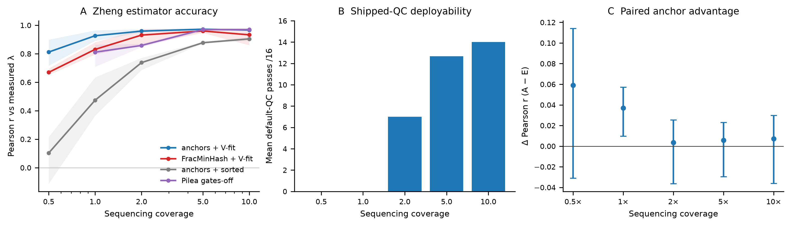
Figure 2
Figure 2. Zheng benchmark performance. A, all-finite correlations by coverage and arm; shading shows seed range. B, mean shipped-QC passes for the anchor + V-fit arm. C, paired A-minus-E Pearson bootstrap intervals.
The stationary RUN_OUT control supported this caution. A-arm log2 PTR values across three seeds were 0.113/-0.015/0.083 at 0.5× and 0.033/-0.036/0.076 at 1×. Sorted regression falsely reported 2.12/2.26/1.99 and 1.94/1.93/1.94.
Finding 1. Deterministic coordinates preserve low-depth gradient signal, but shipped QC does not yet certify that signal as deployable.

Coordinate fitting, not anchor choice alone, explains the gain
At 1×, changing only the estimator changed the result. Anchors + V-fit reached r = 0.960, whereas anchors + sorted regression reached r = 0.571. Changing the sketch had a smaller effect under coordinate fitting: anchors reached r = 0.960 and FracMinHash reached r = 0.923.
Finding 2. Coordinate fitting, rather than deterministic motif choice alone, explains most of the improvement over sorted regression.

Overdispersed low-count windows, not Poisson truncation alone, cause residual compression
In simulations with known tent amplitudes, exact window rates passed through the same windows, V-fit and fusion machinery recovered slopes close to one. After signed fixed-origin fitting, recovered Poisson slopes were 0.774, 0.958, 1.012 and 0.995 at 0.5, 1, 2 and 5×. Overdispersed NB slopes were 0.701, 0.853, 0.857 and 0.982.
The stationary b=0 estimate was now small in all cells: 0.099/0.055/0.035/0.026 for Poisson and 0.033/0.050/0.084/0.036 for NB. Thus the earlier downhill-only floor is no longer the dominant defect. Remaining NB compression at low depth co-occurred with upward bias in low-rate windows.
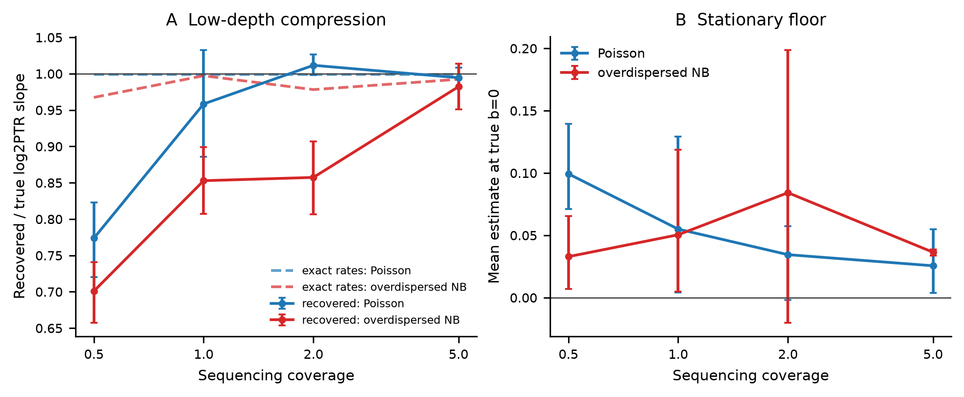
Figure 3
Figure 3. Controlled A4 simulation. A, recovered and exact-rate slopes. B, mean estimate at true log2 PTR = 0.
Finding 3. Signed fixed-origin fitting largely removes the stationary floor; overdispersed low-count windows remain the main compression mechanism.

Mixed-strain validation
We simulated communities from 16 bacterial references at 4, 8 or 16 strains, 1, 2 or 4× coverage per selected genome and two replicates. Strain-specific true log2 PTR values were drawn from Uniform(0,2). Because several reference assemblies contained multiple contigs or plasmid entries, we used explicit coordinate fitting rather than the conservative fragmented-auto refusal.
The current run completed all 18 cells. Recall was 1.00 in every strain-count and coverage cell, with no spurious genomes. Aggregate RMSE was 0.140 and mean signed bias was 0.015 log2 units. RMSE decreased with coverage for 16 strains from 0.197 at 1× to 0.100 at 2× and 0.056 at 4×. At 4 strains it fell from 0.266 at 1× to 0.111 at 2× and 0.097 at 4×. This result shows that the production stack can retain and estimate all simulated strains in the tested range, but it does not measure competitive performance against absent external tools.
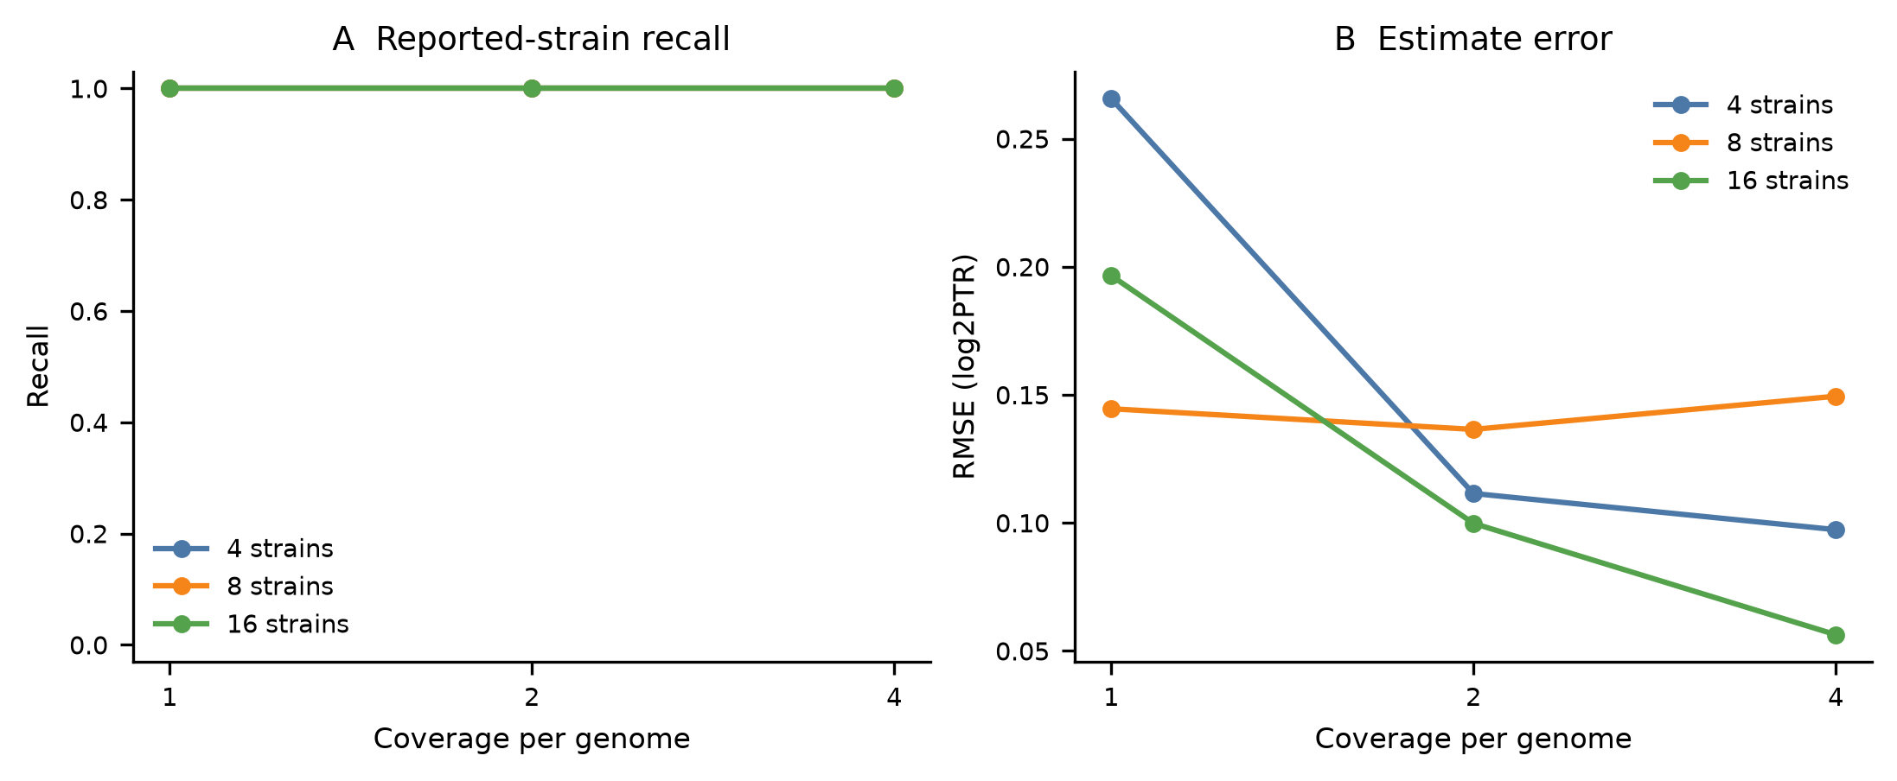
Figure 4
Figure 4. Mixed-strain simulation recall and RMSE by strain number and coverage.
This controlled test measures attribution in a known community. It does not replace real metagenomic validation.

Fragmented-coordinate QC is promising but not production-ready
A two-branch within-contig gradient statistic was evaluated on 324 scrambled, ordered and complete reference profiles. Complete and ordered controls were quiet: 0/36 complete and 0/72 ordered. Scrambled references fired in 15/54 cells at true log2 PTR = 0.5 and 40/54 at each of log2 PTR = 1 and 1.5. Detection was complete for scrambled log2 PTR >= 1 at 5–10× (72/72).
One scrambled stationary control fired at 1×. A post-hoc sensitivity check found that raising the slope-branch z-short cut from 2.0 to 2.5 removed that false fire while retaining all strong 5–10× detections. Because this threshold was selected after seeing the grid, WCG remains prototype evidence.
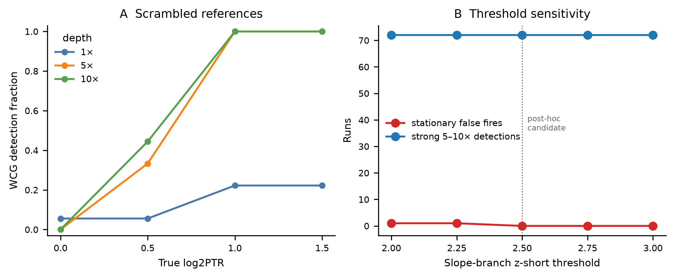
Figure 5
Figure 5. Fragmented-coordinate QC. A, scrambled-reference detection by true PTR and depth. B, sensitivity of stationary false fires and strong detections to the slope-branch threshold.
Finding 4. Within-contig gradients can identify destroyed coordinates in the strong 5–10× regime, but independent validation is required before production use.

Real isolates, marine communities and RBC application define deployment boundaries
Three real-data tracks tested whether the controlled results generalize. In C1b, four Bacillus subtilis, Klebsiella pneumoniae, Morganella morganii and Pseudomonas putida wastewater isolate species were profiled across 0.5–10×. All 18 evaluable cells returned sk2bGrow estimates at every depth. Pooled correlations against digitized measured growth rates were 0.680, 0.278, 0.561, 0.663 and 0.675 at 0.5, 1, 2, 5 and 10×, respectively. Pilea gates-off was undefined at 0.5× but slightly exceeded sk2bGrow at 1× (0.321) and was clearly higher at 2–10× (0.868, 0.736 and 0.787). C1b therefore fails to support a cross-species accuracy-superiority claim.
The C4 marine benchmark used 20 real surface-water metagenomes and 101 marine MAGs. sk2bGrow completed all samples and produced an estimate for 51 MAGs, compared with 64 for Pilea default. Only two MAGs were represented in both protocols sufficiently for a matched comparison, versus 18 for Pilea default; the corresponding median protocol correlations were 0.438 and 0.520. Because the published growth-rate truth was inferred from the same sequencing reads, C4 measures agreement under a noisy external protocol rather than absolute PTR accuracy.
C5 tested application scale in nine rotating biological contactor (RBC) metagenomes against 522 bacterial MAGs. sk2bGrow returned estimates for all 4,698 expected MAG-sample cells (recall = 1.00); 484 estimates passed default QC and no confident estimate mapped to an absent genome. Pilea default returned 333 total estimates with mean recall 0.071, whereas Pilea gates-off returned 1,432 estimates with mean recall 0.914 but represented only three of nine samples. The main deployment limitation was cost: mean wall time was 76,866 s for sk2bGrow, 536 s for Pilea default and 2,379 s for the three represented Pilea gates-off samples. C5 thus demonstrates recall and workflow coverage, not independent community growth-rate accuracy.
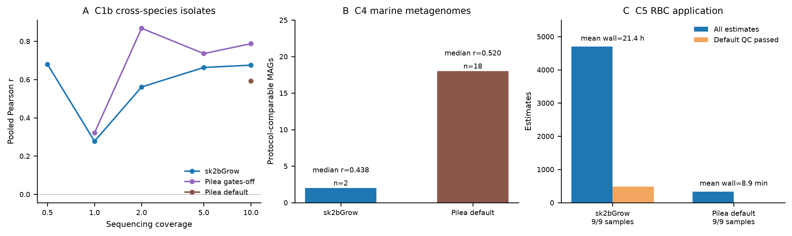
Figure 6
Figure 6. Real-isolate, marine-community and RBC application results. A, pooled Pearson correlations in C1b by depth and protocol; missing points indicate an undefined metric. B, C4 protocol-comparable MAG counts (bars) and median correlations (points). C, C5 total and QC-passed estimates; mean wall time is shown above each bar. Pilea gates-off is omitted from the C5 bar comparison because only 3/9 samples completed.
Finding 5. Real data narrow the method’s claim: sk2bGrow preserves application-scale recall in RBC communities, but Pilea gates-off or default currently provides stronger cross-species isolate accuracy and greater real-marine protocol coverage.

Discussion
sk2bGrow shows that deterministic restriction anchors are useful for more than taxonomic marking. When their coordinates are retained, they support direct origin-to-terminus fitting, enzyme-stratified QC and reproducible low-depth evaluation. The central practical distinction is between estimator signal and deployable output. sk2bGrow can produce informative low-depth estimates, but current default QC rejects many of them. This conservative behavior is preferable to reporting every fit, but low-depth deployment requires further QC development.
The controlled comparison also avoids attributing all gains to anchor choice. Under coordinate fitting, FracMinHash remained competitive. The large low-depth failure occurred with sorted regression on anchors. Coordinate preservation in the estimator, rather than motif choice alone, drives the main improvement.
The A4 result clarifies mechanism. Zero-truncated window modelling was not the sole source of low-depth compression. Signed fixed-origin fitting made the stationary floor small and brought Poisson slopes close to unity by 1×. Remaining NB compression at low depth is consistent with overdispersion and upward bias in weakly observed windows. Future work should model per-anchor efficiency jointly rather than correcting windows after truncation.
Mixed-strain simulation addresses attribution, but not full community deployment. The real-data tracks narrow the claim in three ways. First, divergent cross-species references reduce isolate accuracy relative to Pilea gates-off. Second, sparse marine MAG coverage limits the number of matched comparisons and indicates that anchor coverage and QC behavior, not only the coordinate-aware estimator, control real-community utility. Third, RBC data show that complete reporting is possible at application scale but can be orders of magnitude slower. These results do not support a blanket claim that sk2bGrow outperforms existing tools; they support a coordinate-aware benchmark design that separates signal, deployment readiness and application coverage.

Conclusions
Deterministic 2bRAD/TGT anchors make genomic position, enzyme context and coordinate integrity explicit in PTR estimation. The controlled results show strong low-depth estimator signal and complete attribution in a 16-genome mixed-strain grid, while QC correctly prevents those values from being treated as certified deployments. Real isolates, marine metagenomes and RBC communities further show that current cross-species accuracy, marine protocol coverage and runtime remain material barriers. sk2bGrow is therefore best viewed as a reproducible boundary-aware benchmarking and application framework, with cross-species calibration, faster counting and independently validated community accuracy as priorities before broad production use.

Limitations
- The real-data target was one E. coli K-12 MG1655 isolate. The three sequencing subsamples are technical read-sampling replicates, not biological replicates.
- All-finite and default-QC results answer different questions. Low-depth all-finite performance cannot be quoted as deployable performance.
- Pilea gates-off was competitive under matched coordinate fitting. The study does not support a uniform accuracy-superiority claim.
- The current ZTP PTR model does not use EM fractional weights. Shared anchors are retained as diagnostics and conservatively excluded from PTR.
- WCG is a prototype coordinate-QC statistic and has not been independently validated as a production gate.
- The current comparison focused on Pilea. Broader comparison with iRep, GRiD, CoPTR and DEMIC is required for a general PTR-tool benchmark.
- The mixed-strain evaluation is simulated. Strain abundance, sequence divergence and real metagenomic background are simplified.
- C1b and C4 use externally derived, sometimes noisy growth-rate targets; C5 has no independent growth-rate truth. Real-community results therefore cannot be interpreted as absolute PTR accuracy.
- The C1b, C4 and C5 runs used an earlier sk2bGrow commit plus working-tree fixes, whereas Zheng, A4, R3 and mixed-strain used the current implementation state. This version heterogeneity is explicitly reported in Methods.

Methods

Anchor database
References were converted to uppercase ACGT sequences and digested with 16 2bRAD-associated enzyme definitions. A tag was accepted only when its entire window matched one enzyme pattern, contained no ambiguous bases and lay wholly inside the contig. Tags were stored as forward-strand windows, and canonical hashing allowed reads from either sequencing strand. The database retained genome, contig, coordinate, enzyme, pattern, local GC and flag fields.
Anchors were considered unique within a genome by distinct genomic locus rather than anchor row. Thus two enzymes at one locus were not mistaken for a repeat. Anchors shared across genomes were retained for counting and EM diagnostics but flagged and excluded from conservative PTR fitting.

Read counting
Reads were scanned for complete enzyme tag windows. Candidate tags were matched by canonical hash and verified against stored bases. Hamming mismatch tolerance was two by default. The best distance was retained; multimapping observations were kept for diagnostics. Real 2bRAD mode stopped after the first confirmed tag per read. Shotgun mode counted every complete tag window wholly contained in a read.
The count table contains raw integer observations. The EM sidecar contains fractional assignments for shared anchors, but the current ZTP PTR layer does not consume fractional weights. Database-shared anchors are excluded from conservative PTR fitting.

Window rates
Counts were windowed separately for each enzyme. Auto windowing targeted 25 windows per enzyme, used at least 25 anchors per window and capped windows at 100 anchors. Each window was fitted with zero-truncated Poisson or zero-truncated negative-binomial models selected by BIC. A negative-binomial fit was rejected when its implied detection probability contradicted the observed detected fraction. Window rates were converted to log2 rates with delta-method standard errors.
Per-enzyme GC curves were fitted by lowess on raw anchor counts and shrunk by explained variance. Window rates were corrected by subtracting the mean anchor-level GC offset.

Coordinate fitting
For a candidate origin, circular distance d was used in
log2 mu(x) = a - b1 min(d,k) - b2 max(d-k,0).
With one slope this is the ordinary origin-to-terminus V. With two slopes it represents multi-fork replication. Model selection used BIC, and segmentation was considered only with at least 30 windows and a plain fit suggesting log2 PTR >= 1.
When the origin was supplied or fixed, slope signs were allowed so stationary or near-stationary samples could produce small negative gradients. When the origin was searched, uphill solutions were rejected to prevent the terminus from masquerading as the origin. Weighted least squares used inverse-variance window weights. A second pass re-expressed standard errors as a smooth function of fitted values to reduce self-weighting.

Enzyme fusion and quality control
Per-enzyme fits were fused by inverse-variance weighting. Cochran’s Q tested between-enzyme heterogeneity. When Q rejected homogeneity, DerSimonian-Laird random-effects weights widened the interval. Output retained estimates even when QC failed and reported the reason.
Default QC required coverage >= 1, detected fraction >= 0.75, dispersion <= 5, containment >= 0.5, enzyme consistency p >= 0.05, enzyme fit rate >= 0.8 and a finite estimate.

Zheng benchmark
We used 16 growing-media conditions and one stationary RUN_OUT condition from Zheng 2020 BioProject PRJNA615952. Three sequencing subsample seeds were used. Seed s0 was the archived C1 paired subsample; s1 and s2 were deterministic paired resamples of the C1 20x pool. They quantify technical read-sampling variability and are not biological replicates.
Metrics averaged the three seed estimates within each medium and compared across 16 growing media. The stationary control was excluded from correlation metrics. Uncertainty used a 10,000-resample medium-level bootstrap. For each resampled medium, the three seed estimates were averaged before calculating the metric. Paired A-minus-E deltas used the same resampled media.

A4 low-depth simulation
Reads were simulated from real E. coli K-12 coordinates with a tent-shaped coverage gradient whose amplitude was the true log2 PTR. Depth was 0.5/1/2/5×, true log2 PTR was 0/0.5/1/1.5/2 and there were three seeds. Two arms were used: Poisson counts and per-kilobase lognormal efficiency followed by NB-like overdispersion. Exact expected anchor counts were calculated from the same simulator weights and joined to production windows.

Mixed-strain simulation
A 16-genome reference panel was digested and indexed. Communities contained 4, 8 or 16 strains at 1, 2 or 4× coverage per selected genome, with two replicates. Strain-specific log2 PTR values were drawn from Uniform(0,2), and reads followed a V-shaped gradient from each strain origin. Because several reference assemblies included multiple contigs or plasmid entries, explicit coordinate fitting was used instead of fragmented-auto refusal. Output estimates were matched to known selected genomes. Recall was the fraction of true strains reported; RMSE used matched strains.

R3 coordinate-QC statistic
The within-contig gradient statistic used two branches. The slope branch estimated per-contig slopes, corrected their variance by residual chi-square and compared local amplitude with the global fitted amplitude. The jump branch compared boundary-crossing rate steps with within-contig steps after subtracting the sampling-noise floor. A flag required either branch to exceed its threshold. The current refresh evaluated 27 references across three origin-layout families, 12 read cells and 324 profiles.
Threshold sensitivity varied the slope-branch z-short cut from 2.0 to 3.0. The original cut produced one stationary false fire; a post-hoc cut of 2.5 removed that fire without losing strong 5–10× detections. Independent validation is required before production use.

Real-community benchmarks
C1b used PRJNA1280254, the isolate dataset from the Pilea study. Twenty runs represented four wastewater isolate species across five nutrient concentrations and were subsampled to 0.5, 1, 2, 5 and 10× coverage of each species assembly. sk2bGrow used the full 16-enzyme panel and its fixed coordinate estimator; Pilea v1.3.8 was run with shipped defaults and with gates off (-x 0 -z 0 -c 0). Per-run measured growth rates were digitized from the source figure and validated by reproducing the printed panel-level correlations to within 2 × 10⁻⁴; RMSE against the paper’s predicted log2 PTR was treated as a same-reads comparison rather than independent accuracy.
C4 used PRJNA551656 with 20 marine surface-water metagenomes and 101 marine MAGs. We compared sk2bGrow with Pilea default and recorded both estimates and QC outcomes. A MAG was counted for protocol correlation only when the two protocols had comparable samples and finite estimates; this criterion explains why the matched set (2/101) is smaller than the set of any sk2bGrow estimate (51/101). Growth-rate truth from Long et al. was derived from the same reads and was treated as a noisy external reference [7].
C5 used PRJNA974210: nine RBC metagenomes profiled against 522 bacterial MAGs, giving 4,698 expected MAG-sample cells. Outcomes were total estimates, default QC passes, recall over expected cells, suspicious confident estimates for absent genomes and measured wall time. Pilea gates-off was summarized but not compared as a balanced application arm because only three of nine samples were represented.
These real-community runs were completed before the current implementation refresh using sk2bGrow commit 275778f350b87e10c6366bf90884d965fbab45a6 plus working-tree fixes to python/sk2bgrow/fit.py and python/sk2bgrow/ztp.py. They were not rerun at the current commit. This provenance limitation is retained because the results are informative but not a current-code benchmark.

Statistical reporting
Media bootstrap intervals used 10,000 resamples. Seed estimates were averaged within a resampled medium so that three technical seeds were not treated as independent media. A4 intervals resampled replicates within each true amplitude. R3 detection intervals used Wilson scores. Exploratory bootstrap p values were not corrected for multiplicity and were not treated as confirmatory.

Availability of data and materials
The implementation, benchmark scripts, result archives and figure code are in the sk2bGrow repository. The 2026-09-30 refresh and 2026-10-01 review diagnostics are stored under benches/refresh_20260930/. The current mixed-strain validation is stored under benches/mixedstrain_20261001/. Real-community summaries are stored under benches/realcommunity_20261001/remote_summaries/. Zheng data are available from BioProject PRJNA615952; C1b from PRJNA1280254; C4 from PRJNA551656; and C5 from PRJNA974210. Source and result archive hashes are recorded in docs/PAPER_RESULTS.md, benches/refresh_20260930/README.md and the statistical supplement.

Abbreviations
2bRAD: two-base encoded RAD; C1b: cross-species isolate benchmark; C4: marine real-community benchmark; C5: rotating-biological-contactor application; EM: expectation-maximization; MAG: metagenome-assembled genome; NB: negative binomial; PTR: peak-to-trough ratio; QC: quality control; RBC: rotating biological contactor; RMSE: root mean squared error; WCG: within-contig gradient; ZTP: zero-truncated Poisson

Declarations

Ethics approval and consent to participate
Not applicable. This study used only publicly available sequencing data and simulated reads.

Consent for publication
Not applicable.

Competing interests
The authors declare no competing interests.

Funding
To be completed from the award information used to support this project.

Authors’ contributions
To be completed in accordance with CRediT after author-list confirmation.

Acknowledgements
To be completed at submission.

References
- Brown CT, Olm MR, Thomas BC, Banfield JF. Measurement of bacterial replication rates in microbial communities. Nat Biotechnol. 2016;34:1256–63. doi:10.1038/nbt.3704
- Emiola A, Oh J. High throughput in situ metagenomic measurement of bacterial replication at ultra-low sequencing coverage. Nat Commun. 2018;9:4956. doi:10.1038/s41467-018-07240-8
- Joseph TA, Chlenski P, Litman A, Korem T, Pe’er I. Accurate and robust inference of microbial growth dynamics from metagenomic sequencing reveals personalized growth rates. Genome Res. 2022;32:558–68. doi:10.1101/gr.275533.121
- Chen X, Xu X, Lin Y, Shi X, Wang D, Zhang T. Pilea: profiling bacterial growth dynamics from metagenomes with sketching. Microbiome. 2026;14:128. doi:10.1186/s40168-026-02374-0
- Sun Z, Huang S, Zhu P, et al. Species-resolved sequencing of low-biomass or degraded microbiomes using 2bRAD-M. Genome Biol. 2022;23:36. doi:10.1186/s13059-021-02576-9
- Zheng H, Bai Y, Jiang M, et al. General quantitative relations linking cell growth and the cell cycle in Escherichia coli. Nat Microbiol. 2020;5:995–1001. doi:10.1038/s41564-020-0717-x
- Long AM, Hou S, Ignacio-Espinoza JC, Fuhrman JA. Benchmarking microbial growth rate predictions from metagenomes. ISME J. 2021;15:183–95. doi:10.1038/s41396-020-00773-1

