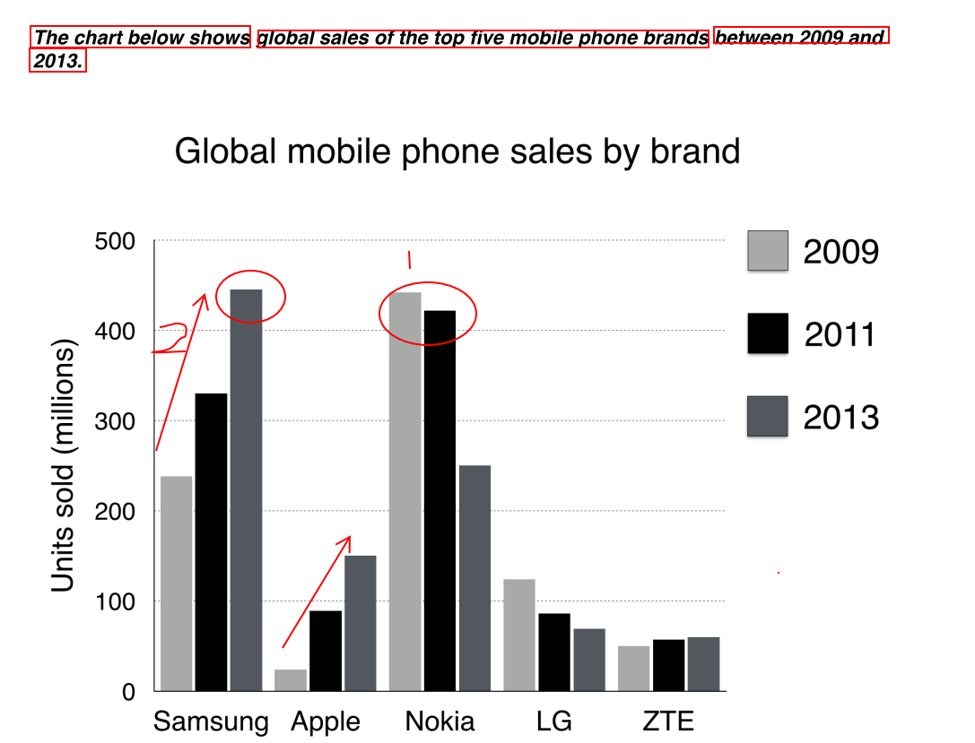

The bar chart compares the number of mobile phones sold worldwide by the five most popular manufacturers in years 2009, 2011 and 2013.

It is clear that Nokia sold the most mobile phones between 2009 and 2011, but Samsung became the best-selling brand in 2013. Samsung and Apple saw the biggest rises over the 5-year period.

In 2009, Nokia sold close to 450 million mobile phones, which was almost double the number of handsets sold by the second most successful manufacturer, Samsung. Over the following four years, Nokia’s sales figures fell by approximately 200 million units, whereas Samsung saw sales rise by a similar amount. By 2013, Samsung had become the market leader with sales reaching 450 million units.

The other three top selling mobile phone brands between 2009 and 2013 were Apple, LG and ZTE. In 2009, these companies sold about 25 million, 120 million and 50 million mobile handsets, respectively, but Apple overtook the other two vendors in 2011. In 2013, Apple handsets sales reached about 150 million units, while LG saw declining sales and the figures for ZTE rose only slightly.