Summary and interpretation

When I compare the sequence between SOD2_human and SOD2_mouse, the percentage of identical amino acids reaches 89.64%. And the score calculated with BLOSUM62 reaches 1091, which verifies the percentage of identical amino acids is high again.

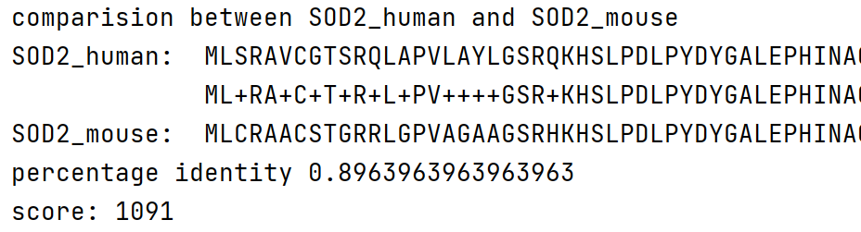

( subsequent sequences are not shown here)

Both human and mouse are [mammal](C:/Program%20Files%20(x86)/Youdao/Dict/8.9.6.0/resultui/html/index.html" \l "/javascript:;)s and genetically related. Therefore, the percentage of their identical amino acid sequences are relatively high compared to other results shown below. Their gene sequences are close to each other.

However, when I compare the human sequence and random sequence, the percentage of identical amino acids is only 5.4%. And the score calculated with BLOSUM62 is -250, which verifies the percentage of identical amino acids is low again.

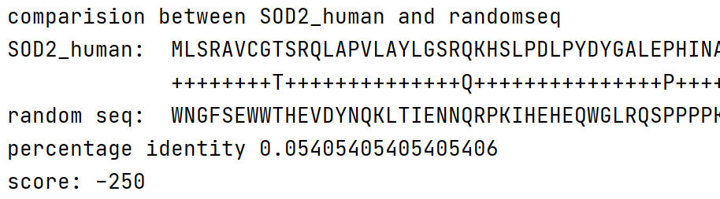

( subsequent sequences are not shown here)

This can act as a control to prove both human and mouse are genetically related.

Similarly, when I compare the mouse sequence and random sequence, the percentage of identical amino acids is only 5.9%. And the score calculated with BLOSUM62 is -250, which verifies the percentage of identical amino acids is low again.

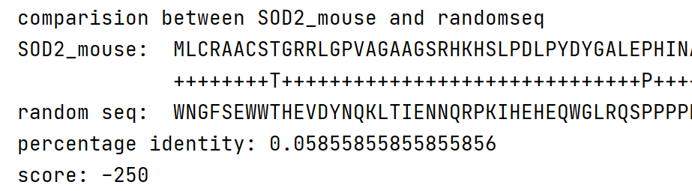

This can also act as a control to prove both human and mouse are genetically related.