目录

1. 2

2. 2

3. 5

# 1.

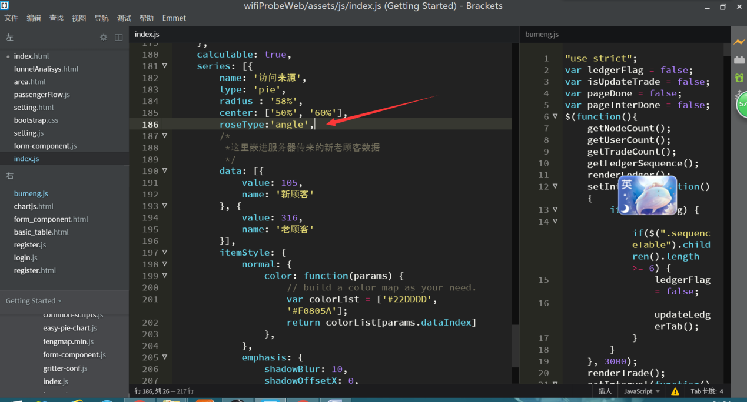

饼图变成南丁格尔图

# 2.

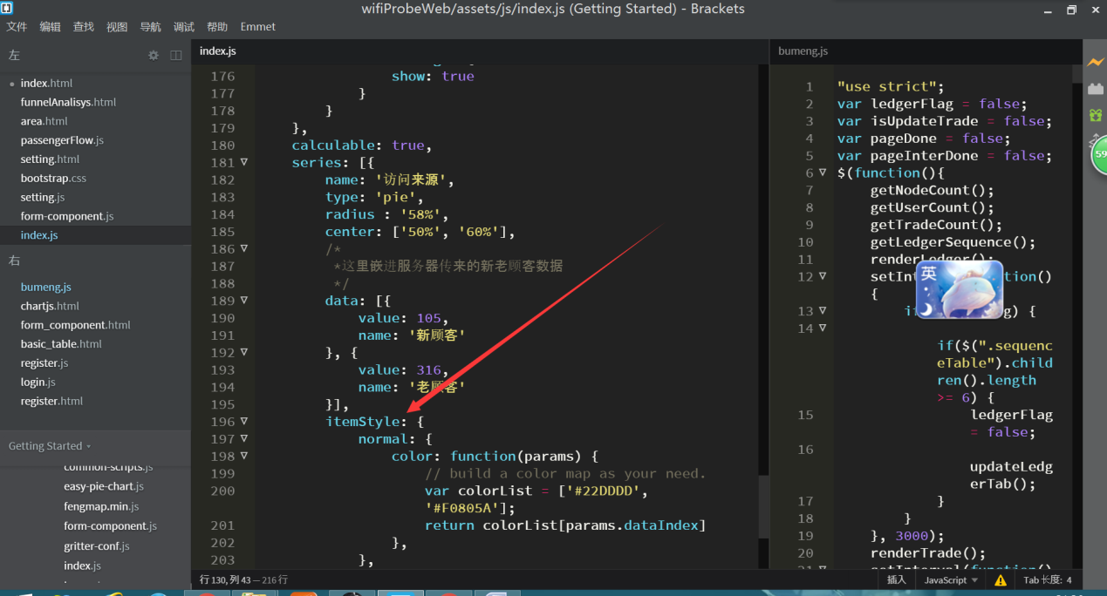

设置阴影

itemStyle: {

normal: {

// 阴影的大小

shadowBlur: 200,

// 阴影水平方向上的偏移

shadowOffsetX: 0,

// 阴影垂直方向上的偏移

shadowOffsetY: 0,

// 阴影颜色

shadowColor: 'rgba(0, 0, 0, 0.5)'

}

}

option = {

title : {

text: '南丁格尔玫瑰图',

subtext: '纯属虚构',

x:'center'

},

tooltip : {

trigger: 'item',

formatter: "{a} <br/>{b} : {c} ({d}%)"

},

legend: {

x : 'center',

y : 'bottom',

data:['rose1','rose2','rose3','rose4','rose5','rose6','rose7','rose8']

},

toolbox: {

show : true,

feature : {

mark : {show: true},

dataView : {show: true, readOnly: false},

magicType : {

show: true,

type: ['pie', 'funnel']

},

restore : {show: true},

saveAsImage : {show: true}

}

},

calculable : true,

series : [

{

name:'半径模式',

type:'pie',

radius : [20, 110],

center : ['25%', '50%'],

roseType : 'radius',

label: {

normal: {

show: false

},

emphasis: {

show: true

}

},

lableLine: {

normal: {

show: false

},

emphasis: {

show: true

}

},

data:[

{value:10, name:'rose1'},

{value:5, name:'rose2'},

{value:15, name:'rose3'},

{value:25, name:'rose4'},

{value:20, name:'rose5'},

{value:35, name:'rose6'},

{value:30, name:'rose7'},

{value:40, name:'rose8'}

]

},

{

name:'面积模式',

type:'pie',

radius : [30, 110],

center : ['75%', '50%'],

roseType : 'area',

data:[

{value:10, name:'rose1'},

{value:5, name:'rose2'},

{value:15, name:'rose3'},

{value:25, name:'rose4'},

{value:20, name:'rose5'},

{value:35, name:'rose6'},

{value:30, name:'rose7'},

{value:40, name:'rose8'}

]

}

]

};

# 3.

切换数据的时候的代码

var ptnMap = {

title: {

text : '我的标题',

x: "center"

},

tooltip : {

trigger: 'item',

textStyle: {

align:'left'

}

},

toolbox: {

show: true,

orient : 'vertical',

x: 'right',

y: 'top',

feature : {

saveAsImage : {show: true}

}

},

dataRange: {

min: 0,

max: 100,

x: 'left',

y: 'bottom',

splitNumber:3,

color: ['#27922f','#f19138','#d24544'],

formatter : function(v, v2){

//console.log("v:"+v + " v2:"+v2);

if (v2 < 35) { return '差'} //value 100

if (v2 > 35&&v2<70) { return '良'} //value 100

if (v2 > 70) { return '优'} //value 100

}

},

series : [

{

name: '测试',

type: 'map',

mapType: '内蒙古',

itemStyle:{

normal:{

label:{show:true},

borderColor:'#009dcd',

borderWidth:1,

areaStyle:{

color: '#ececec'

}

},

emphasis:{label:{show:true},color:'rgba(255,255,255,0.3)'}

},

tooltip:{

show: false

},

data:[

],

markLine: {

smooth:true,

effect : {

show: true,

scaleSize: 2,

period: 30,

color: '#fff',

shadowBlur: 3

},

itemStyle : {

normal: {

label:{show:false,textStyle:{color: '#c9c9c9'}},

borderWidth:1.2,

lineStyle: {

type: 'solid',

shadowBlur: 10

}

}

}

},

geoCoord: res_nei_meng_gu_GEO

}

]

};

var res_ptnMap_forward = $.extend(true, {}, ptnMap);

res_ptnMap_forward.series[0].markLine.data = (function(){

var d = [];

var myId =101; //用于唯一标志

for(var k in res_nei_meng_gu_GEO){

var m = [];

var x = {name:"呼和浩特市"}; //起点

var y ={}; //终点

var tip ='中心' +' > '+ k+

'<br>A1：'+(Math.random()*100).toFixed(2)+"ms"+

'<br>A2：'+(Math.random()*100).toFixed(2)+"%"+

'<br>A3：'+(Math.random()*100).toFixed(2)+"ms";

y = {

name: k,

value: (Math.random()*100).toFixed(2),

tooltip: {

name: '中心'+' > '+ k,

trigger:'item',

myId: 101,

formatter: tip,

show: true

}

};

m.push(x);

m.push(y);

d.push(m);

myId++;

}

//console.log(d); //用于查看该数据格式

return d;

})();

res_ptnMap_forward.title.text= "概况";