To: The Federal Government

From: Group 6 - Scott Huang, Lauren Monk, Katie Shen, Natasha Stallings

Date: November 19, 2021

Subject: Simulation of Gas Tax Policy Changes

**Executive Summary**

Federal revenue for the Highway Trust Fund has been steadily declining due to its dependence on fuel taxation and declining average fuel consumption / vehicle. Policies for increasing the gas tax or indexing the tax to the inflation rate have been suggested as possible solutions to increase federal revenue. This policy brief focuses on two policies: conducting gas taxation based on inflation rate and conducting gas taxation at a new increased rate of 19.4 cents per gallon over the current reference mode of 18.4 cents per gallon. It will present a model that demonstrates the evolution of the light-duty vehicle fleet and the changes in revenue resulting from the different policy implementations. Additionally, the brief will present findings from literature research, provide a causal loop diagram created using systems thinking, and suggest recommendations for ways to solve the gas taxation problem.

**Introduction**

The Congressional Budget Office(CBO) defines the Highway Trust Fund as a tool used for tracking federal spending and revenue for surface transportation (Tax Policy Center, 2021). The Highway Trust Fund consists of two separate accounts: the Highway Account and the Mass Transit Account. The majority of the public spending, around three-quarters, for both of these programs occurs primarily through the state and local governments, while the remaining quarter is financed by the federal government (Tax Policy Center, 2021). Federal revenue for the Highway Trust Fund is generated through transportation-related taxes, such as fuel taxation. In fact, the Congressional Budget Office revealed that 82% of the Highway Trust Fund’s budget came from this “gas tax” (Peter G. Peterson Foundation, 2020). However, the federal revenue received from these taxes have begun declining in recent years because fuel tax rates have remained fixed at 18.4 cents per gallon for gasoline and 24.4 cents per gallon for diesel fuel since the Clinton administration in 1993 (Peter G. Peterson Foundation, 2020). This federal gas tax has not been adjusted for inflation, and so revenue has been steadily declining, causing many policy makers to suggest solutions like increasing the gas tax. Concurently, improvements in fuel efficiency have led to drivers using less fuel/mile, which in turn has led to them paying less in fuel taxes. By implementing two policies, adjusting the gas tax based on the inflation rate and increasing the gas tax itself, the Highway Trust Fund’s revenue would see an increase over time. Not only would these changes affect the gasoline and diesel markets, but they would also affect the status of cars and revenue gains through taxations.

Based on the study from Robbis Orvis at Energy Innovation, the U.S. Chamber of Commerce’s proposal to raise the United States federal fuel user fee (also known as the gas tax) to $0.25 per gallon has caused a lot of debate over how U.S. transportation will be funded in the future (Orvis, 2018). Based on his analysis, there would be $840 million dollars in revenue and $1.5 billion dollars worth of additional electric vehicles generated by increasing the gas tax (Orvis, 2018). Meanwhile, the increasing gas tax would also reduce the total fuel consumption by more than 1.3 billion barrels (Orvis, 2018).

**Policy Statements**

*Policy 1*

As previously stated, the gas tax of 18.4 cents per gallon for gasoline has not been adjusted for inflation for 28 years. If lawmakers were to adjust the gas tax for inflation,it would increase the current rates to 33 cents per gallon of gasoline and 44 cents per gallon of diesel fuel (Peter G. Peterson Foundation, 2020).According to the CBO, increasing those taxes by 35 cents per gallon in October 2022 and adjusting them for inflation thereafter would raise $627 billion. That large of an increase would eliminate the majority if not all of the fund’s shortfalls and also provide $432 billion for additional expenses and spending by 2031 (Kile, 2021). However, increasing the gas tax to anywhere between 33 to 35 cents would reduce business and household income, resulting in the decrease in income and payroll tax receipts which would cancel out the increase in fuel tax receipts (Kile, 2021). Increasing the gas tax would result in an increase in gas revenue which would ultimately increase the budget on developing electric vehicles and car efficiency. The reinforcing loop of R3 in Figure 1shows increasing the gas tax would result in a side effect that impacts business and individual taxable income, which would decrease the reputation of the policy.

*Policy 2*

The Congressional Research Service (CRS) states that simply increasing the gas tax by one cent would provide the trust fund with between $1.7 and $1.8 billion dollars per year (Peter G. Peterson Foundation, 2020). However, increasing the gas tax is not a guaranteed long-term solution due to the rise of electric vehicles and overall fuel efficiency. Ultimately, the demand and amount of total fuel consumed will be reduced (Peter G. Peterson Foundation, 2020). Moreover, the reinforcing loop of R2 in Figure 1 shows that there may be a side effect that could be significant for the development of further technological and substitutional models. The gas revenue could still be reduced since technological developments will lead to more efficient cars overall, which will then lead to a decreasing trend in gas consumption.

**Modeling and Analysis**



*Figure 2. Reference mode on modelling the tax revenue, the gas consumption, and car consumption in different age groups powered by Vensim.*

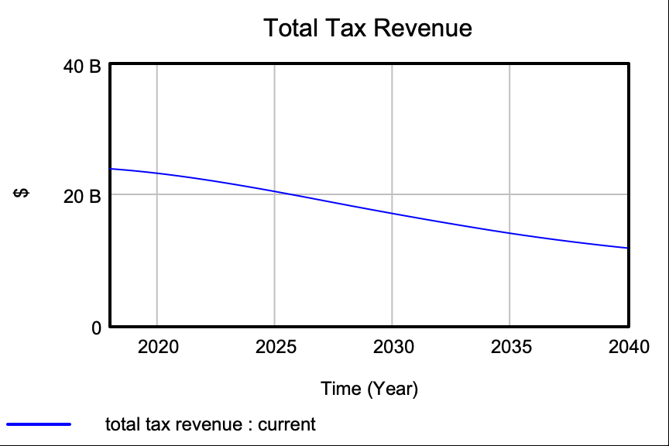

*Figure 3. Total Tax Revenue from 2018 to 2040 in reference mode.*

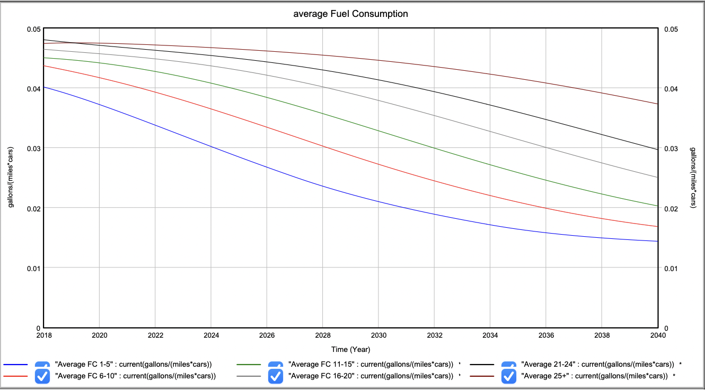

*Figure 4. Reference Mode of Average Fuel Consumption.*

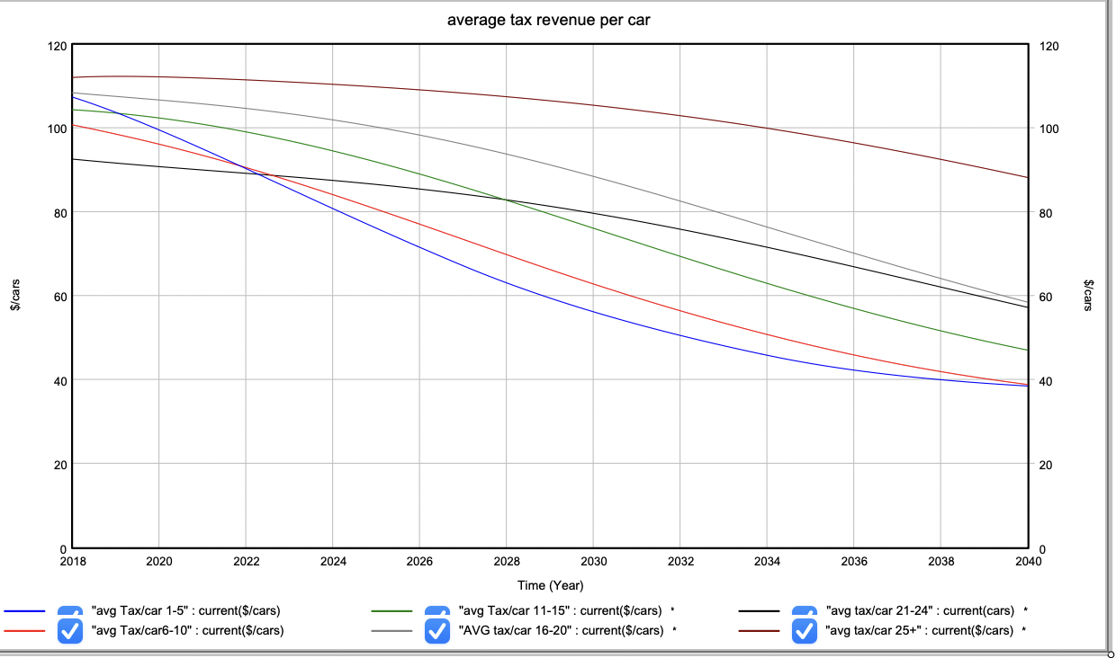

*Figure 5. Reference Mode of Average Tax Revenue per Car.*

Since different alternatives create different effects on gas consumption, car consumption, and total tax revenue, this reference model creates coflow between those three factors. Based on the data from NHTSA’s Vehicle Survivability and Travel Mileage Schedules, this model is set up with different age groups (NHTSA’s National Center for Statistics and Analysis, 2006). Two flows of gas consumption and car consumption in different age groups are connected between the variable called “Average FC,” which refers to the average fuel consumption of gallons in those groups. The total tax revenue is calculated based on the gasoline consumption multiplied by the tax rate. The tax rate in this model is equal to 18.4 cents/gallon, and the entire simulation runs from 2018 to 2040.

**Policy 1 Simulation**

Policy 1 focuses on conducting tax based on inflation rate, and it is conducting tax rate differently based on normal motor gasoline and diesel consumption. Based on the U.S. Information Administration’s data, in 2020, motor gasoline, which is the most consumed gasoline in the United States, comprised 44% of the US petroleum consumption. In contrast, diesel fuel consumption comprised 21% of the US petroleum consumption (U.S Energy Information Administration, 2021). By taking the weighted average, Policy 1 will conduct a gas rate using equation 1:

**(1)**

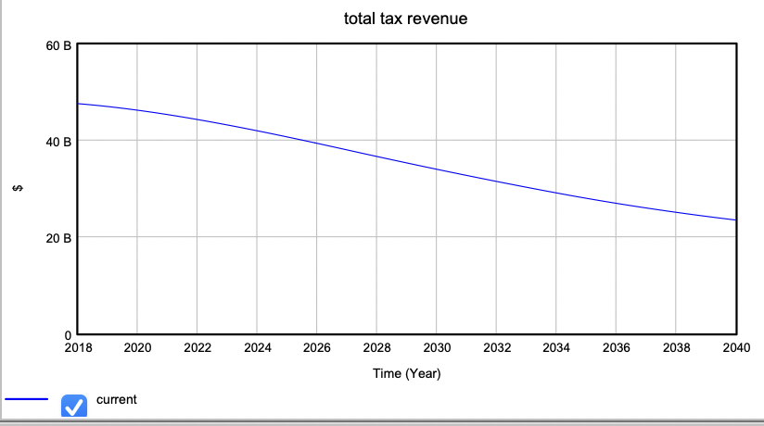

*Figure 6. Total Tax Revenue through 2018-2040 in Policy 1.*

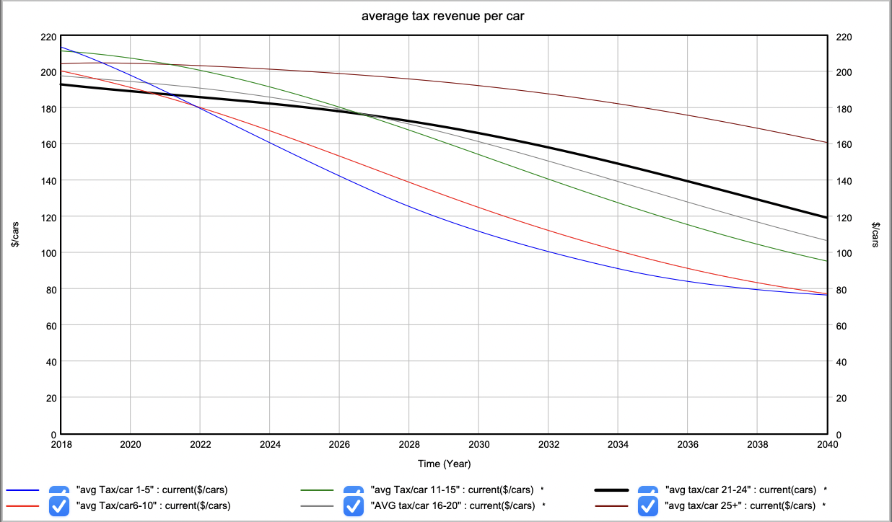

*Figure 7. Average tax revenue per car through 2018-2040 in Policy 1.*

Based on the simulation result in Figure 6, we saw that the tax revenue would start with around $50 billion dollars in 2018 and decrease at an ascending rate through 2040. The final value for total tax revenue on gasoline in 2040 is around $23 billion dollars. Meanwhile, the tax revenue per car in age groups 1-5 is the biggest in contrast to other groups. It is different from the result of reference mode. However, the increasing tax rate based on inflation also creates a deeper reducing trend in the tax revenue generated per car.

**Policy 2 Simulation**

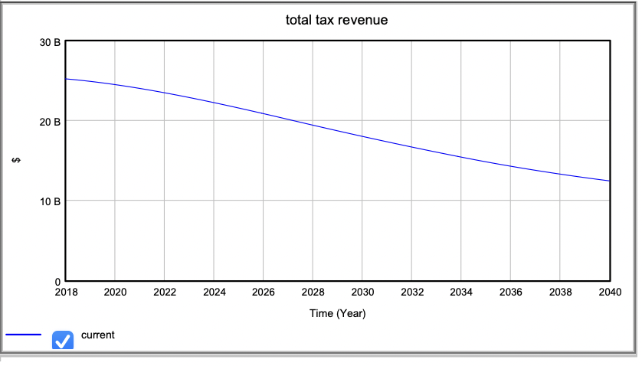

*Figure 8. Total Tax Revenue for different age groups from 2018-2040 in Policy 2.*

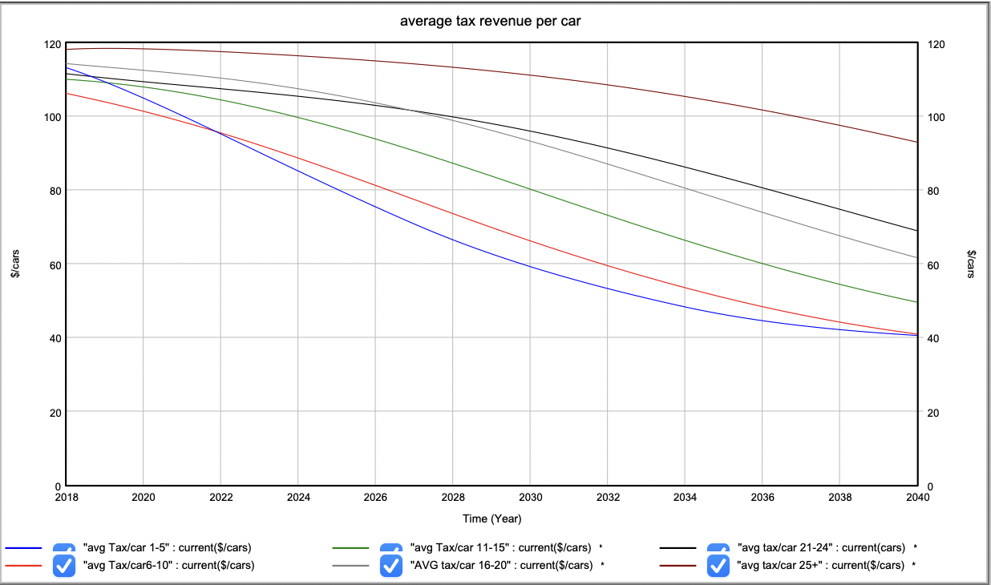

*Figure 9. Average tax revenue per car for different age groups from 2018-2040 in Policy 2.*

In Policy 2, tax on gas is conducted at a new increasing rate at 19.4 cents per gallon in contrast to the reference mode 18.4 cents per gallon. This creates a small amount of the total tax revenue in the future based on figure 8. The average tax amount generated per car is less than the result from Policy 1. However, unlike the first policy, the reducing trend of tax revenue generated by cars is not as steep.

**Conclusions and Recommendations**

Based on the above information, we can see that Policy 1 produces a gas tax of 33 cents per gallon and Policy 2 produces a gas tax of 19.4 cents per gallon. Policy 1 allows for a much higher revenue but comes with drawbacks like income reduction, which harms both individuals and businesses. Policy 2 allows for a smaller increase in revenue that would be steadier, though not guaranteed. As technology continues to develop, overall revenue will eventually decrease. The policy simulations also show that Policy 1 has a steeper reducing tax revenue trend, while Policy 2 has a less steep trend.

Overall, a combination of these two policies is the best strategy. Policy 1 creates a significant revenue increase, which is beneficial because this revenue increase creates opportunities for more advanced electric vehicles and greater efficiency. Policy 2 creates a consistent revenue of approximately $1.7 to $1.8 billion dollars per year but due to the rise of electric vehicles, this is not a guaranteed solution for the long run. Therefore implementing a combination of both policies would be most effective.

**References**

Kile, J. (2021). *Testimony on Addressing the Long-Term Solvency of the Highway Trust Fund.*   
 Congressional Budget Office. Retrieved November 19, 2021, from

https://www.cbo.gov/publication/57138.

NHTSA’s National Center for Statistics and Analysis. (2006, January). *Dot HS 809 952 January   
 2006*. Retrieved November 19, 2021, from   
 https://crashstats.nhtsa.dot.gov/Api/Public/Publication/809952.

Orvis, R. (2018, February). *Effects of a $0.25 federal gas tax increase on U.S*. Retrieved   
 November 19, 2021, from https://energyinnovation.org/wp-content/uploads/2018/02/US-Gas-Tax-Research-Note_FINAL.pdf.

Peter G. Peterson Foundation. (2020, August). *The Highway Trust Fund Explained*. Retrieved   
 November 19, 2021, from   
 www.pgpf.org/budget-basics/budget-explainer-highway-trust-fund.

Tax Policy Center. (2021). *Tax Policy Center Briefing Book: Key Elements of the U.S. Tax   
 System. What is the Highway Trust Fund, and how is it financed?* Retrieved November   
 19, 2021, from https://www.taxpolicycenter.org/briefing-book/what-highway-trust-fund-and-how-it-financed.

U.S. Energy Information Administration - EIA - independent statistics and analysis. *U.S.   
 petroleum consumption decreased to a 25-year low in 2020 - Today in Energy - U.S.   
 Energy Information Administration (EIA)*. (2021, August). Retrieved November 19,   
 2021, from https://www.eia.gov/todayinenergy/detail.php?id=49016.