## **Create a free Google Cloud (**[**https://cloud.google.com**](https://cloud.google.com) **) account with $300 free credit**

## **Create a new project**

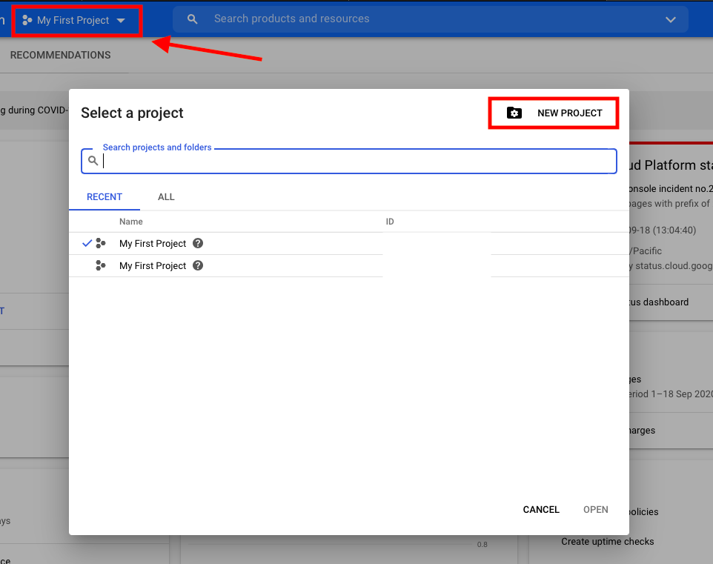

## **Launch an instance**

* Go to …

Compute Engine >> VM instances >> create an instance

Add name, select zone and choose your machine type. Do not forget to allow HTTP and HTTPS traffic and edit details as shown in the following screenshots.

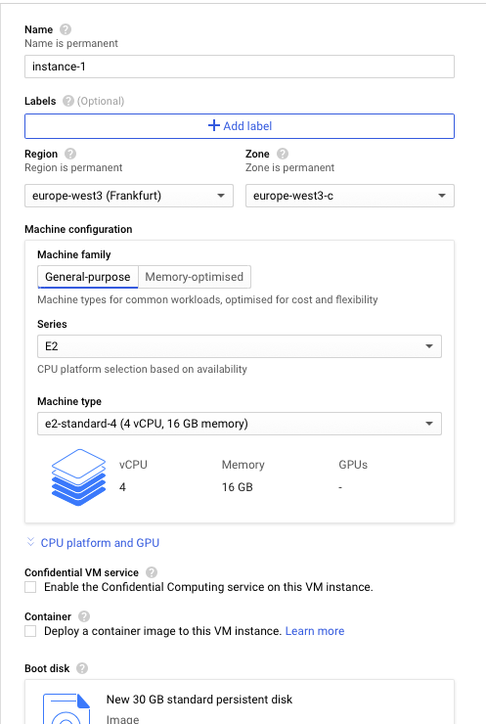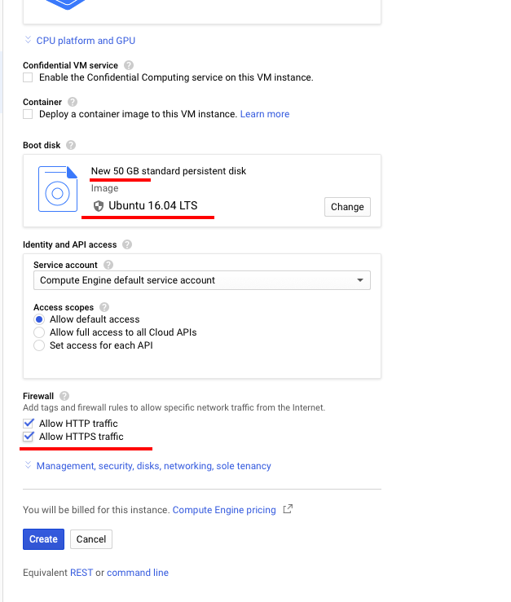

## **Change the Firewall setting**

Before starting the server, you need to change the firewall setting by going to the Firewall page and click on “Create firewall”. Add name, set the port number –this can be any number but in this example, I will be using port 1234–, set “Source IP ranges” to 0.0.0.0/0 and edit details as seen in the following screenshots.

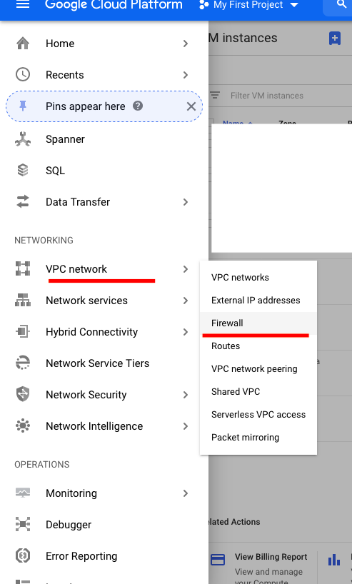

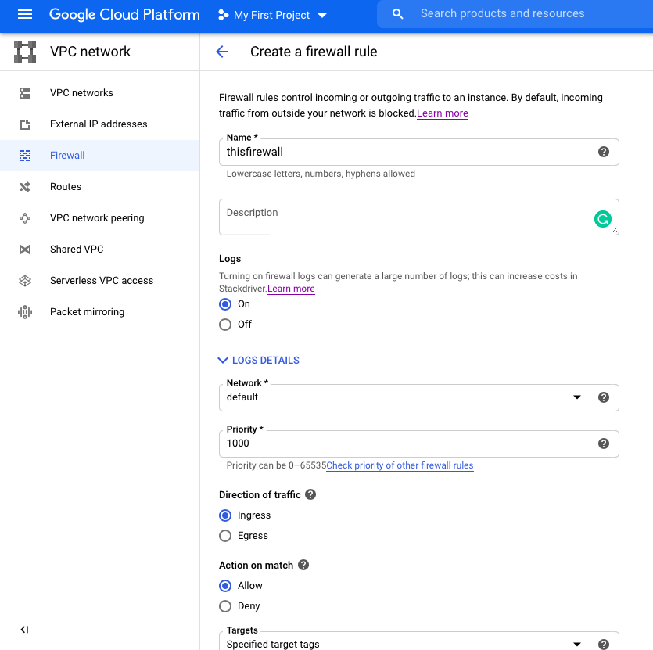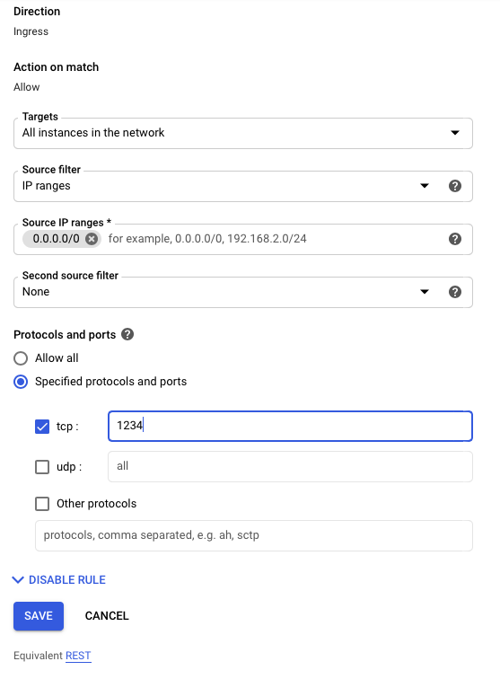

## **Start an instance**

Go back to the VM instances page. To start the instance, click SSH. This should navigate you to an SSH terminal. Note that the external IP address will be used later to access the Jupyter notebook. 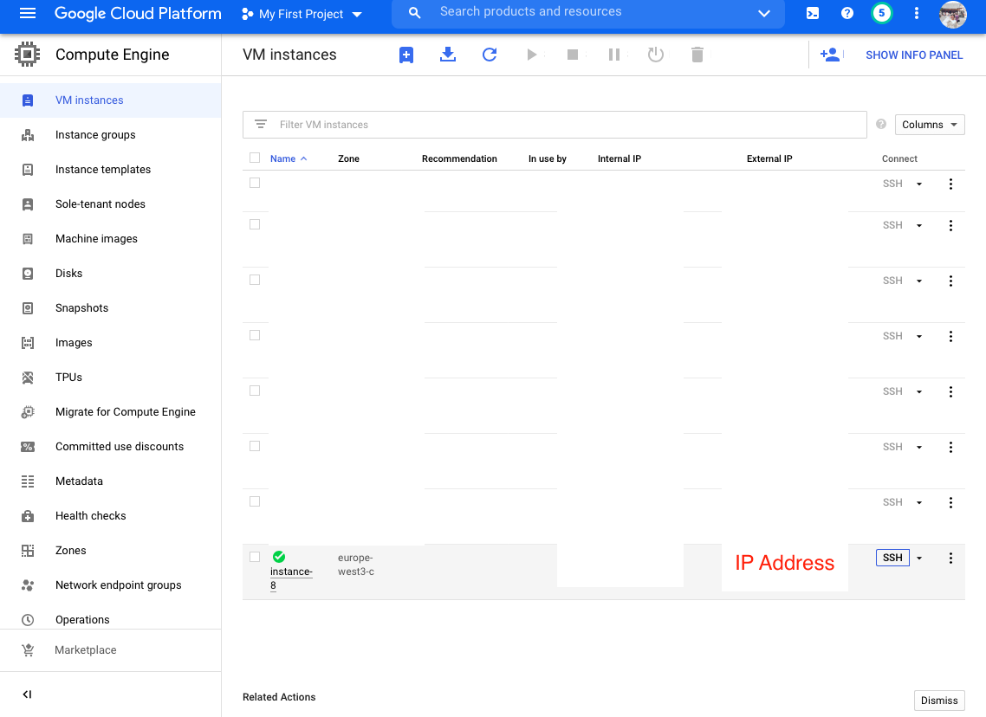

## **In your SSH terminal, enter the codes (without “$”) as followed to prepare the environment and launch a Jupyter notebook.**

### **To install Anaconda**

$ wget https://repo.continuum.io/archive/Anaconda3-4.2.0-Linux-x86_64.sh

$ bash Anaconda3-4.2.0-Linux-x86_64.sh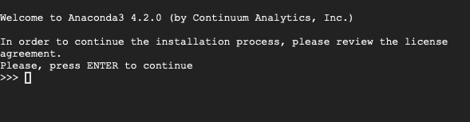

## Press Enter.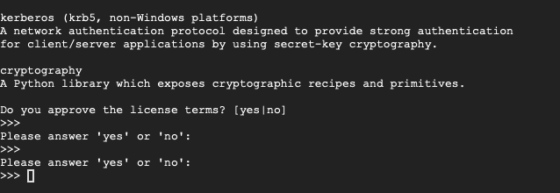

## Enter “yes”.

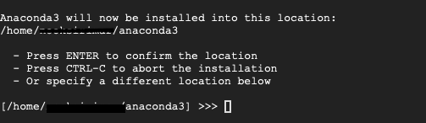

## Press Enter.

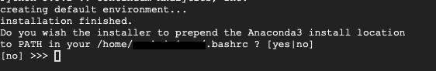

## Enter “yes”.

$ source ~/.bashrc

### **To install python3.6 and tensorflow2 (these steps can take a few minutes)**

$ conda update conda

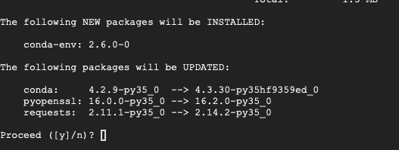

##Enter “y”.

$ conda install python=3.6

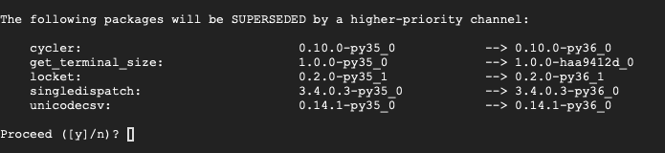

##Enter “y”.

### **To create ImaGene environment**

$ conda create -n ImaGene python=3.6 tensorflow=2 keras numpy scipy scikit-image scikit-learn matplotlib pydot pymc3 ipython jupyter

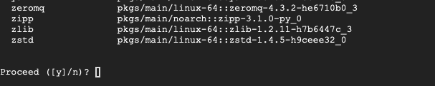

##Enter “y”.

### **To install Java**

$ sudo apt-get update && sudo apt-get upgrade

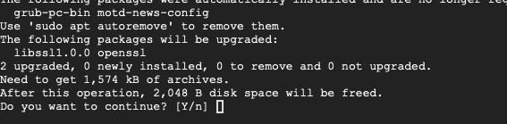

##Enter “y”.

$ sudo apt-get install default-jdk

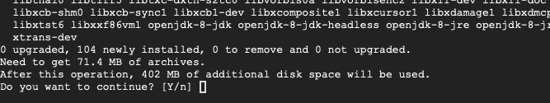

##Enter “y”.

### **To download MSMS files and unzip the files**

$ git clone <https://github.com/mfumagalli/ImaGene>

$ wget https://www.mabs.at/ewing/msms/msms3.2rc-b163.zip

$ sudo apt-get install unzip

$ unzip msms3.2rc-b163.zip

### **To install a bc package for creating simulations**

$ sudo apt install bc

### **To activate ImaGene environment**

$ source activate ImaGene

### **To generate a config file and launch a Jupyter notebook**

$ jupyter notebook --generate-config

$ jupyter notebook --ip=0.0.0.0 --port=1234 --no-browser &

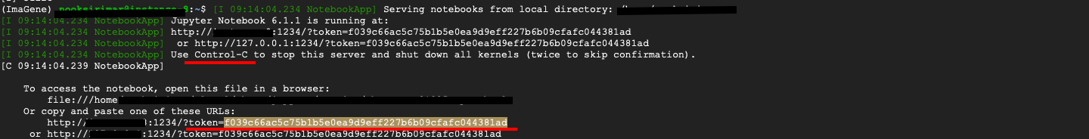

You can access the notebook by clicking on one of the three links as seen in the screenshot. An alternative way of accessing the notebook is to type in the URL search box …

http:// (external IP Address of the instance):Port number

You may be asked for a token to log in to the notebook. The token is highlighted in the previous screenshot. This will navigate you to the Jupyter welcoming page. The ImaGene folder should already be there. You can access and run the codes using the Jupyter interface. All data will be saved to the server.

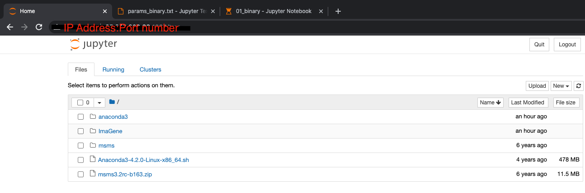

## **Stop the instance**

Do not forget to stop the server when you are done to avoid any extra charge. 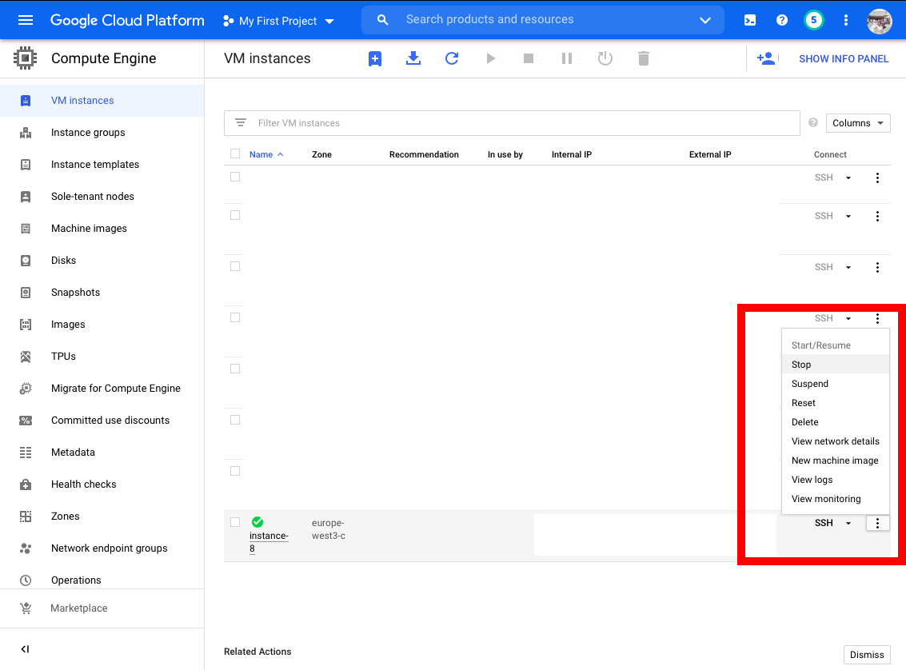

## **Restart the instance**

To restart the server and re-access the notebook, you just have to re-activate the ImaGene environment and re-launch a Jupyter notebook by entering …

$ source activate ImaGene

$ jupyter notebook --ip=0.0.0.0 --port=1234 --no-browser &