電通二甲微處理器實驗 實驗結報

實驗名稱 | Lab02走馬燈
組別 |  | 組員 | 李桓瑋

- 實驗目的
LinkIt7697 D1 –D8 分別接到LED，實作跑馬燈展示。
- 實驗步驟
1.LED 向左及向右執行花色展示
2.執行自定花色展示:
3.所有LED亮滅兩次-> 左移八次->所有LED亮滅兩次->右移八次
- 程式碼
01
const byte leds[]={4,5,6,7,9,10,11,12};
const byte NUM=sizeof(leds);
int i;
void setup()
{
for(int i=0;i<NUM;i++)
{
pinMode(leds[i],OUTPUT);

}
}

void loop()
{
for(i=0;i<NUM;i++)
{
digitalWrite(leds[i],HIGH);
delay(500);
digitalWrite(leds[i],LOW);
}
for(i=NUM-1;i>=0;i--)
{
digitalWrite(leds[i],HIGH);
delay(500);
digitalWrite(leds[i],LOW);
}
}
02
const byte leds[]={4,5,6,7,9,10,11,12};
const byte NUM=sizeof(leds);
int i;
int count;
void setup()
{
for(int i=0;i<NUM;i++)
{
pinMode(leds[i],OUTPUT);

}

}

void loop()
{
for(i=0;i<2;i++)
{
digitalWrite(4,HIGH);
digitalWrite(5,HIGH);
digitalWrite(6,HIGH);
digitalWrite(7,HIGH);
digitalWrite(9,HIGH);
digitalWrite(10,HIGH);
digitalWrite(11,HIGH);
digitalWrite(12,HIGH);
delay(400);
digitalWrite(4,LOW);
digitalWrite(5,LOW);
digitalWrite(6,LOW);
digitalWrite(7,LOW);
digitalWrite(9,LOW);
digitalWrite(10,LOW);
digitalWrite(11,LOW);
digitalWrite(12,LOW);
delay(400);
}
for(count=0;count<8;count++)
{
for(i=0;i<NUM;i++)
{
digitalWrite(leds[i],HIGH);
delay(100);
digitalWrite(leds[i],LOW);
}
}
for(i=0;i<2;i++)
{
digitalWrite(4,HIGH);
digitalWrite(5,HIGH);
digitalWrite(6,HIGH);
digitalWrite(7,HIGH);
digitalWrite(9,HIGH);
digitalWrite(10,HIGH);
digitalWrite(11,HIGH);
digitalWrite(12,HIGH);
delay(400);
digitalWrite(4,LOW);
digitalWrite(5,LOW);
digitalWrite(6,LOW);
digitalWrite(7,LOW);
digitalWrite(9,LOW);
digitalWrite(10,LOW);
digitalWrite(11,LOW);
digitalWrite(12,LOW);
delay(400);
}
for(count=0;count<8;count++)
{
for(i=NUM-1;i>=0;i--)
{
digitalWrite(leds[i],HIGH);
delay(100);
digitalWrite(leds[i],LOW);
}
}
}
03
const byte leds[]={4,5,6,7,9,10,11,12};
const byte NUM=sizeof(leds);
int i;
int count;
int t;
void setup()
{
for(int i=0;i<NUM;i++)
{
pinMode(leds[i],OUTPUT);

}
pinMode(2,INPUT);
}

void loop()
{
t = digitalRead(2);
if( t== HIGH)
{
for(i=0;i<NUM;i++)
{
digitalWrite(leds[i],HIGH);
delay(100);
digitalWrite(leds[i],LOW);
}
for(i=NUM-1;i>=0;i--)
{
digitalWrite(leds[i],HIGH);
delay(100);
digitalWrite(leds[i],LOW);
}

}
else
{
for(i=0;i<2;i++)
{
digitalWrite(4,HIGH);
digitalWrite(5,HIGH);
digitalWrite(6,HIGH);
digitalWrite(7,HIGH);
digitalWrite(9,HIGH); digitalWrite(10,HIGH);
digitalWrite(11,HIGH);
digitalWrite(12,HIGH);
delay(400);
digitalWrite(4,LOW);
digitalWrite(5,LOW);
digitalWrite(6,LOW);
digitalWrite(7,LOW);
digitalWrite(9,LOW);
digitalWrite(10,LOW);
digitalWrite(11,LOW);
digitalWrite(12,LOW);
delay(400);
}
}
}
- 實驗結果及分析
LED能透過ARDUINO7697完成控制跑馬燈走位

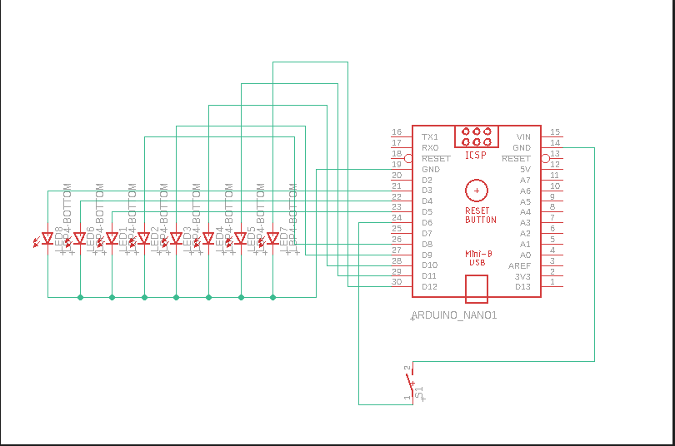

- 心得討論
CODE變得有點長了，開始要細心地去檢查與編碼，不難但是邏輯要清楚。

- 電路圖

- 修正程式碼

