2022-11-13

Huanwei Xu 14090118

**Google stock price exploration**

STDS |Autumn 2022 | AT3

Table of Contents

Introduction 2

Background 2

Rationale 2

Aims 2

Methods 3

GARCH 3

Demonstrate the GARCH formula 3

DATA 4

ESTIMATION OF THE GARCH MODEL 5

RESULTS 6

Can uncertainty be measured? 6

Testing for ARCH effects 6

Choose an optimal model 7

How does the uncertainty affect the stock price if the uncertainty can be measured? 9

DISCUSSION 11

How does the uncertainty support the investment strategy? 11

LIMITATION 13

CONCLUSION 13

REFERENCE 14

Marcelo Scherer Perlin, Mauro Mastella, Daniel Francisco Vancin, Henrique Ramos. (2021). A GARCH Tutorial with R. https://www.redalyc.org/journal/840/84064925005/html/ 14

Alexios Galanos, Tobias Kley. (2022). rugarch: Univariate GARCH Models. https://cran.r-project.org/web/packages/rugarch/index.html 14

# Introduction

## Background

In the previous project (AT2), our group focus on stock price analysis on Santo, an oil company in Australia, and bring the prediction of the stock price movement/direction to provide transaction strategies by given business requirements.

The providing model of AT2 recap:

* Logistic Regression. A model to predict the stock price movement direction, predictors with Santo’s previous day price, holiday factor (Yes or No), Monday factor (Yes or No) and Qantas’s previous day price. With 75% accuracy and other major measurements above 70% (e.g., recall, F1, etc).
* ARIMA. A times series model, analysis focus on the auto-regression and moving average of Santo’s stock price itself.

## Rationale

The previous 2 methods can only provide a short-term prediction, hence there is a limitation for cover mid-term and long-term business support.

Furthermore, although we can try to provide a relatively reliable advisement for a short-term investment, uncertainty is a threat that will potentially bring huge risks throughout the investment process.

## Aims

To dive deeper into the stock market analysis, 3 questions will be answered:

* Can uncertainty be measured?
* How does the uncertainty affect the stock price if the uncertainty can be measured?
* How does the detection of uncertainty support the investment strategy? (extension)

# Methods

To better understand the effects of the uncertainty, we introduce GARCH model to try to

figure out those questions. GARCH is a model to capture the uncertainty/risk factor of the return of the stock price, volatility, from historical, and forecast the future volatility.

## GARCH

The volatility of the return of the stock price (volatility is the same as standard deviation), it’s the most important factor to determine the stock price movement and GARCH (generalized autoregressive conditional heteroscedasticity), is the most popular model used in the financial/econometrics field to analysis the volatility.

The key concepts of GARCH are:

* To obtain a long-term reversion of the variance (long-term mean of variance of the return of the stock price)
* To predict the future variance by the long-term reversion and the latest K-lag variance.

### Demonstrate the GARCH formula

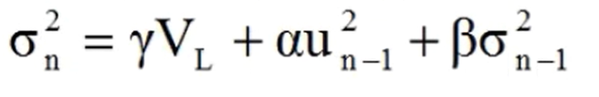

Figure 2. The formula of the standard GARCH model

Take a simple example, GARCH (1,1), to describe the formula.

: long-term reversion of the variance

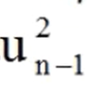: Square of the return of stock price the previous day

: variance of the return of stock price the previous day (Note: variance the of price return instead of the price itself)

γ: The extent of the long-term reversion of the variance

α: The extent of the return of stock price the previous day to affect future

β: The extent of the variance of the return of stock price the previous day to affect future

and γ+α+β = 1 or **Persistence** = 1- γ= α+β <1, which means if the higher persistence, the longer it will take to revert to the long-term mean.

Figure 3. Different GARCH models we might use during this project.

## DATA

Google stock price as being selected as the analysis object and the period is from 2004-08-20 to 2022-05-27.

Since the column which only worthy of consideration is the closing price or the adjusted closing price, we don’t expand any other and focus on the adjusted closing price only.

For some statistical properties, I chose Logarithm returns during this project.

Figure 4. The formula of logarithm return

Figure 5. Part A shows the stock price of Google from 2004-08 to 2022-05 and the nominal arithmetic total/annual return, adjusted total/annual return was presented in the caption respectively. Part B shows the nominal Logarithm returns from 2004-08 to 2022-05, and the red spots were the points which were the highest absolute values of the top 10 returns.

The stock price of Google is stably rising and has a rare negative effect even during the Covid period.

The highest log return happened on 2008-04-18 which is 0.182 while the lowest one happened on 2008-09-29 which is -0.123. The latest anomaly happened on 2020-03-16 which is -0.118

## ESTIMATION OF THE GARCH MODEL

Conventionally, 2 measurements were used to estimate the goodness of a GARCH model, which are AIC and BIC respectively (other alternatives are fine but we only focus on these 2 measurements in this case), and the better of the model which with lower AIC or BIC.

The concept of both AIC and BIC are trying to balance the model explanation and penalty of the extra Lag(s).

Figure 6. The formula of AIC and BIC.

# RESULTS

## Can uncertainty be measured?

### Testing for ARCH effects

Before we jump into modelling, we need to make sure the ARCH effects exist in the dataset.

Figure 7. The result of the Lagrange Multiplier (LM) test for ARCH effects within the lag of 5 days.

The p-values show there statistically significant with the Null hypothesis ARCH effects is zero and we rejected the Null hypothesis. Therefore, the dataset could be used to model with GARCH.

### Choose an optimal model

To find out the best model, we have to complete the setting of the argument.

Figure 8. The argument setting. Notice the “dist_to_use” variable, I try to fit the data as a student/T distribution since the return of the stock is skewed in the real world.

Figure 9. The list of performances of the various models. The blue star shows the best one.

Figure 10. The best model is ARMA(0,0), eGARCH(1,1) with student distribution which has both the lowest AIC and BIC.

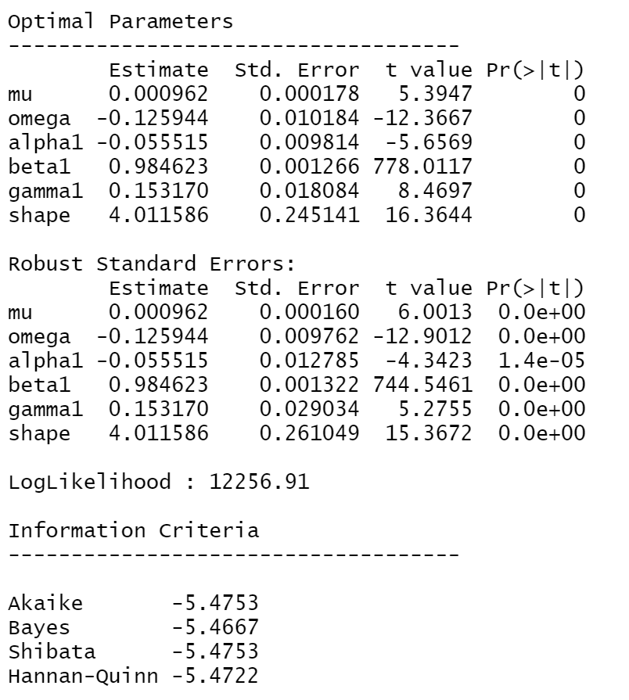

Figure 11. The summary of the best model

After we got the best model, we can answer question 1 as described in the parameters.

* Mu. The value of the intercept, mu, is positive. This implies Google is likely to have a positive return and increase its value in the long run.
* Alpha and beta. The sum of alpha and beta is 0.93 in this case, which means the current value of Google is far away from the mean of long-term return, and since the sum of alpha and beta is relatively high, it will take a long time to revert to the long-term mean.
* Gamma and shape. The coefficient gamma is positive, which means the volatility has different reactions to bad news and good news. The volatility increases strongly when bad news hit the market. On the other hand, the shape is relatively high, which is 4, which means the distribution of the return is right skew and therefore Google is more likely to gain.

## How does the uncertainty affect the stock price if the uncertainty can be measured?

Figure 12. The red lines are the rolling prediction of the volatility while the blue lines are the real return of the stock price.

As figure 12 shows, the fluctuation of return was almost totally affected by the rolling prediction of the volatility, if the volatility fluctuation. The predictions have well present on the historical return.

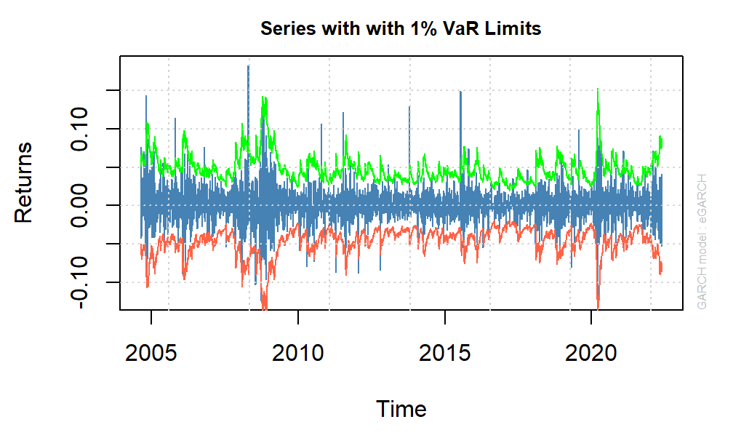

Figure 13.

We focus figure 13 on the red line and blue lines. The red lines mean that given some conditions (It’s volatility in this case) in the given time frame, there 99% would not exceed the amounts of loss (Value in Risk, VaR, a way to quantify the risk of potential losses for a firm or an investment). The losses were well covered by the red line, in other words, the 99% confidence interval of VaR had well covered the expected losses.

# DISCUSSION

## How does the uncertainty support the investment strategy?

Since we have the optimal GARCH model, we can use that to simulate the future values of the return and the possible path of Google stock movement.

Figure 14. Setting of simulation

Figure 15. The path of simulation.

Figure 16. The probability of Google reaching its historical peak as time varies.

Simulation is a way to connect the prediction and the investment strategy. These potential strategies:

* Long a call option and hold a certain period (given a date when the highest probability is to reach the historical peak or the revenue is satisfied), exercise that after the target is reached. The highest loss of this strategy is the option fee.
* Selected Strangle strategy as a period that has relatively high volatility. That means the investment strategy is that long the volatility (long a call option and put option at the same time), gains no matter the price rise or fall since the volatility is high in this period, whereas it will lose if the price is stable.

## LIMITATION

The limitation of simulation by GARCH is that things always change, especially using the past to predict the unseen future. Even though the history phenomenon seems will repeat, it’s hard to tell that will repeat for the same reasons and as well as cycle-wise.

# CONCLUSION

As I mention the limitation previously, the GARCH model has its limitation, and no model can capture the market perfectly, the reason is the market is integrated by every investor in the world, and the hardest thing is to predict human behaviour. Even so, it always helps if we can learn from the previous lessons through the statistics model.

# REFERENCE

# Marcelo Scherer Perlin, Mauro Mastella, Daniel Francisco Vancin, Henrique Ramos. (2021). A GARCH Tutorial with R. <https://www.redalyc.org/journal/840/84064925005/html/>

## Alexios Galanos, Tobias Kley. (2022). rugarch: Univariate GARCH Models. <https://cran.r-project.org/web/packages/rugarch/index.html>

Idriss Tsafack. (2021). GARCH models with R programming: a practical example with TESLA stock.

<https://www.idrisstsafack.com/post/garch-models-with-r-programming-a-practical-example-with-tesla-stock>

Eric Zivot. (2021). IntroCompFinR: Introduction to Computational Finance in R.

<https://bookdown.org/compfinezbook/introcompfinr/>

[Ralf Becker](https://www.youtube.com/c/RalfBecker). (2018). R GARCH.

<http://eclr.humanities.manchester.ac.uk/index.php/R_GARCH>