Question:

Using Java or Python develop these 3 applications:
1. Application to generate an RSA key pair, key size = 2048 bits (Standard Java library can be used to generate all keys and hashes).
2. Application to generate SHA-256 hash of the attached file. No signing is needed. Just print hash in HEX encoding to standard output.
3. Application that will encrypt and decrypt the file using the RSA key pair generated.
4. Send us public and private key, along with original and encrypted files so we can confirm the contents of the file is the same as the file encrypted.

Answers:
1st, compile all java file into classes so that we can run it in command line as long as we have JDK installed.

Preparation:
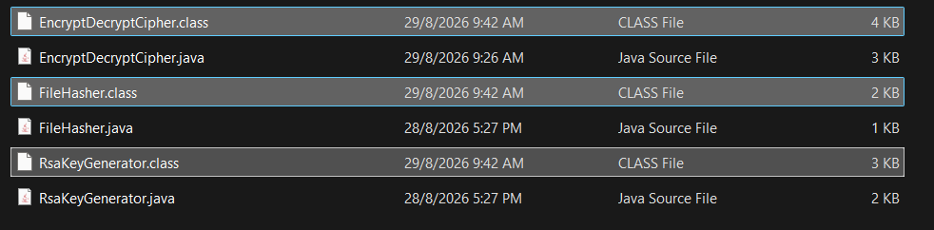

1. Generate Key Pair (Application 1)

2. SHA256 HASH of the image: fa1bed1a61ca81be4d6ecbfe3a75523213a5e399b9db9dd74cfd65303d9c3cc4

3.
Encrypt:
Decrypt:

