**Chapter 13**//IRR: expected cash flows. // Cost of capital: opportunity cost of capital. The rate of return investors could expect to receive by investing. Expected value. // smart decision, then expected rate of return is higher than cost of capital. // hurdle rate: the exp. rate of return above which management decides to accept and go forward with the project,=cost of capital. Good: hurdle rate = cost of capital = required expected rate of return. CAPM &PV: don’t use promised CF. exp. CF < promised. //CAPM: exp. rate of return=risk-free rate + equity premium*beta; -cost+payouts/exp.rate of return// independent projects should be considered based on their own costs of capital.//hedging: lower the mkt exposure and risk. Help create value in imperfect mkt. // if the capital mkt for the target is inefficient, the act of acquisition can create value. Unrelated firm and unrelated CC merge, then lower risk but not add value. //select the combination of projects that gives the highest overall NPV. Overall NPV=NPV proj1+NPV proj2 + NPV interactions(externality). Projects independent, then zero proj. interactions. Positive interactions(synergies协作) are why firms exist to begin with, cheaper and efficient. Internal conflict and cost allocation procedures often hinder corporations from taking advantages of many positive externalities. Positive interactions: competition, research, cut cost. Negative interactions: pollution and congestion, cannibalization, complexity, resource exhaustion. // marginal method: credit/charge to this project all externalities that this project conveys onto the existing firm. Solvability is its advantage. Marginal cost=new quantity*new average cost-old quantity*old average cost. // Sunk costs are the ooposite of marginal costs. It’s an incurred cost that cannot be altered or reversed thus should not enter into your current decisions. A sunk cost has no cost contribution on the margin, it should therefore be ignored. “overhead” is often a sunk cost. Allocating already existing overhead budget to a project(i.e. adding it to the new project’s cost) is a common real-world example of bad project valuation and decision making. Limited capacity is a subject that it closely related to overhead allocation. // A real option is the value of the flexibility to change course in the future. With the real option, you can shut down the factory if there is no demand. Uncertainty usually makes real options more valuable, like limited liability. // Scenario analysis: first determine all possible scenarios, then figure out your own behavior and the cash flow this earns in each scenario, and only finally compute expectations over all possible scenarios. // Overconfidence is the tendency of people to believe that their own assessments are more accurate than they really are.

**Notes**: firms cannot reduce risk through diversification b/c investors could do it themselves. // Loss/Gains=offer-true value. Merged CC=prob.1*exp.rate of return1+2. New prob. =offer/(total CF/1+merged CC)// In a perfect mkt, you should use the CC unique to each project and to each project components.

Ex: 60% ship not return; back, then expect to sell the spices for 30000 and the ship 10000; spices cost 1000 and ship costs 1000. Spice CC 25%, ship’s 5%. Answer: ship: -10000+(0.4*10000/1.05) and spices: -1000+(0.4*30000/1.25)

Public good: tragedy of the commons. Fix: someone owns it.

Corporation allocate overhead: good team left.

Not tell the truth: punishment after knowing the truth(contract). If I were the owner of real option, I love volatility. Other strategic options: the ability to leverage a product into future mkts; find product spinoffs; learn about future products; stop the project if conditions are bad; delay or mothball-restart the project if conditions are bad; accelerate the project if conditions are good; expand the project if conditions are good.

**Chpater12**: mkt efficiency: a situation in which prices reflect all available info. In a fully efficient mkt, you should not be able to use any available info to predict future returns better than the mkt can. Mkt uses all available info in setting the price. It is not necessary that any investor has all the info(as perfect mkt setting). Mkt efficient is a very powerful concept over short time intervals. Perfect mkt=efficient mkt. but efficient mkt not equal to perfect mkt. The most important perfect mkt assumption driving prices toward efficiency is the absence of transaction costs. Mkts are efficient for large corporate stocks. The advantage of EM: prices can be trusted. The tradition classification: Weak mkt efficiency: all info in past prices if reflected in today’s stock prices. technical analysis cannot be used to beat the mkt. Semistrong: all public info is reflected in today’s stock price, so that neither fundamental trading(such as CF or discount rates) nor technical analysis can be used to beat the mkt. Strong: all info, both puvlic and private, is reflected in today’s stock prices, so that nothing can be used to beat the mkt. Momentum strategy violate even weak form EM, unless you believe that their returns are just normal b/c they reflect some sort of normal compensation for risk; value strategy. Fundamental-based classification: A true believer: Price is always PV of the firm’s CF. financial prices always reflect the best NPV. Prices should change correctly if and only if news about fundamental appears. A firm believer: Price deviates from PV, but is not exploitable. financial prices may sometimes deviate from the appropriate best estimate of future CF. transaction costs make it practically impossible for investors to find unusually good bets. A mild believer: Price deviate from PV, exploiting is possible. financial prices may sometimes deviate from the appropriate best estimate of future CF. there are occasions when it is possible to exploit this misvaluation. A nonbeliever: strongly from PV, investors easily get rich. regularly deviate from the appropriate value. Fin mkt between mildly and firmly efficient. Signal-to-noise ratio: signal is the appropriate expected price change is small compare to the noise is the day-to-day price volatility that clouds our senses. This low ratio allows our arguments about mkt efficiency to continue. It is difficult to determine why a particular trading strategy has earned high returns. EM=RW, not vice versa. P1 = P0+m*P0 tiny drift+e noise. N-day T-stat=excess mean/standard deviation=N*E(r)/sqrt(N)*sdv(r)=sqrt(N)*1day Tstat. A true arbitrage is a business transaction that offers positive net cash inflows in at least some scenarios and under no circumstance-either today or in the future-has a negative net cash flow. This means that it is risk-free. It is not the same as “earning money without risk”. A risky arbitrage is a business transaction that may not be risk-free but that still offers an excessive expected rate of return given its(risk and other) characteristics. It is a great bet. It could possibly lose a little money. If arbitrage could not repeat, people might prefer risky arbitrage. Positive NPV projects under certainty are arbitrage. Don’t forget costs and risks. Transaction costs. Price change. EM: impossible arbitrage. Predict with past rates of return mostly appears to fail. Survivorship bias: you cannot consider the historical performance of existing funds to be a fair projection of their future performances. Create value for firm: perfect mkt? NO. imperfect? YES by reduce mkt imperfections. Inefficient? YES by you may be able to identify underpriced firms that you can take over, or even create value by working on how info about you rown company comes to the mkt. Undervalue: repurchase you own cheap, underpriced shares. High CC. Overvalue: issue more shares. Low CC. An event study is an empirical analysis of the effect of a set of events on the price of assets. In finance, they often tell us whether corporate actions are good news. Empirical evidence: fund manager’s luck>ability. Corporate consequences: learn from your own mkt value, competitors’ value, other values. Cannot add value by doing things investors can do, cannot make money by trying to time interest rates or gambling on commodities.

**Chapter11**: perfect mkt assumption: no differences in opinions, no transaction costs, no taxes, a large mkt w/ many competitive sellers and buyers(competitive mkt; monopoly power). CC: borrow money to finance your projects. Rate of return(RR): save money. Perfect mkt: CC=RR, not quoted, quoted is different from exp. Mkt is not perfect: the separation of ownership and value breaks down, so project value is no longer unique. Socially useful—need not worry about that one deal is better than another. Perfect: Default:20%, then 0.8*r+0.2*-100%=5%; r is promised. Imperfect: bank perspective: 0.7r+0.3*-100%=5% your perspective: 0.9*exp.rate of return+0.1*-100%=5%. The fact that credit spreads reflect a default premium—a diff. between the promised RR and the exp. RR—is not a mkt imperfection. The fact that credit spreads reflect differences in opinion between borrower and lender—a diff. about the two assessed exp. RR—is a mkt imperfection. If the world is risk-neutral and mkt if perfect, then the promised and exp. RR may be different, but the exp. RR on all loans should be equal. Three mechanisms: covenants契约; collateral; credit rating. Direct costs: brokerage commissions, round-trip costs: ((bid price-ask price)/ask). Indirect: opportunity cost. Spread: the difference between the bid price and the ask price. RR=(dollars returned after transaction costs-dollar invested)/dollar invested. NPV=-cost+receive/(1+opportunity CC) Annuity: CF/r*[1-1/(1+r)^T]. Liquidity premium-an extra exp.RR to compensate you for your willingness to hold an asset that you may find difficult to convert into cash if a need were to arise. **Tax**: before-tax net return*(1-tax rate) = after-tax net return. Before tax better than after tax. Ordinary income: tax rate is the highest. Interest income: like ordinary. Dividend income: lower, like half of ordinary. Capital gains: losses are deductible against your capital gains. Taxed only when realized. Average tax rate: the ratio of paid taxes to taxable income is lower than the marginal tax rate-the rate on the last dollar of income b/c lower marginal tax rates are applied to you first few dollars of income in the progressive US tax system. Taxes are on profits instead of values or sales. (1-t(tax rate))*before-tax net return=after-tax net return. Minucipal bonds or munis are tax-exempt bonds. r_after tax = (1-t_marginal)*r_before tax) == t_marginal=1-r_after/r_before. Perform all NPV calculations in after-tax money. This apploes both to the exp. CF and to the opportunity CC. NPV = C0+E[C1]/E[r1]. 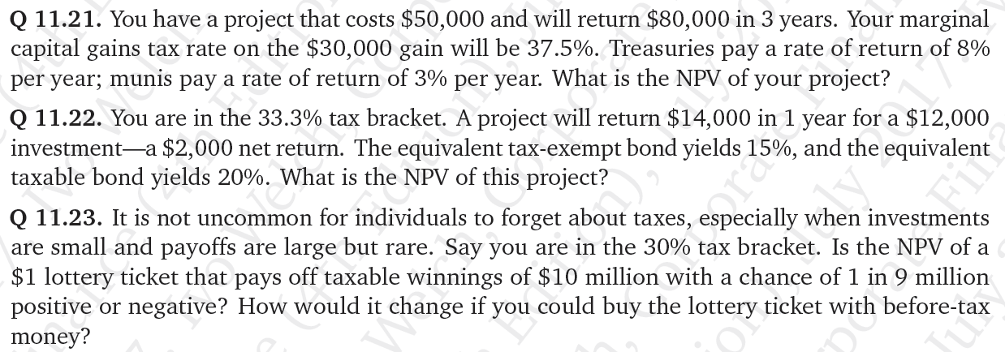

Entrepreneurial finance: CC will be higher.

Promised RR=time premium+default+risk+liquidity+imperfect

Expected RR=time+exp. risk+imperfect mkt+tax

Actual RR=time+default realization+risk+liquidity_tax

Highly rated: liquidity+tax; low:liquidity+risk+tax

C0*[1+r_nominal,before tax*(1-t)]=C1

C1/(1+r) = P0

R_after tax,real = P0-C0/C0=r_nominal,before tax *(1-t)-r/(1+r)

Nominal RR=(1+inflation)*(1+real RR)

Higher inflation and interest rates hurt taxable savers, help taxable borrowers. r_real could be negative

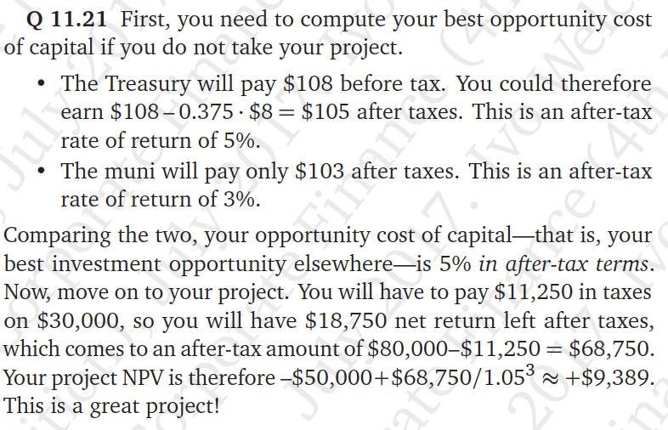 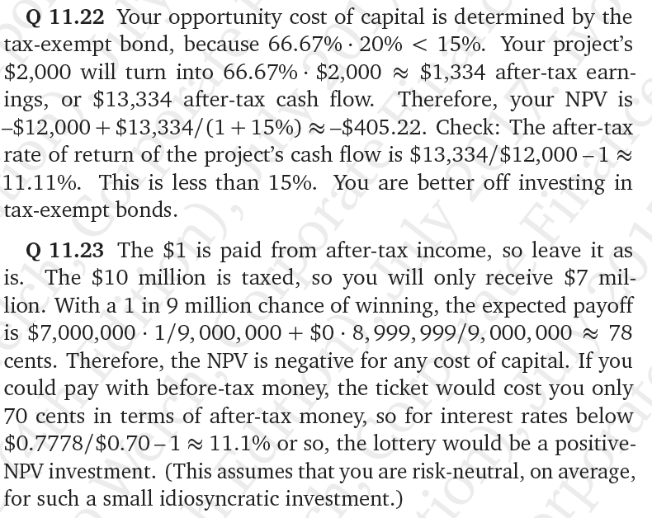

Law of one price—perfect mkt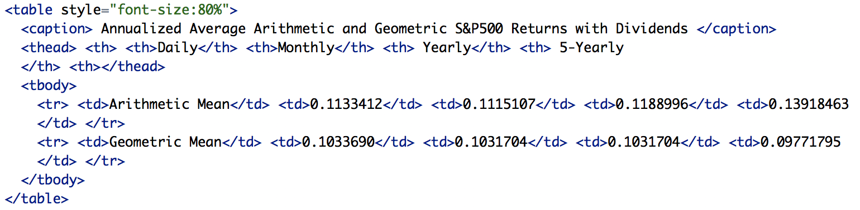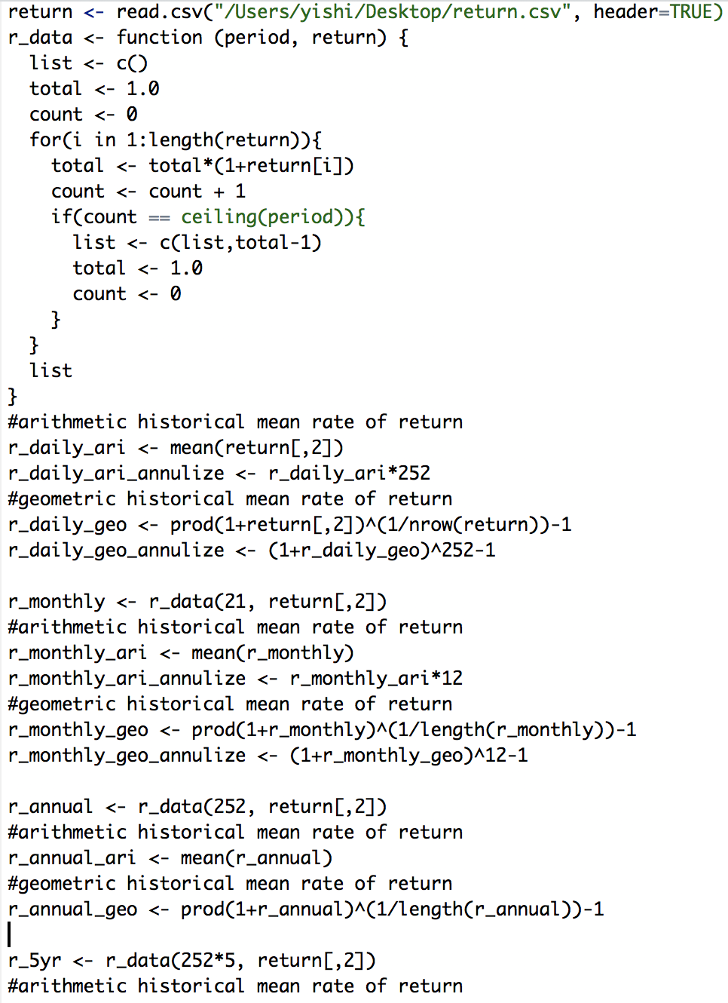

YTM=IRR-RR; efficient frontier=portfolio optimization, portfolio optimization better than efficient frontier and CAPM.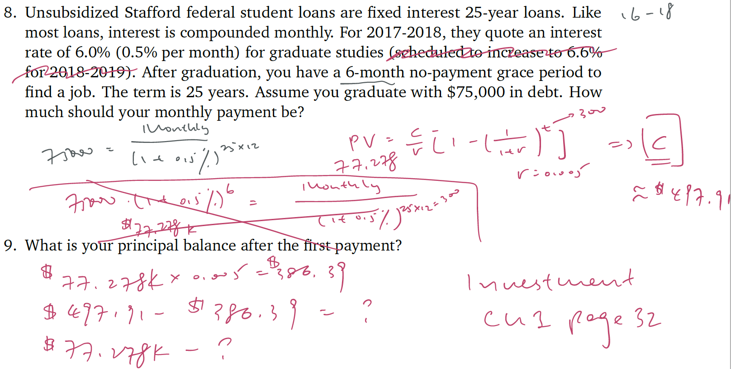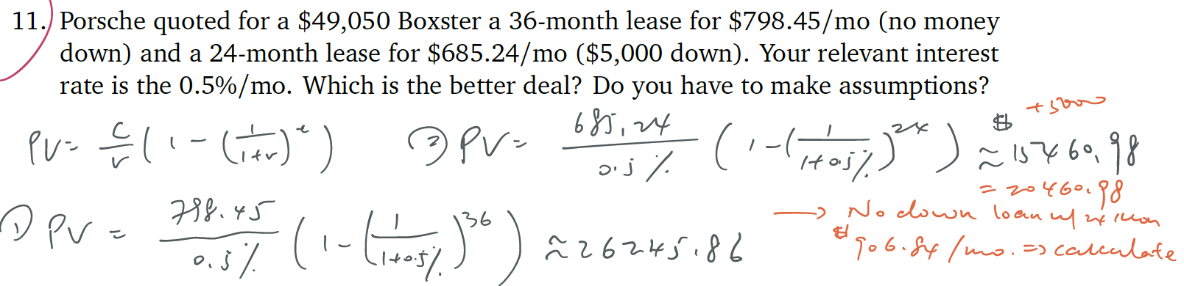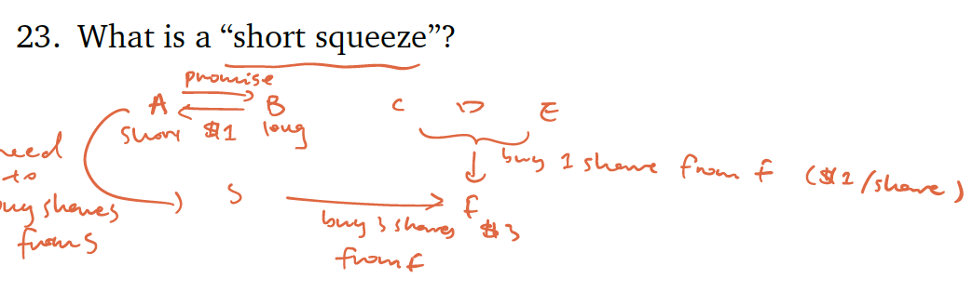

Relativism: tendency of people to consider issues of relative scale when they should not. Compartmentalization: tendency of people to categorize decisions. Agency moral hazard: hire only employees that you judge to be intrinsically honest and ethical. Ex: competition for capital; employment concerns; perks; power; hidden slack; reluctance to take risk; direct theft. Contributing factors: scale and owner engagement; project duration; external noise; opaqueness. Control Mechanisms: “voluntary” disclosure; contract specificity; audits; truth-telling incentives; contingent compensation. Reputation; capital rationing; selecting managers.

**Chapter 14**: the diff. between income and economic CF is accruals. CF+: reduce inventory; delay payments to suppliers; lean on customers to accelerate payment; sell off their receivables at a discount; reduce the profit that the firm will ultimately receive. Growing firms consume more cash. NOTES CF = NetSales-Tax-CapExpense; CF=NI+Depre.-CapExpense+Interest. Take the depre. from CFS. Deferred tax: diff. between tax expense and tax liability.(IRS&GAAP) taxes-payable: tax due in US. NOTES Investment in Goodwill: merges&acquisitions. Project=CF Operations+CF Investing+IntExp. Equity=CF Oprations+CF Investing+Net Debt Issuing. BS: believe in cash&cash equ. Not believe in receivables&payable&inventories. Compare to similar companies and see relative numbers to figure out whether they cheat or not. **Chapter 15 Comparables**: 1. Identify projects that are close comparables 2. Identify a measure that is value-relevant (P/E ratio) 3. Mkt values similar projects similarly-law of one price. Whole firm are easier to value with comparables analysis, while individual projects are easier to value with PV analysis. Earnings is more reflective for long term. P/E*earnings(NI)=price of project. P=E/(r-g). P/E=1/(r-g). All else equal, the P/E ratio is higher for firms w/ more future earnings and more future earnings growth. Near bankruptcy firms can have high P/E ratio. Firm A:P$200 E$10 Firm B:P$200 E$1 merge:P$400E $11, so PE=400/11. Not value-weighted. Besides merge, P/E is equal-weighted. 1/X problem: ignore nonpositive earnings firms; use the median not the mean; average E/P yields and invert; work with sums. Growth: more debt increases P/E ratio; Value: more debt decreases P/E ratio. Price to sales/employees/scientists/patent…

NPV: adv. Identify what actually matters and how differently timed CF matter in diff. way; give you exact relationship between various estimated inputs and measurements; inadv. input estimates may far from the truth; no objective standard for estimates. Comp: adv. if high correlation of true NPV and your measure, then it provide good estimates. inadv. Good comparable firm? Appropriate valuation attribute?

**Chapter 16**: capital structure is the sum total of all claims on the assets of the firms. CF rights: how much money the claims holders are supposed to receive. Control rights: what remedies claims holders have, especially when they do not receive the cash flows originally proposed to them. Liabilities: leverage. Equity: stock. Shareholders “own” corporations-only after other obligations are satisfied. Debt: creditors: you could make the company bankruptcy. Equity: shareholders: elect manager. Convertible bonds allow the bondholder to exchange the bond into something else, usually into equity. Why would shareholders be willing to give bondholders this right? b/c bondholders would pay more for bond upfront. Then shareholders can negotiate for a lower interest rate. Secured debt: secured w/ some assets collateral. Senior/junior: paying order, senior first. Puttability allows the bondholders to return the bond to the issuer. Callability allows the issuer(firm) to “call in” the outstanding bond at a prespecified price. A public bond usually owned by many diffuse creditors, but a bank loan is owned by one bank and can take the form of a credit line or of negotiated debt. Non-financial liability=trade credit. NFL w/ strong control rights: income tax obligation; weak control rights: customer who bought a warranty from the firm. Preferred equity is a claim w/ both debt and equity characteristics. Dividends usually higher than common dividends; can’t make the shares outstanding; get divd. first. Firms’ leverage/debt burden: FD/FD+EQ or TL/TA(no book value but mkt value of EQ). Biggest determinant of debt ratio: the change of value of underlying assets(change equity more than debt). Value up and leverage ratio down. **Chapter 17 capital structure in PM**: NOTES arbitrage opportunity if there was a capital structure worth $1 more or less but not in PM. Firm value does not depend on the value of debt and equity. No risk neutrality NOTES fixed projects means control rights cannot change project CF. risk aversion causes expected int. rates on debt to be lower than expected rates of return on the project. E(debt)+E(equity)=E(firm) WACC: w_d*E(r_d)+w_e*E(r_e)=E(r_firm). Firm takes more debt, debt and equity become riskier and CC for the d&e E(r_d)& E(r_e) increases, but it doesn’t mean the overall firm becomes riskier because w_d increases and w_e=1-w_d decreases**. Chapter 18 tax and capital structure**: investors “after-corporate-income-tax” returns, taxes mean that the after-tax rate of return is lower than the before-tax rate of return. PV=E(C_after-corp-tax)/(1+E(r_after-corp-tax)). Have more debt could decrease tax, but if too much, then other forces raise the firm’s CC to the point where further increases in debt are no longer value-increasing. Debt can reduce money to the IRS. Interest payments before tax pay less tax. If debt and equity are treated symmetrically, then payments to creditors and shareholders are deducted from profits, shareholders and creditors pay equal taxes on receipts. If not, then payments to creditors but not to shareholders, same for the latter. WACC: ratio of debt; APV: amount of debt. Personal income tax-DT&EQ treated symmetrically—payment same, shareholders pay lower taxes than creditors on receipts. Making DT relatively worse than EQ. High-tax investors should hold equity. Low-tax, unprofitable firms should pay out via share repurchase or div.(thus have equity). High-tax firms should pay out via interest. **Chapter 19**: