**MFE409 HW5 – Case Study**

*Group Members: Sejal Bharati, Huanyu Liu, Tongsu Peng, Yong Jia Tan*

**Question 1**

Jasper’s aim is to build Guang Guo’s risk management function, introduce international standards in risk measurement and management to Guang Guo, and control risk-adjusted returns using minimum capital requirements based on VaR.

Charles’s goal is to find an overseas trained Chinese candidate for risk management, ultimately establish overseas branches of Guang Guo.

Jianguo is in charge of trading strategy and asset allocation and lacks interest in risk management. He just wants to make profitable actions and believed his own experience and judgement in better than statistical risk management models.

Obvious tensions existed between Jasper and Jianguo, as Jasper is effectively limiting Jasper’s actions due to risk management. Jianguo’s resistance to Jasper’s risk management ideas also effects Charles, as he wants to turn Guang Guo into an international corporation.

**Question 2**

The VaR model is an internationally used measure for risk, recommended by Basel rules as well. It is widely used to calculate banks’ minimum capital requirements.

**Question 3**

Jianguo argued that no VaR model could replace his years of experience in Chinese markets and stated that Chinese markets are different from Western markets. He thought that the Shanghai equity markets were dominated by speculative retail investors and prone to unpredictable movements that cannot be captured well by statistical models

**Question 4**

For this question, I calculate the rolling VaR for Shanghai Composite Index and S&P 500 Index. The rolling (lookback) periods are 3-month, 6-month, and 9-month. Under the risk management assumptions, the average return is zero and the VaR is the lookback period volatility times the z statistics.

The table below summarizes the number of exceptions per year for the three different lookback periods and for Shanghai Composite Index and S&P500. Given the 95% confidence level and 252 trading days each year, we would expect about 12-13 exceptions per year. To get a more concrete range for the acceptable number of exceptions, we would do the binomial tests and get the range to be [6, 19]. If the number of exceptions falls outside of the range, we could reject with 95% confidence. ***I highlight the ones that is not significant in yellow***.

Comparing the number of non-significant exceptions between the two indexes, we could conclude that S&P 500 index does more poorly in this VaR backtest. Lengthening the lookback period does not improve the performance of VaR at all. On the contrary, lengthening the lookback period monotonically worsens the performance. This is consistent with our understanding that shorter lookback period captures more recent volatility better.



***\*Note: 1999 has less than 250 data tries due to the lookback period***

***\*\*Non-significant number of exceptions is highlighted in yellow.***

The two charts below plot the returns of two indexes along with the VaR level with 3-month, 6-month, and 9-month lookback period, respectively.

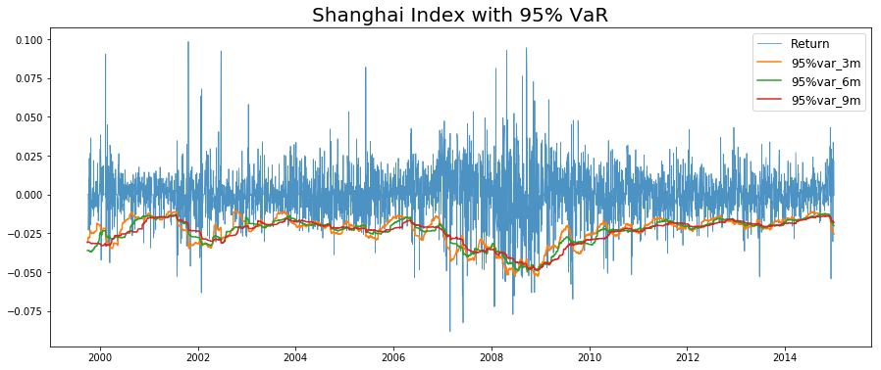

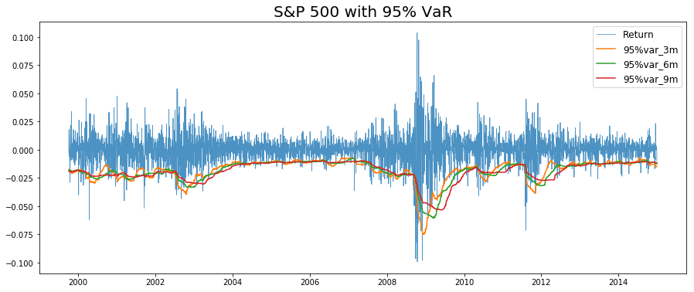

**Question 5**

As the backtest results uses historical data in China and shows that the VaR results have been even better with the Shanghai Composite than the S&P 500, Jasper can use this as strong evidence that the VaR measure is actually very suitable for risk management in a Chinese equity environment.

**Question 6**

We think his attempt will be hard to implement in actual practice, because the traders and asset managers are used to their ways of business and have a strong bias towards the specialties of the Chinese markets. Advice we would give to someone is his role would be to seek strong support from both the CEO and other colleagues, as well as trying to pitch the risk management measures in a more intuitive way to persuade traders and asset managers to agree that the methods are consistent with their own beliefs.

**Question 7**

The main regulatory body that oversees the Chinese banking system is the [China Banking Insurance Regulatory Commission](http://www.cbrc.gov.cn/EngdocView.do?docID=F495CC398DAD4FA4B10B0B25A8BDC9E5) (CBIRC), which replaced the China Banking Regulatory Commission (CBRC) in April 2018. The CBIRC is charged with writing the rules and regulations governing the banking and insurance sectors in China. It also conducts examinations and oversight of banks and insurers; collects and publishes statistics on the banking system; approves the establishment or expansion of banks; and resolves potential liquidity, solvency, or other problems that might emerge at individual banks.

The People's Bank of China also has considerable authority over the Chinese banking system. Aside from the typical central bank responsibility for [monetary policy](https://www.investopedia.com/terms/m/monetarypolicy.asp) and representing the country in an international forum, the PBC's role is to reduce overall risk and promote the stability of the financial system. The PBC also regulates lending and [foreign exchange](https://www.investopedia.com/terms/f/foreign-exchange.asp) between banks and supervises the payment and settlement system of the country.

After the crisis, the People’s Bank of China increased its window guidance to banks and took other initiatives to slow the growth of lending starting in mid-2009. As a result, new loans extended in the second half of the year were less than a third of the new lending volume in the first half. Although lending spiked upward in January 2010, the China Banking Regulatory Commission (CBRC) the same month announced tougher measures to moderate the pace of lending over the balance of 2010. The CBRC reinstated mandatory lending quotas on individual banks and imposed tougher regulations to prevent banks from lending out most of their lending quota in the first quarter or two of the year. They also raised the required reserve ratio by 50 basis points in January, in February, and again in March 2010. This had the effect of cutting banks’ excess reserves and signaled the transition away from the “appropriately loose” (*shidu kuansong*) monetary policy initiated in November 2008 to the appropriately loose monetary policy implemented with “better targeting and more flexibility based on changing conditions” in 2010. The central bank followed up by hiking benchmark lending rates and further increasing the required reserve ratio in late 2010 and the first half of 2011, key steps inaugurating a “tight” (*wenjian*) monetary policy.

The CBRC also took a series of other steps to curtail the expansion of bank credit. In 2008 it had put pressure on banks to increase their minimum bank capital adequacy ratio by 2 percentage points (from 8 to 10 percent) and in late summer 2009, when the commission sought to slow the lending growth, it apparently raised this ratio further, to 12 percent, for selected city commercial banks. In August 2009 the commission circulated a draft regulation stating that banks would no longer be able to count subordinated debt and hybrid capital as part of their tier-two capital. During the lending boom of 2009 banks had kept their capital adequacy ratios from falling sharply by selling large amounts of subordinated debt. But over half of the subordinated bonds sold by banks were purchased by other banks. The CBRC recognized that these large cross-holdings of subordinated bank debt did not add any capital to the banking system as a whole, revealing that high capital adequacy ratios reported by individual banks overstated the soundness of the banking system. Thus, the draft regulation restricting the use of subordinated debt was adopted in what the CBRC chairman described as a “historic decision” (Liu Mingkang 2010).

Raising the capital adequacy ratio and disallowing subordinated debt as a source of capital meant that banks had to either raise more equity capital or slow down their lending and other activities that require capital backing.