Vibration decoupling system for massive bolometers in dry cryostats
3 Sep 2018
- Content
- Pulse-tube based dilution refrigerators are massively employed in low temperature physics. They allow to reduce the running costs and to be operated with unprecedented easiness. However, the main drawback of this technology is the mechanical vibrations induced by the pulse-tube cryocooler. These perturbations can cause extra-noises drastically affecting the detector performance.（内容）
- In this paper, we propose a solution to mitigate the impact of these vibrations by mounting the detectors in an elastic-pendulum based suspended tower. Based on vibration modeling and experimental tests, we show that the vibration levels are attenuated by up to two orders of magnitude at most frequencies, especially above ∼ 20 Hz, for both vertical and radial directions.（描述）
- Thanks to this passive isolation solution, vibration levels, both along vertical and radial directions, below 1 μg/√Hz in the frequency range [1-1000] Hz are obtained. This provides a convenient environment to test the ultimate performance of low temperature detectors. As a result, we report an improvement by one to two orders of magnitude on the noise levels of massive cryogenic bolometers, leading to thermal energy resolutions improved by a factor 5 to 40. Finally, we conclude that the energy resolution of our cryogenic bolometers are no longer limited from any residual vibrations, hence allowing the perspective of further improving our bolometer performance in the neutrino physics applications. （描述）//ABSTRACT
- Dry Dilution Refrigerators (DDR) are a convenient alternative to Wet Dilution Refrigerators (WDR) in terms of low-cost and ease of operation. They have a high level of automation and avoid the consumption of liquid helium while providing a similar low temperature environment as the one obtained with WDR. The cool-down process of the two first stages within DDR is ensured by the technology of pulse-tube cryocoolers. However, the mechanical vibrations they induce can drastically affect the performance of cryogenic detectors. This effect has been reported by several cryogenic experiments using such bolometers [1 2 3]. （内容）//INTRODUCTION
- Results
- Attenuated by up to two orders of magnitude at most frequencies, especially above ∼ 20 Hz
- Below 1 μg/√Hz in the frequency range [1-1000] Hz are obtained
- Leading to thermal energy resolutions improved by a factor 5 to 40
- The energy resolution of our cryogenic bolometers are no longer limited from any residual vibrations

- Set up
- 目的：引力波探测器 — 降低热噪声与热透镜效应
- 途径：脉冲制冷，进而引入振动，最终采用主动控制
- 结果：减少两个数量级。

- In the case of a plate suspended by several springs, the system can pitch.
- minimizes the coupling to any transverse modes.
- anti-triboelectric coaxial cable.

- Questions
- based on a ∼ 25 cm long free elastic-pendulum with one stainless steel spring at a single fixing contact point
- The first two stages (50 K and 4 K) of this DDR are thermally coupled by low-pressure gas exchangers (HexagasTM) to avoid any mechanical contact between the pulse-tube cold head and the dilution unit.
- For the wire at the still plate, both nylon and Kevlar were used.
- With this approach, the total pendulum length lp from the still plate to the center of mass of the detector assembly, can be equal to 25 cm.

- Need to read
- A first attempt was made to suspend a massive TeO2 detector array with a Teflon damped steel spring [4].
- The system was improved in [5] to a two-stage low-pass mechanical filter by adding an intermediate lead disk anchored to the cryostat by three stainless steel wires and harmonic stainless steel strips.
- The CUORE experiment has implemented a different strategy. A Y-Beam (with three connecting points) at 300 K isolated from the cryostat through Minus-K suspensions supports the whole 988 TeO2 detector array. Despite the use of three CRYOMECH PT415 pulse tubes, they report keV-scale detector energy resolutions [6, 7].
- The LUMINEU and CUPID-Mo collaboration, adopted a decoupling strategy with the help of three springs on each tower hosting three to four detectors. They clearly demonstrated the benefit of this suspended structure in the low-background EDELWEISS cryostat at Modane [8].
- In the experiment AMoRE, the detector array is fixed to a platform which is suspended below the mixing chamber by four phosphor bronze springs [9].
- This work has been done using the dry cryostat at the Institut de Physique Nucléaire de Lyon (IPNL) provided by Cryoconcept [13].
- Recent works in [3] have demonstrated how the use of an edge-welded bellow to mechanically decouple the cold head from the cryostat frame considerably reduced vibrations and improved low-temperature performance. espacially in the radial direction!

- Idea
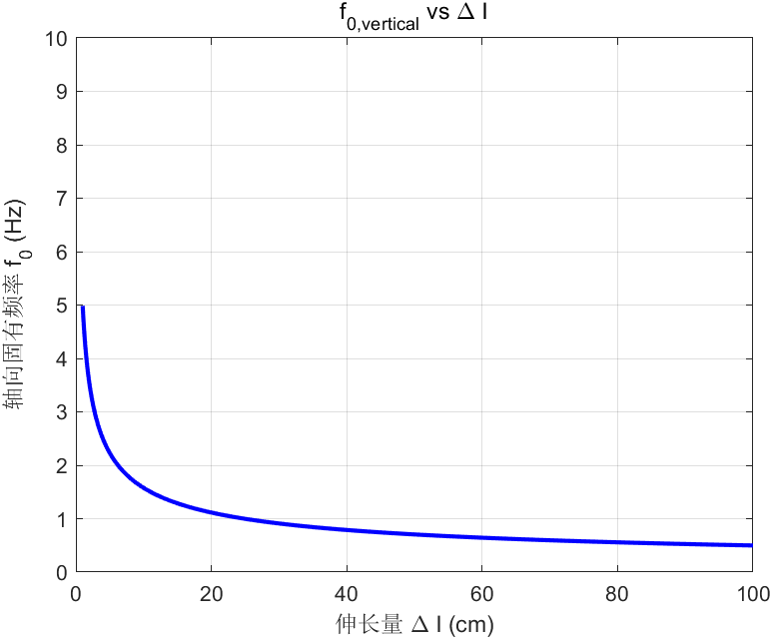
- 对于结果的描述
- 需要知道减少了几个数量级。
- Vibration below ？μg/√Hz in the frequency range [1-1000] Hz.
- 热信号分辨率：Leading to thermal energy resolutions improved by a factor 5 to 40.

Vibration-free cryostat for low-noise applications of a pulse tube cryocooler
19 Sep 2006
- Content
- Results
- more than two orders of magnitude by means of an active system.（降低2个数量级）
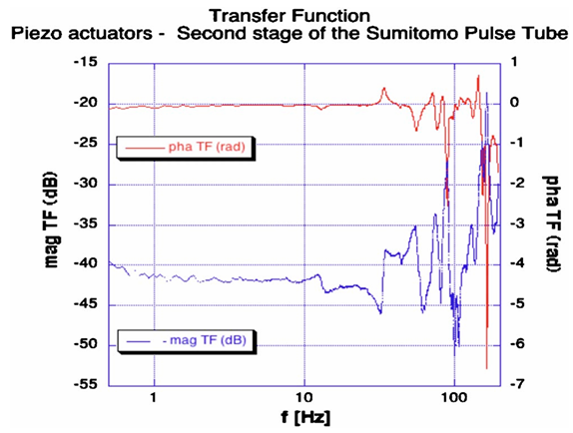
- A typical result of this measurement is shown in Fig. 8. We notice that in the low frequency range up to 10 Hz, the system behaves as a rigid body, while at higher frequencies some mechanical resonances are present.
- Set up
- 目的：引力波探测器 — 降低热噪声与热透镜效应
- 途径：Cryomech PT 407&Sumitomo SRP-052A（噪声小）制冷，进而引入振动，最终采用主动控制
- 结果：减少两个数量级
- 振动的测量：a fiber-bundle position sensor 光纤束位移传感器 & A similar curve characterizes a second fiber-bundle sensor, by Philtec,
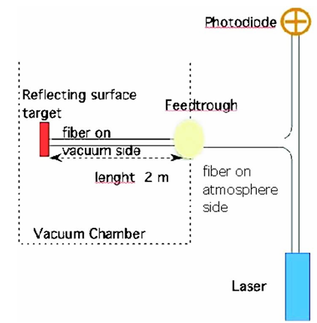
- 在该装置中，激光通过 Y 型光纤束的一条分支发射至反射靶面，并通过另一条分支接收（详见图1左侧）。
- The super attenuator
- providing both a passive and an active attenuation of the seismic noise
- drawback：requiring a larger cooling power and a very long heat link
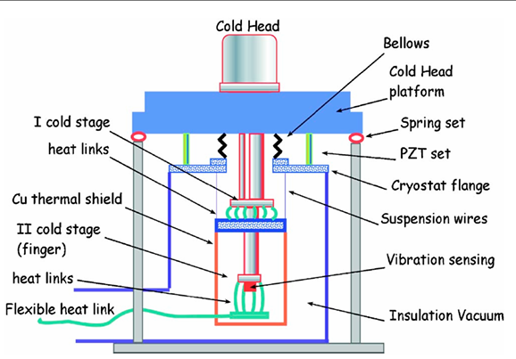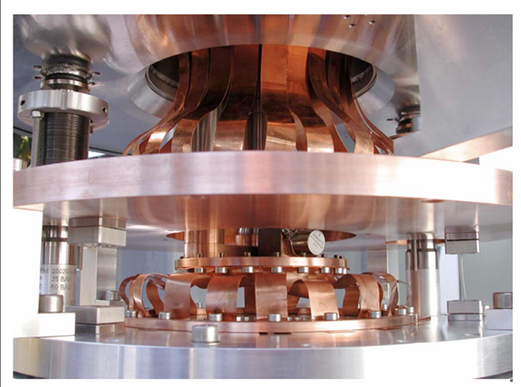
- As expected, the softness of the thermal links between the PT cryocooler and the inner vacuum chamber limits the 4 kHz transmission at the level of the inner vacuum chamber.
- Questions
- Need to read
- Idea
Atomic resolution scanning tunneling microscopy in a cryogen free dilution refrigerator at 15 mK
24 March 2014
- Content
- The main advantages of a PT-cooler are the significant reduction of labor intensity of precooling the dilution refrigerator or experiment as compared to cryogen cooled (dilution) refrigerators, where helium needs to be refilled regularly. In addition, considering the steep global increase of helium scarcity, running the pulse tube is much less costly and does not depend on the quality or quantity of the helium supply.（内容—pulse tube优势）
- The reason is that the pulse tube relies on a varying pressure between 7 and 22 bars, resulting on the one hand in square wave-like, low frequency, kilonewton forces acting on the top parts of the cryostat... （内容—pulse tube drawbacks）
- ...and on the other hand in kilohertz range acoustical vibrations due to the gas flow through the pulse tube regenerator and the flexible hoses connected to the rotary valve and expansion vessels. （内容—pulse tube drawbacks）
- However, a downside of a pulse tube system is the vibration level at the cold-head, which is in most designs several micrometers. （内容—pulse tube drawbacks 冷头振动数微米）
- The pressure variation in the pulse-tube is realized through a rotary valve that switches the PT-inlet between the 7 and 22 bars outputs of a compressor at a frequency of 1.4 Hz. （内容—pulse tube 工作机理）
- In order to reduce the horizontal forces acting on the cryostat, we have lengthened the hose which connects the PT and the rotary valve, implementing a flexible “swan-neck” shape, and placed the rotary valve on a flexible platform inside an acoustic isolation box.（内容—天鹅颈）
- In the default configuration, the PT is rigidly connected to the plates at the room temperature, 50 K, and 3 K stages. The periodic expansion of the PT due to the pressure variations is reported to be 25 μm.¹⁵ （内容—出厂默认设置，位移25μm）
- AFM—Atomic Force Microscopy 原子力显微镜
- STM—Scanning Tunneling Microscopy 扫描隧道显微镜
- Results
- 旋转阀（Rotary Valve）的“天鹅颈”软连接+隔音箱
- 将旋转阀与压缩机之间的软管用绳索悬挂在邻近走廊的天花板上
- 3K和still盘由刚性连接→改为弹簧+涡流阻尼器（抑制3Hz振动）& 钢环弹簧（高频隔振）
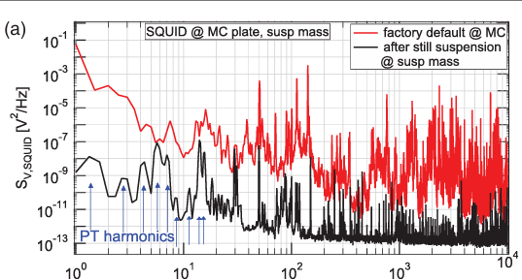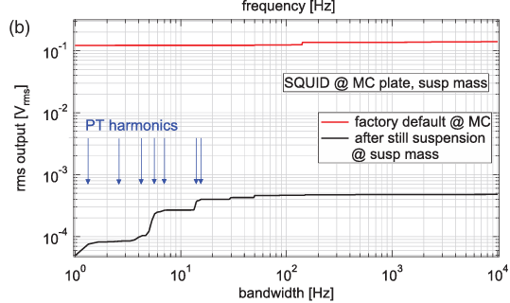
- 红线：原始配置下，SQUID位于混合腔板上（~9mk）
- 黑线：隔振优化后，SQUID安装在第二层悬挂质量块上（<15mk）
- 改造后200Hz以上的噪声已降至仪器本身的本底噪声，说明外部机械振动基本被隔离。在1Hz–10kHz的频率范围内，整体振动幅度（rms）下降了291倍。
- 测量装置：SQUID（超导量子干涉仪），通过监测磁通变化反推振动，亚皮米级别。
- The data below 1 Hz are influ enced by the DC offset of the SQUID output, which is there fore not integrated. 1 Hz 以下的信号因受到 SQUID 输出直流偏移的影响，因此未计入积分。
- Pulse tube 抬高（弹性垫圈和支撑杆）& 用铜带热连接3K/50K

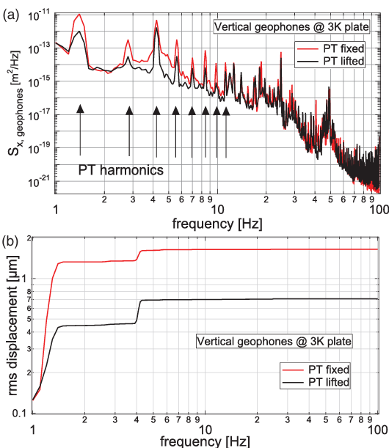
- 测量位置：3K盘（3K）
- 可以明显看出，在 PT 调制频率的多个整数倍处（谐波峰值），振动都有所减弱，直到第8次谐波为止。
- 通过对这些 PSD 曲线进行积分再开方，我们得到如图3(b)所示的位移噪声的 均方根（rms）值。从图中可以看到，在抬升 PT 冷头前后，整个频带内的 rms 位移噪声分别为 1.65 微米 和 0.71 微米，因此总的改善因子为 2.3 倍【14】。
- 考虑到在混合室平台（mixing chamber plate）上实现了 300 倍的改善，而在 3K 级平台上测得的是 0.71 微米的位移噪声，我们估算在图1中位置1的第二个质量块上的残余位移噪声约为 3 纳米，这是在抬升 PT 以及 still 板悬挂之后的估算值。
- 测量装置：地震仪（Geophone），关注 1 Hz ~ 100 Hz，毫米-微米级别。
- 加入粗的支撑杆—“三角架”

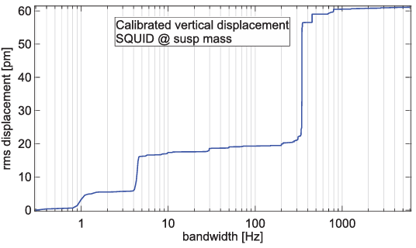
- 测量位置：图中位置4（~15 mK以下）
- 我们绘制了实施所有改进后，MRFM 装置内部检测线圈的 rms 位移噪声随积分带宽变化的曲线。某个频率下压低了，但是其他频率有所上涨，但是总体的积分值还是减小的。
结果表明：在该 MRFM 装置内的总 rms 位移噪声仅为 61 pm（皮米），已经足够支持原子级别的成像。
- 测量装置：SQUID（超导量子干涉仪）
- Set up
- 本文应用：magnetic resonance force microscopy experiments at milli-kelvin temperatures 磁共振显微镜
- SPM振动要求：scanning probe microscopy (SPM) applications on the atomic scale（SPM，振动低于1nm）
- 本文的振动隔离系统是专门为超灵敏的基于SQUID（超导量子干涉器）磁共振力显微实验（MRFM）优化的。为了测试振动隔离的性能，研究人员将MRFM装置替换为STM（能够分辨原子级结构）装置进行了实验。
- 解耦1：he hoses between the rotary valve and the compressor are loosely suspended with ropes from the ceiling of an adjacent hallway. 旋转阀与压缩机之间的软管则被用绳索悬挂在隔壁走廊的天花板上。In this way, the expansion of the hose between PT and rotary valve results in an acceleration of the rotary valve and the hoses to the compressor, rather than that of the PT head. 通过这种方式，PT与旋转阀之间的软管膨胀时，产生的加速度作用于旋转阀和其连接的压缩机软管，而不是直接传递给PT冷头。
- 解耦2：In order to reduce the forces acting between the top three cryostat stages, caused by this expansion, we have lifted the PT a few cm, so that it is resting on support rods and a rubber ring on the room temperature plate.为减少该膨胀对顶部三个温层的影响力传递，我们将PT整体抬高数厘米，使其由支撑杆和橡胶圈支撑在室温平台上。
- 热连接：The PT is thermalized to the 50 K and 3 K stages with soft copper braids.¹⁴ PT与50 K和3 K温层之间的热连接是通过软铜编织带实现的。
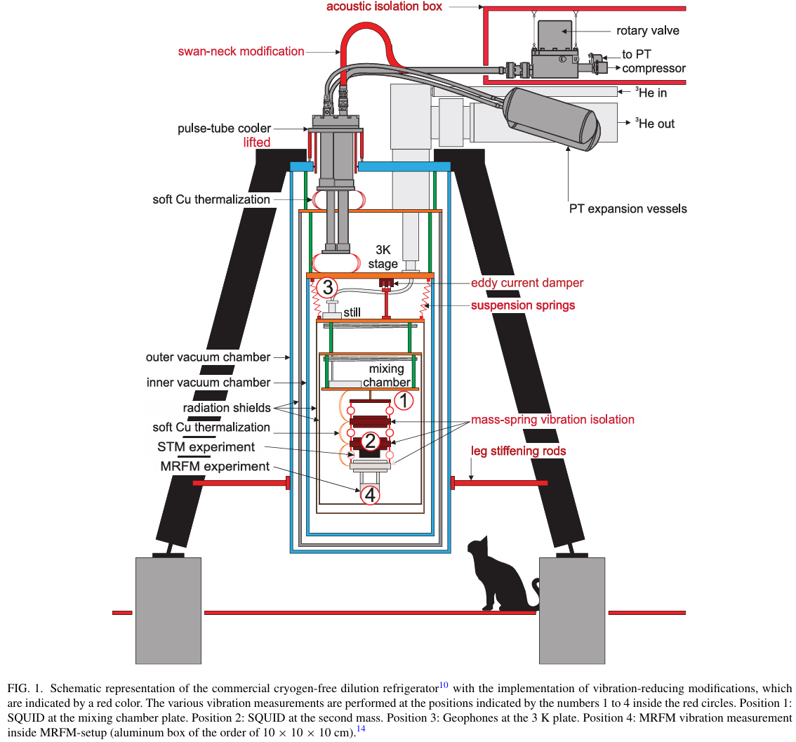
- 隔离振动1：The three support legs of the cryostat are placed on a concrete block that is separated from the foundation of the surrounding building.该制冷机的三条支撑腿被放置在一个混凝土块上，此混凝土块与建筑基础隔离。
- 隔离振动2：We have stiffened the connection between the legs and the outer vacuum chamber (OVC) by making the leg connection to the room temperature plate more bulky as well as by adding rods between the bottom of the OVC and the legs, thus creating triangular support structures. 我们加粗了腿与常温平台之间的连接部位，并在外真空腔（OVC）底部和支撑腿之间加入了加强杆，从而形成三角支撑结构。
- 隔离振动3：The default connection between the 3 K plate and the still plate is provided by rigid poles. We have removed these poles and suspended the lower three stages of the cryostat from the 3 K plate with tension springs. 原本3K板与still板（稀释制冷机中部热板）之间是刚性连接。他们改成用拉伸弹簧悬挂下部三个温区。
- 注意：The total mass of the suspended part is 55 kg. We use 5 pairs of springs with a stiffness of 1.31 N/m, which leads to an estimated vertical resonant frequency of 3 Hz. 悬挂部分总重为55 kg，采用5对弹簧，每对刚度为1.31 N/m，估计竖向固有频率为3 Hz。
- 涡电流阻尼器：In order to reduce the vibration amplitude at this frequency, which is uncomfortably close to the second harmonic of the PT excitation, we implemented an eddy current damper that is thermalized at the 3 K plate. 为了减少3 Hz附近的共振振幅（刚好接近脉冲管二次谐波），他们引入了一个涡电流阻尼器，并将其热连接在3K板上。
- MXC盘下的弹簧悬挂系统：Furthermore, we added a mass-spring vibration isolation system below the mixing chamber plate, consisting of three 5 kg brass masses, suspended from tool steel ring springs, which was designed to provide a 100 dB vibration isolation in a frequency range between 1 kHz and 5 kHz. 此外，他们在混合腔板下增加了一个质量-弹簧式振动隔离系统，包括三个5kg黄铜块，用钢环弹簧悬挂，目标是提供100 dB的振动隔离（1kHz–5kHz范围内）。
- 铜锅的热连接：The masses are thermalized to the mixing chamber with commercial soft Cu tape, clamped with brass bolts. 这些质量块通过柔软的商业铜带与混合腔进行热连接，用黄铜螺栓夹紧。
- Questions
- 悬挂部分总重为55 kg，采用5对弹簧，每对刚度为1.31 N/m，估计竖向固有频率为3 Hz。为什么是3 Hz？
- 我怎么查看多少Hz会受到直流分量的影响？
- Need to read
- 参考文献14
- Idea
- 解耦方式：
- 旋转阀与压缩机之间的软管用绳索悬挂在隔壁走廊的天花板上。通过这种方式，PT与旋转阀之间的软管膨胀时，产生的加速度作用于旋转阀和其连接的压缩机软管，而不是直接传递给PT冷头。
- 为减少该膨胀对顶部三个温层的影响力传递，我们将PT整体抬高数厘米，使其由支撑杆和橡胶圈支撑在室温平台上。
- 隔振
- The three support legs of the cryostat are placed on a concrete block that is separated from the foundation of the surrounding building.
该制冷机的三条支撑腿被放置在一个混凝土块上，此混凝土块与建筑基础隔离。
- 需要确认的事情
- 地面是否有必要做隔振？框架是否有必要做三角形支撑？
- 是否需要把pulse tube抬高？加上做热连接？
- 给旋转阀加上隔音箱？
- Still盘与4K盘是否需要把刚性连接改为弹簧系统呢？
- 涡电流阻尼器是否考虑（增加阻尼）？

