- Introduction
Pulse-tube based dilution refrigerators (DDRs) are massively employed in low temperature physics. They allow to reduce the running costs and to be operated with unprecedented easiness. However, the main drawback of this technology is the mechanical vibrations induced by the pulse-tube cryocooler. These perturbations can cause extra-noises drastically affecting the detector performance.^{[1]} //DDR & PT drawback

To mitigate pulse-tube-induced vibrations in DDRs, Maisonobe et al. (2018) deployed a simple yet highly efficient single-spring elastic pendulum: a detector module suspended ~ 42 cm from a single point via a stainless-steel spring and nylon or Kevlar wire. This minimalist, mechanically simple design suppresses transverse modes and behaves as a second-order low-pass filter, achieving vibration levels of 0.04 –1 µg/√Hz over 1–1000 Hz, with attenuation up to two orders of magnitude above ~ 20 Hz. When EDELWEISS-type germanium bolometers were installed under pulse-tube-on conditions, baseline thermal noise decreased by 1–2 orders of magnitude, and energy resolution improved by factors of 5–40, with the best resolution reaching ~250 eV RMS—demonstrating that detector performance became electronics-limited rather than vibration-limited.^{[1]} // A example setup and result in 2018.

A similar strategy was employed by the NUCLEUS collaboration, who used a ∼1.8 m stainless-steel spring pendulum to passively isolate their detector from cryostat vibrations. The entire 10 mK detector assembly was suspended from a rigid structure, forming a low-pass mechanical filter with sub-hertz natural frequencies in all directions. Under continuous pulse-tube operation, axial and radial displacements were reduced to ∼1 nm and ∼100 pm RMS, respectively. This setup enabled a gram-scale CaWO₄ calorimeter to achieve a baseline energy resolution of (6.22 ± 0.07) eV FWHM at 0.6 keV, with stable performance over several weeks. These results demonstrate that spring-based suspensions can effectively suppress pulse-tube-induced vibrations in full-scale cryogenic systems.^{[2]} //another one in 2025.

Maisonobe’s system uses a short (~42 cm) spring with minimal components, offering a simple and effective solution for vibration isolation. The NUCLEUS setup adopts a longer (~1.8 m) spring with added thermal and structural complexity, achieving sub-nanometer stability. Both are passive and efficient, but differ in ease of implementation and precision. Maisonobe’s design favors rapid deployment, while NUCLEUS targets long-term, high-precision applications. //compare(2018&2025)

In this work, we use a single‑spring elastic pendulum to mitigate the impact of these vibrations by mounting the detectors in an elastic-pendulum based suspended tower. Based on vibration modeling, we show that the vibration levels are attenuated by up to two orders of magnitude at most frequencies, especially above ∼ 20 Hz, for both vertical and radial directions. ^{[1]} //simulation results
[1] Vibration decoupling system for massive bolometers in dry cryostats
[2]Decoupling Pulse Tube Vibrations from a Dry Dilution Refrigerator at milli-Kelvin Temperatures
- Methods
We modeled the suspended tower as a 3D elastic pendulum with mass M, spring constant k, and effective length l. Under the small-angle approximation, and based on the Lagrangian formalism, the system decouples into axial and radial modes. where leq is the spring length at static equilibrium. These expressions are derived by linearizing the equations of motion from the Euler-Lagrange equations. The natural frequencies are:
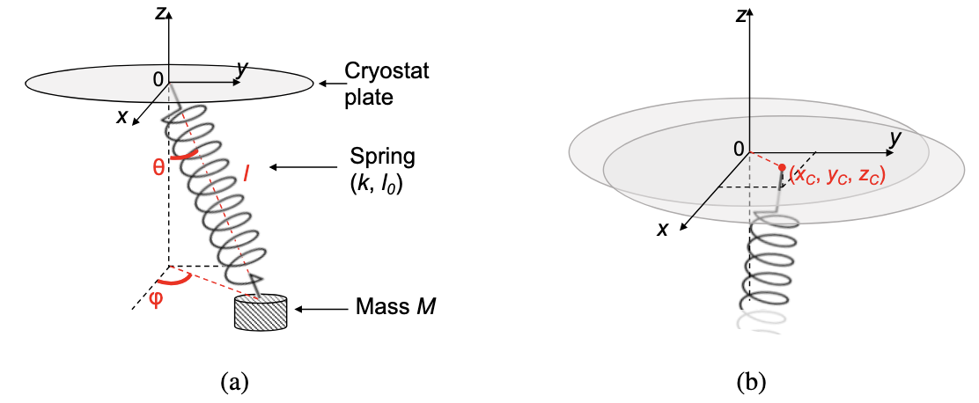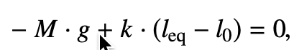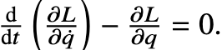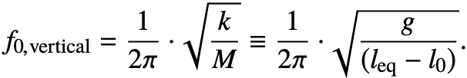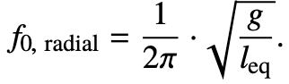
The vibration levels are then visualized through the mean Linear Power Spectral Density (LPSD) of acceleration as follows:
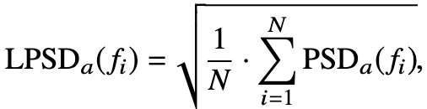
where N is the total number of time windows. Using the calibration gain of the accelerometer, the LPSDa is given in [g/√Hz].
The LPSD of displacement can be reconstructed from the LPSD of acceleration as follows:
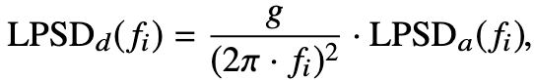
where g is the Earth gravitational constant. The LPSDd is given in [m/√Hz].
An overall comparison can be done by calculating the standard deviation (RMS) in acceleration
and displacement over two frequency regions: the detector bandwidth [1-40] Hz and the so-called acoustic frequency range [40-1k] Hz. The RMS values are then obtained by integrating the linear power spectral densities following:
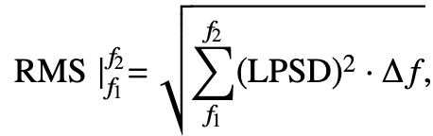
where ∆ f is the discrete frequency step and f1, f2 are the limits of the frequency range.
- Results
Using stainless steel, we consider fatigue limits (normal and shear), spatial constraints (spring length ≤ 0.35 m), and diameter limits (outer diameter < 0.10 m). By sweeping parameters, we identify spring designs with axial natural frequency below 1 Hz that meet all conditions, and extract the corresponding stiffness K.
Figure #1 shows the transmissibility versus frequency for the optimal design. Based on the identified K, Figure #2 shows the integrated transmissibility (0–100 Hz) for different damping coefficients c, with the optimal c at the minimum point.
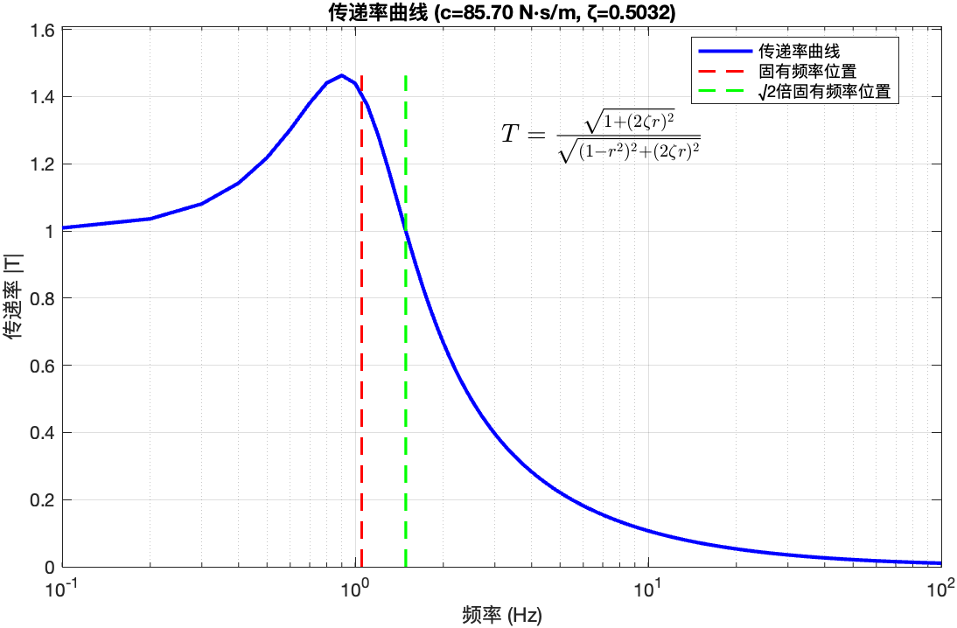


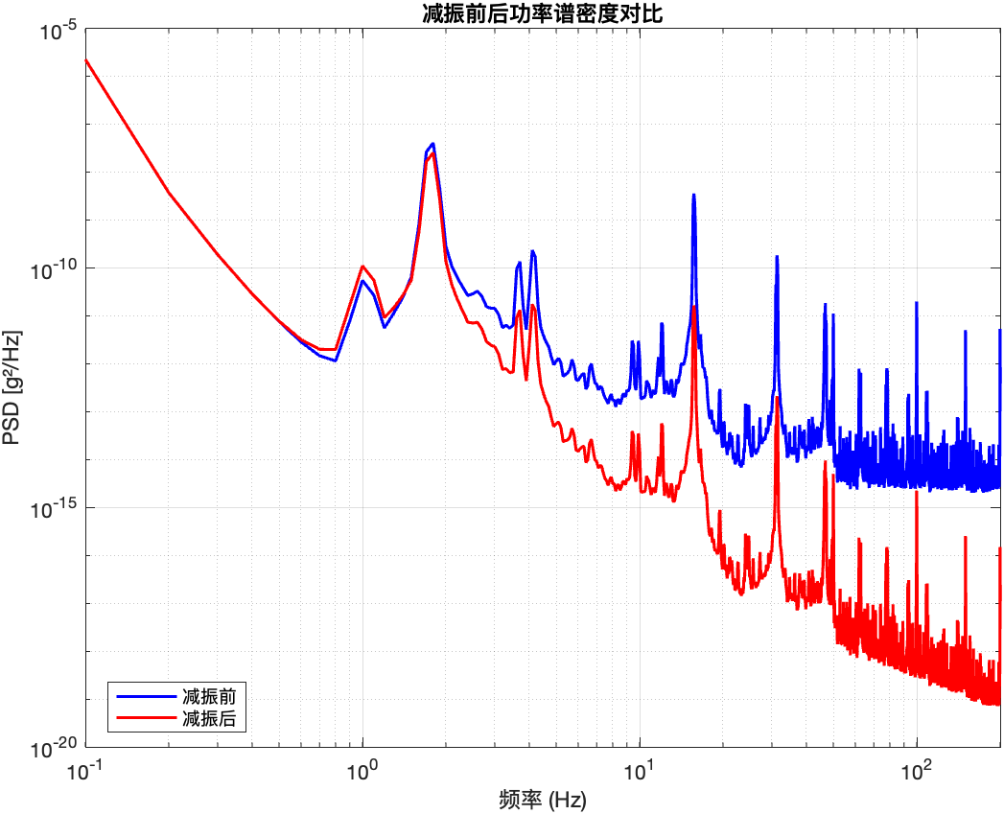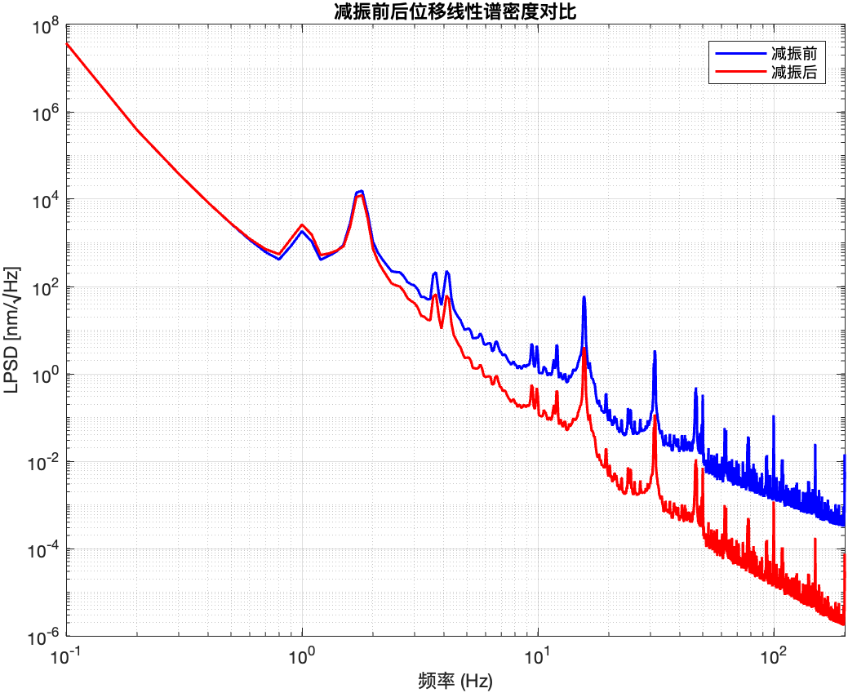
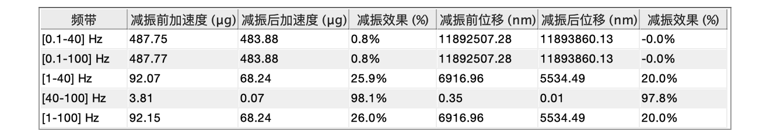
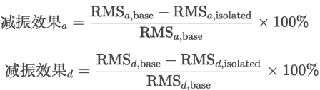
To better visualize the vibration reduction, we computed the RMS values across specific frequency bands in the frequency domain, as detailed in the method section.
We also calculated the power spectral density (PSD) of acceleration and the linear power spectral density (LPSD) of displacement, And plotted both for comparison.
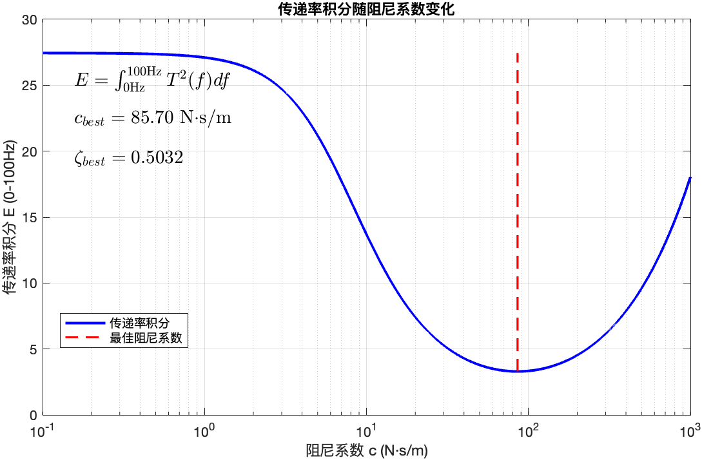

Figures #3–#5 show that significant attenuation occurs above 40 Hz, with up to 98% reduction in acceleration and 97.8% in displacement.
Figure #2
Figure #2
- Conclusions
In this work, we mitigate vibrational disturbances by mounting the detectors on a suspended tower using a single‐spring elastic pendulum design. Vibration modeling indicates that, in the vertical direction, this suspension provides substantial attenuation across the 1–100 Hz range. Specifically, the vertical RMS vibration levels are reduced by approximately an order of magnitude in the 1–40 Hz band and by nearly two orders of magnitude in the 40–100 Hz band. Integrated over 1–100 Hz, the overall vertical vibration level is lowered by roughly one order of magnitude relative to a rigidly mounted detector. This refined model prediction confirms that the elastic‐pendulum suspension effectively isolates the detectors from vertical vibrations in the targeted frequency bands.
- References
- [1] Maisonobe et al., JINST 13 (2018) P09018
- [2] Olivieri et al., Nucl. Instrum. Meth. A 858 (2017) 73

