Tutorial Jahia 7 - Dynamic content display with JQuery & Ajax

1. Foreword
A common issue with Web content is the increase of the number of content that can display on a page. Imagine a page with several thousand of contents on it. Common way to access content can be pagination or filtering with facets. I present here another way to address this issue by dynamically display content as end user pass mouse at the bottom of the page. This will give me the opportunity to show how to implement Ajax call with JQuery and Jahia action in a Jahia 7 environment.

2. Prerequisite
You need for this tutorial Jahia 7. Please note that it's also a good idea to have a maven and a git client configured. Source of the tutorial are available here: https://github.com/Huault/ajax-extendable.

3. Module creation
First step consists in creating the module. connect to Jahia studio, click new Module.

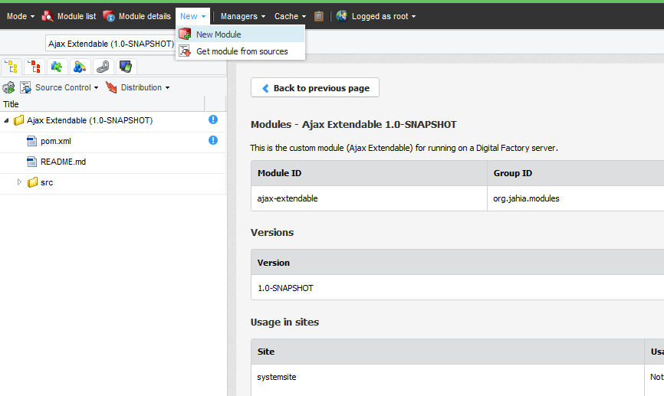Then choose the module name :

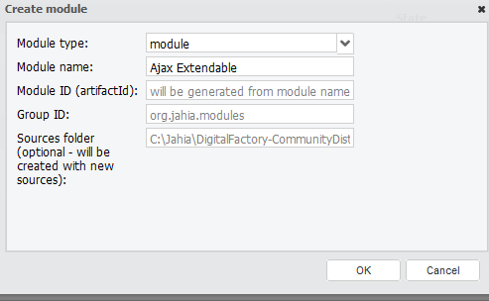

For this module, no specific content is required. We'll simply add a view extendable on the Content List component type.

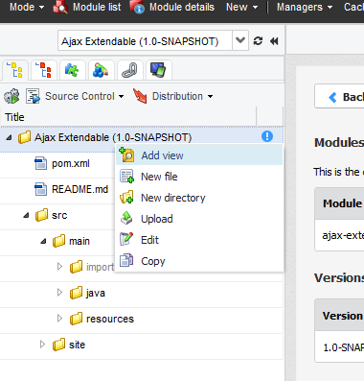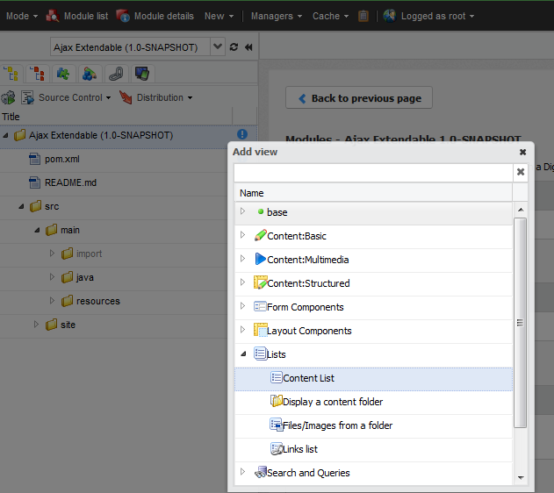
then chose the view name : extendable.

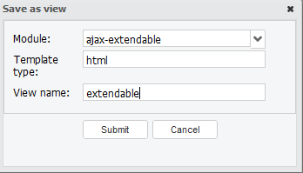

4. JSP Code

Fisrt : here is the code for display content list in edit mode :

<c:if test="${renderContext.editMode}">
<c:forEach items="${currentNode.nodes}" var="child">
<template:module node="${child}" />
</c:forEach>
<template:module path="*" nodeTypes="jnt:bigText" />
</c:if>

Then the code for non edit : first part : at page first load display the 3 last content.

<c:if test="${not renderContext.editMode}">
<div id="extendable" >
<c:set var="index" value="0"/>
<c:set var="inital_size" value="3" />
<c:set var="extend_step" value="1" />
<c:forEach items="${currentNode.nodes}" var="child">
<c:if test="${index < inital_size }">
<div class="part"><template:module node="${child}" /></div>
</c:if>
<c:set var="index" value="${index + 1 }"/>
</c:forEach>
</div>
</c:if>

After this, you can deploy module and first test.

5. Action and Ajax Call
It is time now to get in the heart of the matter. Add action and ajax call.

